

**Common Top Cottages, Almshouse Lane, Heath**

**For Sale £189,950.00**

***TWO BEDROOM COTTAGE - NO ONWARD CHAIN*** Adair Paxton are pleased to offer this two bedroom cottage overlooking Heath Common. Located in the highly regarded village of Heath to the south east of Wakefield city centre, within easy reach of the M1/M62 motorways and railway station nearby. This mid-cottage is set in an idyllic location full of character and charm, and briefly comprises; entrance porch, lounge and kitchen to the ground floor. To the first floor there is a double bedroom with built in wardrobes, a second bedroom and a house bathroom. Externally, the property has a lawned area to the front with views over Heath Common.

**0113 258 1150**

**0800 000 000**

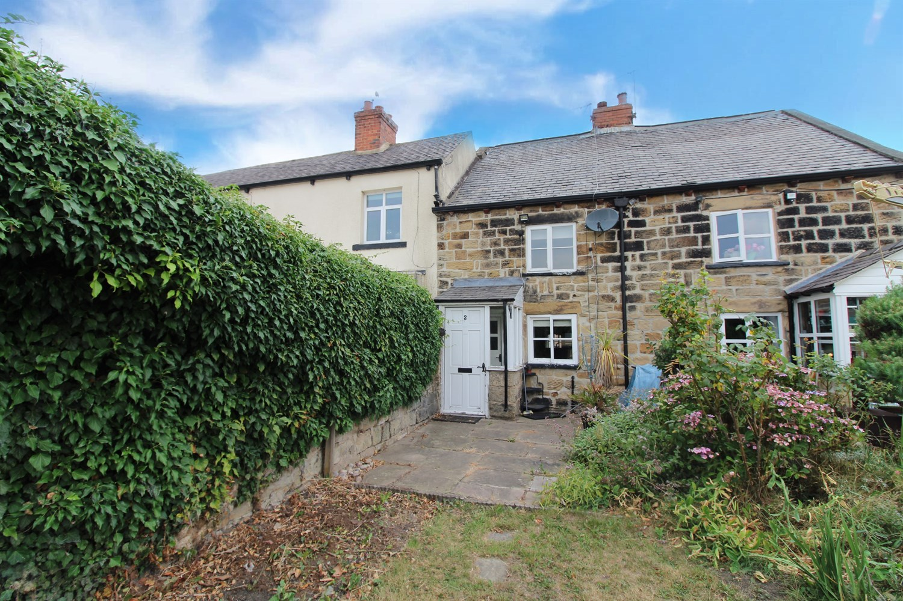

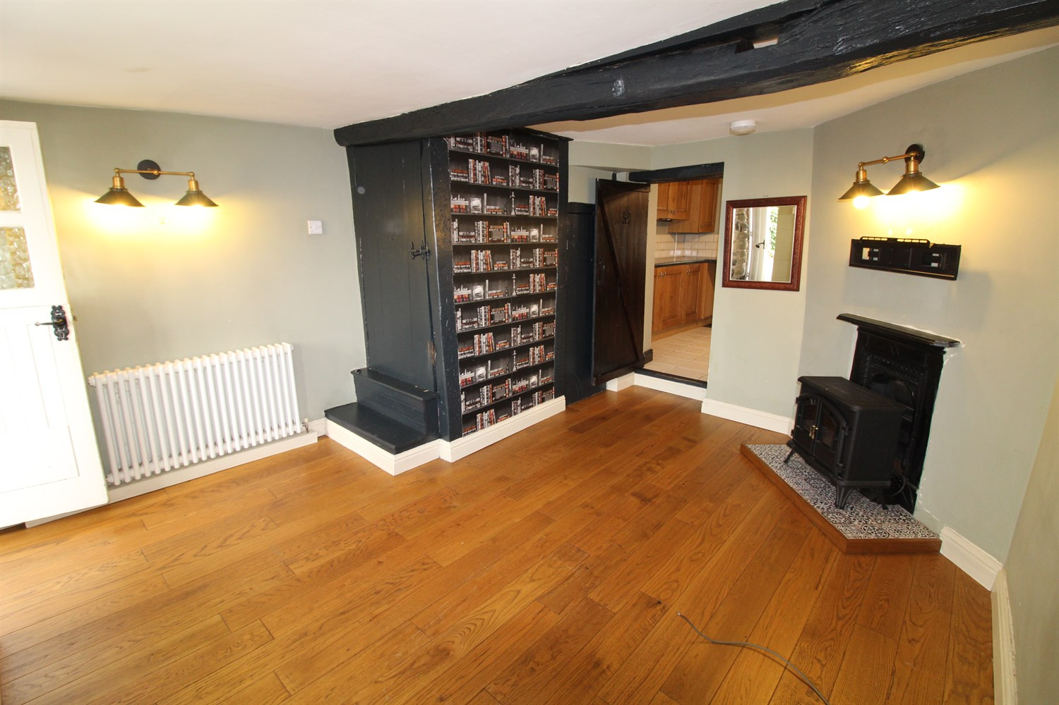

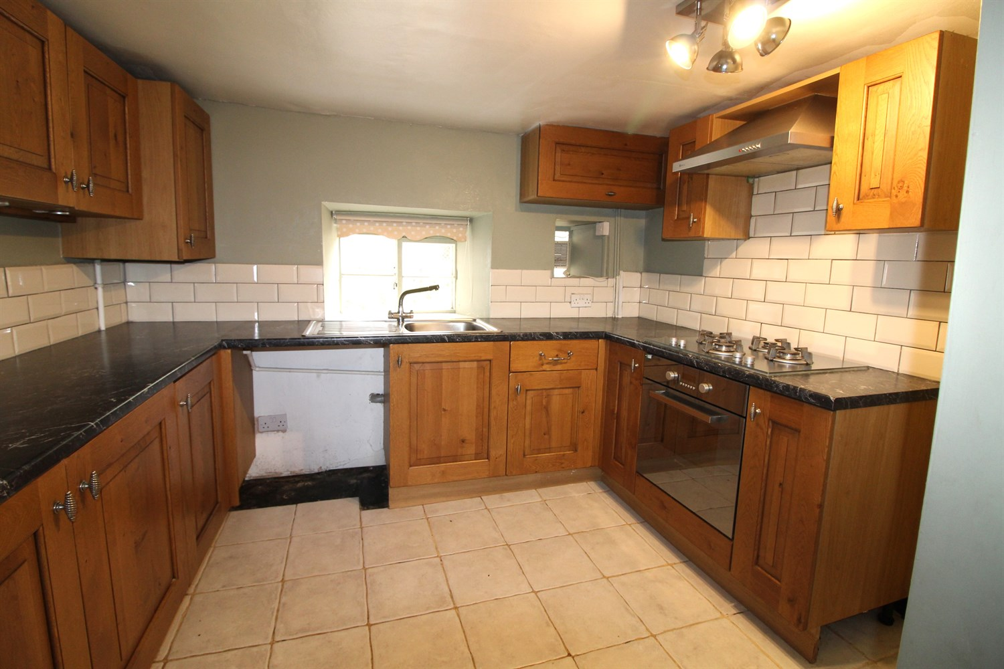

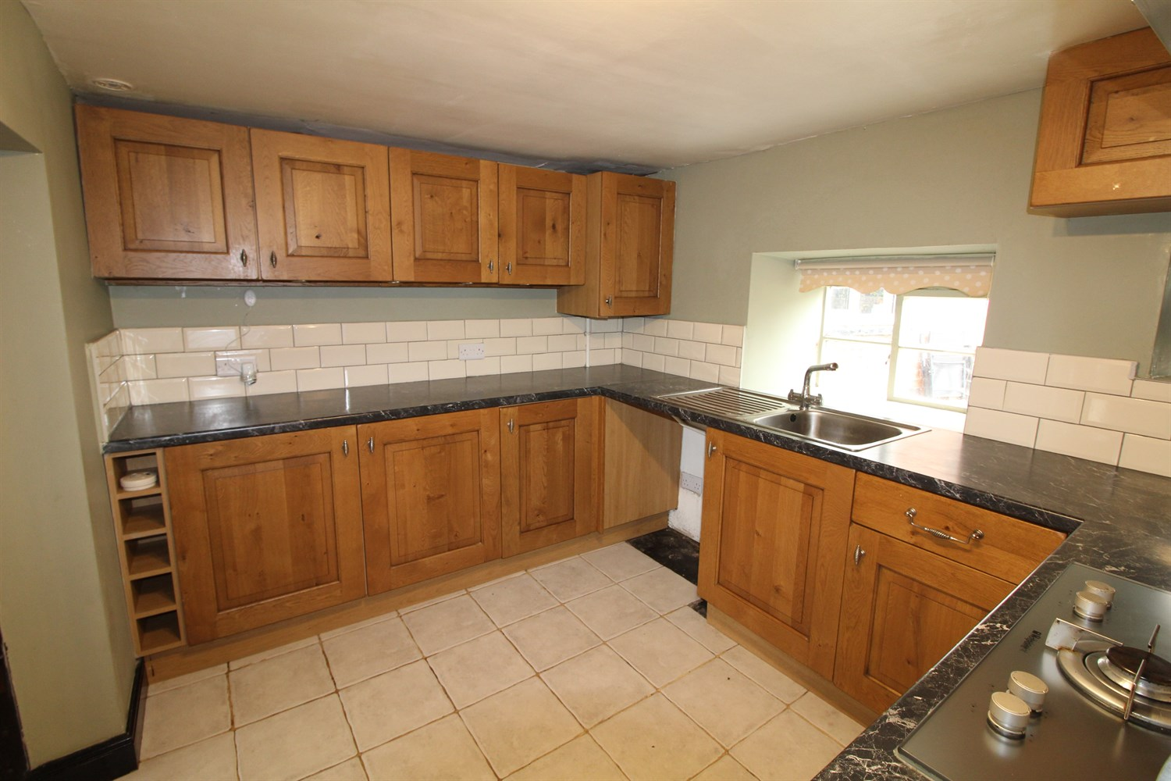

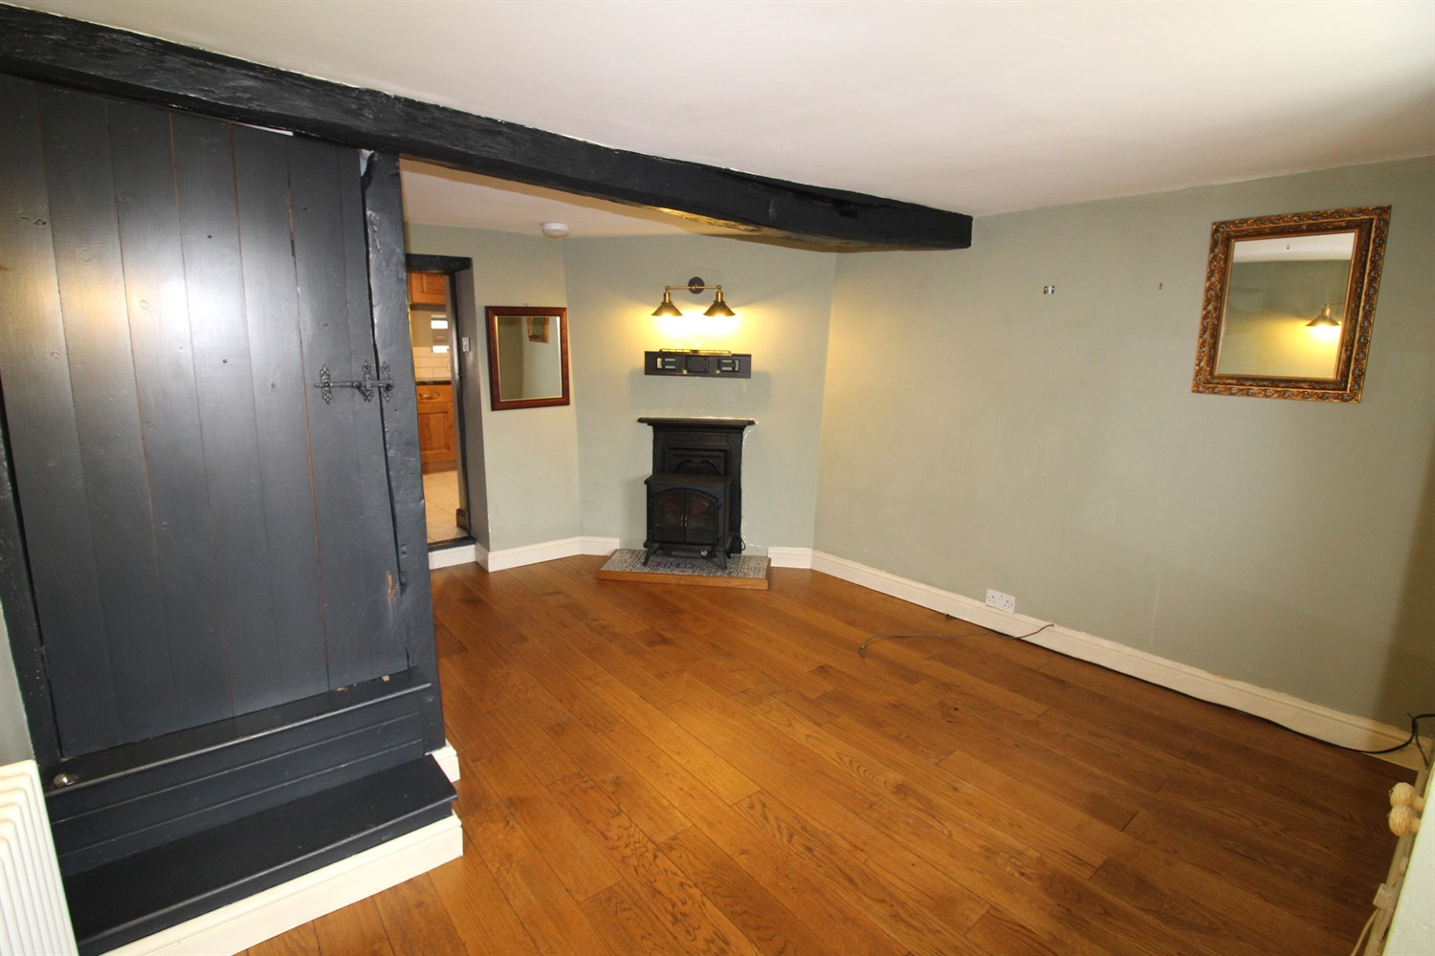

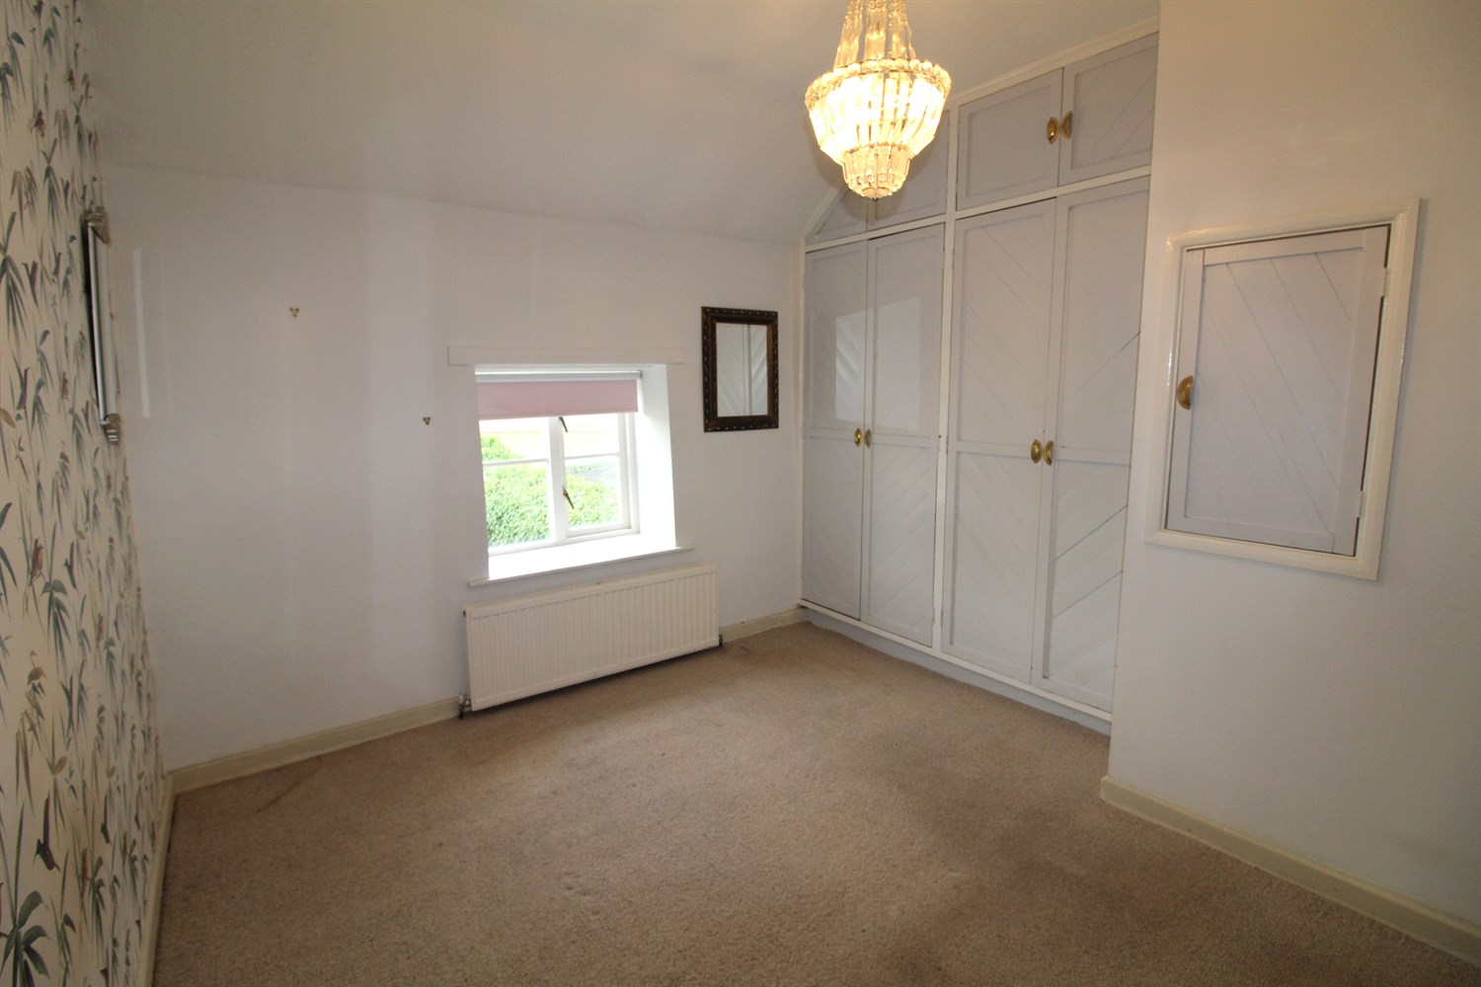

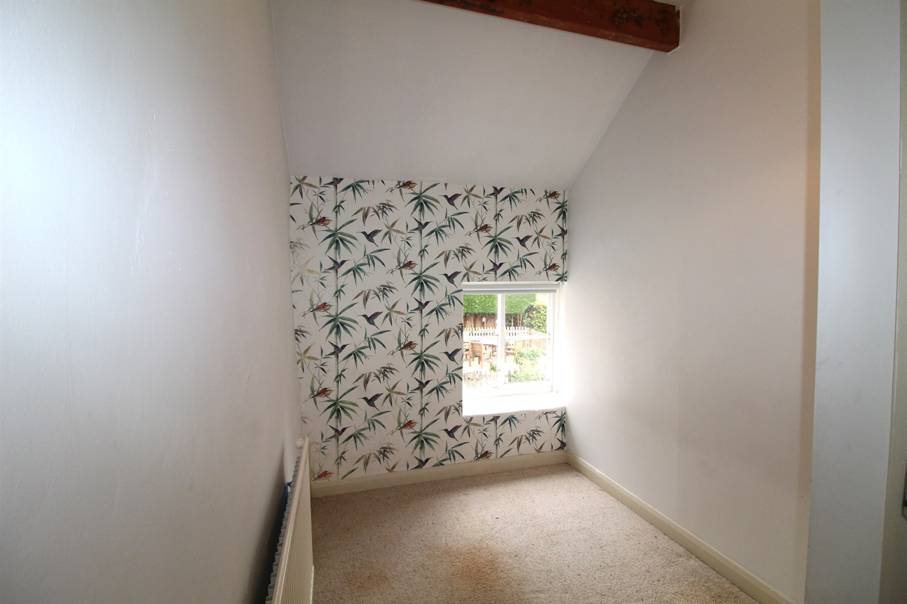

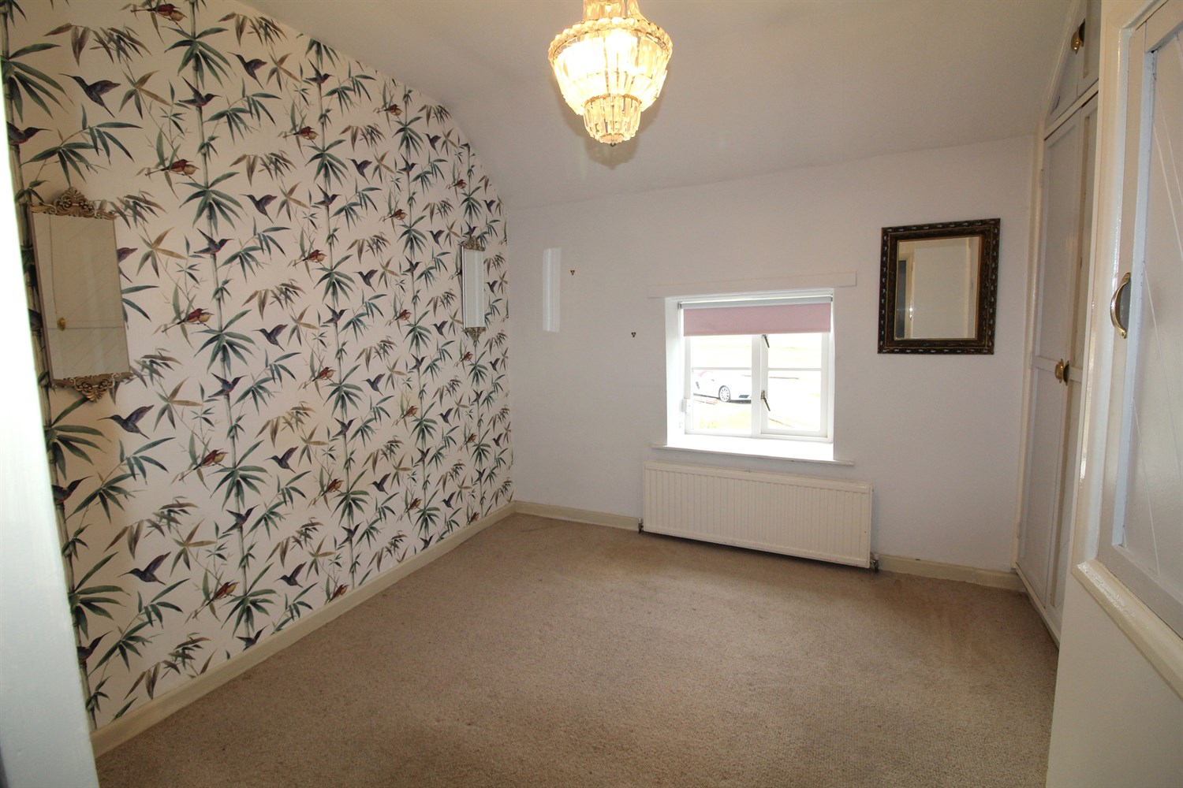

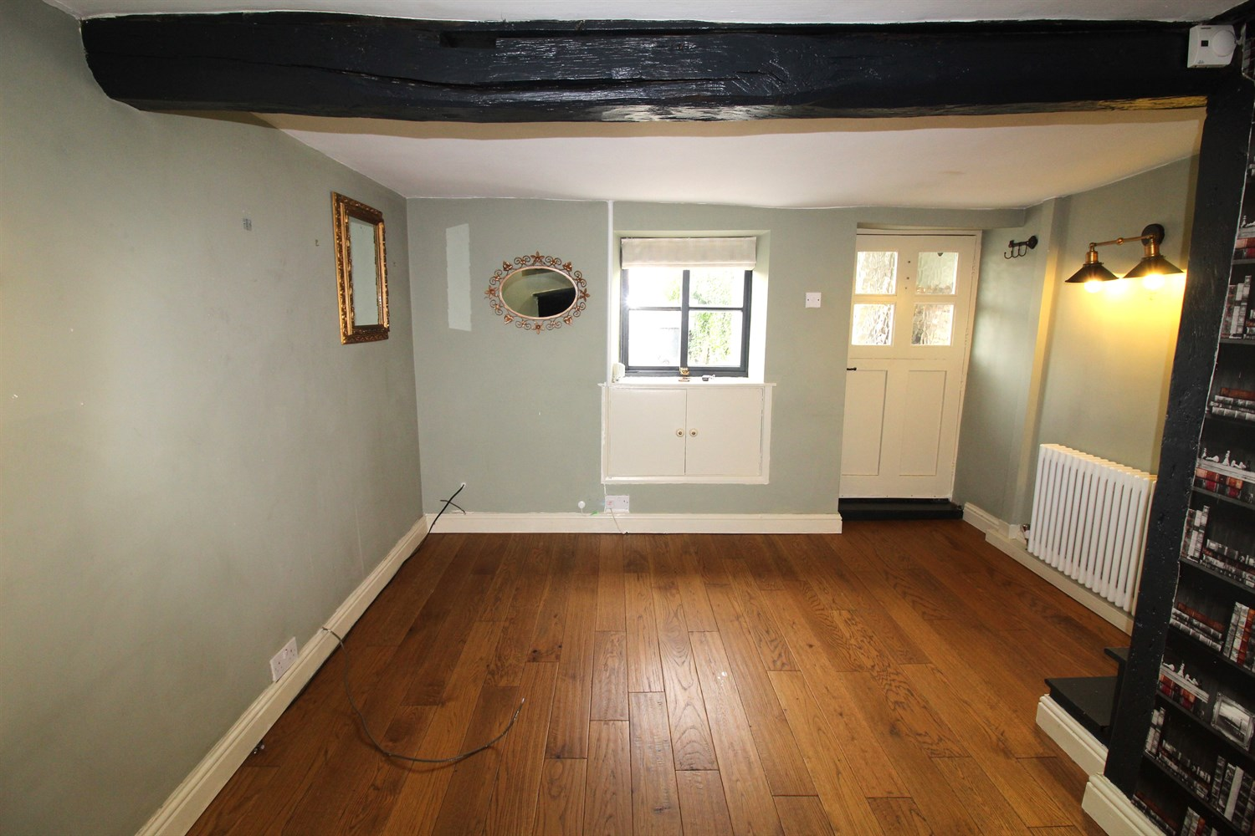

|  |
| --- |
| **Entrance Porch**  Via front entrance door. Tiled floor. stable style door leading to lounge. |
| **Lounge 3.55m (11'8) x 3.95m (13')**  Living area with feature beam to ceiling. Window to front. Hardwood flooring throughout. Gas central heating radiator. Stairs to first floor. |
| **Kitchen 2.49m (8'2) x 3.06m (10'0)**  Fitted with a range of wall, base and drawer units. Integrated electric oven with 4-ring gas hob and extractor hood over. Tiled floor and part tiled walls. Space for washing machine and tall fridge/freezer. Stainless steel sink with mixer tap and drainer. |
| **Landing**  Loft access point. Store cupboard. |
| **Bedroom One 2.94m (9'8) Max x 3.2m (10'6)**  Master bedroom with window to front. Built in wardrobes. Gas central heating radiator. |
| **Bedroom Two 2.17m (7'1) x 1.93m (6'4)**  Second bedroom with window to the rear. Feature ceiling beam. Gas central heating radiator. |
| **Bathroom**  Fitted with a three piece suite comprising; corner bath with shower above, WC and wash hand basin. Tilled walls. |
| **Outside**  Lawned garden to the front with views over Heath Common. |

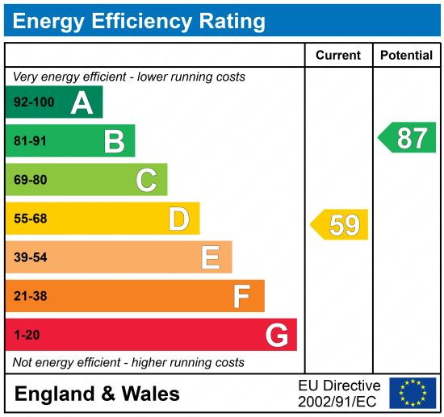

|  |
| --- |
|  |

These particulars are intended to give a fair description of the property, but their accuracy cannot be guaranteed, and they do not constitute an offer of contract. Intending purchasers must rely on their own inspection of the property. None of the above appliances/services have been tested by ourselves. We recommend purchasers arrange for a qualified person to check all appliances/services before legal commitment.

**Property Ref:** 7179

**For more information, please contact**

0113 258 1150 **|** [sales@adairpaxton.co.uk](mailto:sales@adairpaxton.co.uk) **|** www.adairpaxton.co.uk