

**26 Sugar Hill Close, Oulton, Cross Green Lane, LS26**

**Available to let £695.00pcm**

Recently refurbished one bed first floor apartment located in the lovely village of Oulton.  
This fantastic apartment has recently undergone an extensive refurb and offers a modern living space for renters. Located in the vibrant village of Oulton, just 4 miles from Leeds City Centre, it makes a perfect location for home working and commuting. The flat comes unfurnished and is neutrally decorated throughout. The living room leads off to a light kitchen. Hallway leading to a good-sized double bedroom. The stunning modern bathroom is finished to a high standard. Available now. EPC rating C, council tax band A. Deposit £800.

**0113 258 1150**

**0800 000 000**

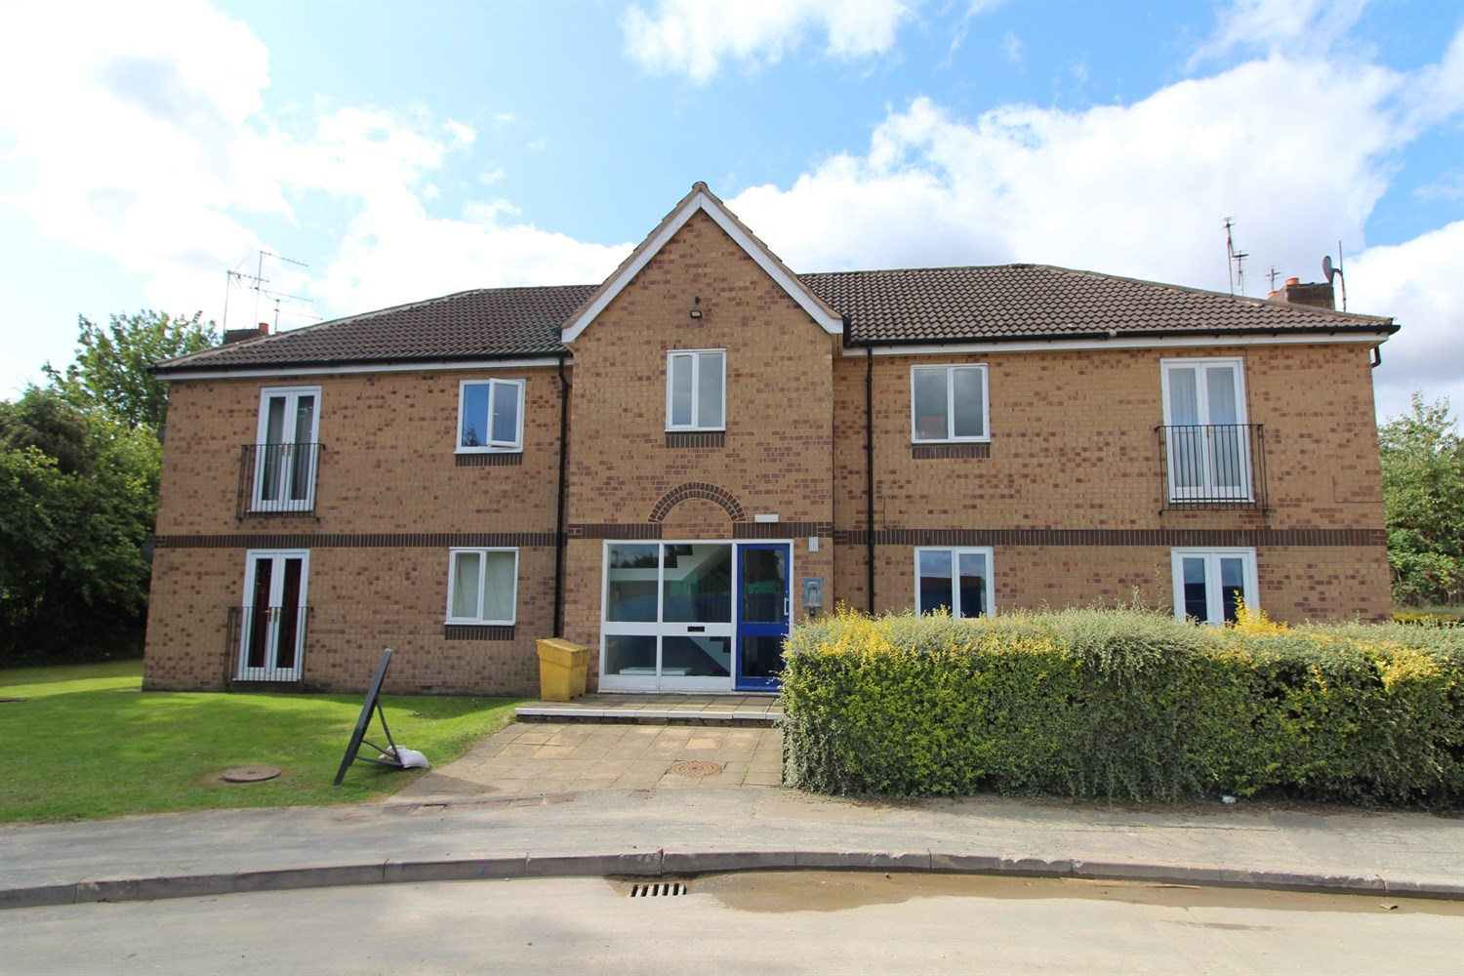

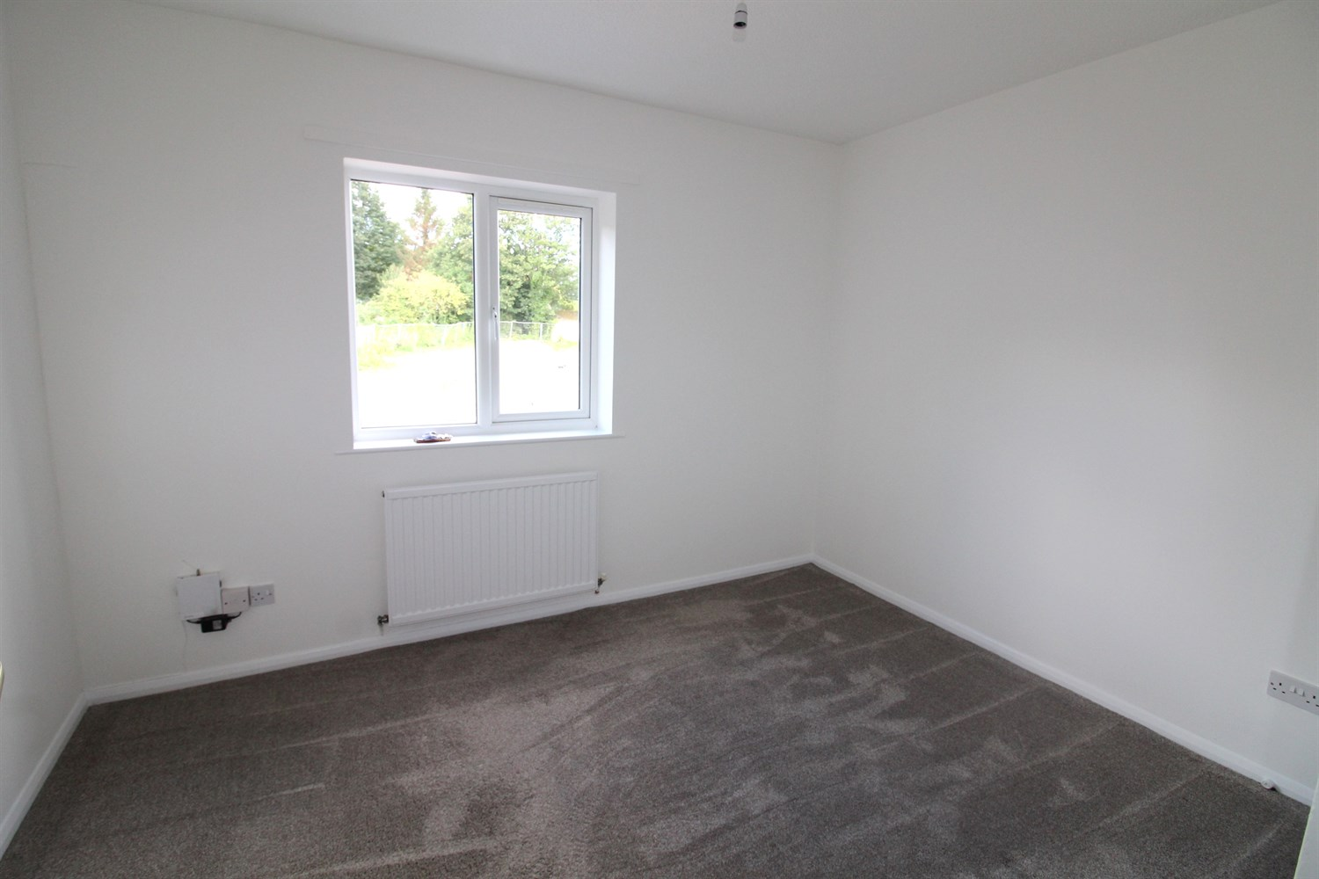

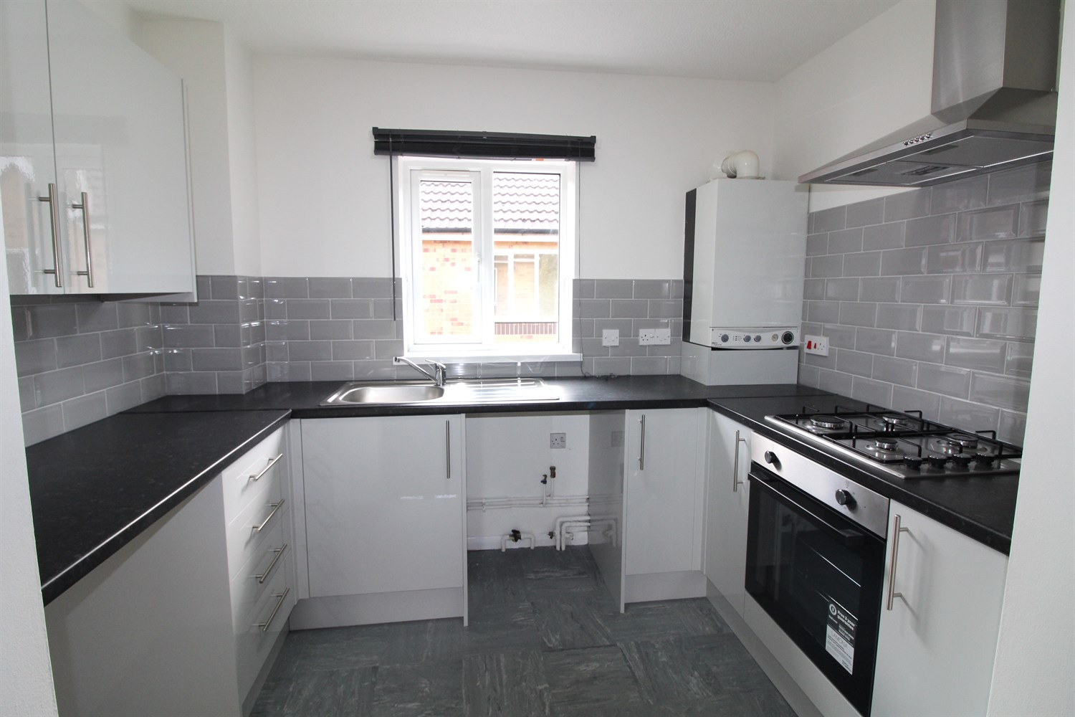

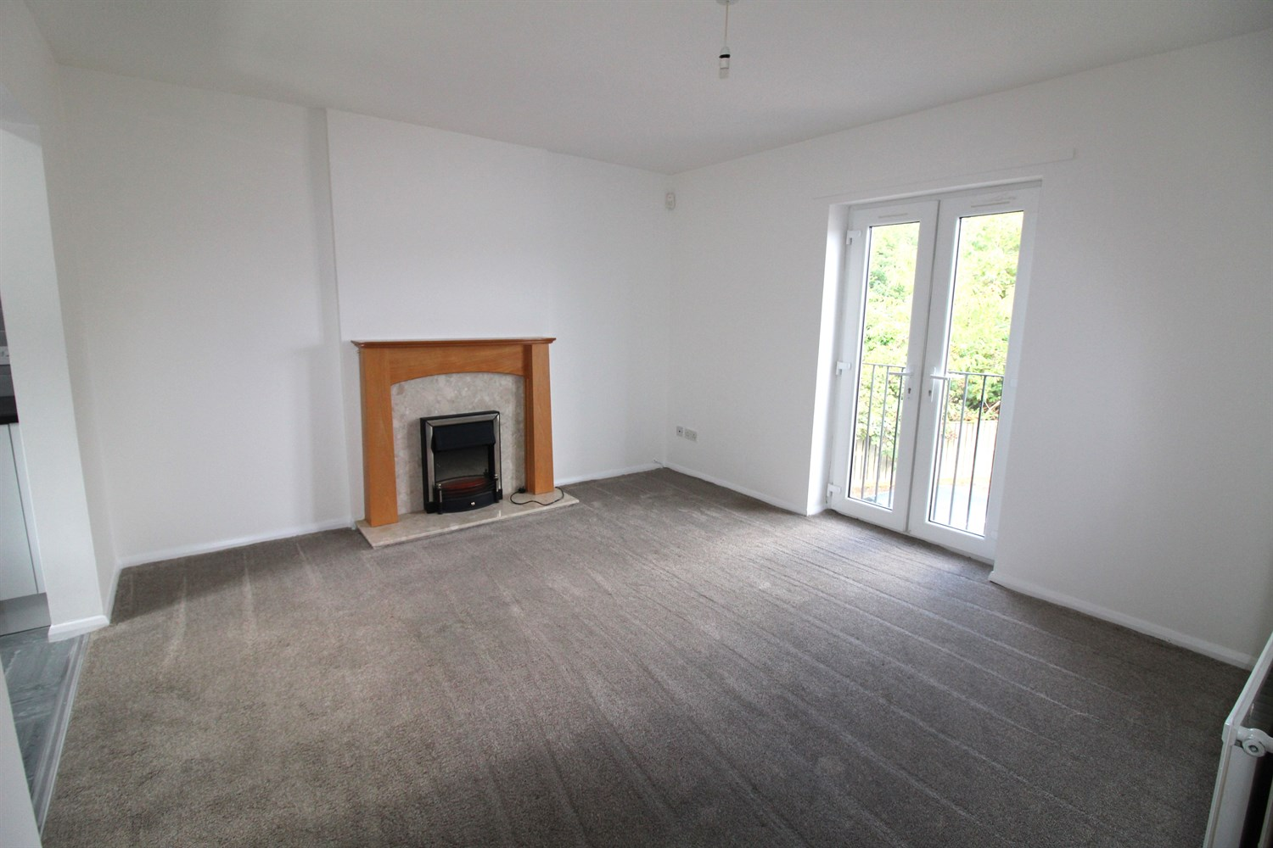

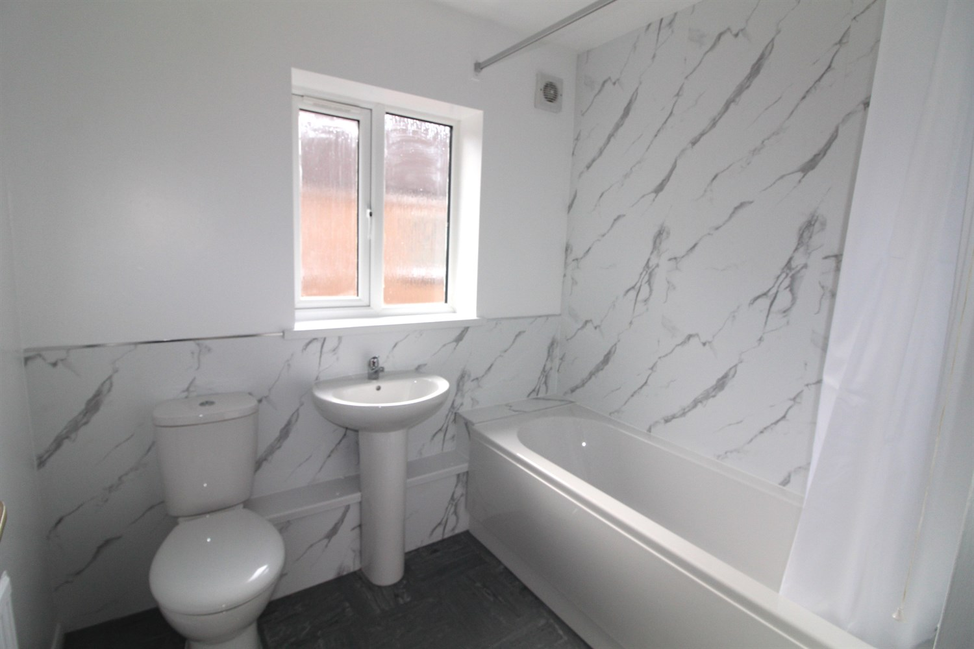

|  |
| --- |
| **Communal Entrance Hall**  Stairs to all floors. |
| **Entrance Hall**  Private entrance hall. |
| **Open Plan Living/Kitchen**  Bright lounge with French doors opening onto a Juliet balcony - Modern kitchen with wall and base units and work tops over, tiled splash back and vinyl flooring. Electric oven, gas hob with cooker hood over, plumbing for a washing machine and under counter space for a fridge. |
| **Bedroom**  Carpeted double bedroom with window, gas central heating radiator. |
| **Bathroom**  Three piece bathroom suite with shower over bath, W/C and hand wash basin, part tiled walls. |
| **Home Information**  EPC Band: C Council Tax Band: A Leasehold property.  Broadband: Standard 19 Mbps 1 Mbps Good Superfast --Not available --Not available Unlikely Ultrafast --Not available   Mobile availability: EE likely to have good coverage. Three likely to have good coverage. O2 likely to have good coverage. Vodafone likely to have good coverage.  Utilities: Gas, supplied on standard meter. Water supplied on a meter. Electric mains supplied on standard meters. |

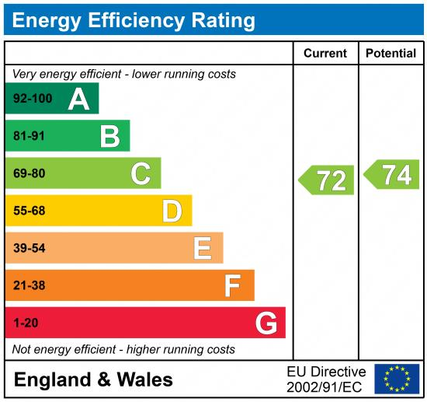

|  |
| --- |
|  |

These particulars are intended to give a fair description of the property, but their accuracy cannot be guaranteed, and they do not constitute an offer of contract. Intending purchasers must rely on their own inspection of the property. None of the above appliances/services have been tested by ourselves. We recommend purchasers arrange for a qualified person to check all appliances/services before legal commitment.

**Property Ref:** 7143

**For more information, please contact**

0113 258 1150 **|** [lettings@adairpaxton.co.uk](mailto:lettings@adairpaxton.co.uk) **|** www.adairpaxton.co.uk