

**Velocity West, Leeds**

**For Sale £165,000.00**

*** TWO BEDROOM, TWO BATHROOM CITY CENTRE APARTMENT WITH PARKING - NO CHAIN*** Adair Paxton are delighted to offer this fourth floor two bedroom, two bathroom apartment with parking. Located a short walk to all the amenities Leeds City Centre has to offer and the Train station. The accommodation briefly comprising; Entrance hall, open plan lounge/dining/kitchen with integrated appliances, two double bedrooms, one with en-suite and a house bathroom. Parking. Council tax band D. EPC rating B

**0113 258 1150**

**0800 000 000**

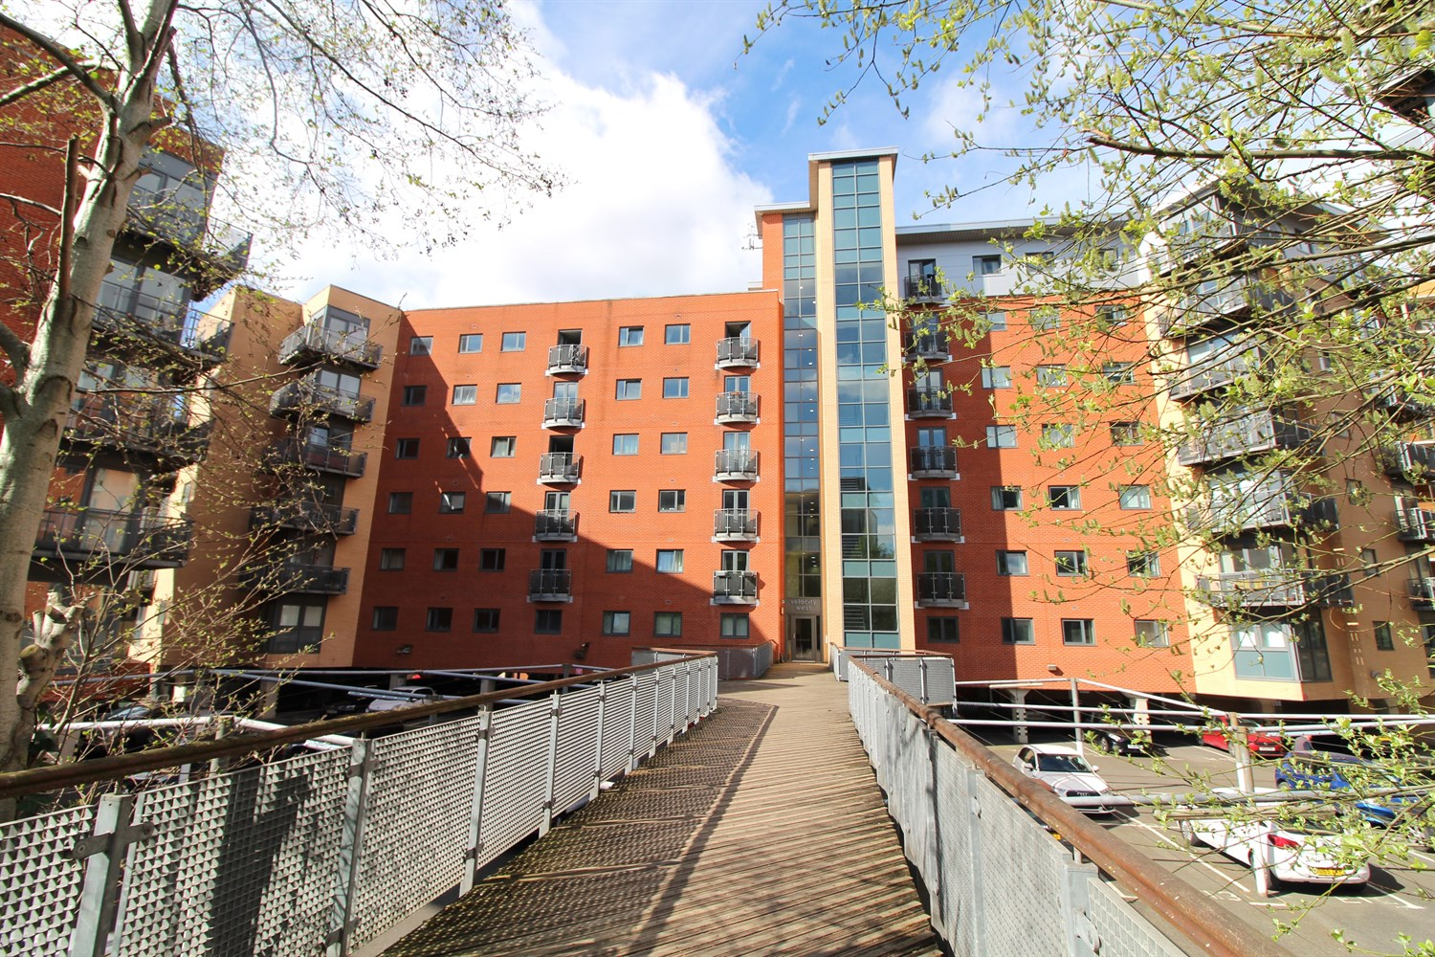



1 Reception(s)

2 Bathroom(s)

2 Bedroom(s)

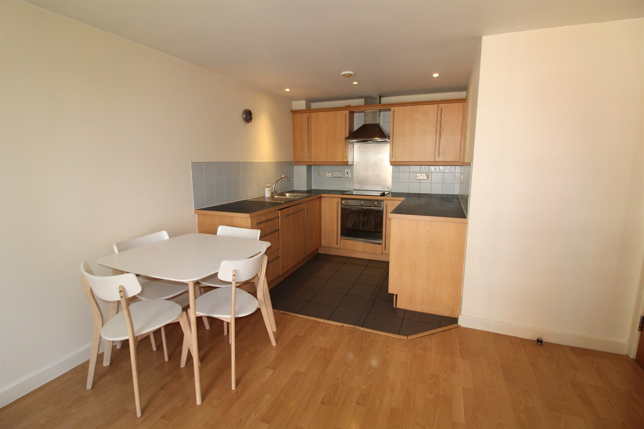

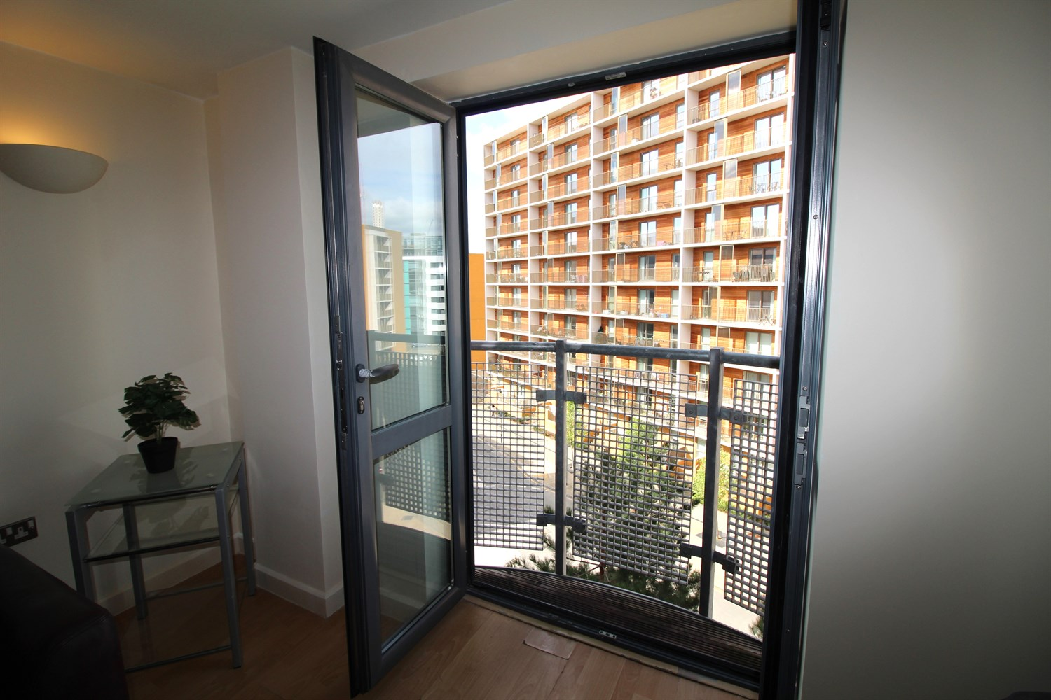

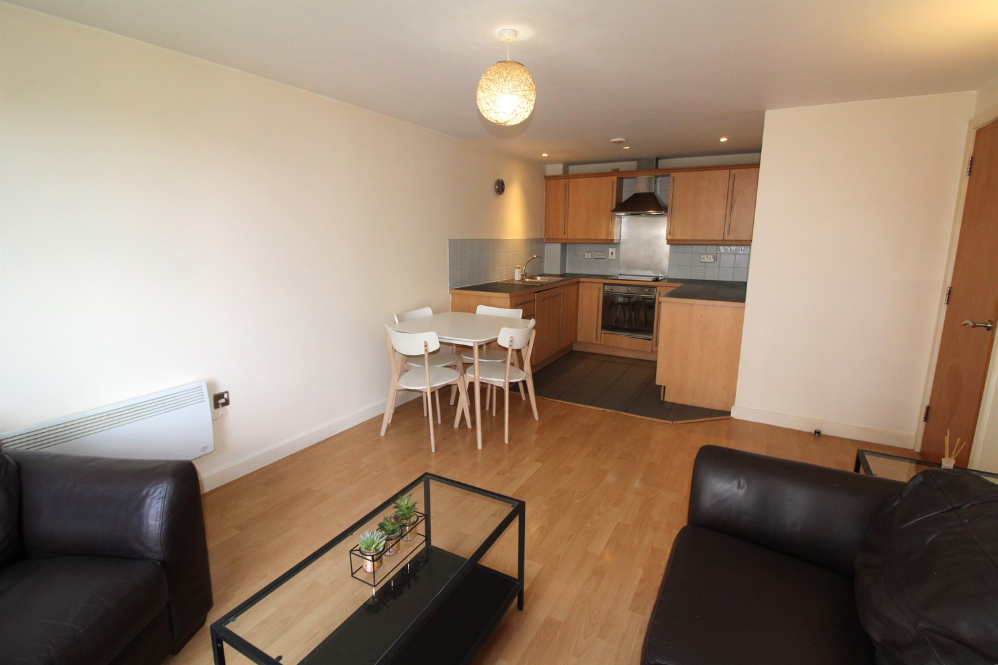

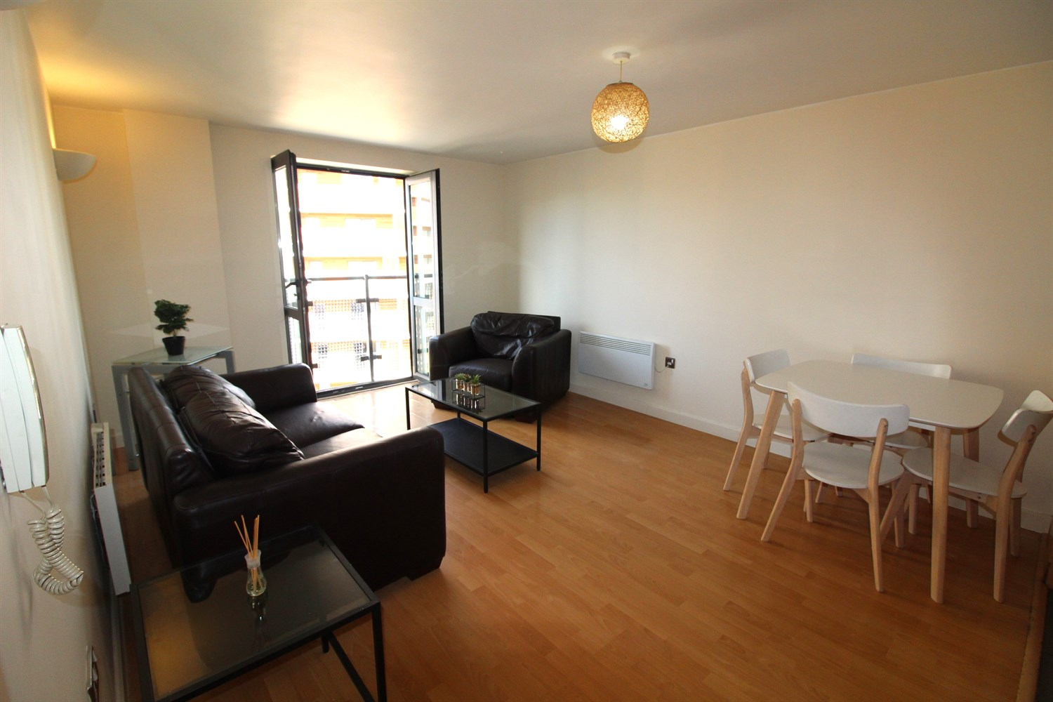

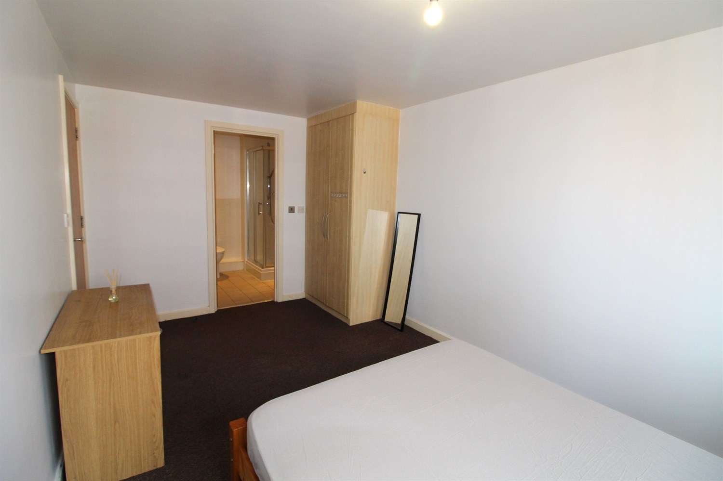

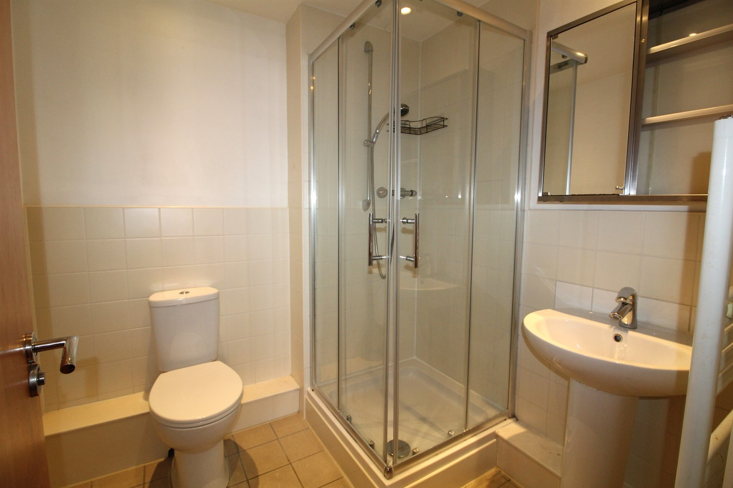

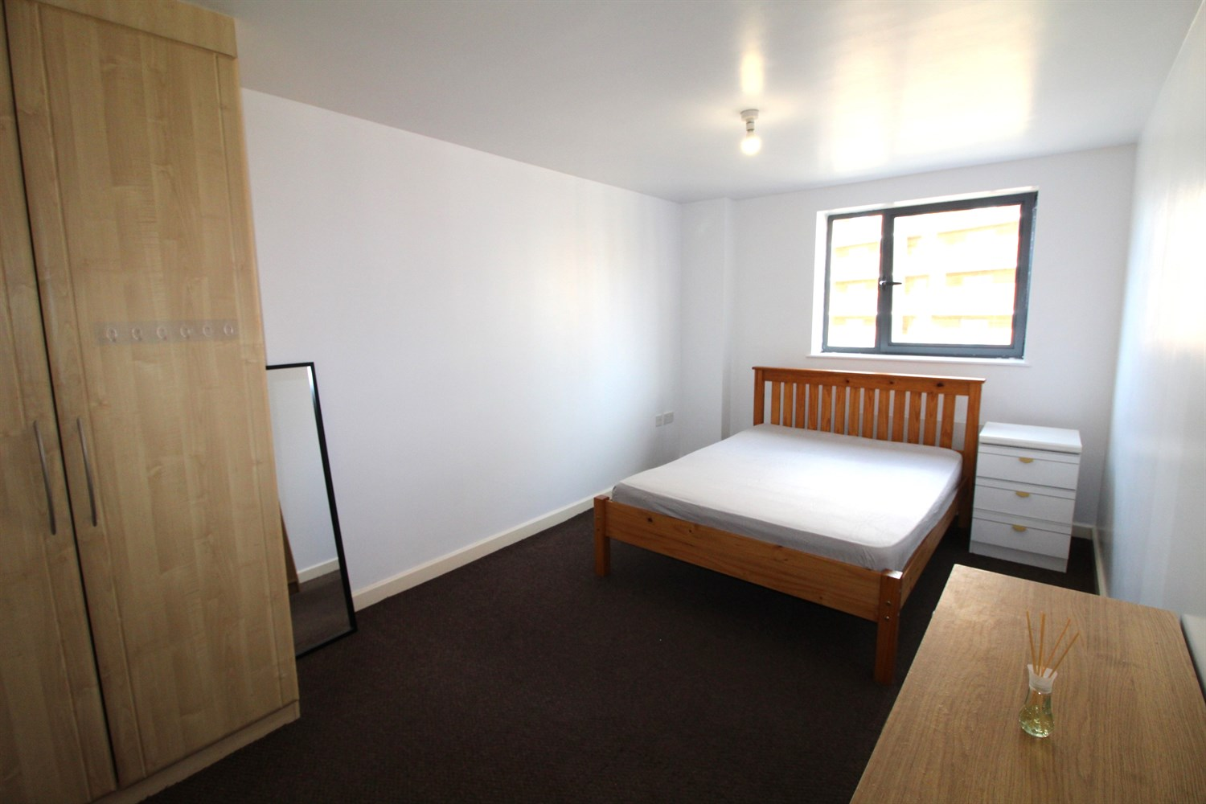

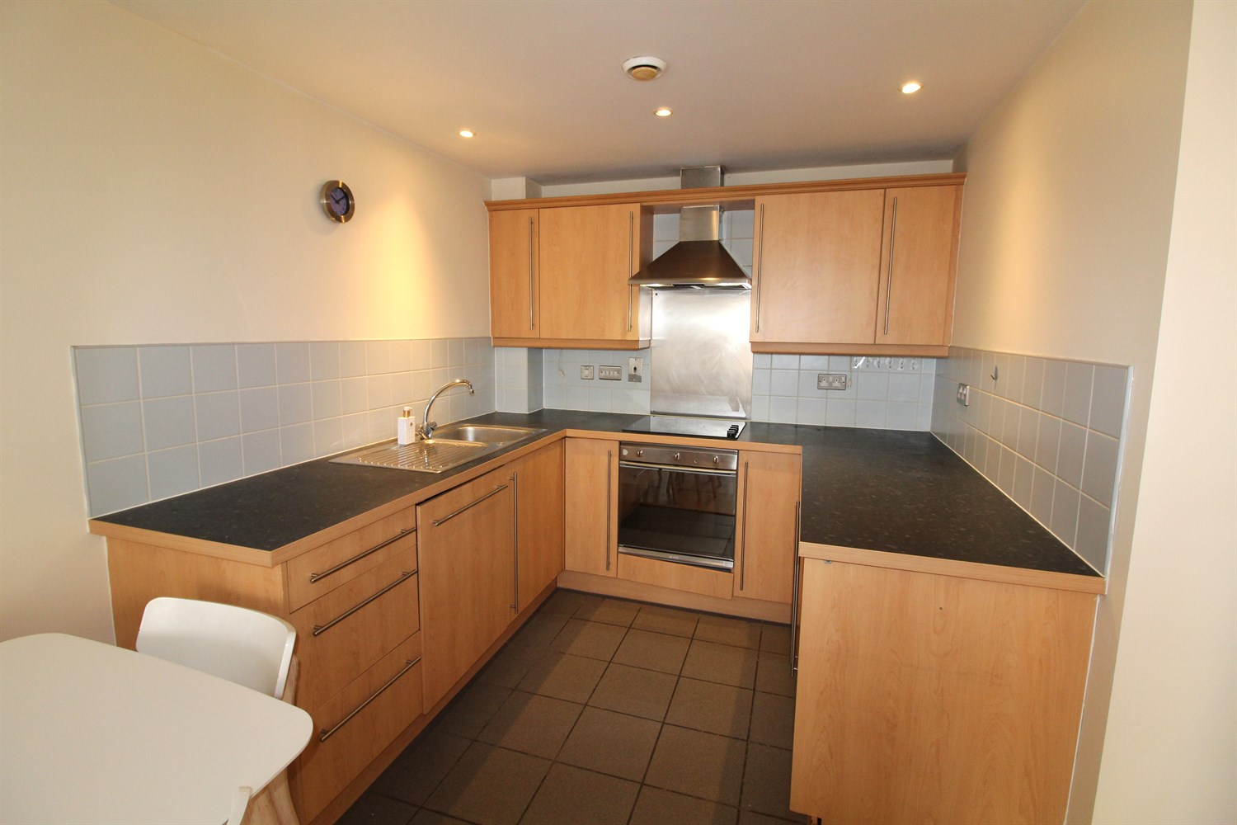

|  |
| --- |
| **Communal Entrance**  Communal entrance with stairs and lift to all floors. |
| **Private Entrance Hall**  Entrance hall via front entrance door. Inset ceiling spotlights |
| **Open Plan Living/Kitchen 3.58m (11'9) x 6.79m (22'3)**  Fitted kitchen comprising wall, base and drawer units with worktops over. Single drainer stainless steel sink unit with mixer tap, integrated fridge freezer, oven, hob and extractor, washing machine and dishwasher. Living area with laminate flooring and doors leading to Juliette balcony. Wall mounted lights. Electric radiator. |
| **Bedroom 1 2.81m (9'3) x 4.8m (15'9)**  Double bedroom with double glazed window. Built in wardrobe. Wall mounted electric heater. |
| **En-Suite**  Shower room comprising; shower cubicle, wash hand basin and WC. Tiled walls. |
| **Bedroom 2 3.7m (12'2) x 2.4m (7'10)**  Second double bedroom with double glazed window. Wall mounted electric heater. |
| **Bathroom**  Three piece white suite comprising; bath, WC and wash hand basin. |
| Allocated Parking Space |
| **Tenure**  999 years from 2003 Ground rent - £200 per annum |
| **Service Charge**  Service Charge is £1631.70 per annum. |

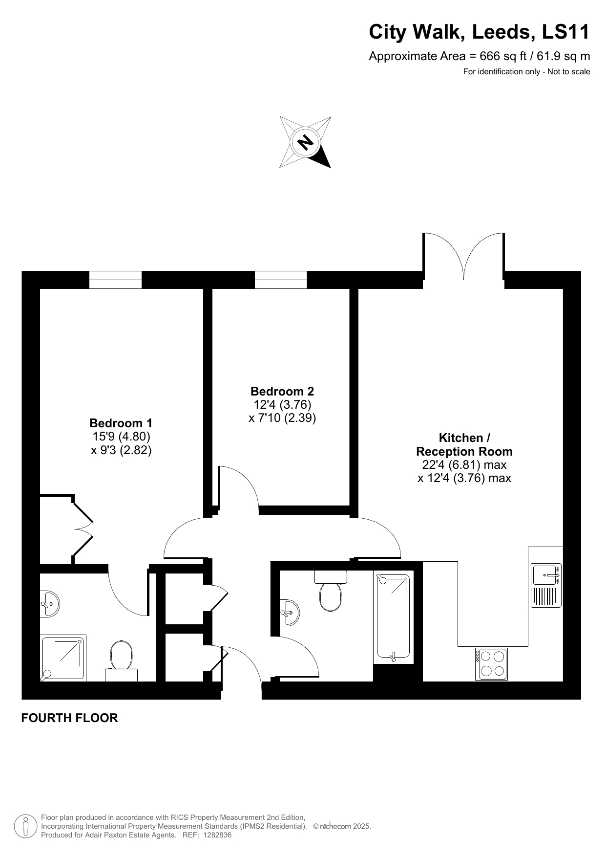

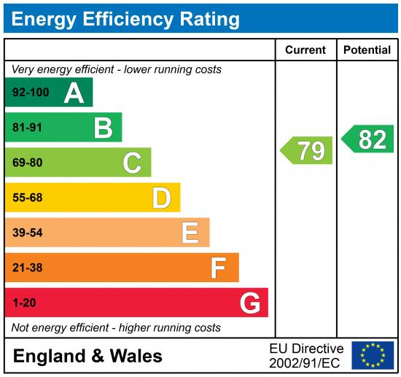

|  |
| --- |
|  |

These particulars are intended to give a fair description of the property, but their accuracy cannot be guaranteed, and they do not constitute an offer of contract. Intending purchasers must rely on their own inspection of the property. None of the above appliances/services have been tested by ourselves. We recommend purchasers arrange for a qualified person to check all appliances/services before legal commitment.

**Property Ref:** 5152

**For more information, please contact**

0113 258 1150 **|** [sales@adairpaxton.co.uk](mailto:sales@adairpaxton.co.uk) **|** www.adairpaxton.co.uk