

**Brownberrie Avenue, Horsforth**

**Available to let £1,350.00pcm**

*** DELIGHTFUL DOUBLE FRONTED DETACHED FAMILY HOME*** Set just a couple of minutes away from Horsforth station, on a tree lined street, this THREE BEDROOM detached house will not be on the market for long and early viewing is highly recommended. The property briefly comprises: entrance hall, spacious lounge which is open plan to the conservatory, dining room and kitchen to the ground floor. To the first floor there is a generous master bedroom, two further bedrooms and a house bathroom. Externally a driveway provides ample off street parking for a number of vehicles. There is a garden to the rear which is mostly paved for ease of maintenance and an oversized garage. The property is located for all of the amenities on both Station Road and Town Street as well as reputable local schools, this would make a lovely family home. Deposit £1,555. EPC rating D, Council tax band D. Available 18th August.

**0113 258 1150**

**0800 000 000**

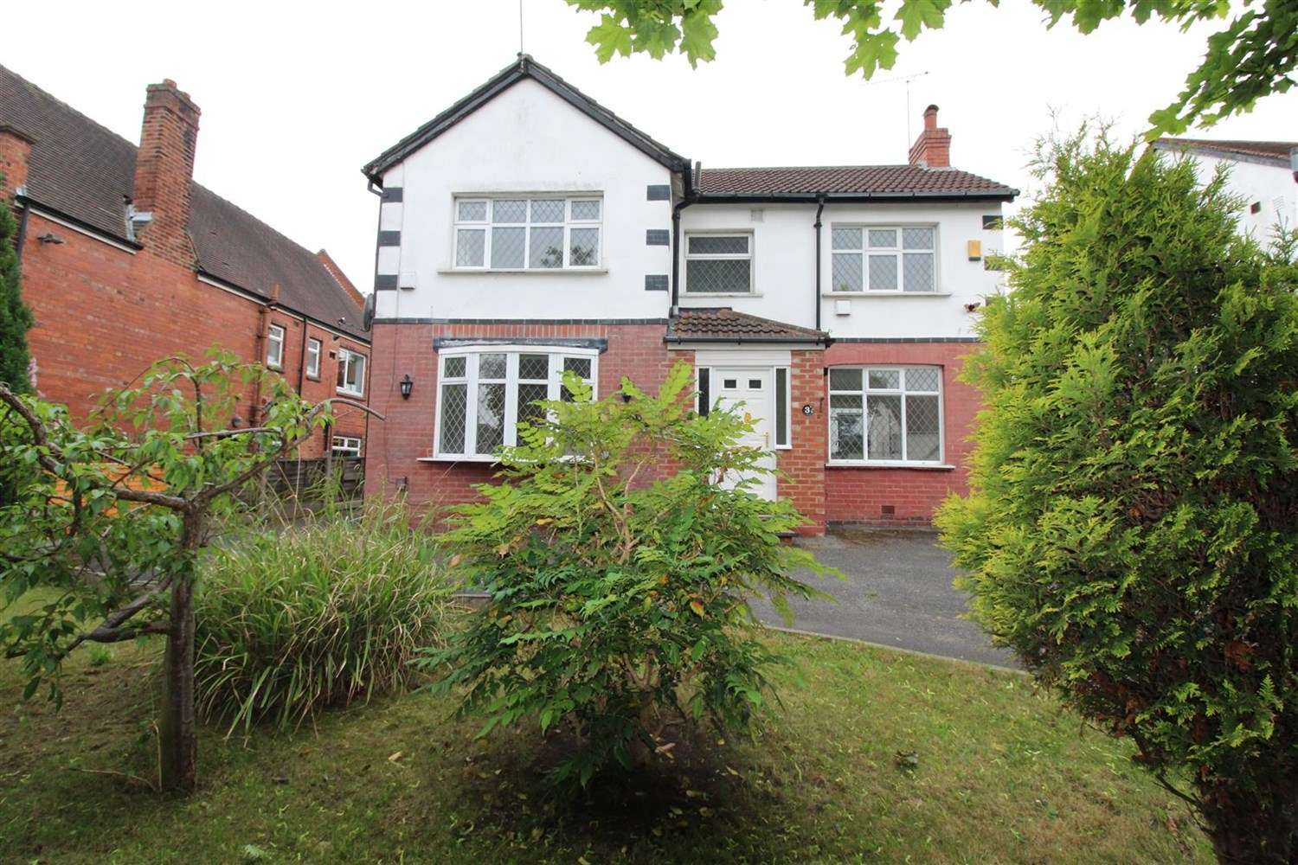

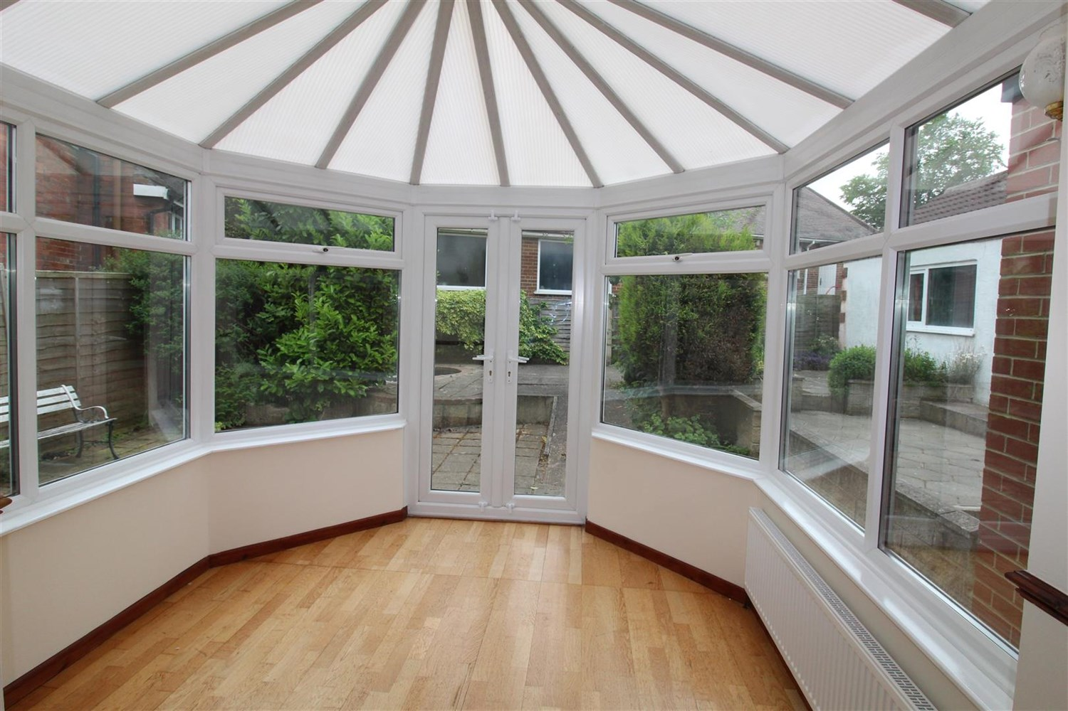

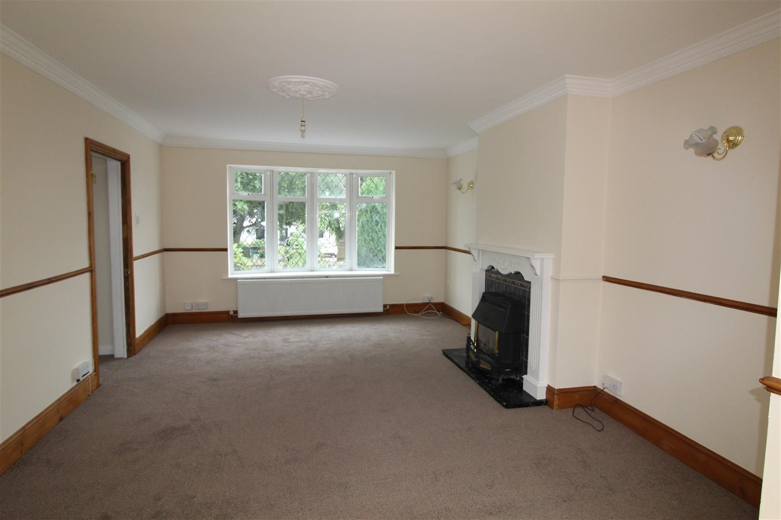

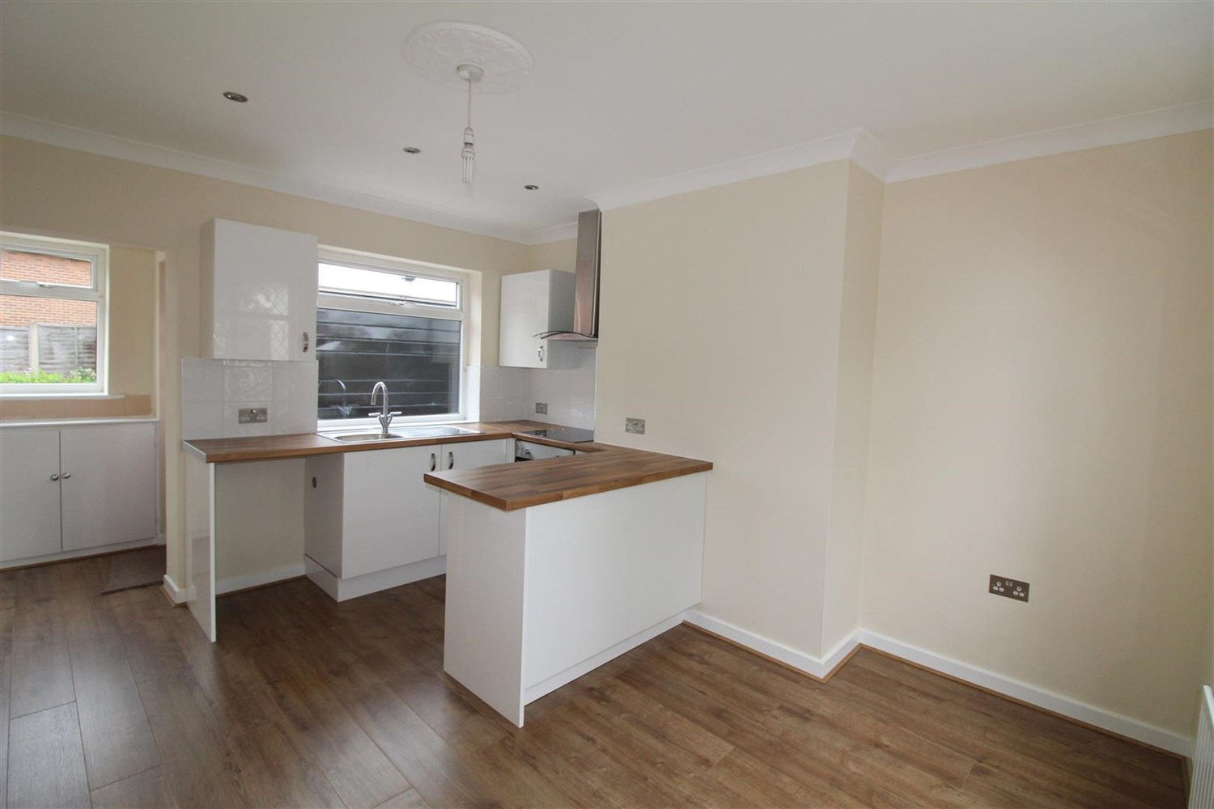

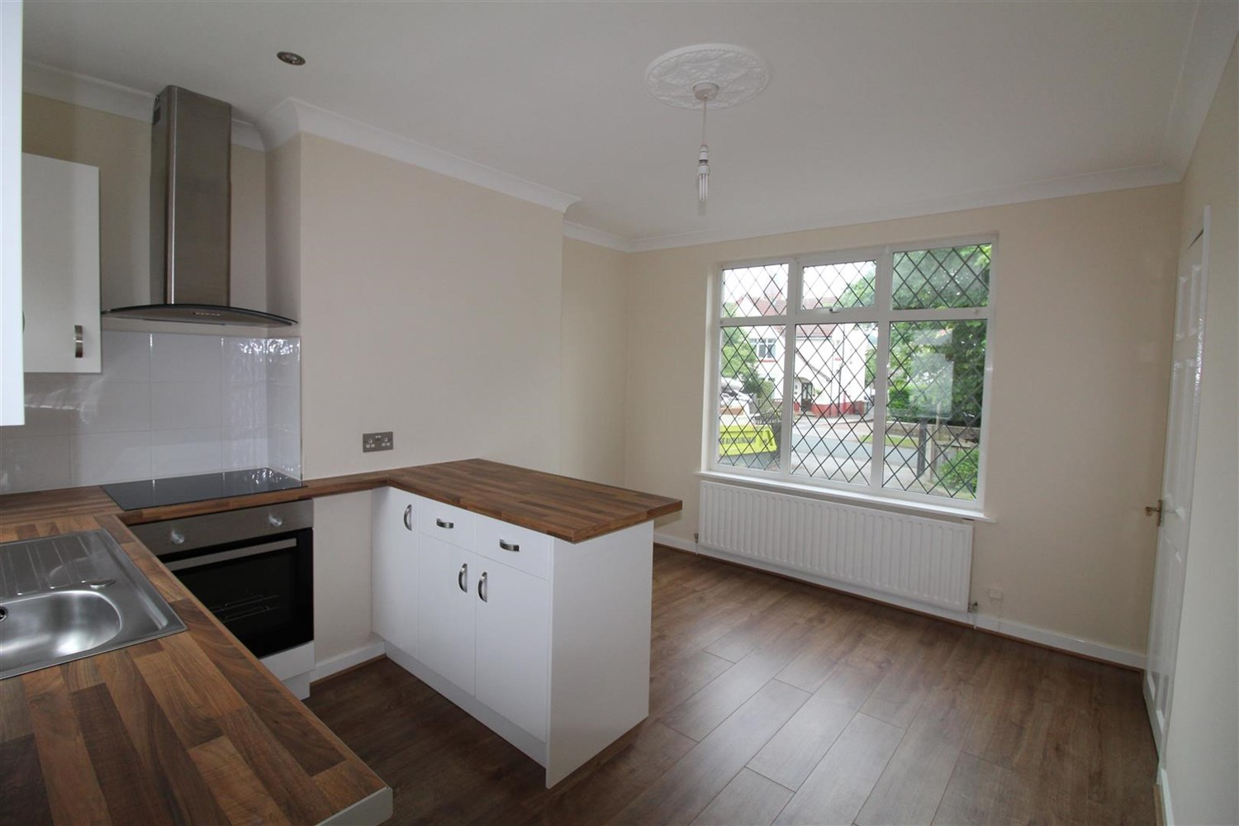

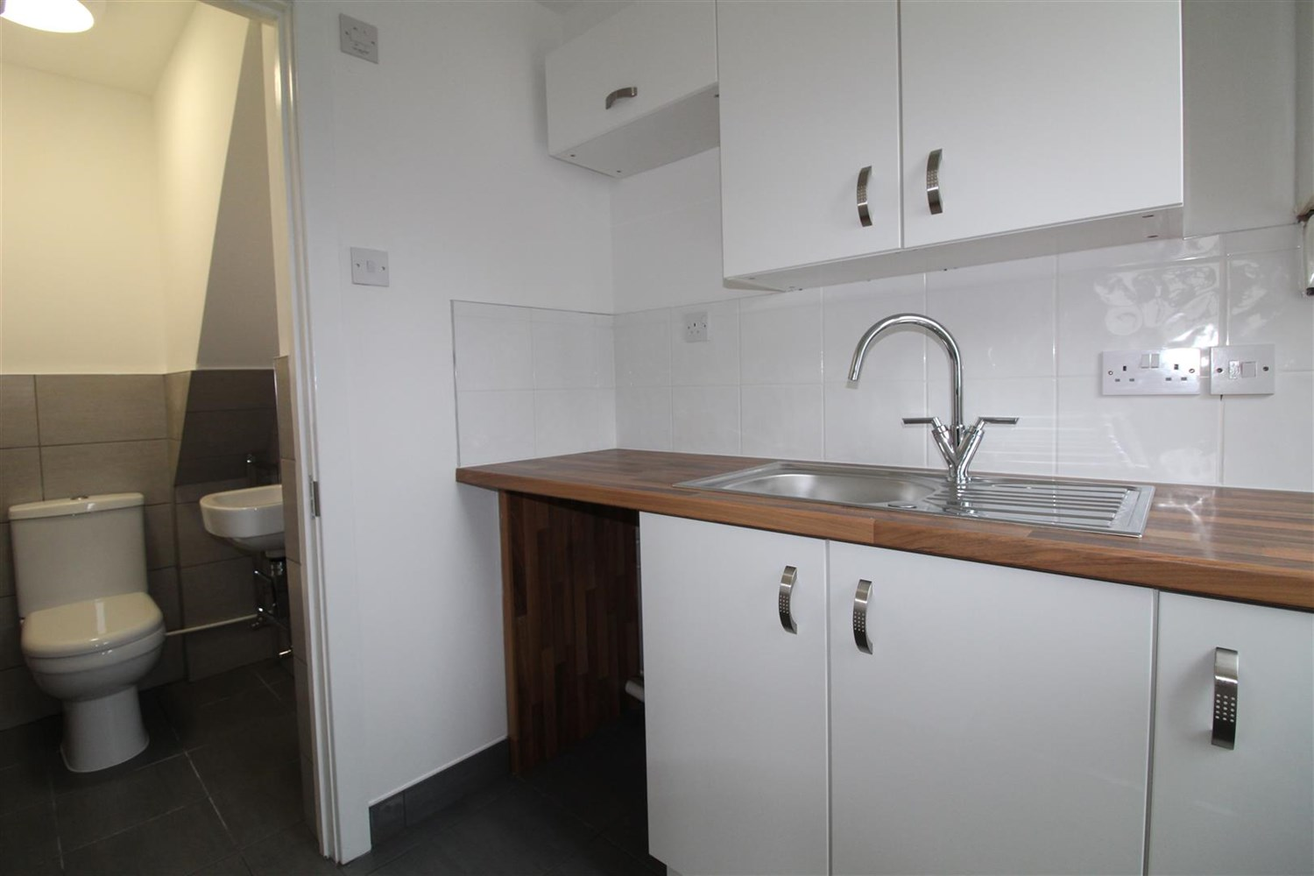

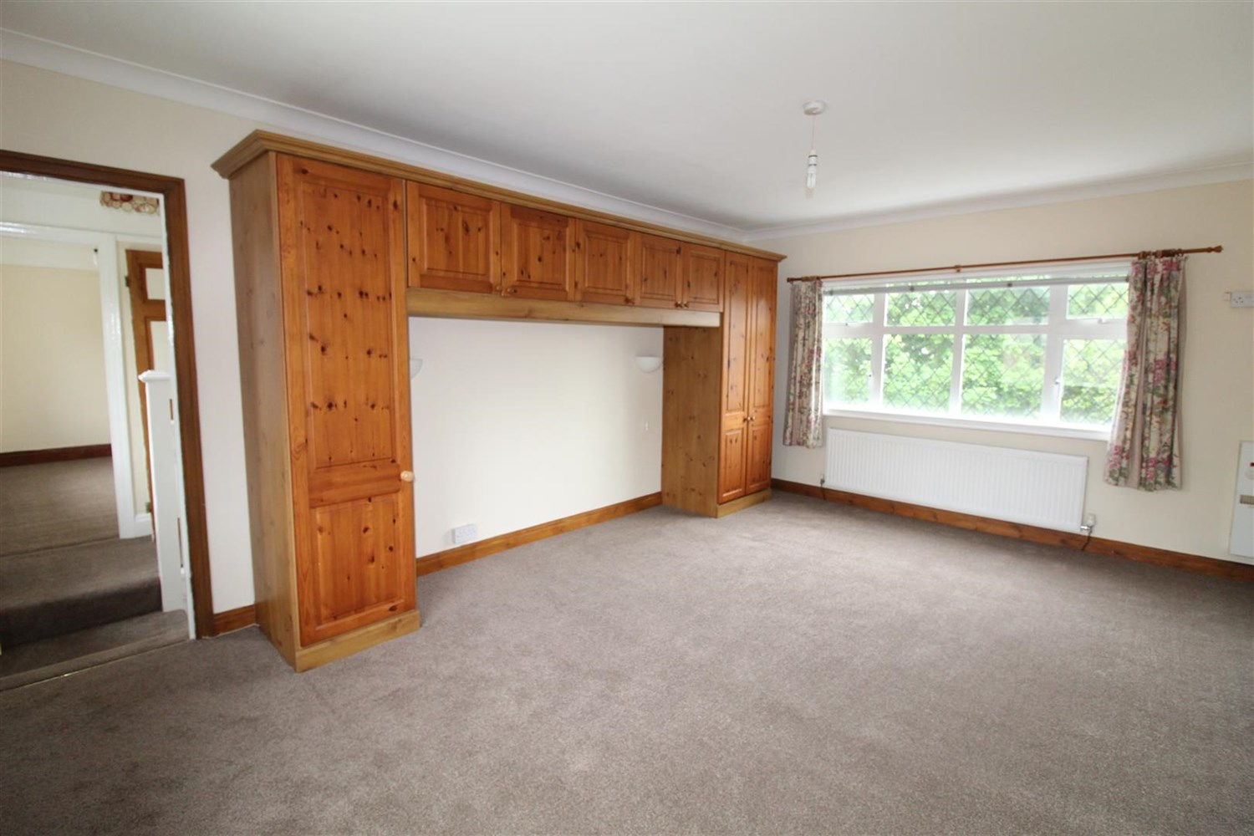

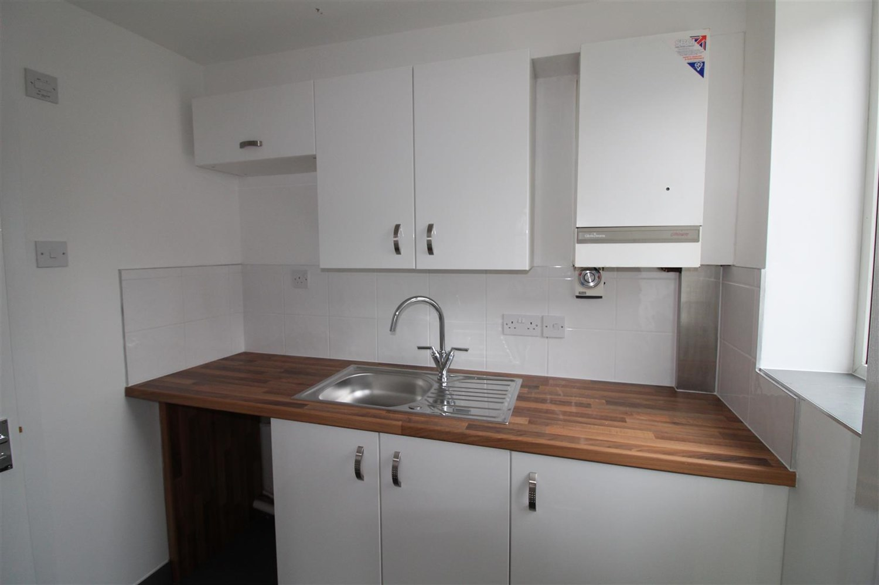

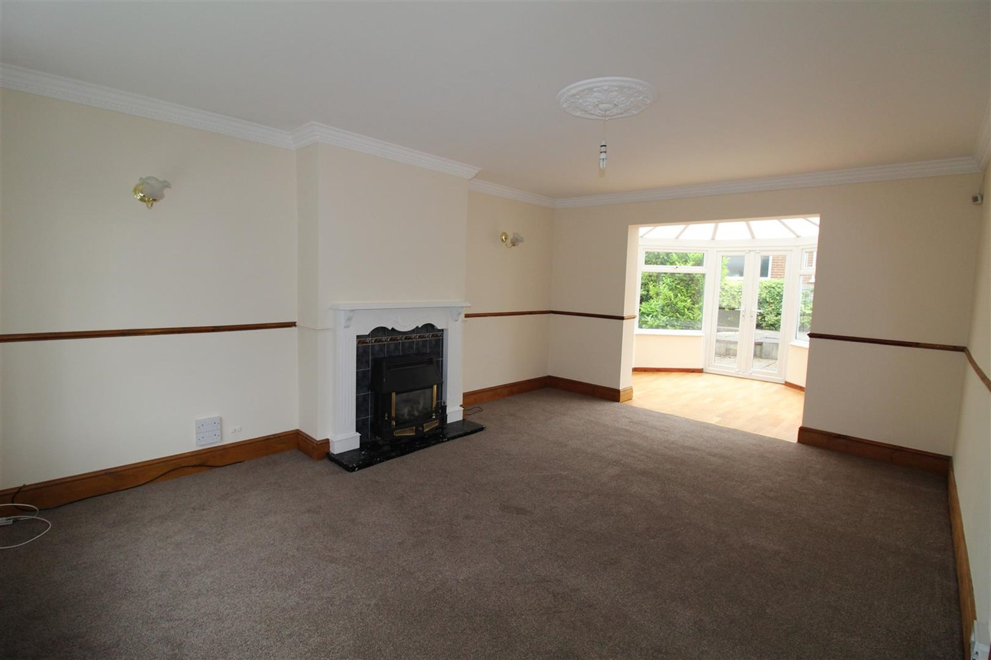

|  |
| --- |
| **Reception 1 5.26m (17'3) x 3.89m (12'9)**  A spacious lounge with a bright and airy feel. uPVC double glazed window to the front. Gas fire set in feature surround. Coving to ceiling. Wall lights. Gas central heating radiator. Open plan to the conservatory. |
| **Kitchen 1.75m (5'9) x 3.61m (11'10)**  Fitted with a range of wall, base and drawer units with work surfaces over. 1 1/2 bowl sink and drainer with mixer tap. Integrated electric oven and four ring gas hob. Plumbing for washing machine. uPVC double glazed window to rear. |
| **Conservatory 2.95m (9'8) x 2.82m (9'3)**  uPVC double glazed windows and French style doors opening out to the rear garden. Laminate flooring. Gas central heating radiator. |
| **Bedroom 1 5.26m (17'3) x 3.91m (12'10)**  A superb master bedroom with uPVC double glazed windows to both the front and rear. Fitted wardrobes provide hanging and storage space. Gas central heating radiator. |
| **Bedroom 2 3.02m (9'11) x 2.41m (7'11)**  uPVC double glazed window to front. Built in wardrobe. Gas central heating radiator. |
| **Bedroom 3 3.38m (11'1) x 1.52m (5')**  uPVC double glazed window to the rear. Gas central heating radiator. |
| **Bathroom**  Fitted with a three piece white suite comprising bath with shower over, WC and wash hand basin, uPVC double glazed window to the front. Gas central heating radiator. |
| **Medium sized Garden**  The property boasts a good sized front garden which has been lawned and a driveway provides off street parking for a number of vehicles. This leads to an oversized garage with an up and over door. The rear garden has been mostly paved for ease of maintenance. |
| **Garage**  Large garage. |
| **Parking**  Off road parking. |
| **Home Information**  COUNCIL TAX BAND: D EPC Rating: D  Freehold property: Driveway    Broadband: Standard 8 Mbps 0.9 Mbps Good Superfast 56 Mbps 16 Mbps Good Ultrafast 1800 Mbps 220   Mobile availability: EE limited coverage. Three limited coverage. O2 likely to have good coverage. Vodafone likely to have good coverage.  Utilities: Water supplied on standard meters. Electric mains supplied on standard meters. Gas meters supplied on standard meters. |

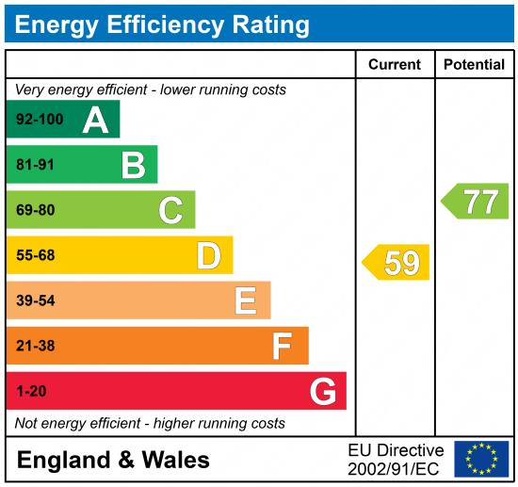

|  |
| --- |
|  |

These particulars are intended to give a fair description of the property, but their accuracy cannot be guaranteed, and they do not constitute an offer of contract. Intending purchasers must rely on their own inspection of the property. None of the above appliances/services have been tested by ourselves. We recommend purchasers arrange for a qualified person to check all appliances/services before legal commitment.

**Property Ref:** 6701

**For more information, please contact**

0113 258 1150 **|** [lettings@adairpaxton.co.uk](mailto:lettings@adairpaxton.co.uk) **|** www.adairpaxton.co.uk