

**0113 258 1150**

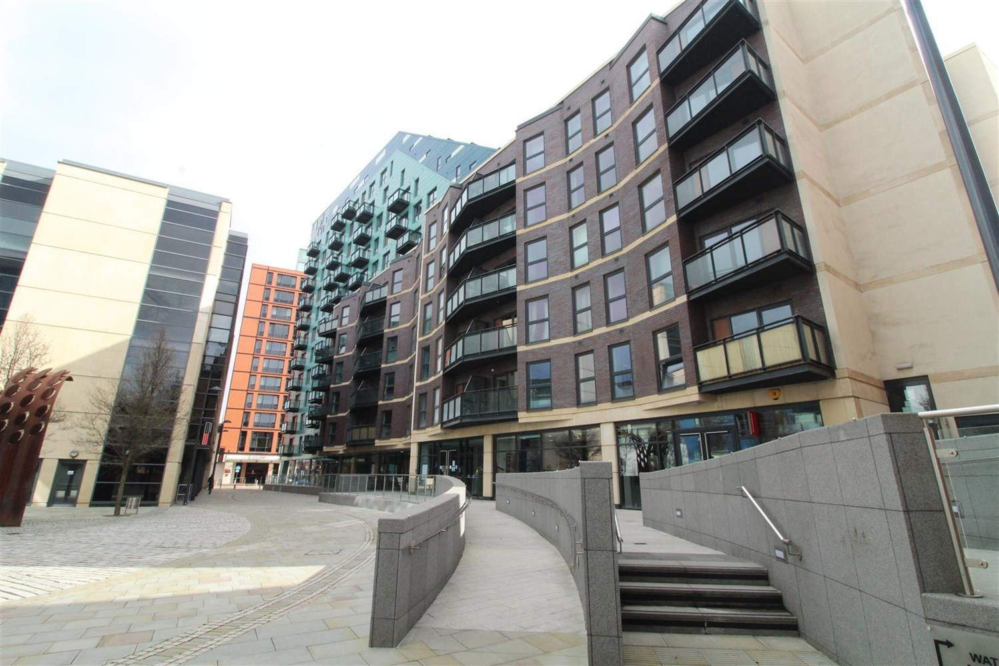



**For Sale £180,000.00**

**One Brewery Wharf, Leeds**

***SUPERB TWO BEDROOM, TWO BATHROOM APARTMENT with SECURE PARKING*** Wonderfully situated in the fashionable Brewery Wharf area of Leeds, with trendy bars, restaurants and waterfront on your doorstep, this beautiful third floor property is available to purchase with the added bonus of a secure allocated parking space. The property briefly comprises; hallway, lounge, kitchen, master bedroom with en-suite shower room, second bedroom and house bathroom. Tenanted until October 2024 at £1200pcm.

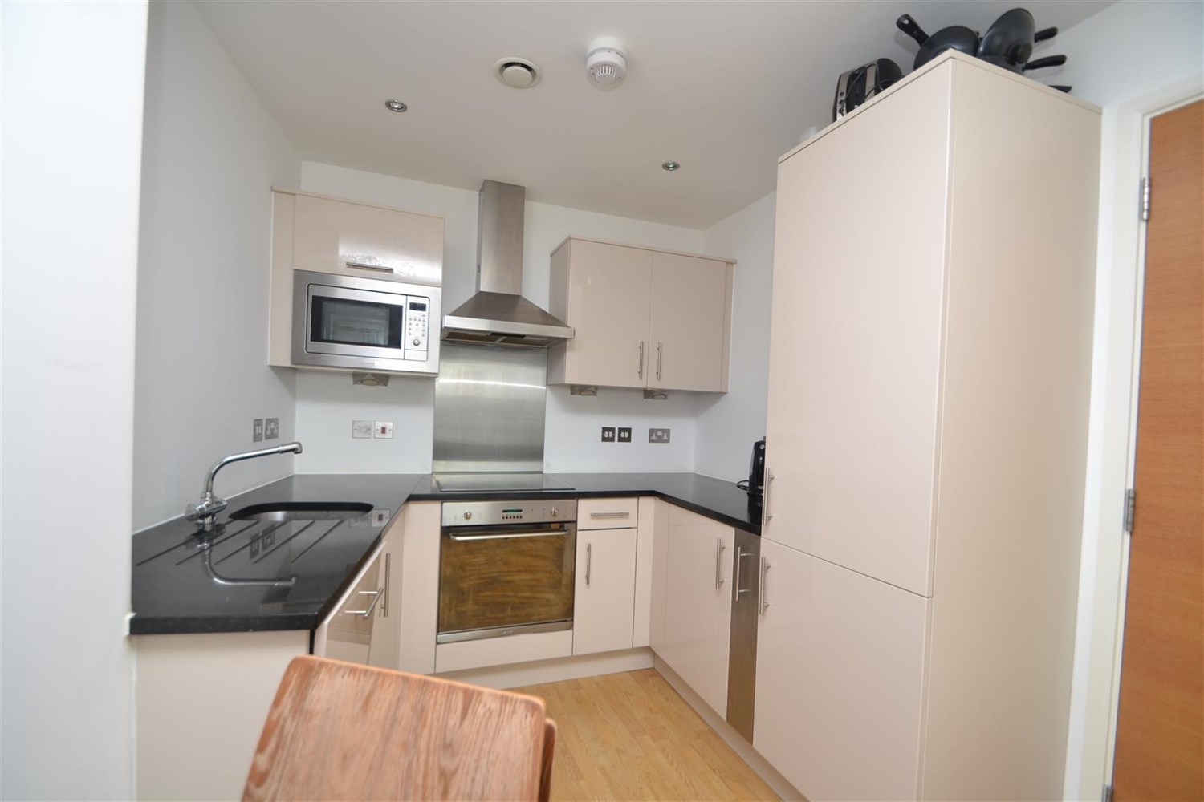

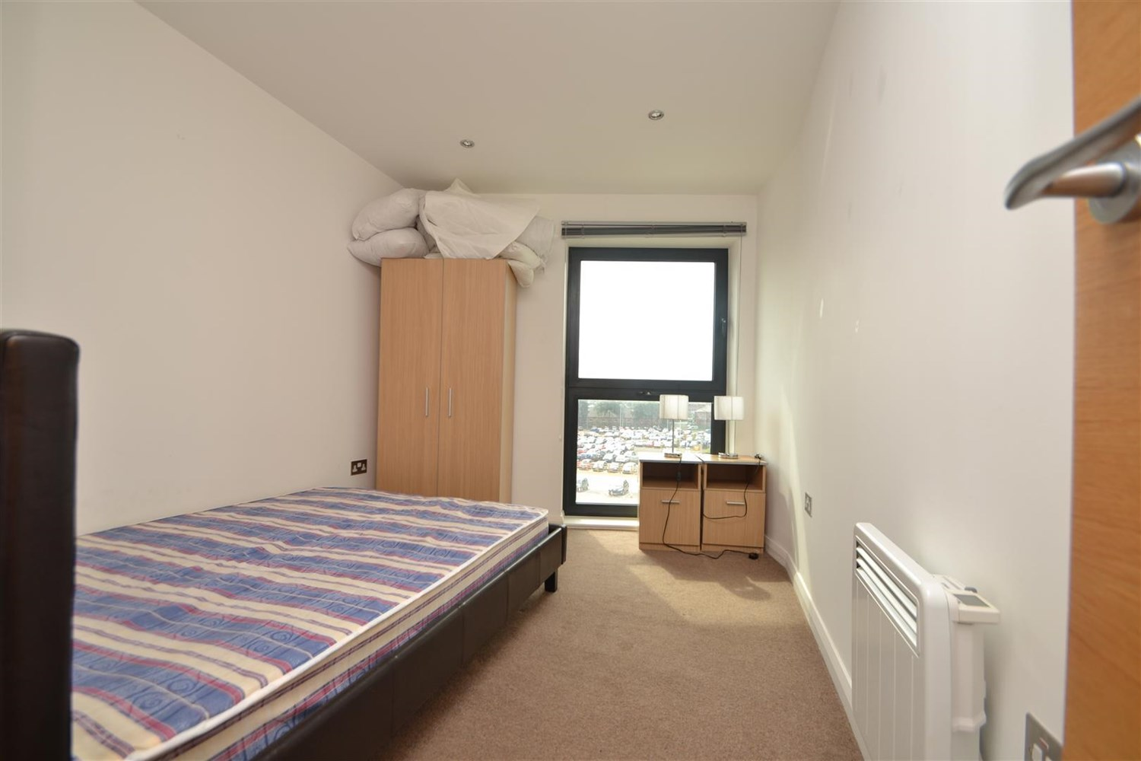

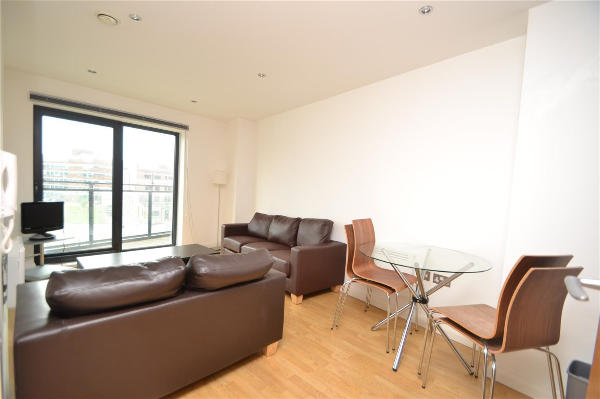

2 Bathroom(s)

1 Reception(s)

2 Bedroom(s)

00

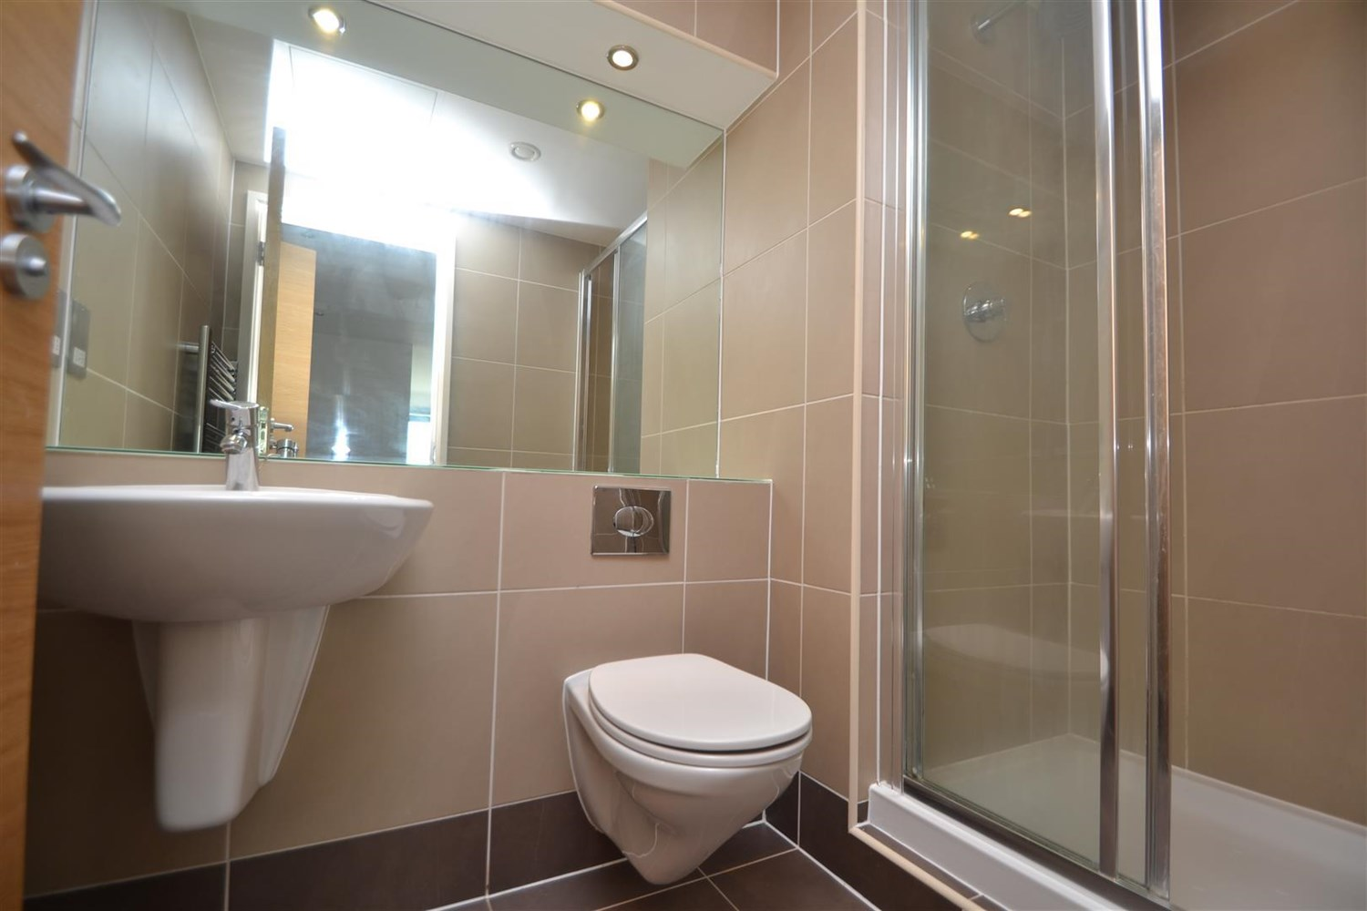

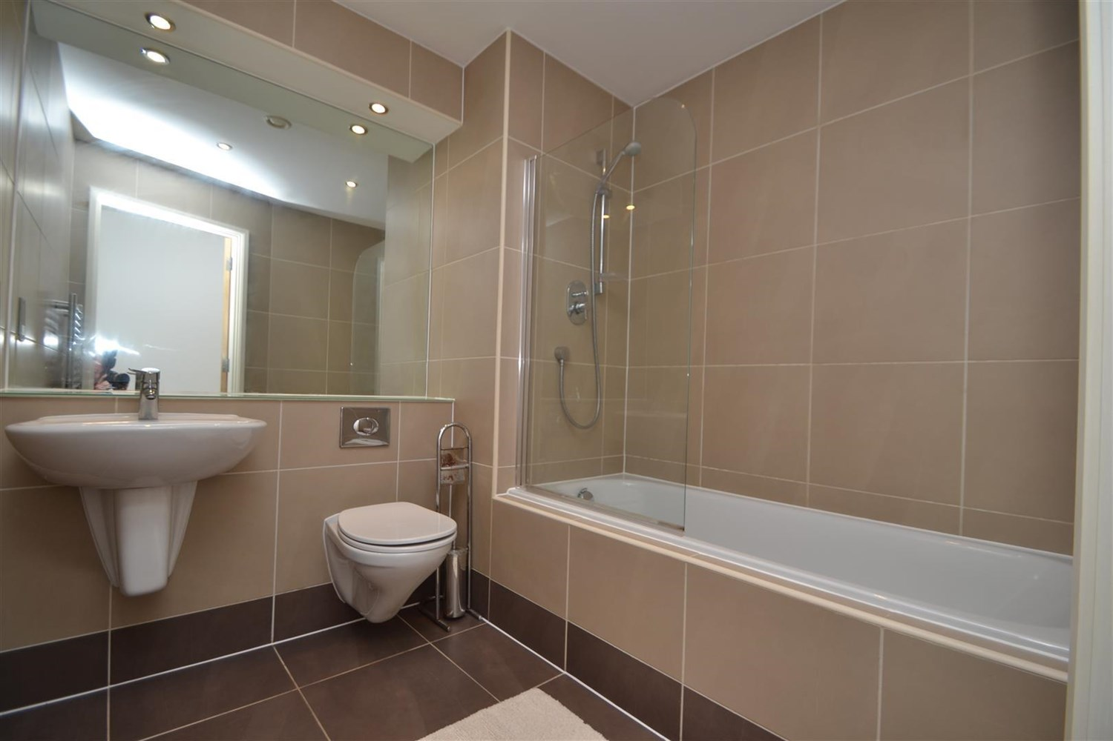

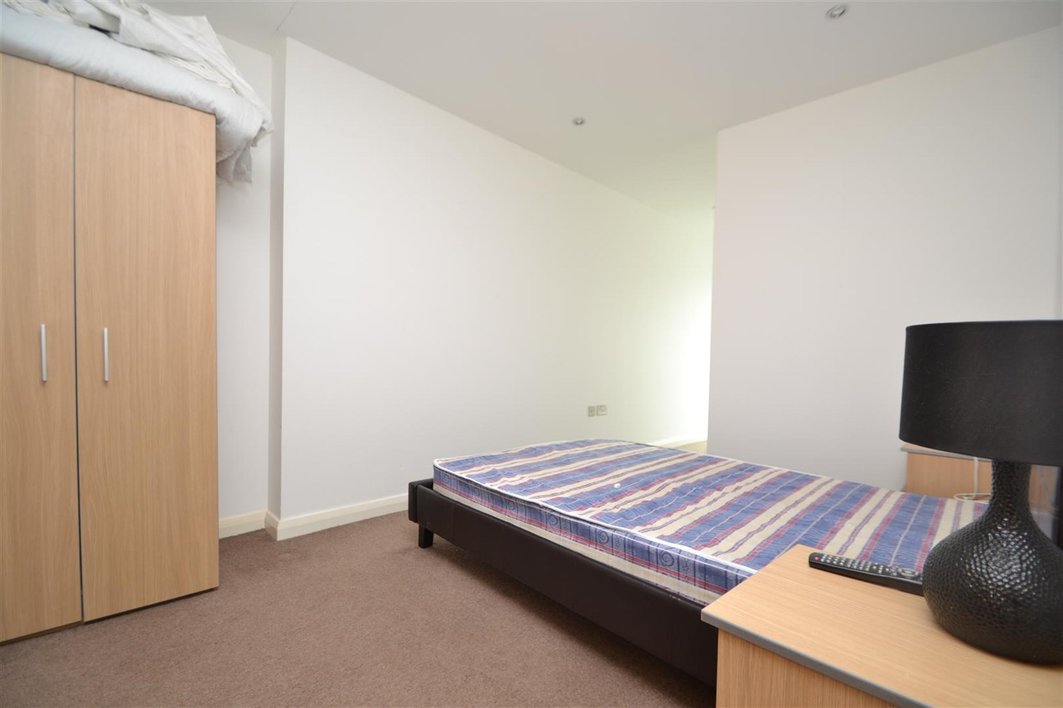

|  |
| --- |
| **Hallway**  With modern neutral decoration and provides access to; |
| **Open Plan Living Room/Kitchen**  Spacious living area with floor to ceiling patio doors leading out to the balcony. Inset ceiling spot lights. Two wall mounted electric radiators. Fitted with a range of wall, base and drawer units with worktops over. Integrated oven and 4-ring hob with extractor hood above. Integrated fridge/freezer, microwave and dishwasher. Inset ceiling spotlights. |
| **Bedroom 1**  Double bedroom with double glazed window. Wall mounted electric heater. |
| **En-Suite Shower Room**  Fitted with a shower cubicle, WC and wash hand basin. Tiled walls and floor. |
| **Bedroom 2**  Second double bedroom with double glazed window. Wall mounted electric heater. |
| **Bathroom**  Fitted with a three piece suite comprising bath with shower above, WC and wash basin. Tiled walls and floor. |
| **Tenure**  Leasehold - 999 years from 2006 Annual Ground Rent £428.44 |
| **Service Charge**  The service charges are £737.56 per quarter (£2,950.24 annually). The car parking charge is £437.50 per quarter (£1,750.00 annually). The car park maintenance is £25 per 6 months (£50 annually). |

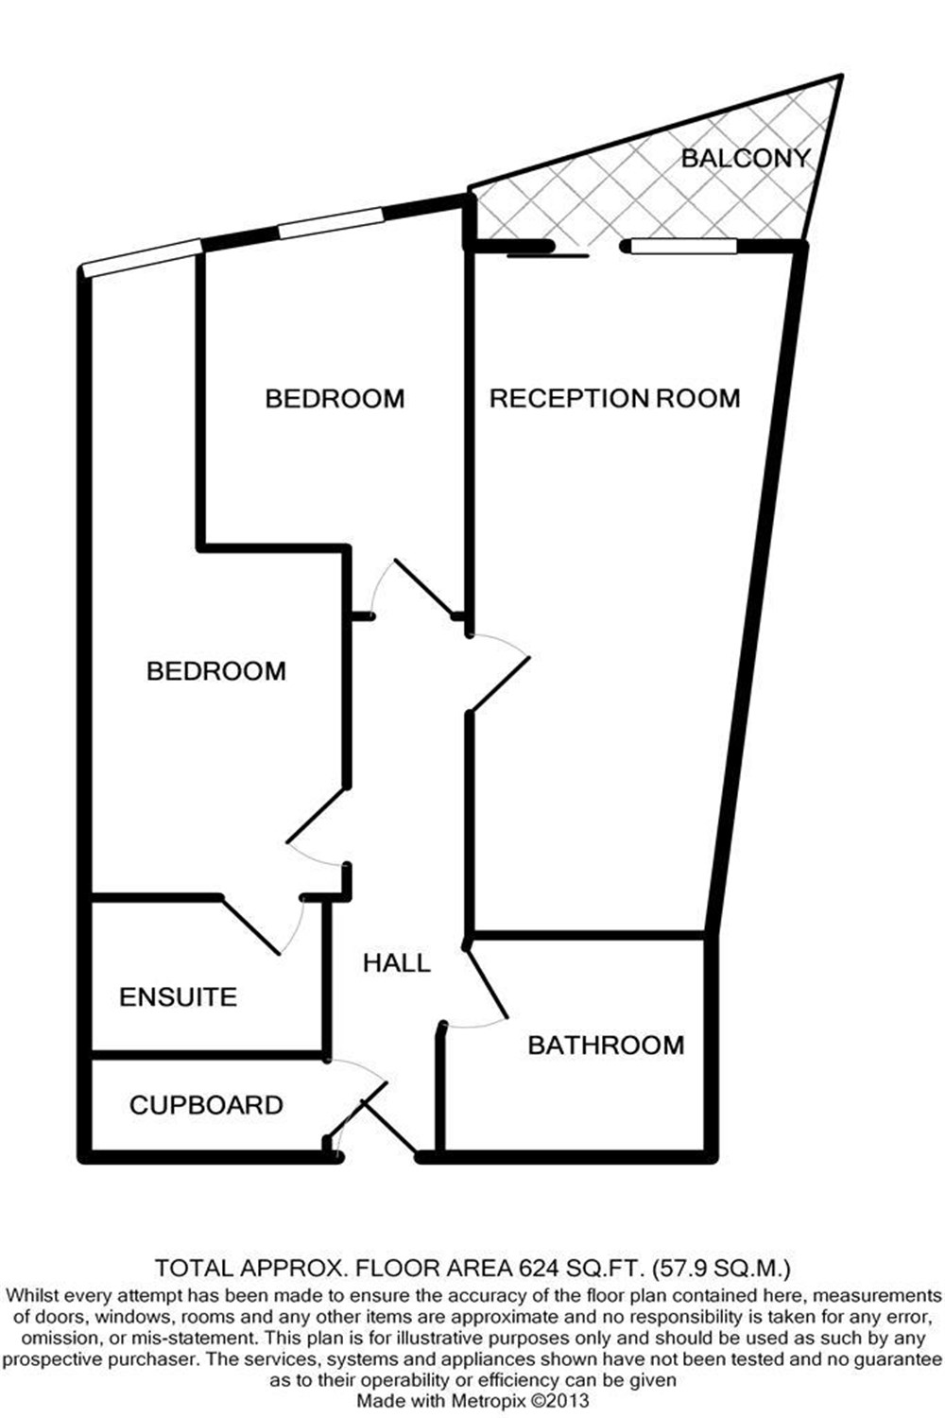

|  |  |
| --- | --- |
| These particulars are intended to give a fair description of the property, but their accuracy cannot be guaranteed, and they do not constitute an offer of contract. Intending purchasers must rely on their own inspection of the property. None of the above appliances/services have been tested by ourselves. We recommend purchasers arrange for a qualified person to check all appliances/services before legal commitment.  **Property Ref:** 1049  **For more information, please contact**  0113 258 1150 **|** [sales@adairpaxton.co.uk](mailto:sales@adairpaxton.co.uk) **|** www.adairpaxton.co.uk |  |