

**0113 258 1150**

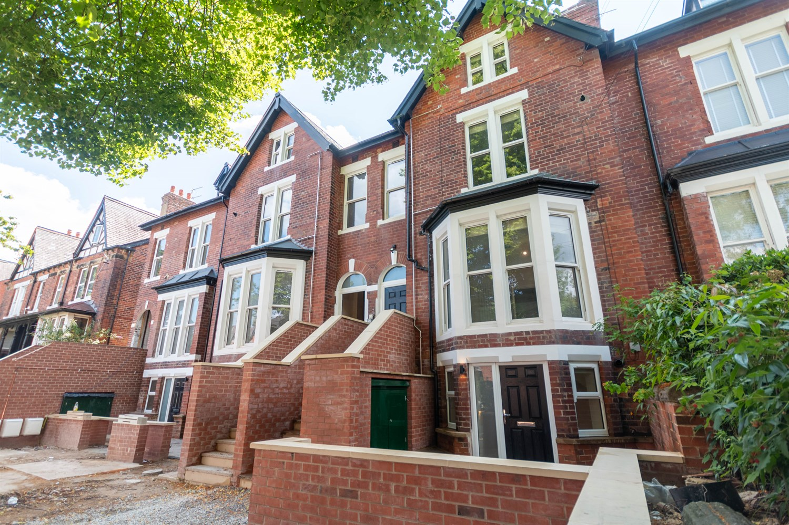



**Available to let £1,000.00pcm**

**21A Oakwood Avenue, Oakwood**

**STUNNING ONE BEDROOM DUPLEX APARTMENT - A STONE'S THROW FROM OAKWOODS SHOPS, RESTAURANTS and BAR'S** This newly refurbished one bedroom apartment is set over two floors and sits in a sought after Roundhay location. This property is finished to an immaculate standard and briefly comprises; Open plan kitchen/dining room/living room to the ground floor. To the first floor is the master bedroom and a shower room. Located in this much sought after Oakwood location, a stone's throw to local amenities including shops, bars and restaurants, as well as transport links in to Leeds. This property wont be on the market for long - Call now to book a viewing.

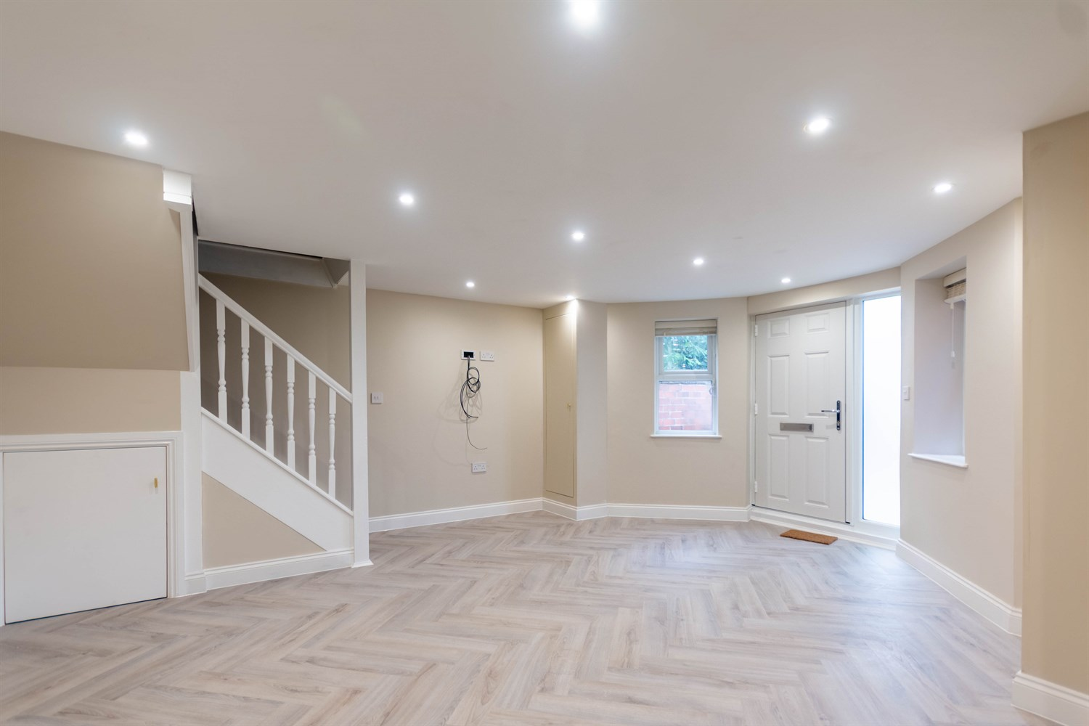

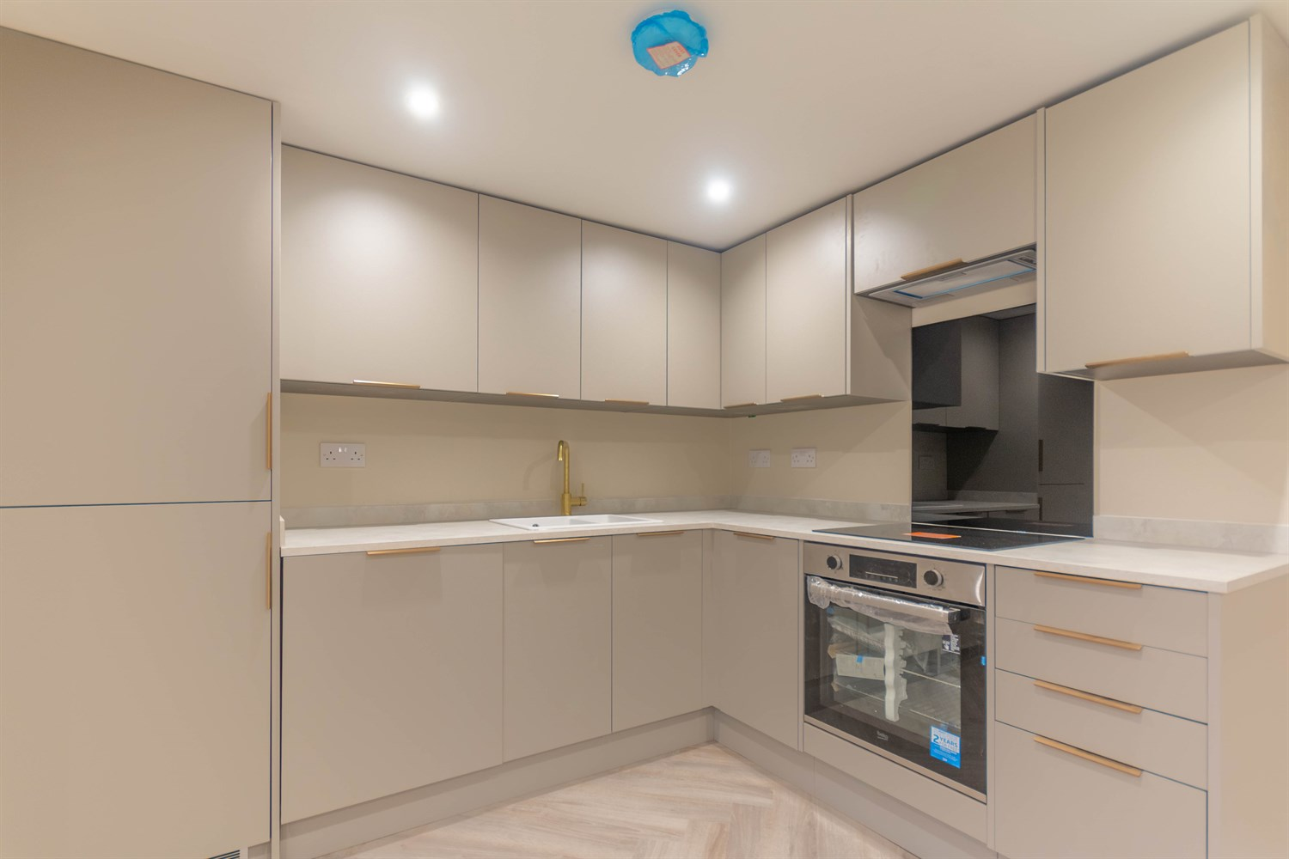

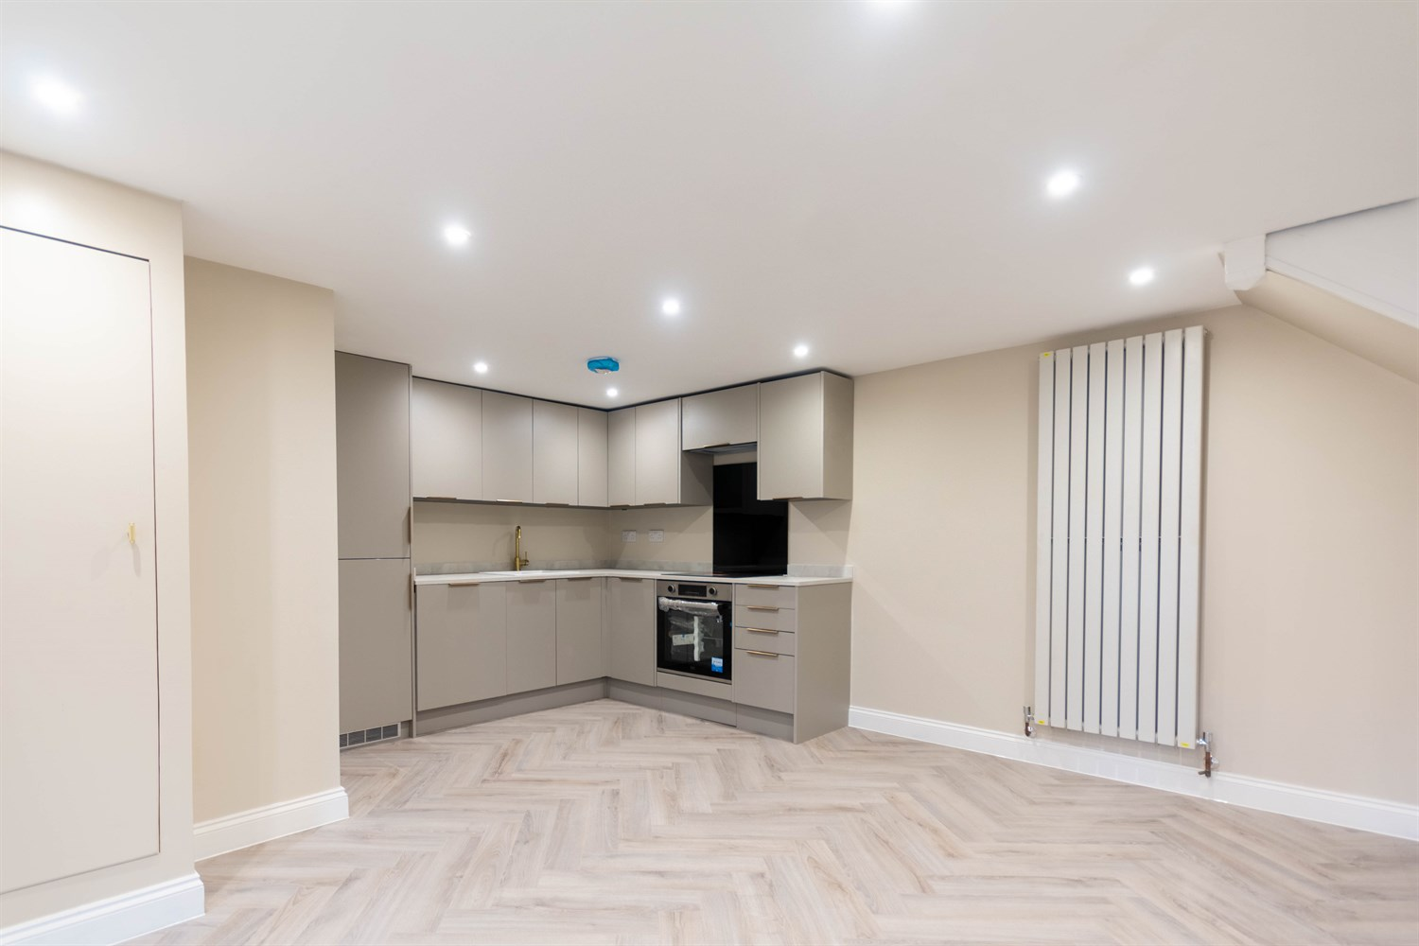

1 Bathroom(s)

1 Reception(s)

1 Bedroom(s)

00

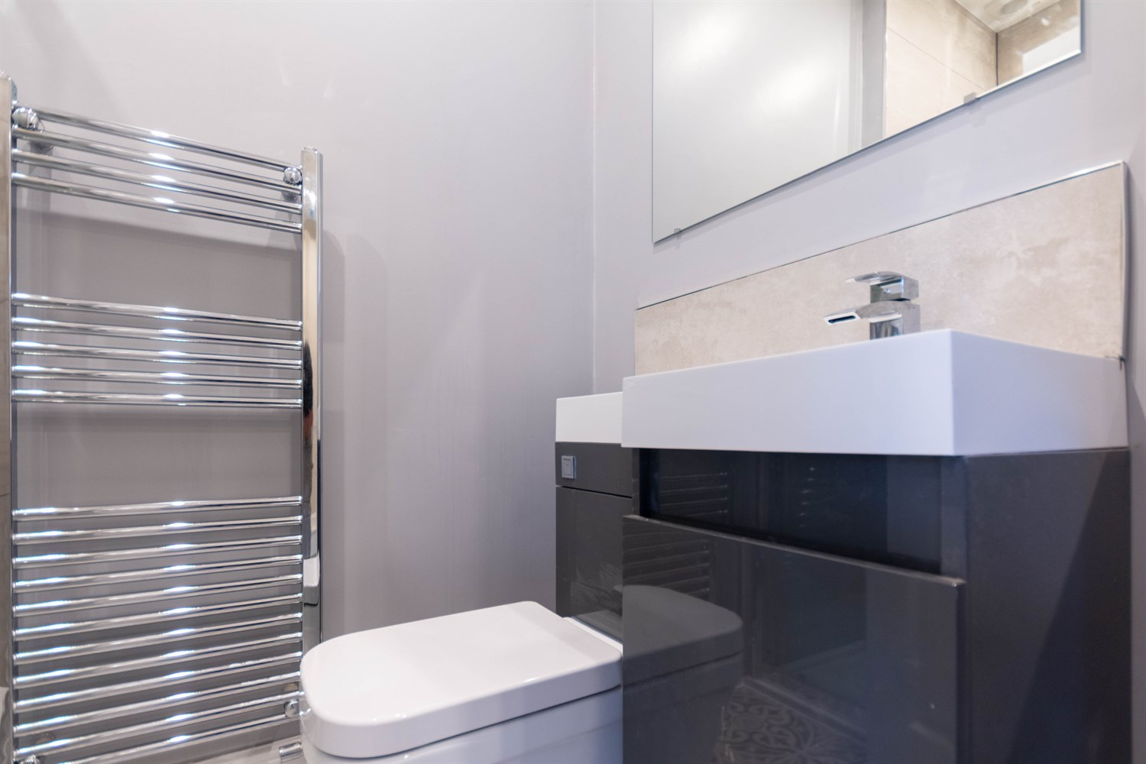

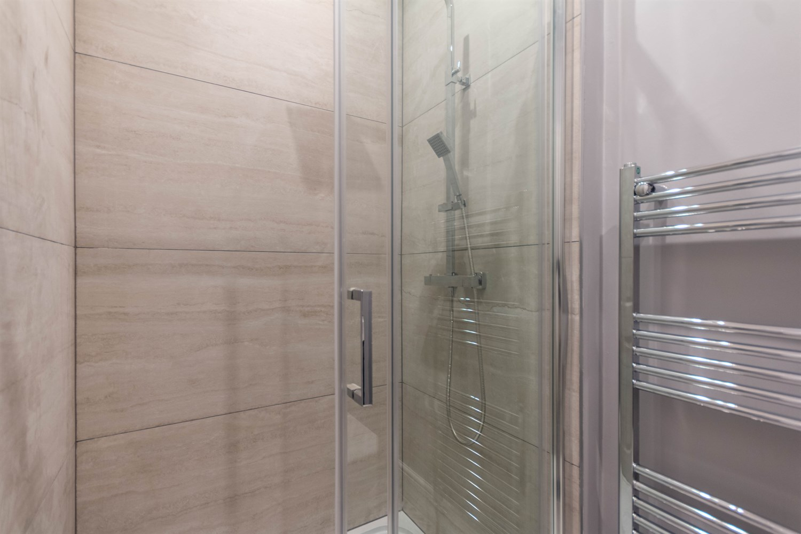

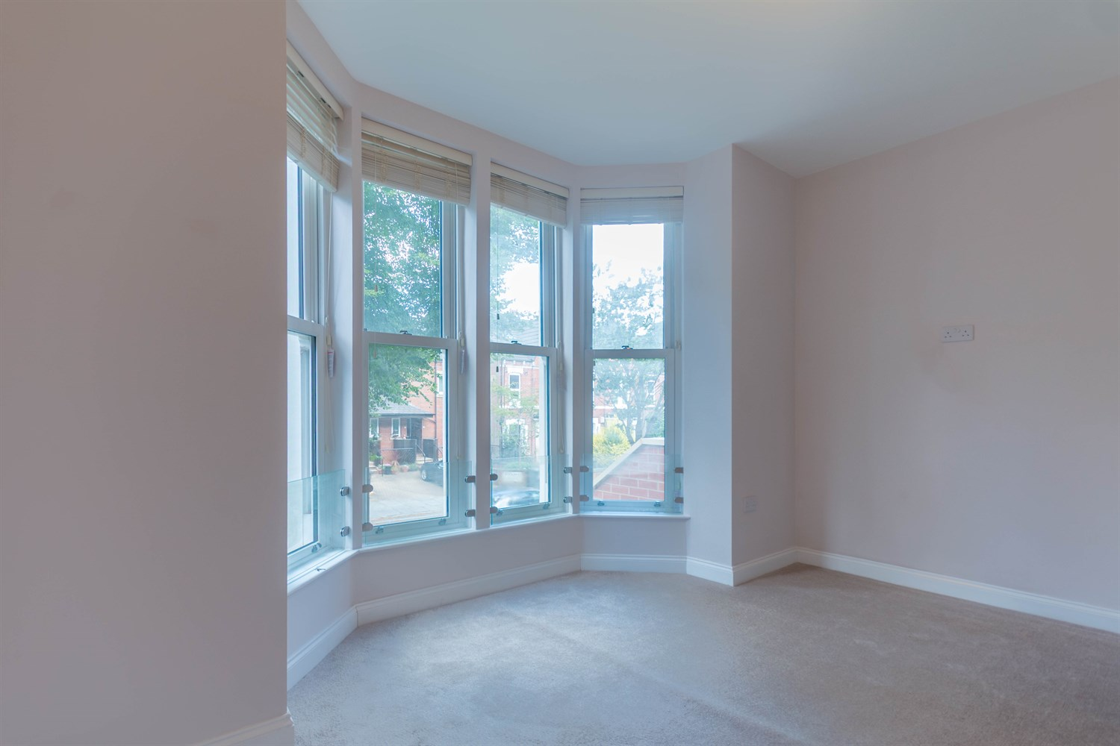

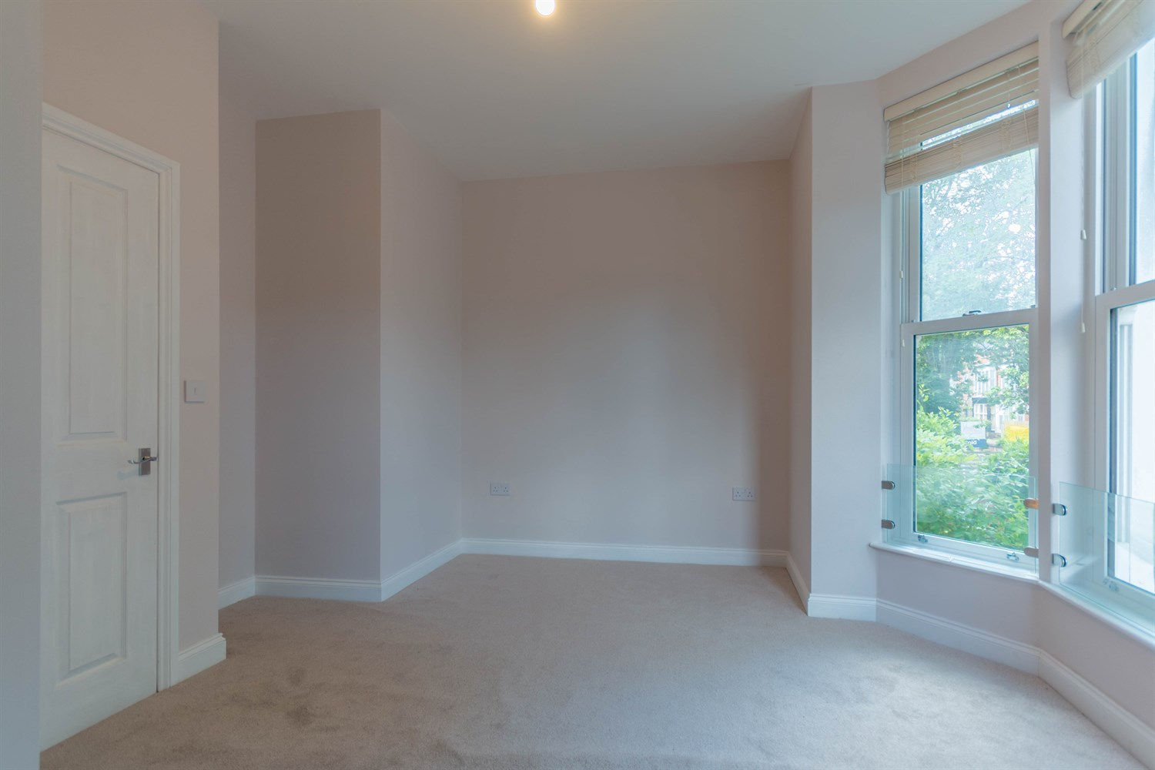

|  |
| --- |
| **Open Plan Kitchen/Living Area 5.68m (18'8) x 5.12m (16'10)**  Accessed via front entrance door. Fitted with a range of wall, base and drawer units with worktops over. Integrated fridge/freezer and washing machine. Integrated oven with 4-ring hob and extractor hood over. Inset ceiling spotlights. uPVC double glazed window to front. Living area. Stairs to first floor. |
|  |
| **First Floor** |
| **Bedroom 1 4.36m (14'4) x 3.47m (11'5)**  Double bedroom with uPVC double glazed sash windows to front. Gas central heating radiator. |
| **Shower Room**  Fitted with a three piece suite comprising walk in shower cubicle, WC and wash hand basin. |

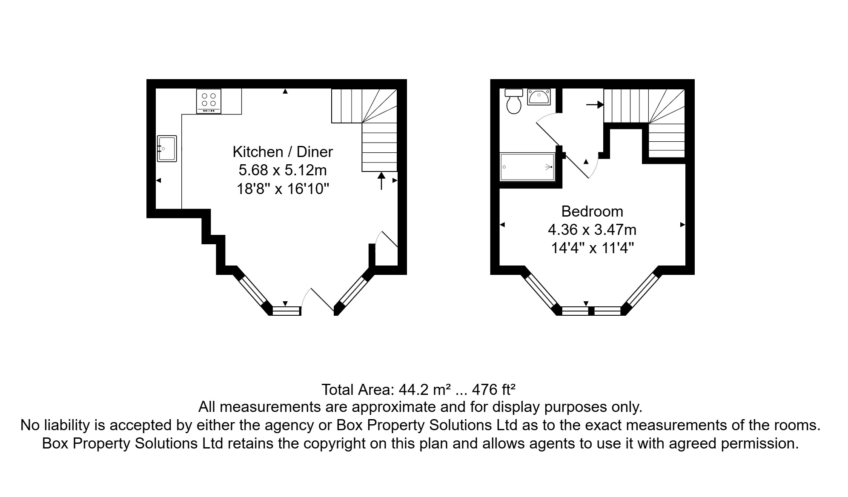

|  |  |
| --- | --- |
| These particulars are intended to give a fair description of the property, but their accuracy cannot be guaranteed, and they do not constitute an offer of contract. Intending purchasers must rely on their own inspection of the property. None of the above appliances/services have been tested by ourselves. We recommend purchasers arrange for a qualified person to check all appliances/services before legal commitment.  **Property Ref:** 6686  **For more information, please contact**  0113 258 1150 **|** [lettings@adairpaxton.co.uk](mailto:lettings@adairpaxton.co.uk) **|** www.adairpaxton.co.uk |  |