

**Wykebeck Valley Road, Leeds**

**For Sale £350,000.00**

***FOUR BEDROOM DETACHED HOUSE with NO ONWARD CHAIN*** Set just off the A64 York Road, this property is conveniently located for Leeds City Centre and surrounding districts. This deceptively spacious family home offers versatile accommodation and briefly comprises; Entrance hall, spacious lounge with door leading out to the rear garden, fitted kitchen and additional reception room/double bedroom with en-suite shower room to the ground floor. To the first floor there is a master bedroom with an en-suite toilet, two further double bedrooms, a study and house bathroom. Externally, the property had an enclosed driveway offering off-street parking for several vehicles and leading to a detached garage. To the rear is a lawned garden. The property is well located for all shopping and transport amenities as well as offering easy access into Leeds City Centre. Nearby motorway links ideal for the commuter who is looking to travel further afield.

**0113 258 1150**

**0800 000 000**

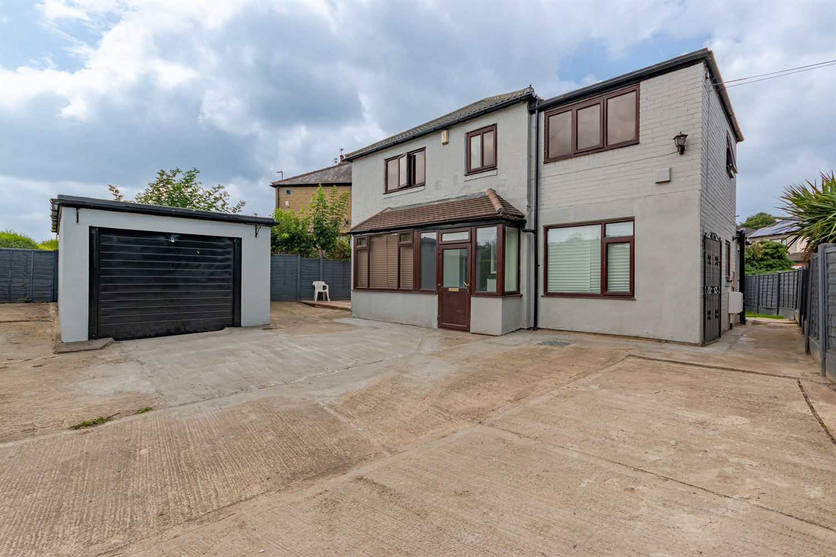

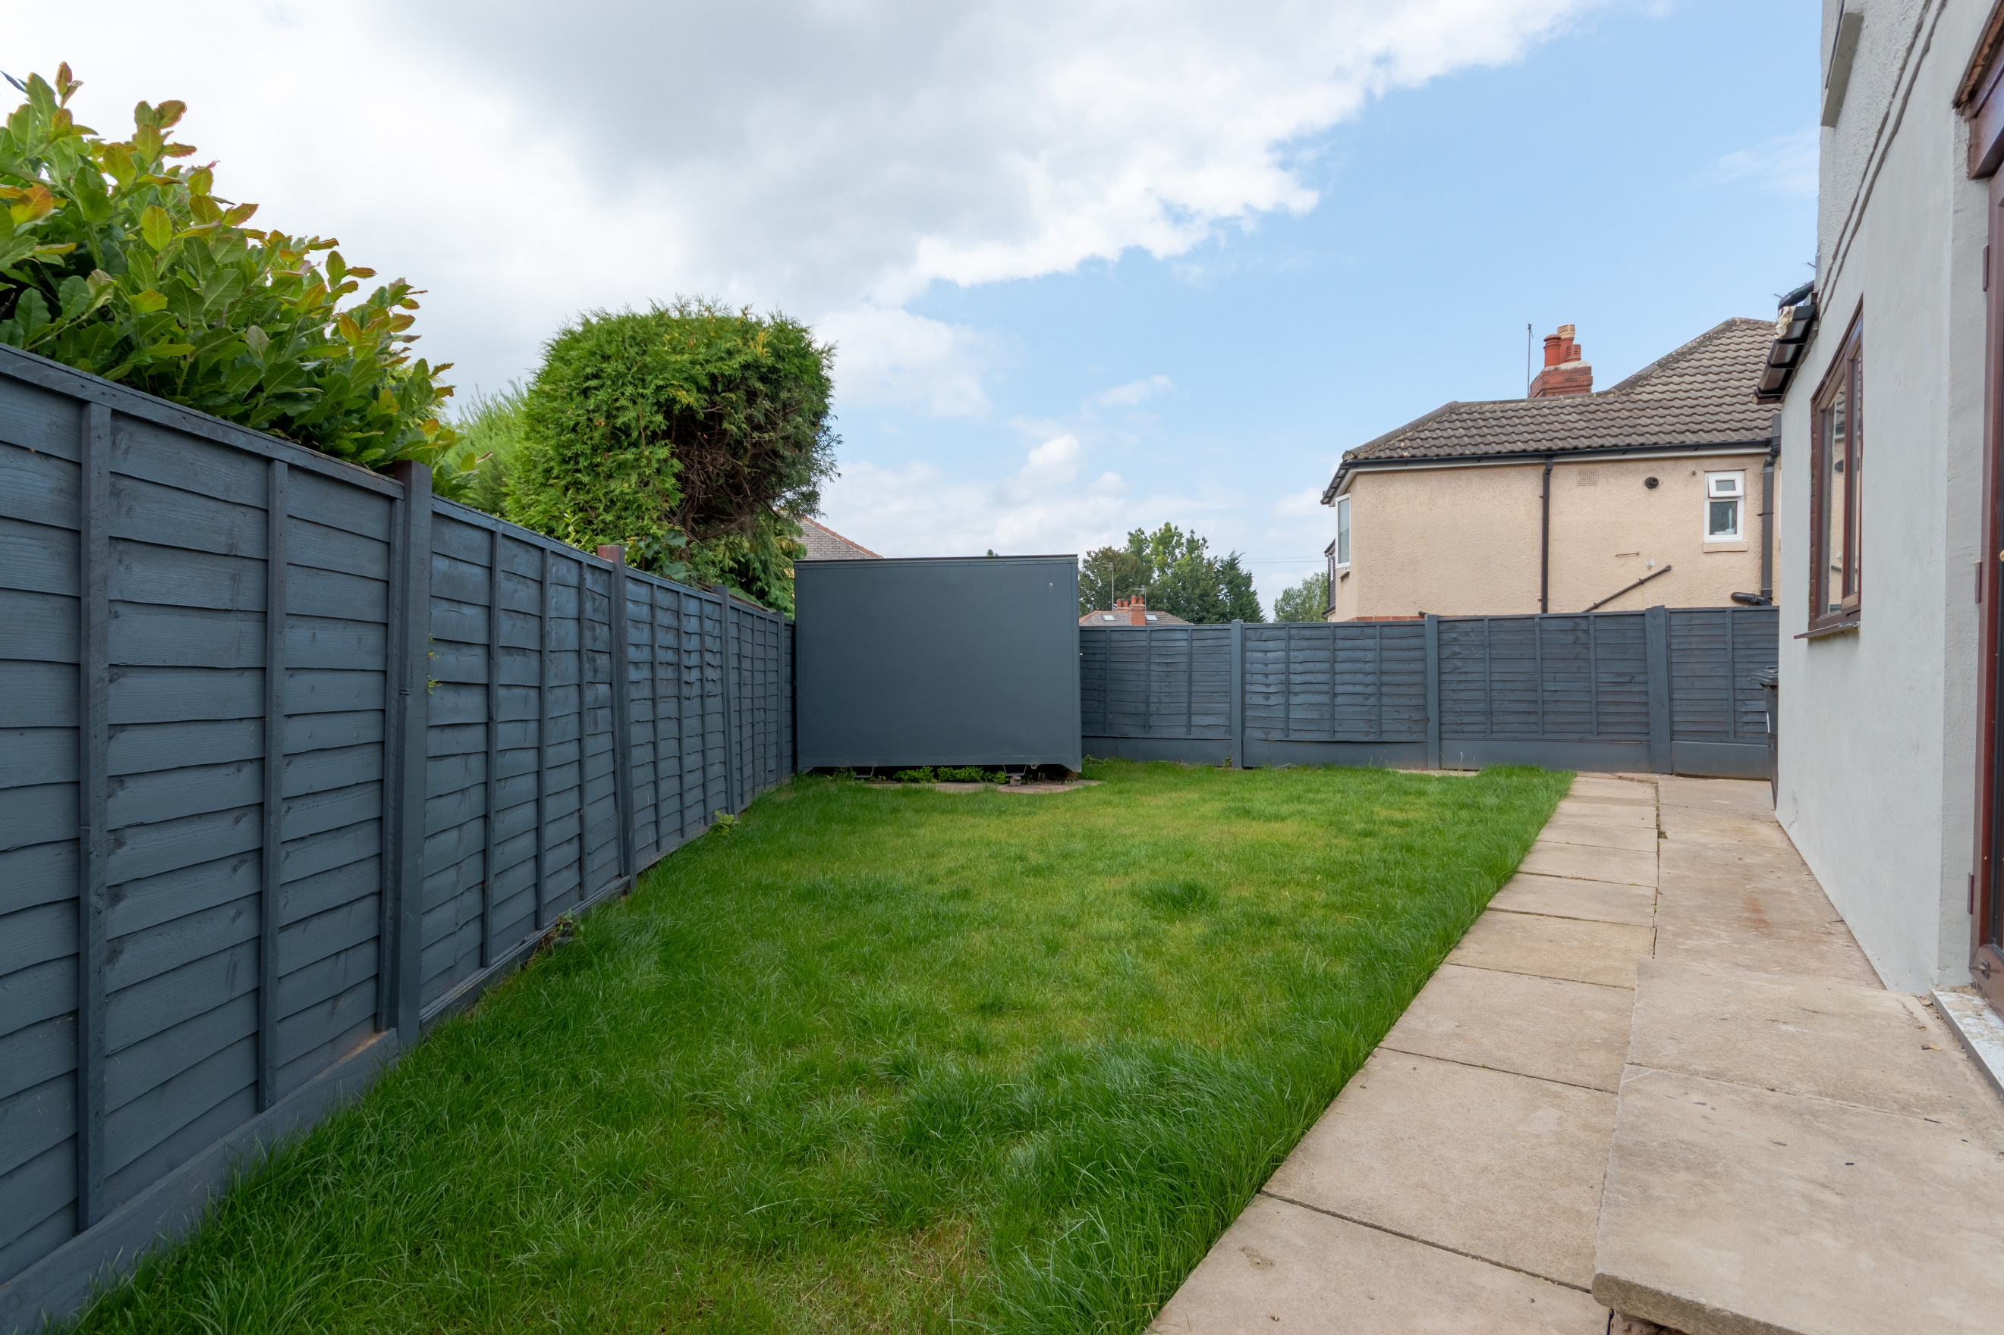

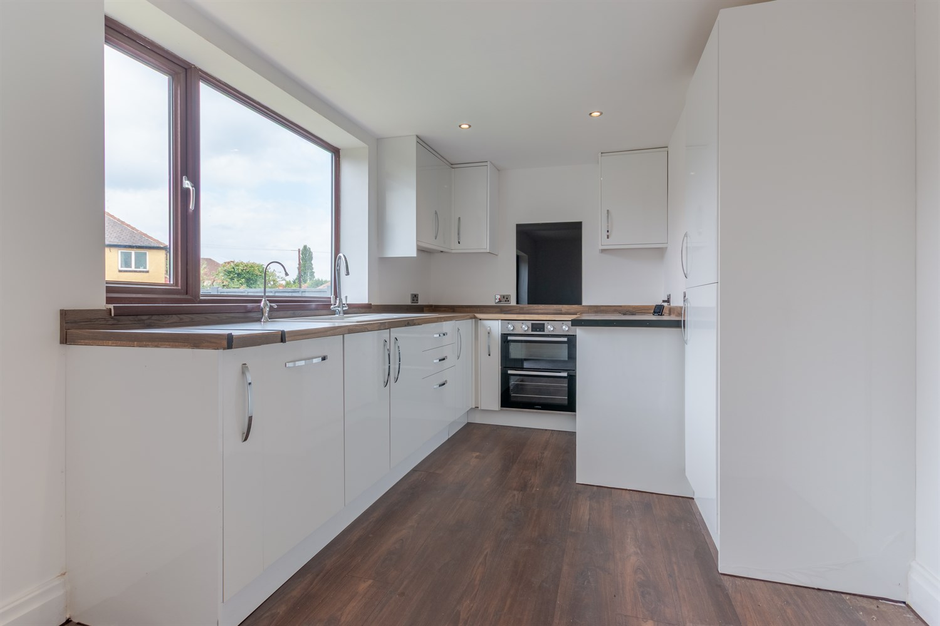

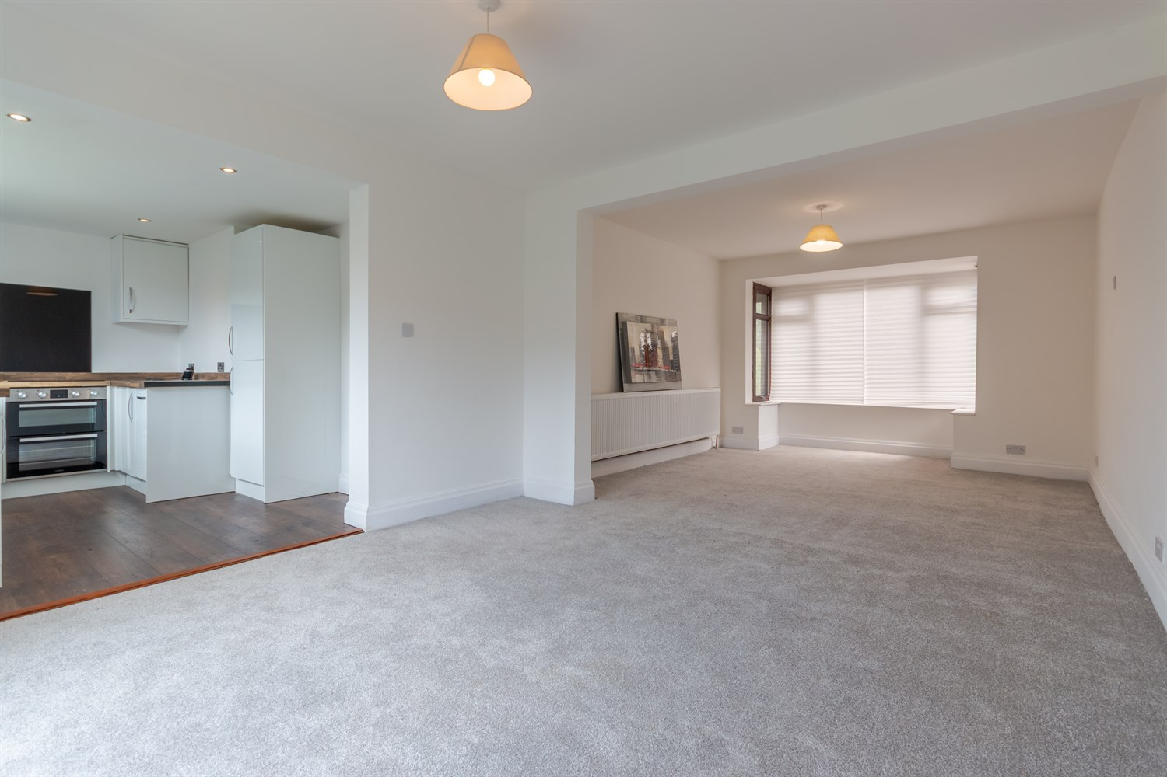

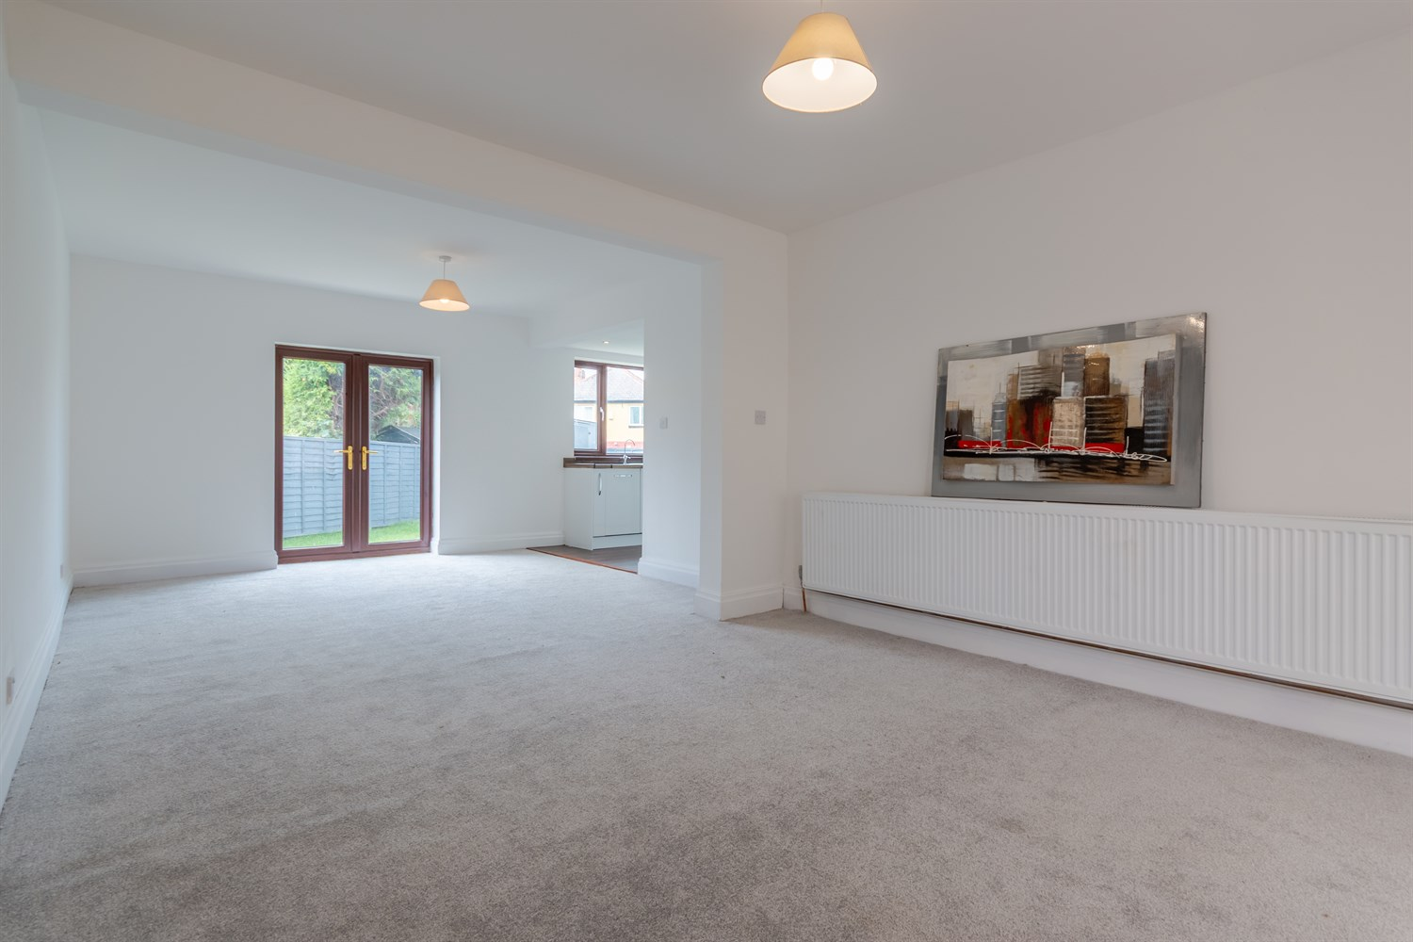

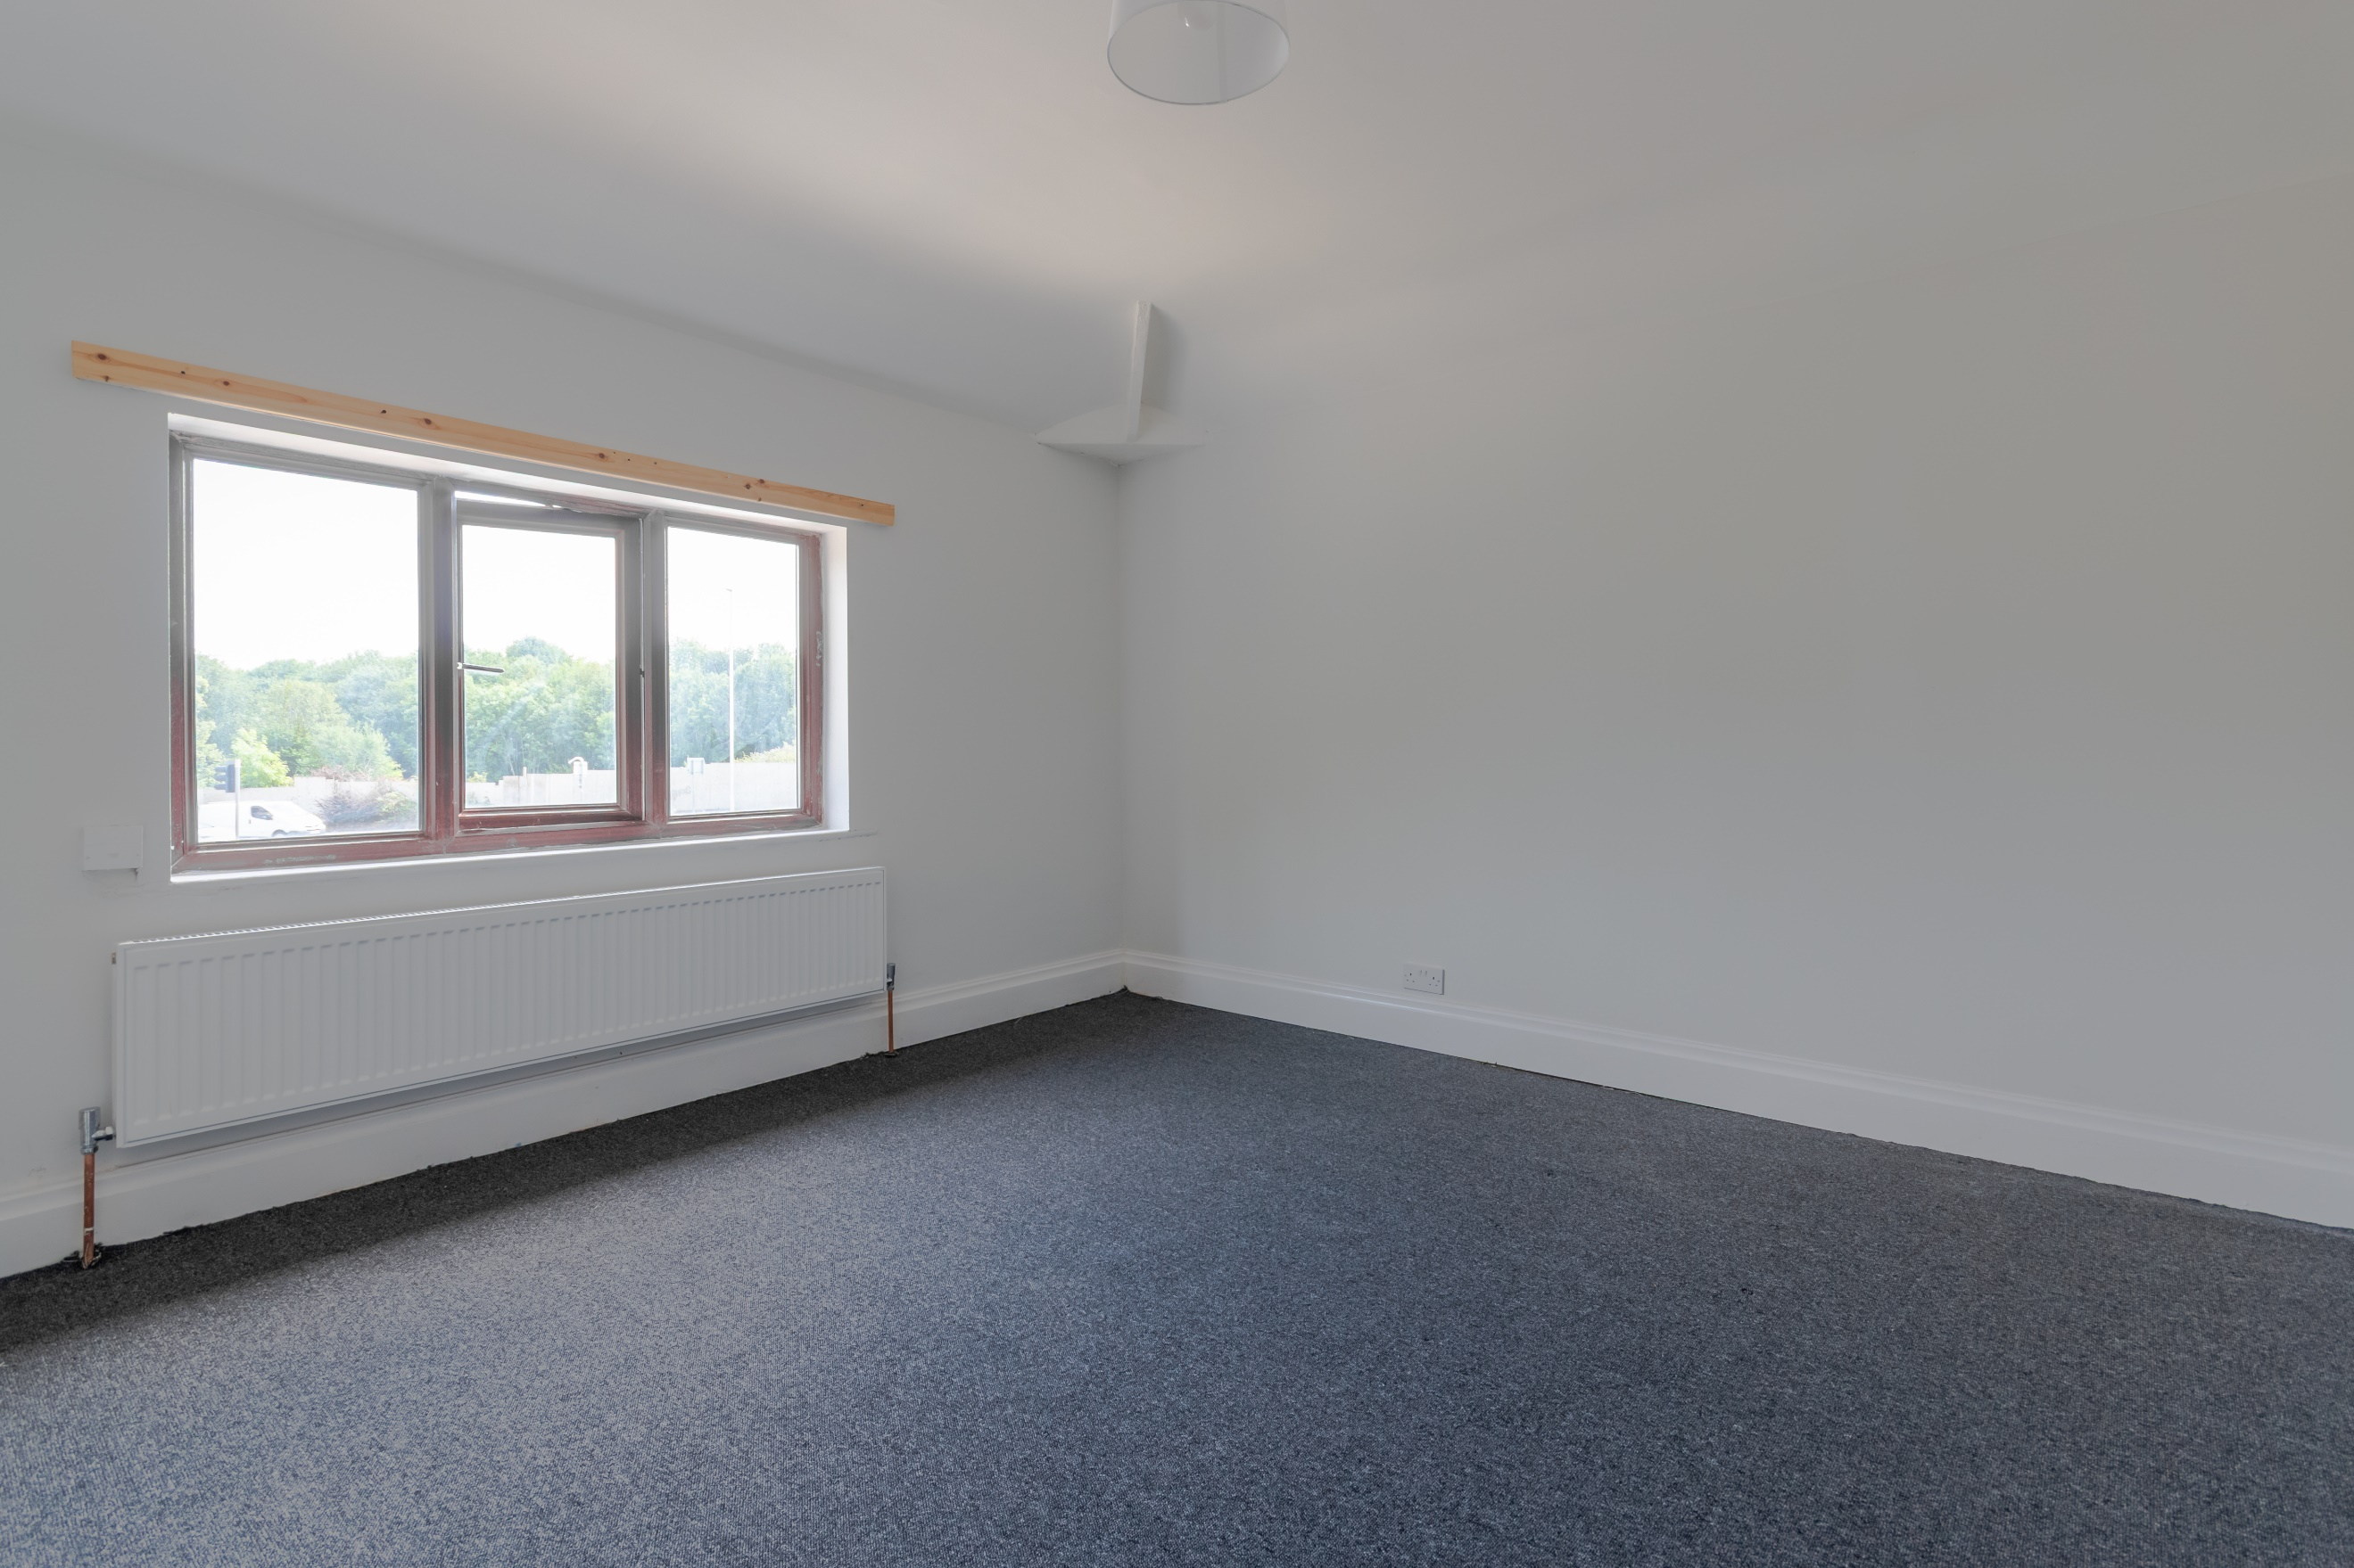

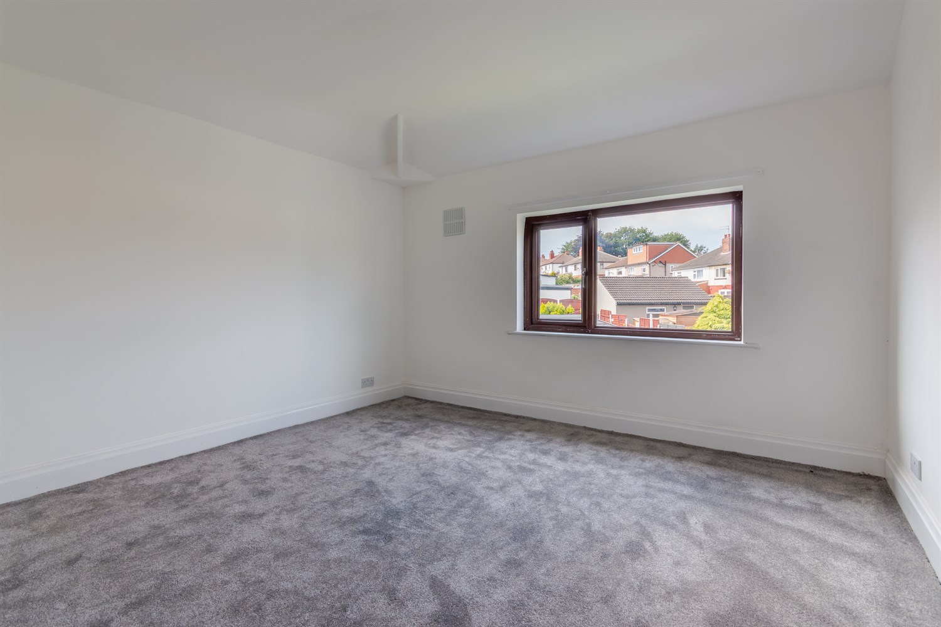

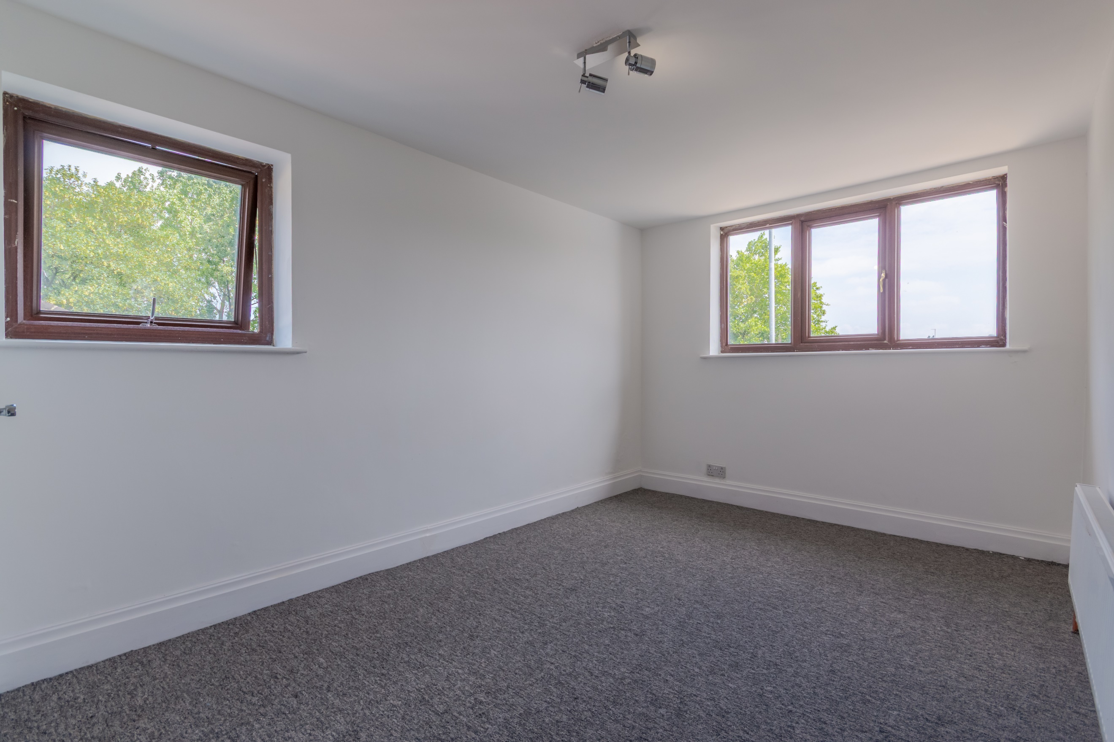

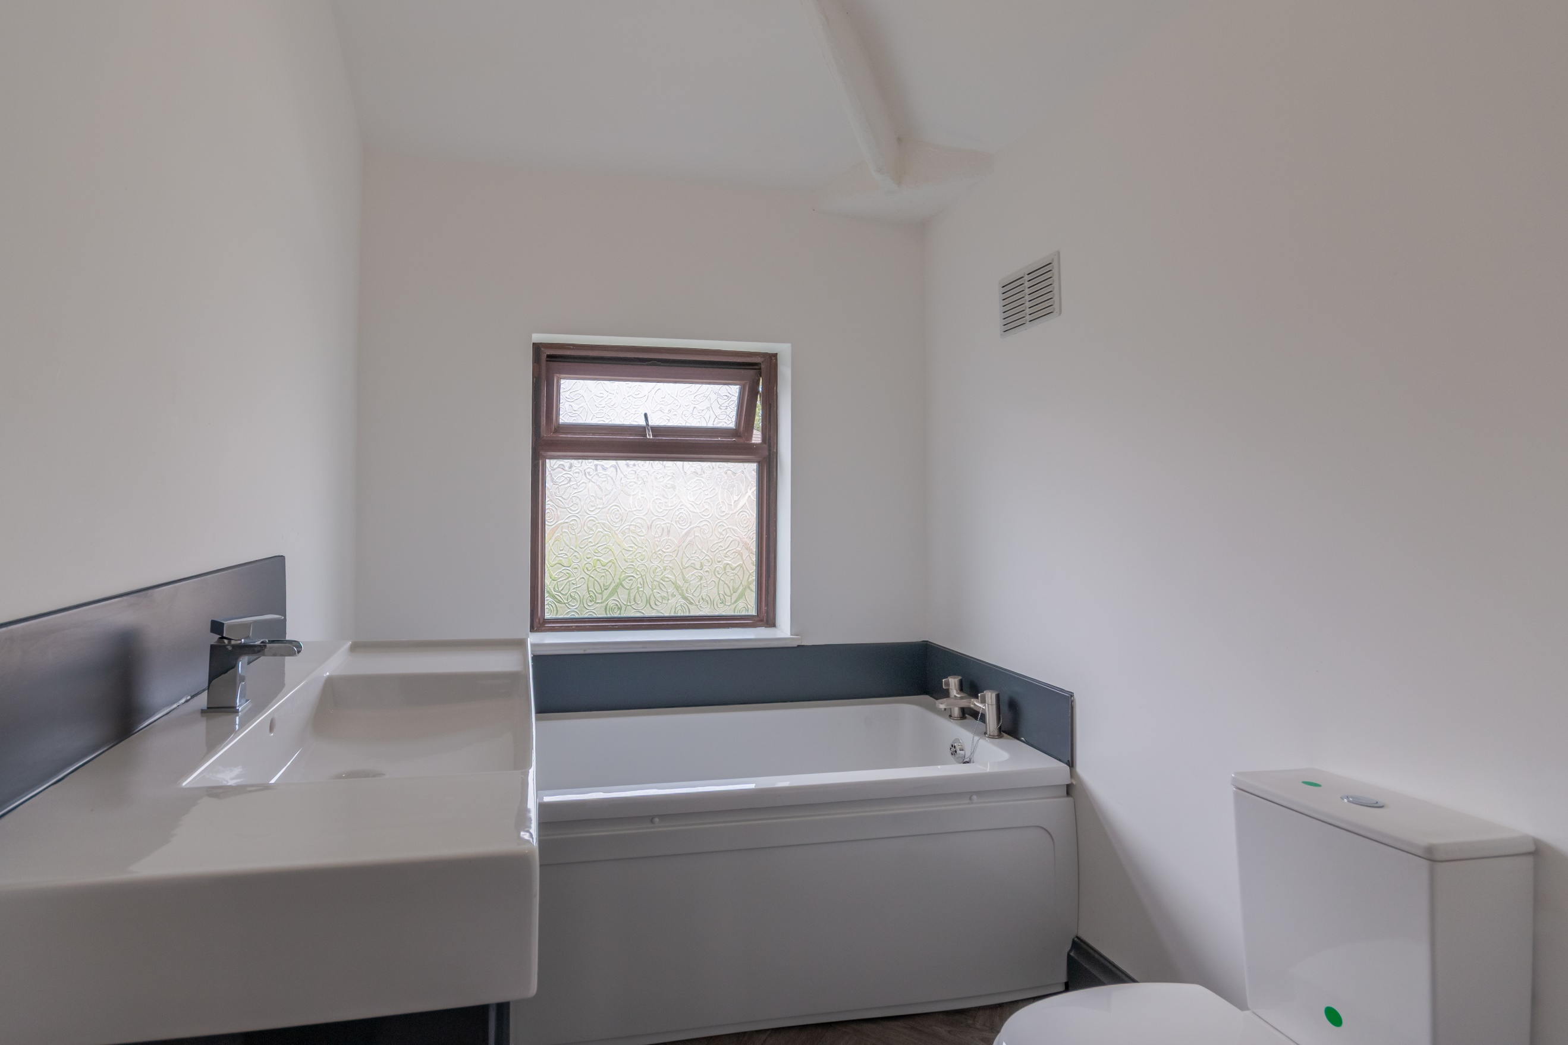

|  |
| --- |
| **Hallway**  Via entrance porch. Stairs to first floor. Gas central heating radiator. |
| **Sitting Room 3.64m (11'11) x 8.24m (27'0)**  Spacious living area with double glazed window to front. Gas central heating radiator. Double doors leading out to the rear garden. |
| **Kitchen 3.38m (11'1) x 2.64m (8'8)**  Fitted with a range of wall, base and drawer units with worktops over. Integrated fridge/freezer and dishwasher. Integrated electric oven with 4-ring hob over. Sink with mixer tap and drainer. Inset ceiling spotlights. |
| **Reception Room/Bedroom**  Versatile room to the ground floor, ideal to be used as a bedroom or reception room. Double glazed window to front and side. Gas central heating radiator. |
| **En-Suite Shower Room**  Fitted with a three piece suite comprising; Shower cubicle, WC and wash hand basin. Double glazed window. |
| **Bedroom 1 3.63m (11'11) x 3.65m (12')**  Double bedroom with double glazed window to front. Gas central heating radiator. |
| **Separate WC**  Fitted with a two piece suite comprising; WC and wash hand basin. |
| **Bedroom 2 3.63m (11'11) x 3.63m (11'11)**  Second double bedroom with double glazed window to front. Gas central heating radiator. |
| **Bedroom 3 2.65m (8'8) x 4.73m (15'6)**  Double bedroom with double glazed window to front. Gas central heating radiator. |
| **Bedroom 4/Study 1.89m (6'2) x 2m (6'7)**  Home office or Nursery. Double glazed window to front. Gas central heating radiator. |
| **House Bathroom**  Fitted with a three piece suite comprising; bath, vanity wash hand basin and WC. Double glazed window. |
| **Outside**  To the front of the property is a driveway offering off street parking for several cars and leading to a detached garage. To the rear is garden that has been mainly laid to lawn. |
| **Garage**  Detached garage. |
|  |
|  |

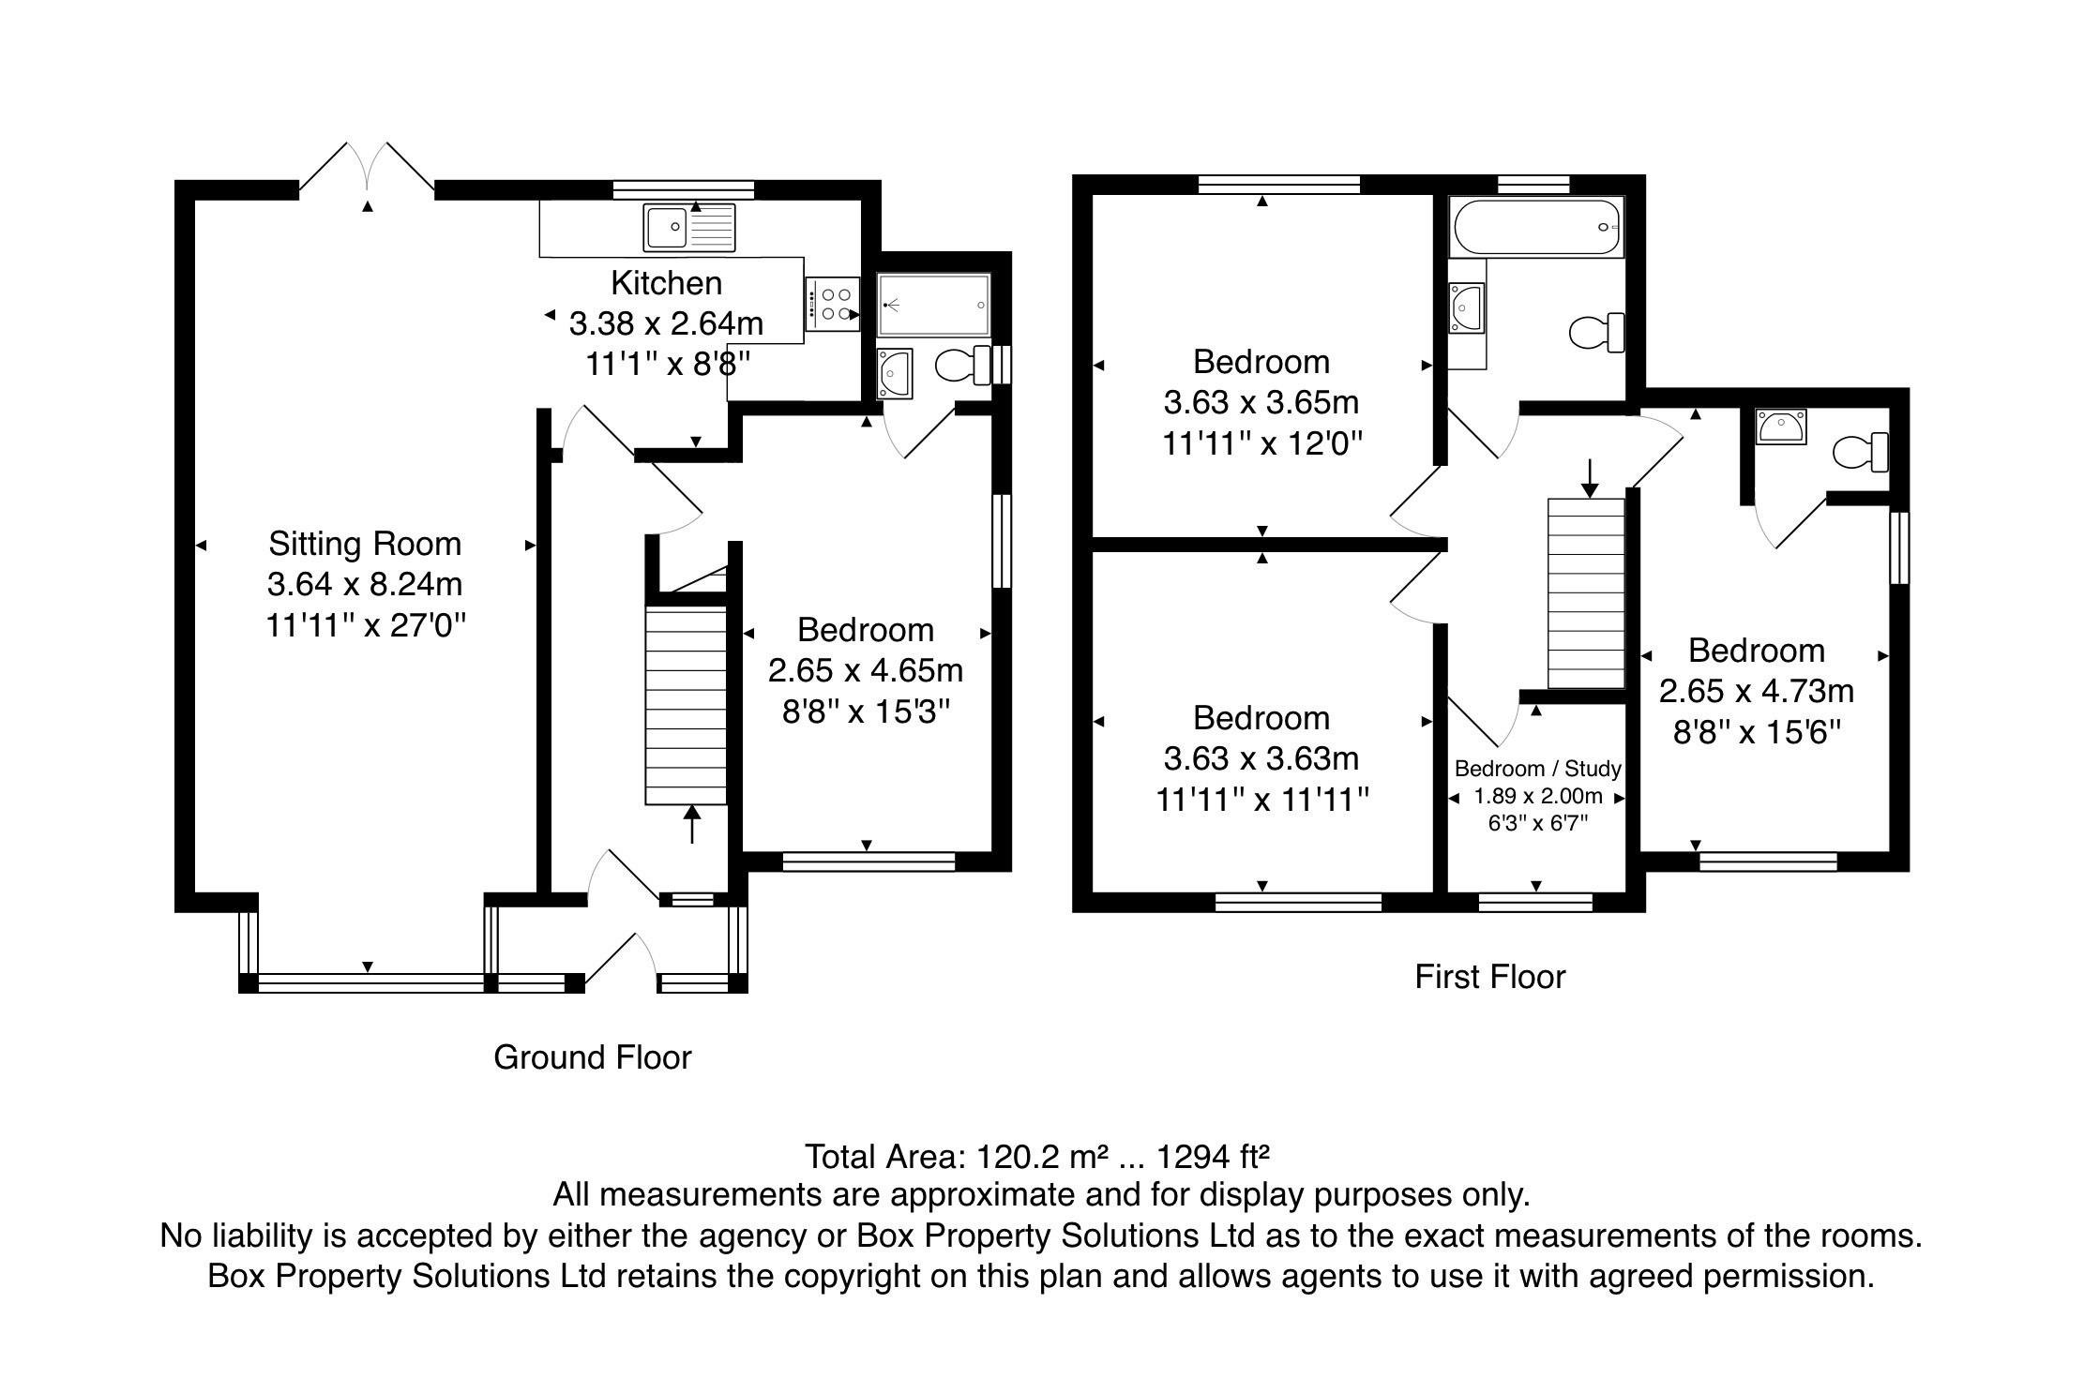

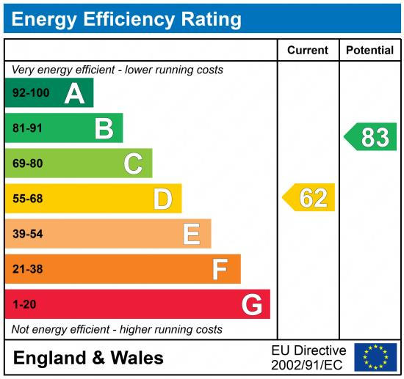

|  |
| --- |
|  |

These particulars are intended to give a fair description of the property, but their accuracy cannot be guaranteed, and they do not constitute an offer of contract. Intending purchasers must rely on their own inspection of the property. None of the above appliances/services have been tested by ourselves. We recommend purchasers arrange for a qualified person to check all appliances/services before legal commitment.

**Property Ref:** 6977

**For more information, please contact**

0113 258 1150 **|** [sales@adairpaxton.co.uk](mailto:sales@adairpaxton.co.uk) **|** www.adairpaxton.co.uk