

**0113 258 1150**

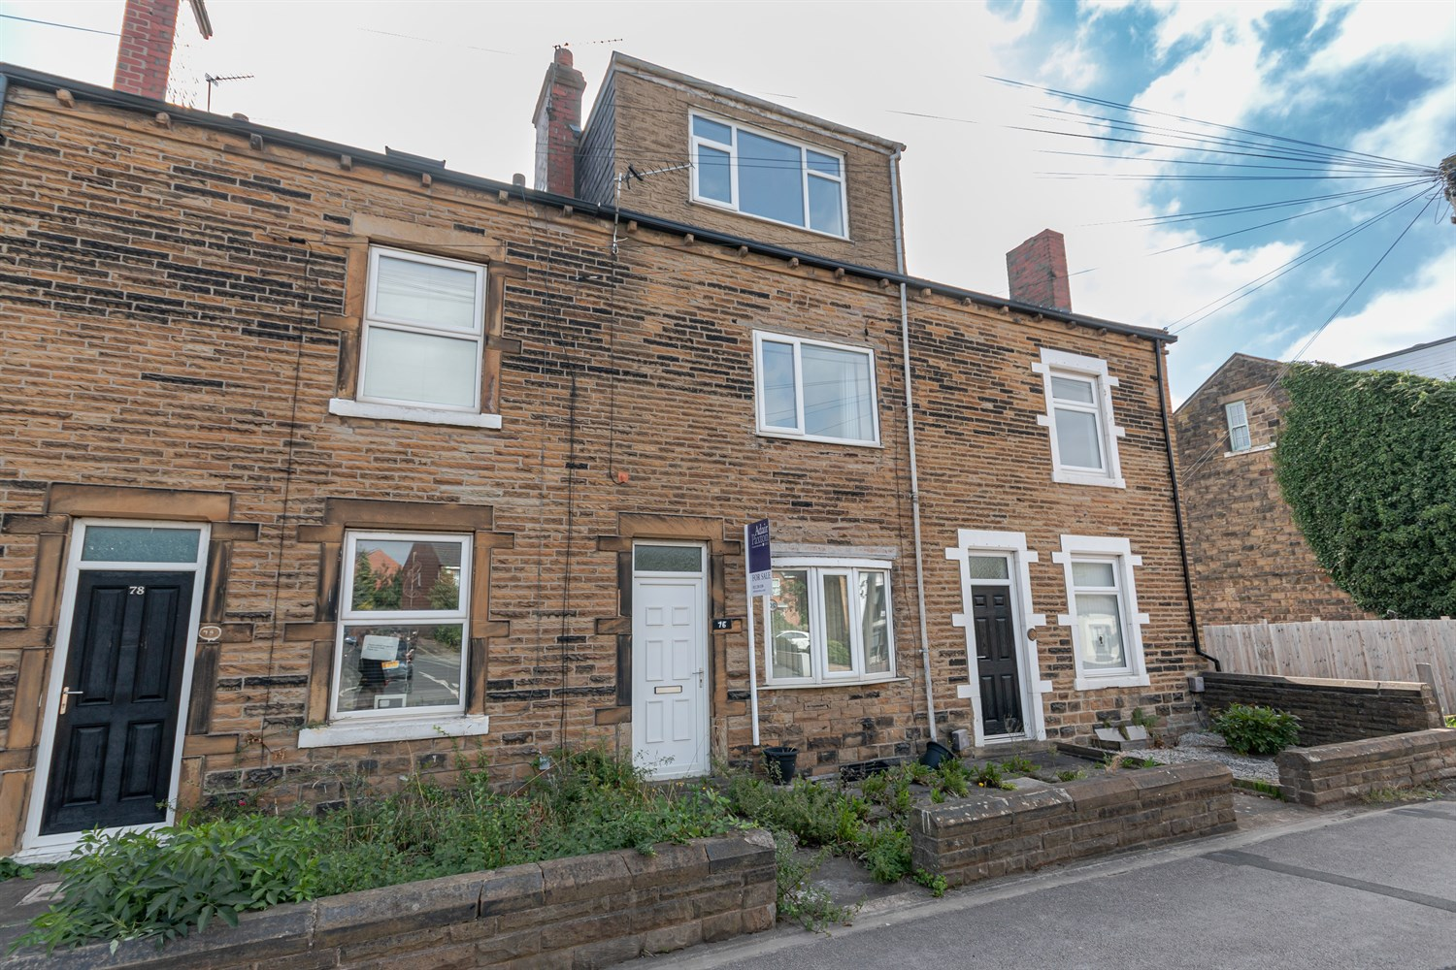



**For Sale £150,000.00**

**Wakefield Road, Rothwell**

***FOUR BEDROOM THROUGH MID-TERRACE - NO ONWARD CHAIN*** Located in the popular area of Rothwell, this spacious and well presented house would make a great first time buy or investment. The property is set over three floors and is now in need of some cosmetic updating, and briefly comprises: lounge and dining/kitchen to the ground floor. Cellar useful for storage. To the first floor there is a master bedroom, second double bedroom and house bathroom. To the second floor is a further two double bedrooms. Externally, the property has a courtyard style garden to the front and off street parking to the rear. The property has gas central heating and uPVC double glazing - An early internal viewing is highly recommended to appreciate the accommodation on offer. This property is well placed for daily travel to Leeds & Wakefield City centres via the A61, also within easy reach is the A1/M1 link road and national motorway networks.

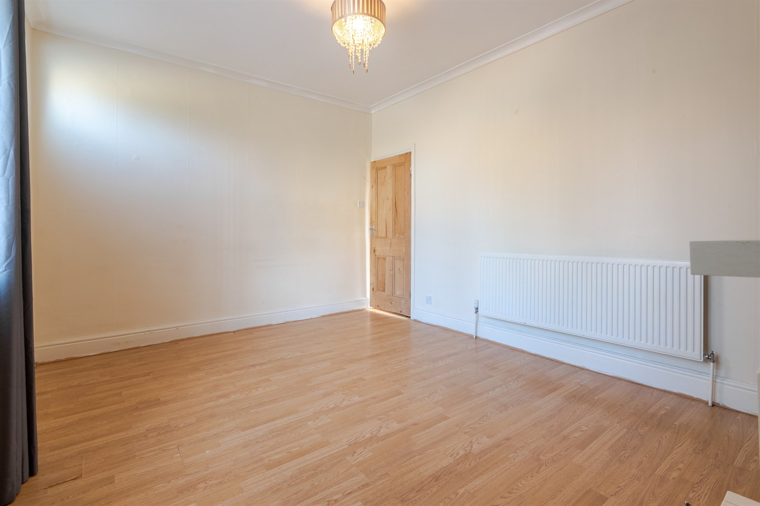

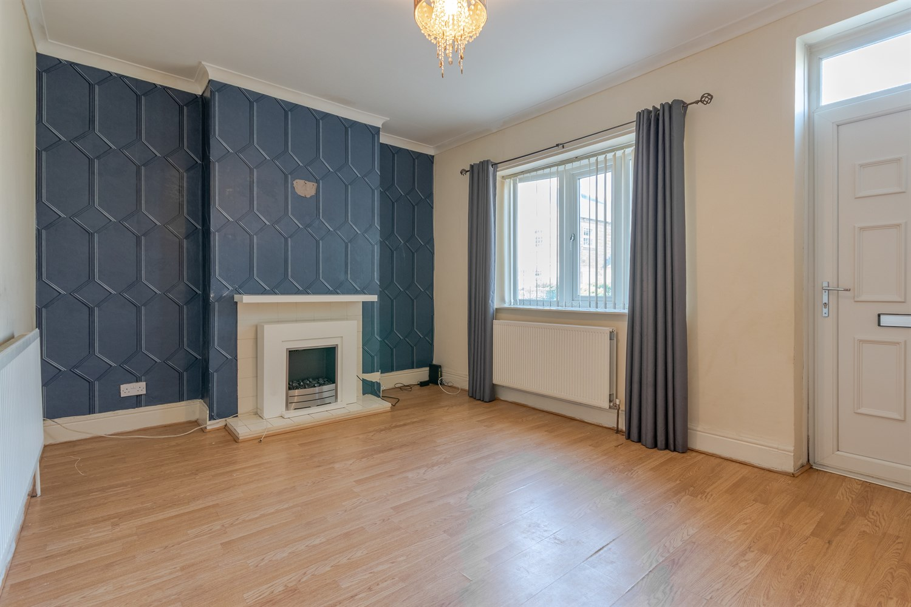

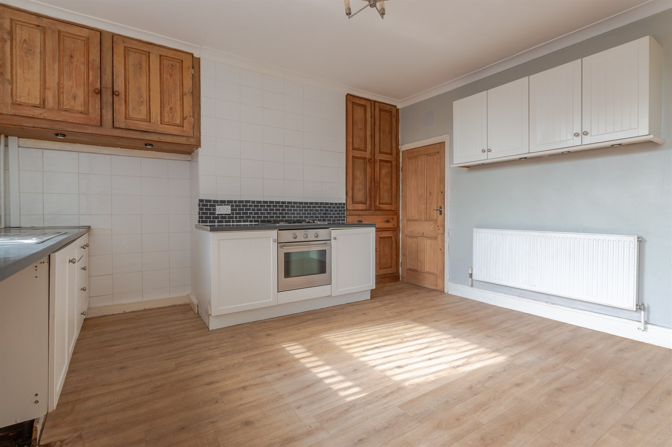

1 Bathroom(s)

1 Reception(s)

4 Bedroom(s)

00

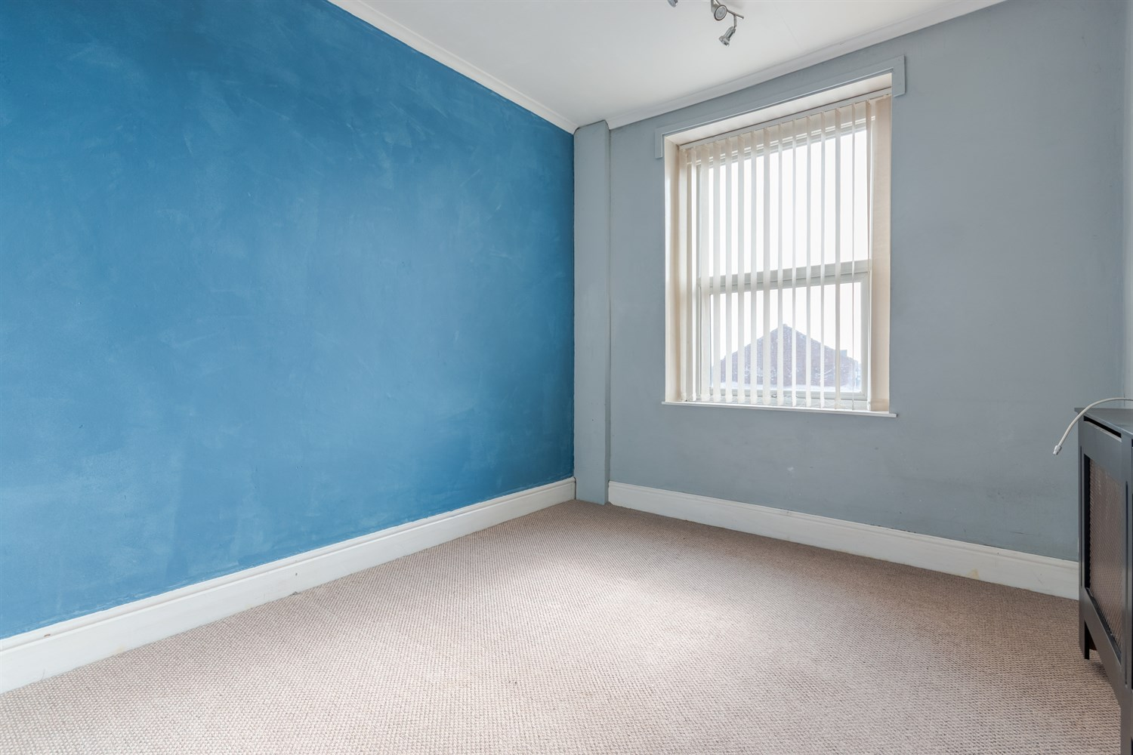

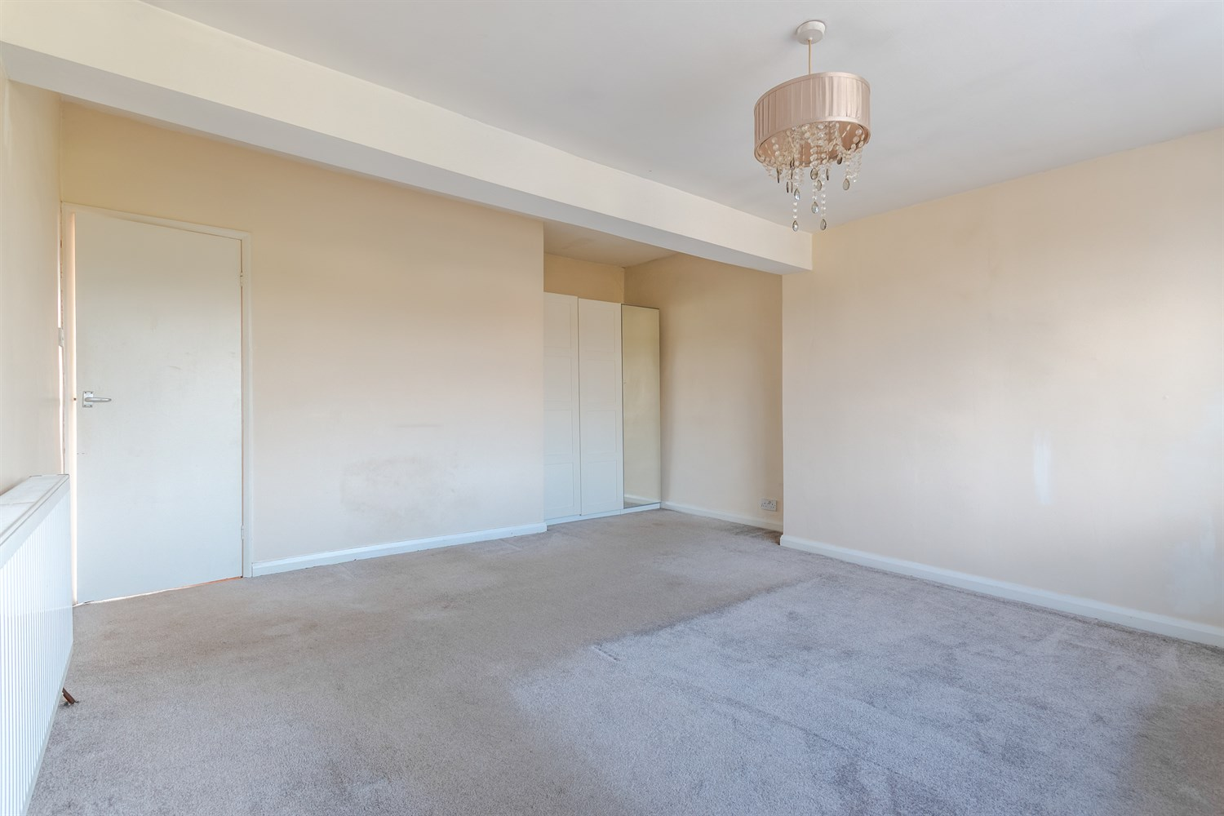

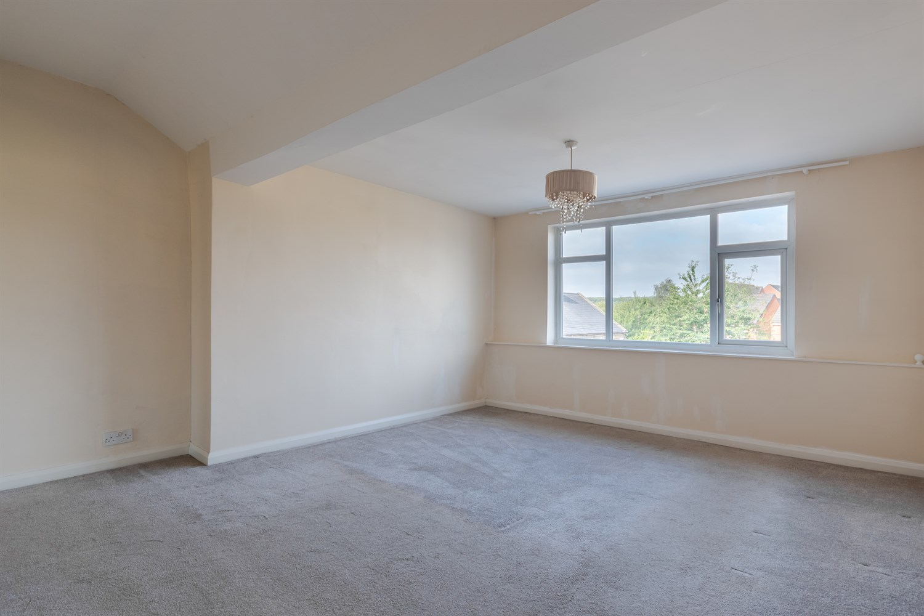

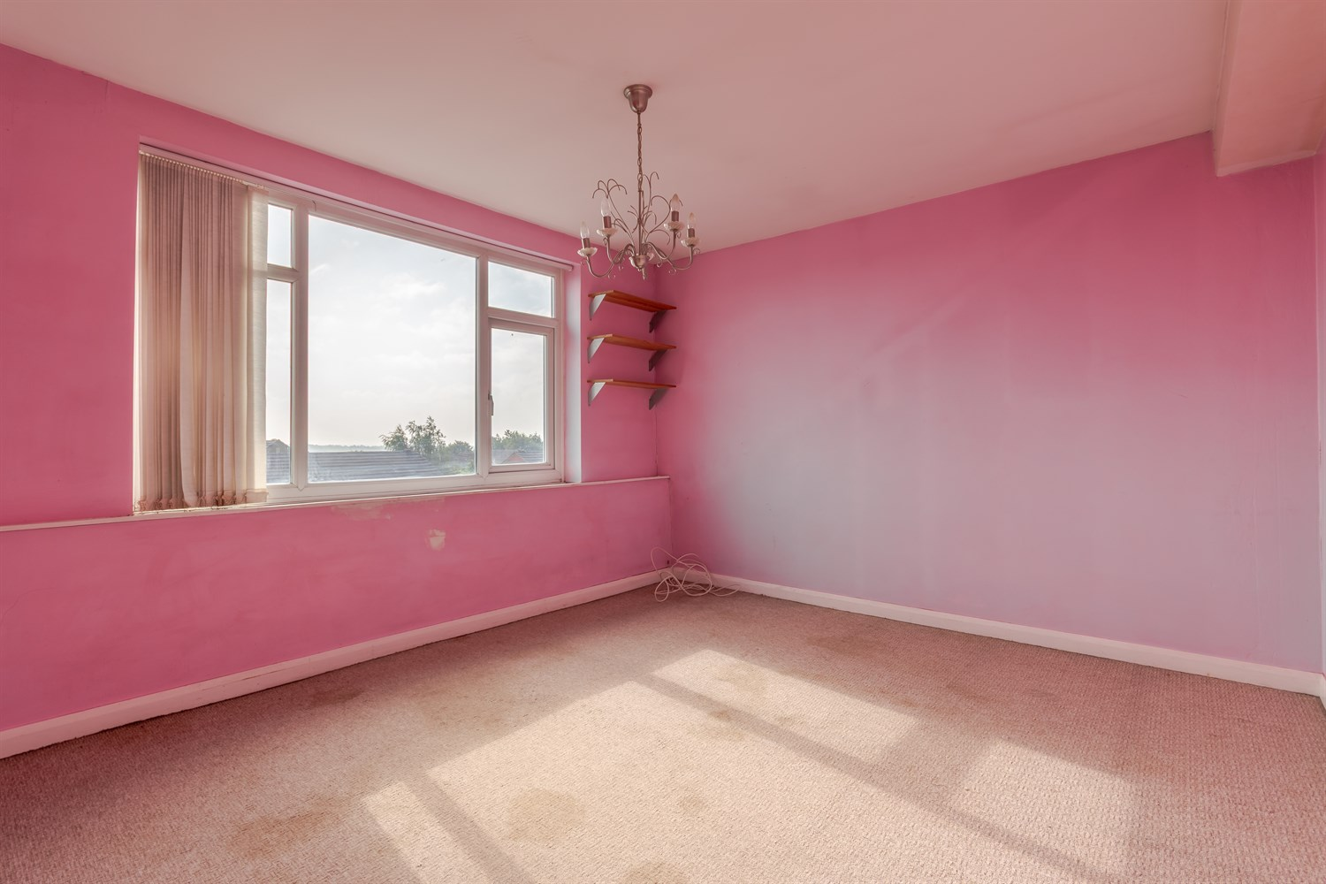

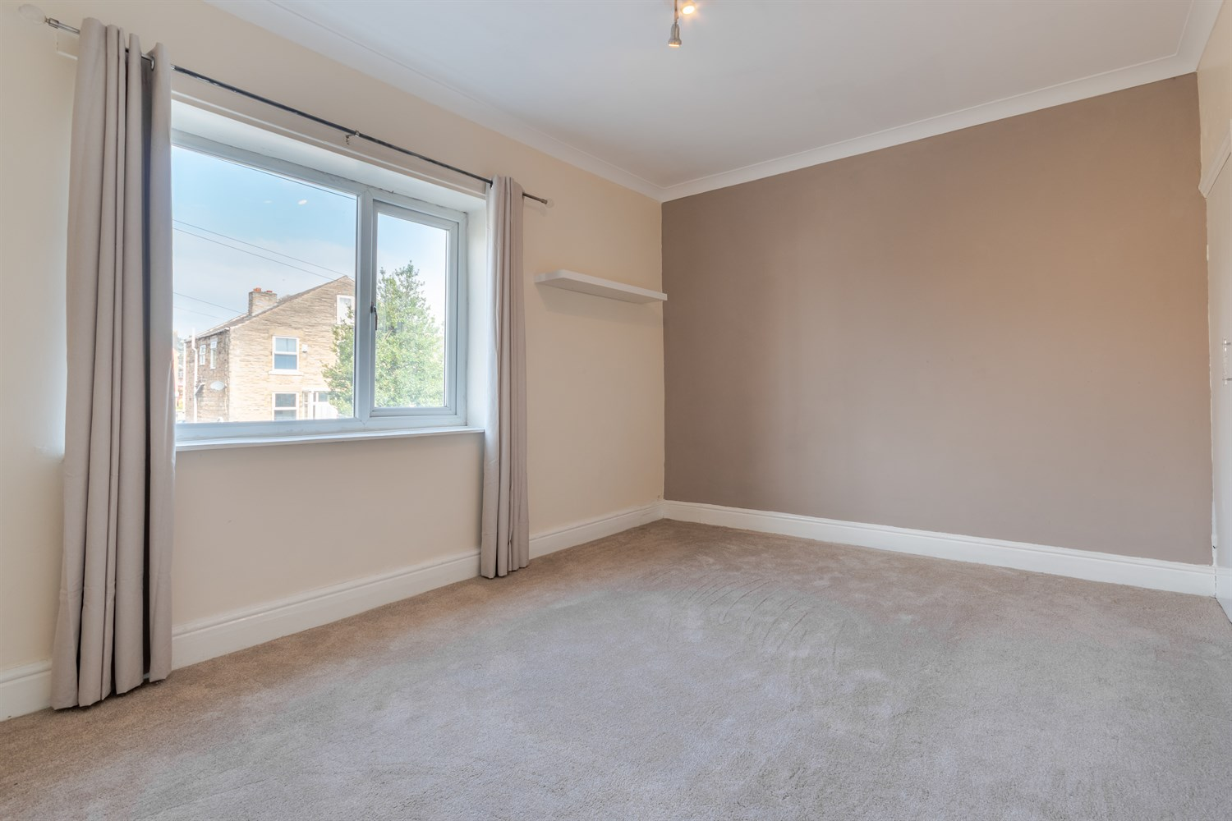

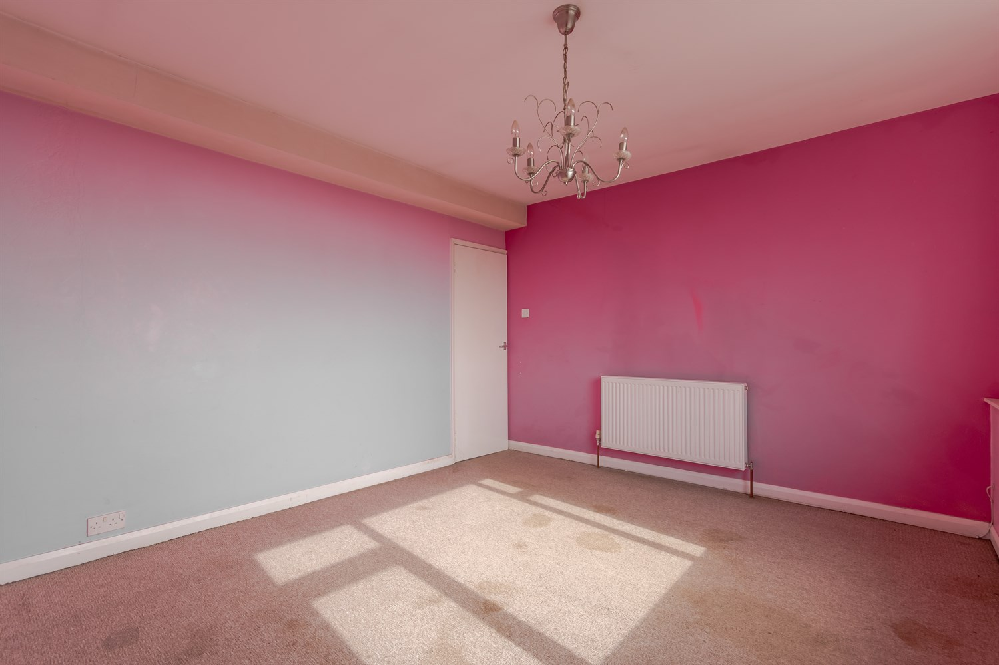

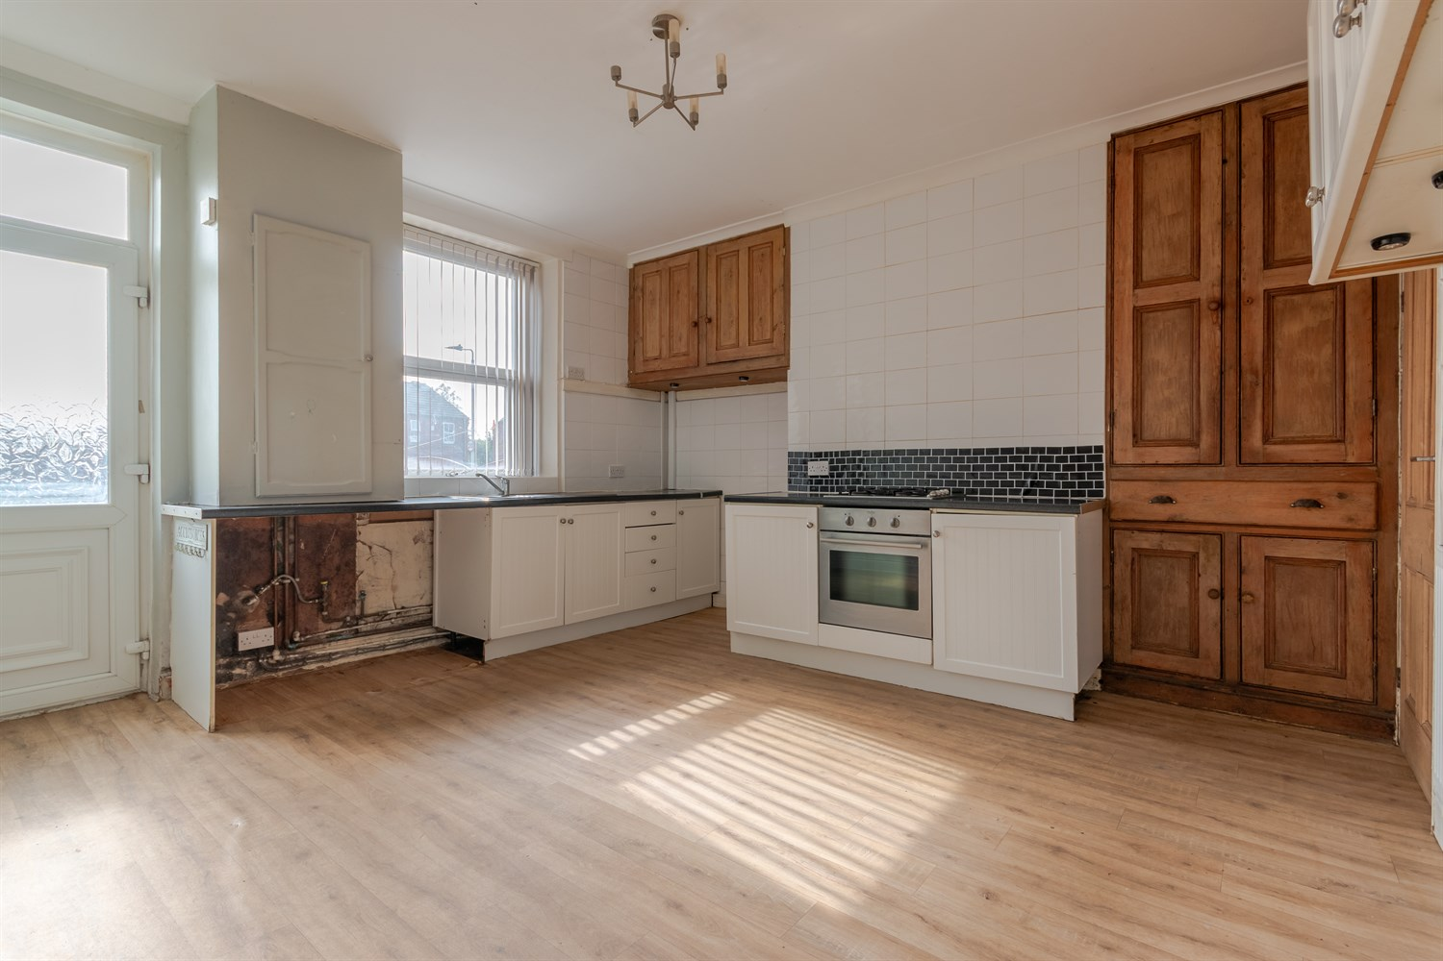

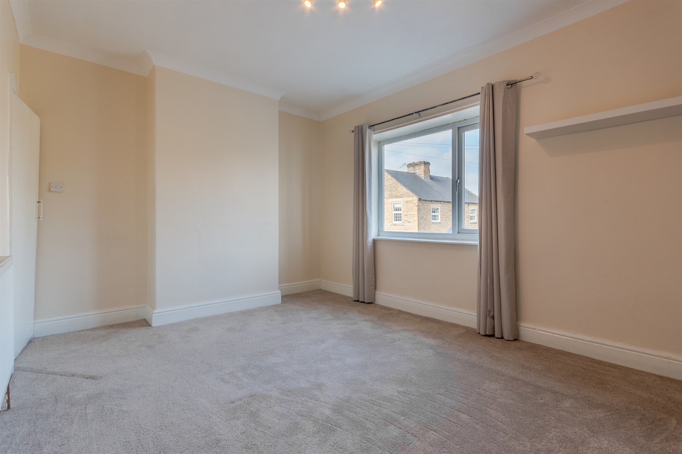

|  |
| --- |
| **Lounge 4.36m (14'4) x 3.34m (10'11)**  Via front entrance door. uPVC double glazed window to front. Two gas central heating radiators. Electric fire to chimney breast. |
| **Kitchen/Diner 4.36m (14'4) x 4.28m (14'1)**  Fitted with a range of wall, base and drawer units with worktops over. Integrated electric oven with 4-ring gas hob over. 1.5 bowl stainless steel sink with mixer tap and drainer. uPVC double glazed window and door to rear. |
| **Cellar**  Useful for storage. |
| **Bedroom 1 4.36m (14'4) x 3.34m (10'11)**  Double bedroom with uPVC double glazed window to front. Gas central heating radiator. Store cupboard. |
| **Bedroom 2 2.78m (9'1) x 3.4m (11'2)**  Second double bedroom with uPVC double glazed window to rear. Gas central heating radiator. Store cupboard. |
| **Bathroom**  Fitted with a three piece suite comprising; bath with shower over, WC and wash hand basin. Part tiled walls. uPVC double glazed window. |
| **Bedroom 3 3.98m (13'1) x 4.53m (14'10)**  Double bedroom with uPVC double glazed window to front. Gas central heating radiator. |
| **Bedroom 4 3.98m (13'1) x 3.55m (11'8)**  Double bedroom with uPVC double glazed window to rear. Gas central heating radiator. |
| **Outside**  To the front of the property is a courtyard style garden. To the rear is off street parking. |

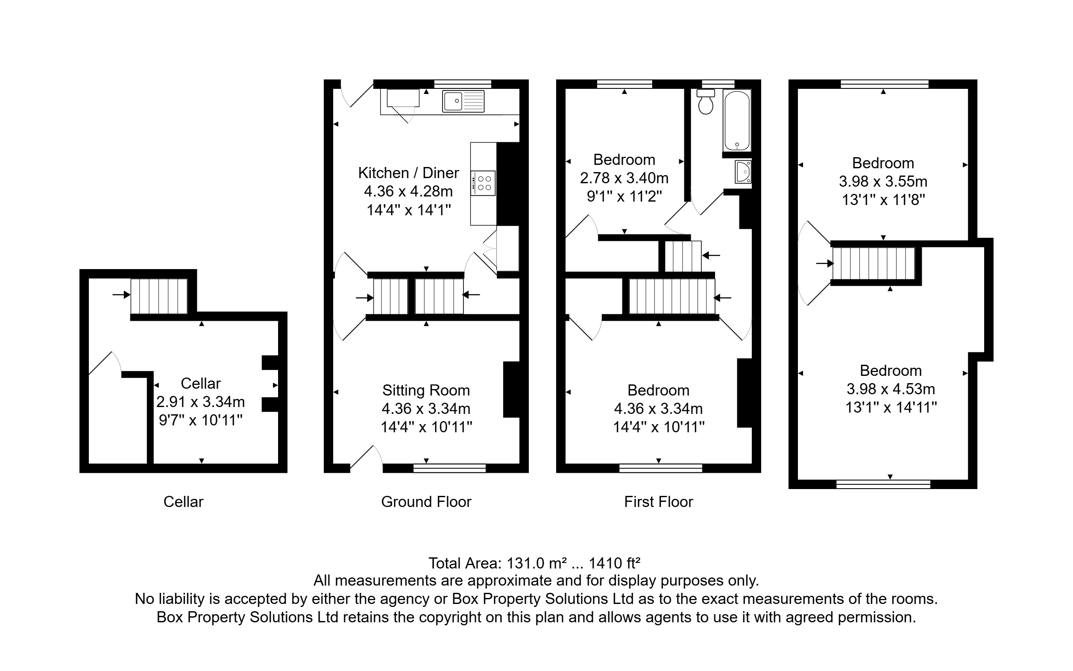

|  |  |
| --- | --- |
| These particulars are intended to give a fair description of the property, but their accuracy cannot be guaranteed, and they do not constitute an offer of contract. Intending purchasers must rely on their own inspection of the property. None of the above appliances/services have been tested by ourselves. We recommend purchasers arrange for a qualified person to check all appliances/services before legal commitment.  **Property Ref:** 6979  **For more information, please contact**  0113 258 1150 **|** [sales@adairpaxton.co.uk](mailto:sales@adairpaxton.co.uk) **|** www.adairpaxton.co.uk |  |