

**0113 258 1150**

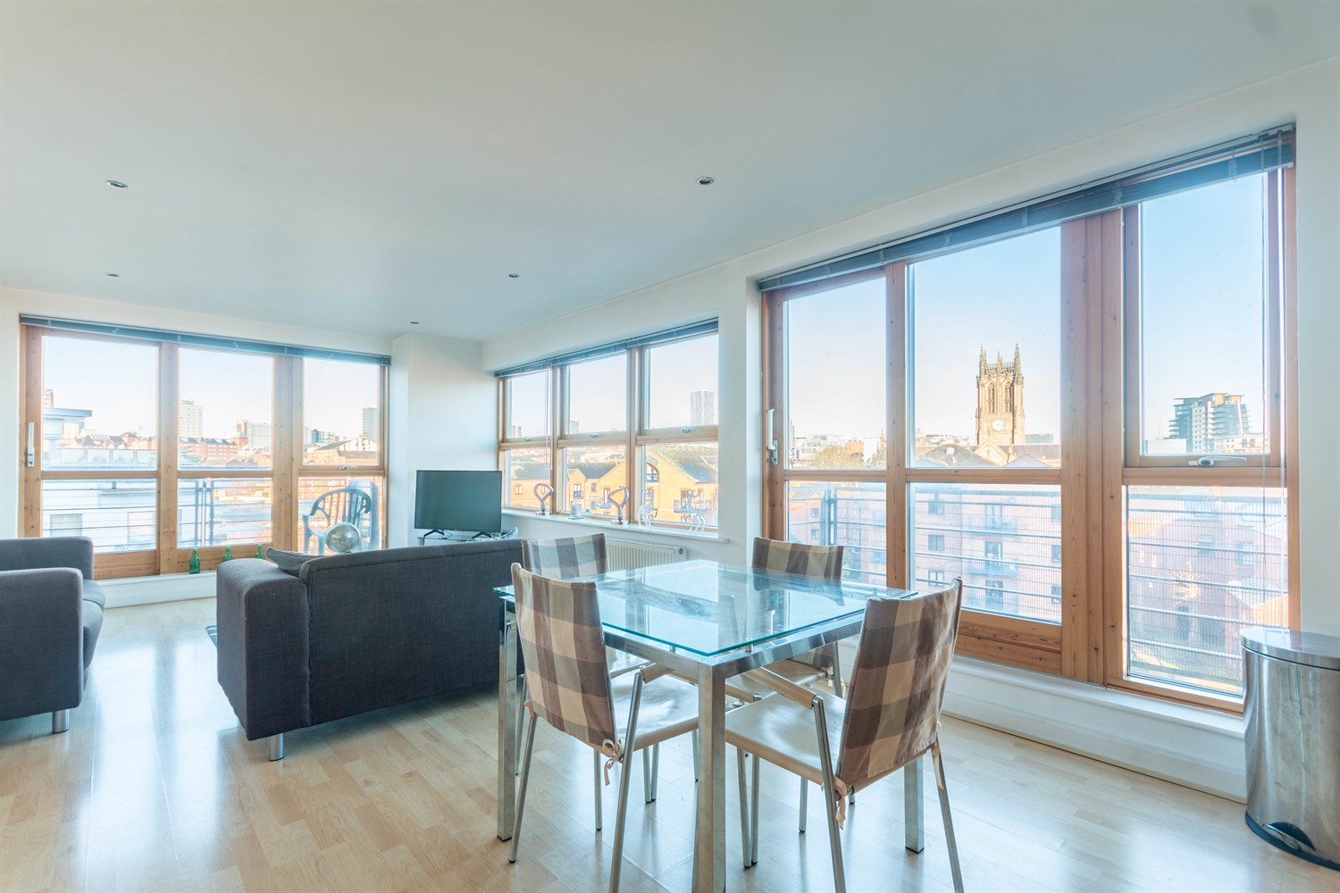



**For Sale £325,000.00**

**35 Regents Quay, Brewery Wharf, Leeds**

**TWO BEDROOM, TWO BATHROOM FOURTH FLOOR APARTMENT with VIEWS OVER THE RIVER***NO ONWARD CHAIN*** A truly stunning riverside apartment with uninterrupted views of the River Aire available at Brewery Wharf, Leeds City Centre. The property is immaculate throughout with an open plan living room and kitchen, two double bedrooms, two bathrooms and two balconies. Secure allocated parking is included. The development benefits from on site concierge, private residents gym and immaculate communal grounds. An internal viewing is highly recommended to appreciate the accommodation on offer.

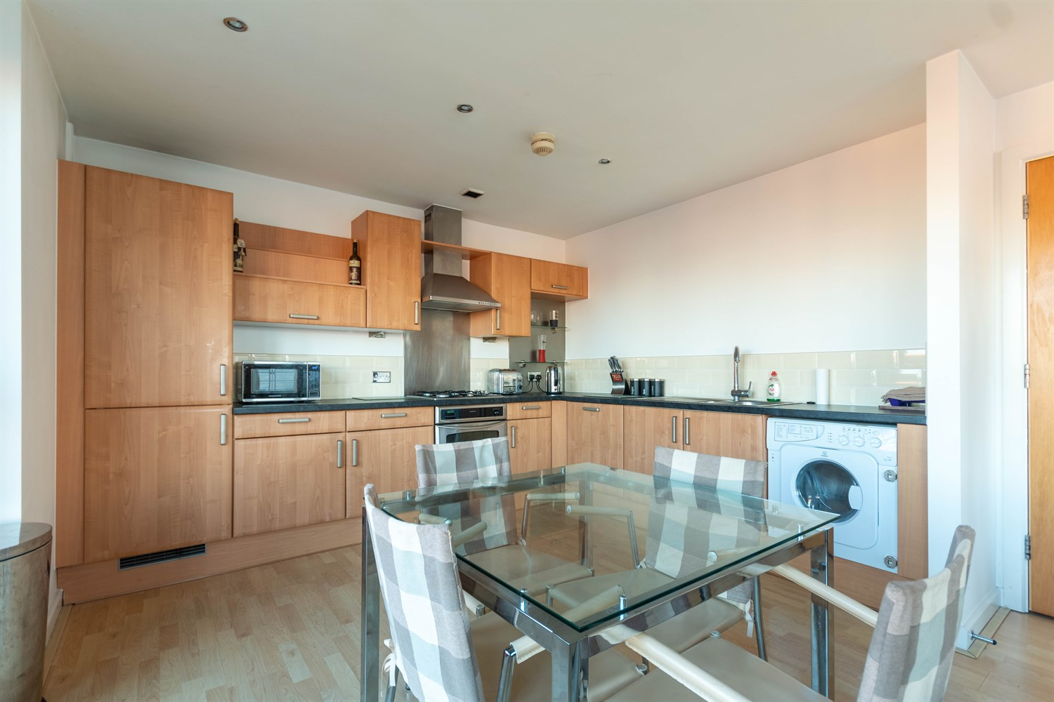

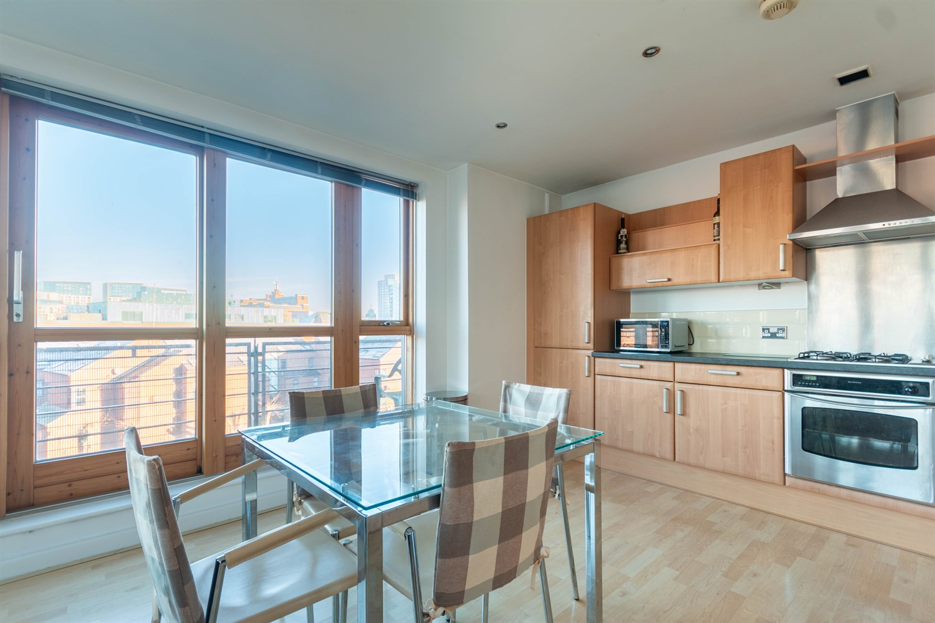

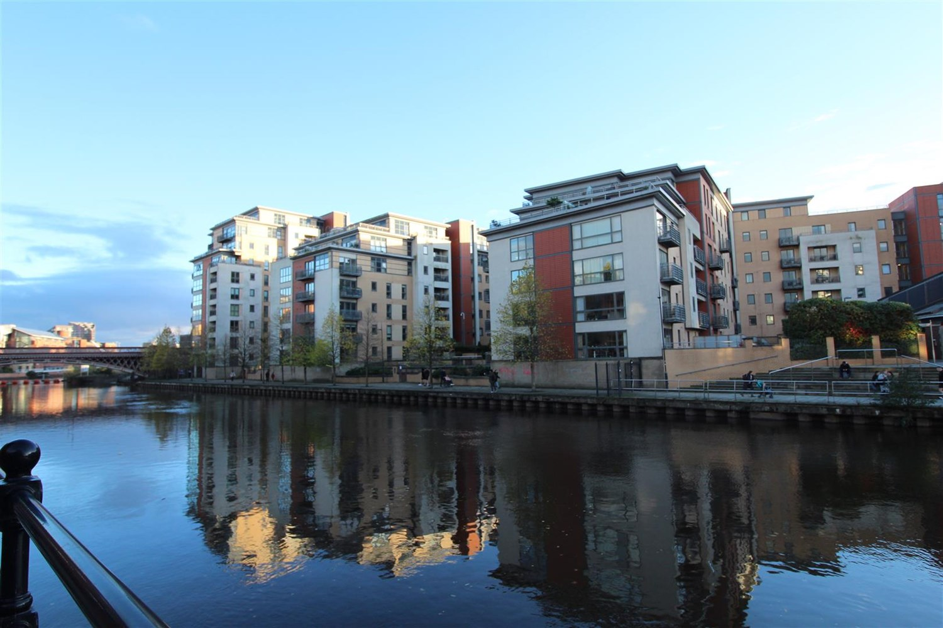

2 Bathroom(s)

1 Reception(s)

2 Bedroom(s)

00

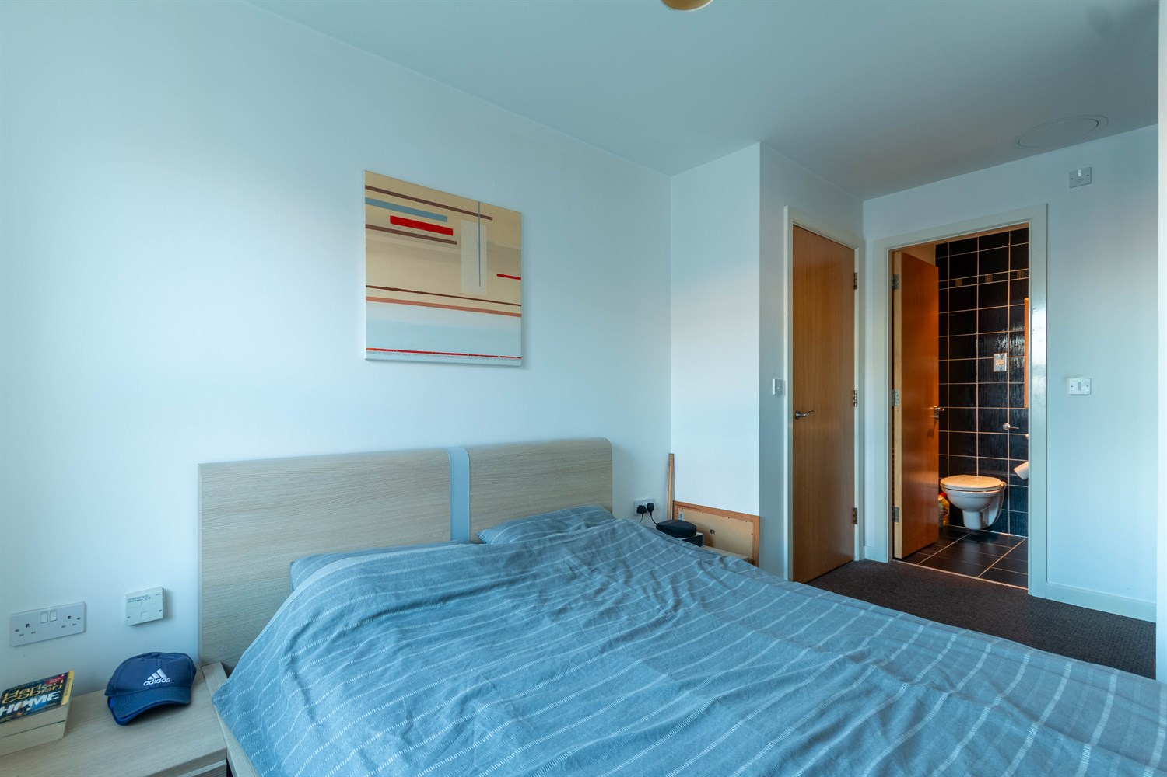

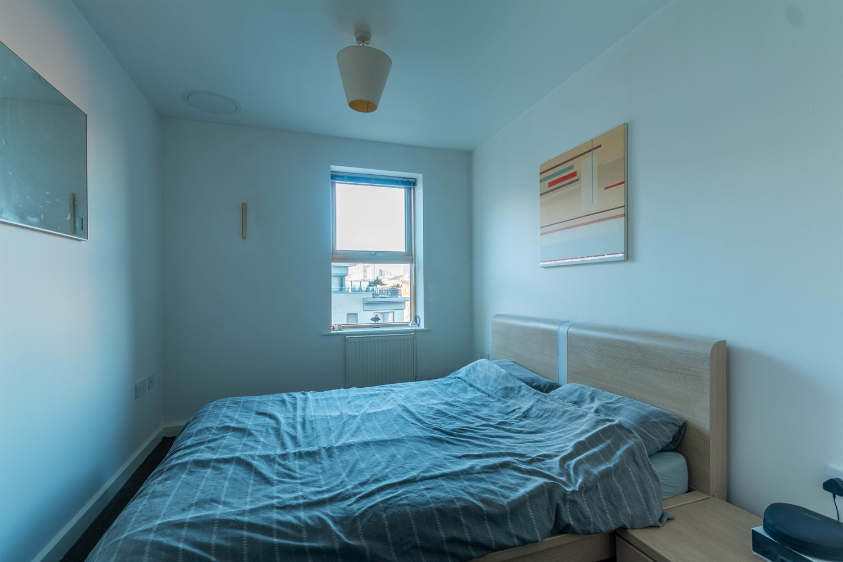

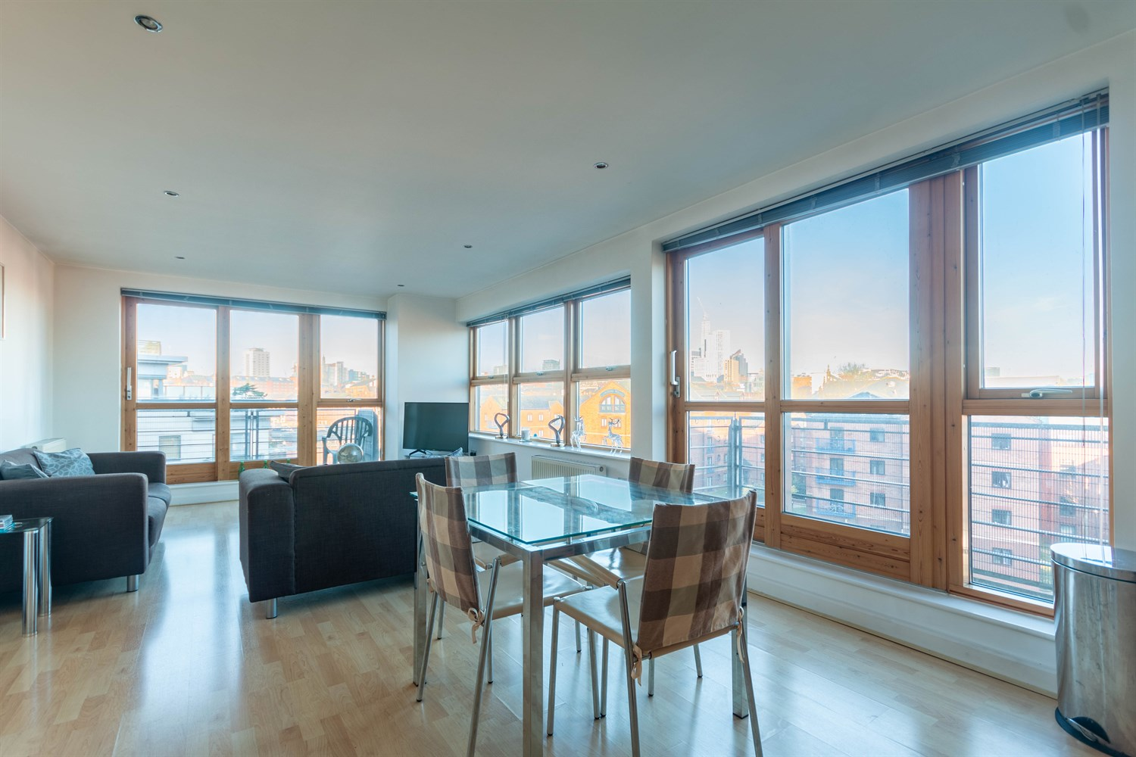

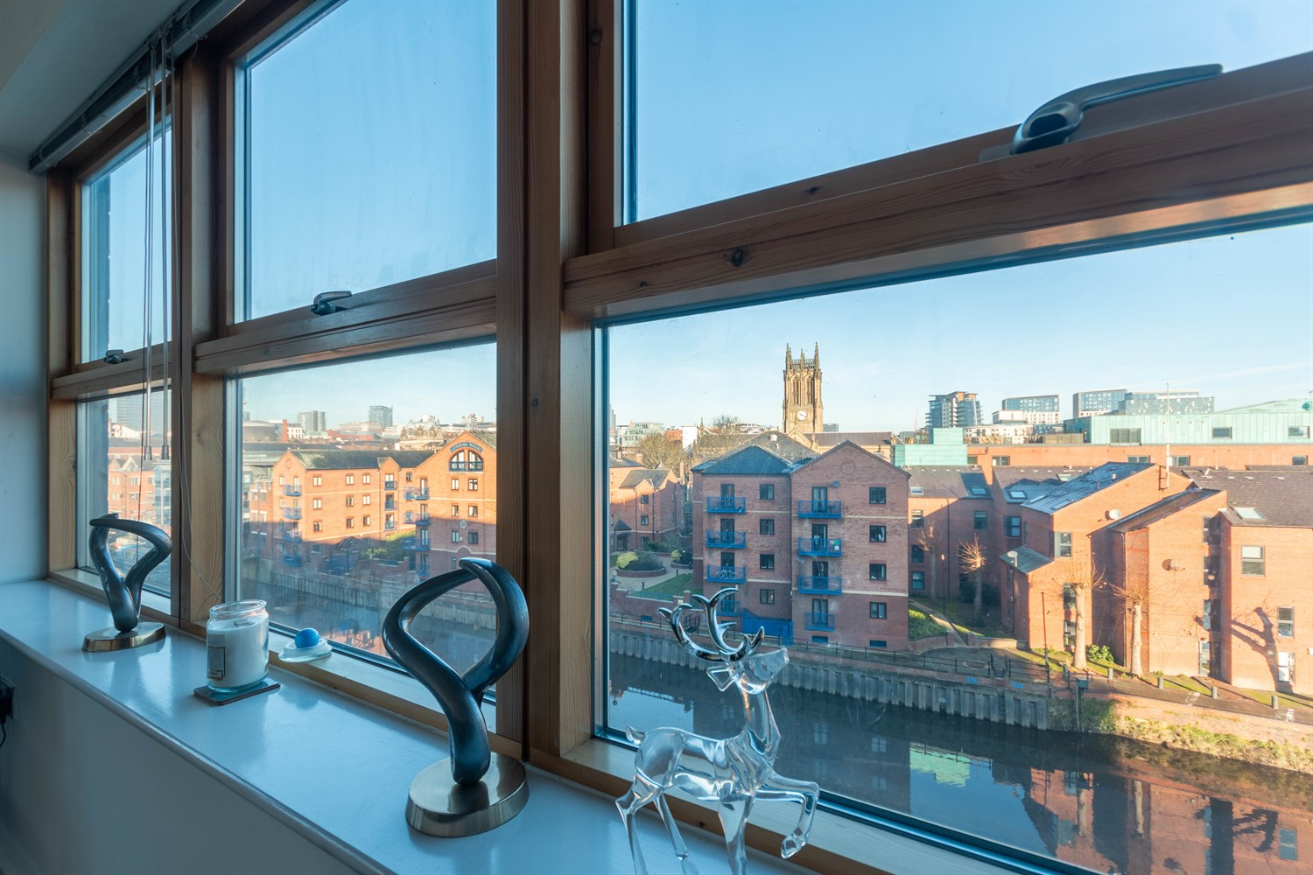

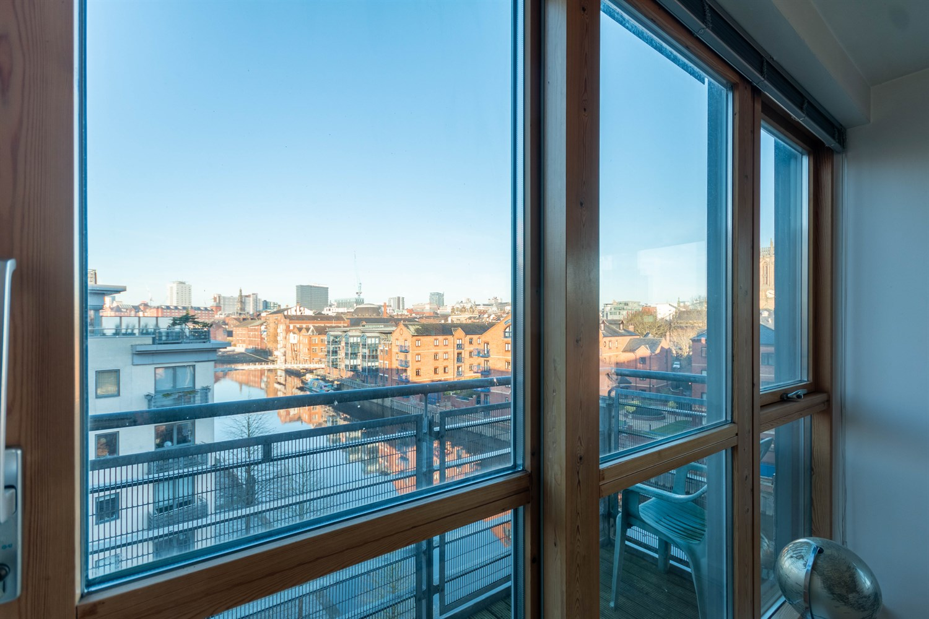

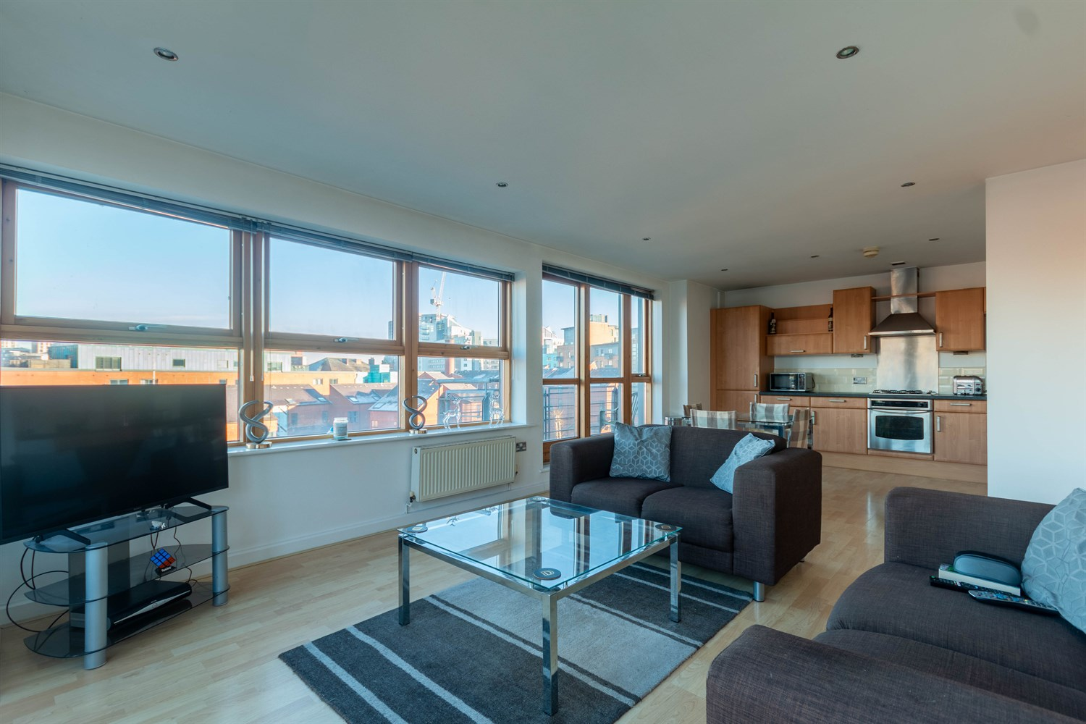

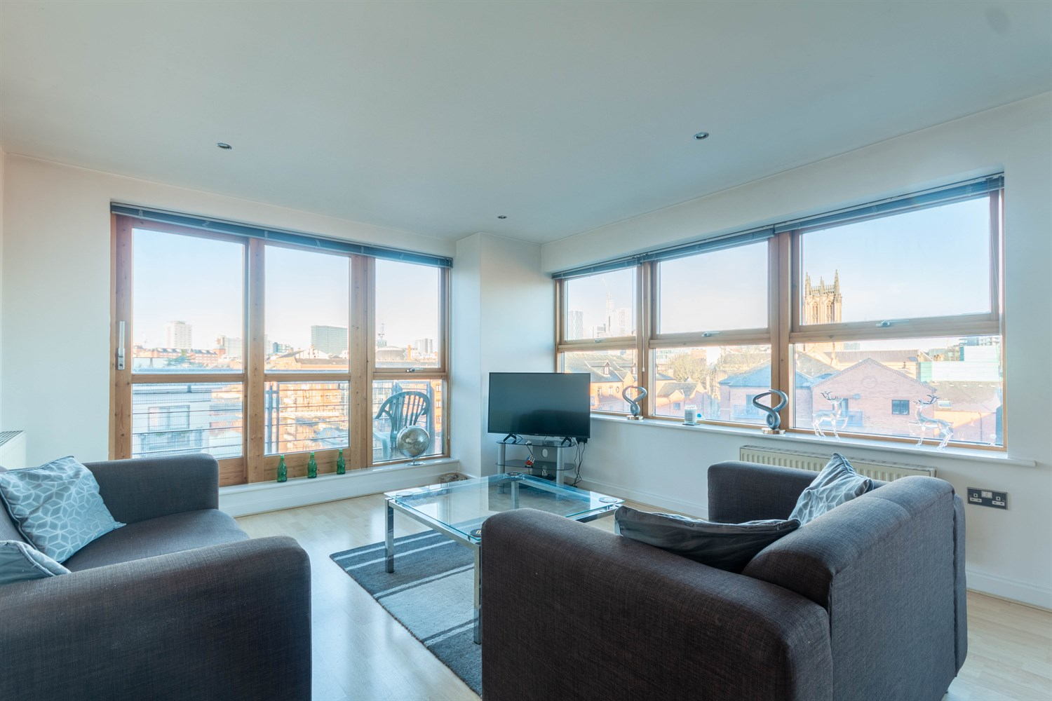

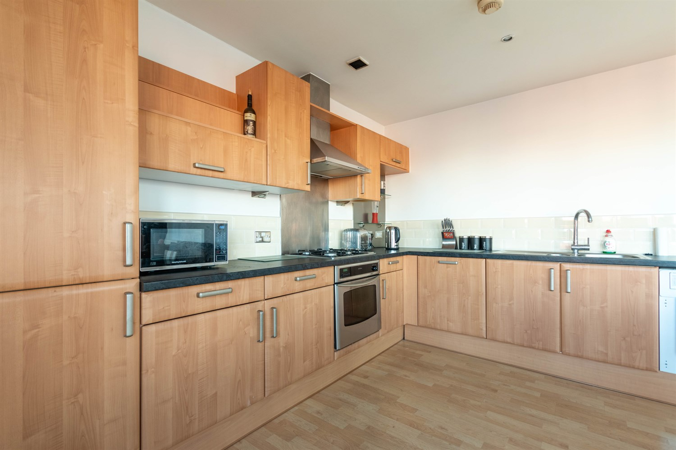

|  |
| --- |
| **Communal Hallway**  Via front entrance door. Stairs and lift to all floors. |
| **Private Hallway**  Via front entrance door. Secure entry phone system. Storage cupboard. |
| **Open Plan Living Room/Kitchen 4.07m (13'4) x 8.08m (26'6)**  Good sized open plan living area with floor to ceiling windows and two balconies with panoramic views overlooking the River Aire and communal gardens. The room has laminate flooring throughout, two gas central heating radiators and inset ceiling spotlights. |
| **Kitchen**  This open plan kitchen has a range of fitted base and wall units and integrated appliances include; integrated fridge/freezer, dishwasher, washing machine. Electric oven with four ring gas hob and extractor above. Stainless steel sink with mixer tap and drainer. |
| **Bedroom One 2.59m (8'6) x 4.24m (13'11)**  Double bedroom with double glazed window. Gas central heating radiator. |
| **En-Suite Shower Room**  Three-piece suite in white comprising integrated W.C, basin and shower with glass door. Black tiled walls. Stainless steel towel rail. Recessed mirror shelving unit. Shaver point. |
| **Bedroom Two 2.87m (9'5) x 3.43m (11'3)**  Second double bedroom with double glazed window. Gas central heating radiator. |
| **Bathroom m (') x 3.43m (11'3)**  White three piece suite comprising integrated W.C basin and bath with shower over and glass screen. Part-tiled walls. Stainless steel towel rail. Recessed mirror shelving unit. Shaver point. |
| **Parking**  Secure Underground parking. |
| **Service Charge**  £843.24 quarterly  Communal electric charge £418.32 per annum. |
| **Tenure**  Leasehold - 999 years from 2002 Ground rent - £315.98 per annum (reviewed every 20 years - next review date 2042) |
| **Garage** |

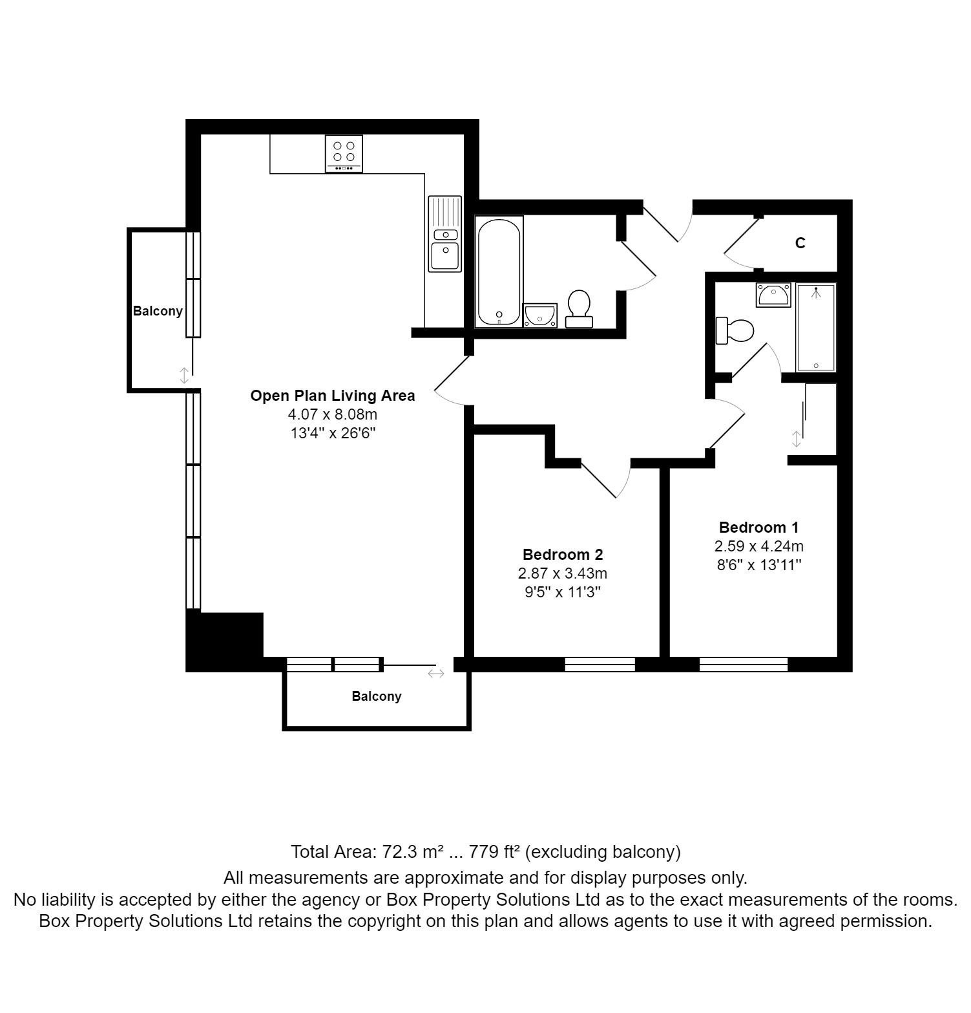

|  |  |
| --- | --- |
| These particulars are intended to give a fair description of the property, but their accuracy cannot be guaranteed, and they do not constitute an offer of contract. Intending purchasers must rely on their own inspection of the property. None of the above appliances/services have been tested by ourselves. We recommend purchasers arrange for a qualified person to check all appliances/services before legal commitment.  **Property Ref:** 5061  **For more information, please contact**  0113 258 1150 **|** [sales@adairpaxton.co.uk](mailto:sales@adairpaxton.co.uk) **|** www.adairpaxton.co.uk |  |