

**0113 258 1150**

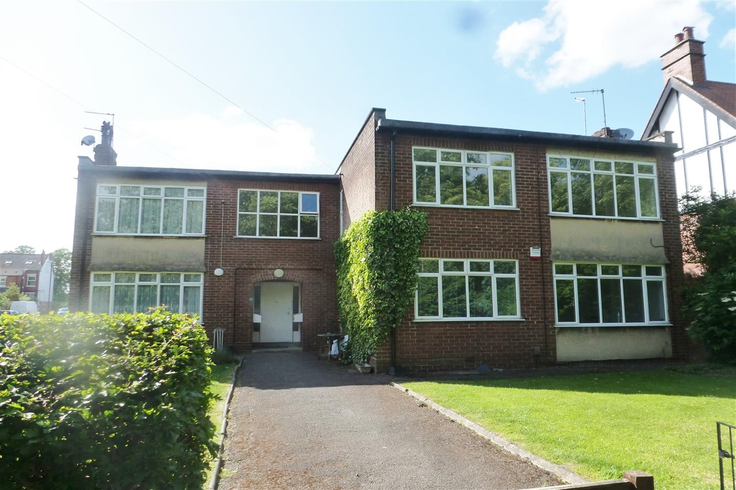



**Available to let £825.00pcm**

**Shaftesbury Avenue, LS8**

Adair Paxton are delighted to offer this spacious TWO DOUBLE BEDROOM ground floor flat in this sought after location. The property is close to the excellent shops, restaurants and amenities of Street Lane and nearby Roundhay Park and benefits from gas central heating, double glazing and suited to the professional or retired couple. Comprising; Hallway and spacious Lounge, Two Double Bedrooms and Bathroom with shower over bath. UNFURNISHED. deposit £950. Available18th August. Due to the lease this property has a no pet policy. Council tax band B, EPC rating D.

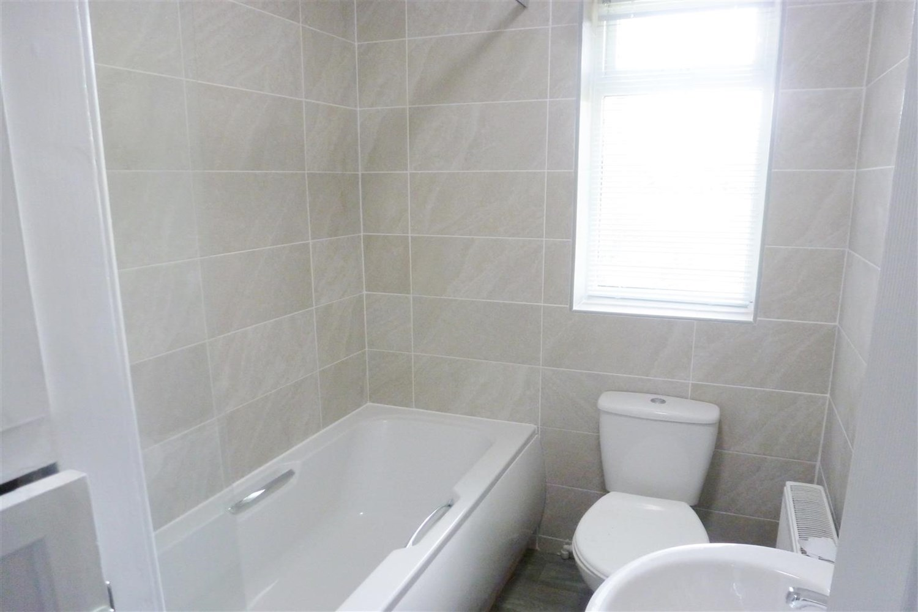

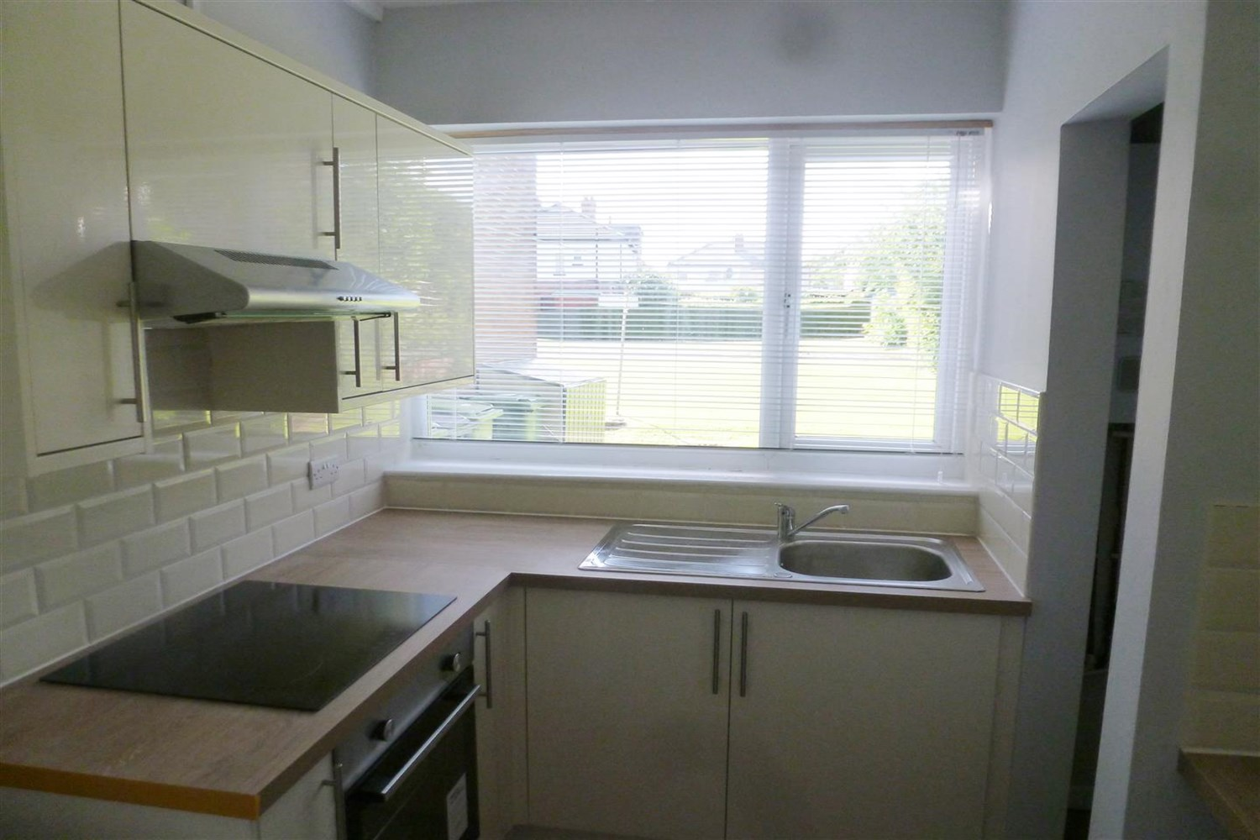

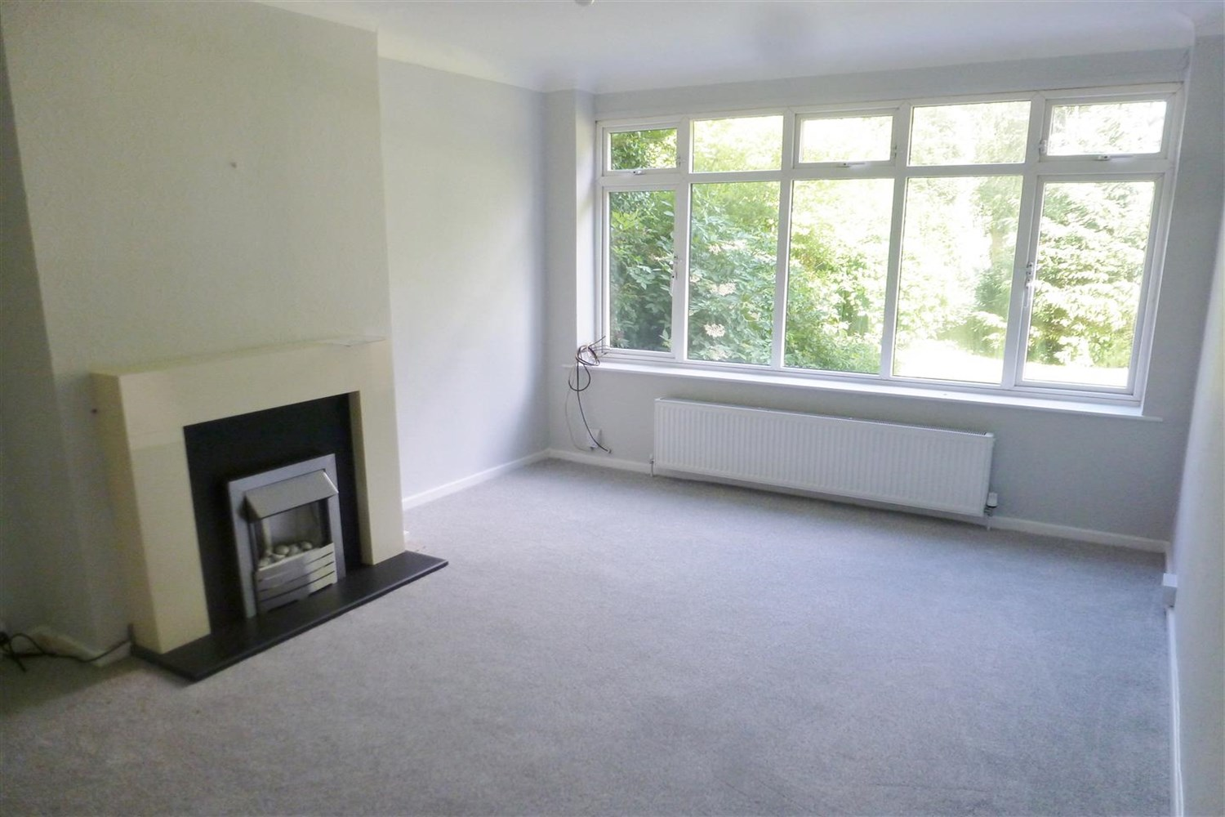

1 Bathroom(s)

1 Reception(s)

2 Bedroom(s)

00

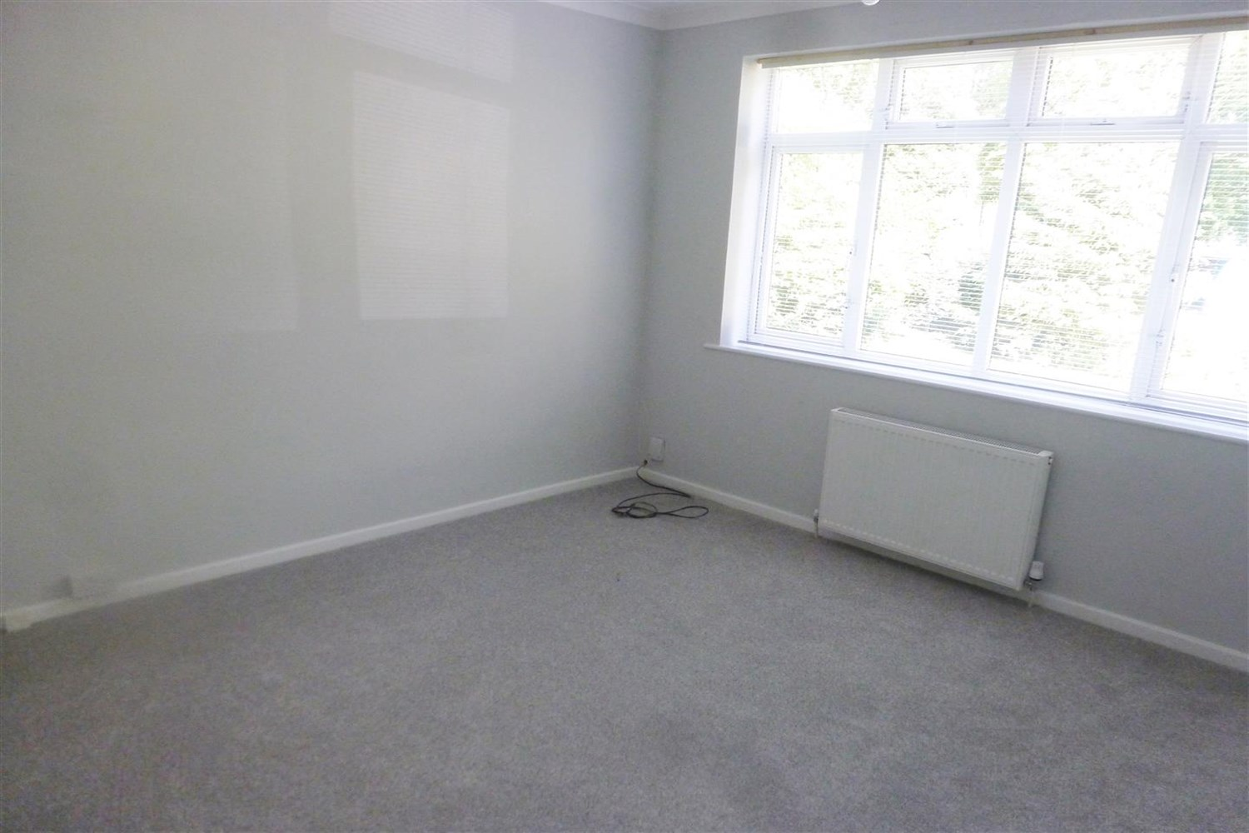

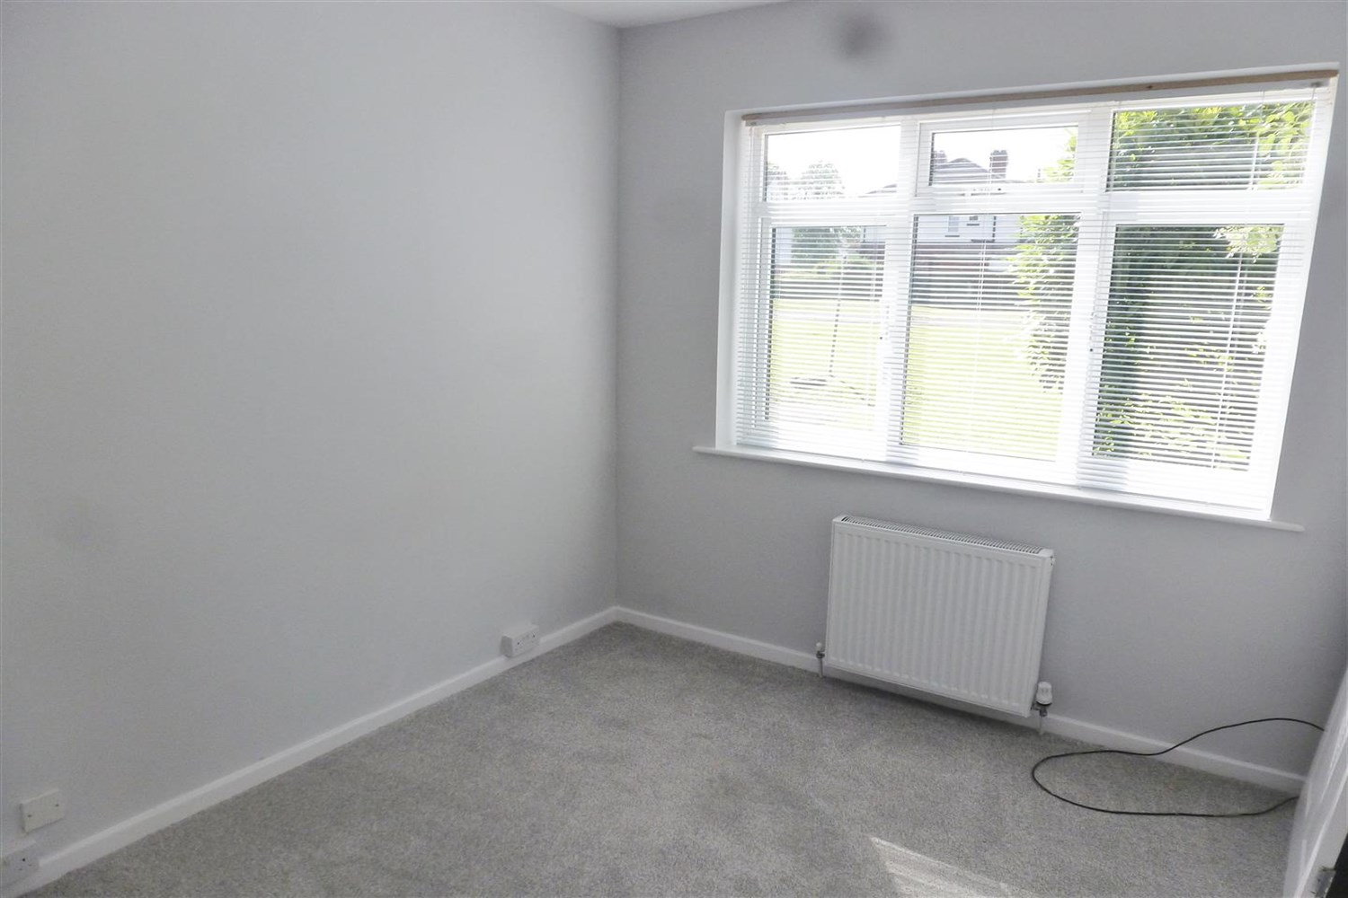

|  |
| --- |
| **Communal Entrance**  Communal entrance with stairs to the first floor. |
| **Living Room**  Light and airy lounge with gas fire and surround. large window to front overlooking the garden. |
| **Kitchen**  Fitted with a range of wall and base units with worktops over. large pantry style cupboard. Gas cooker, stainless steel sink and drainer. |
| **Bedroom 1**  Large light and airy bedroom with window to rear over looking the rear garden. |
| **Bedroom 2**  Large light and airy bedroom with window to rear over looking the rear garden. |
| **Bathroom**  Three piece bathroom suite with shower over bath, W/C and hand wash basin, tiled walls, window. |
| **Home Information**  SIX MONTH TENANCY ONLY. COUNCIL TAX BAND: B EPC Rating D  Leasehold property Broadband: Standard 4 Mbps 0.6 Mbps Good Superfast 68 Mbps 20 Mbps Good Ultrafast 1800 Mbps 220 Mbp  Mobile availability: EE Likely to have good coverage ,Three Likely to have good coverage, O2 Likely to have good coverage Vodafone Likely to have good coverage.  Gas and Electric mains supply, water on mains supply. |

|  |  |
| --- | --- |
| These particulars are intended to give a fair description of the property, but their accuracy cannot be guaranteed, and they do not constitute an offer of contract. Intending purchasers must rely on their own inspection of the property. None of the above appliances/services have been tested by ourselves. We recommend purchasers arrange for a qualified person to check all appliances/services before legal commitment.  **Property Ref:** 6814  **For more information, please contact**  0113 258 1150 **|** [lettings@adairpaxton.co.uk](mailto:lettings@adairpaxton.co.uk) **|** www.adairpaxton.co.uk |  |