

Stoneythorpe, Horsforth
For Sale £375,000

***WELL PRESENTED THREE BEDROOM SEMI-DETACHED HOUSE IN CENTRAL HORSFORTH LOCATION*** This delightful semi-detached house sits in a sought after Horsforth location; ideal for access to the amenities of both Town Street and New Road Side and in close proximity to Horsforth High School. The property is presented to an immaculate standard and briefly comprises; entrance hall, lounge and kitchen/diner to the ground floor. To the first floor there are two double bedrooms, a study and a house bathroom. To the third floor is a third double bedroom. Externally, the property has a driveway leading to a detached garage. An enclosed garden to the rear and lawned garden to the front. The property benefits from gas central heating, uPVC double glazing and an EV CHARGING POINT. The property is within walking distance of Horsforth Park, the train station, local shopping facilities, bars and restaurants. An early internal viewing is highly recommended to appreciate the accommodation on offer.
0113 258 1150
0800 000 000
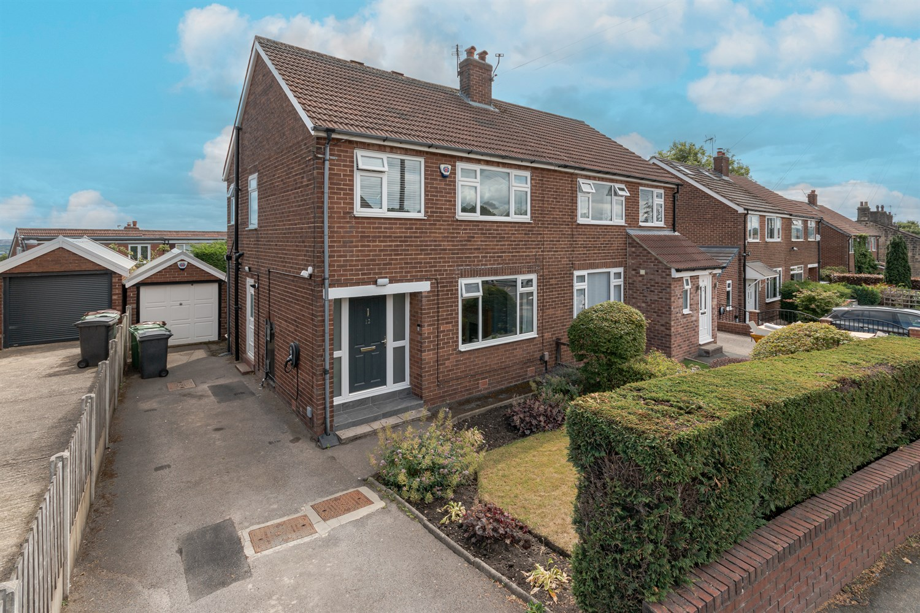
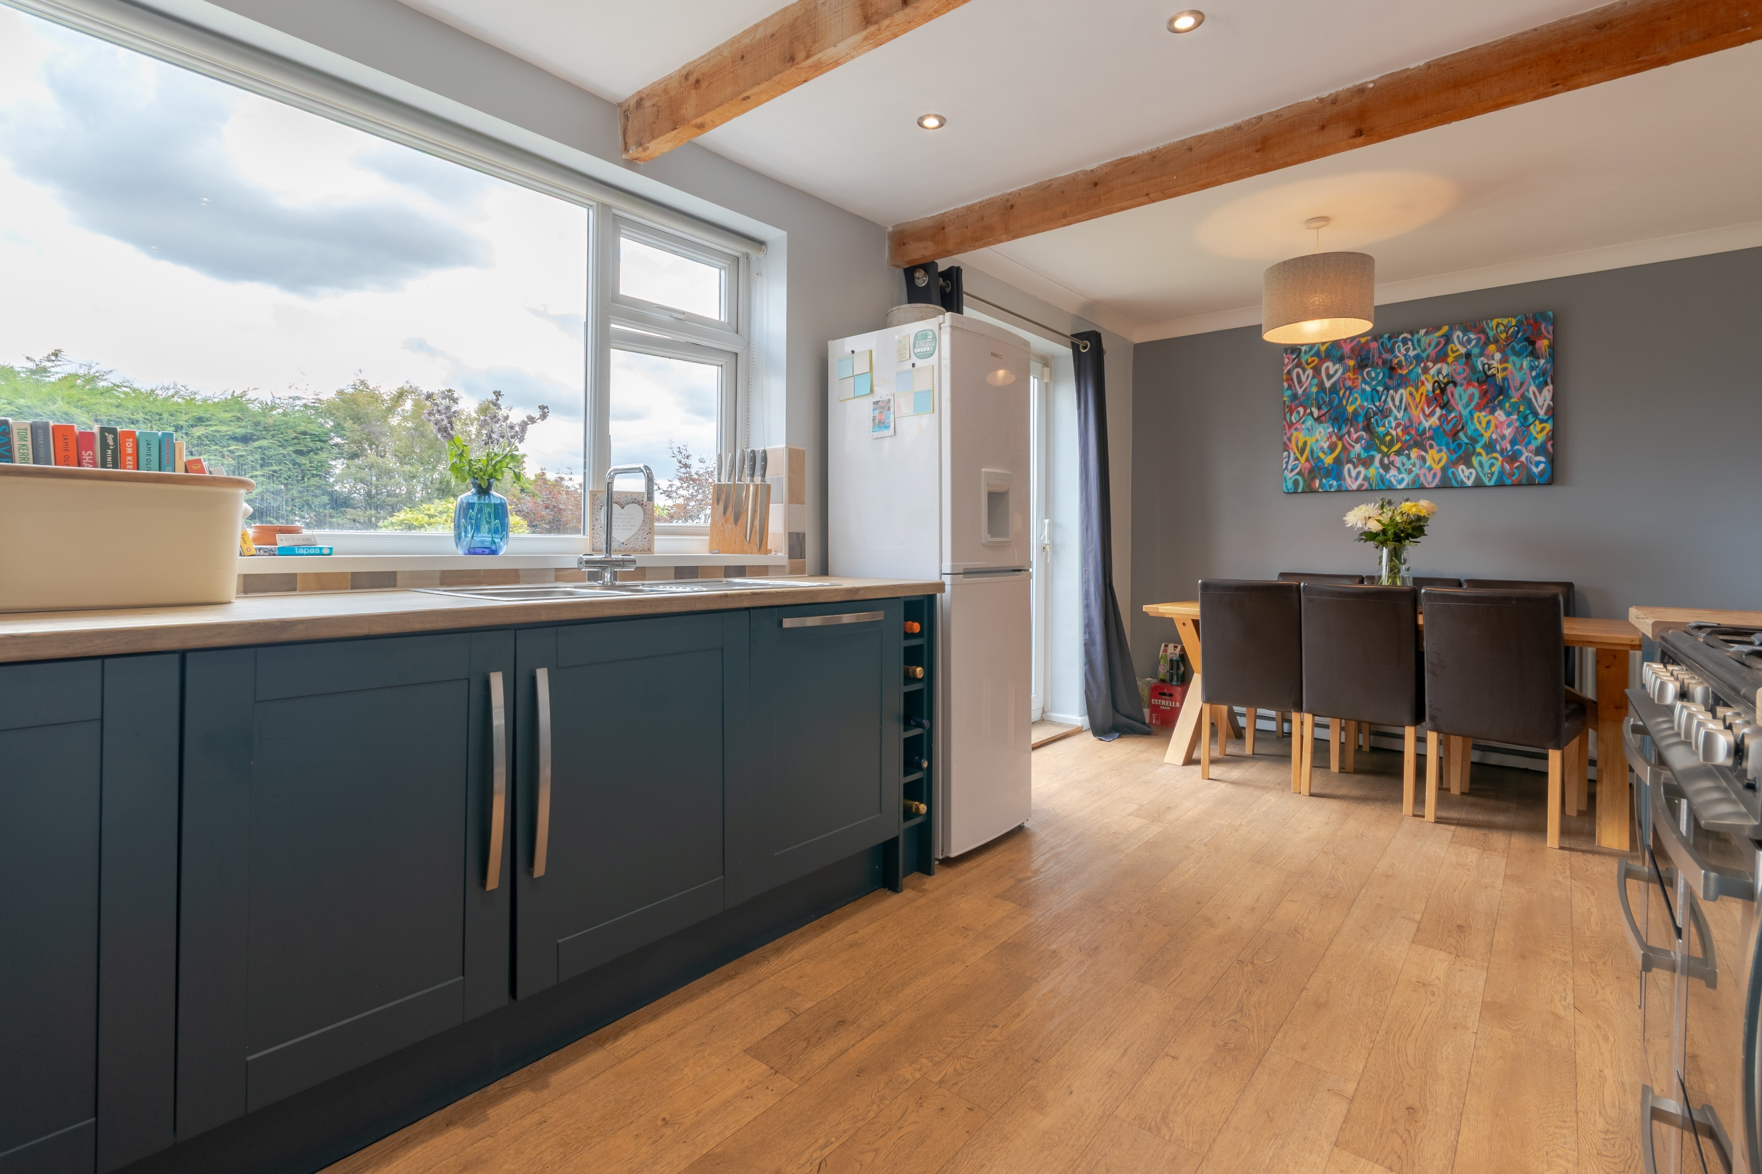
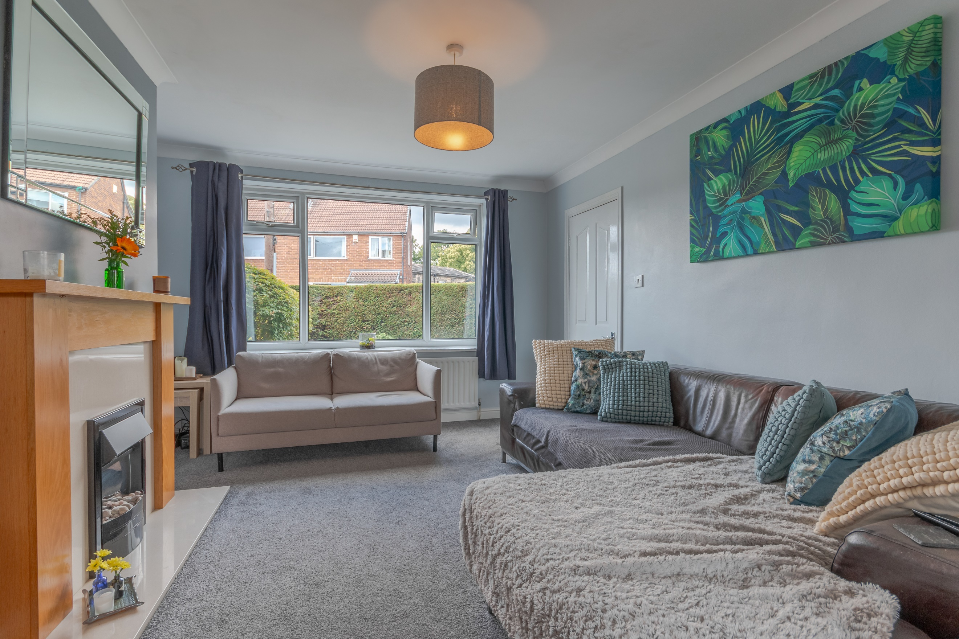
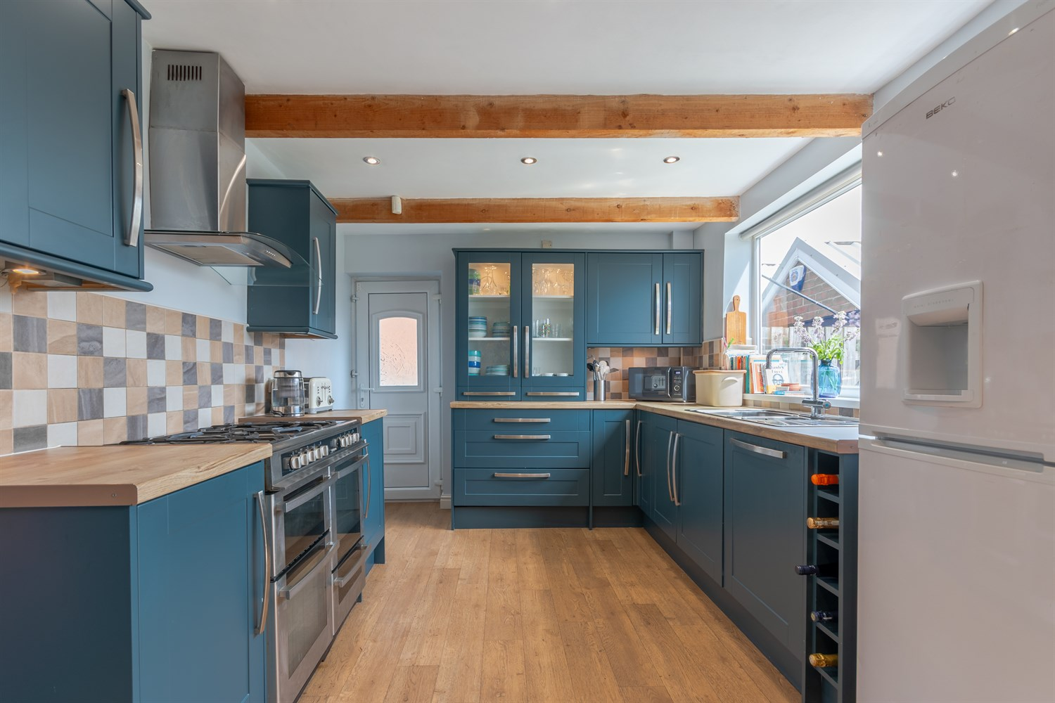
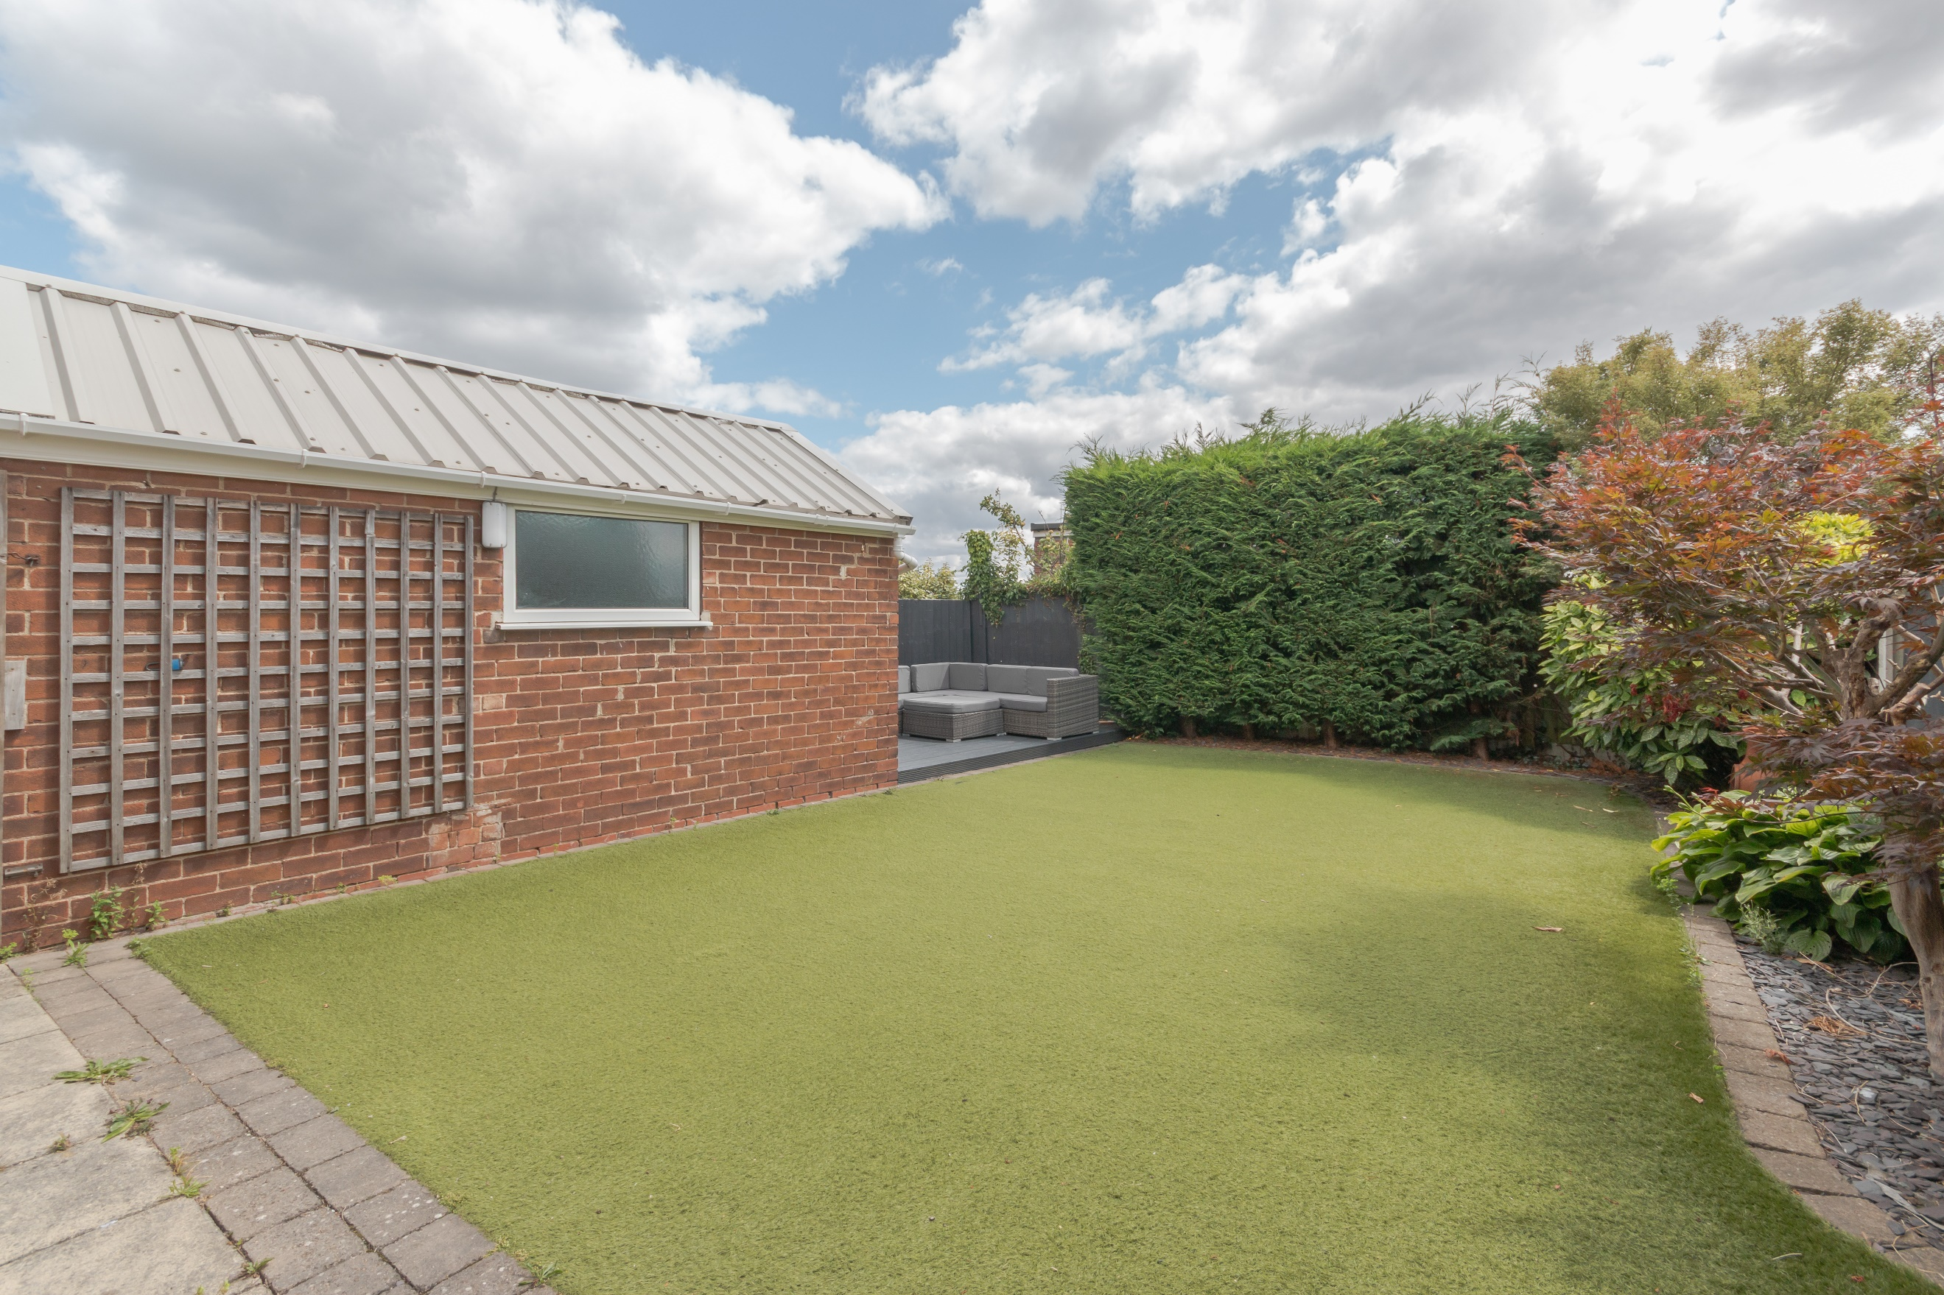
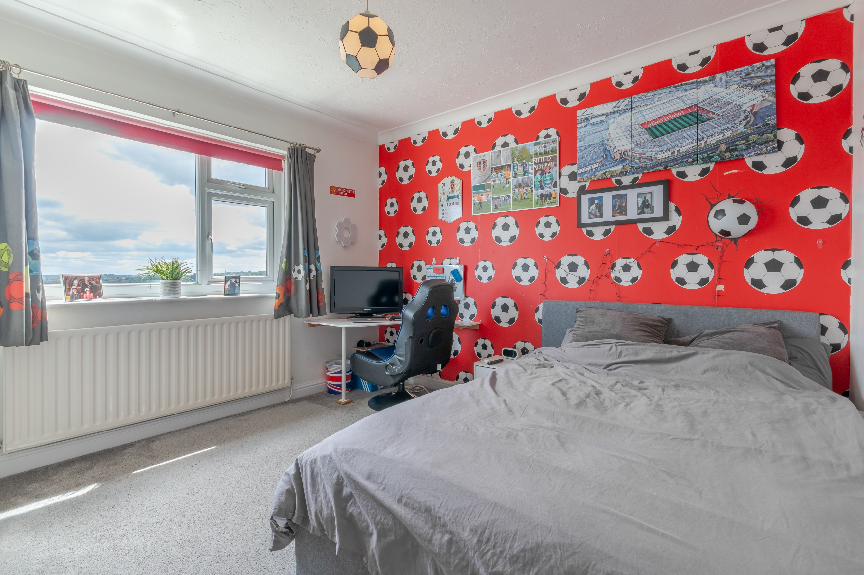
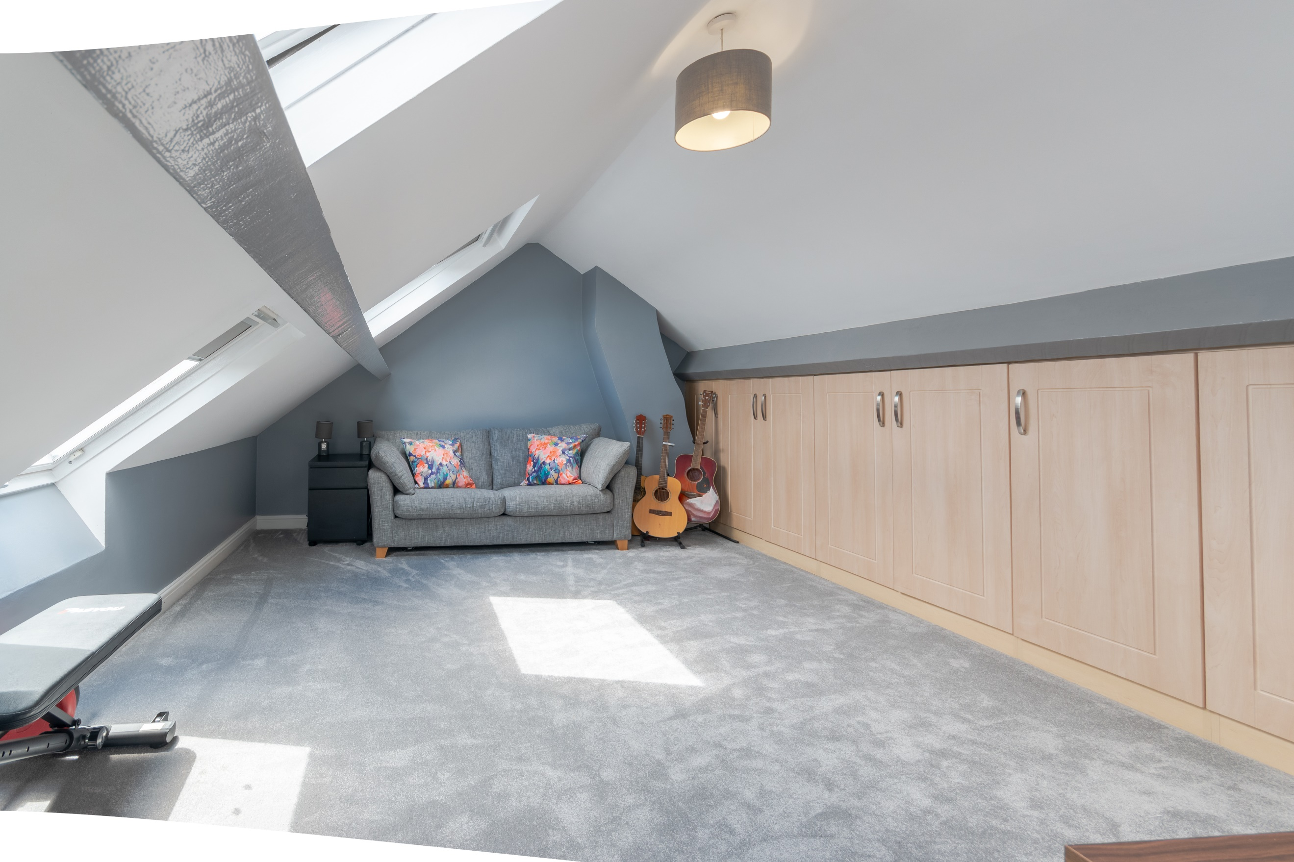
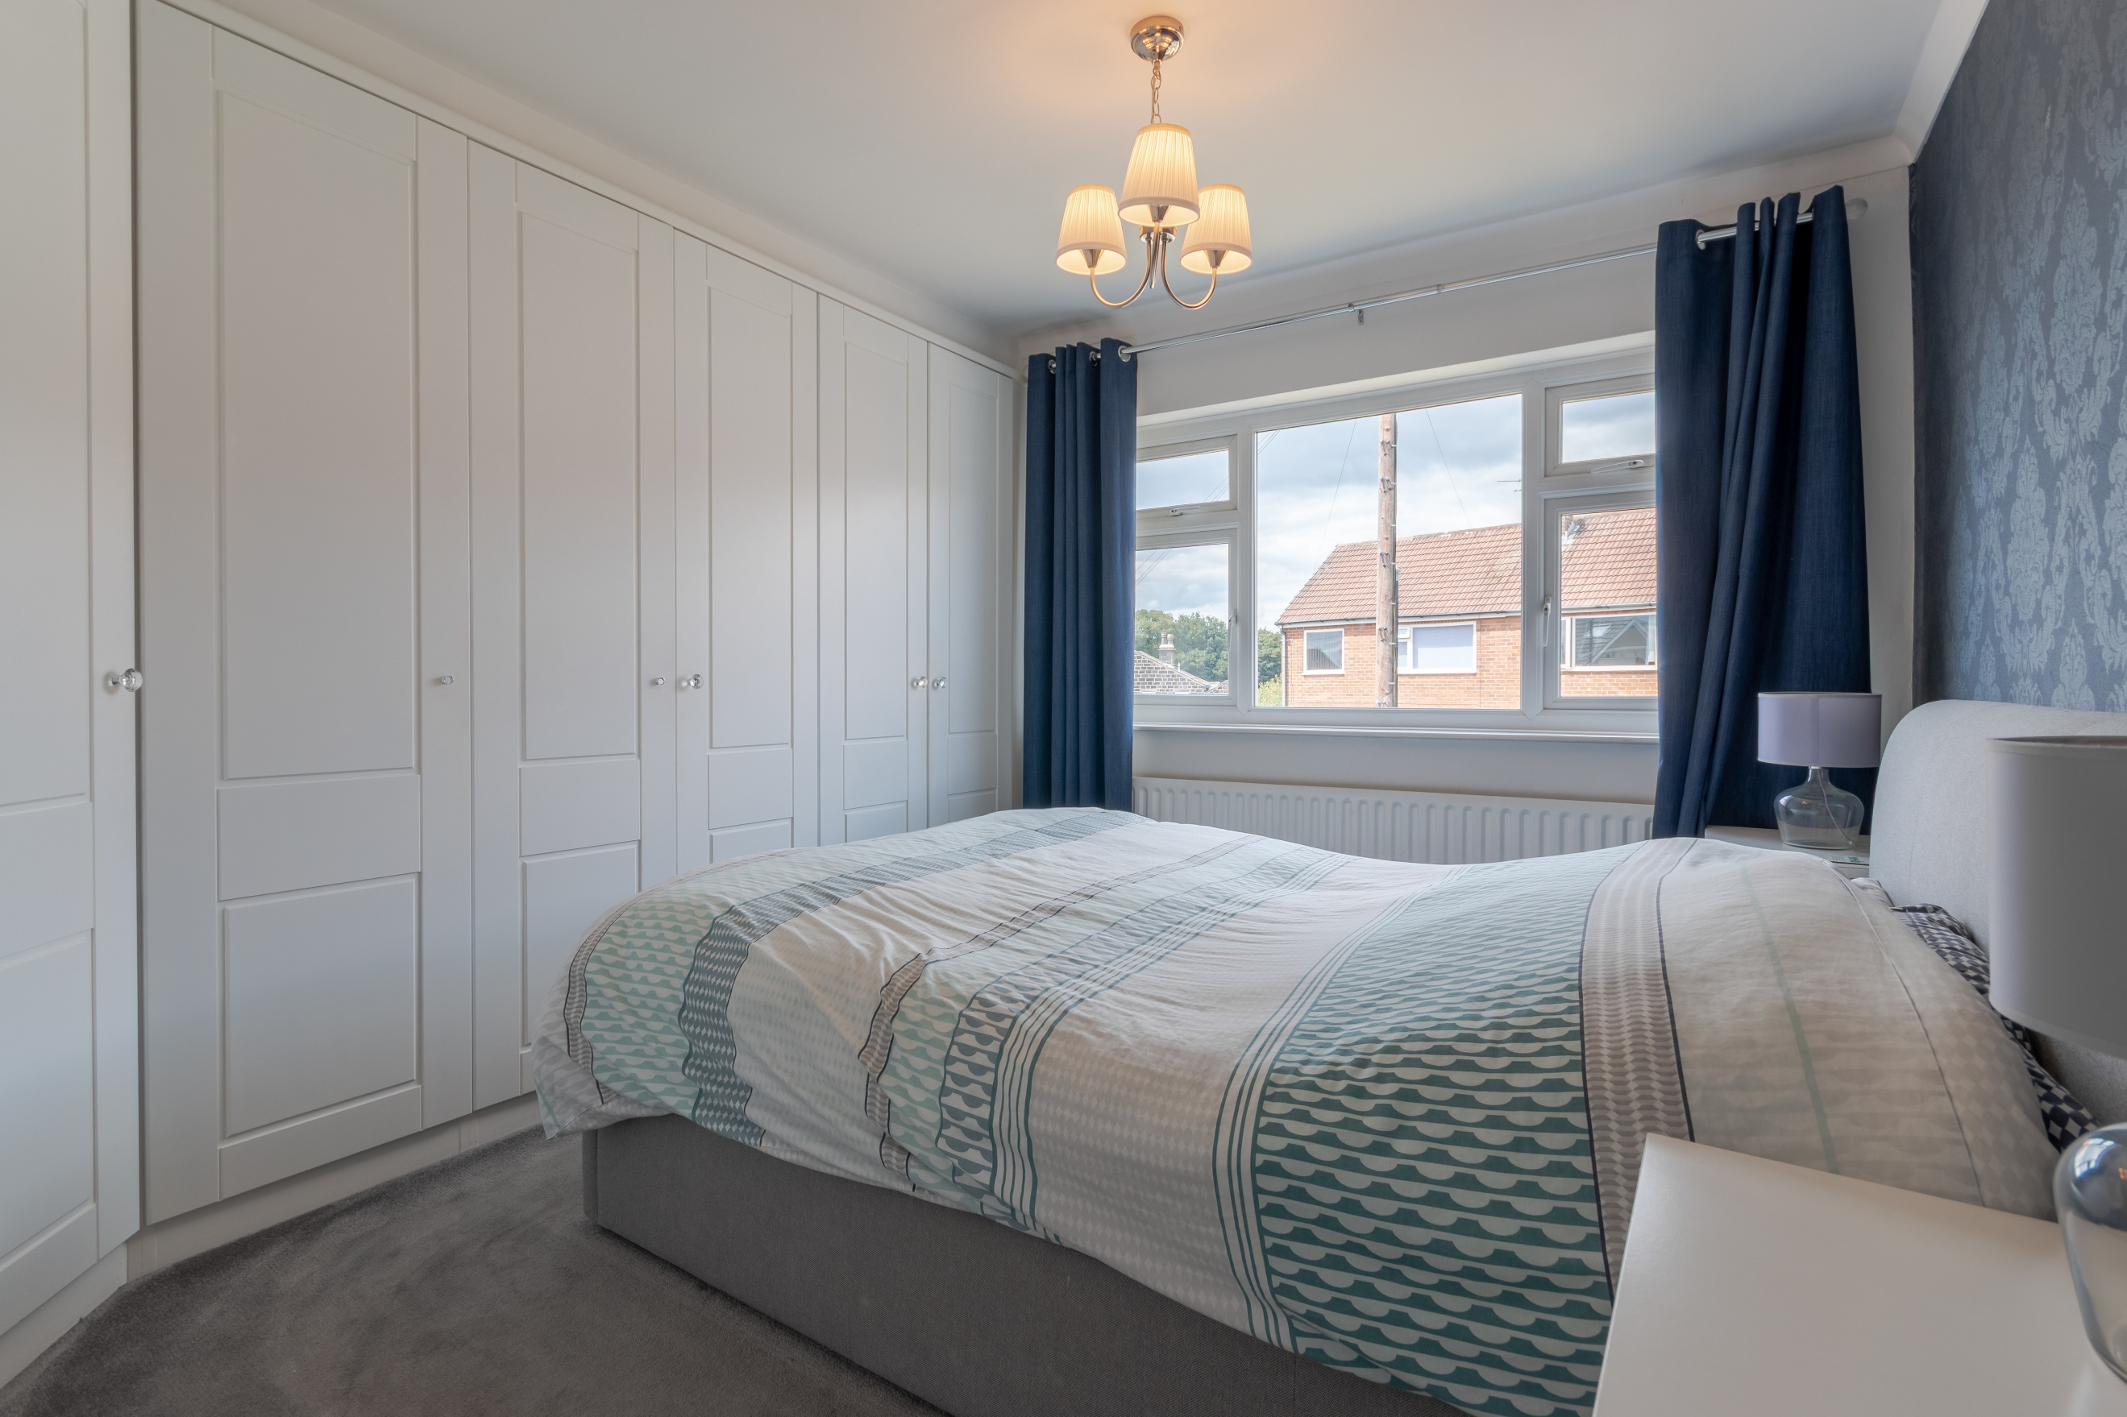
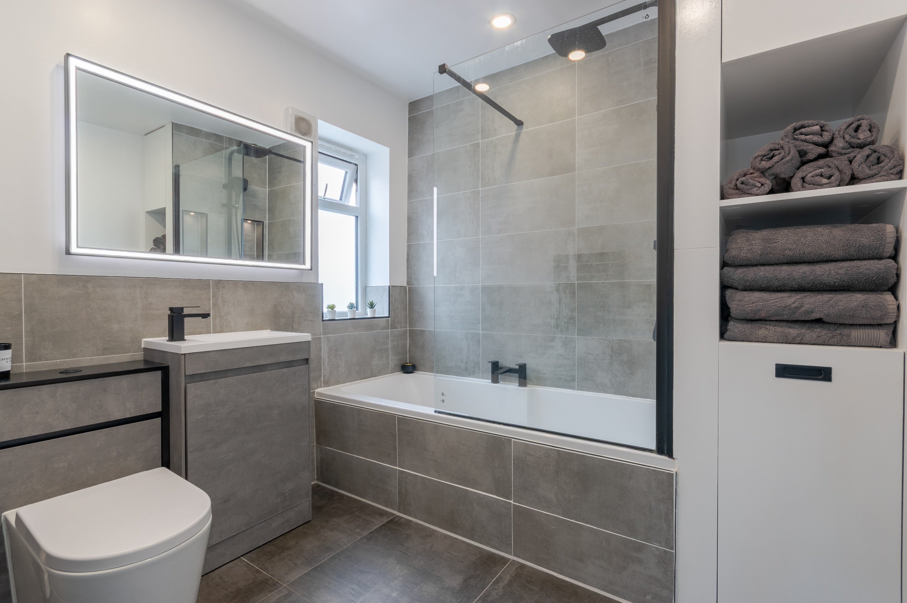

Entrance Hall
Via front entrance door. Spacious storage cupboard. Stairs to first floor.

Lounge 3.63m (11'11) x 4.04m (13'3)
Light and airy living area with uPVC double glazed window to front. Electric fire to chimney breast. Gas central heating radiator.

Kitchen/Diner 5.78m (19') x 2.97m (9'9)
Fitted with a range of wall, base and drawer units with worktops over. Integrated dishwasher. 1.5 stainless steel sink with mixer tap and drainer. Range cooker with extractor hood over. Space for fridge/freezer. Part tiled walls. Inset ceiling spotlights. uPVC double glazed window. uPVC double glazed door to side. Opening to a dining area with uPVC double glazed sliding doors to rear garden. Gas central heating radiator.

First Floor

Bedroom 1 3.34m (10'11) x 3.66m (12'0)
Double bedroom with uPVC double glazed window to front. Built in wardrobes. Gas central heating radiator.

Bedroom 2 3.34m (10'11) x 3.35m (11')
Second double bedroom with uPVC double glazed window to rear. Gas central heating radiator.

Study 2.28m (7'6) x 2.69m (8'10)
Study area with uPVC double glazed window. Gas central heating radiator. Stairs to second floor.

Second Floor

Bedroom 3 5.78m (19') x 3.44m (11'3)
Third double bedroom with three Velux windows to rear. Built in storage cupboards. Gas central heating radiators.

Bathroom
Fitted with a modern three piece suite comprising; bath with shower over, vanity wash hand basin and WC. Part tiled walls and tiled floor. Inset ceiling spotlights.

Outside
To the front of the property is a lawned garden with borders of plants and shrubs. A driveway leading to a detached garage. To the rear of the property is an enclosed garden with a decked area to the rear. EV charging point.

Garage 2.46m (8'1) x 4.58m (15'0)
Detached garage with up and over door. Light and power.

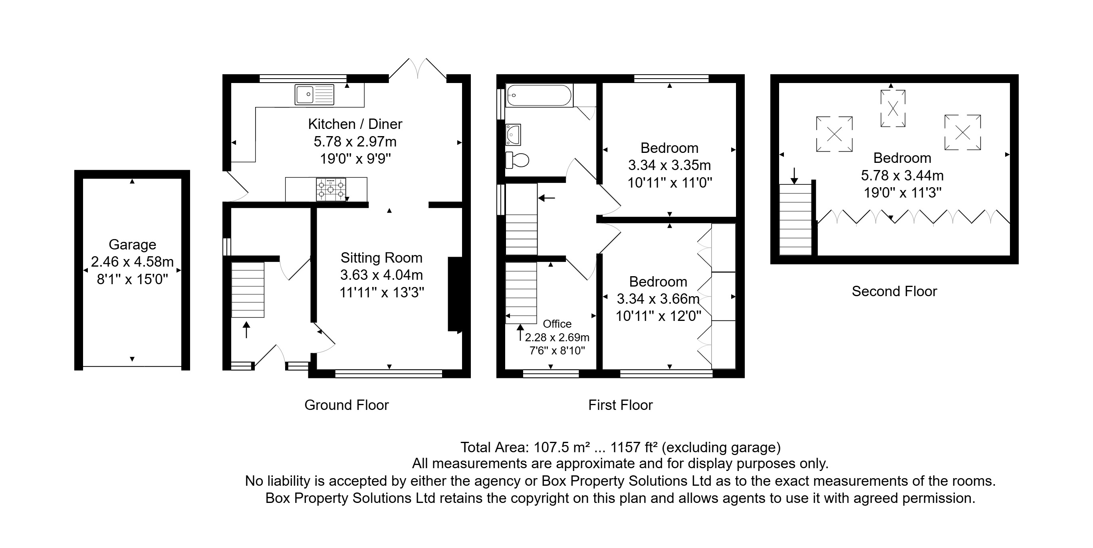

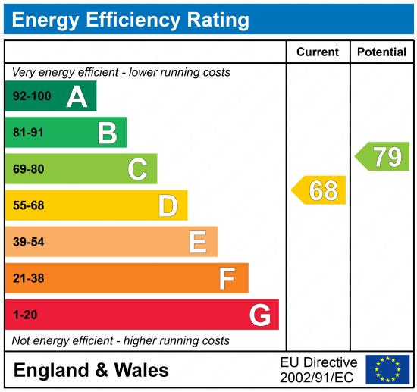

These particulars are intended to give a fair description of the property, but their accuracy cannot be guaranteed, and they do not constitute an offer of contract. Intending purchasers must rely on their own inspection of the property. None of the above appliances/services have been tested by ourselves. We recommend purchasers arrange for a qualified person to check all appliances/services before legal commitment.

Property Ref: 6825

For more information, please contact

0113 258 1150 | sales@adairpaxton.co.uk | www.adairpaxton.co.uk

