

**Bletchley Avenue, Horsforth**

**For Sale £345,000**

***STUNNING THREE BEDROOM SEMI-DETACHED HOUSE SET IN MUCH SOUGHT AFTER HORSFORTH VALE LOCATION*** This beautifully presented home offers ready to move into accommodation and simply must be viewed to be appreciated. Located in the idyllic Horsforth Vale development, this property occupies a prominent position just opposite The Green, Brodie & Flynn and The Vale Convenience Store. The property briefly comprises: Entrance hall with access to WC and generous storage cupboard, fitted kitchen/diner and living room with doors out to the rear garden. To the first floor there are three bedrooms (two doubles, one single) and the house bathroom. Externally, there is an open garden to the front of the property, driveway for two cars to the side and an enclosed landscaped garden to the rear. Call us now to arrange a viewing!

**0113 258 1150**

**0800 000 000**

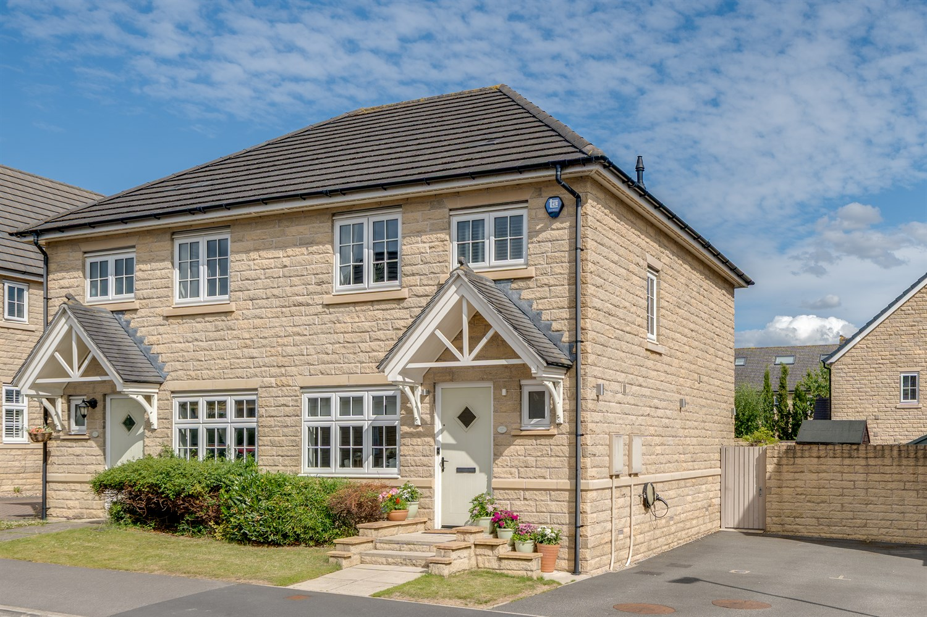

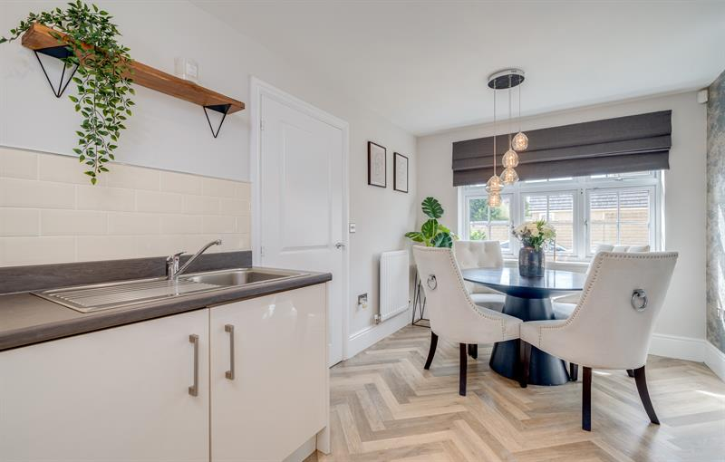

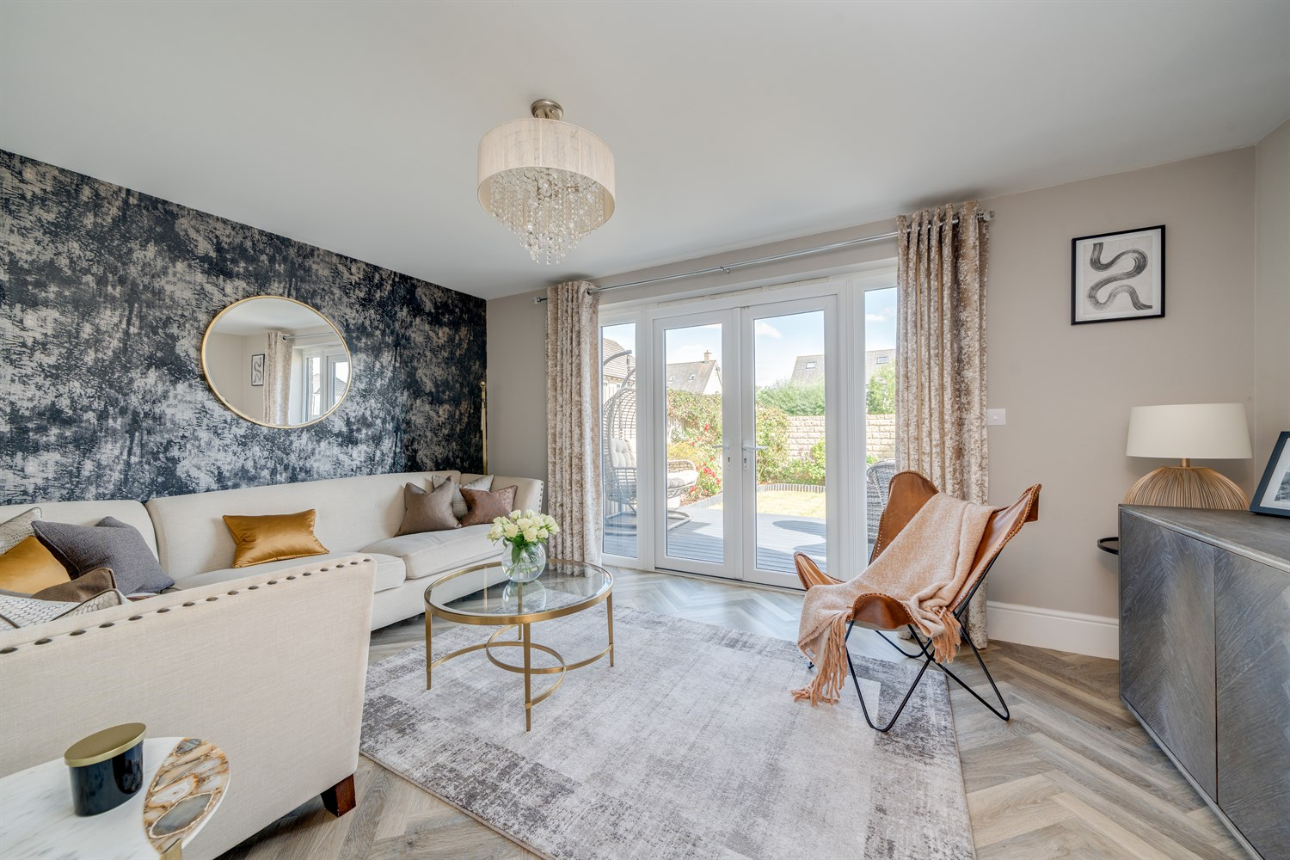

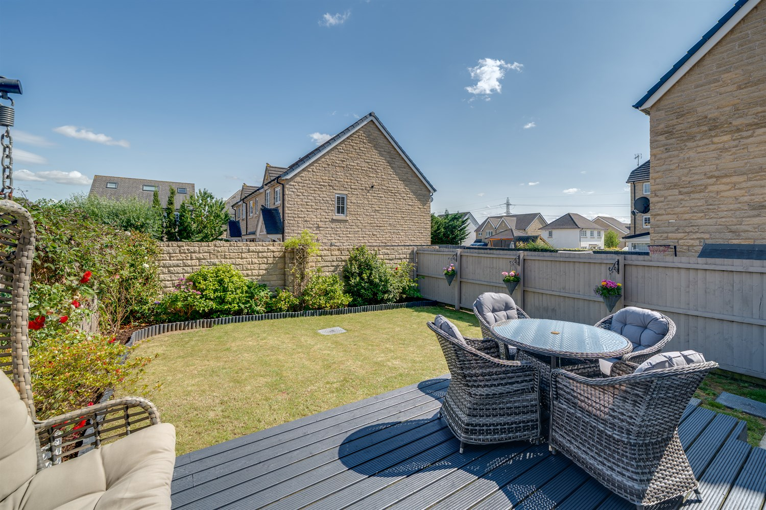

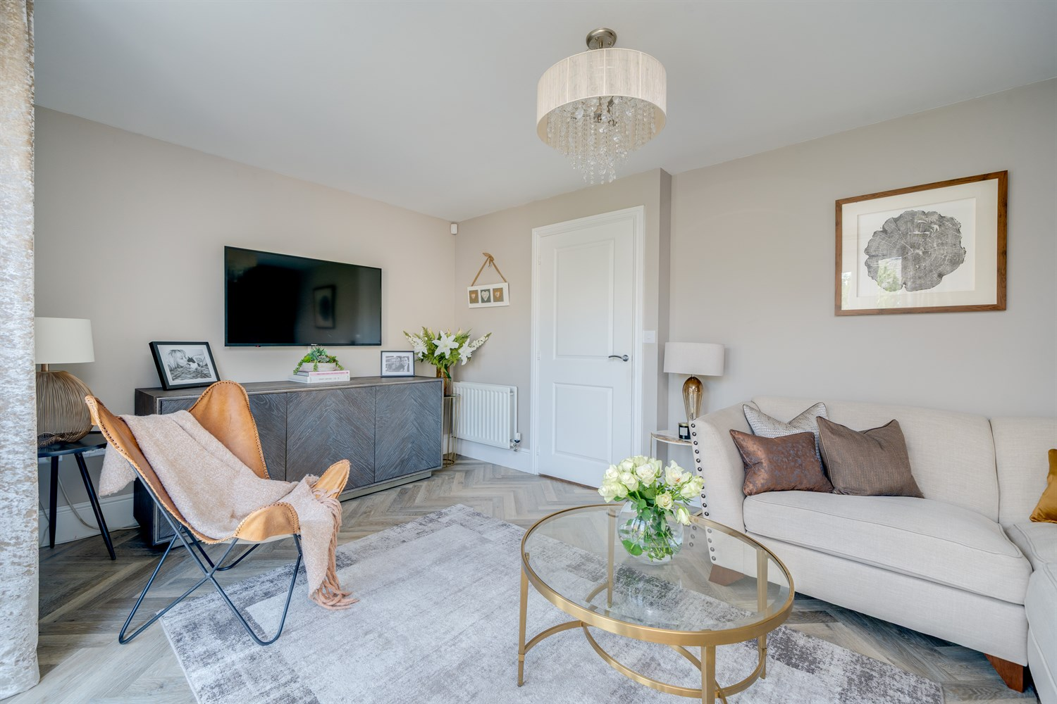

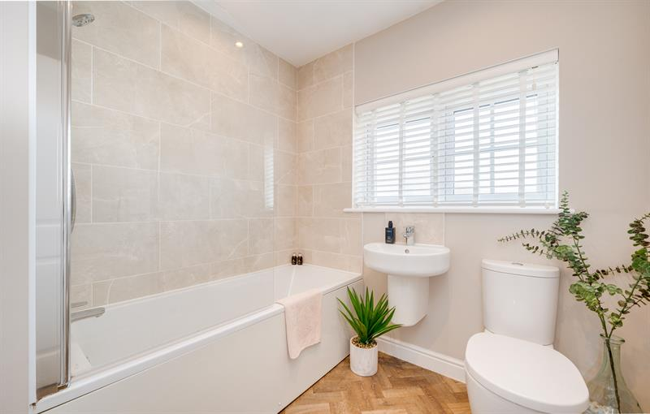

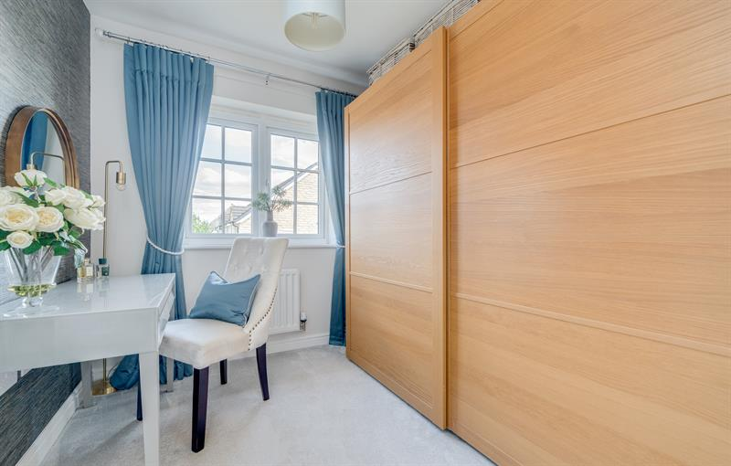

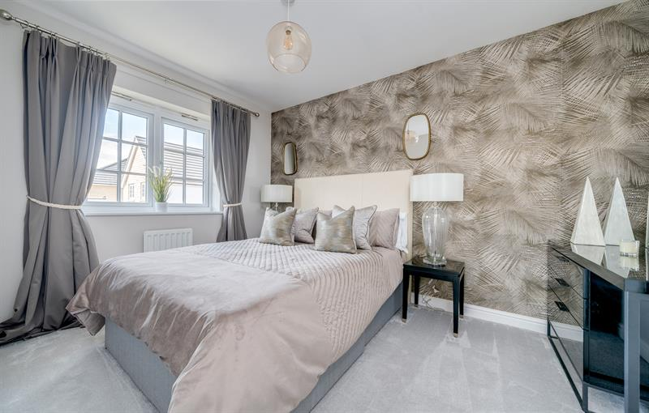

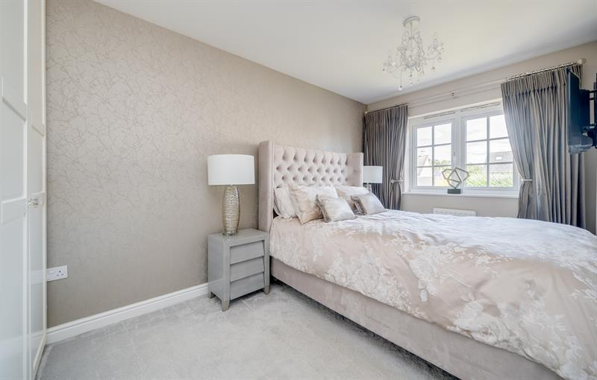

|  |
| --- |
| **Entrance Hall**  A bright entrance hall accessed via composite and glazed front door, neutral décor, Karndean herringbone flooring, useful storage cupboard, stairs to first floor. Radiator. |
| **Guest Cloakroom**  Fitted with a two piece white suite comprising WC and half pedestal wash hand basin. uPVC double glazed window to the front. Karndean herringbone flooring. Radiator. |
| **Living Room 4.62m (15'2) x 3.23m (10'7) max**  A spacious lounge with French Style uPVC double glazed doors opening out to the rear garden. Karndean herringbone flooring. Radiator. |
| **Kitchen 4.65m (15'3) x 2.49m (8'2)**  Fitted with a range of gloss wall, base and drawer units with work surfaces over. Stainless steel sink and drainer with mixer tap. Tiled splashbacks. Integrated electric oven and gas hob with extractor hood over. Integrated fridge/freezer and washing machine. uPVC double glazed window to the front. Karndean herringbone flooring. Radiator. |
| **First Floor Landing**  uPVC double glazed window to side. Access to part boarded loft. Large storage cupboard housing the combination boiler. Radiator. |
| **Bedroom 3.45m (11'4) x 2.54m (8'4) max**  Double bedroom with uPVC double glazed window to the front. Radiator. |
| **Bedroom 4.42m (14'6) x 2.54m (8'4) max**  Double bedroom with uPVC double glazed window to the rear. Fitted wardrobes with hanging storage, shelves and drawers. Radiator. |
| **Bedroom 2.39m (7'10) x 2.26m (7'5)**  Single bedroom with uPVC double glazed window to the rear. Radiator. |
| **Bathroom**  Fitted with a three piece white suite comprising bath with shower over and glass screen, WC and wash hand basin. Part tiled walls. Heated towel rail. Amtico flooring. uPVC double glazed window to the front. |
| **Outside The Property**  Open lawned garden to the front with planted shrubs. Driveway to the side with parking for two cars. Podpoint tethered electric charger.  The rear garden is fully enclosed and boasts a decked patio area leading to a lawned garden with borders of planted shrubs and flowers. Timber shed. |
|  |
| **Estate charges**  Please note an annual estate charge is payable for the upkeep of the public open space, which includes the cricket pitch and pavilion on Calverley Lane. The charge for 01/04/2025 to 31/03/2026 is £187.82.  In accordance with the Estate Agents Act 1979, we advise that the vendor of this property is an employee of Adair Paxton. |

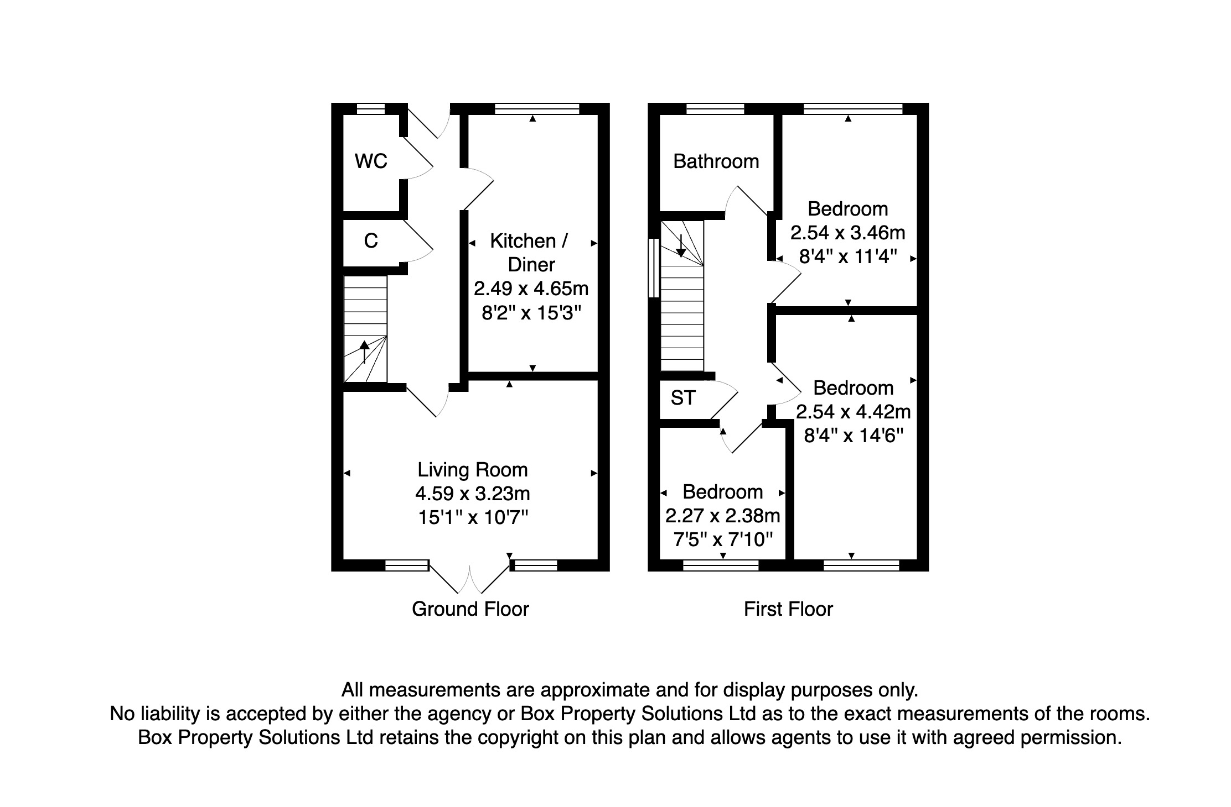

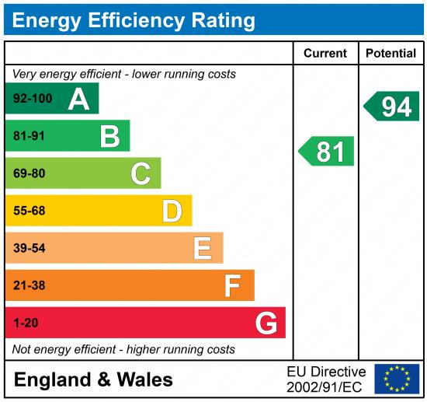

|  |
| --- |
|  |

These particulars are intended to give a fair description of the property, but their accuracy cannot be guaranteed, and they do not constitute an offer of contract. Intending purchasers must rely on their own inspection of the property. None of the above appliances/services have been tested by ourselves. We recommend purchasers arrange for a qualified person to check all appliances/services before legal commitment.

**Property Ref:** 6637

**For more information, please contact**

0113 258 1150 **|** [sales@adairpaxton.co.uk](mailto:sales@adairpaxton.co.uk) **|** www.adairpaxton.co.uk