

**Foxhill Court, Weetwood**

**For Sale £185,000**

## **BEAUTIFULLY PRESENTED TWO BEDROOM TOP FLOOR APARTMENT with GARAGE and EV CHARGING POINT** Situated in the highly sought after location of Weetwood, this property boasts spacious accommodation throughout, fabulous grounds and is well positioned for excellent transport links and local amenities. This second floor apartment is ready to move into and briefly comprises; Communal entrance with stairs to all floors, private entrance hall, lounge, kitchen, two double bedrooms and a shower room. Externally, the property has well maintained communal gardens and off street parking.

**0113 258 1150**

**0800 000 000**

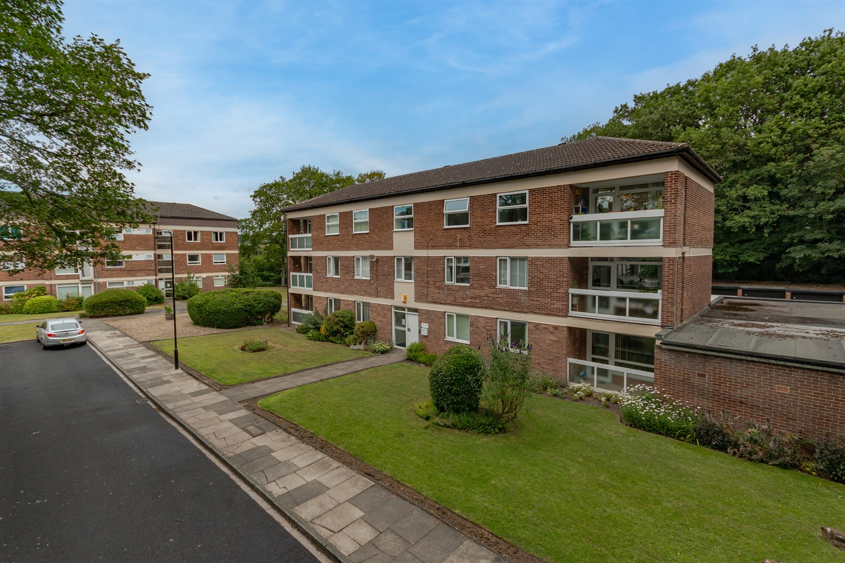



1 Reception

1 Bathroom

2 Bedrooms

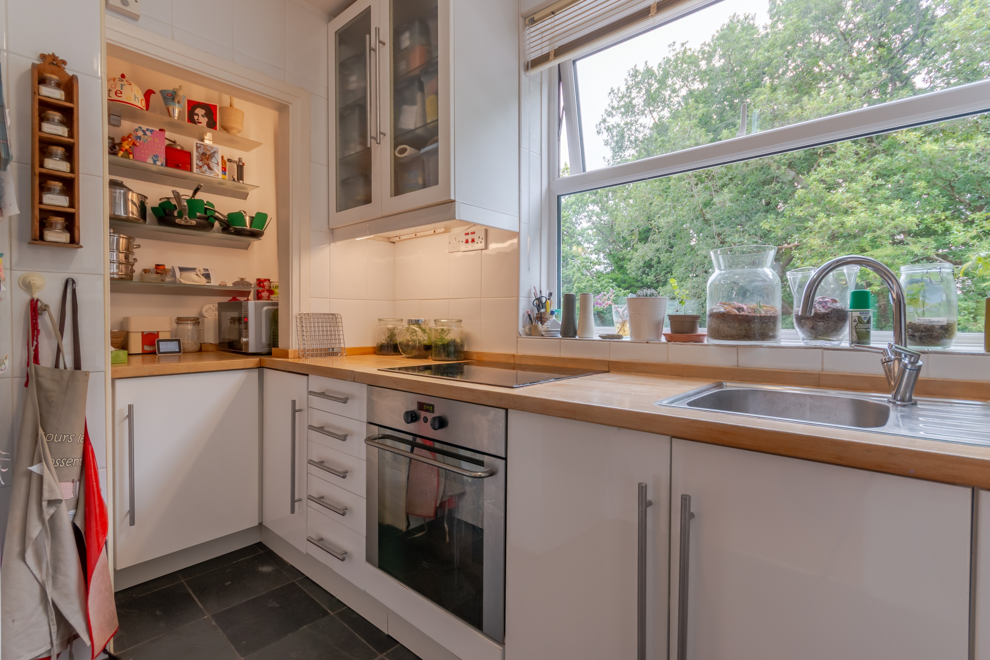

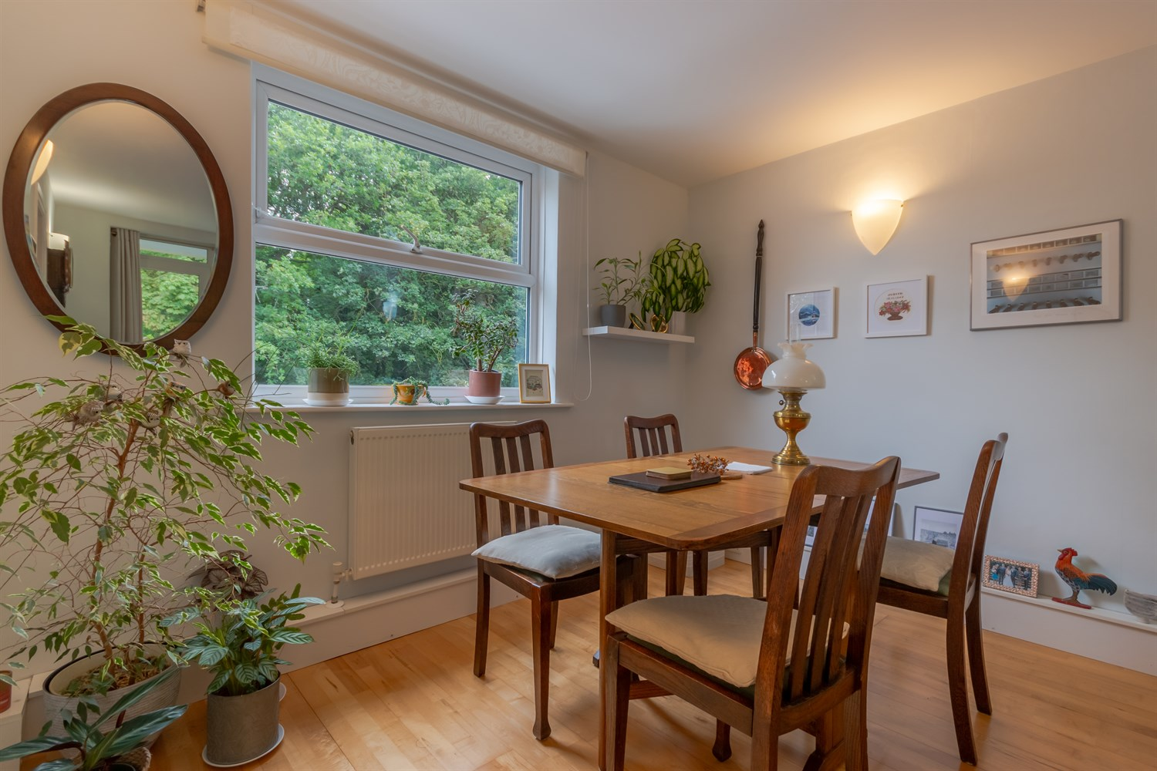

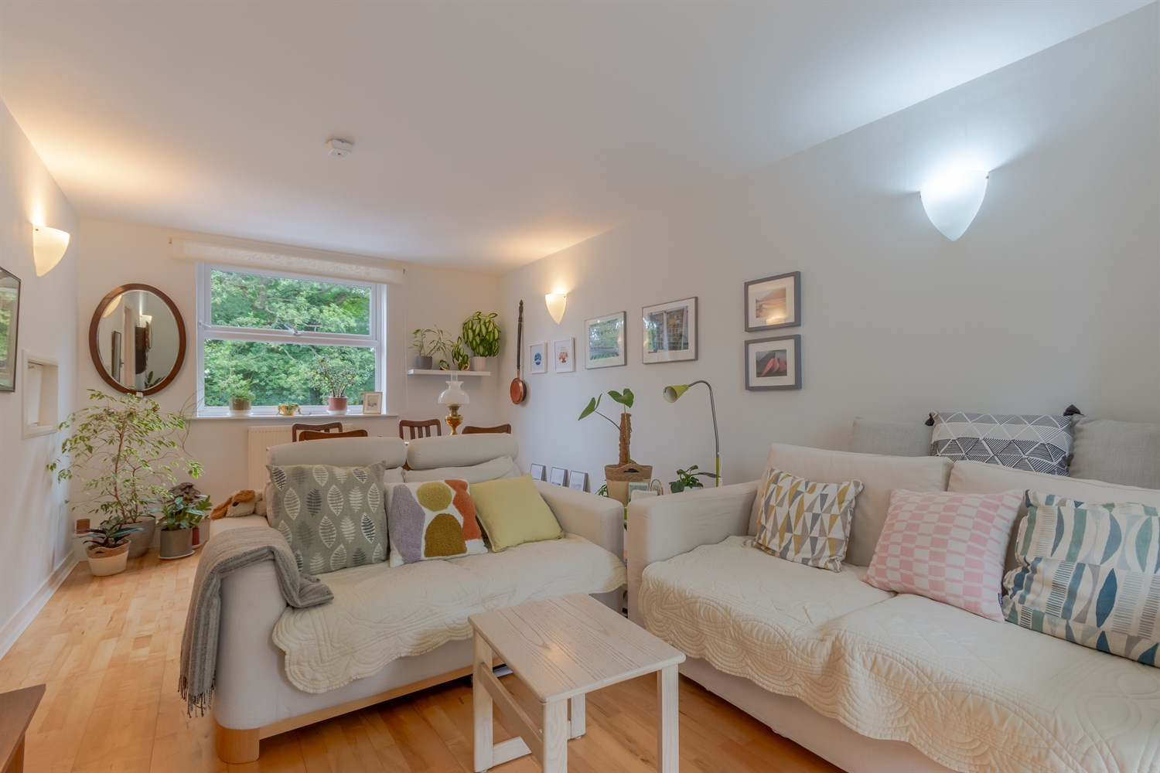

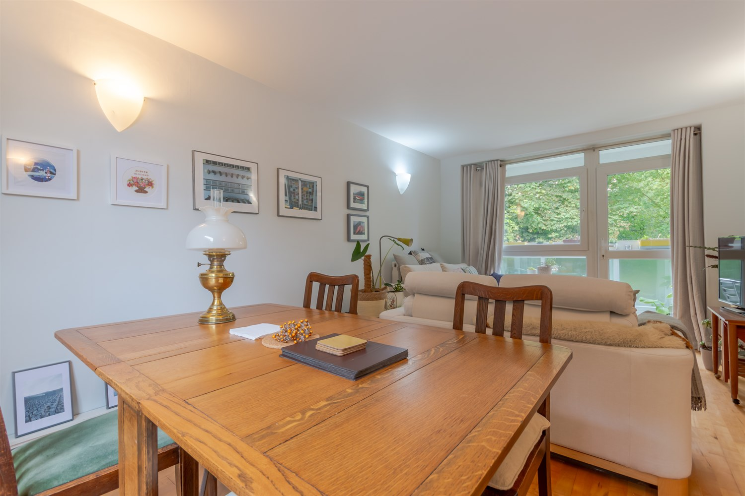

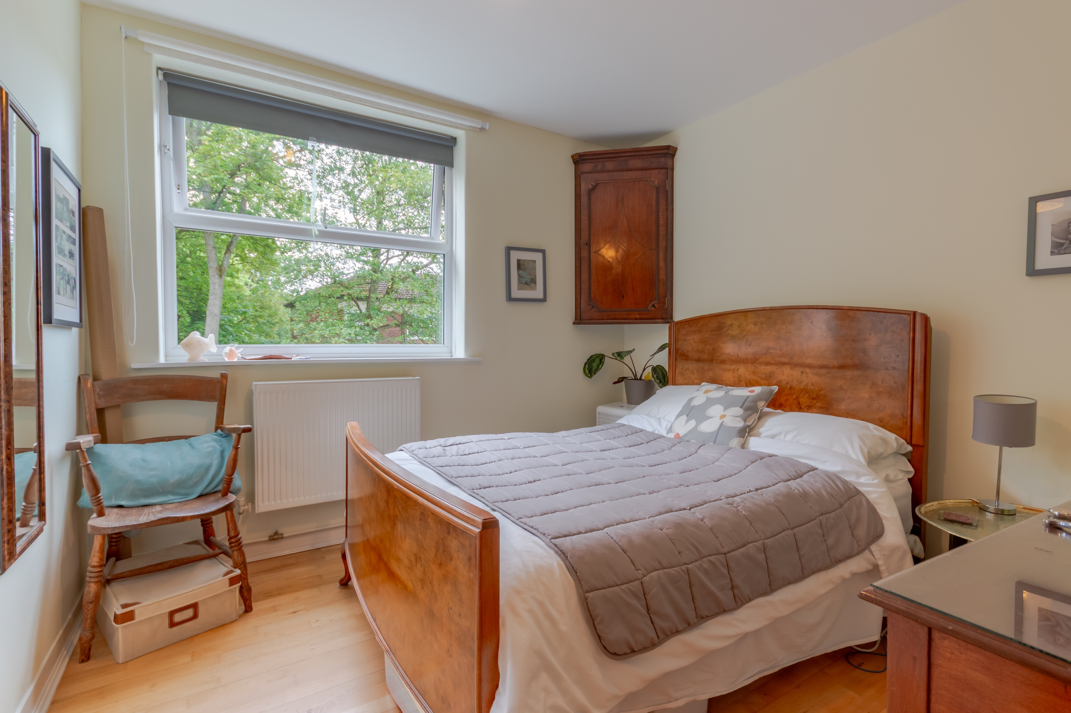

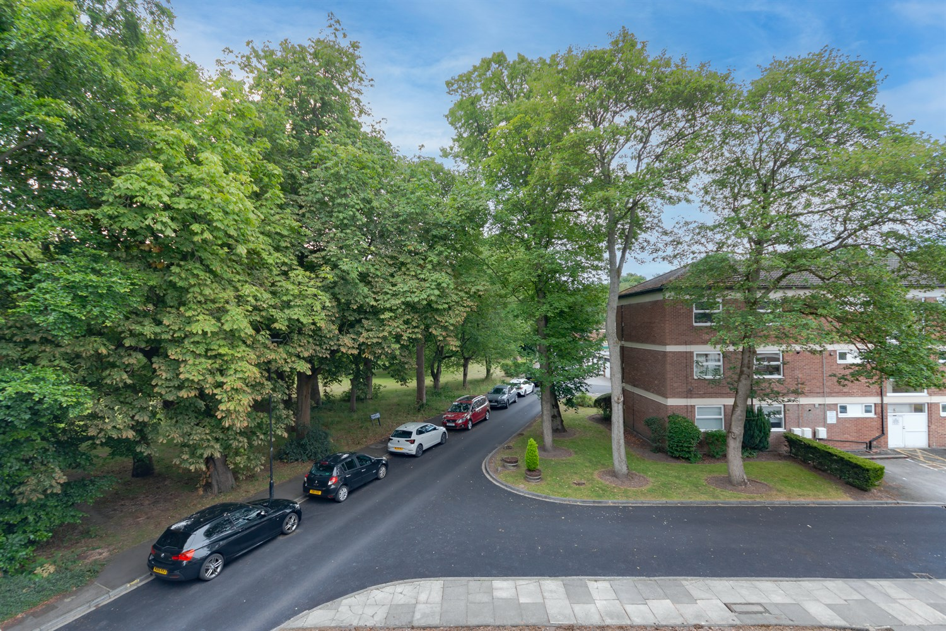

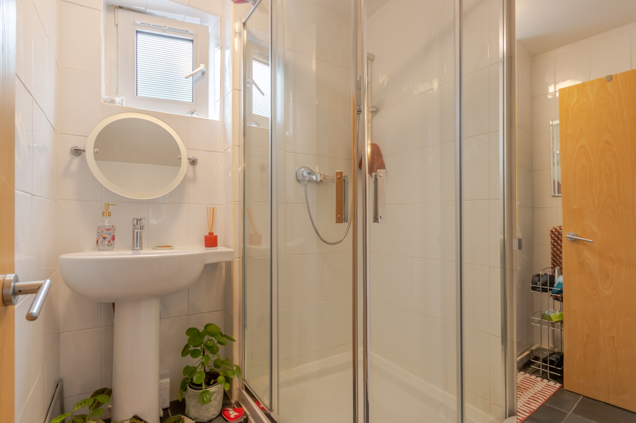

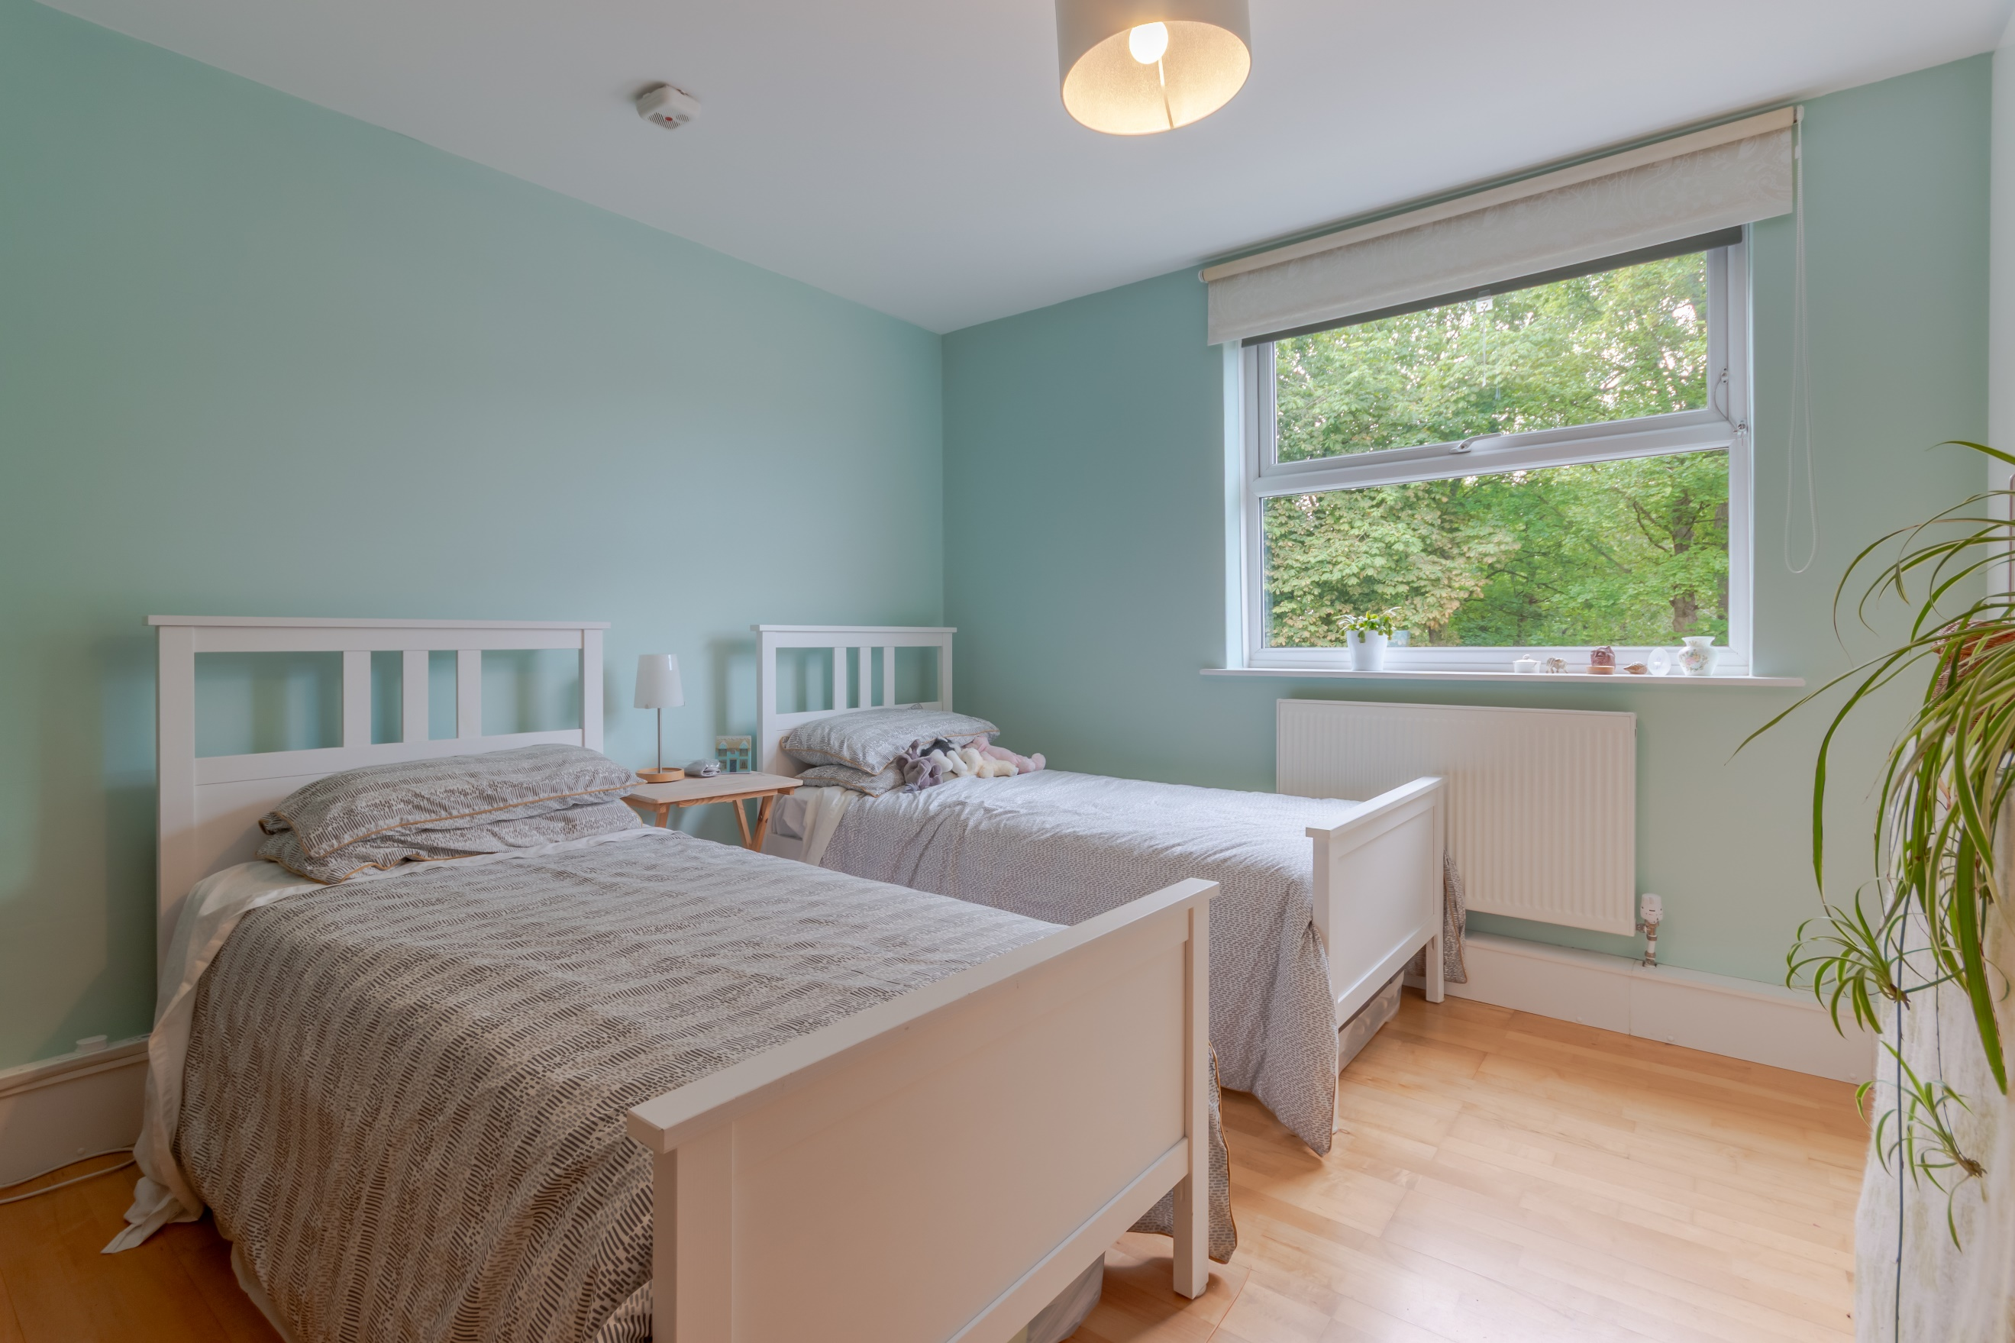

|  |
| --- |
| **Communal Entrance**  Via front entrance door. Secure entry phone system. Stairs to all floors. |
| **Private Entrance**  Via front entrance door. Two Store cupboards. |
| **Kitchen**  Fitted with a range of wall, base and drawer units with worktops over. Integrated electric oven with 4-ring induction hob over. Stainless steel sink with mixer tap and drainer. Space for washing machine and dishwasher. Tiled walls. uPVC double glazed window. |
| **Lounge**  Light and airy living/dining area with uPVC double glazed door to the front leading out to the balcony and uPVC double glazed window to rear. Two gas central heating radiator. |
| **Bedroom One**  Double bedroom with uPVC double glazed window to front. Gas central heating radiator. Built in wardrobe. |
| **Bedroom Two**  Second double bedroom with uPVC double glazed window to front. Gas central heating radiator. Two built in wardrobes. |
| **Shower Room**  Fitted with a two piece suite comprising; walk in shower cubicle and wash hand basin. Tiled walls. uPVC double glazed window. |
| **WC**  Fitted with a WC. uPVC double glazed window. |
| **Outside**  Externally, there are well maintained communal gardens. off-street parking and an allocated garage with an EV charging point. |
| **Tenure**  Leasehold.  999 years from 1960  Ground Rent - £0 |
| **Service Charge**  Service charge - £400 per quarter. |

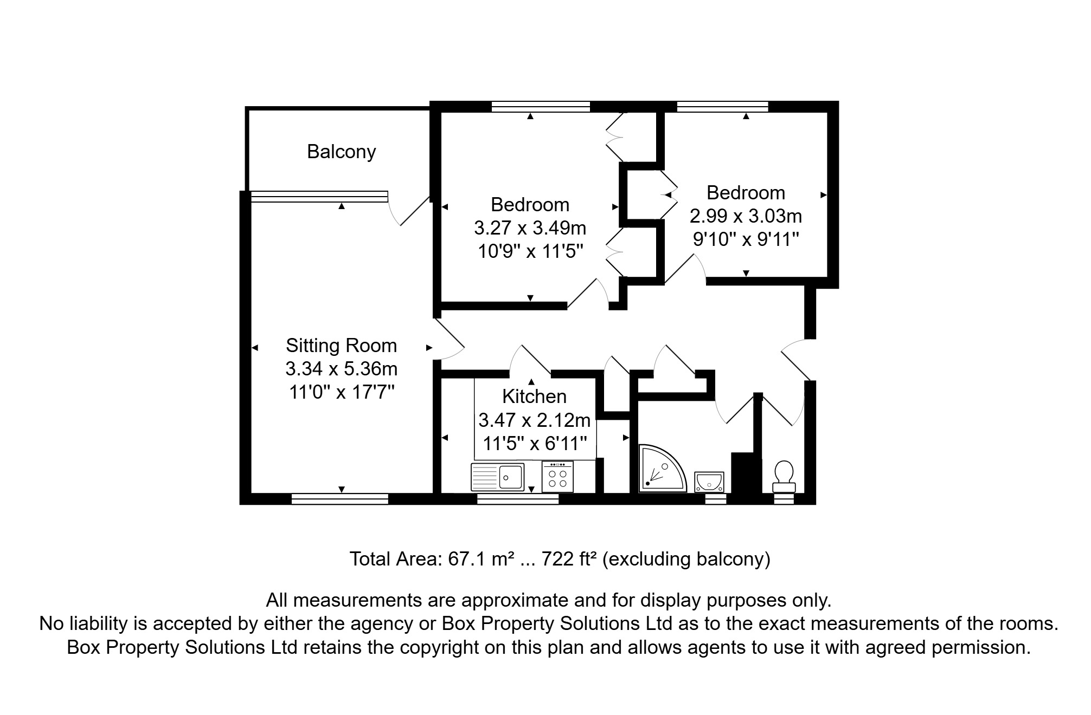

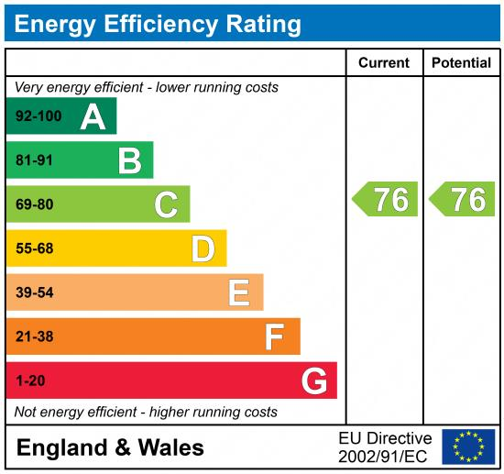

|  |
| --- |
|  |

These particulars are intended to give a fair description of the property, but their accuracy cannot be guaranteed, and they do not constitute an offer of contract. Intending purchasers must rely on their own inspection of the property. None of the above appliances/services have been tested by ourselves. We recommend purchasers arrange for a qualified person to check all appliances/services before legal commitment.

**Property Ref:** 6700

**For more information, please contact**

0113 258 1150 **|** [sales@adairpaxton.co.uk](mailto:sales@adairpaxton.co.uk) **|** www.adairpaxton.co.uk