

**0113 258 1150**

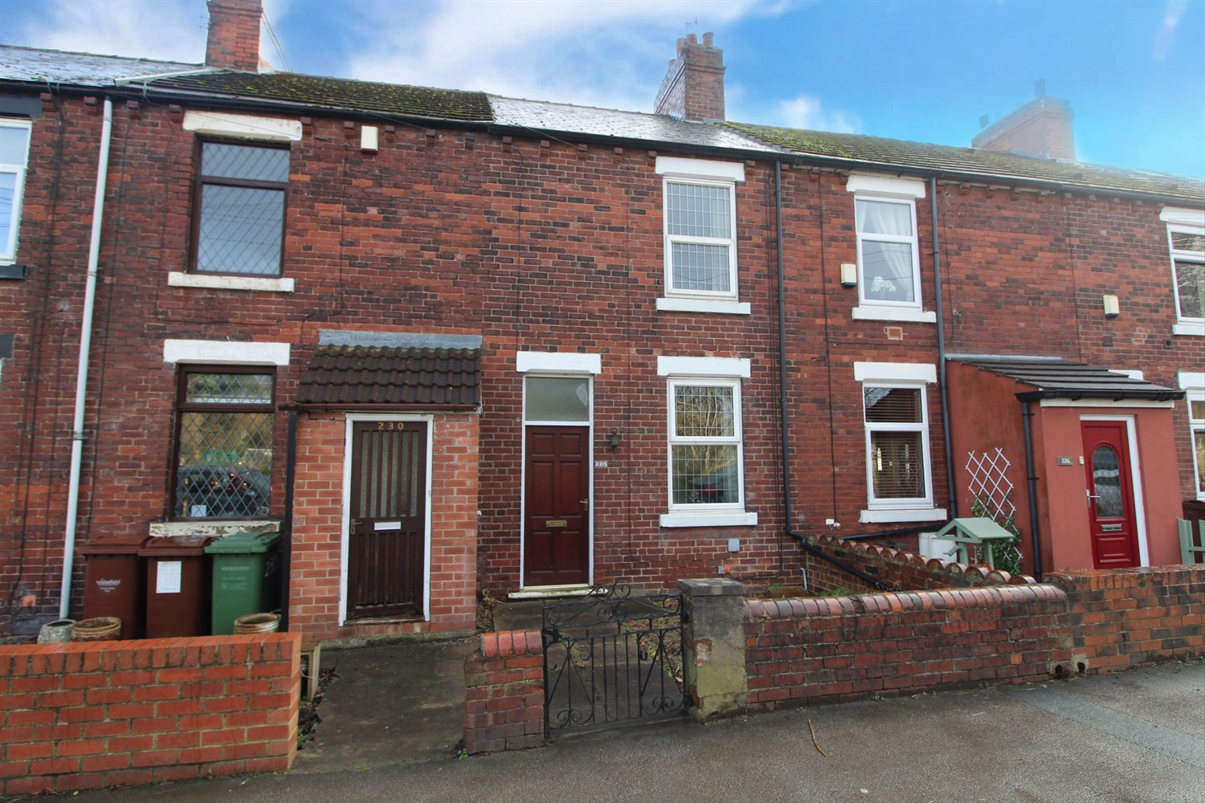

**For Sale £110,000.00**

**Aberford Road, Stanley**

***INVESTMENT PROPERTY***6% YIELD with the potential to increase***  
  
Offered to the market under market value is this tenanted two bedroom mid-terrace house. The property is in need of updating and briefly comprises; lounge and kitchen/diner to the ground floor. To the first floor there are two double bedrooms and a house bathroom. Externally the property has a small courtyard style garden to the front and a rear garden offering off street parking. The property also benefits from views over open fields to the rear.  
  
The tenant is on a periodic AST paying £550pcm.

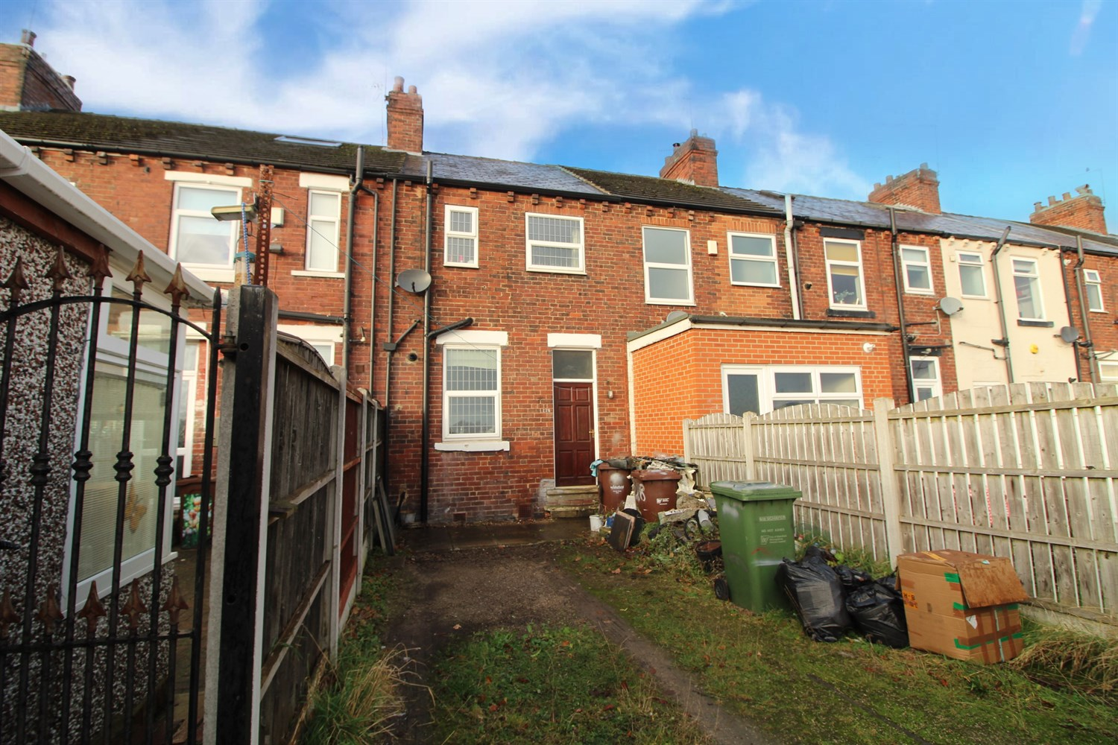



|  |
| --- |
| **Lounge 3.43m (11'3) x 4.07m (13'4)**  Living area with uPVC double glazed window to front. Gas central heating radiator. |
| **Kitchen/Diner 3.74m (12'3) x 4.07m (13'4)**  Fitted with a range of wall, base and drawer units with worktops over. Stainless steel sink. Plumber for washing machine. Space for fridge. uPVC double glazed window. |
|  |
| **Bedroom One 3.43m (11'3) x 4.07m (13'4)**  Double bedroom with uPVC double glazed window to front. Gas central heating radiator. |
| **Bedroom Two 3.74m (12'3) x 2.3m (7'7)**  Second bedroom with uPVC double glazed window to rear. Gas central heating radiator. |
| **Bathroom**  Fitted with a two piece suite comprising; bath and WC. Window to rear. |

|  |  |
| --- | --- |
| These particulars are intended to give a fair description of the property, but their accuracy cannot be guaranteed, and they do not constitute an offer of contract. Intending purchasers must rely on their own inspection of the property. None of the above appliances/services have been tested by ourselves. We recommend purchasers arrange for a qualified person to check all appliances/services before legal commitment.  **Property Ref:** 4665  **For more information, please contact**  0113 258 1150 **|** [sales@adairpaxton.co.uk](mailto:sales@adairpaxton.co.uk) **|** www.adairpaxton.co.uk |  |