

**0113 258 1150**

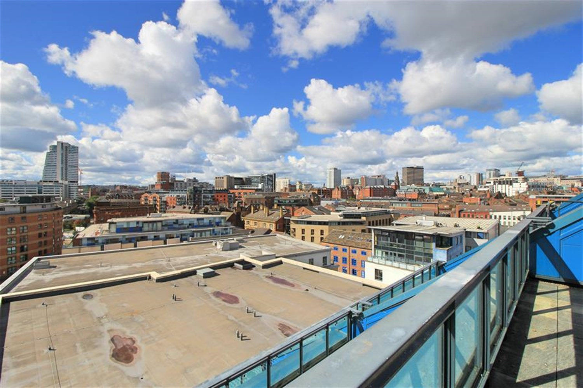

**For Sale £200,000.00**

**One Brewery Wharf, Leeds**

***TWO BEDROOM, TWO BATHROOM APARTMENT WITH A LARGE TERRACE OVERLOOKING THE CITY***EWS1 COMPLIANT***30% UNDER MARKET VALUE*** Offered to the market with NO ONWARD CHAIN is this stunning eighth floor apartment, offering spectacular views over the city. Located in the Brewery Wharf development with easy access to shops, bars and restaurants. An allocated parking space in the secure basement carpark is also included. The property briefly comprises: Entrance hall, Open plan living room/kitchen, Master bedroom with en-suite shower room, second bedroom and house bathroom. This property is an absolute MUST SEE!

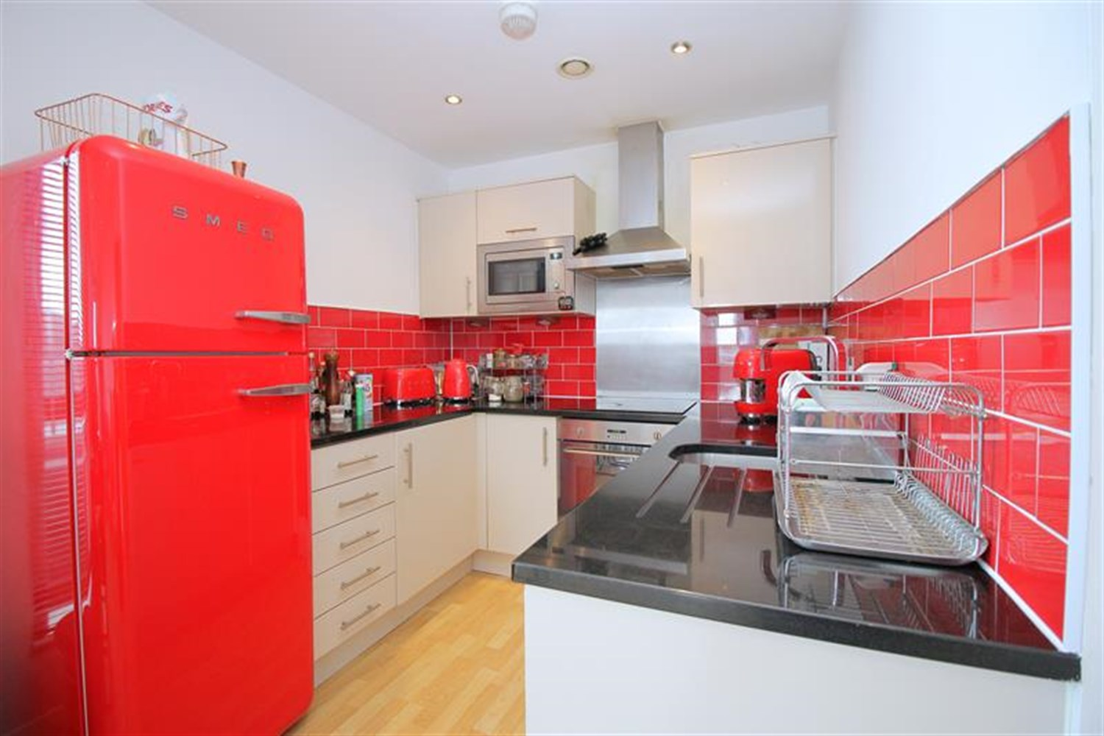

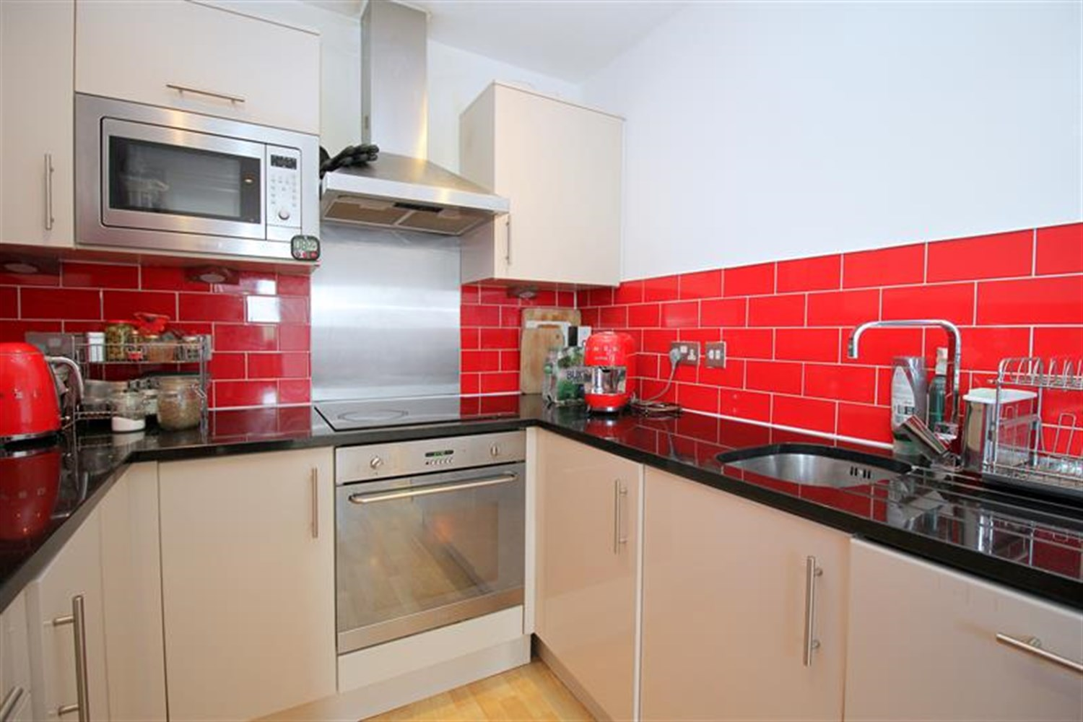

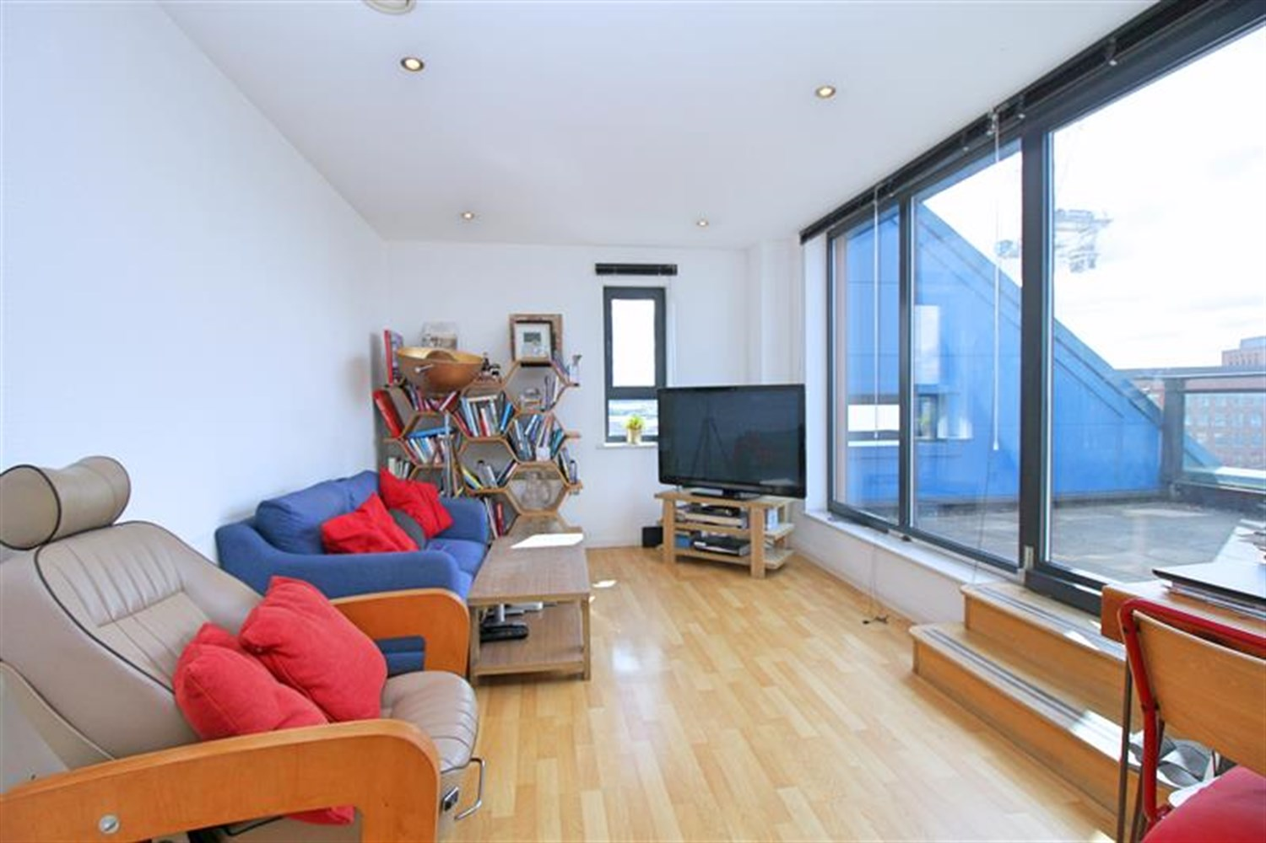

00

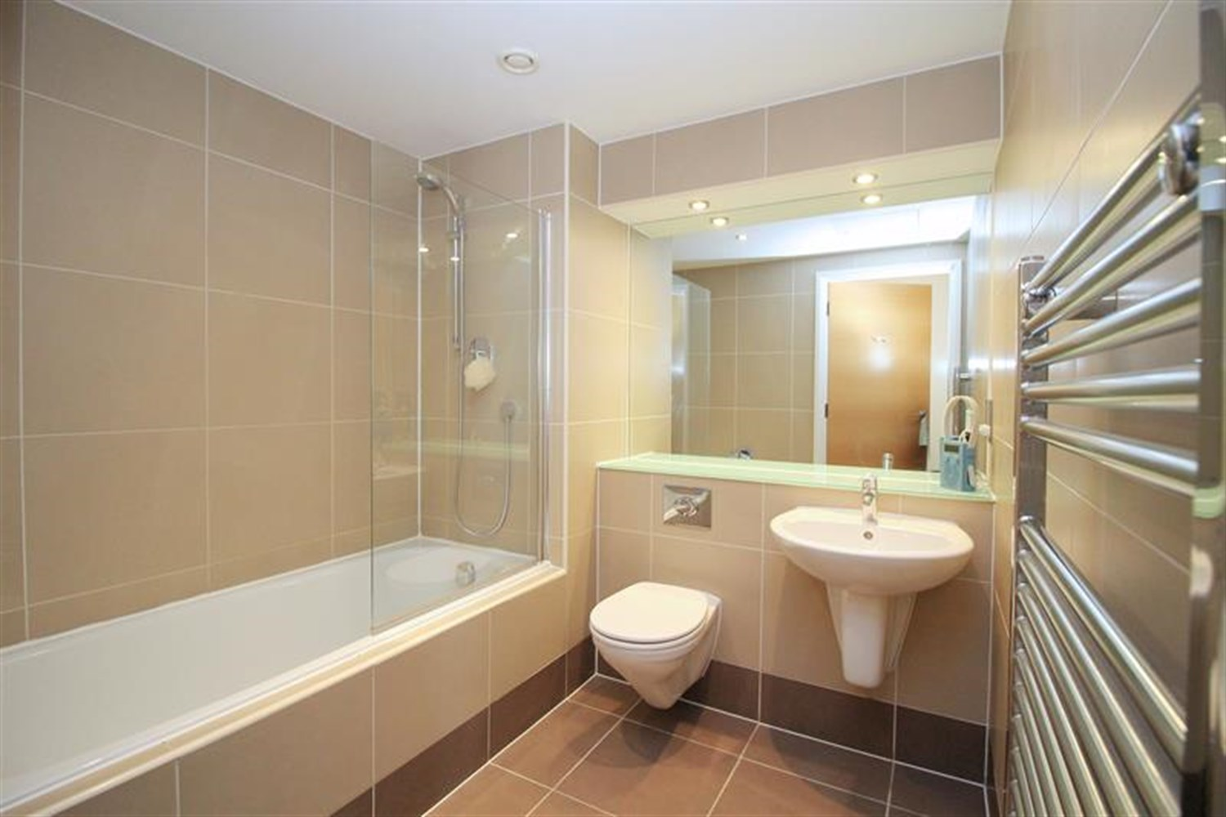

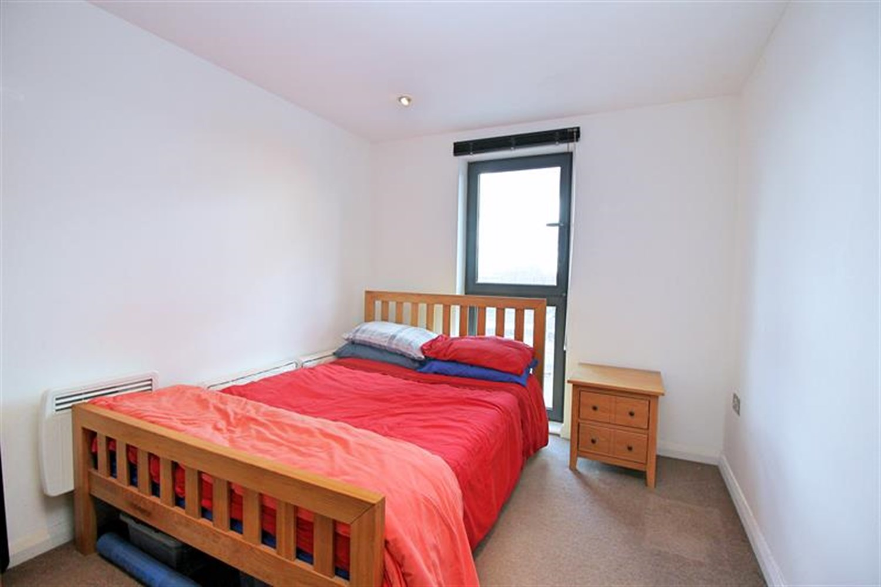

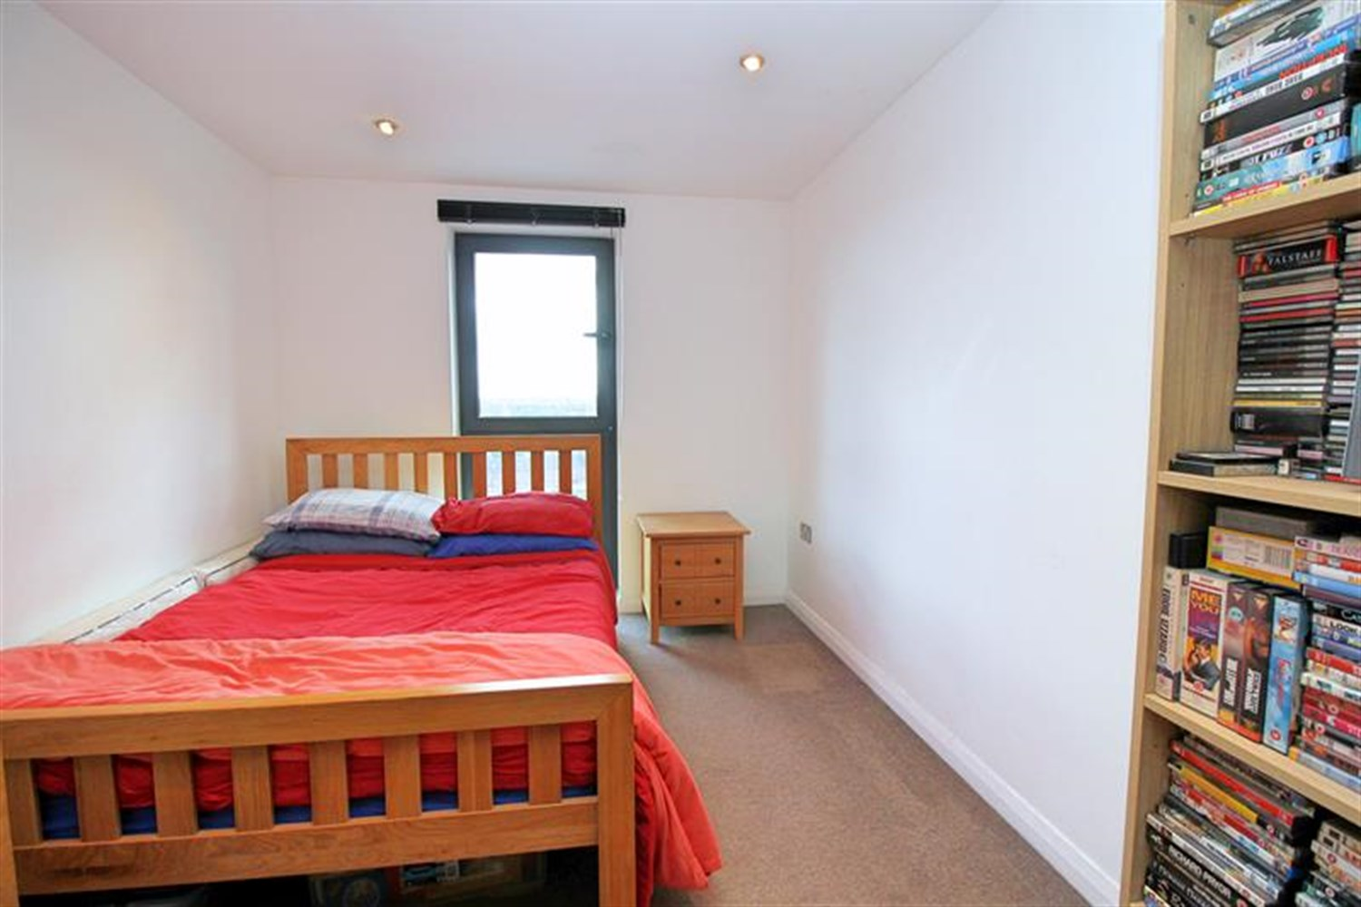

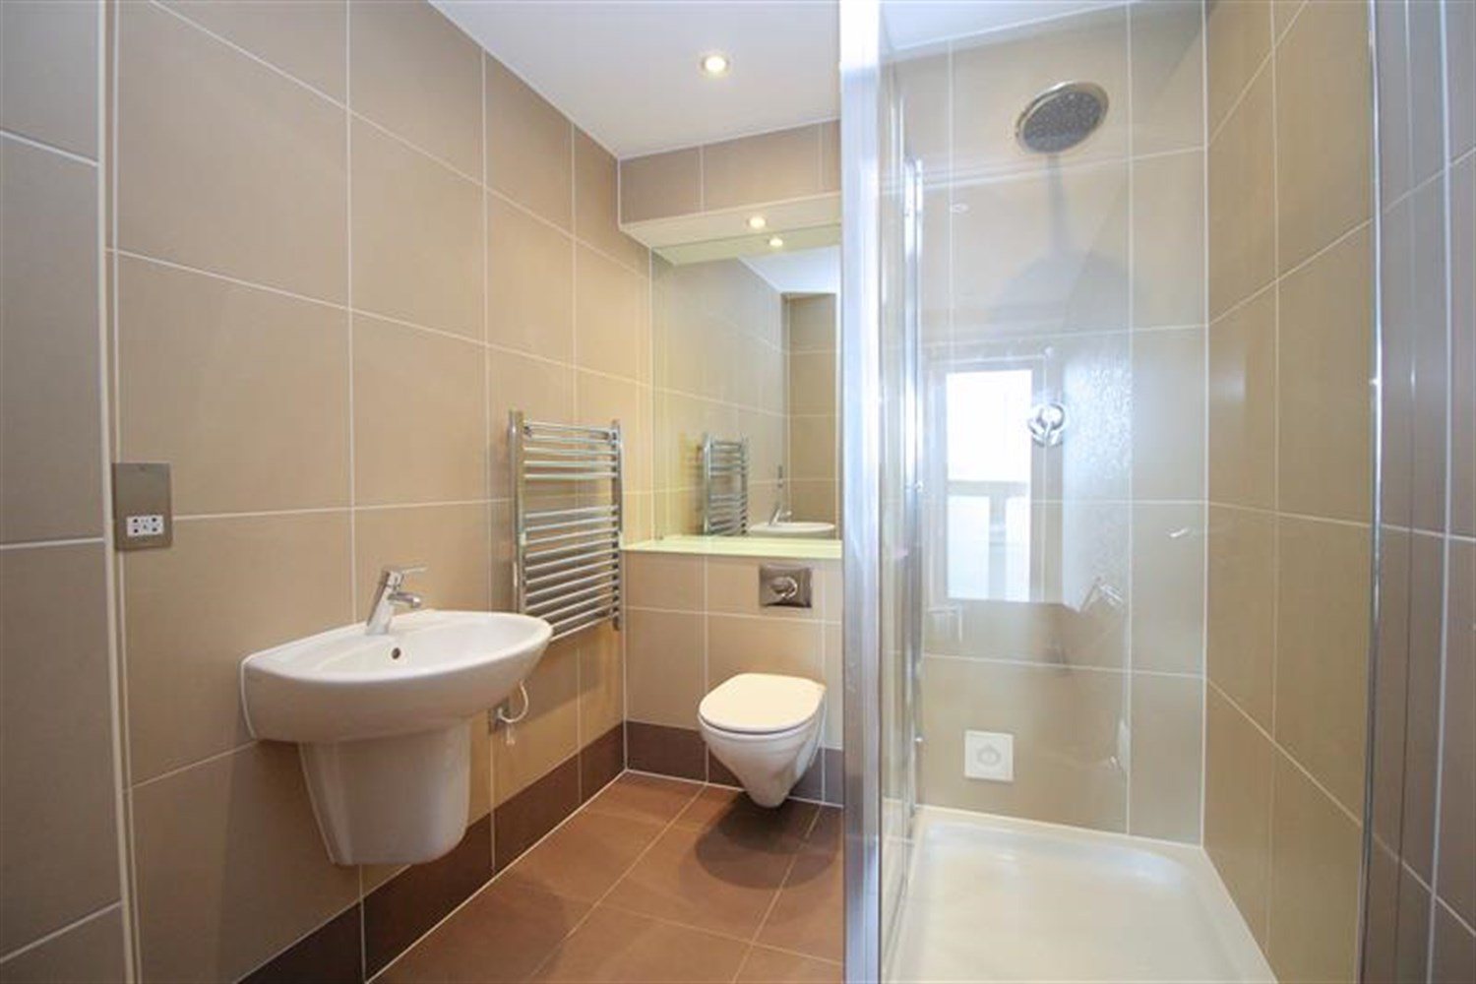

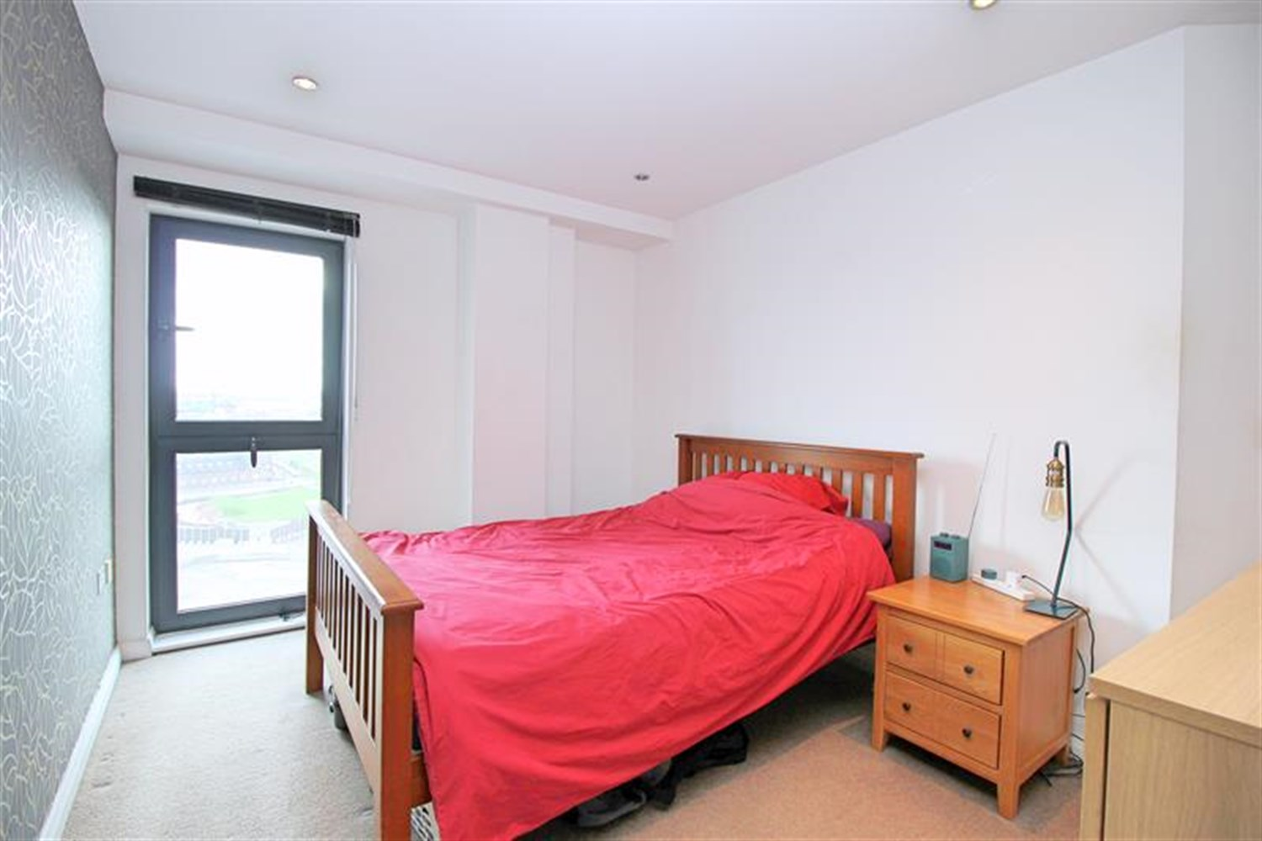

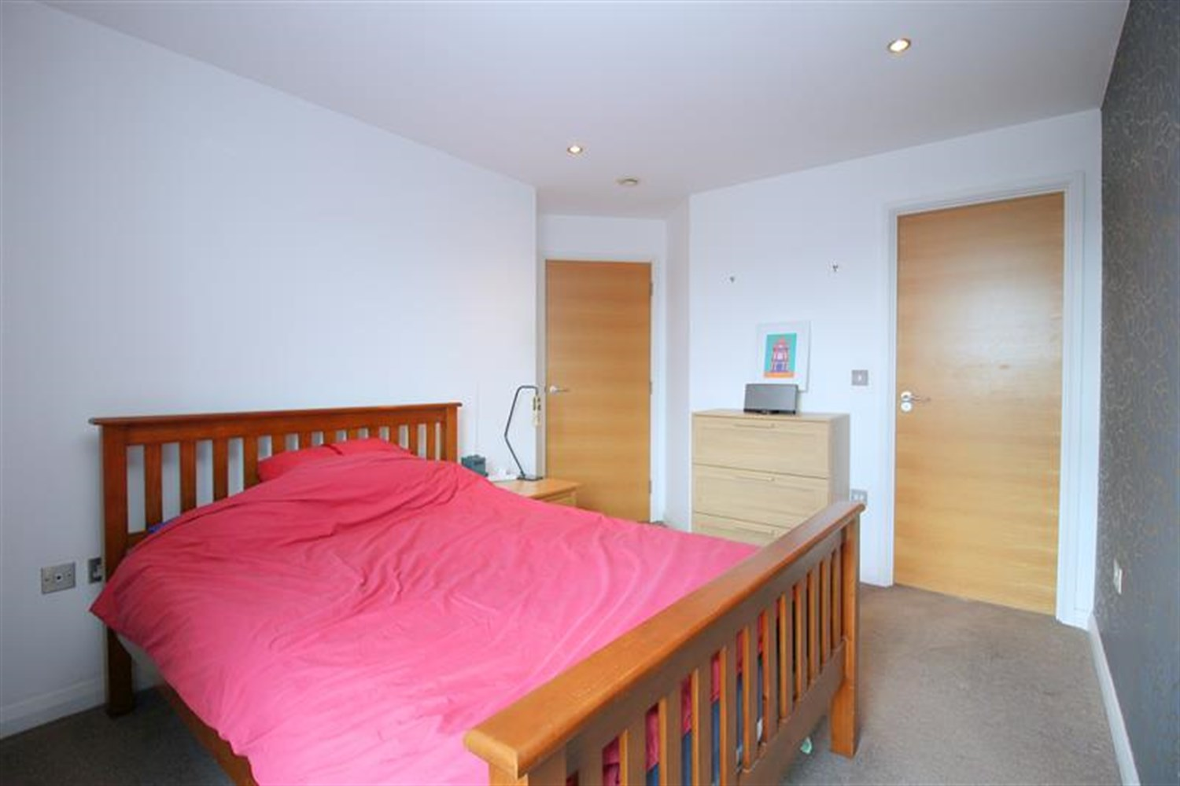

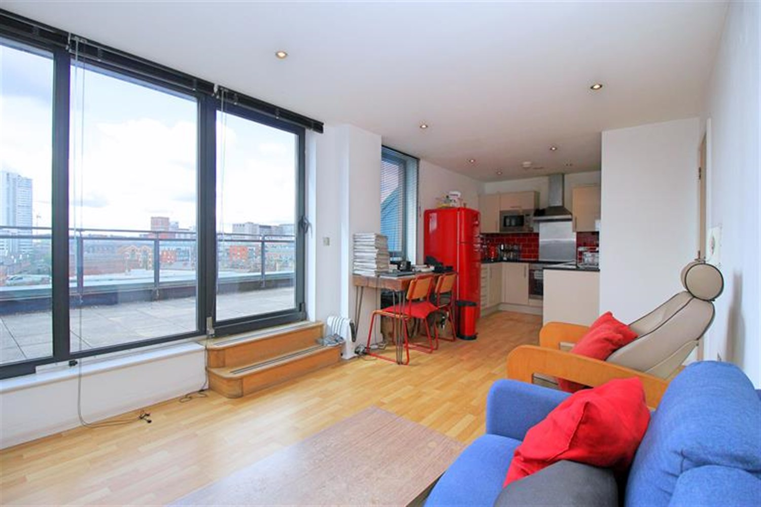

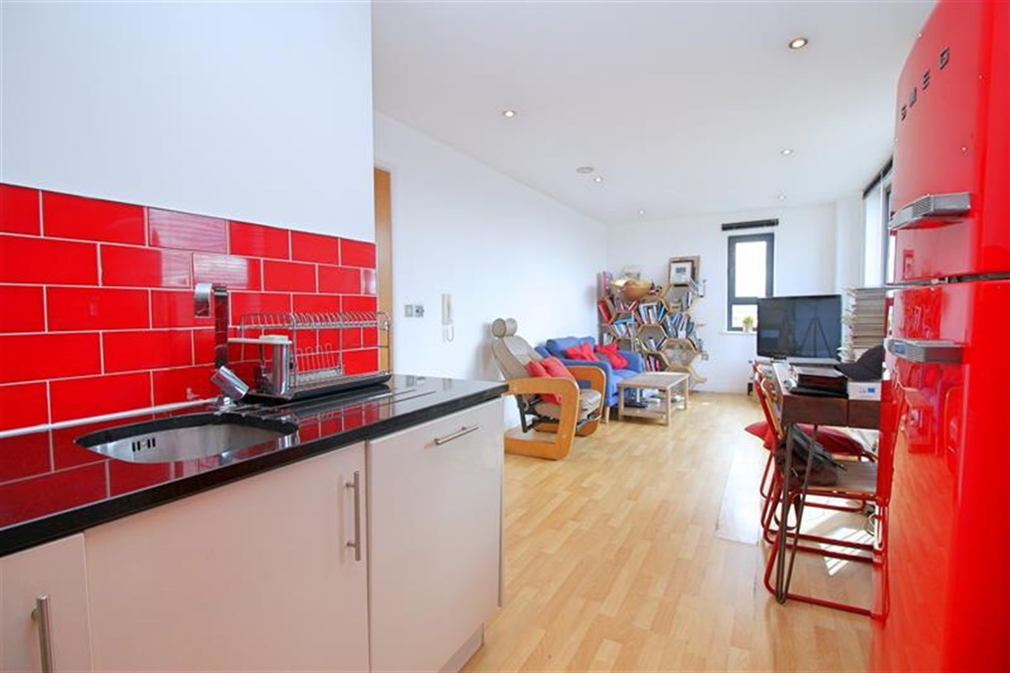

|  |
| --- |
| **Communal Entrance**  Communal entrance with telephone entry system, mail boxes and access to all floor via lift and staircase. |
| **Open Plan Living Room/Kitchen**  Open plan living area with wood effect flooring. Wall mounted electric radiator. Sliding door leading out onto the large terrace. The kitchen is fitted with a range of wall, base and drawer units with worktops over, stainless steel sink with mixer tap and drainer. Integrated oven with 4-ring hob and extractor hood over. Space for a fridge/freezer. Integrated dishwasher. and microwave. Inset ceiling spotlights and tiled walls. |
| **Spacious Terrace**  Large private roof terrace with city views. |
| **Bedroom 1**  A double bedroom with double glazed floor to ceiling window. Wall mounted electric radiator. |
| **En-suite**  En-suite shower room comprising; shower cubicle, wash hand basin and WC and a wall mounted towel radiator. Tiled walls and floor. |
| **Bedroom 2**  A further good sized double room with double glazed floor to ceiling window. Wall mounted electric radiator. |
| **Bathroom**  Three piece white suite comprising; bath with shower above, WC and wash hand basin. Tiled floor and walls. Wall mounted heated towel rail. |
| **Parking**  Secure underground parking with an allocated parking space. |
| **Tenure**  Leasehold - 999 years from 1st January 2006. Ground rent - £428.44 annually. Service Charge - £766.83 per quarter. Car Park Maintenance charge - £25.00 half yearly. |
| **Home Information**  Service Charge - £766.83 per quarter Ground Rent - £428.44 per annum Council Tax - D Lease Term - 999 Years from 1st January 2006 Heating - Electric  Water - Mains connected Broadband - No issues to report Mobile availability - No issues to report EWS1 Rating - B1 Construction type - Concrete Flood Risk - Low |

|  |  |
| --- | --- |
| These particulars are intended to give a fair description of the property, but their accuracy cannot be guaranteed, and they do not constitute an offer of contract. Intending purchasers must rely on their own inspection of the property. None of the above appliances/services have been tested by ourselves. We recommend purchasers arrange for a qualified person to check all appliances/services before legal commitment.  **Property Ref:** 6524  **For more information, please contact**  0113 258 1150 **|** [sales@adairpaxton.co.uk](mailto:sales@adairpaxton.co.uk) **|** www.adairpaxton.co.uk |  |