

**Echo Central Two, Leeds**

**For Sale £85,000.00**

***ONE BEDROOM APARTMENT - SEVENTH FLOOR***INVESTMENT OPPORTUNITY*** Set in the ever popular Echo Central development is this spacious one bedroom apartment. The apartment is located close to Leeds City Centre and must be viewed to be appreciated. The well planned living accommodation briefly comprises: Communal entrance hall with lift to all floors, private entrance hall, contemporary open plan living room/kitchen with good quality fixtures and fittings, double bedroom and modern shower room/WC. To arrange a viewing please call us on 0113 2581150.

**0113 258 1150**

**0800 000 000**

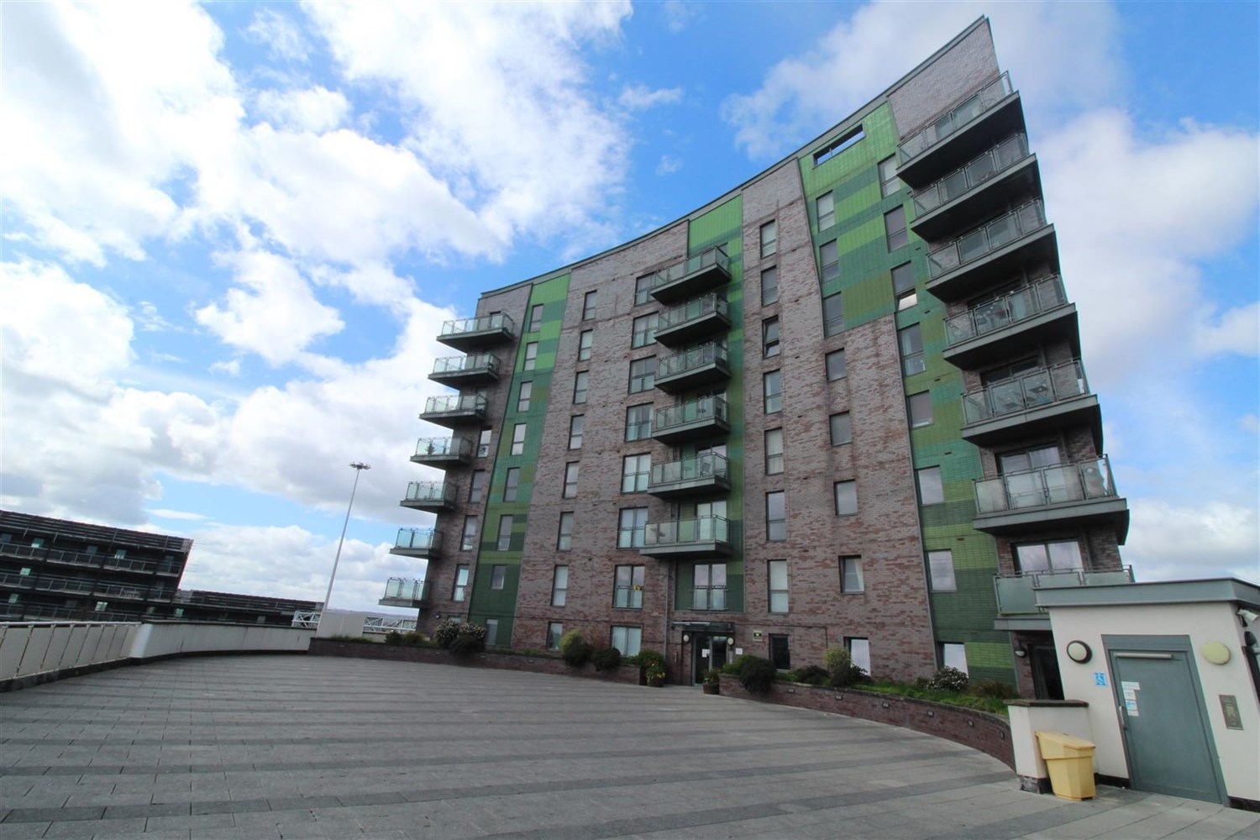



1 Reception(s)

1 Bathroom(s)

1 Bedroom(s)

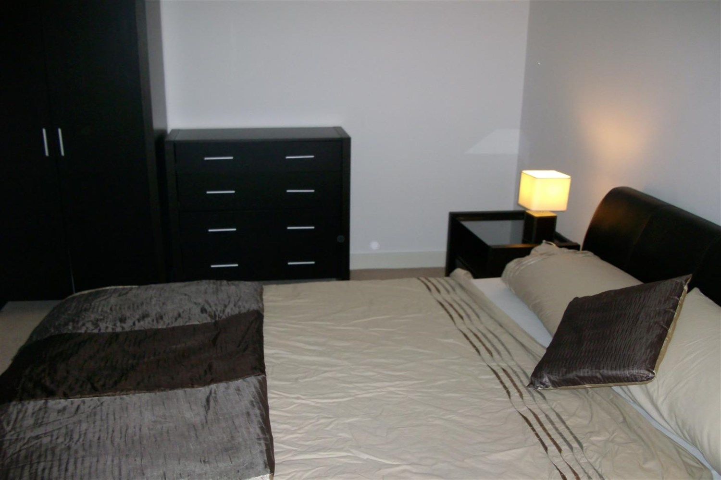

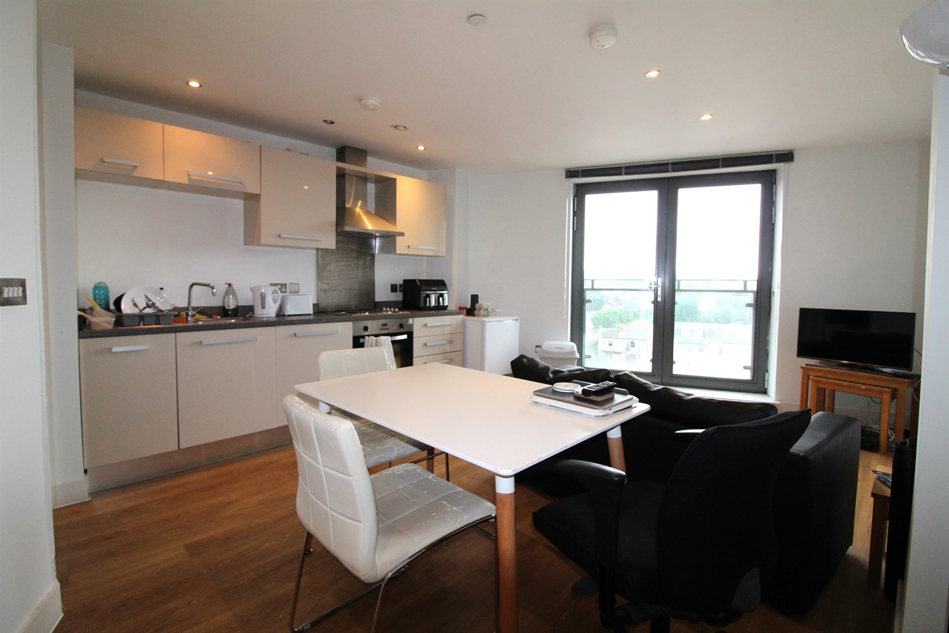

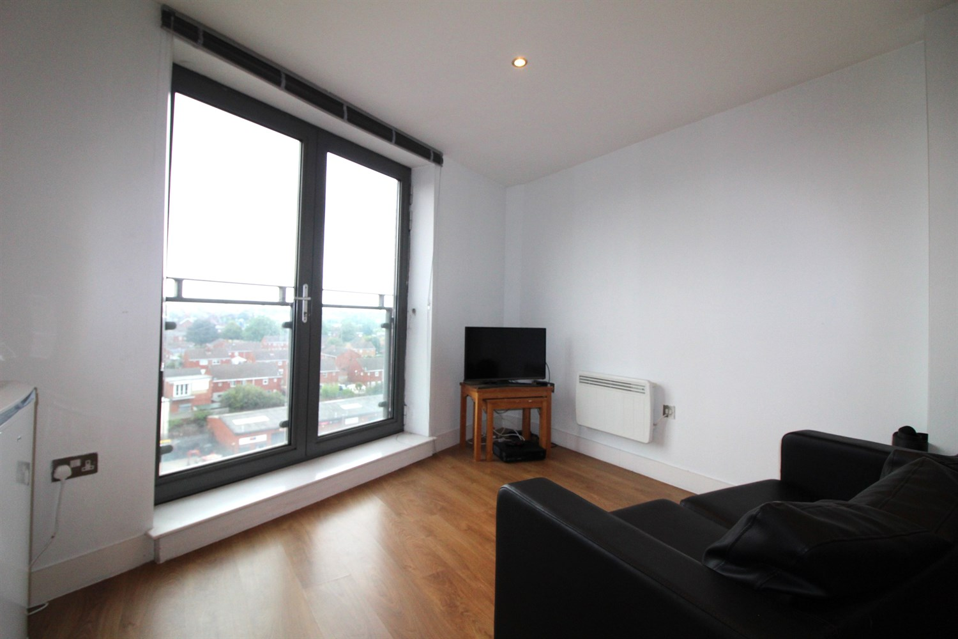

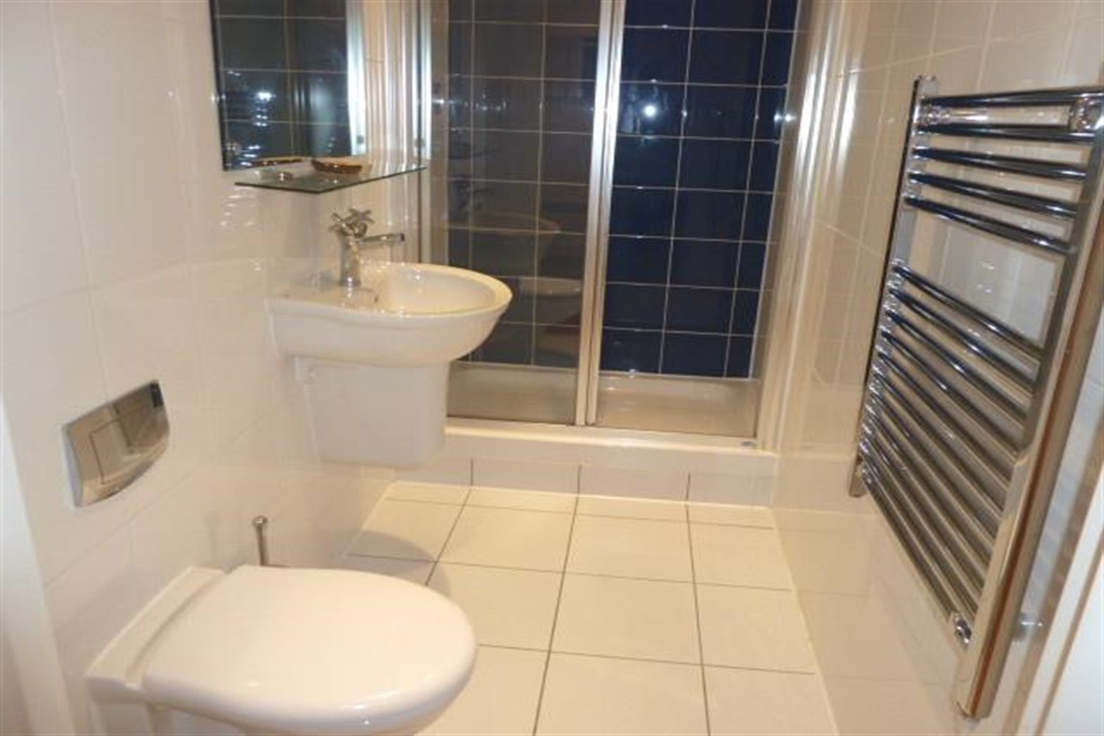

|  |
| --- |
| **Communal entrance**  Entry via secure video intercom entry system. Stairs and lift to all floors. |
| **Open Plan Kitchen/Living/Dining/ room 5.75m (18'10) x 4.04m (13'3)**  Contemporary open plan living room/kitchen with double glazed French doors opening to a Juliet balcony. Wall mounted electric heater. Open plan to the living room and fitted with a range of high gloss wall, base and drawer units. Stainless steel sink with mixer tap. Integrated electric oven and hob with extractor hood over. |
| **Bedroom 3.64m (11'11) x 3.1m (10'2)**  A double bedroom with a wall mounted electric heater and window in to the living room. |
| **Bathroom 2.61m (8'7) x 1.18m (3'10)**  Fitted with a modern three piece white suite comprising shower cubicle, wash hand basin and low level WC. Chrome heated ladder towel rail. Tiled floor. Part tiled walls. |
| **Tenure**  Leasehold - 150 years from Jan 2007 - 134 years remaining. The ground rent is £335.98 per year. |
| **Service Charge**  The service charges are £822.22 for 6 months. |

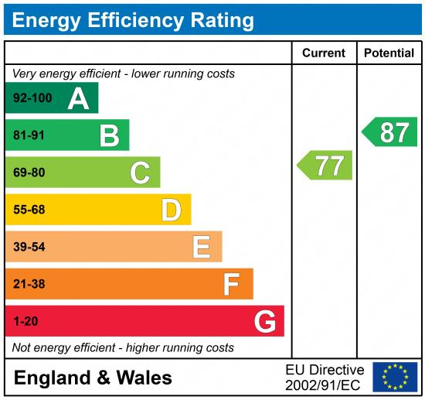

|  |
| --- |
|  |

These particulars are intended to give a fair description of the property, but their accuracy cannot be guaranteed, and they do not constitute an offer of contract. Intending purchasers must rely on their own inspection of the property. None of the above appliances/services have been tested by ourselves. We recommend purchasers arrange for a qualified person to check all appliances/services before legal commitment.

**Property Ref:** 3578

**For more information, please contact**

0113 258 1150 **|** [sales@adairpaxton.co.uk](mailto:sales@adairpaxton.co.uk) **|** www.adairpaxton.co.uk