

**Flat 3, 21 Oakwood Avenue, Roundhay**

**Available to let £1,000pcm**

**STUNNING ONE BEDROOM TOP FLOOR APARTMENT - A STONE'S THROW FROM OAKWOODS SHOPS, RESTAURANTS and BAR'S** This newly refurbished one bedroom apartment sits in a sought after Roundhay location and simply must be viewed to be appreciated. This property is finished to an immaculate standard and briefly comprises; Communal entrance with stairs leading to the first floor, stairs leading to private entrance hall, open plan kitchen/dining room/living room, Master bedroom and a shower room. Located in this much sought after Oakwood location, a stone's throw to local amenities including shops, bars and restaurants, as well as transport links into Leeds. This property won’t be on the market for long - Call now to book a viewing. Available now. Council tax band: TBC. EPC rating: TBC Deposit £1150.

**0113 258 1150**

**0800 000 000**

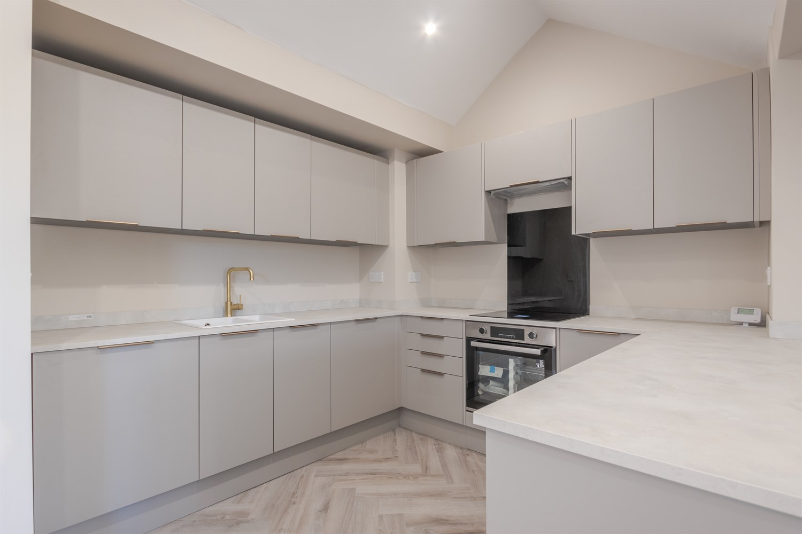



1 Reception

1 Bathroom

1 Bedroom

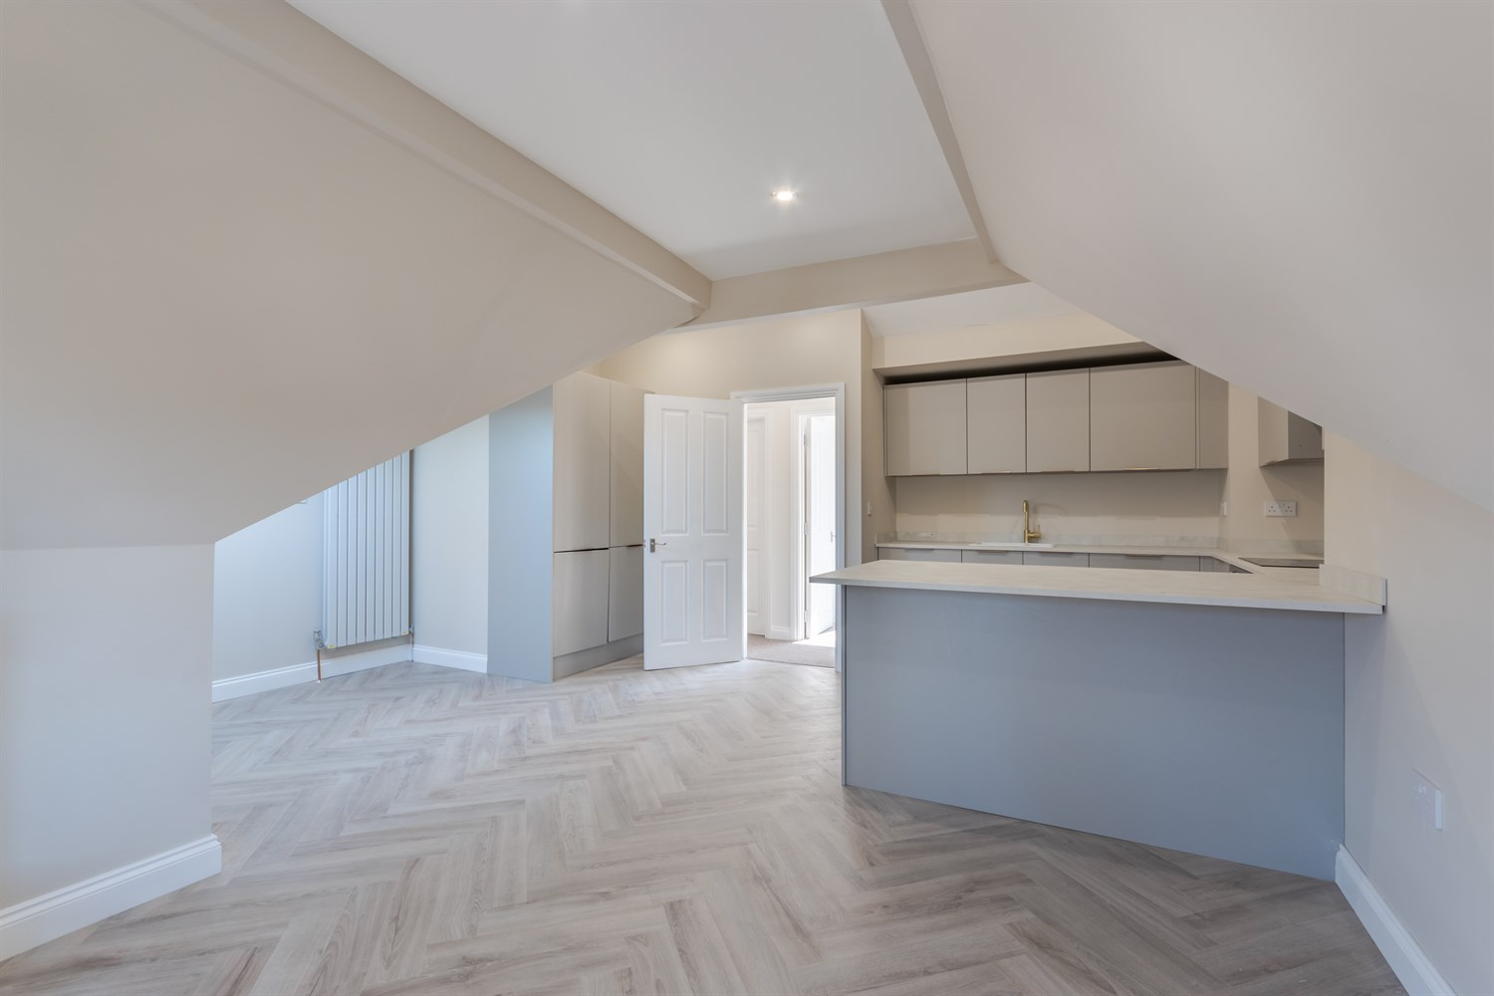

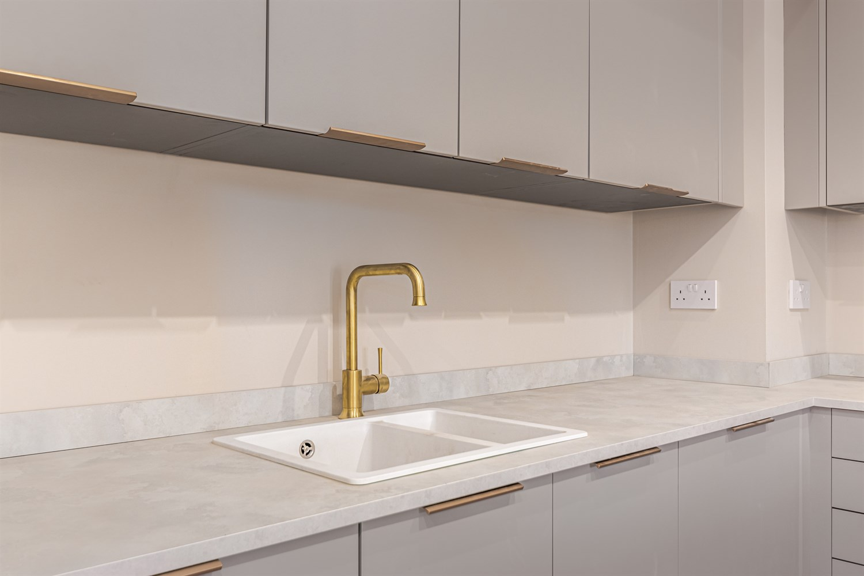

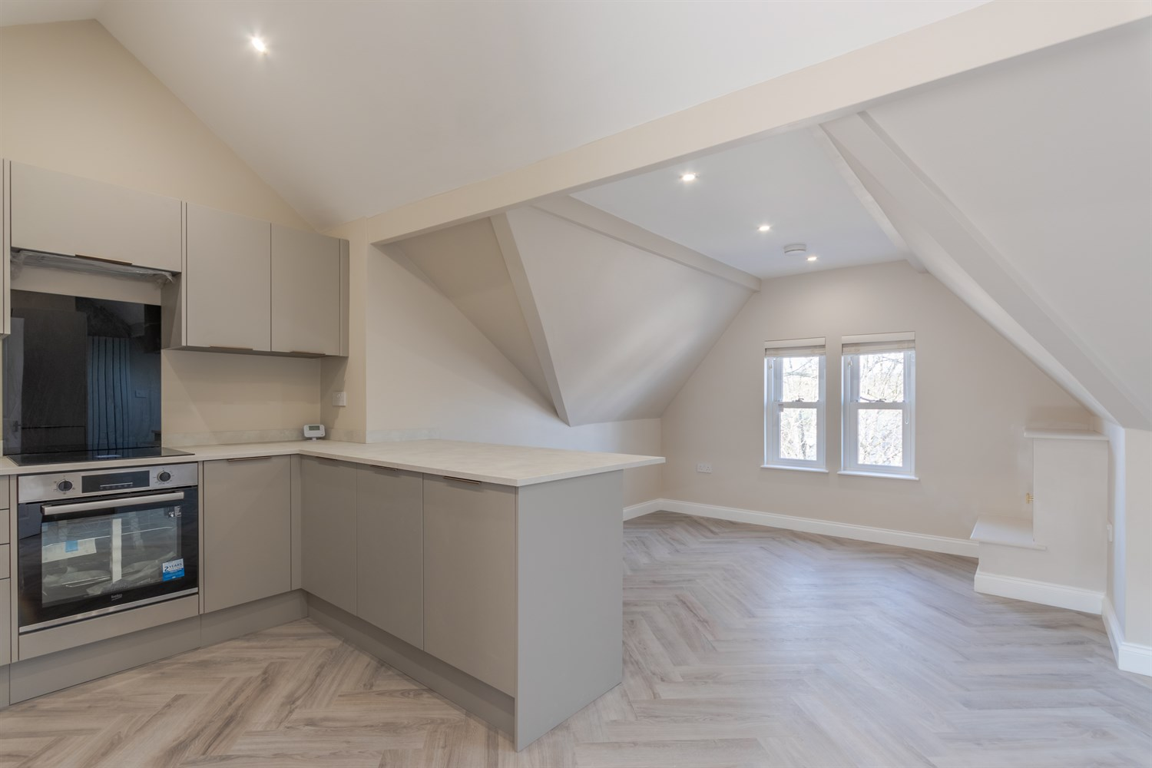

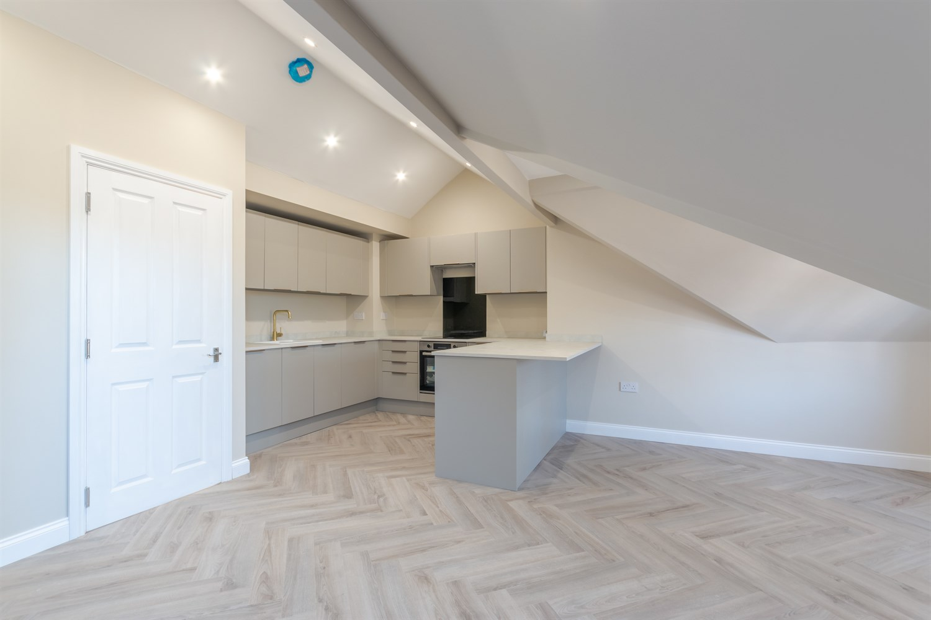

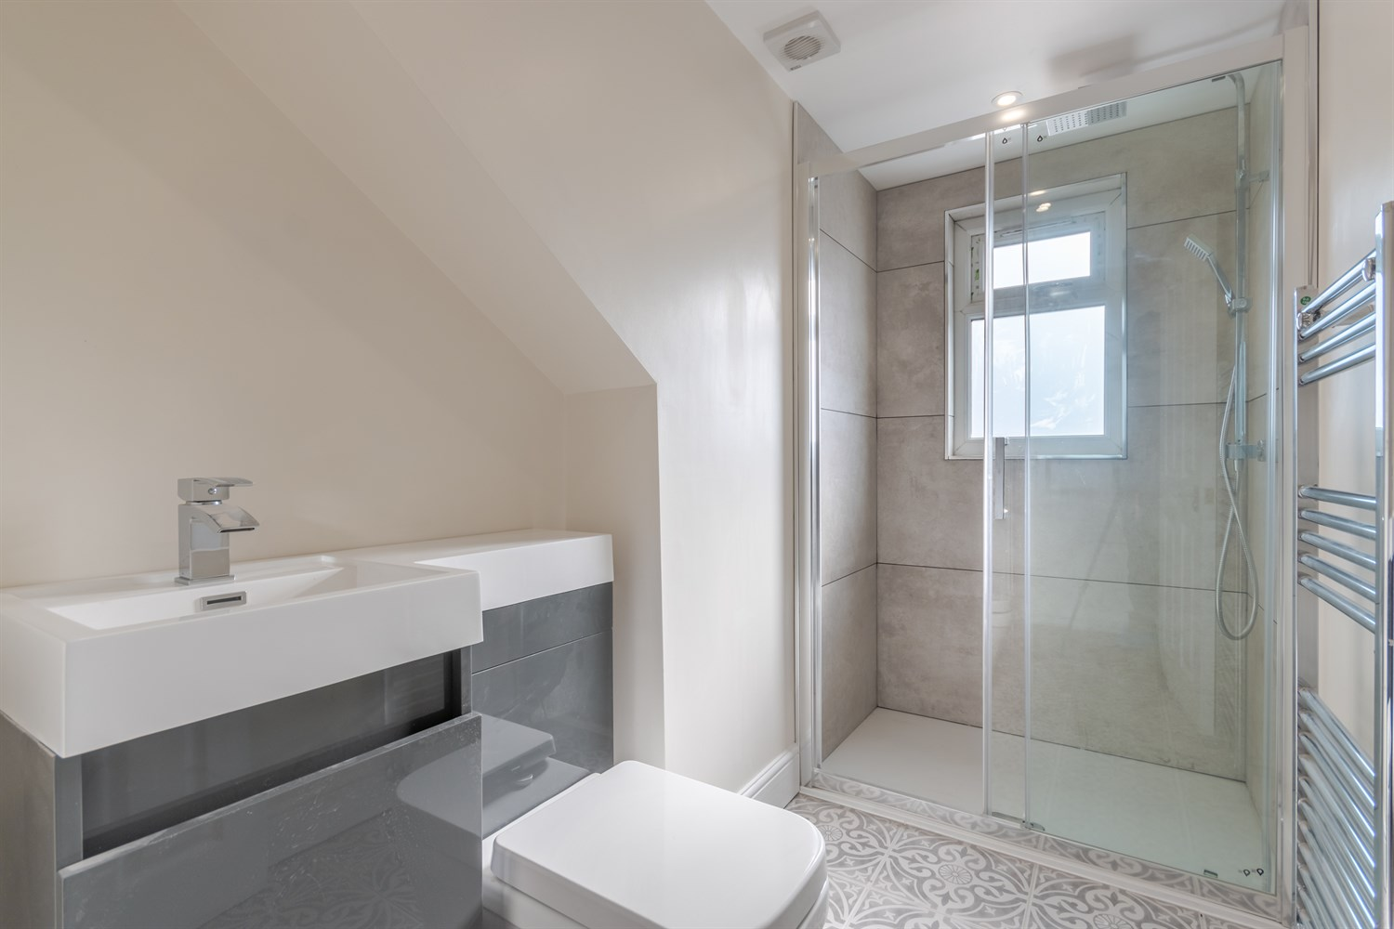

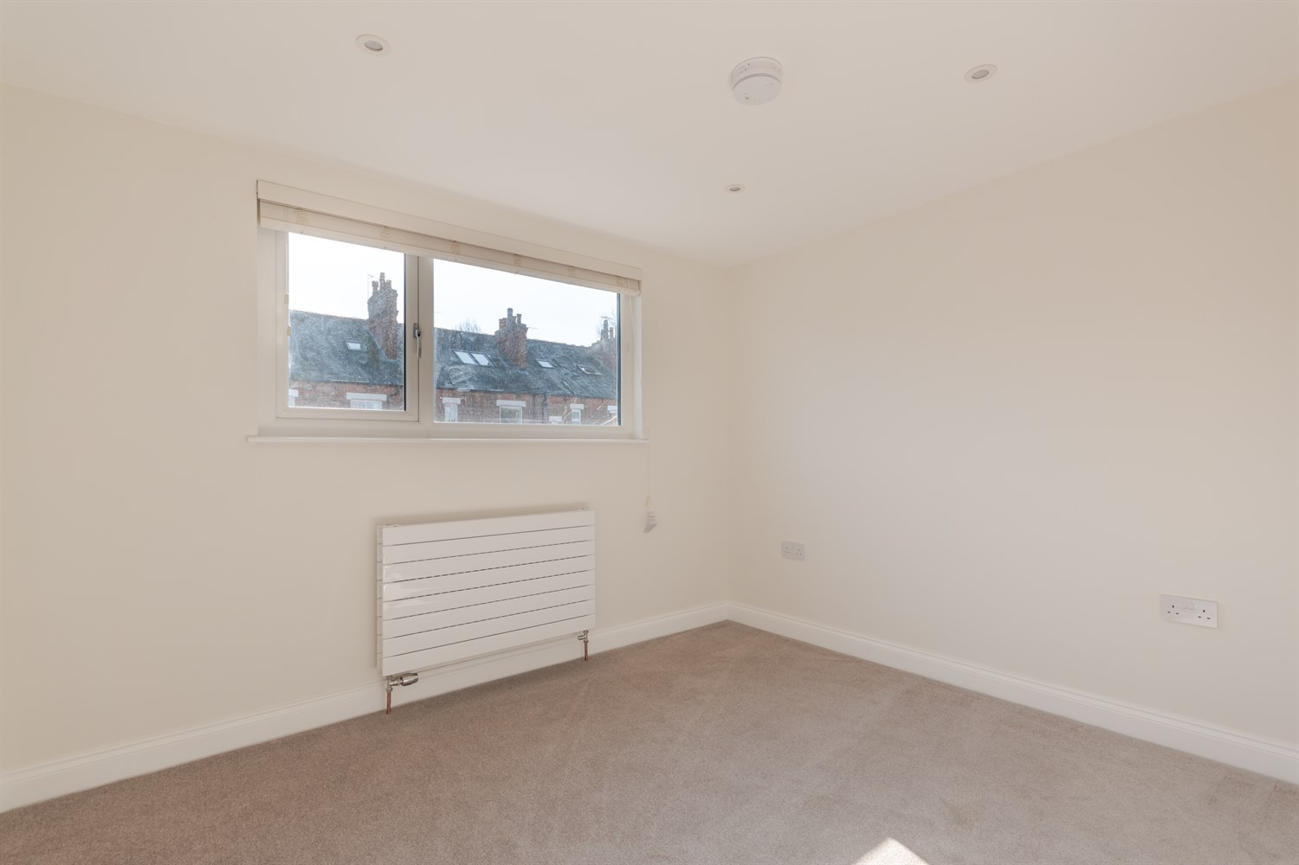

|  |
| --- |
| **Entrance Hall**  Communal entrance with stairs to all floors. |
| **Private Entrance**  Private entrance with stairs leading up to apartment 3. |
| **Open Plan Kitchen/Lounge 5.37m (17'7) x 6.17m (20'3)**  Fitted with a range of wall, base and drawer units with worktops over. Integrated fridge/freezer, washing machine and dishwasher. Integrated oven with 4-ring hob and extractor hood over. Breakfast bar. Inset ceiling spotlights. uPVC double glazed window and Velux window. |
| **Lounge Area**  Opening from the kitchen. A modern, light and airy living space. |
| **Bedroom 3.12m (10'3) x 2.64m (8'8)**  Double bedroom with uPVC double glazed window. Gas central heating radiator. |
| **Shower Room**  Fitted with a three piece suite comprising shower cubicle, WC and wash hand basin. Part tiled walls and tiled floor. Wall mounted heated towel rail. |
| **Central Heating** |
| **Double Glazing** |

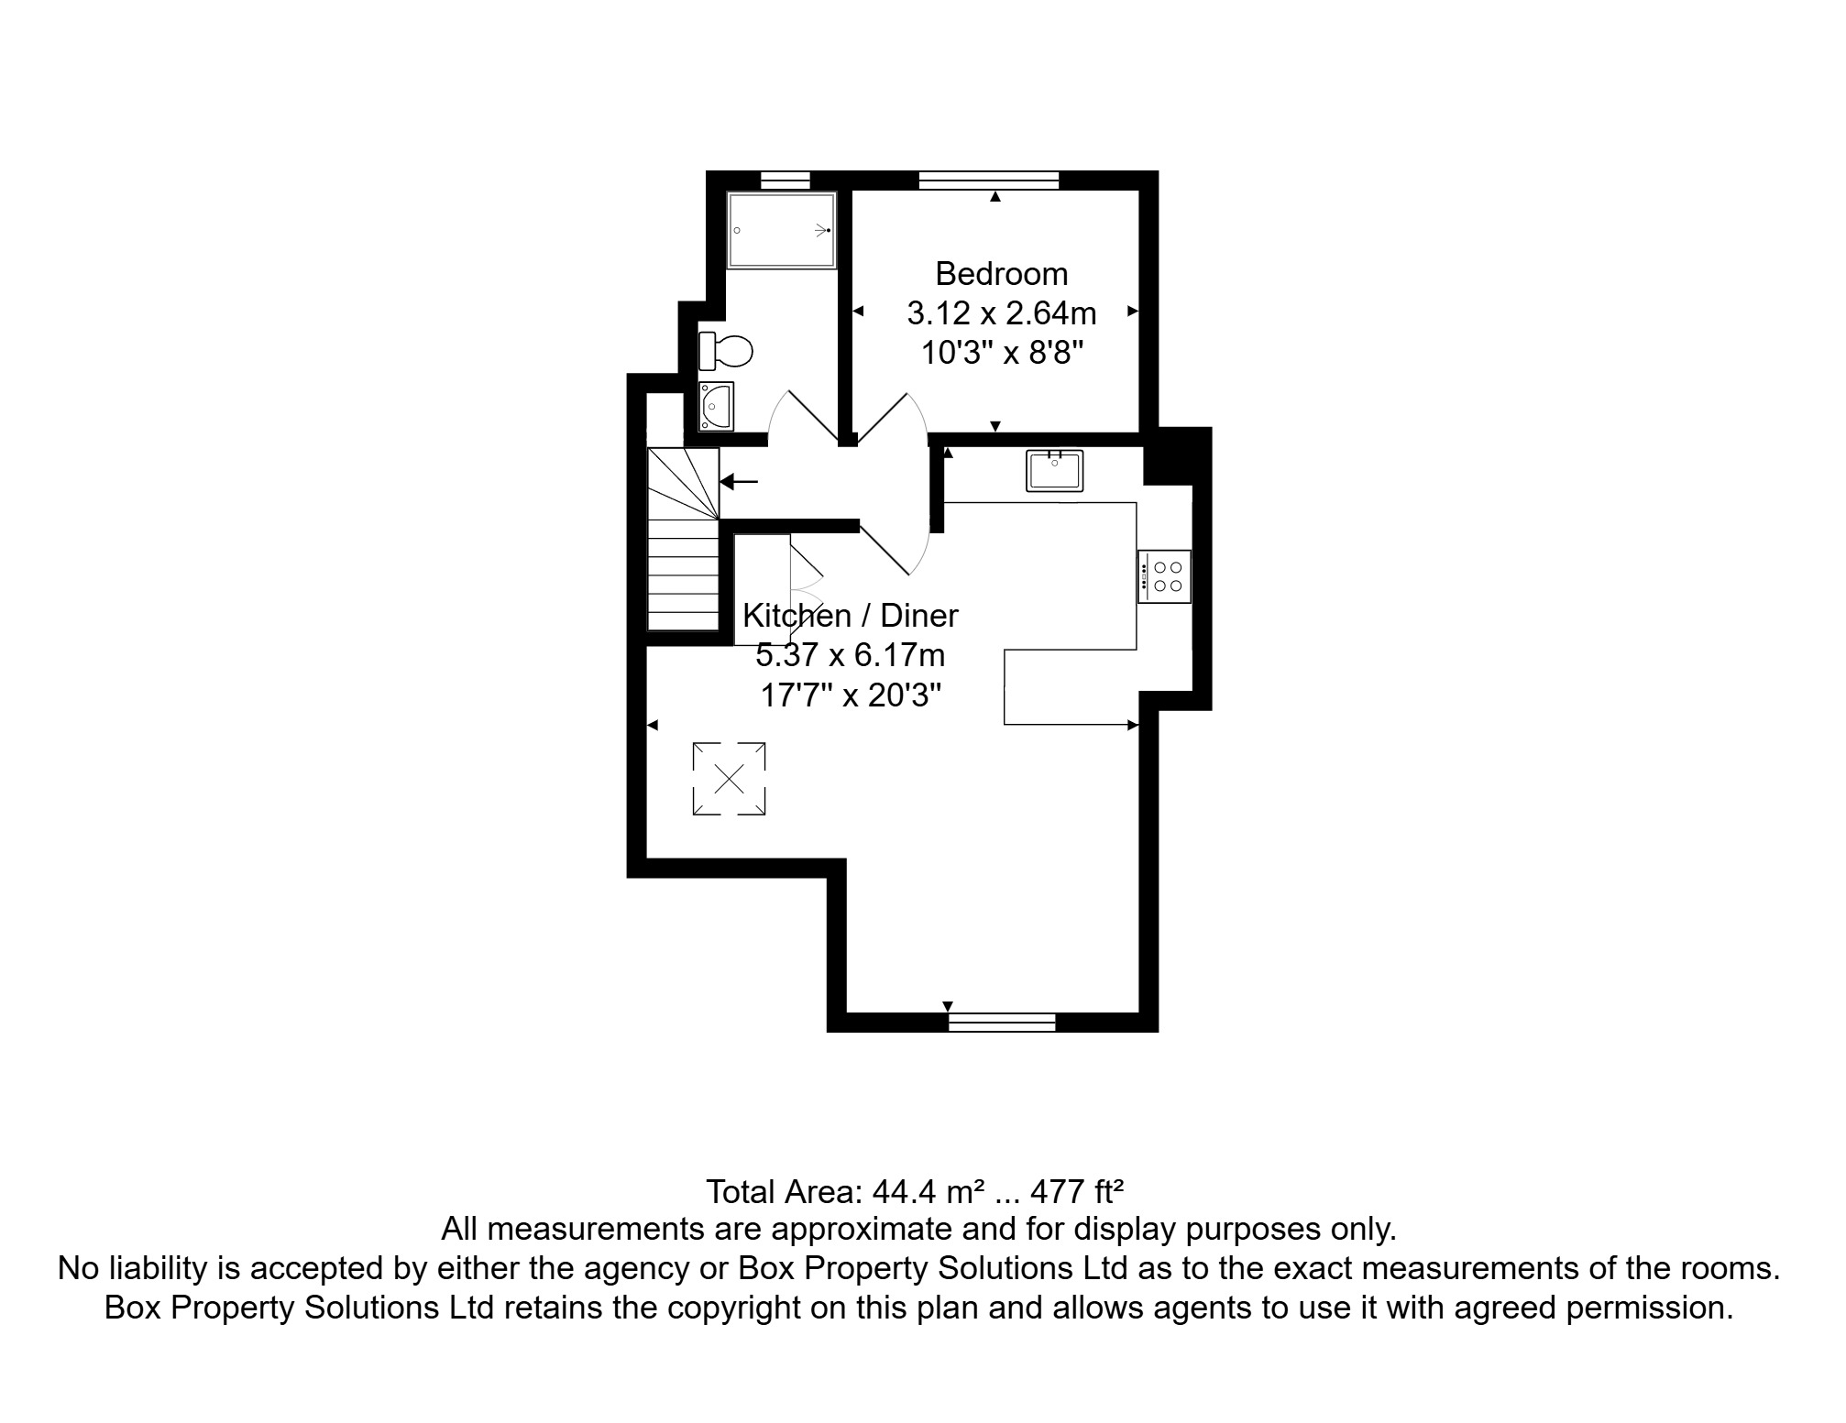

|  |
| --- |
|  |

These particulars are intended to give a fair description of the property, but their accuracy cannot be guaranteed, and they do not constitute an offer of contract. Intending purchasers must rely on their own inspection of the property. None of the above appliances/services have been tested by ourselves. We recommend purchasers arrange for a qualified person to check all appliances/services before legal commitment.

**Property Ref:** 5675

**For more information, please contact**

0113 258 1150 **|** [lettings@adairpaxton.co.uk](mailto:lettings@adairpaxton.co.uk) **|** www.adairpaxton.co.uk