

**2, 21 Oakwood Avenue, Roundhay**

**Available to let £1,300pcm**

**STUNNING TWO BEDROOM, TWO BATHROOM FIRST FLOOR APARTMENT - A STONE'S THROW FROM OAKWOODS SHOPS, RESTAURANTS and BAR'S** This newly refurbished two bedroom apartment sits in a sought after Roundhay location and simply must be viewed to be appreciated. This property is finished to an immaculate standard and briefly comprises; Communal entrance with stairs leading to the first floor, private entrance hall, open plan kitchen/dining room/living room, Master bedroom with en-suite shower room, second bedroom and a house bathroom. Located in this much sought after Oakwood location, a stone's throw to local amenities including shops, bars and restaurants, as well as transport links into Leeds. This property won’t be on the market for long - Call now to book a viewing.

**0113 258 1150**

**0800 000 000**

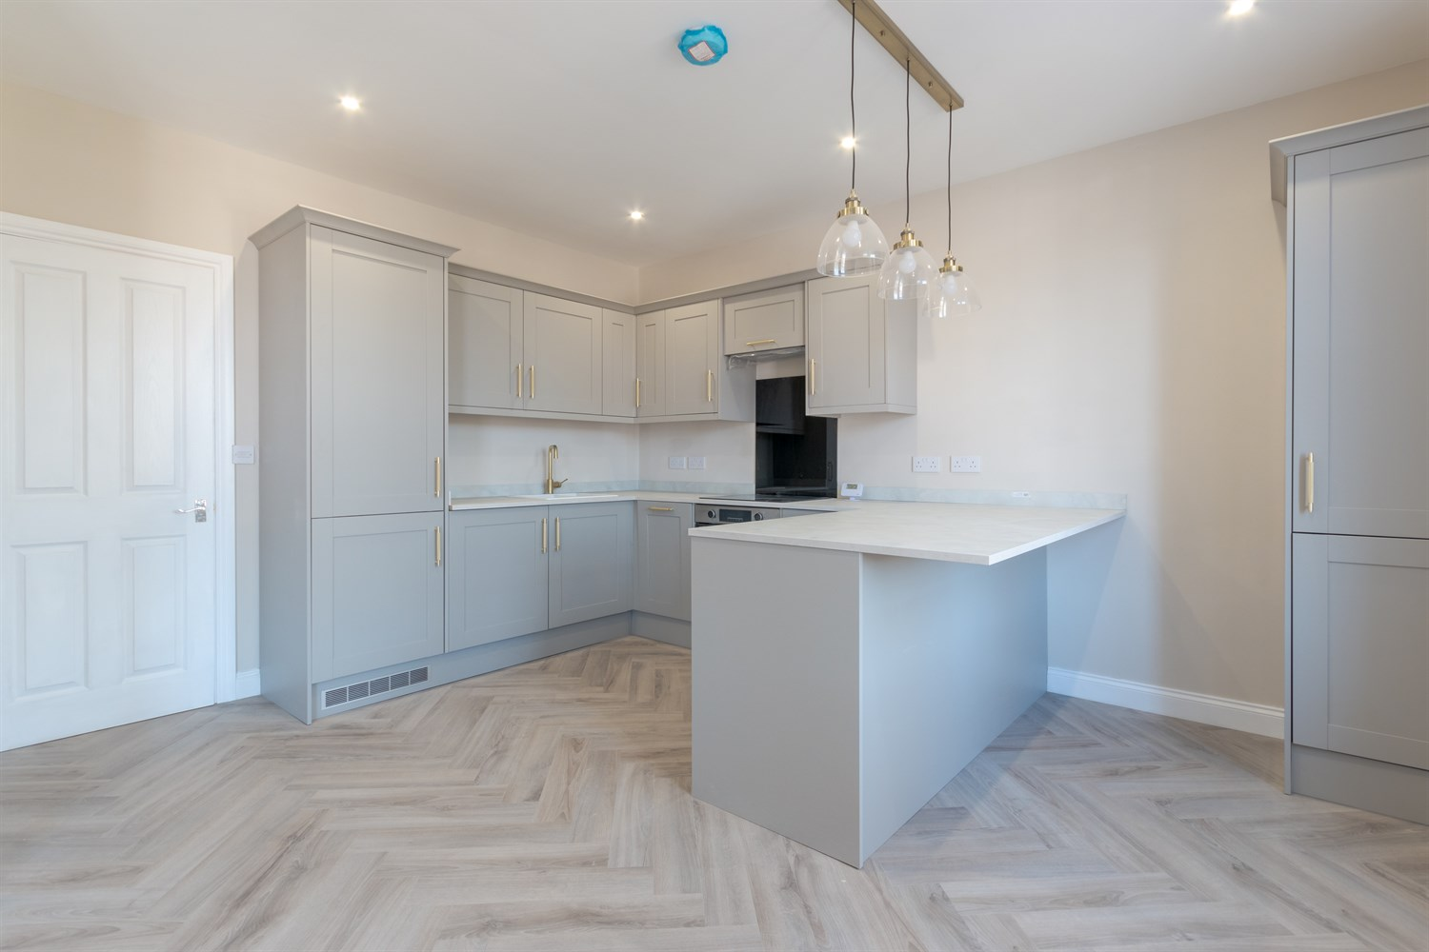

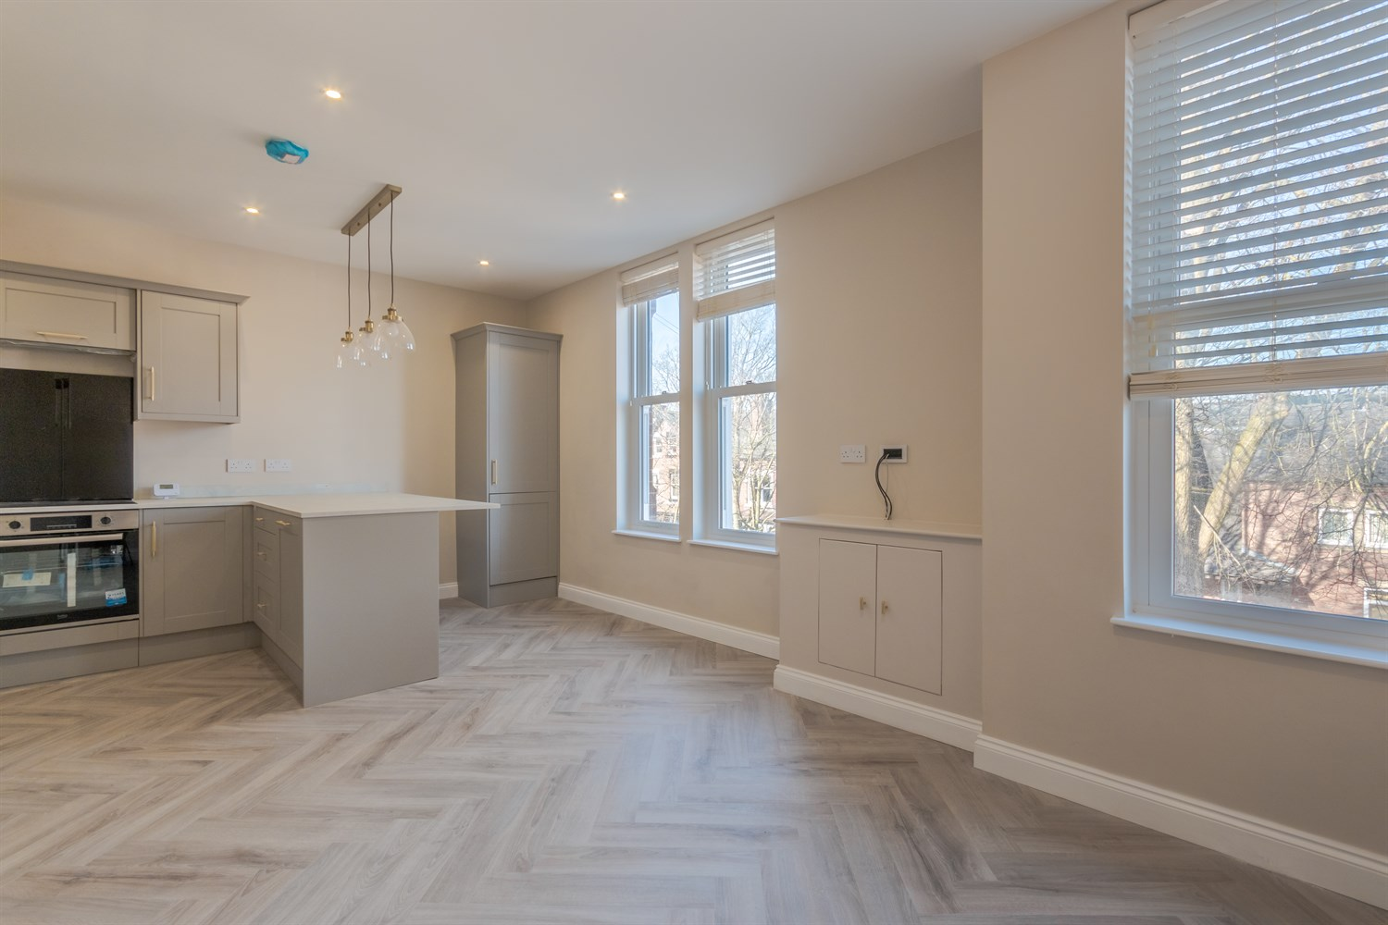

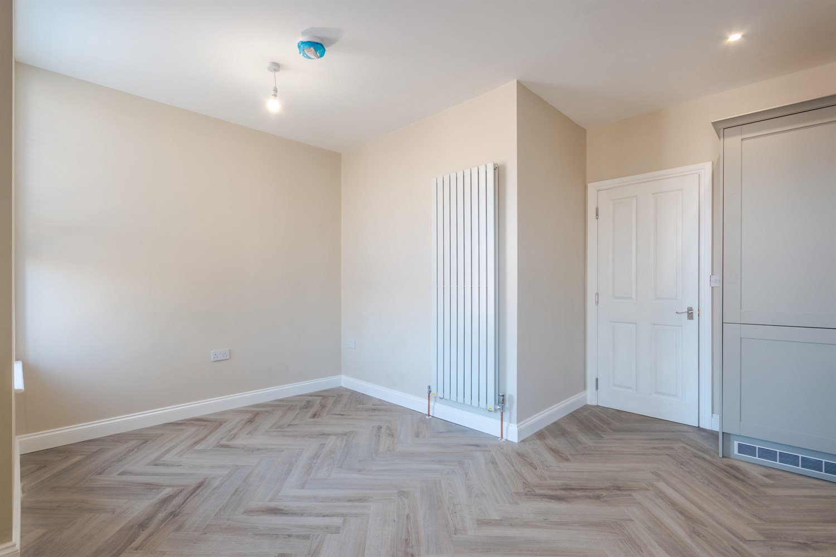

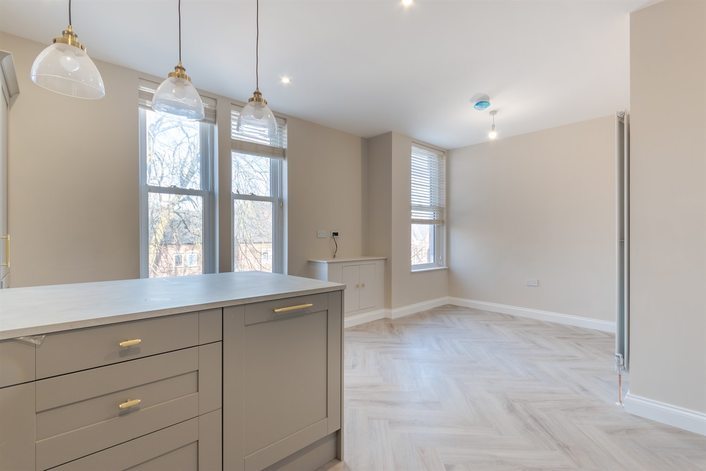

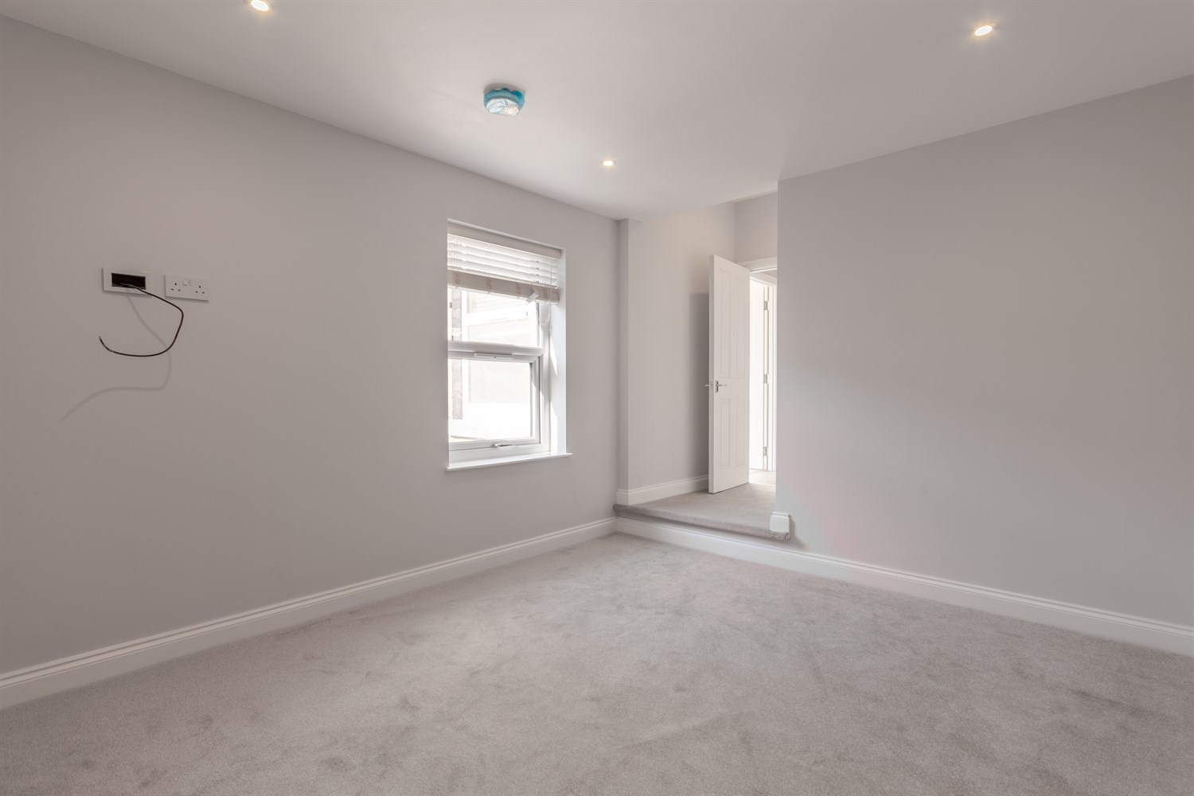

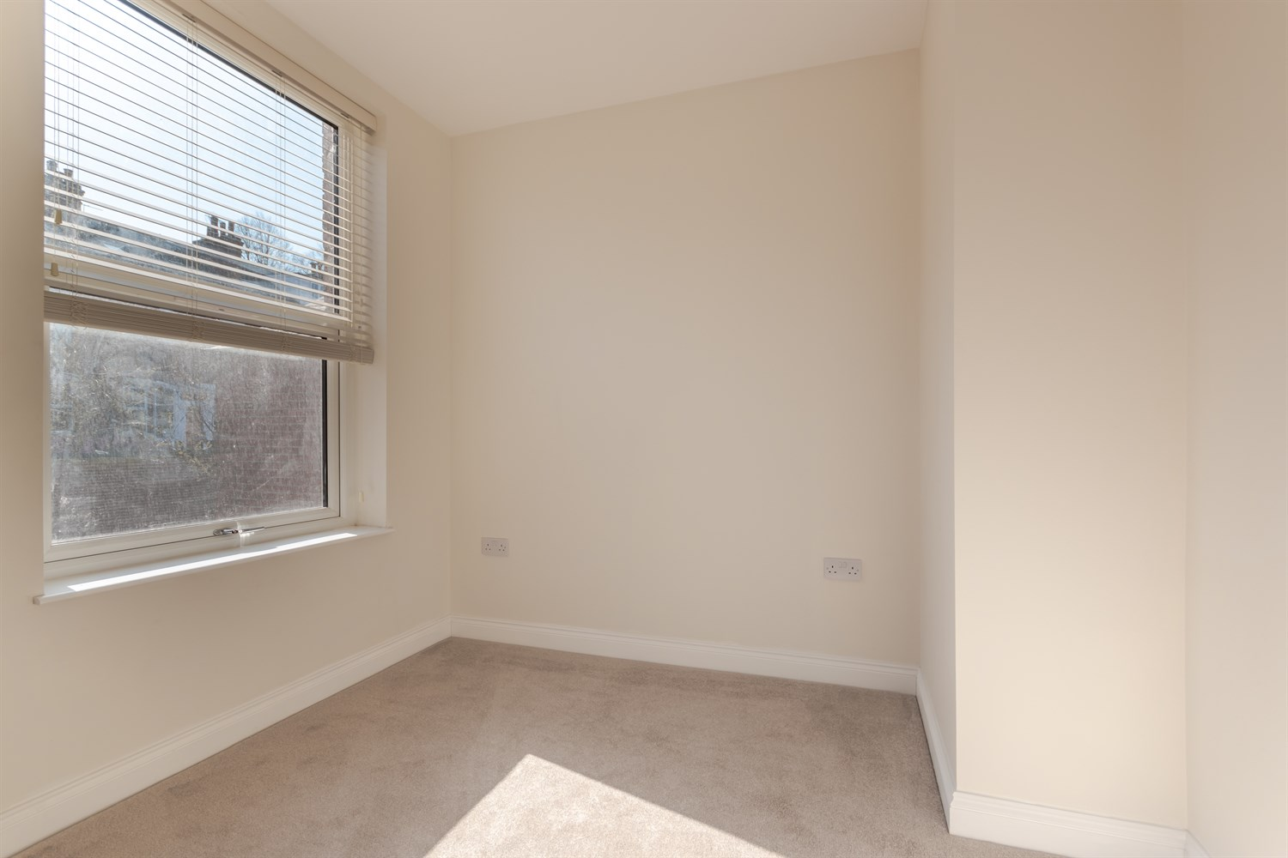

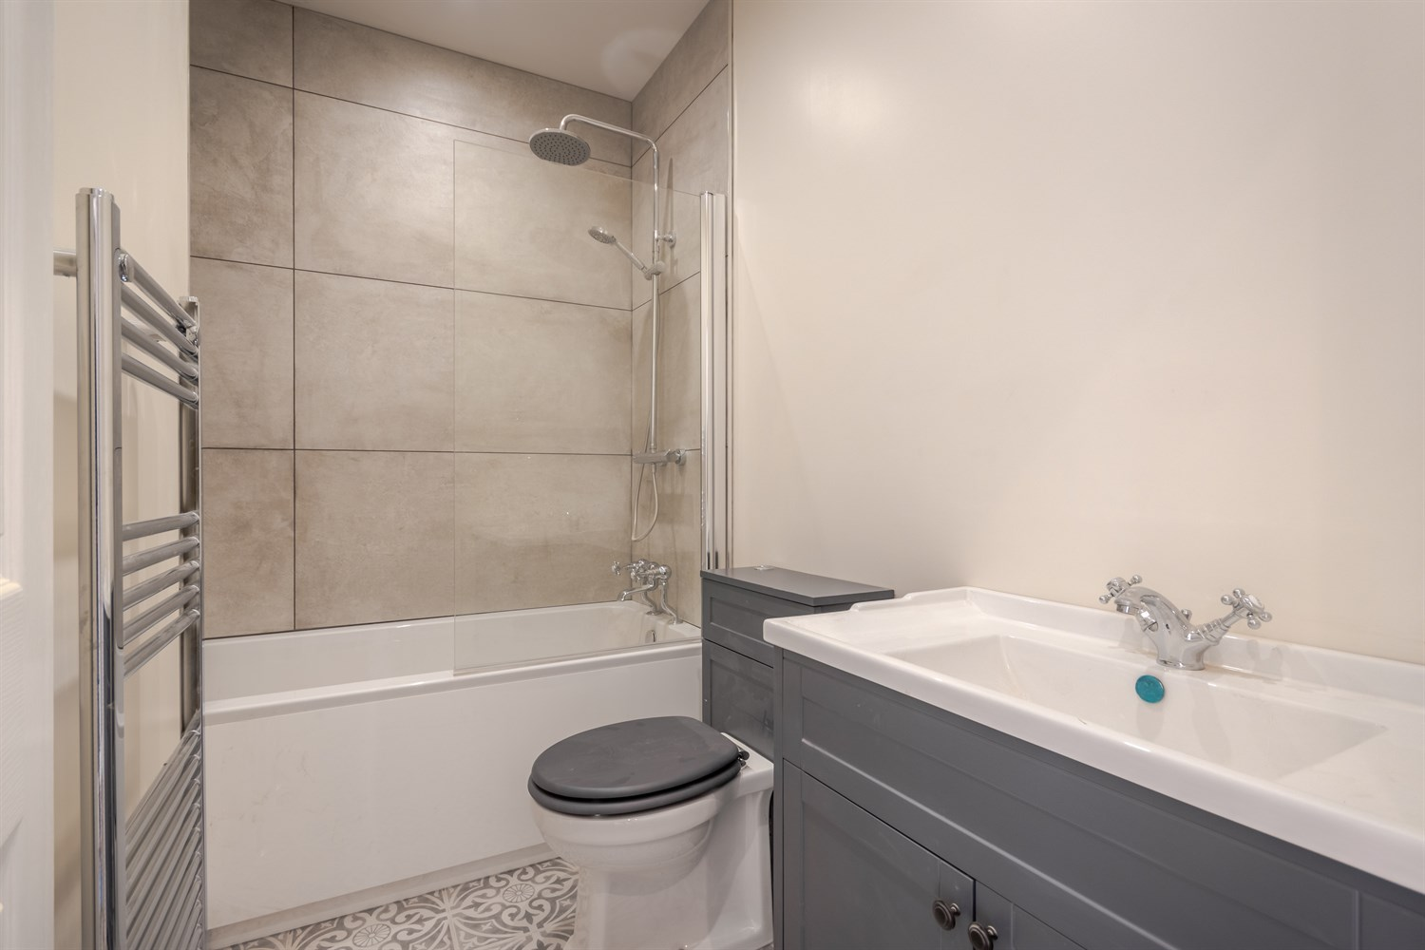

|  |
| --- |
| **Communal Entrance**  Via front entrance door. Stairs to first floor. |
| **Private Entrance**  Via front entrance door. |
| **Open Plan Kitchen/Lounge**  Fitted with a range of wall, base and drawer units with worktops over. Integrated fridge/freezer, washing machine and dishwasher. Integrated oven with 4-ring hob and extractor hood over. Breakfast bar. Inset ceiling spotlights. Three uPVC double glazed sash windows to front. |
| **Living Area**  Opening from the kitchen/diner. Light and airy living space. |
| **Bedroom 1**  Double bedroom with uPVC double glazed sash window. Gas central heating radiator. |
| **En-Suite Shower Room**  Fitted with a three piece suite comprising; Shower cubicle, WC and wash hand basin. Tiled floor. uPVC double glazed window. |
| **Bedroom 2**  Second bedroom with uPVC double glazed sash window. Gas central heating radiator. |
| **Bathroom**  Fitted with a three piece suite comprising; bath, WC and wash hand basin. Tiled floor. Wall mounted heated towel rail. |

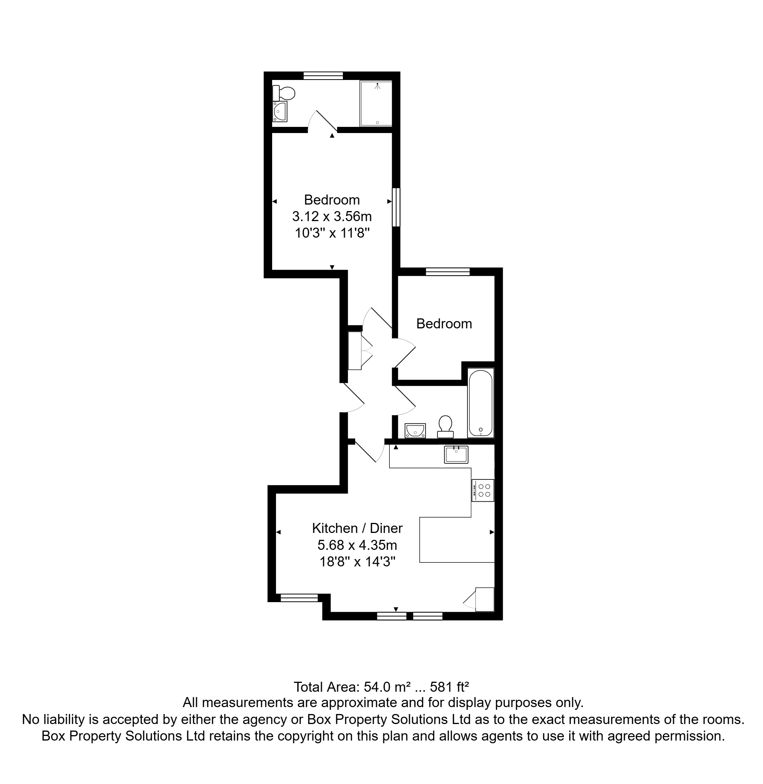

|  |
| --- |
|  |

These particulars are intended to give a fair description of the property, but their accuracy cannot be guaranteed, and they do not constitute an offer of contract. Intending purchasers must rely on their own inspection of the property. None of the above appliances/services have been tested by ourselves. We recommend purchasers arrange for a qualified person to check all appliances/services before legal commitment.

**Property Ref:** 5568

**For more information, please contact**

0113 258 1150 **|** [lettings@adairpaxton.co.uk](mailto:lettings@adairpaxton.co.uk) **|** www.adairpaxton.co.uk