

**Basilica, LS1**

**Available to let £795.00pcm**

***STYLISHLY PRESENTED FOURTH FLOOR STUDIO/ONE BEDROOM APARTMENT*** Superbly located within this converted building. The property is larger than a lot of similar apartments in the building. Basilica is surrounded by local amenities including shops, bars and restaurants. With great transports links and easy access to the hospital and universities. Deposit £915. Available 27th July, council tax band B, EPC rating B.

**0113 258 1150**

**0800 000 000**

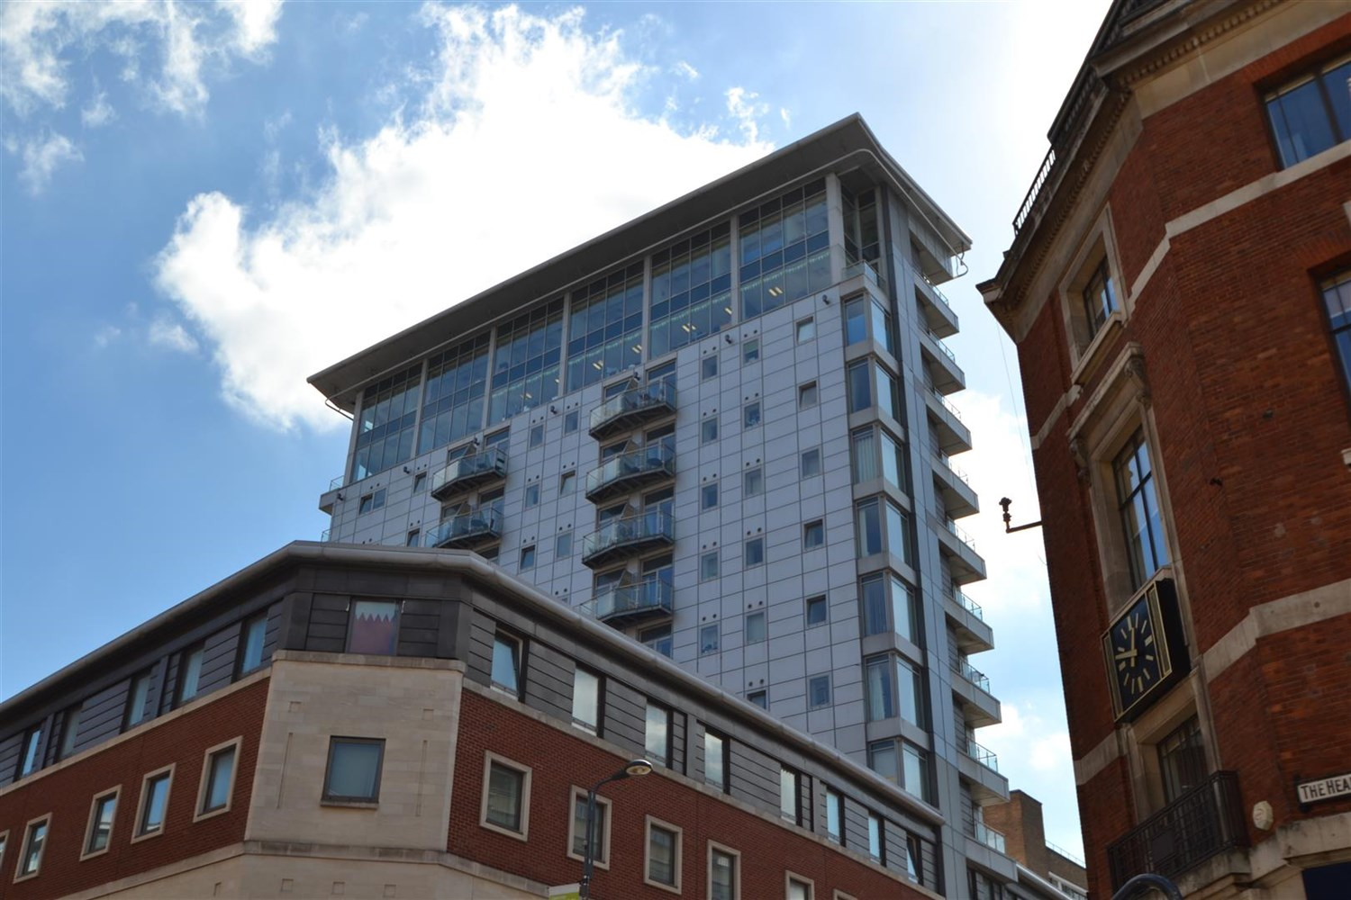



1 Reception(s)

1 Bathroom(s)

1 Bedroom(s)

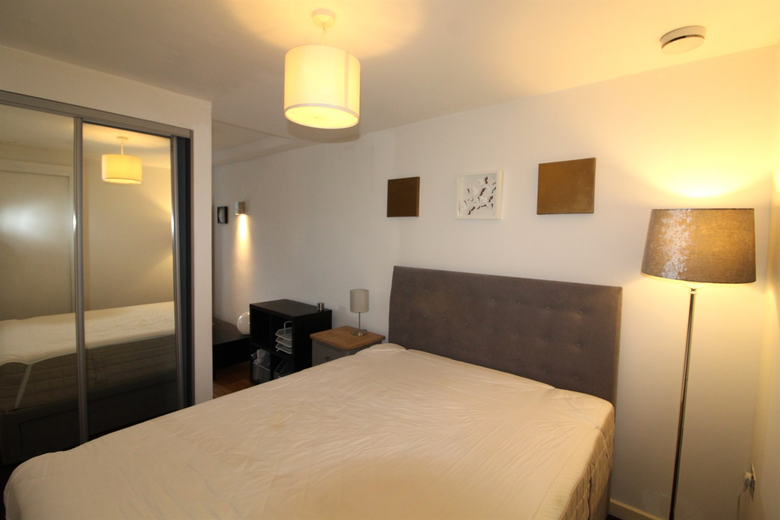

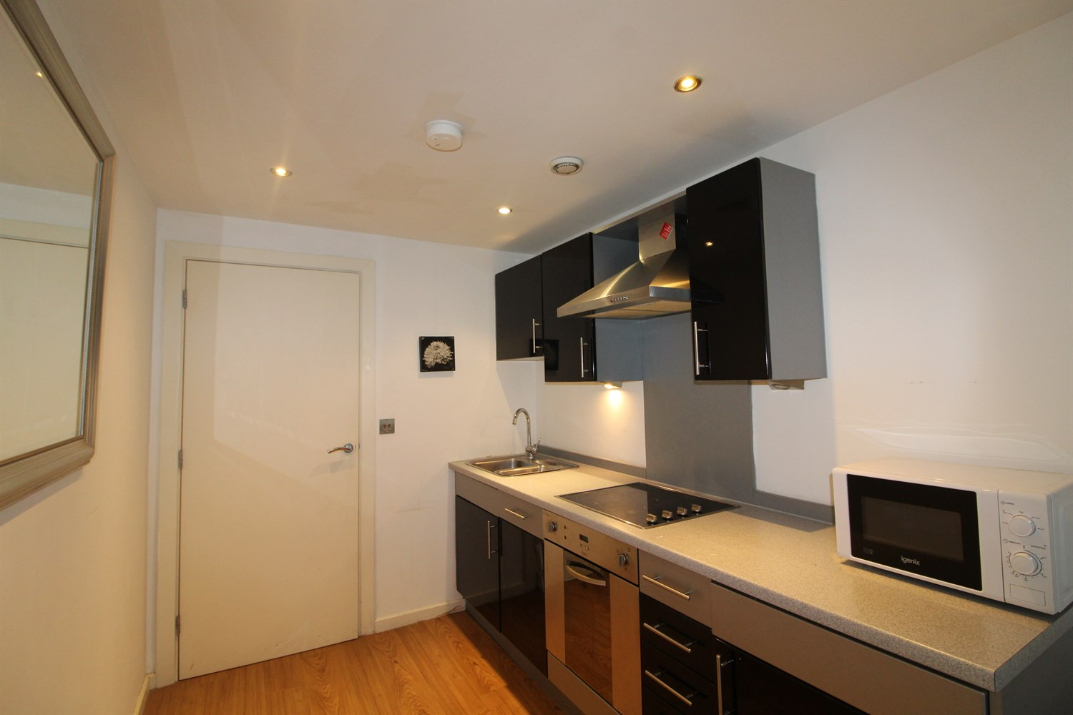

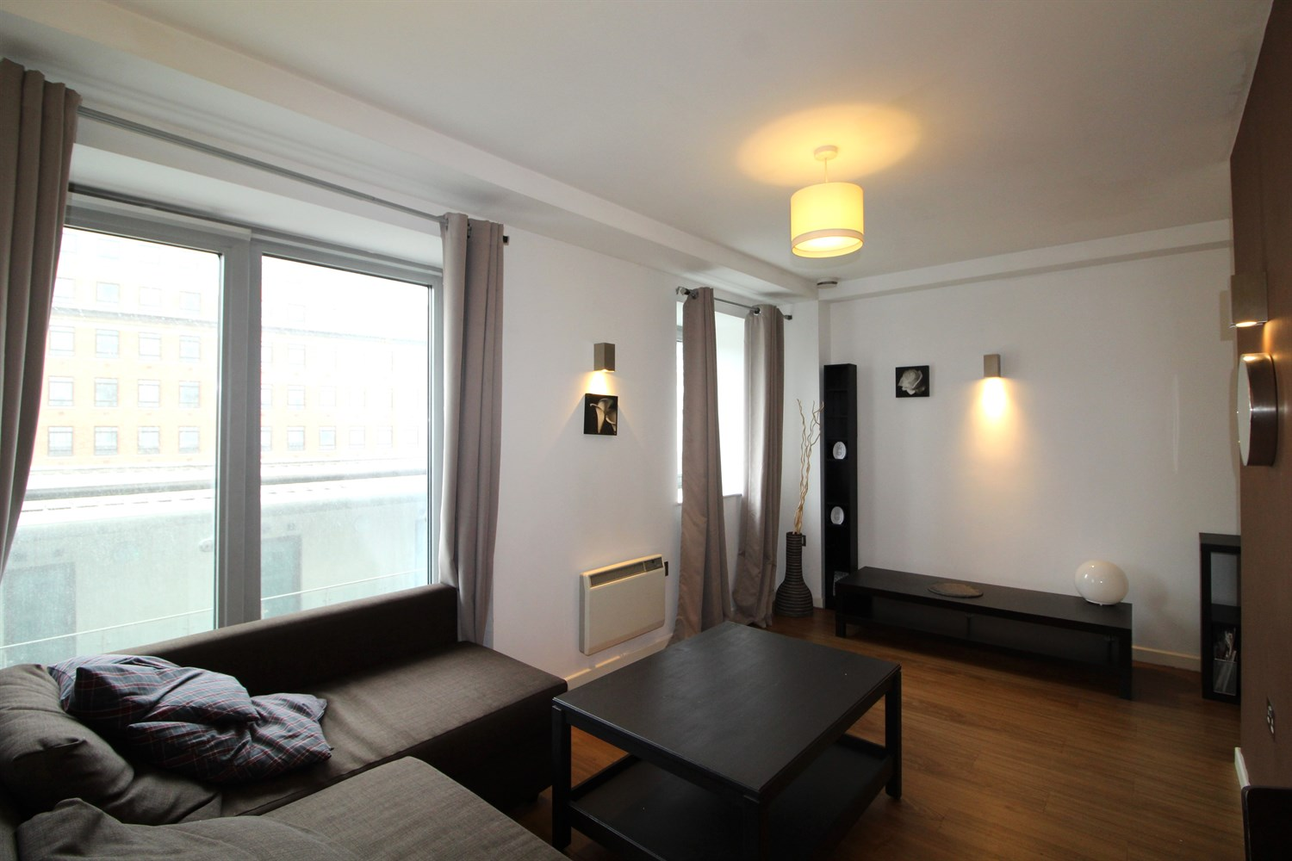

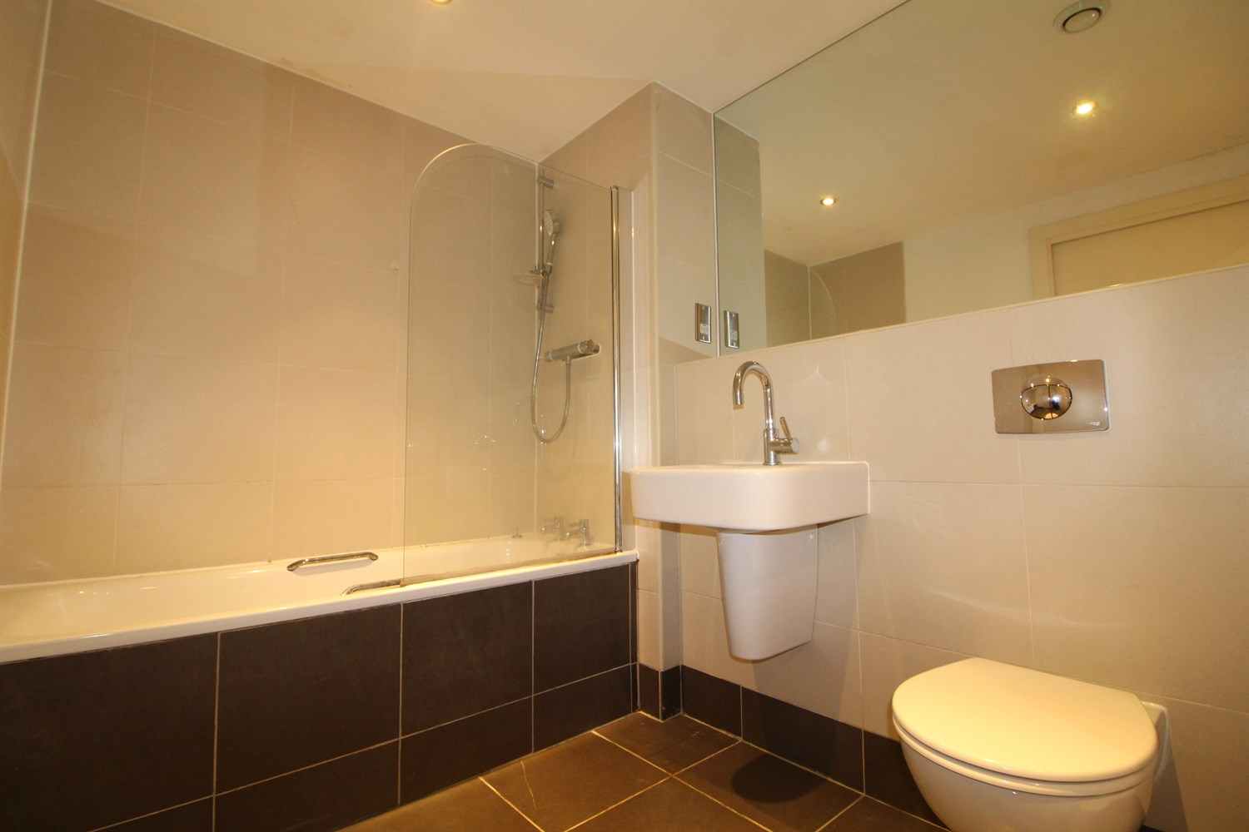

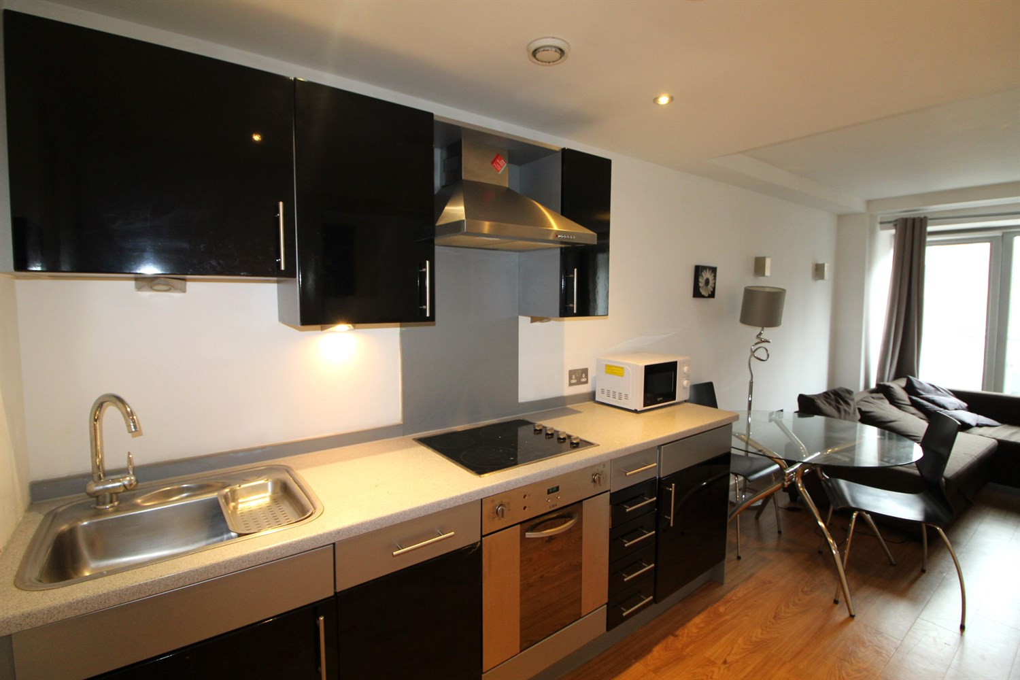

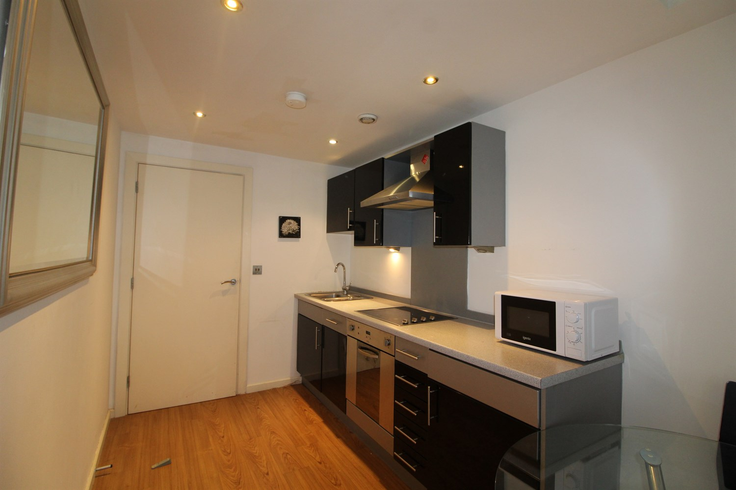

|  |
| --- |
| **Communal Entrance**  Entry fob system, concierge onsite. Lift to all floors. |
| **Reception 1**  Open plan living room and kitchen. Kitchen fitted with a range of wall and base units with worktops over, electric oven and hob with extractor overhead. Stainless steel sink with mixer tap. Wooden floors, electric heating. |
| **Bedroom Area**  Double bed just off the living room with large mirrored wardrobe. |
| **Bathroom**  Three piece shower room with walk in shower WC and hand wash basin. Tiled walls and floor. |
| **Home information**  COUNCIL TAX BAND: B EPC Rating B  Leasehold property No Parking  Mobile availability: EE likely to have good coverage. Three likely to have good coverage. O2 likely to have good coverage. Vodafone likely to have good coverage. Broadband: Standard 22 Mbps 1 Mbps or Ultrafast 1000 Mbps 1000 Mbps Utilities: Water supplied on standard meters. Electric mains supplied on standard meters. |

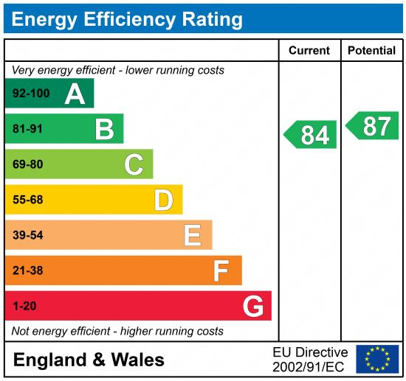

|  |
| --- |
|  |

These particulars are intended to give a fair description of the property, but their accuracy cannot be guaranteed, and they do not constitute an offer of contract. Intending purchasers must rely on their own inspection of the property. None of the above appliances/services have been tested by ourselves. We recommend purchasers arrange for a qualified person to check all appliances/services before legal commitment.

**Property Ref:** 6605

**For more information, please contact**

0113 258 1150 **|** [lettings@adairpaxton.co.uk](mailto:lettings@adairpaxton.co.uk) **|** www.adairpaxton.co.uk