

**0113 258 1150**

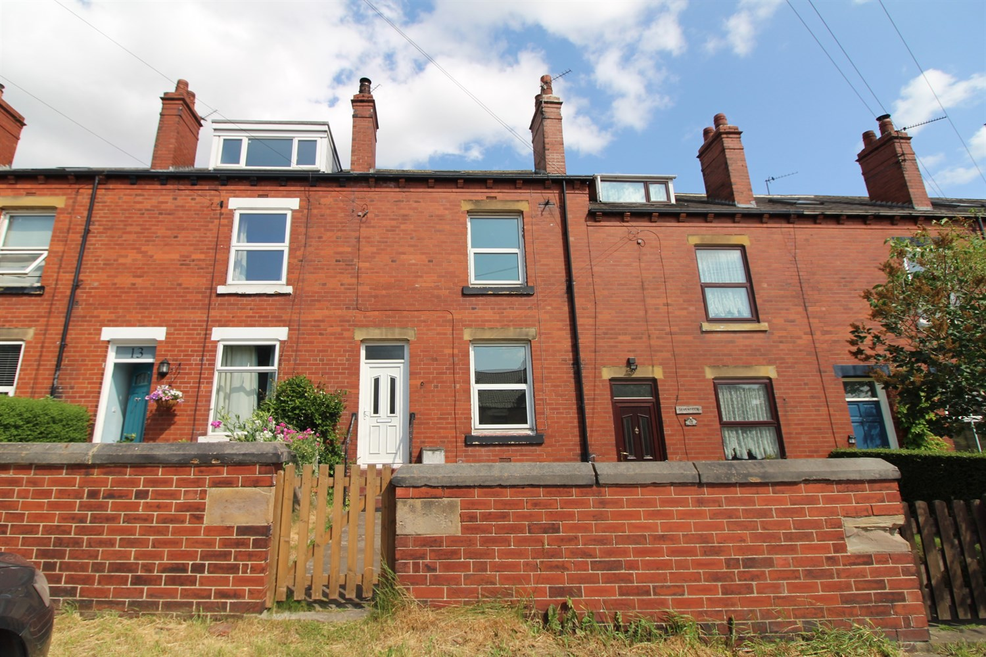



**For Sale £150,000.00**

**Claremont View, Oulton**

***THREE BEDROOM THROUGH MID-TERRACE - NO ONWARD CHAIN*** Located in the popular area of Oulton, this spacious and well presented house would make a great first time buy. The property is set over three floors and is now in need of some cosmetic updating, and briefly comprises: lounge and dining/kitchen to the ground floor. Cellar useful for storage. To the first floor there is a master bedroom, second double bedroom and house bathroom to the first floor. To the second floor is a double bedroom. Externally, the property has a courtyard style garden to the read and an enclosed lawned garden to the front. Gas central heating and uPVC double glazing - An early internal viewing is highly recommended to appreciate the accommodation on offer. Located in the sought after village of Oulton, the property is close to a range of amenities, including supermarkets, shops, restaurants and pubs. Excellent transport links can be found from the M1, M621, M62 and Woodlesford rail station, connecting the property to Leeds City Centre and beyond.

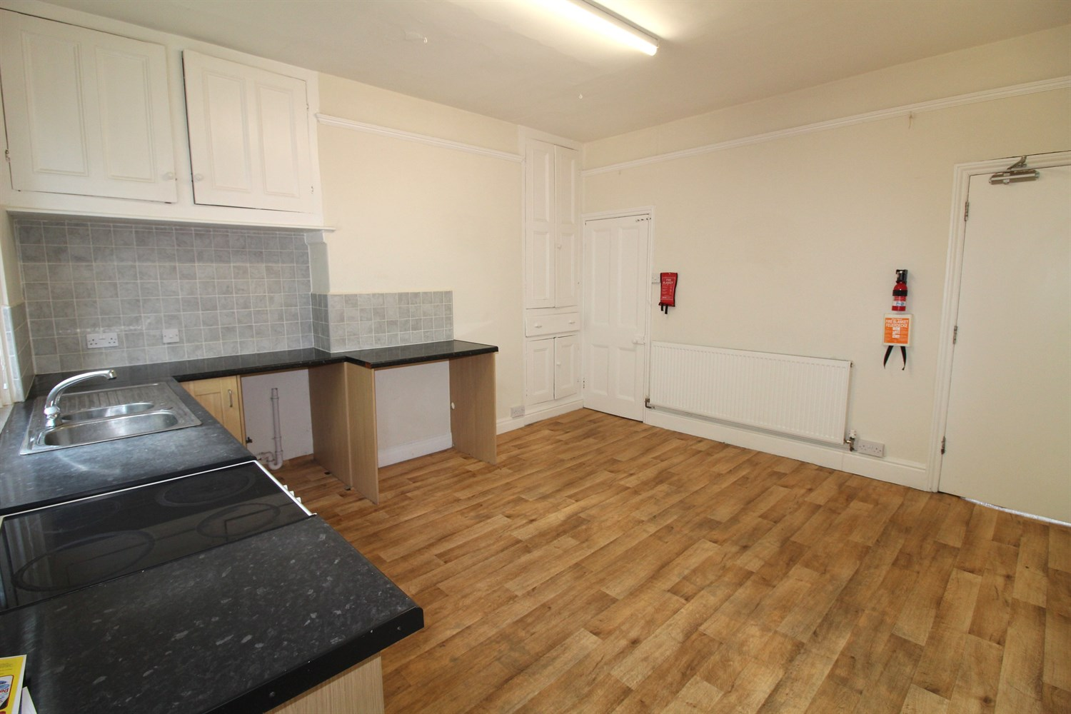

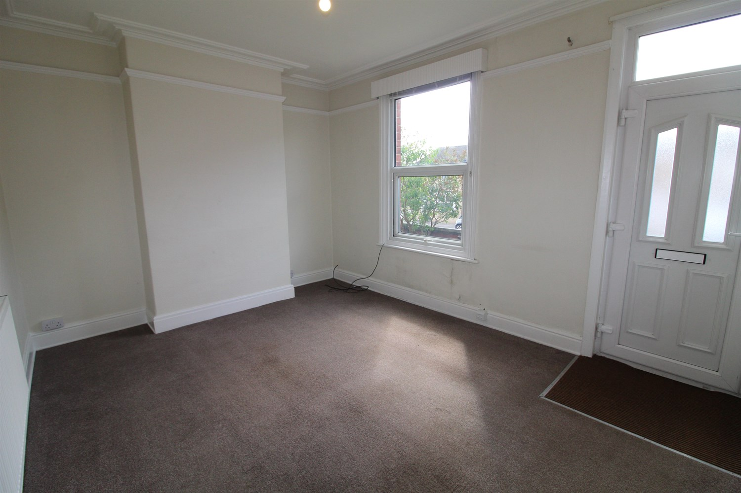

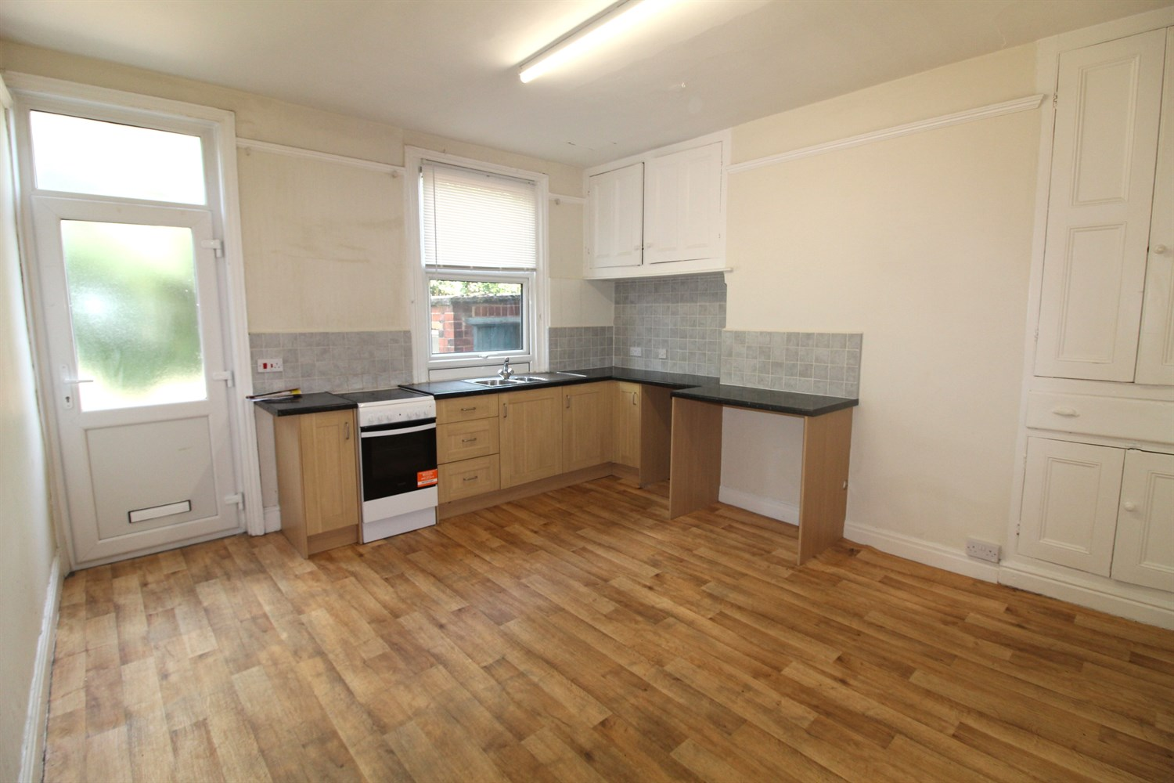

1 Bathroom

1 Reception

3 Bedrooms

00

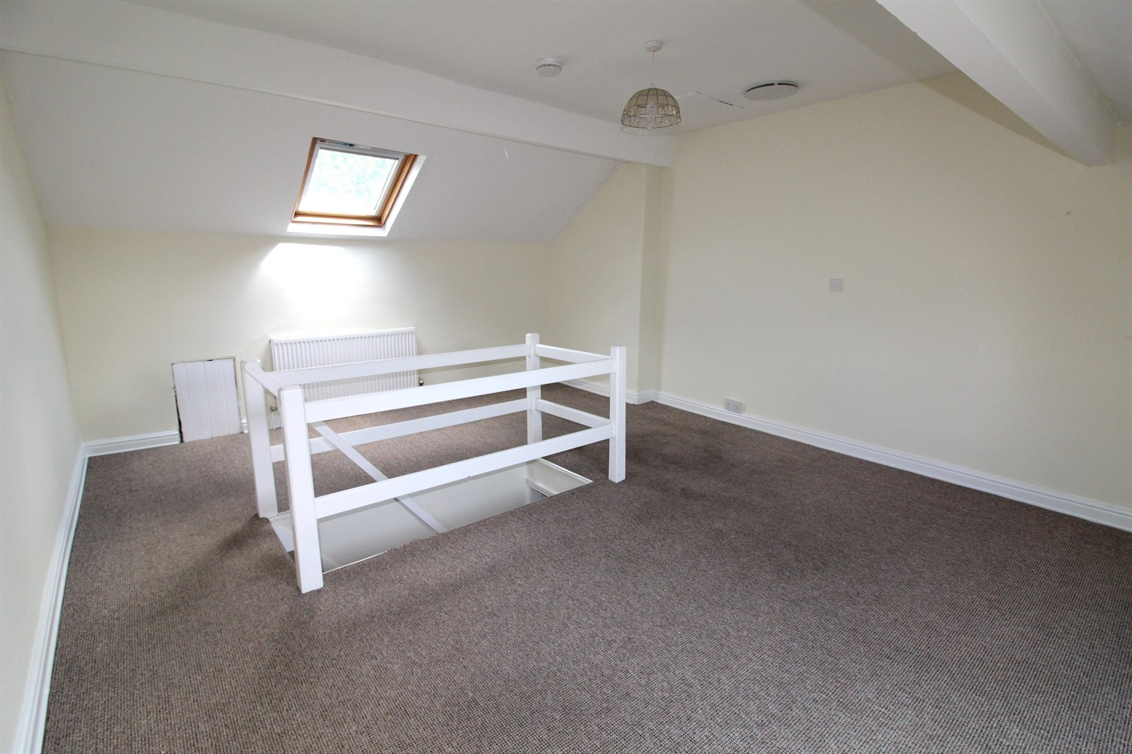

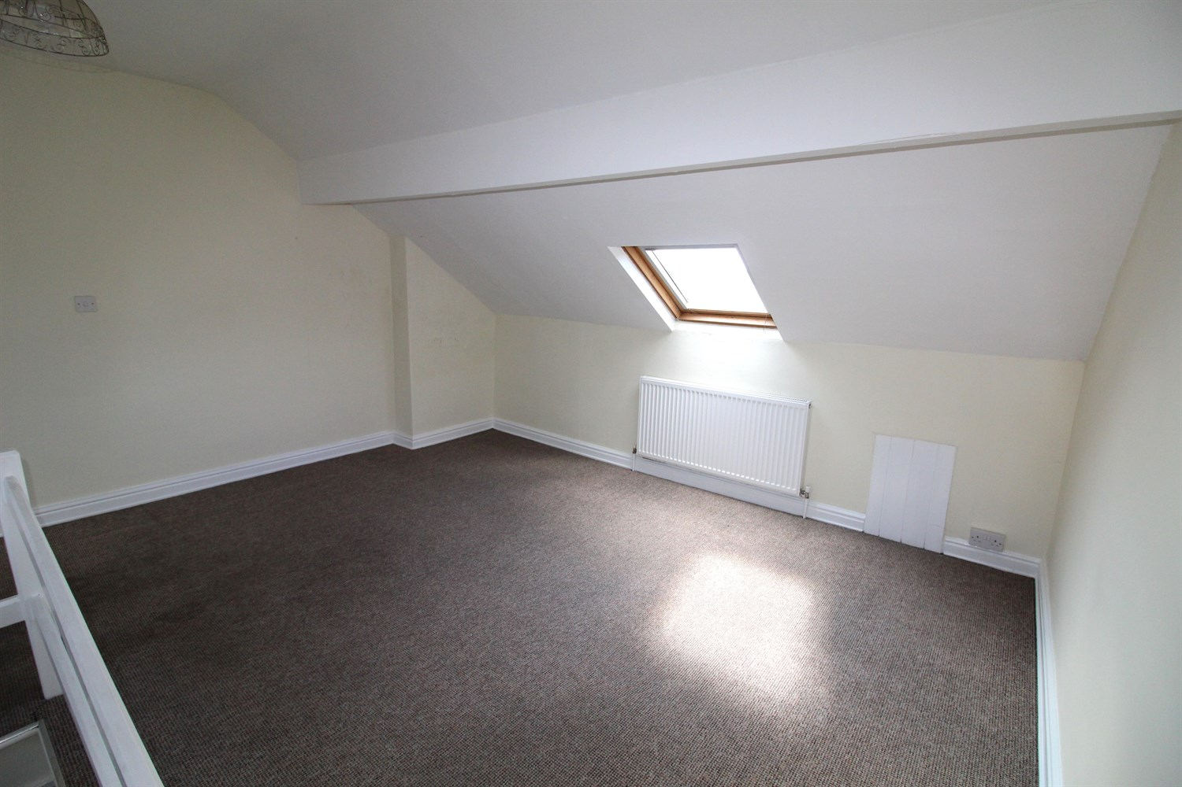

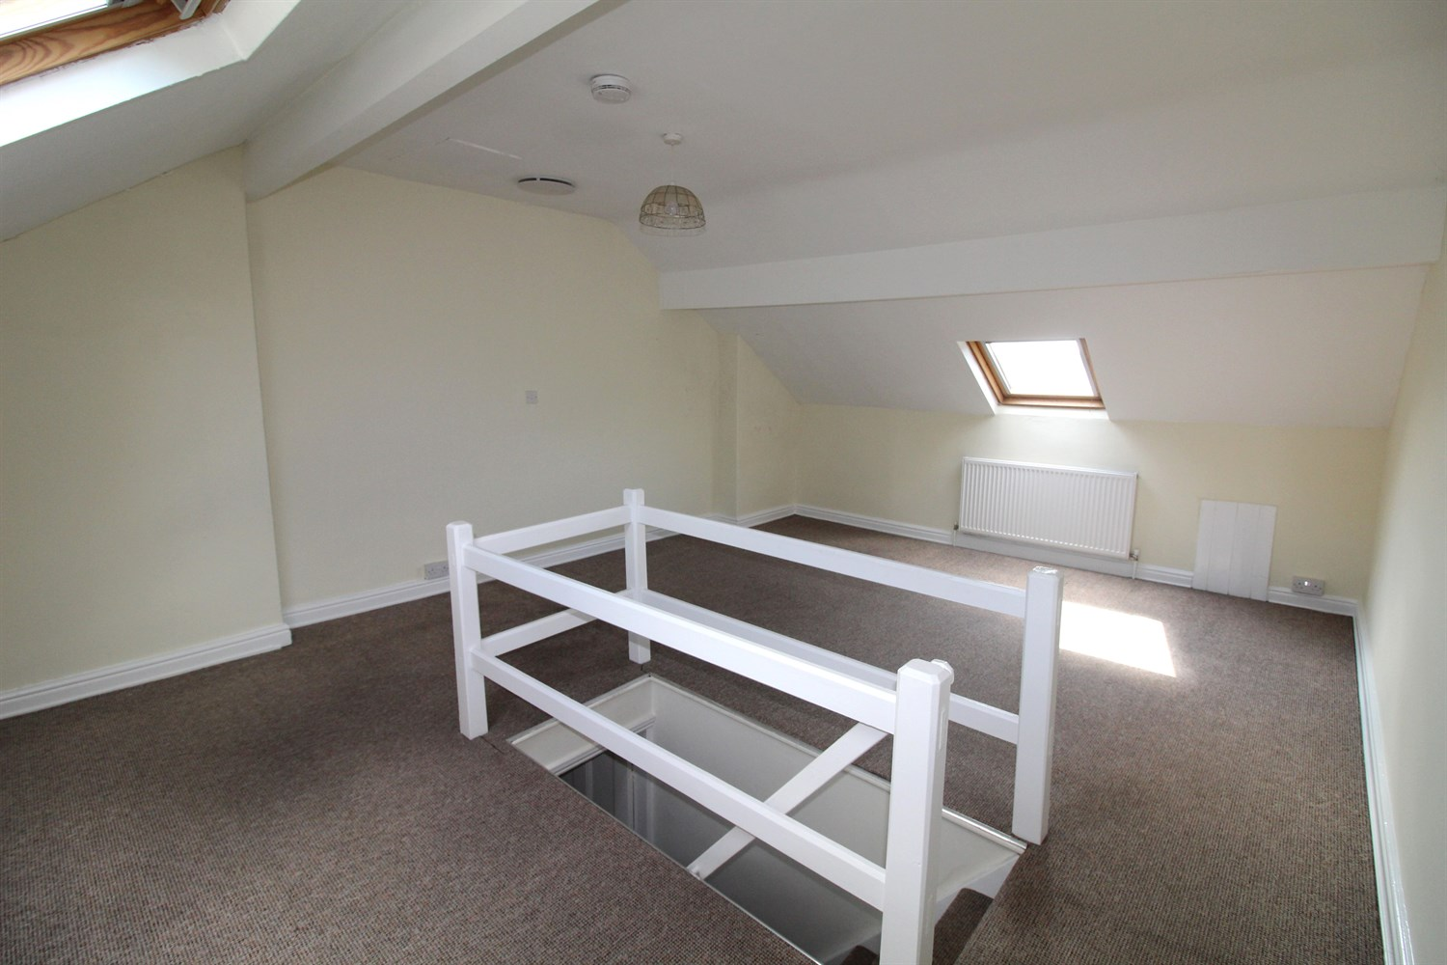

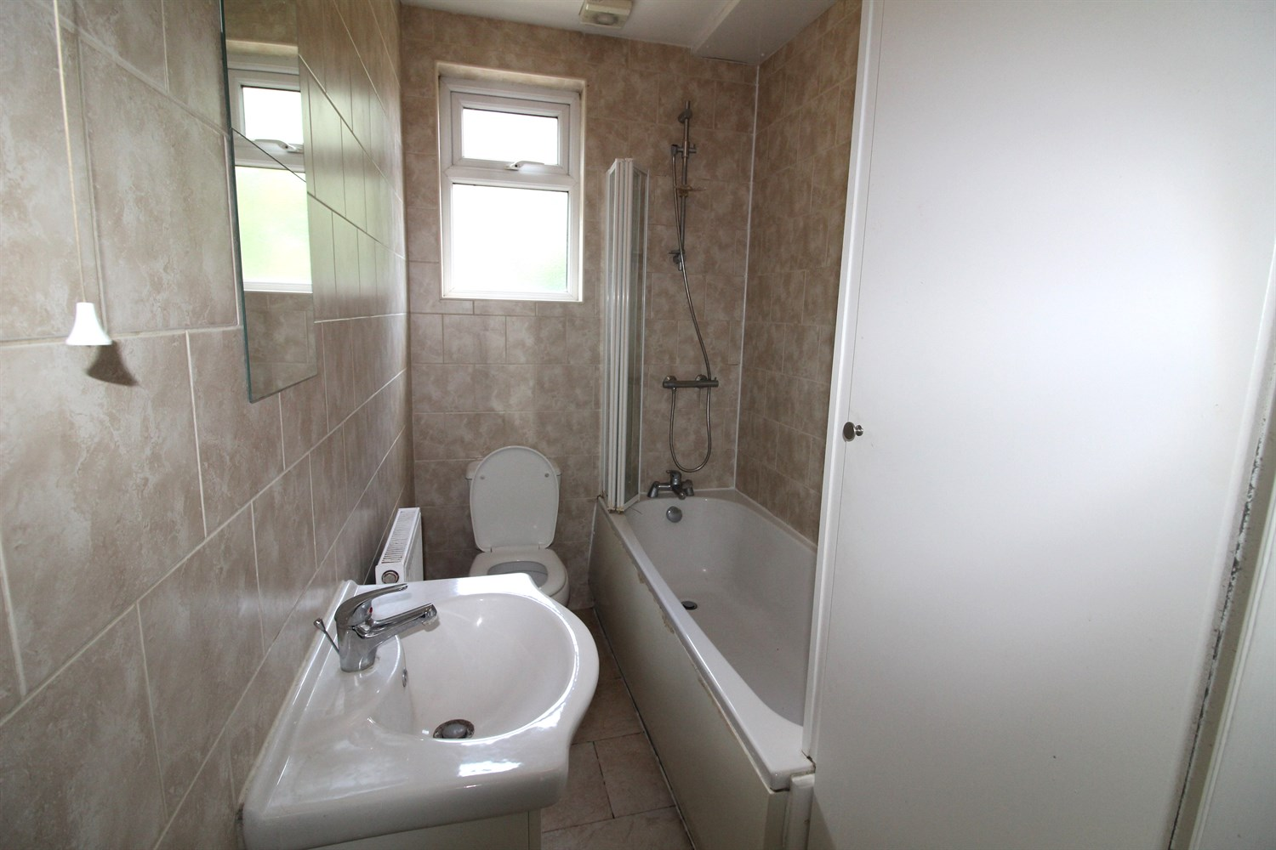

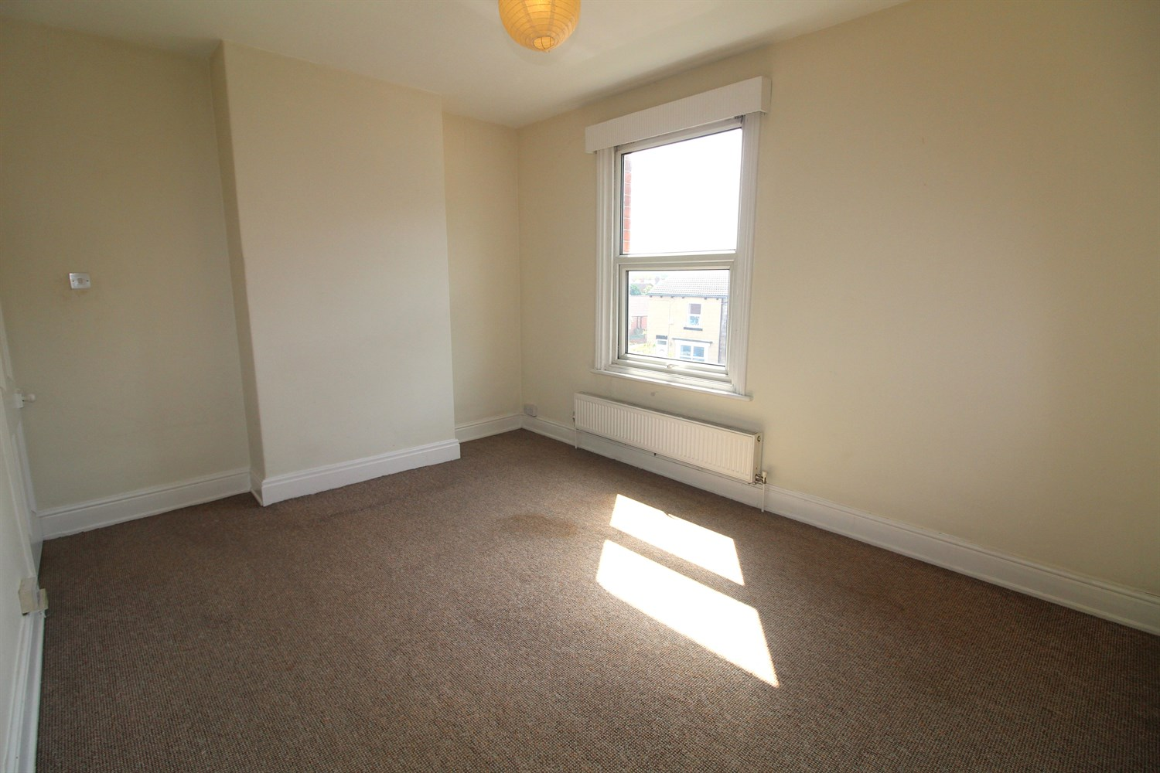

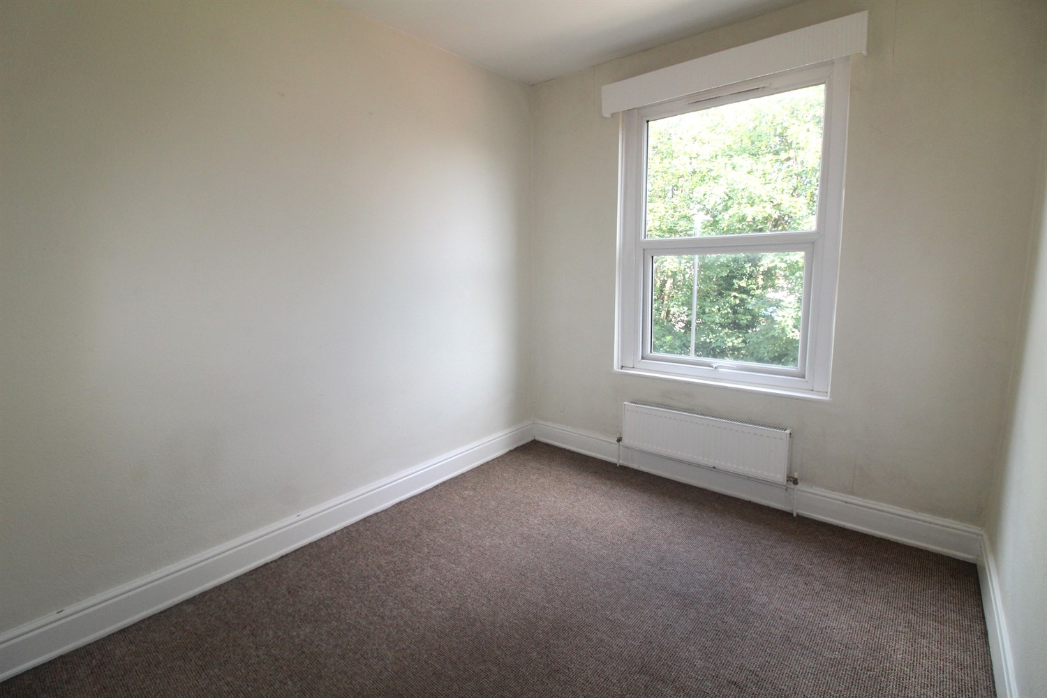

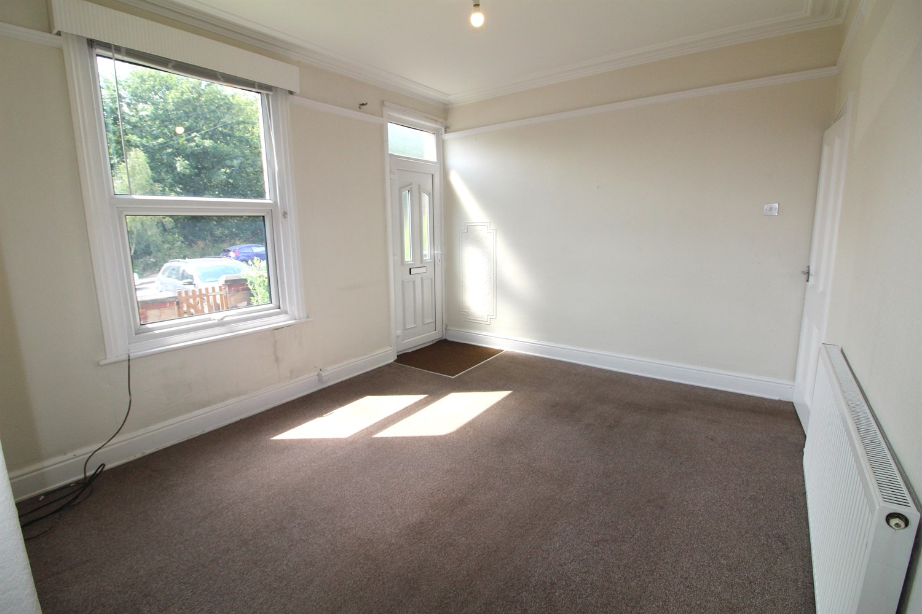

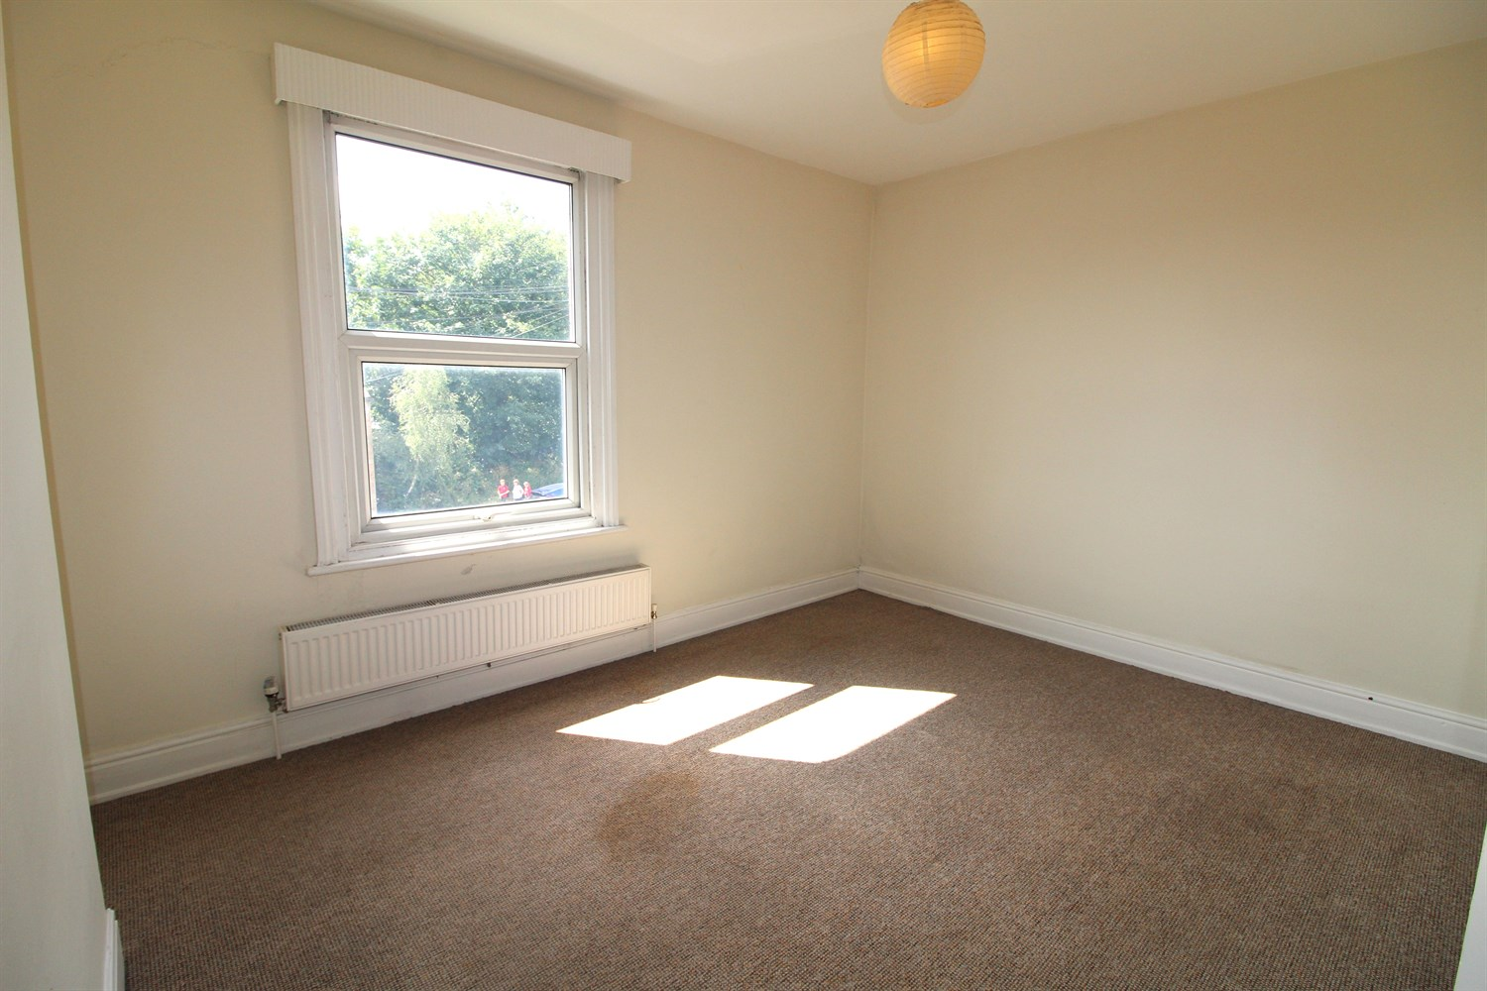

|  |
| --- |
| **Living Room 4.35m (14'3) Max x 3.36m (11'0)**  Via front entrance door. Light and airy living room with window to front. Gas central heating radiator. |
| **Kitchen 4.25m (13'11) x 3.82m (12'6)**  Spacious kitchen fitted with a range of wall, base and drawer units with worktops over. Space for free standing cooker. Stainless steel sink with mixer tap and drainer. Space for washing machine. uPVC double glazed window and door to rear of the property. Gas central heating radiator. |
| **Landing**  First Floor |
| **Bedroom 1 3.37m (11'1) x 4.34m (14'3)**  Large double bedroom with uPVC double glazed window to front. Gas central heating radiator. |
| **Bedroom 2 3.34m (10'11) x 2.71m (8'11)**  Double bedroom with uPVC double glazed window to rear. Gas central heating radiator. |
| **Bathroom**  Three piece bathroom suite with shower over bath, WC and hand wash basin. Tiled walls. Window to rear. |
| **Second Floor** |
| **Bedroom 3 4.34m (14'3) x 5.75m (18'10)**  Double bedroom with Velux window to front and rear. Gas central heating radiator. Restricted head height in some areas. |
| **Garden**  Gardens to front and rear. |

|  |  |
| --- | --- |
| These particulars are intended to give a fair description of the property, but their accuracy cannot be guaranteed, and they do not constitute an offer of contract. Intending purchasers must rely on their own inspection of the property. None of the above appliances/services have been tested by ourselves. We recommend purchasers arrange for a qualified person to check all appliances/services before legal commitment.  **Property Ref:** 6608  **For more information, please contact**  0113 258 1150 **|** [sales@adairpaxton.co.uk](mailto:sales@adairpaxton.co.uk) **|** www.adairpaxton.co.uk |  |