

**Sandlewood Crescent, Meanwood**

**For Sale £165,000.00**

**TWO BEDROOM GROUND FLOOR APARTMENT - NO ONWARD CHAIN** Adair Paxton are pleased to offer to the market this well maintained ground floor apartment situated on the highly regarded Woodlea development offering spacious accommodation with leafy outlook to all sides. Having uPVC double glazing and electric central heating the property comprises entrance hall, open plan living room/kitchen with French doors onto a patio area, master bedroom with en-suite shower room, second double bedroom and a house bathroom. Externally the property has communal gardens and an allocated parking space.

**0113 258 1150**

**0800 000 000**

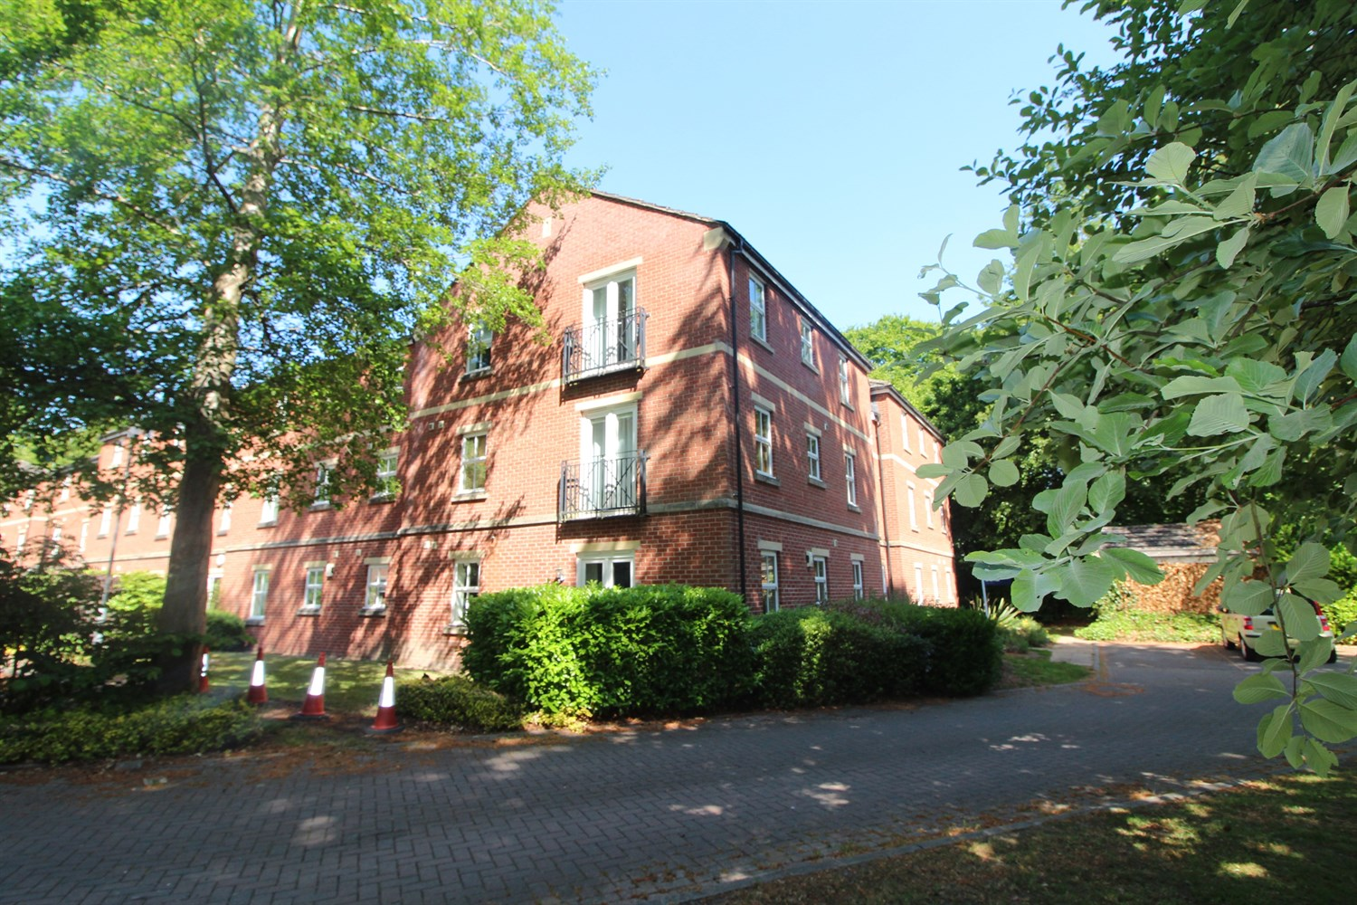

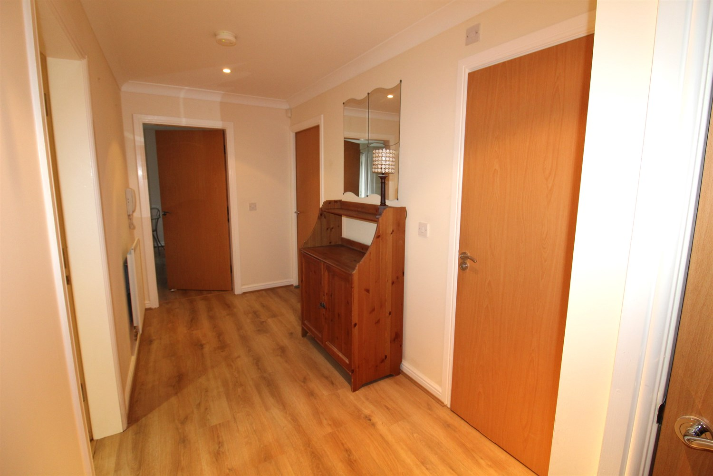

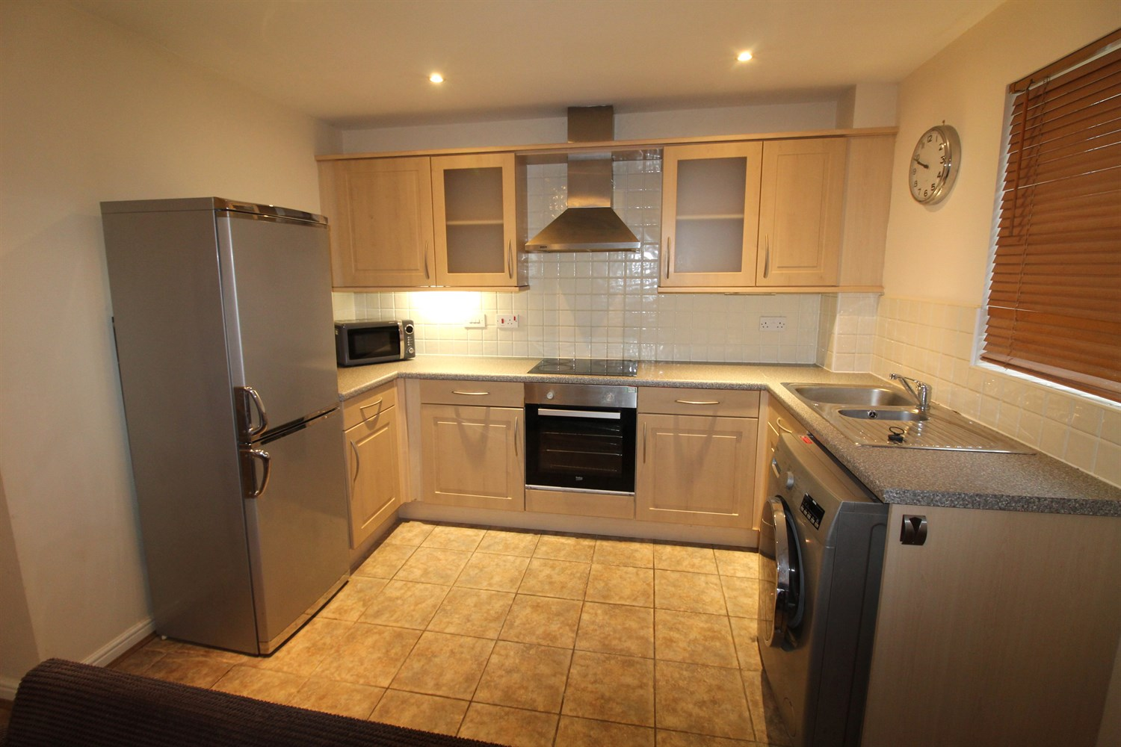

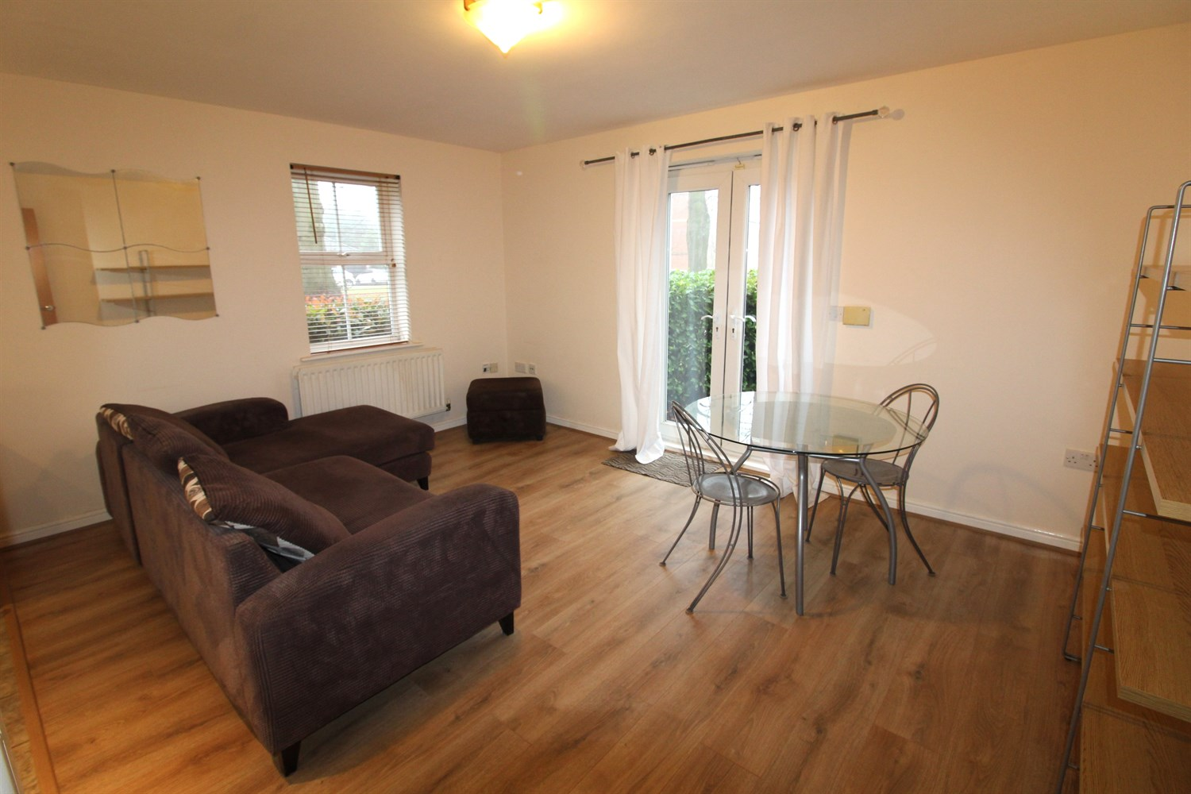

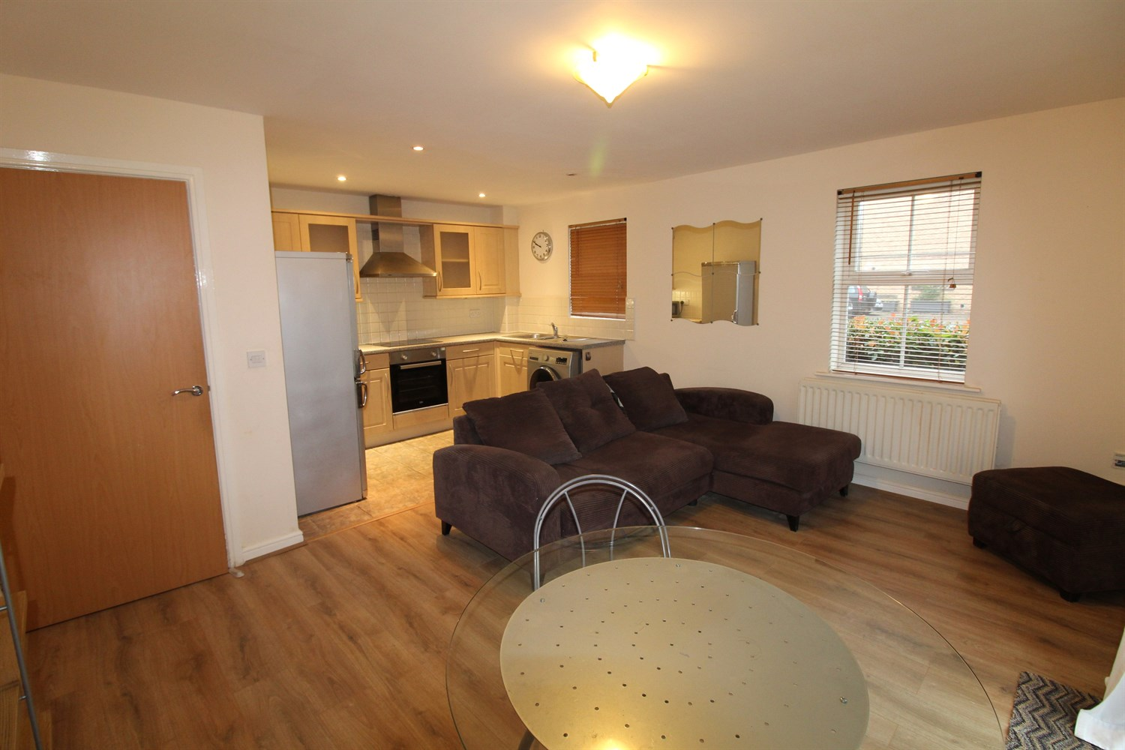

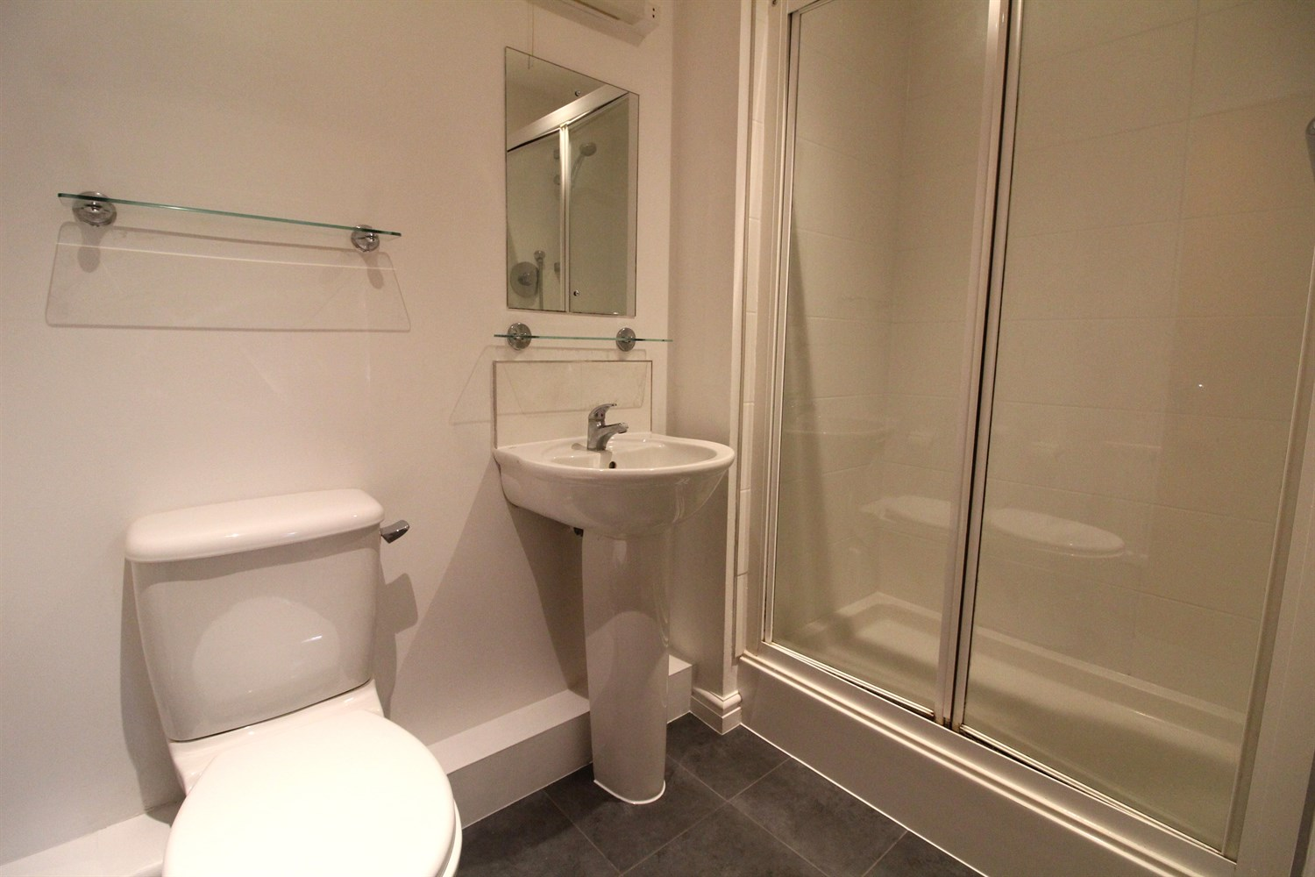

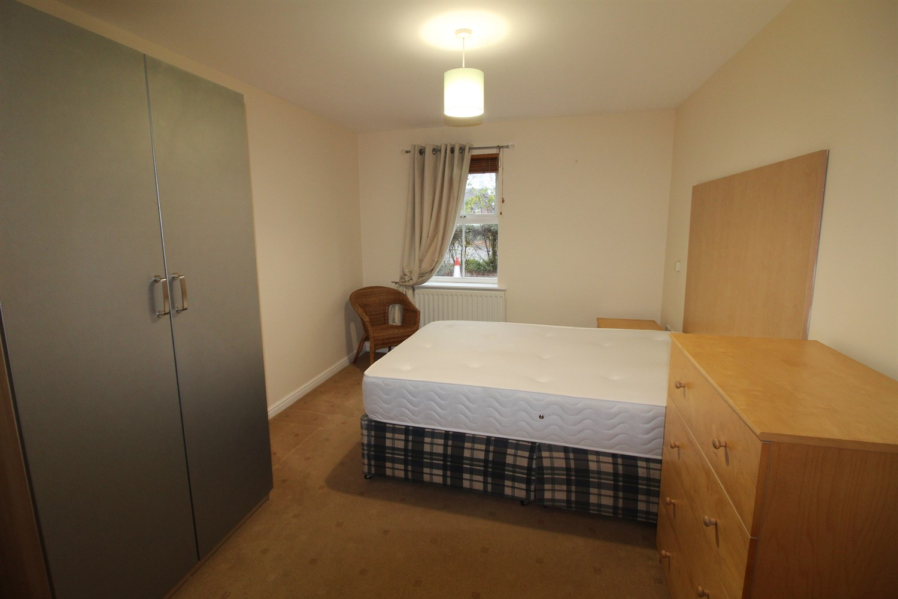

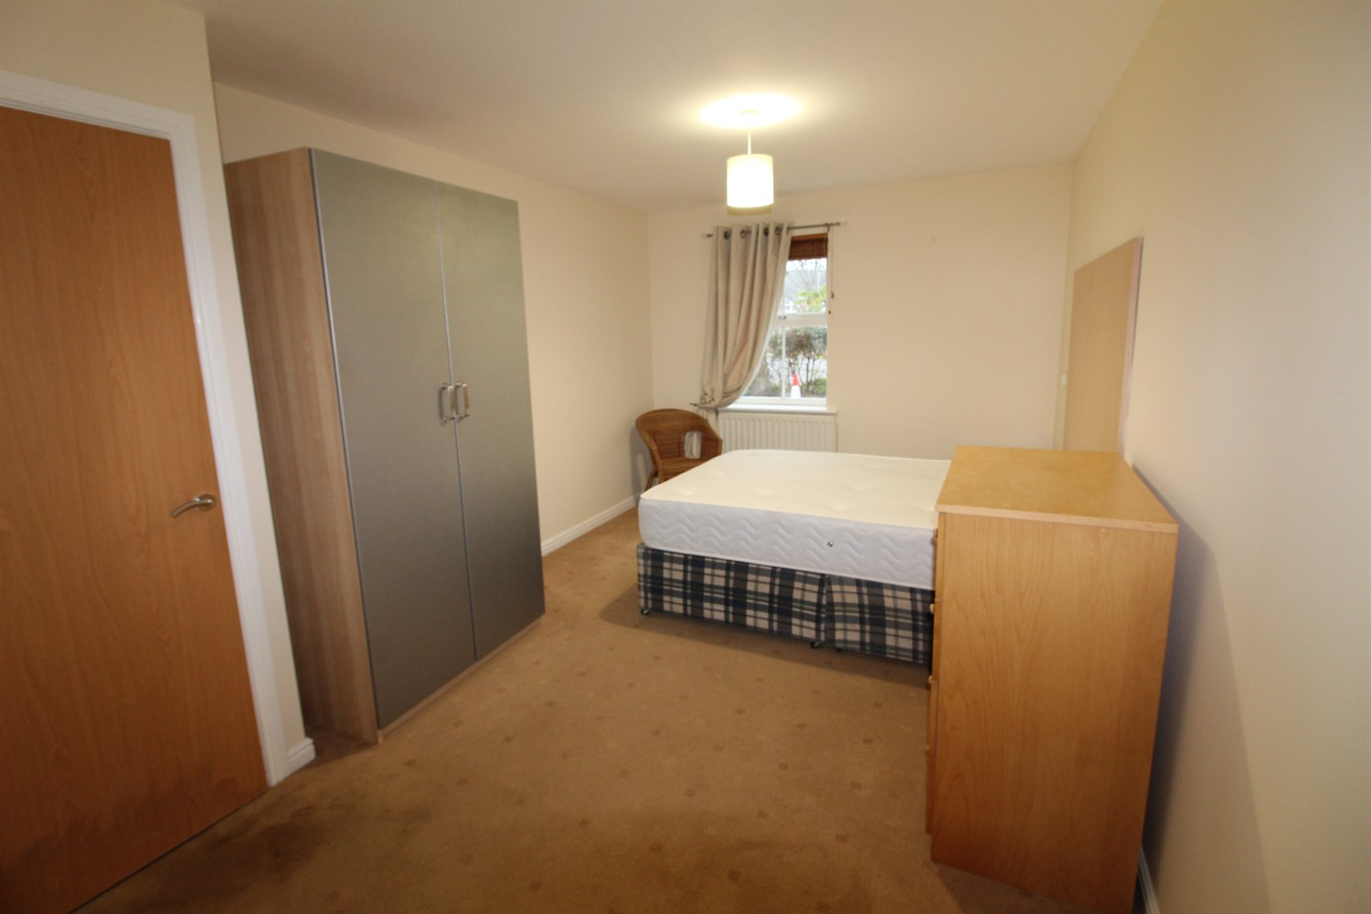

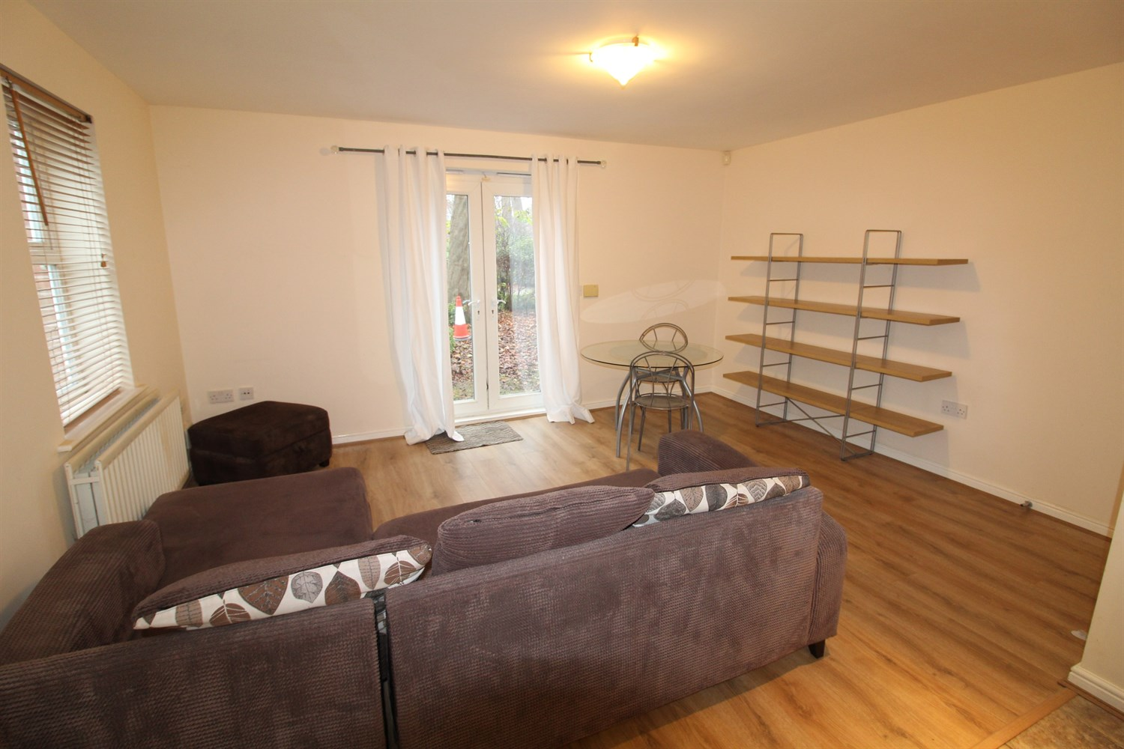

|  |
| --- |
| **Communal Entrance**  Communal Hallway. |
| **Private Entrance Hall**  Via front entranced door. Spacious hallway. |
| **Open Plan Living Room/Kitchen 4.53m (14'10) x 3.36m (11'0)**  Open plan living area with uPVC double glazed doors leading out to a patio area. uPVC double glazed window to side. |
| **Kitchen 3.24m (10'8) x 1.9m (6'3)**  Fitted with a range of wall, base and drawer units with worktops over. 1.5 bowl bowl stainless steel sink with mixer tap and drainer. Space for washing machine and fridge/freezer. Integrated oven with 4-ring hob and extractor hood over. uPVC double glazed window to side. |
| **Master Bedroom 2.98m (9'9) x 4.8m (15'9)**  Master bedroom with uPVC double glazed window. |
| **En-Suite Shower Room**  Fitted with a three piece suite comprising shower cubicle, WC and wash hand basin. |
| **Bedroom Two 3.24m (10'8) x 3.24m (10'8)**  Second double bedroom with uPVC double glazed window. |
| **House Bathroom**  Fitted with a four piece white suite comprising; bath with shower over, WC and wash hand basin. Part tiled walls. |
| **Outside**  Communal Gardens. Allocated parking. |
| **Tenure**  Leasehold - 999 years from 2001 Ground rent - £125 per annum. Service £1539 per annum |
|  |

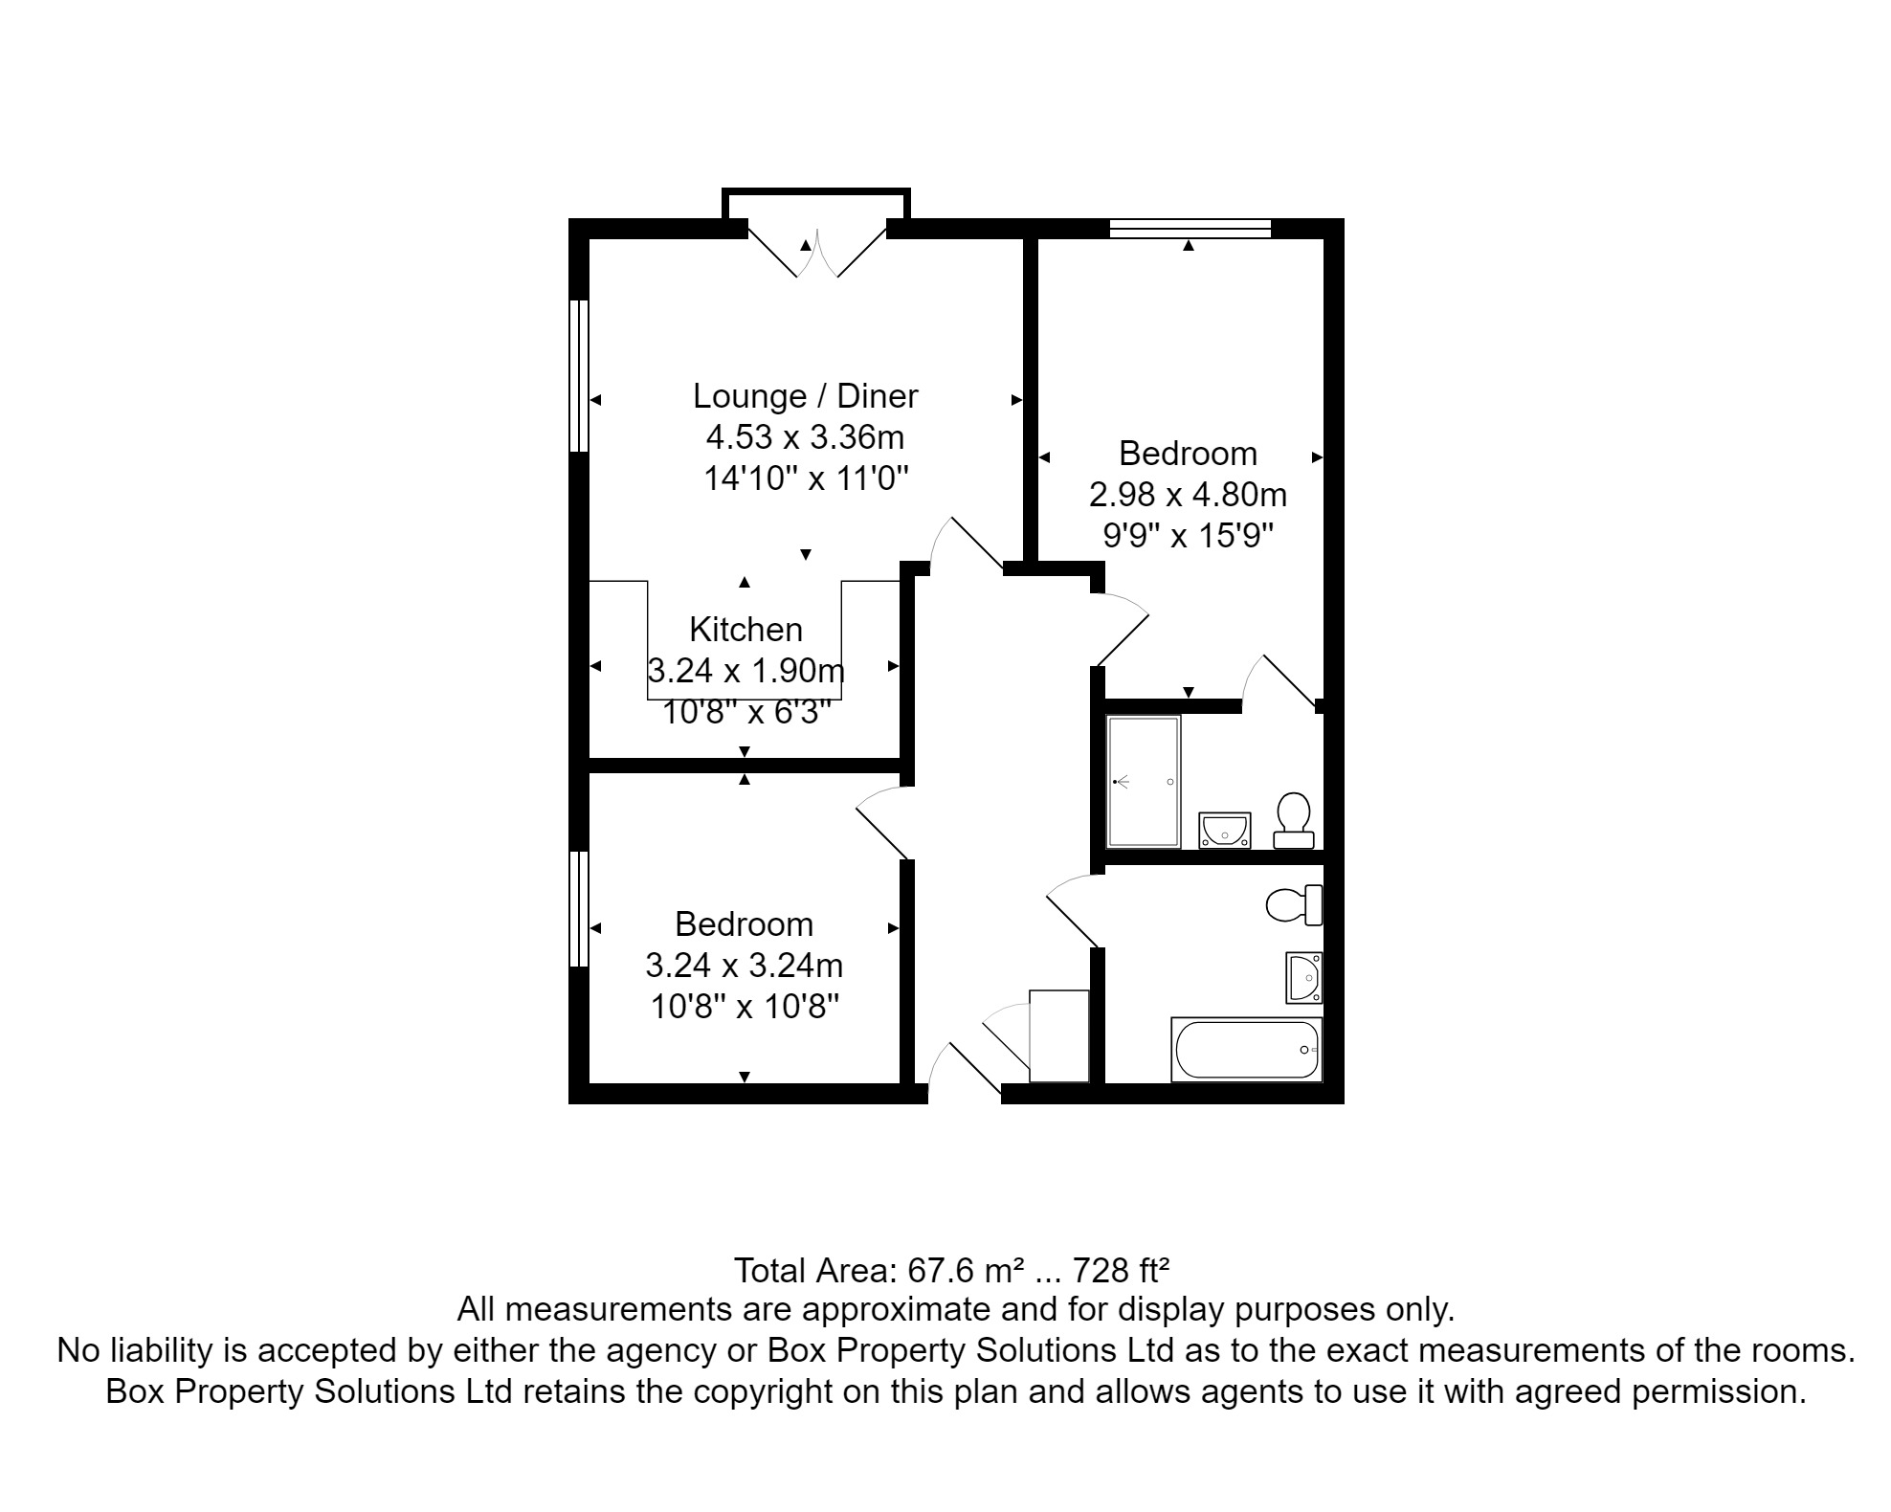

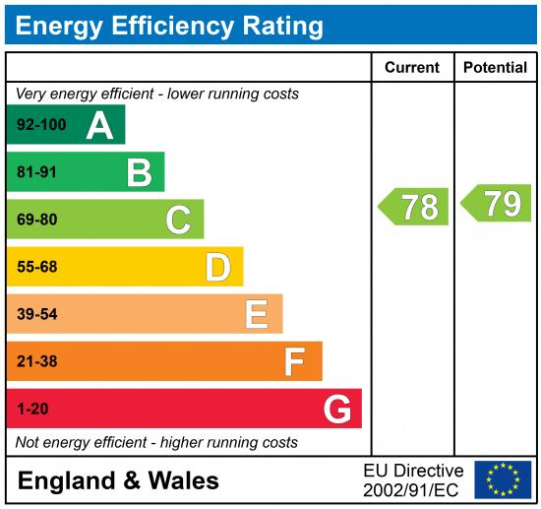

|  |
| --- |
|  |

These particulars are intended to give a fair description of the property, but their accuracy cannot be guaranteed, and they do not constitute an offer of contract. Intending purchasers must rely on their own inspection of the property. None of the above appliances/services have been tested by ourselves. We recommend purchasers arrange for a qualified person to check all appliances/services before legal commitment.

**For more information, please contact**

0113 258 1150 **|** [sales@adairpaxton.co.uk](mailto:sales@adairpaxton.co.uk) **|** www.adairpaxton.co.uk