

**0113 258 1150**

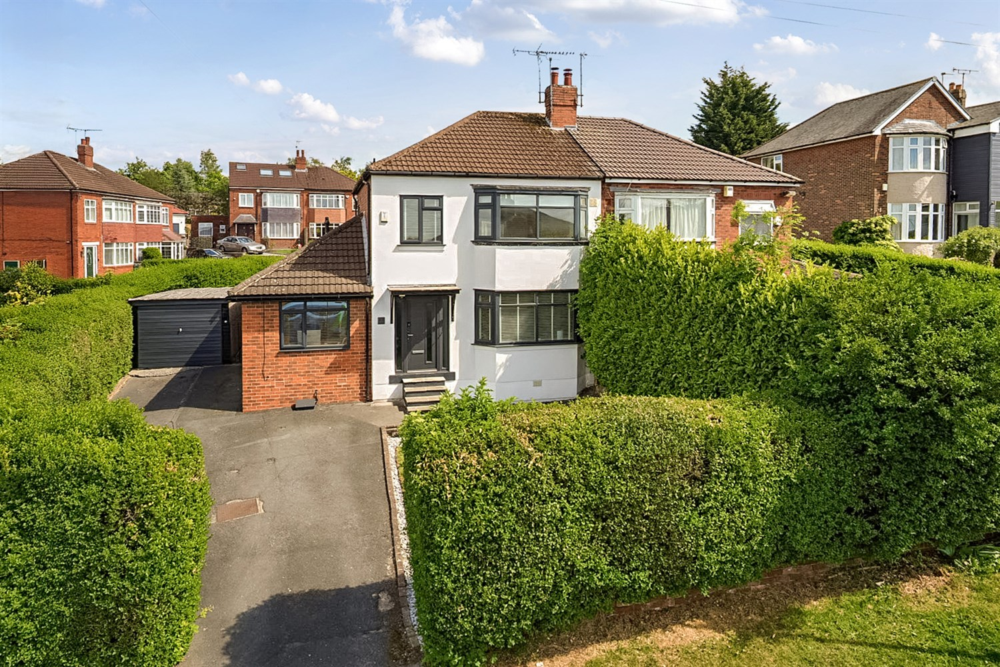



**For Sale £485,000.00**

**Primley Park Mount, Alwoodley**

**DECEPTIVELY SPACIOUS THREE/FOUR BEDROOM SEMI-DETACHED MODERN FAMILY HOME** Adair Paxton are pleased to offer to the market this extremely well presented semi-detached house on Primley Park Mount. The property sits within an elevated position with long distance views to the front over Alwoodley and beyond, and briefly comprises; entrance hall, guest WC, home office, spacious lounge/dining area, open plan kitchen/breakfast room and second reception room/bedroom four to the ground floor. To the first floor there are two double bedrooms, a third bedroom and modern house bathroom. Externally the property sits on a corner plot with lawned gardens to the front and rear. A driveway offering off street parking and leading to a detached garage. Primley Park Mount is conveniently located being within easy vehicular access to the extensive amenities of Moortown Corner and of Street Lane. Further amenities at the Moor Allerton complex include Sainsbury¿s and Argos and the David Lloyd leisure centre opposite on the Ring Road. Leeds City Centre is also easily accessible via frequent public transport links and there are a variety of golf courses and good schools for all ages within the area.

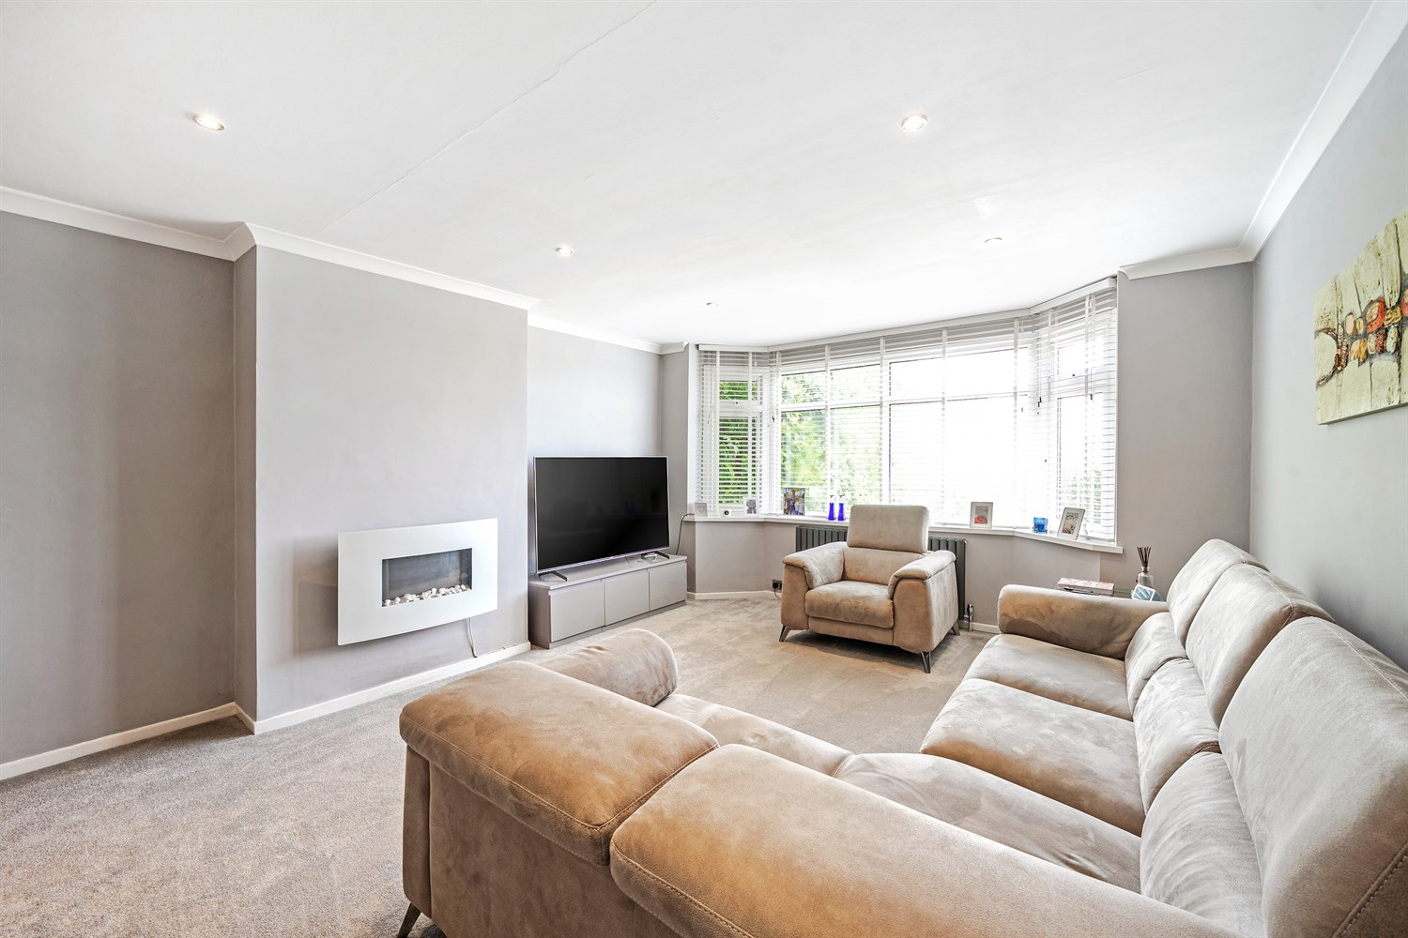

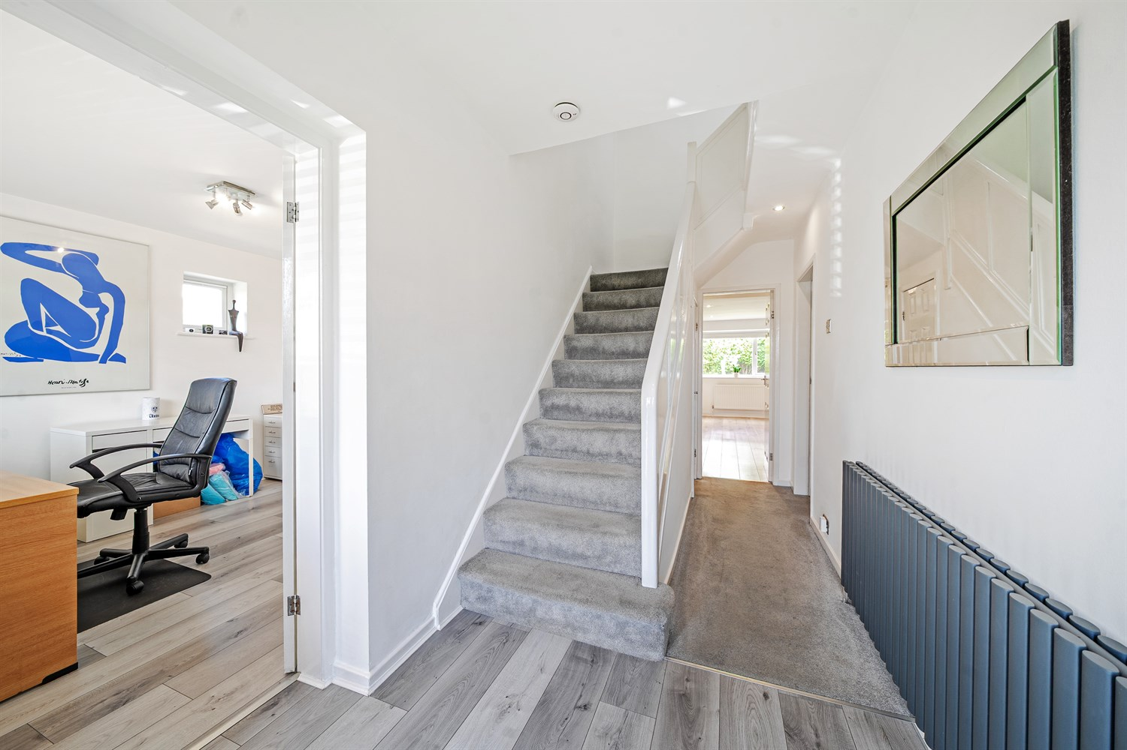

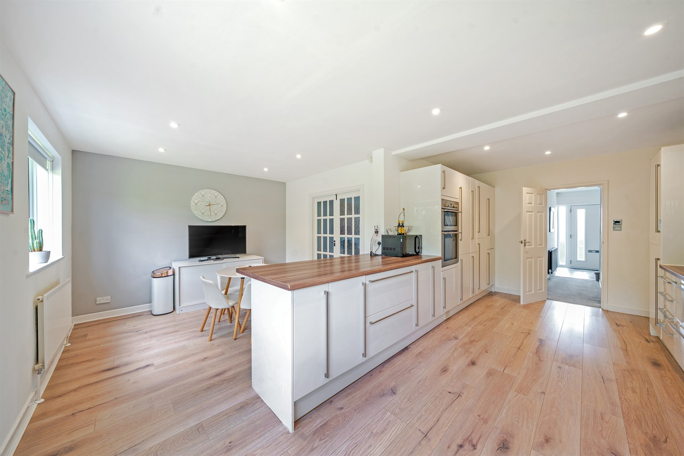

2 Bathroom(s)

3 Reception(s)

3 Bedroom(s)

00

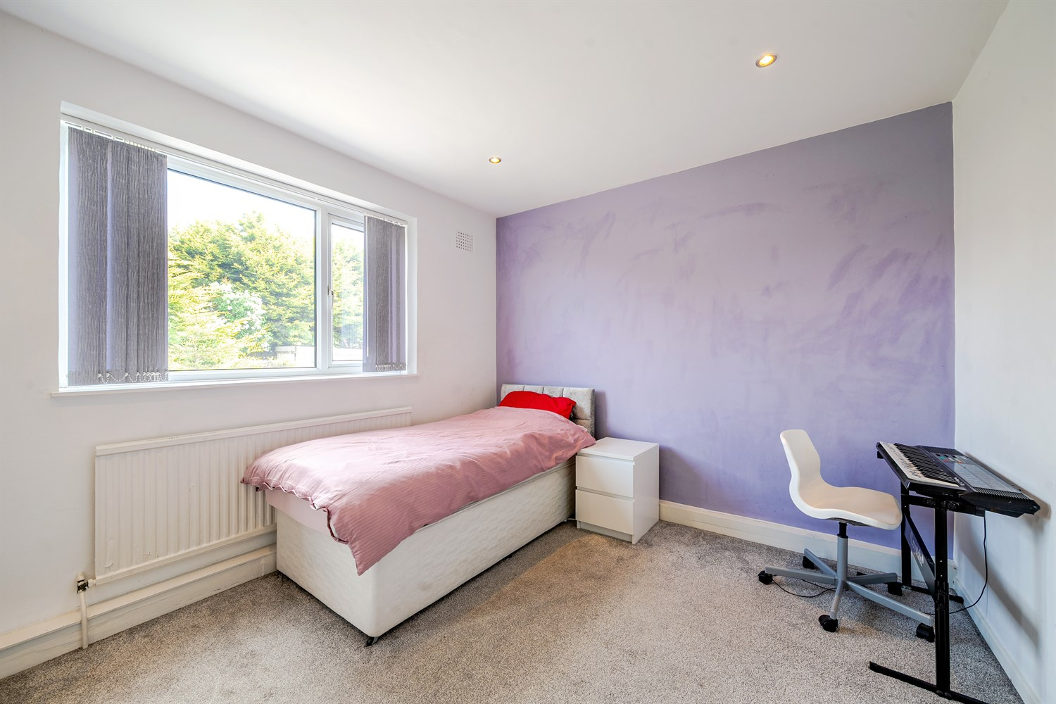

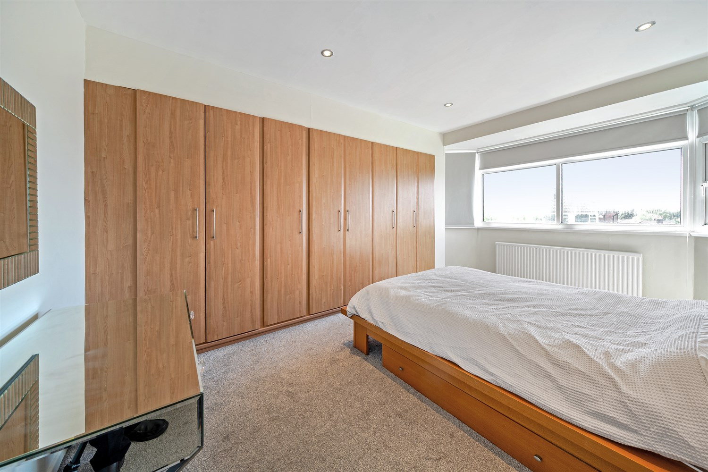

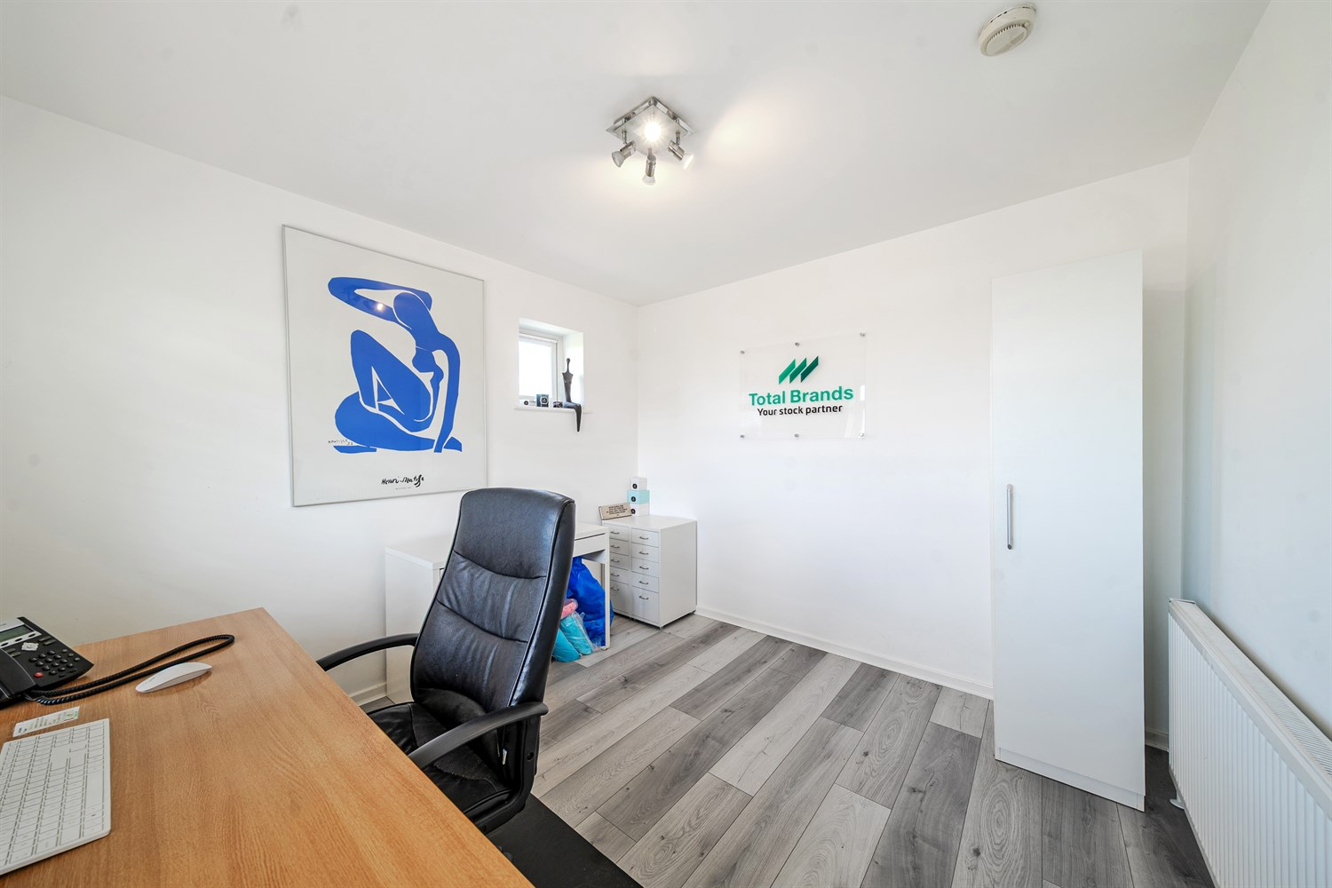

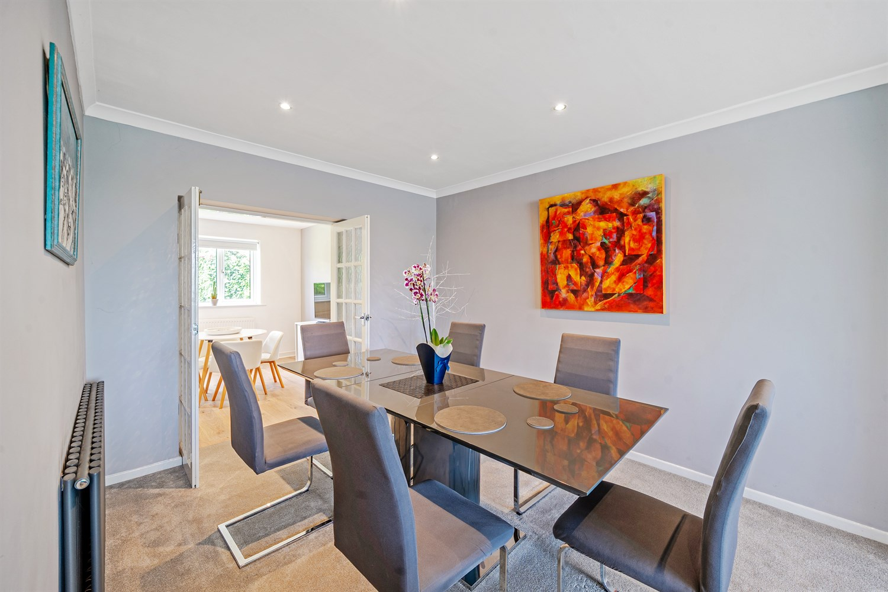

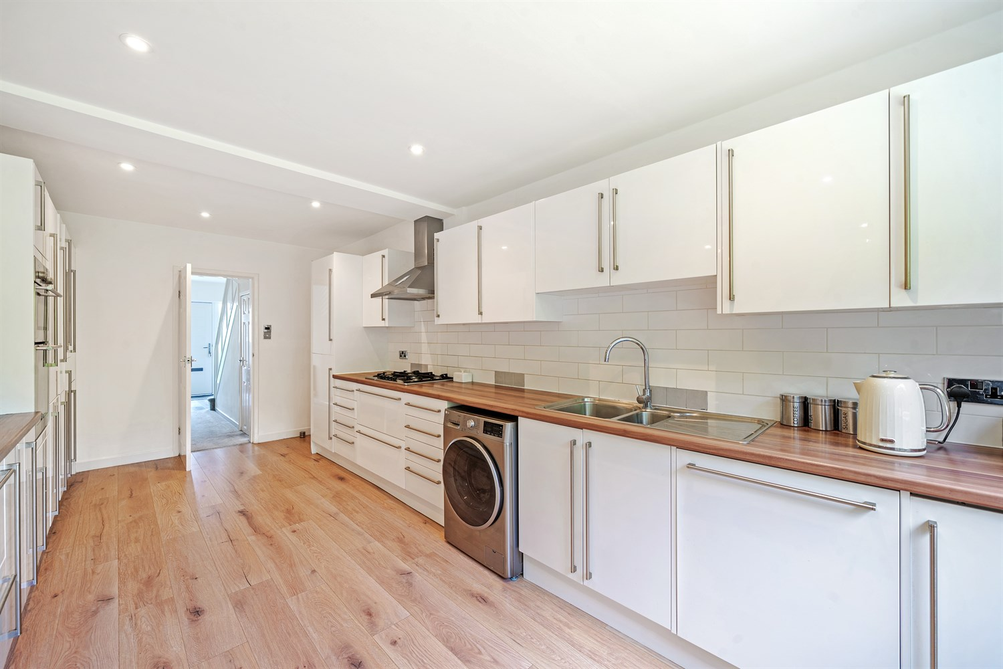

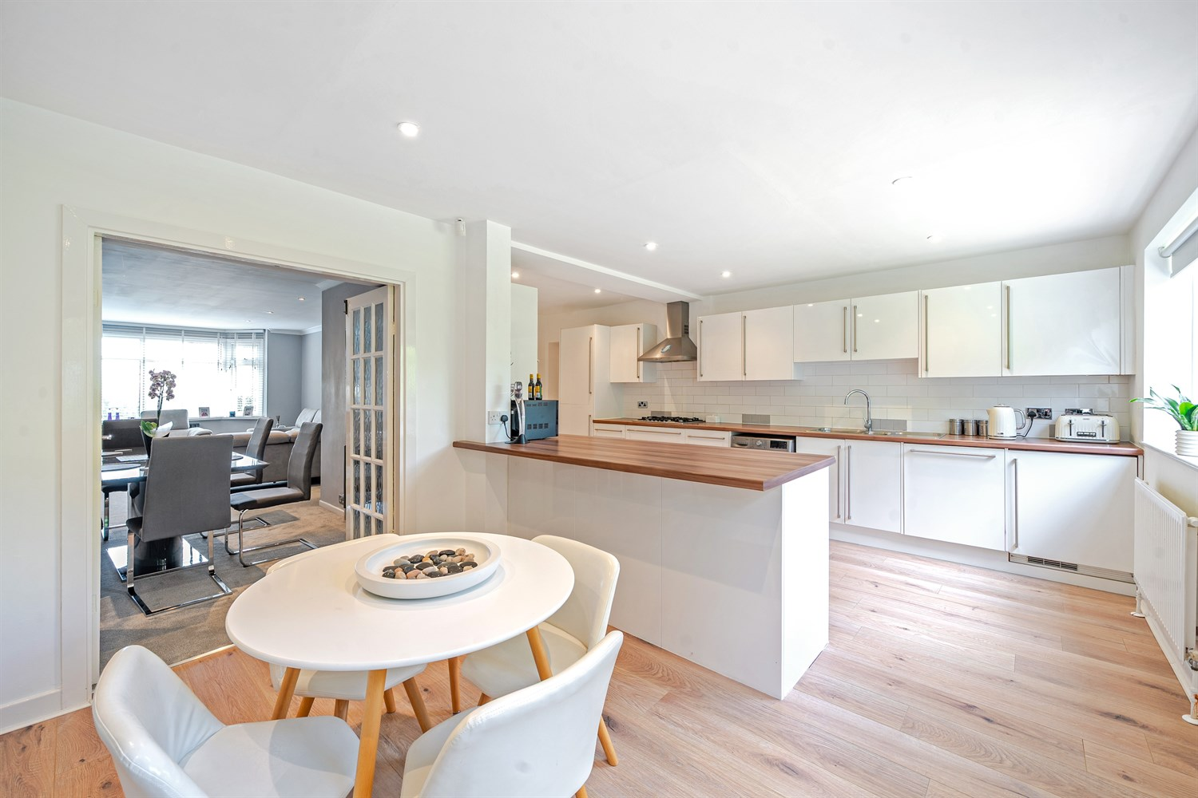

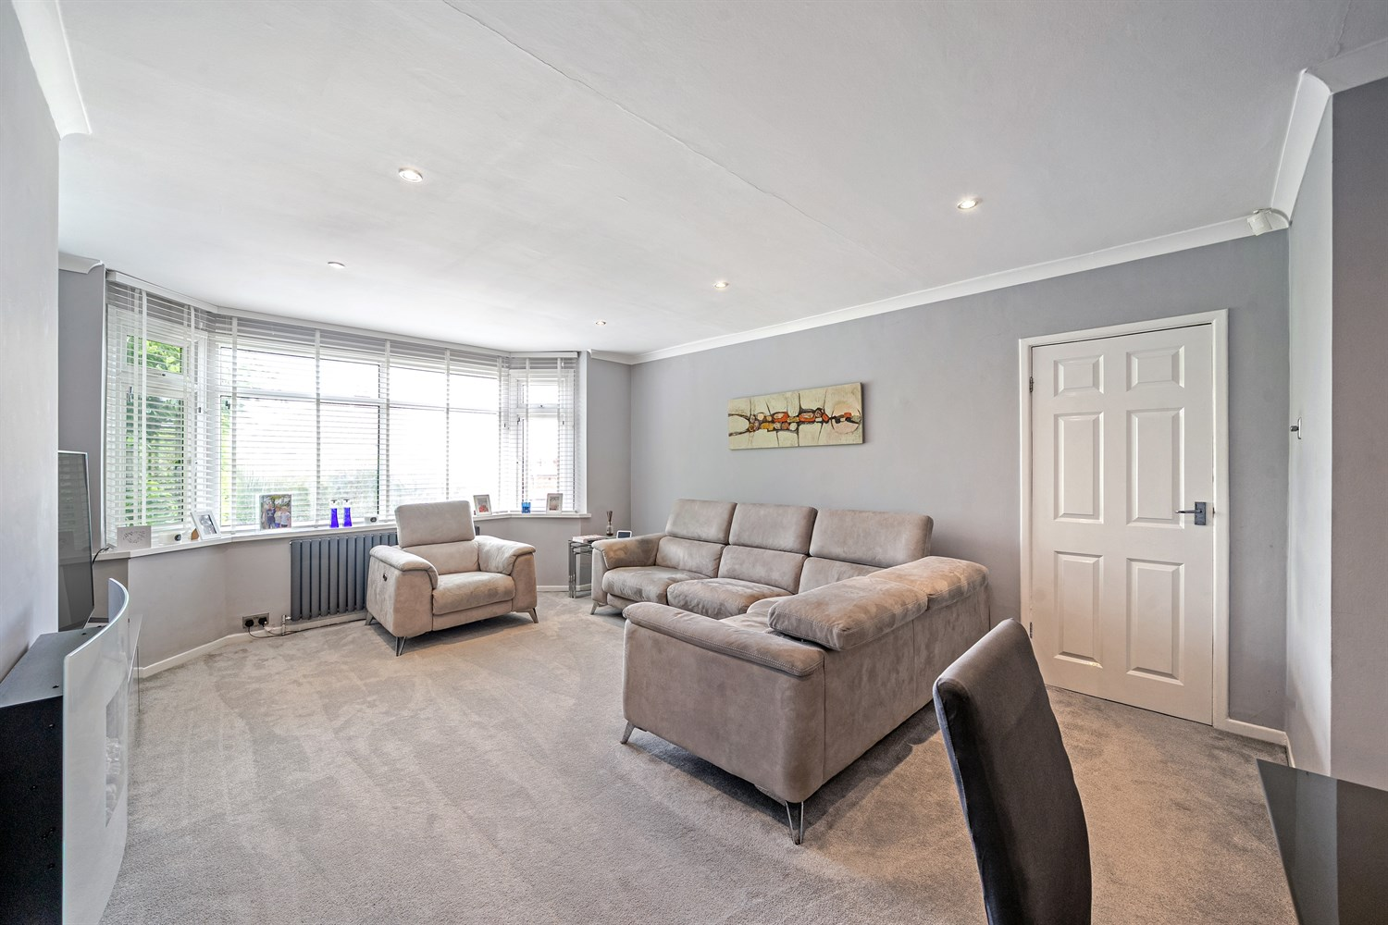

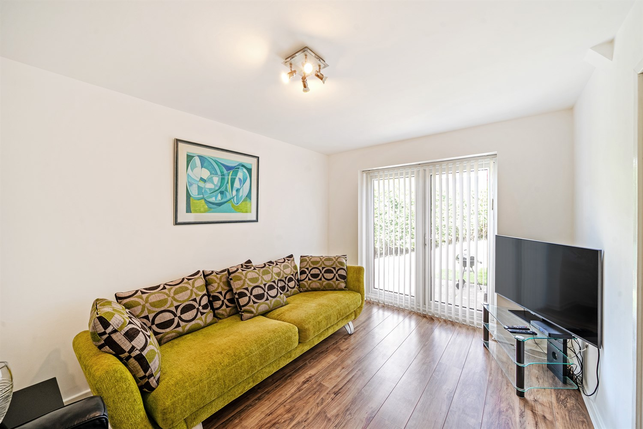

|  |
| --- |
| **Entrance Hall**  Via front entrance door. Gas central heating radiator. Stairs to first floor. |
| **Guest WC**  Fitted with a modern two piece suite comprising; WC and wash hand basin. |
| **Office 3.25m (10'8) x 2.93m (9'7)**  Light and airy reception room, making a generous sized home office. uPVC double glazed window to front. Gas central heating radiator. |
| **Living Room / Dining Area 7.74m (25'5) x 4.21m (13'10)**  Spacious reception room with uPVC double glazed window to front. Gas central heating radiator. Opening to the dining area, a great entertaining space. Double doors opening to the open plan kitchen/breakfast room. |
| **Kitchen/Breakfast Room 6.06m (19'11) x 5.93m (19'5)**  Fitted with a range of wall, base and drawer units with worktops over. Stainless steel sink with mixer tap and drainer. Integrated oven, gas hob and extractor hood over. Integrated dishwasher and fridge/freezer. Plumbed for washing machine. Inset ceiling spotlights. Gas central heating radiator. uPVC double glazed window to rear. Opening to breakfast room. |
| **Snug/Bedroom four 3.77m (12'4) x 2.92m (9'7)**  Versatile room with uPVC double glazed doors leading out to the rear garden - Ideal for a snug, play room or additional bedroom. Gas central heating radiator. |
| **Bedroom 1 4.86m (15'11) x 3.6m (11'10)**  Spacious double bedroom with uPVC double glazed bay window to the front offering far reaching views over Alwoodley and beyond. Built in wardrobes. Gas central heating radiator. |
| **Bedroom 2 3.64m (11'11) x 3.04m (10')**  Second double bedroom with uPVC double glazed window to rear. Gas central heating radiator. |
| **Bedroom 3 3.36m (11'0) x 2.43m (8')**  Third bedroom with uPVC double glazed window to front. Gas central heating radiator. |
| **House Bathroom**  Fitted with a modern four piece suite comprising bath, shower cubicle, vanity wash hand basin and WC. Tiled walls and floor. Wall mounted heated towel rail. Inset ceiling spotlights. uPVC double glazed window. |
| **Outside**  To the front of the property is a driveway offering off street parking and leading to a detached garage. There are lawned gardens to the front and rear of the property offering a good deal of privacy. |
| **Garage 5.34m (17'6) x 2.84m (9'4)**  Detached garage with up and over door. |
| **Parking** |
| **Central Heating** |
| **Double Glazing** |

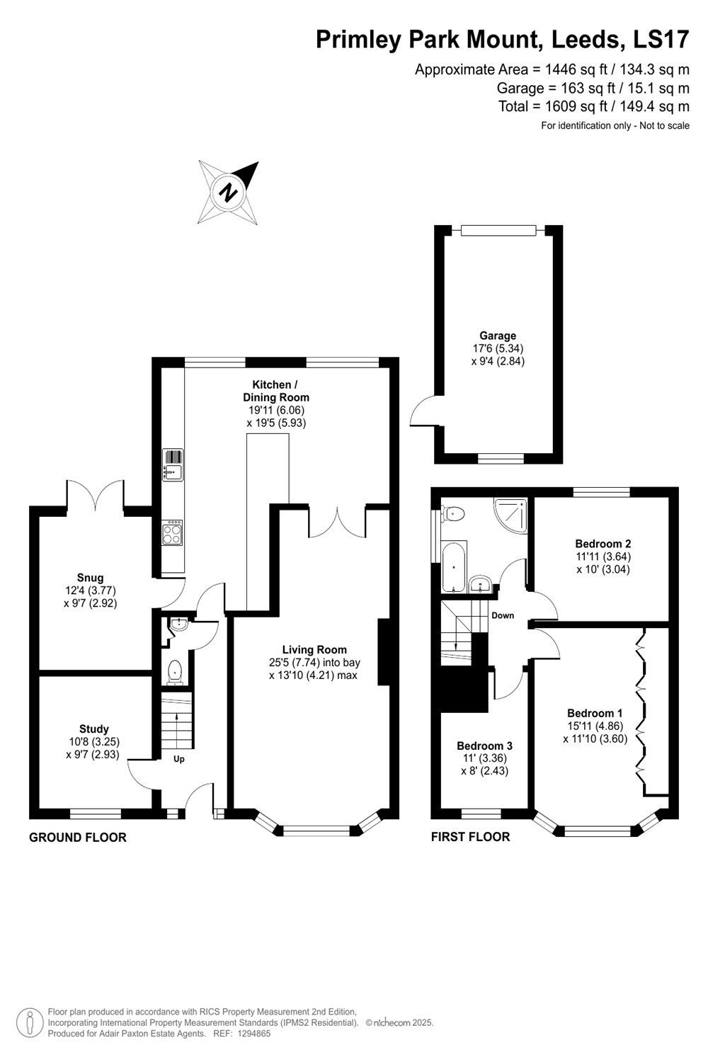

|  |  |
| --- | --- |
| These particulars are intended to give a fair description of the property, but their accuracy cannot be guaranteed, and they do not constitute an offer of contract. Intending purchasers must rely on their own inspection of the property. None of the above appliances/services have been tested by ourselves. We recommend purchasers arrange for a qualified person to check all appliances/services before legal commitment.  **Property Ref:** 6210  **For more information, please contact**  0113 258 1150 **|** [sales@adairpaxton.co.uk](mailto:sales@adairpaxton.co.uk) **|** www.adairpaxton.co.uk |  |