

**Harewood Street, Leeds**

**For Sale £180,000.00**

***STUNNING ONE BEDROOM PENTHOUSE APARTMENT-NO ONWARD CHAIN*** This delightful grade 2 listed former department store retains much of its original features. The exposed brickwork and large windows create an impressive setting for this city centre apartment. This one bedroom penthouse property briefly comprises: curved entrance hall, spacious sitting room with recessed kitchen, light and airy bedroom and stunning shower room. The property is very centrally located on the corner of Harewood Street and Vicar Lane, with the Victoria Gate development just a stones throw away. Ideal for access to local transport links, Leeds City Bus Station and Leeds Train Station, and the motorway networks. Early internal viewing is highly recommended.

**0113 258 1150**

**0800 000 000**

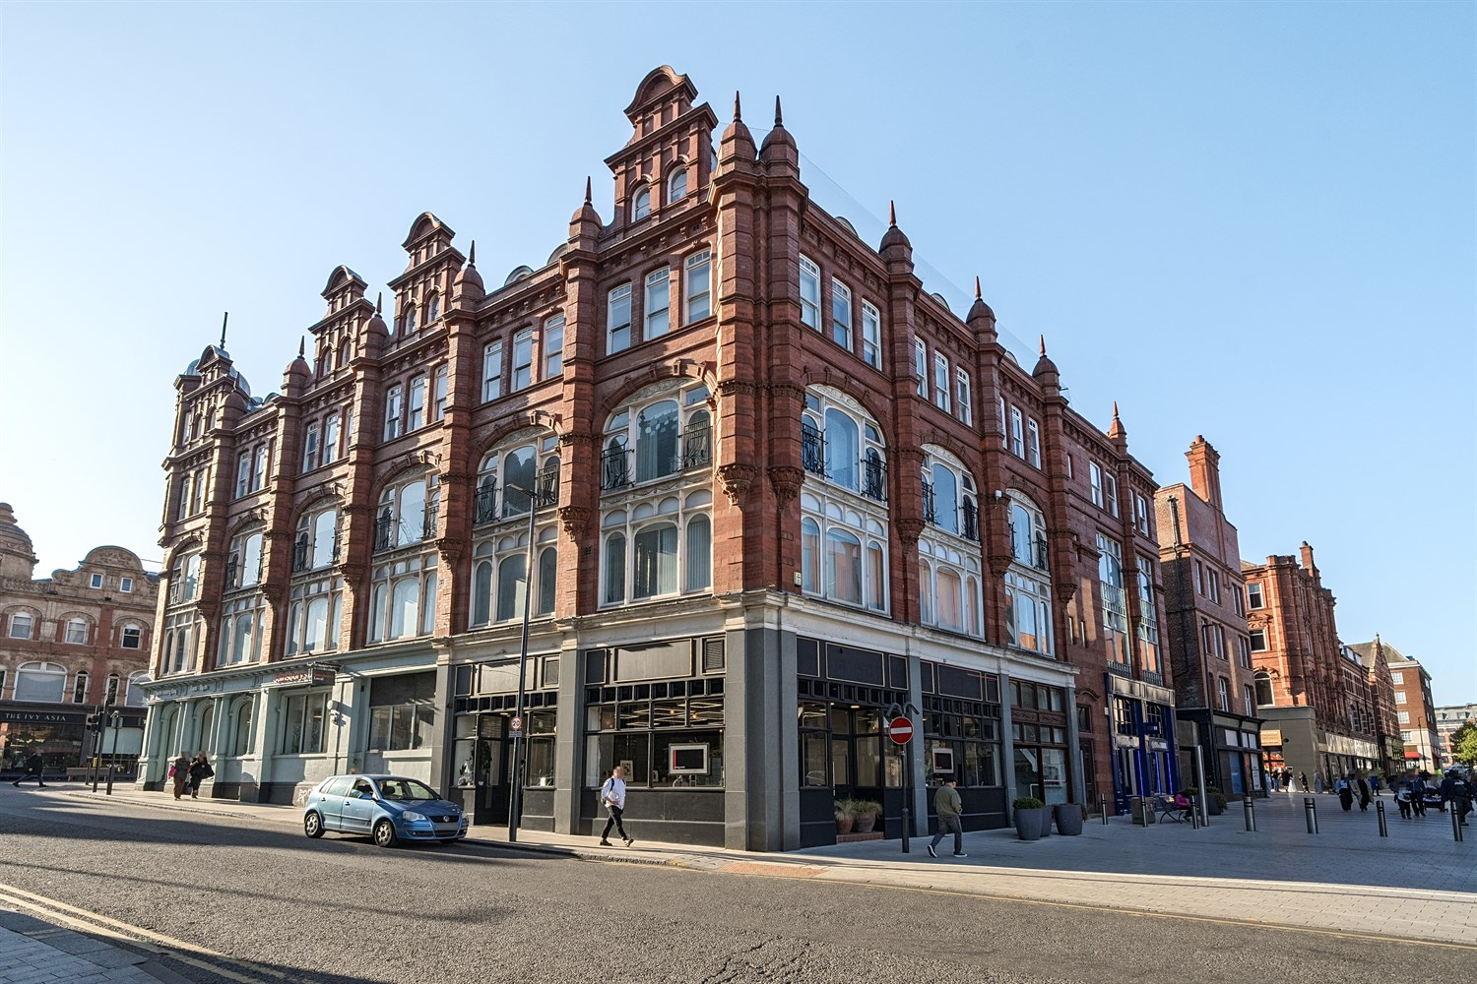

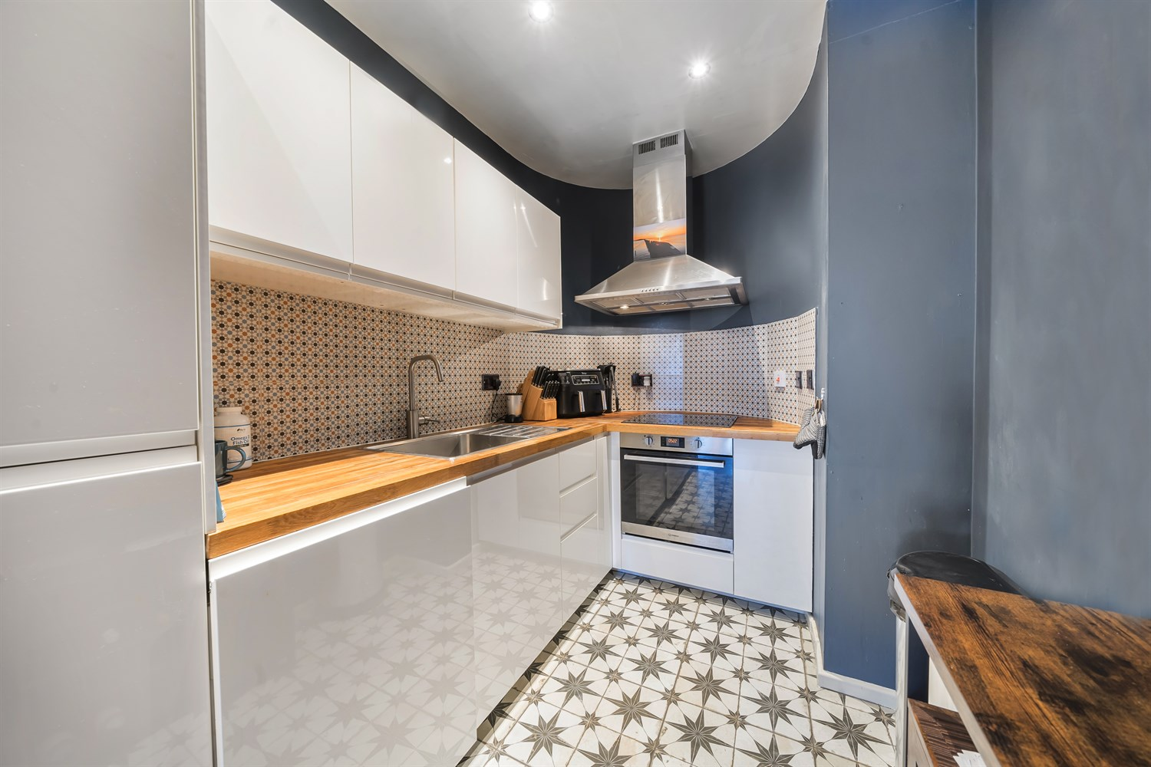

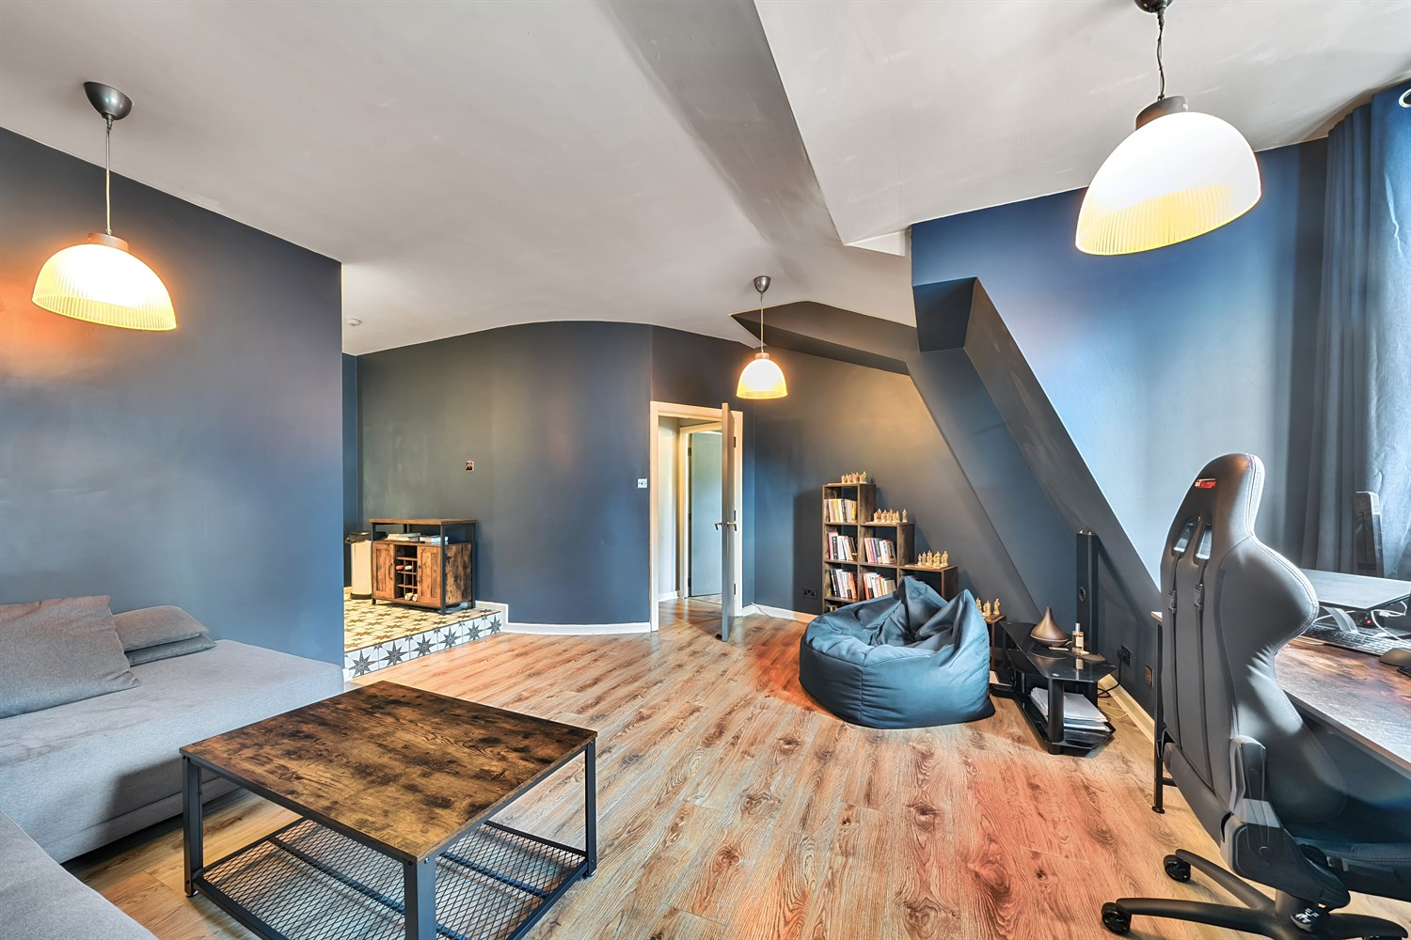

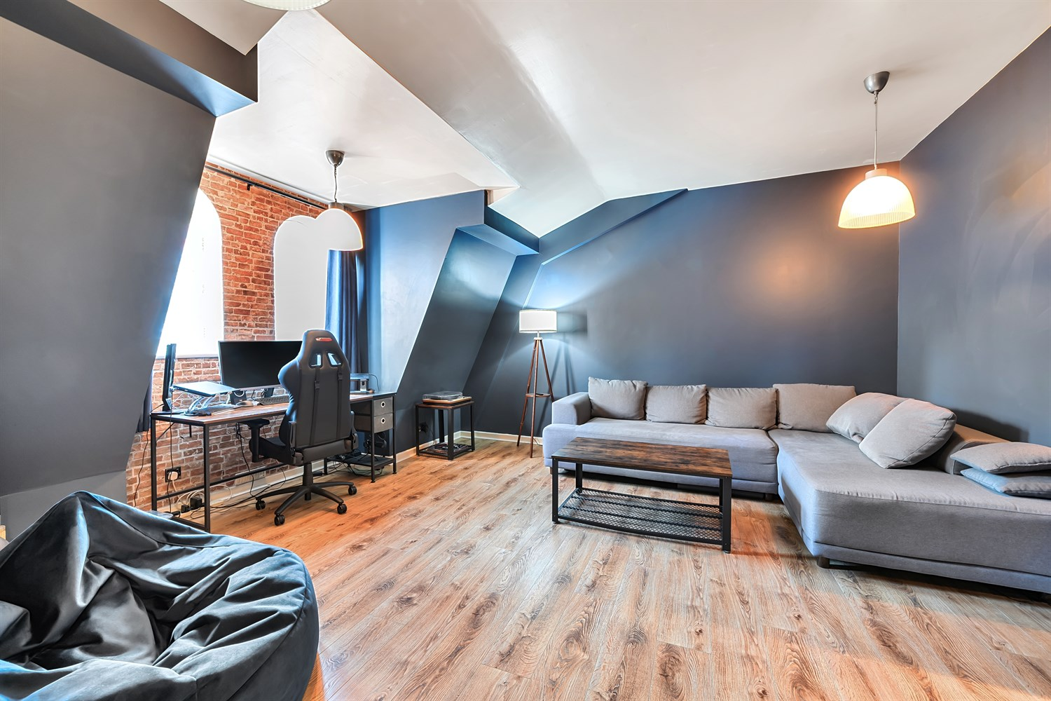

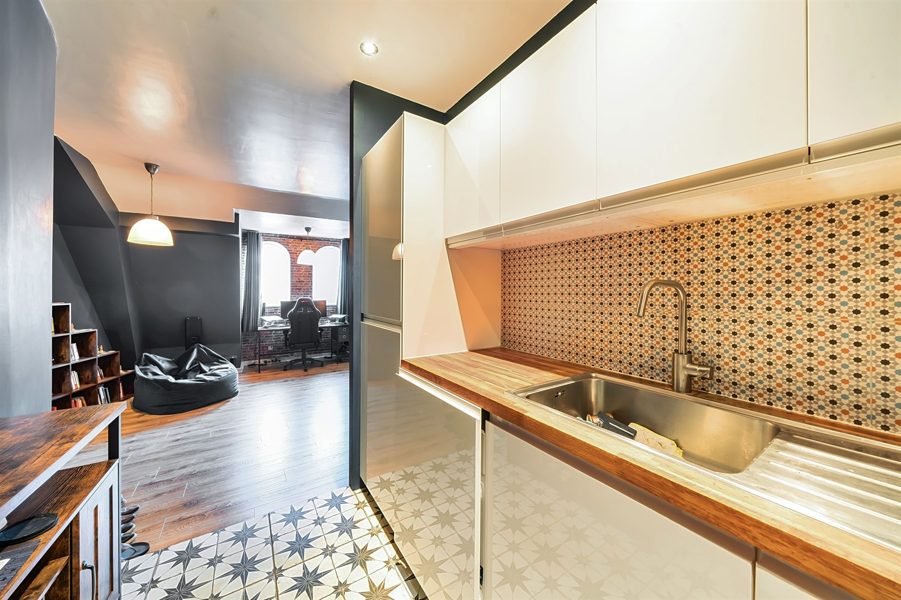

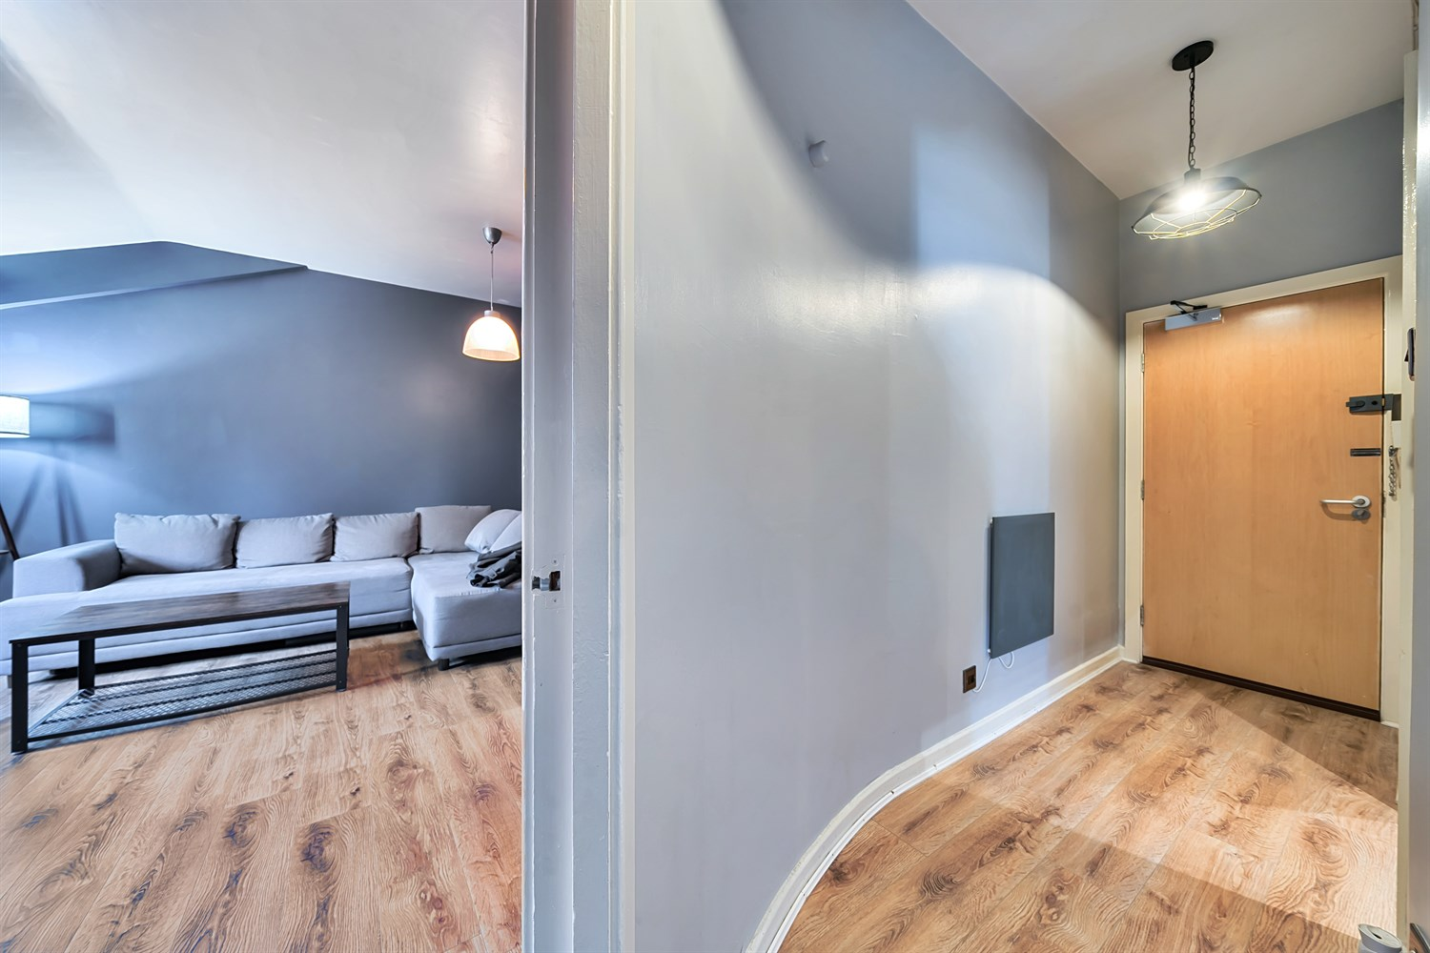

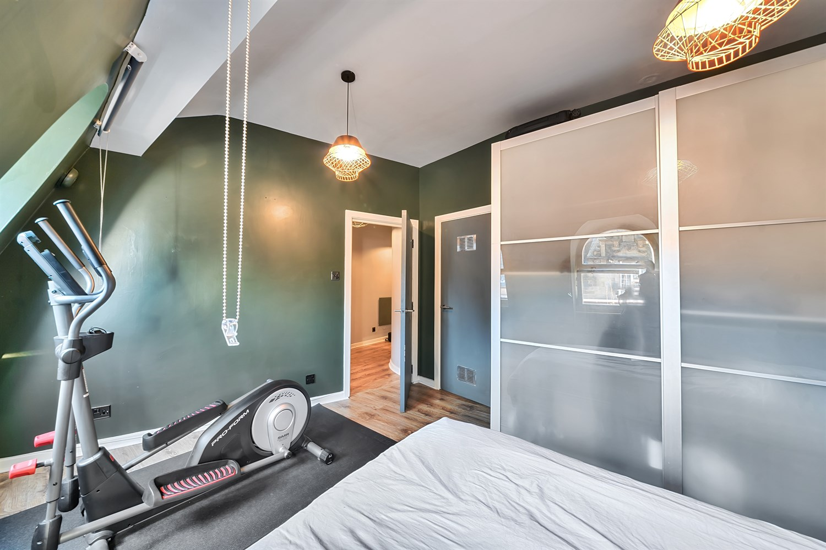

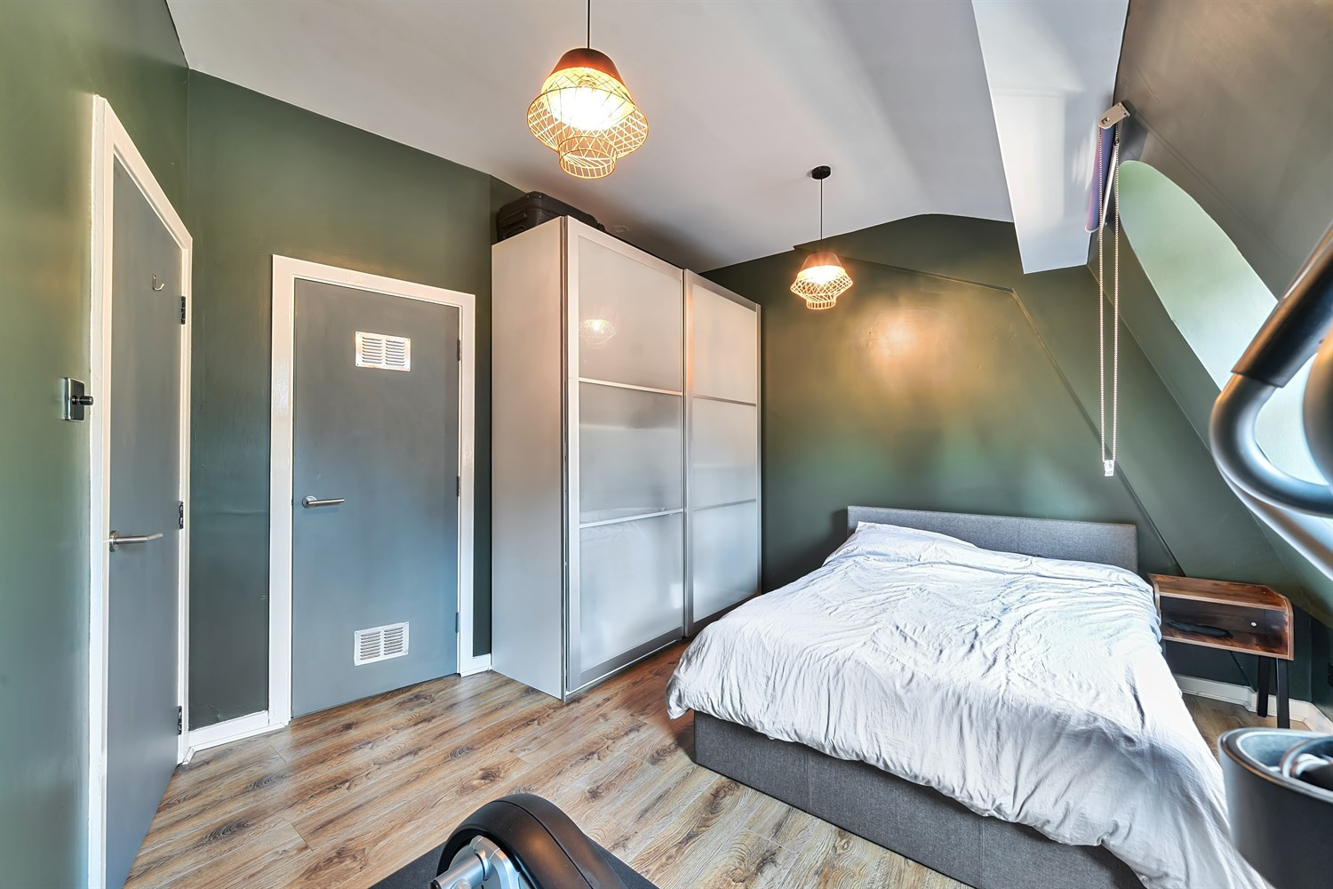

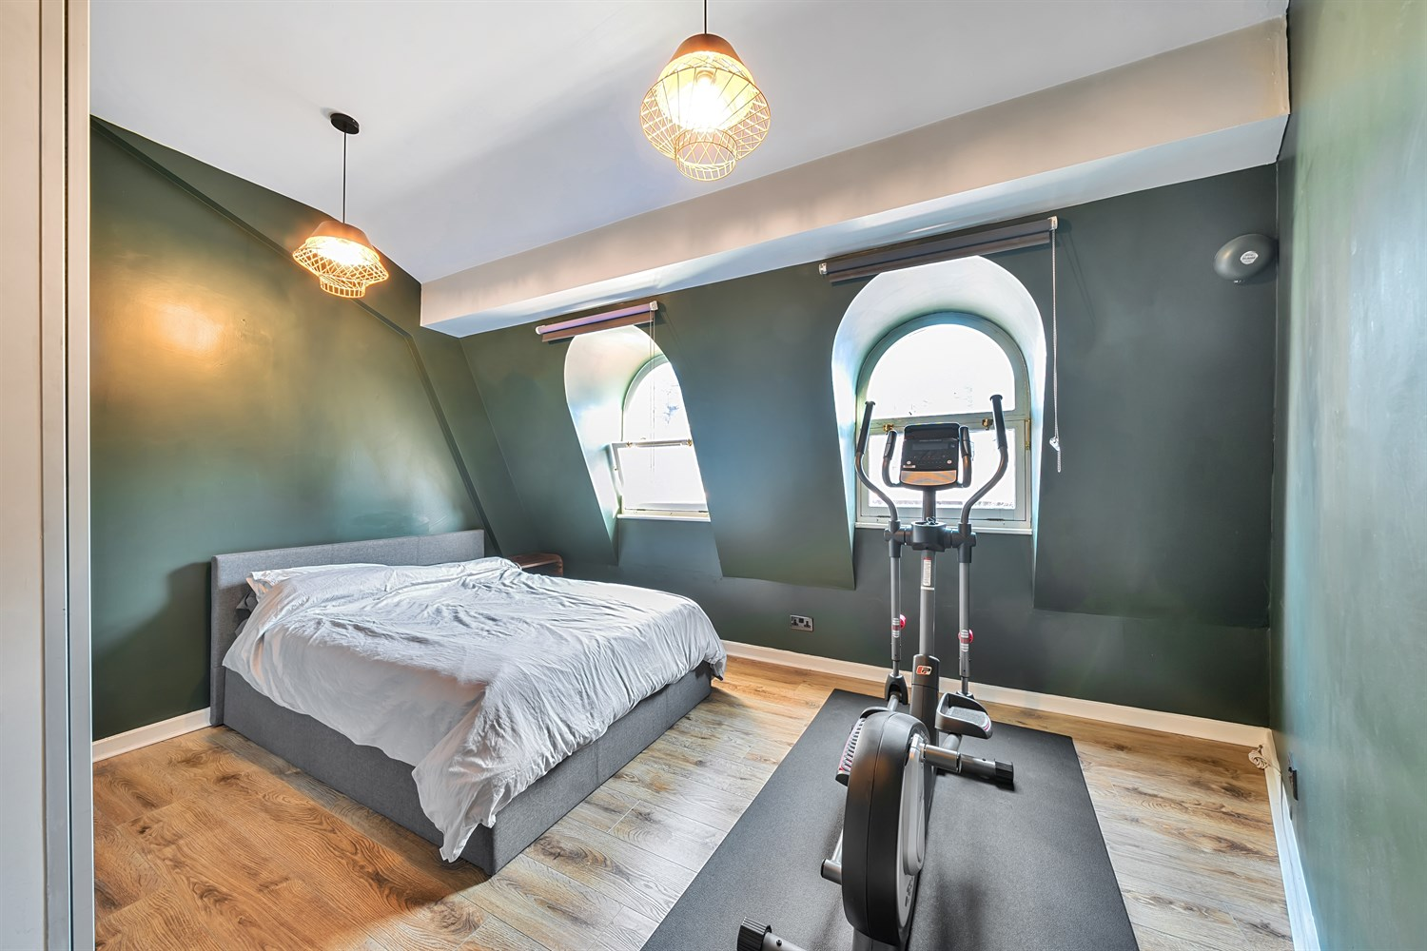

|  |
| --- |
| **Communal Entrance**  Stairs and lift to all floors. Secure entry system. |
| **Private Entrance**  Curved entrance hallway. Entry phone system. |
| **Open Plan Living Room 5.6m (18'4) x 4.9m (16'1)**  Light and Airy living area with two feature windows that offer south facing views. |
| **Kitchen 2m (6'7) x 2.42m (7'11)**  The recessed kitchen is fitted with a range of wall, base and drawer units with worktops over. Integrated fridge/freezer and dishwasher. Integrated oven with 4-ring hob and extractor. Stainless steel sink with mixer tap. Part tiled wall. |
| **Bedroom 4.38m (14'4) x 3.47m (11'5)**  Spacious double bedroom with two feature windows. Large storage cupboard. |
| **Shower Room**  Fitted with a three piece white suite comprising; double walk-in shower, WC and wash hand basin. Subway style tiled walls. Inset ceiling spotlights. |
| **Tenure**  Ground Rent £100 per annum Lease - 175 years from 1999 |
| **Service Charge**  Service charge £785.54 paid quarterly |

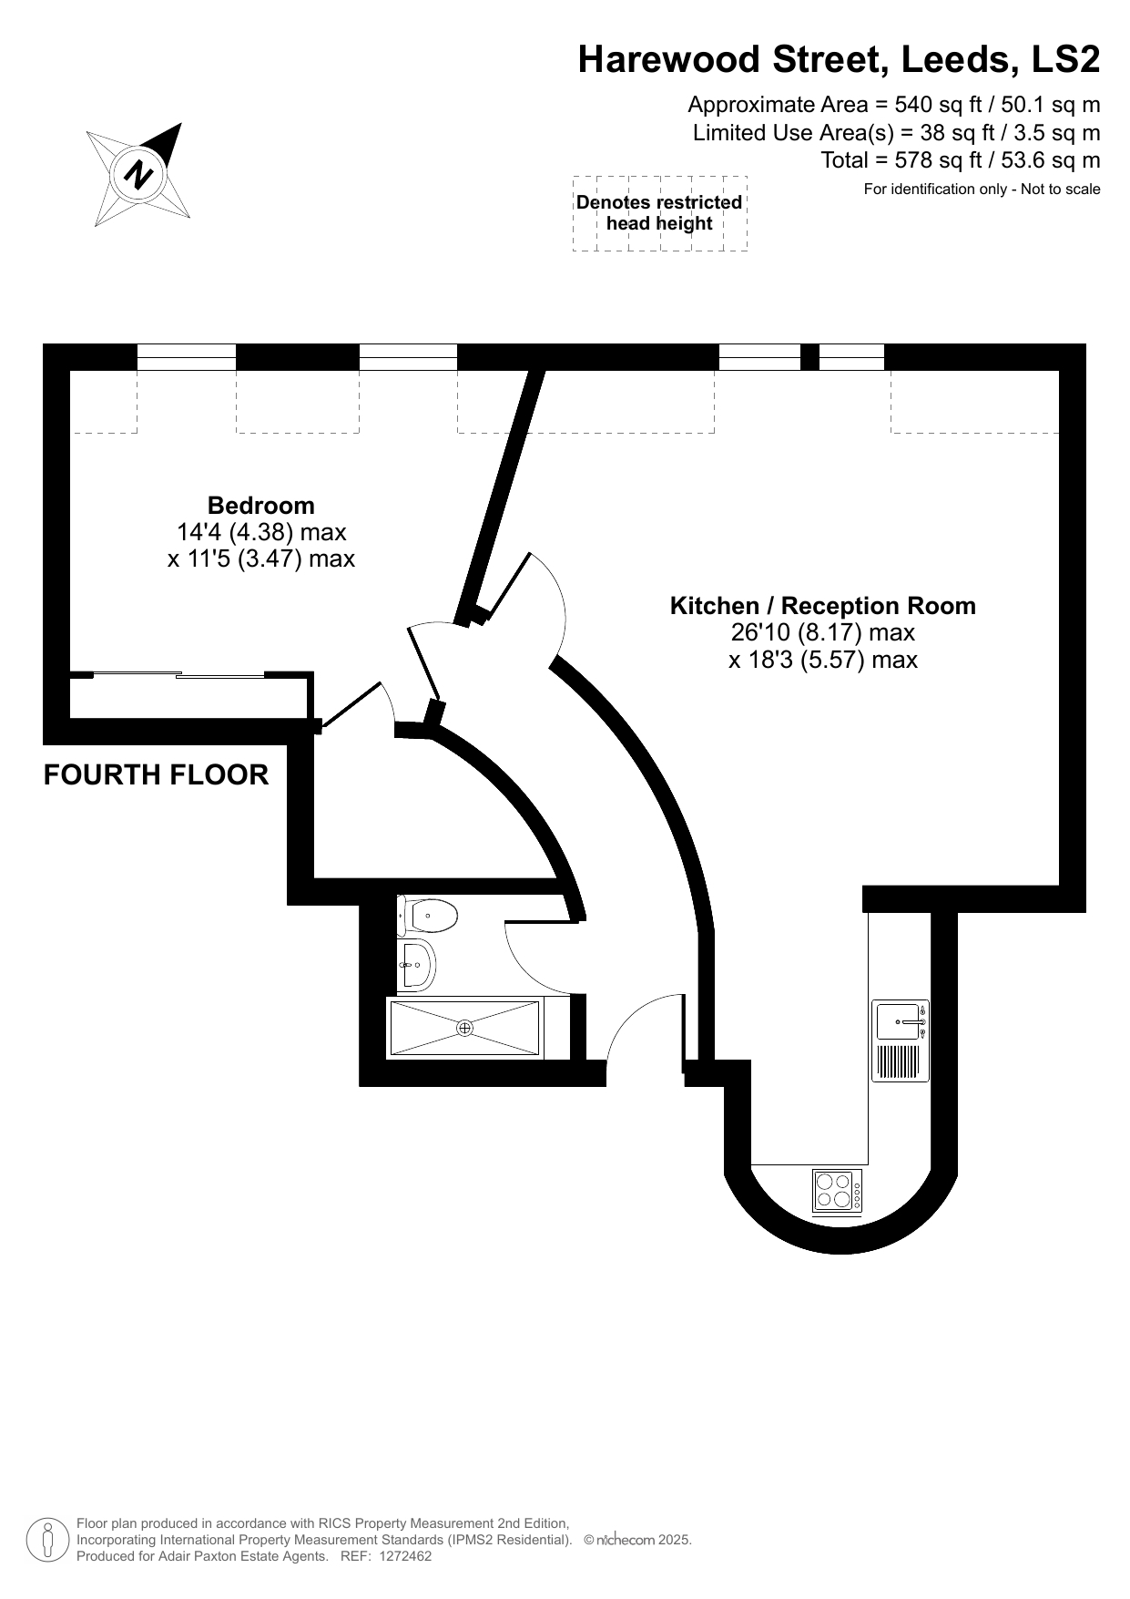

|  |
| --- |
|  |

These particulars are intended to give a fair description of the property, but their accuracy cannot be guaranteed, and they do not constitute an offer of contract. Intending purchasers must rely on their own inspection of the property. None of the above appliances/services have been tested by ourselves. We recommend purchasers arrange for a qualified person to check all appliances/services before legal commitment.

**For more information, please contact**

0113 258 1150 **|** [sales@adairpaxton.co.uk](mailto:sales@adairpaxton.co.uk) **|** www.adairpaxton.co.uk