

**Richmond Court, Rodley**

**For Sale £165,000.00**

***TWO BEDROOM, TWO BATHROOM FIRST FLOOR APARTMENT *** Must be viewed to be appreciated. This apartment is ideally located for the shops, bars and restaurants in Rodley as well as useful transport links to both Leeds and Bradford. This apartment briefly comprises: Communal Entrance hall, private entrance hall, open plan lounge/kitchen/diner, master bedroom with en-suite shower room, second bedroom and house bathroom. Gas central heating. Council tax band: C. EPC rating: B.

**0113 258 1150**

**0800 000 000**

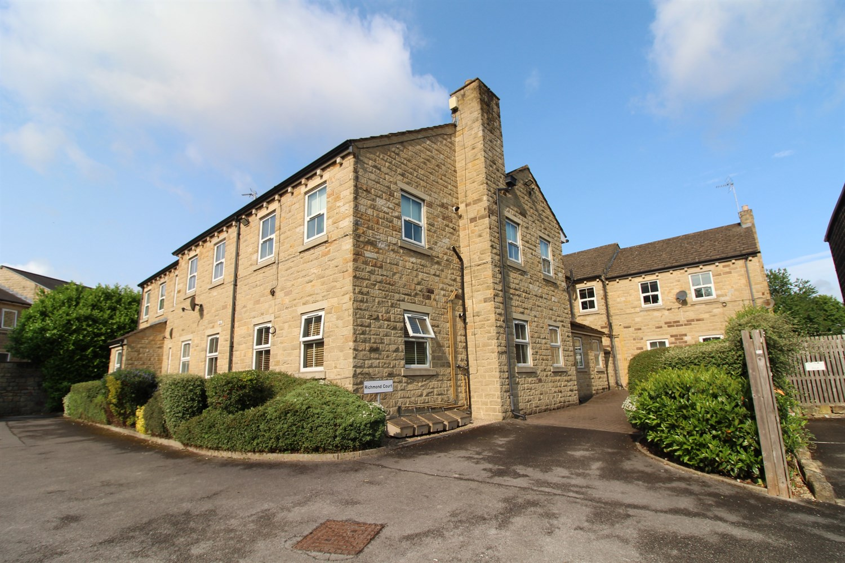



1 Reception(s)

2 Bathroom(s)

2 Bedroom(s)

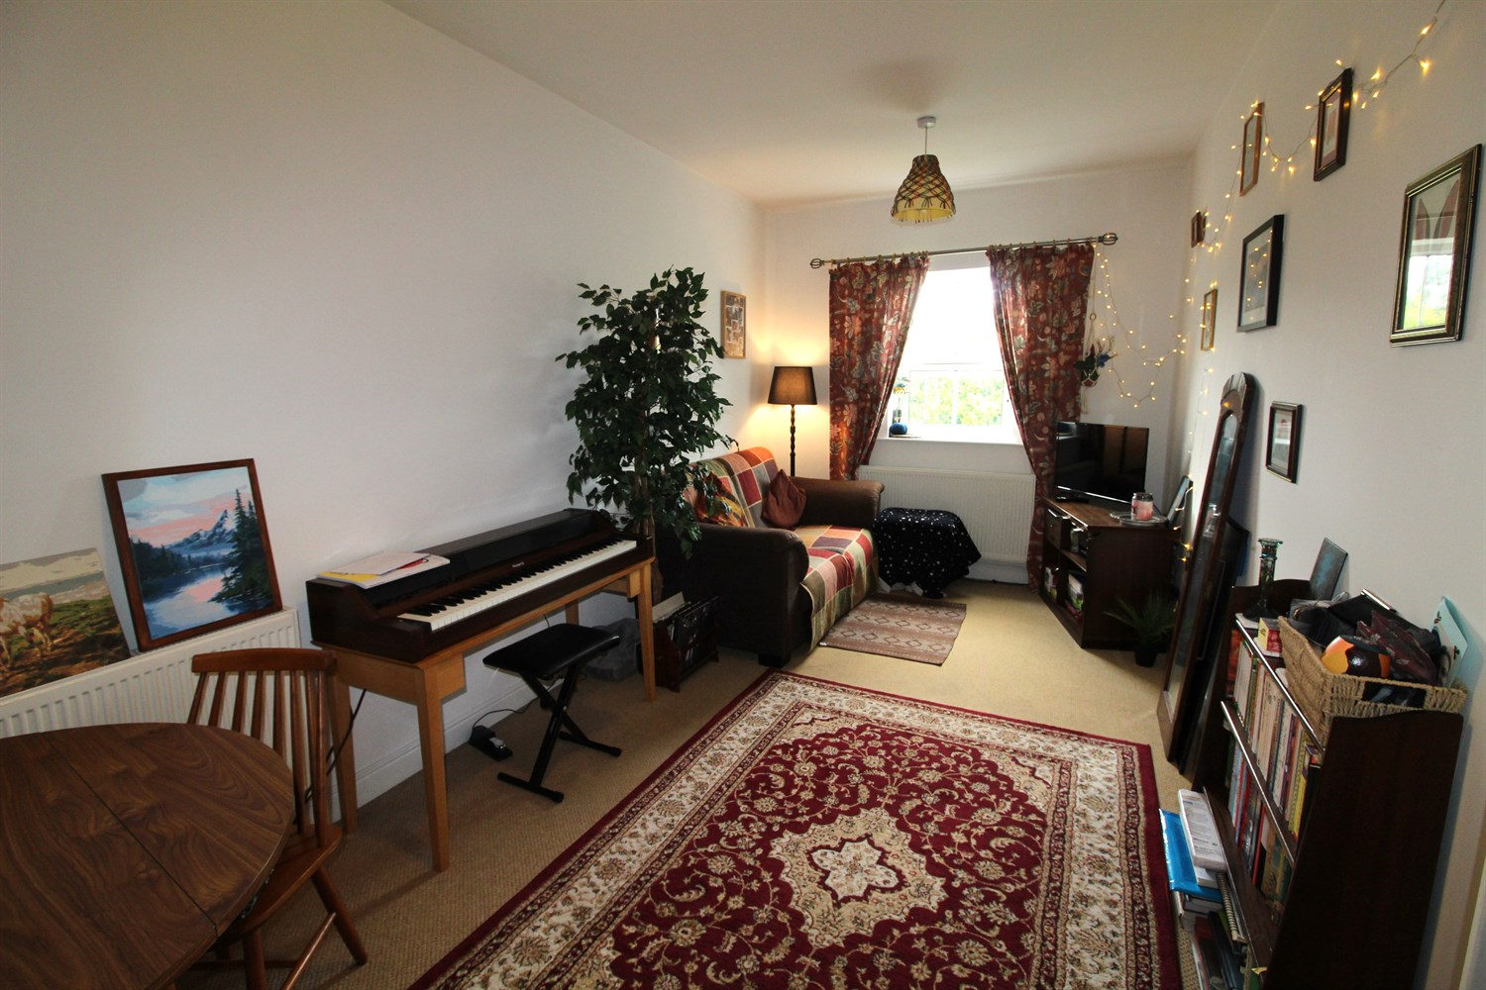

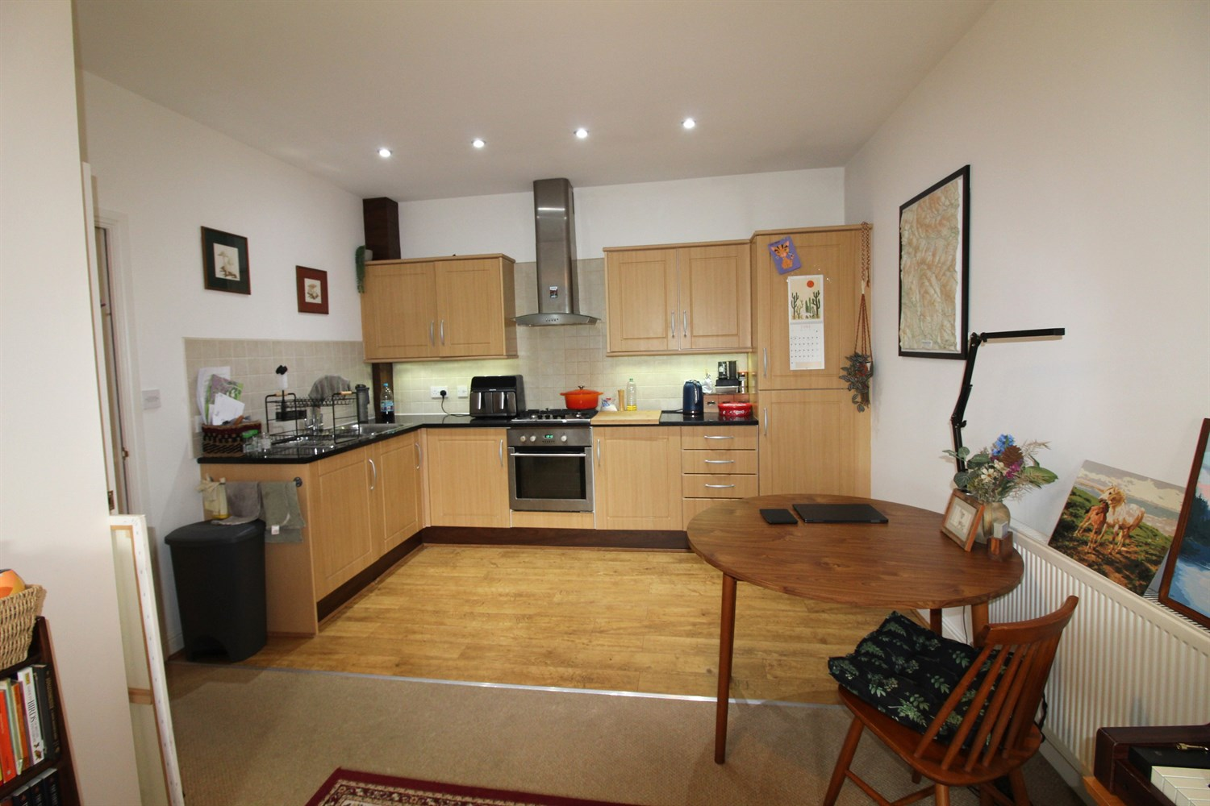

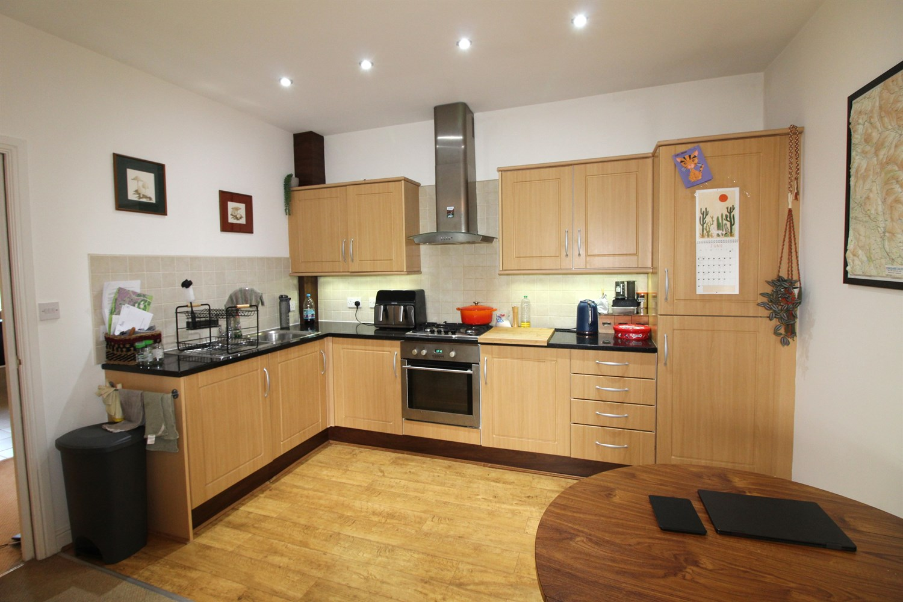

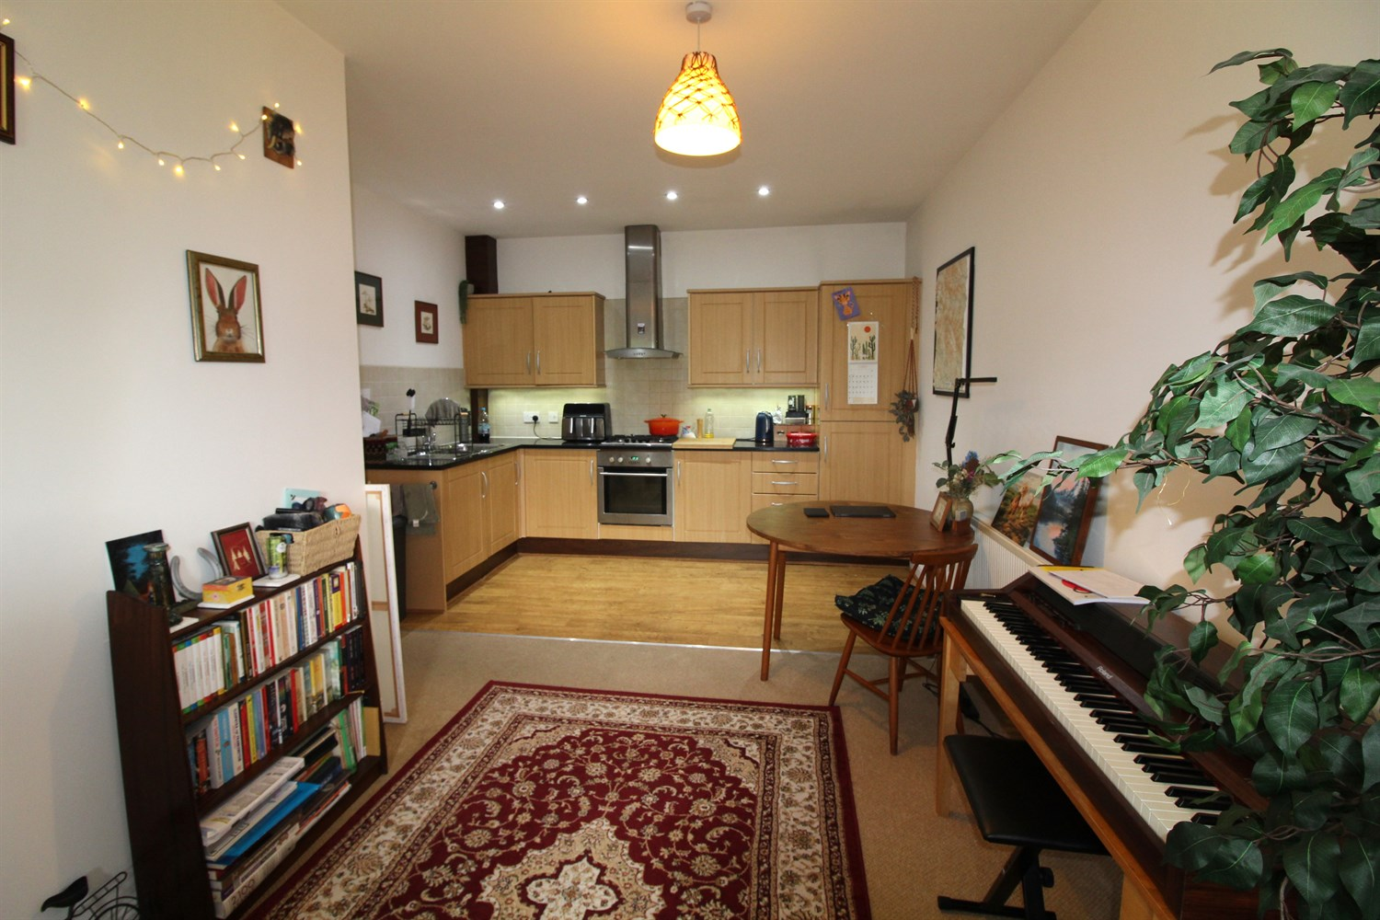

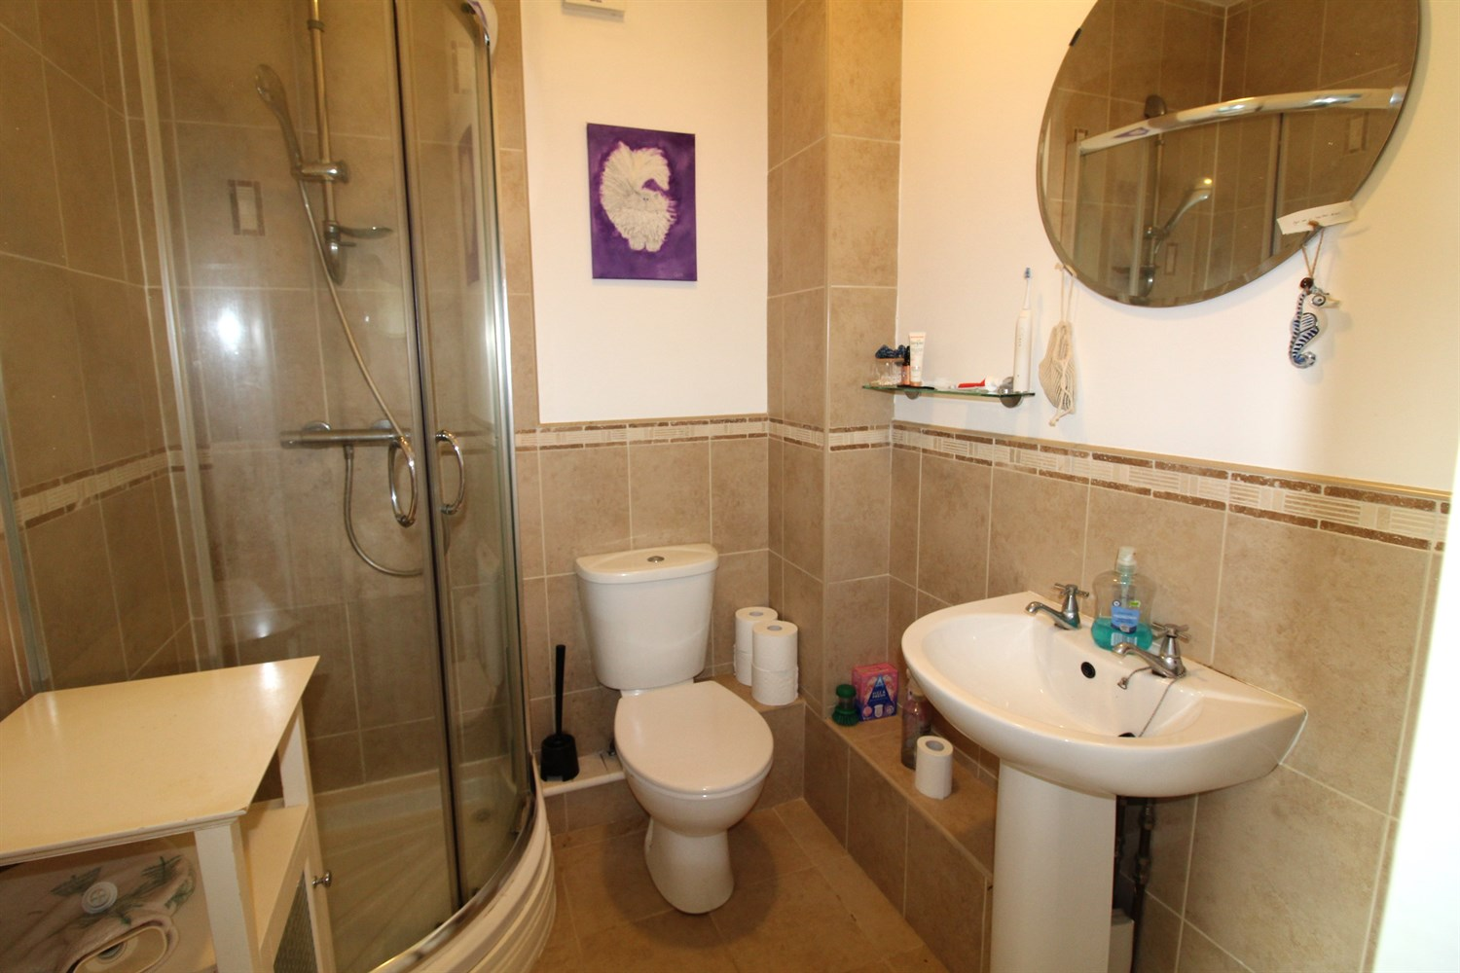

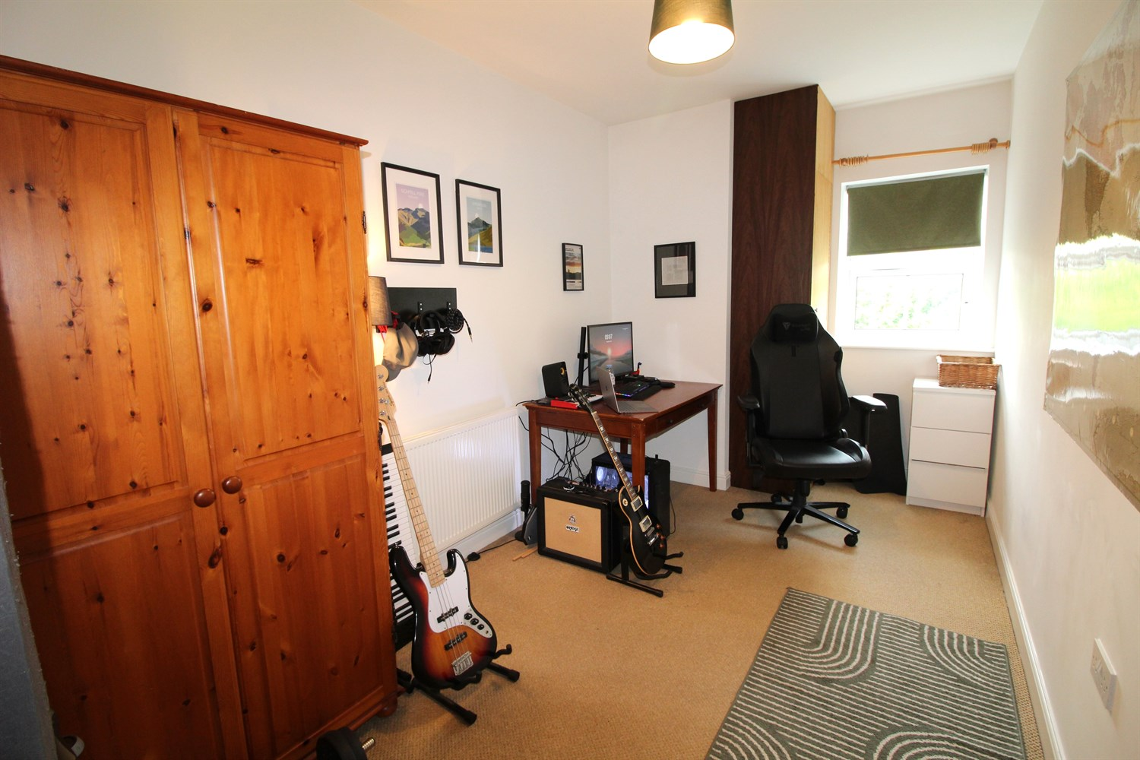

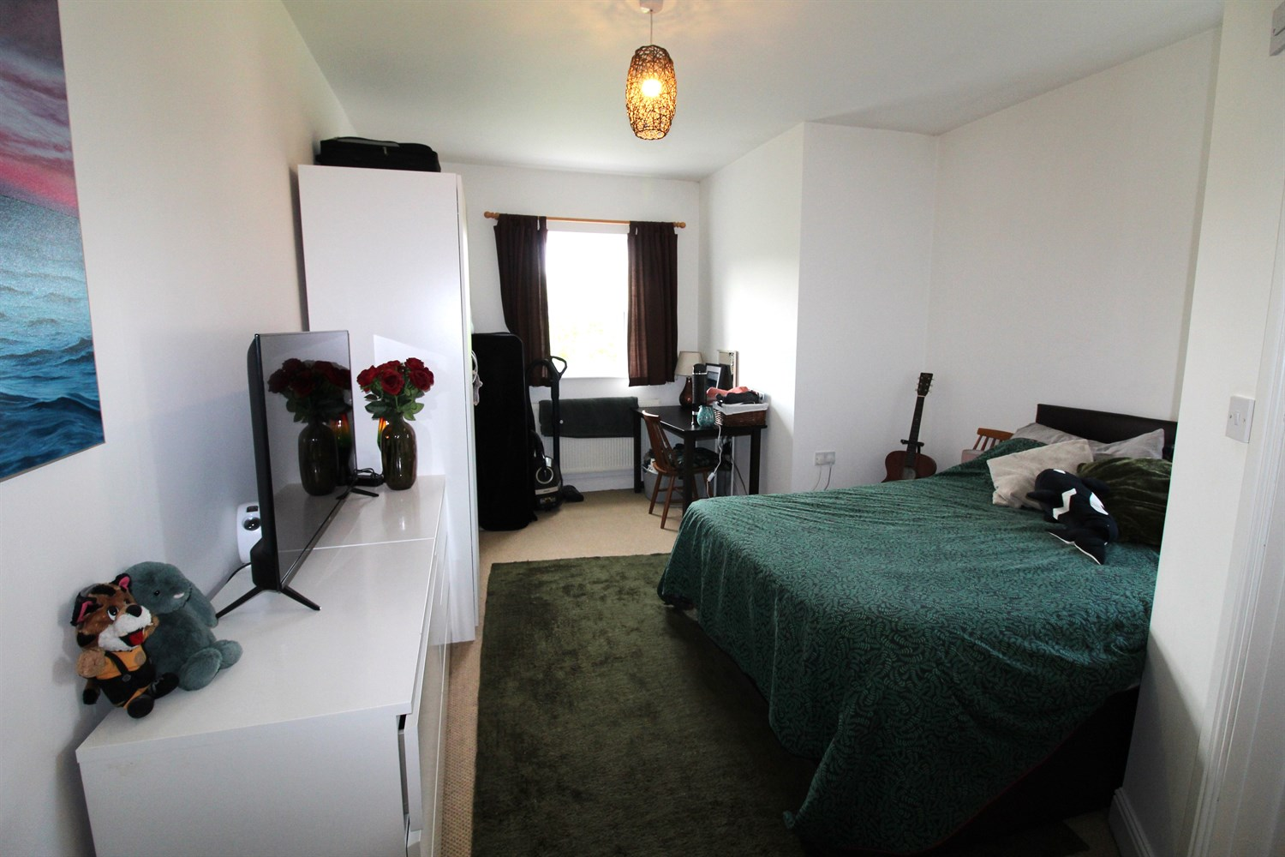

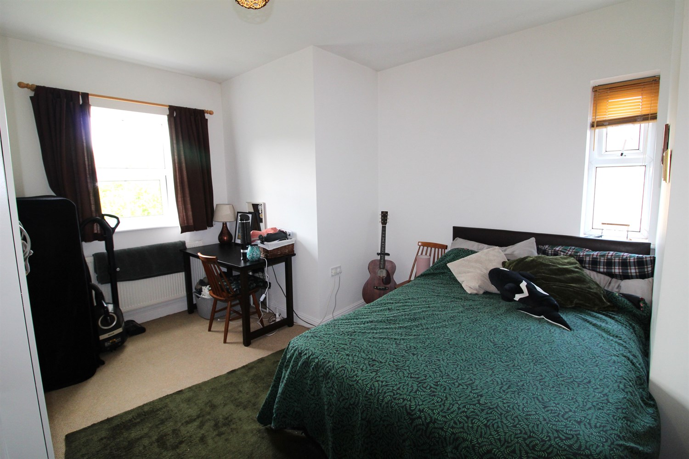

|  |
| --- |
| **Communal Hallway**  Via front entrance door. |
| **Hallway**  Spacious hallway. Gas central heating radiator. |
| **Open Plan Kitchen/Lounge**  Fitted with a range of wall, base and drawer units with worktops over. Integrated oven with 4-ring gas hob and extractor hood over. Integrated washing machine and fridge/freezer. 1.5 bowl stainless steel sink with mixer tap and drainer. High ceilings. Inset ceiling spotlights. Opening up to the living area with double glazed window. |
| **Master Bedroom**  Master bedroom with double glazed window to front and side. Gas central heating radiator. |
| **En-Suite Shower Room**  Fitted with a three piece suite comprising; shower cubicle, WC and wash hand basin. Part tiled walls. |
| **Bedroom 2**  Second double bedroom with double glazed window. Gas central heating radiator. |
| **Bathroom**  Fitted with a three piece suite comprising; bath with shower over, WC and wash hand basin. Part tiled walls. |
| **Outside**  Well maintained communal gardens. Allocated parking. |
| **Tenure**  Leasehold - 999 years from 1 January 2006. Ground Rent - £152.29 per annum |
| **Service Charge**  £1022.30 per annum |

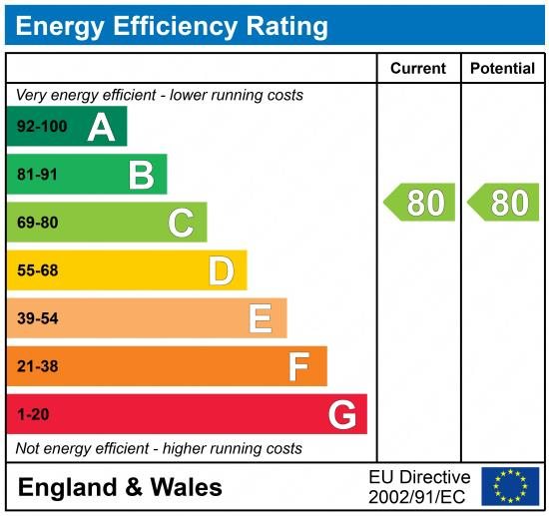

|  |
| --- |
|  |

These particulars are intended to give a fair description of the property, but their accuracy cannot be guaranteed, and they do not constitute an offer of contract. Intending purchasers must rely on their own inspection of the property. None of the above appliances/services have been tested by ourselves. We recommend purchasers arrange for a qualified person to check all appliances/services before legal commitment.

**Property Ref:** 5502

**For more information, please contact**

0113 258 1150 **|** [sales@adairpaxton.co.uk](mailto:sales@adairpaxton.co.uk) **|** www.adairpaxton.co.uk