

**0113 258 1150**

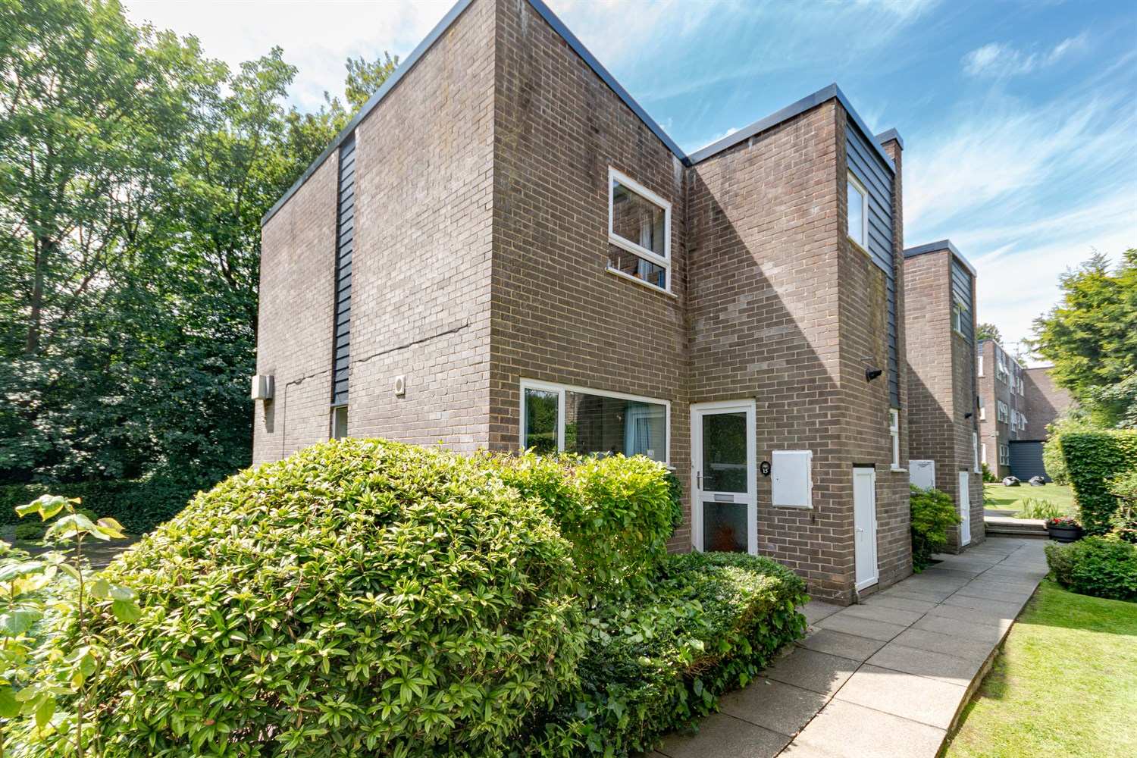



**For Sale £235,000.00**

**Fernwood, Park Villas, Roundhay**

***THREE BEDROOM END TERRACED HOUSE WITH NO ONWARD CHAIN*** Situated in this sought after location of Roundhay, within just a few minutes walking distance of shops, bars and restaurants on Street Lane. The property is now in need of some cosmetic updating, but does benefit from a new roof and cladding, and briefly comprises; Entrance hall, kitchen, lounge and downstairs WC to the ground floor. To the first floor there are two double bedrooms, a single bedroom and a house bathroom. Externally the property is set in well maintained communal gardens and benefits from off street parking. Located directly next to Canal gardens and Roundhay Park which offers many recreational amenities including parkland walks, sports grounds on Soldiers Field and Tropical World. This property would be ideal for first time buyers, investors or a small family. EPC Rating - D

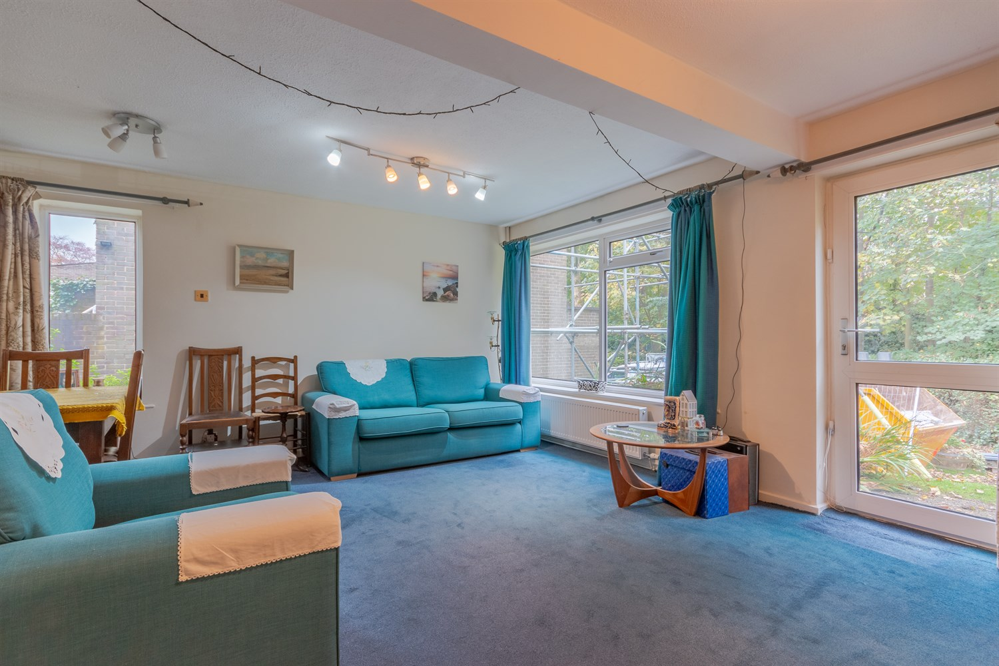

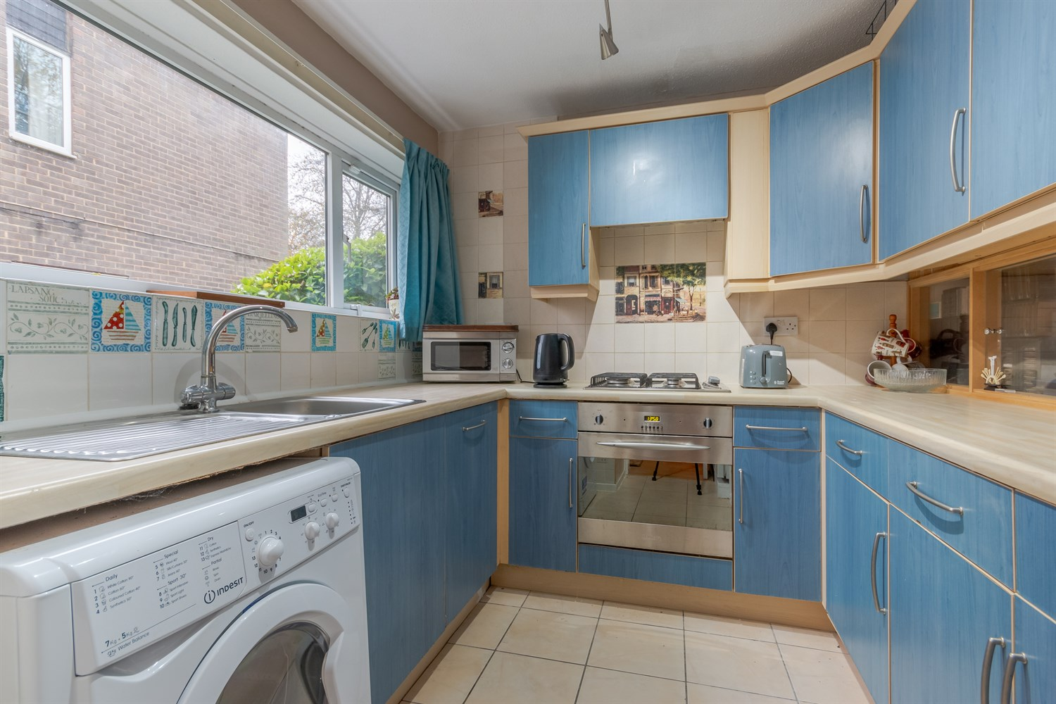

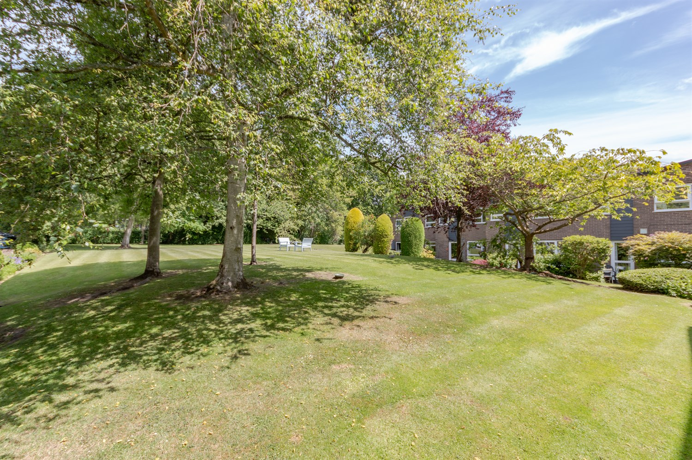

1 Bathroom(s)

1 Reception(s)

3 Bedroom(s)

00

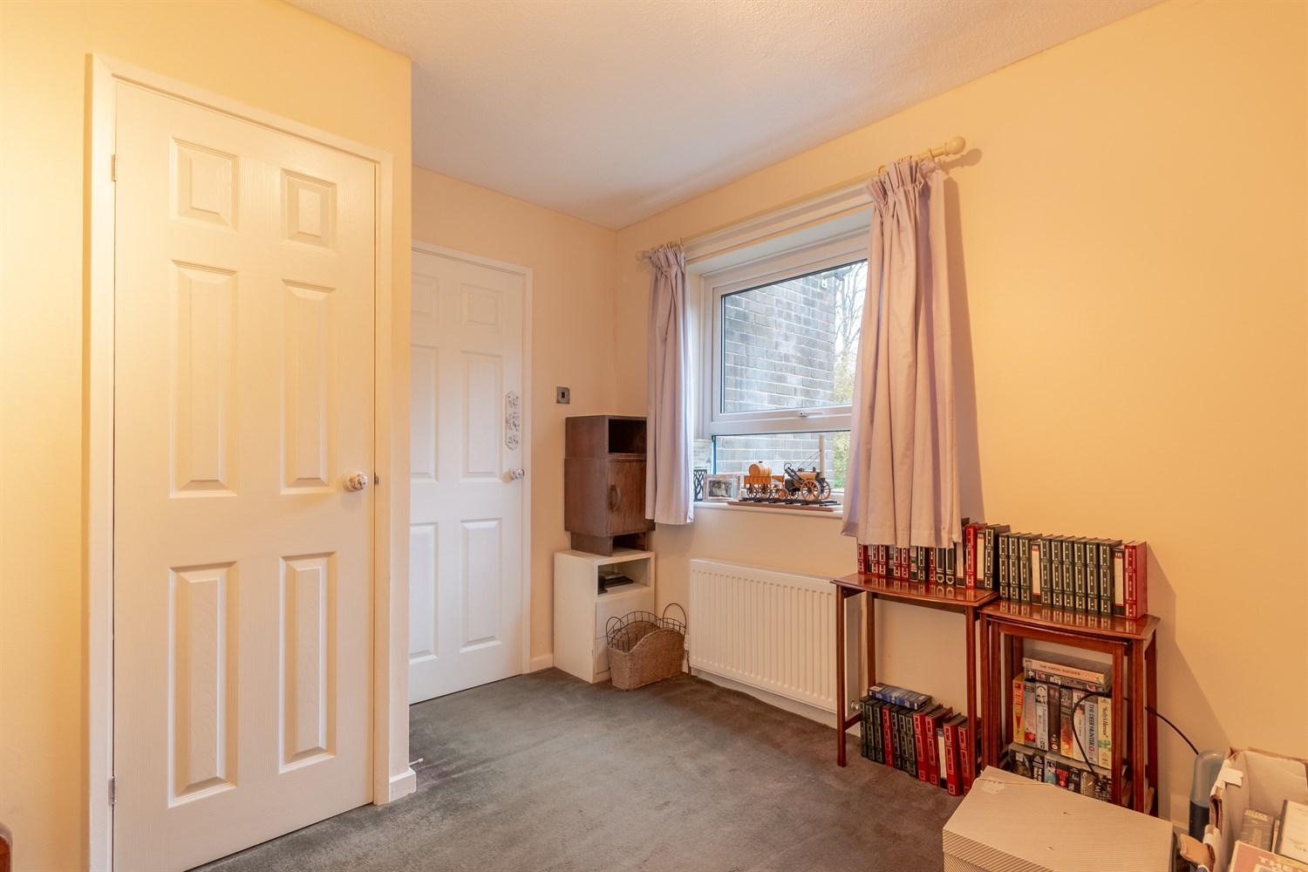

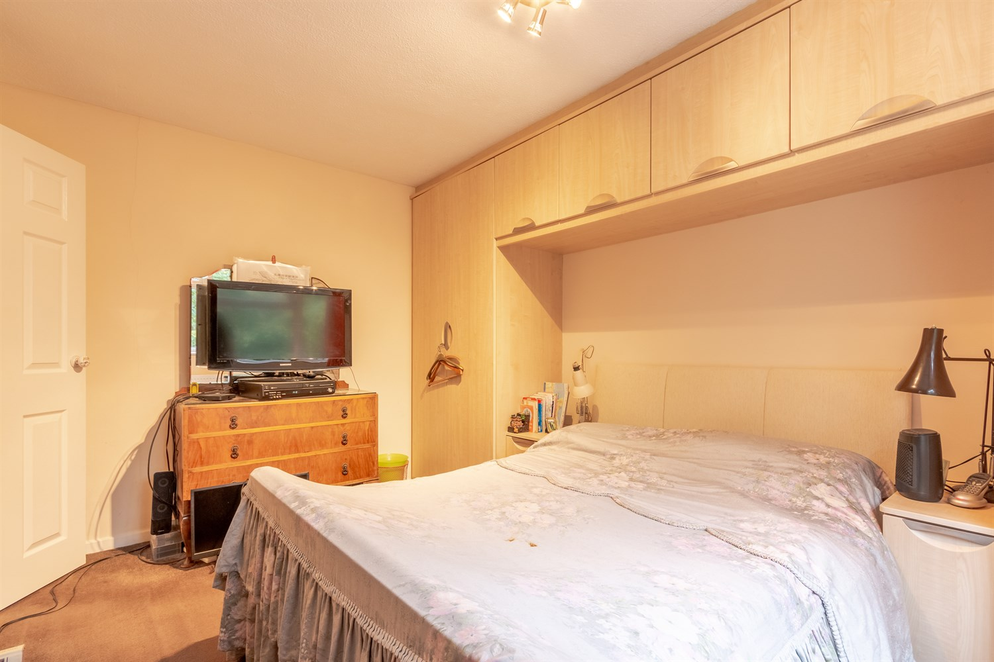

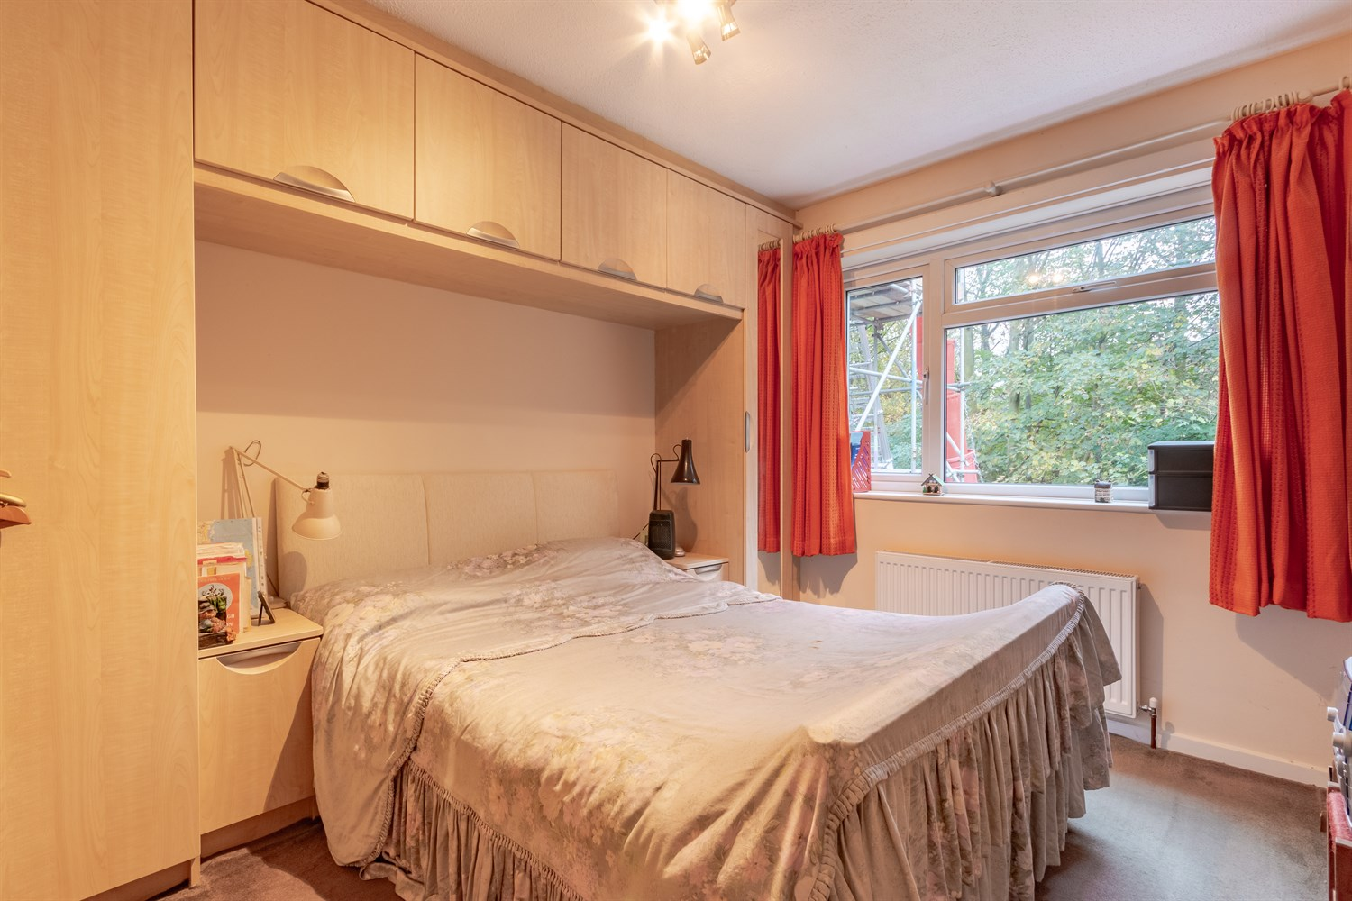

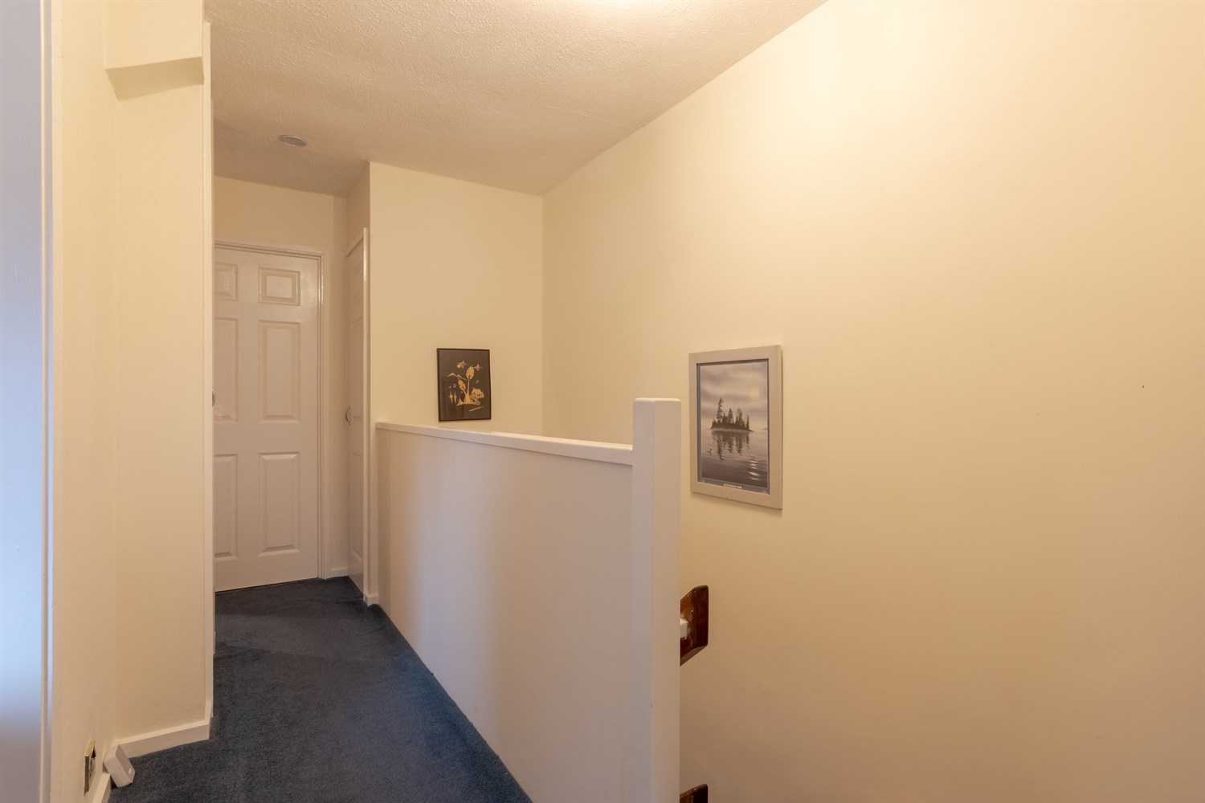

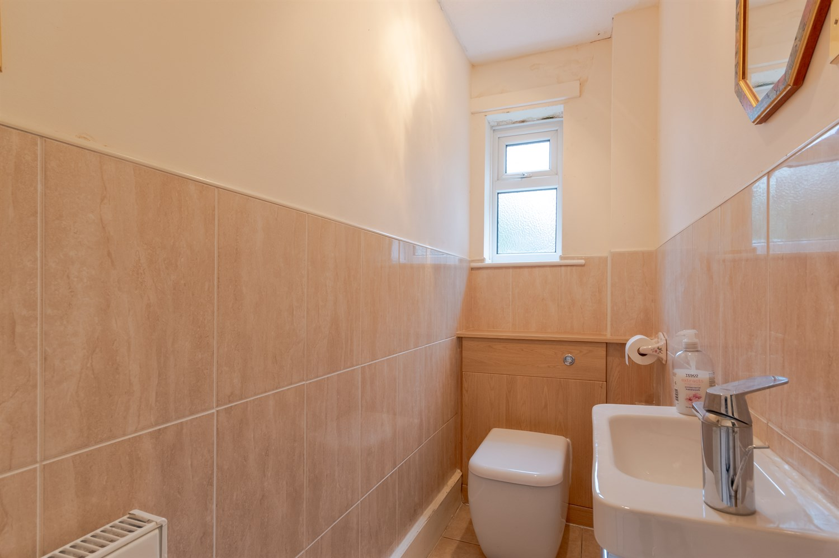

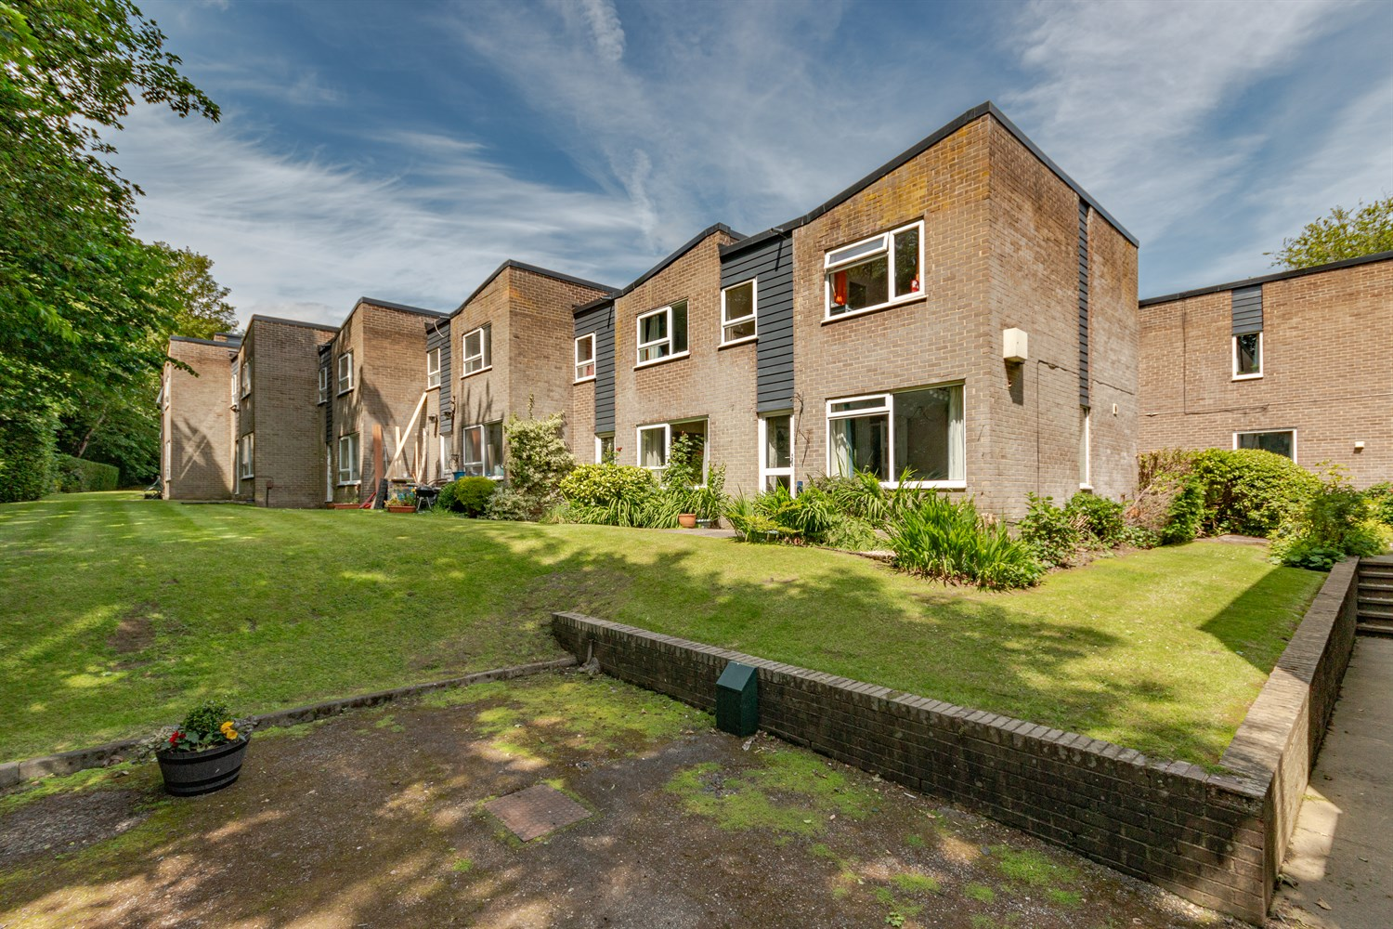

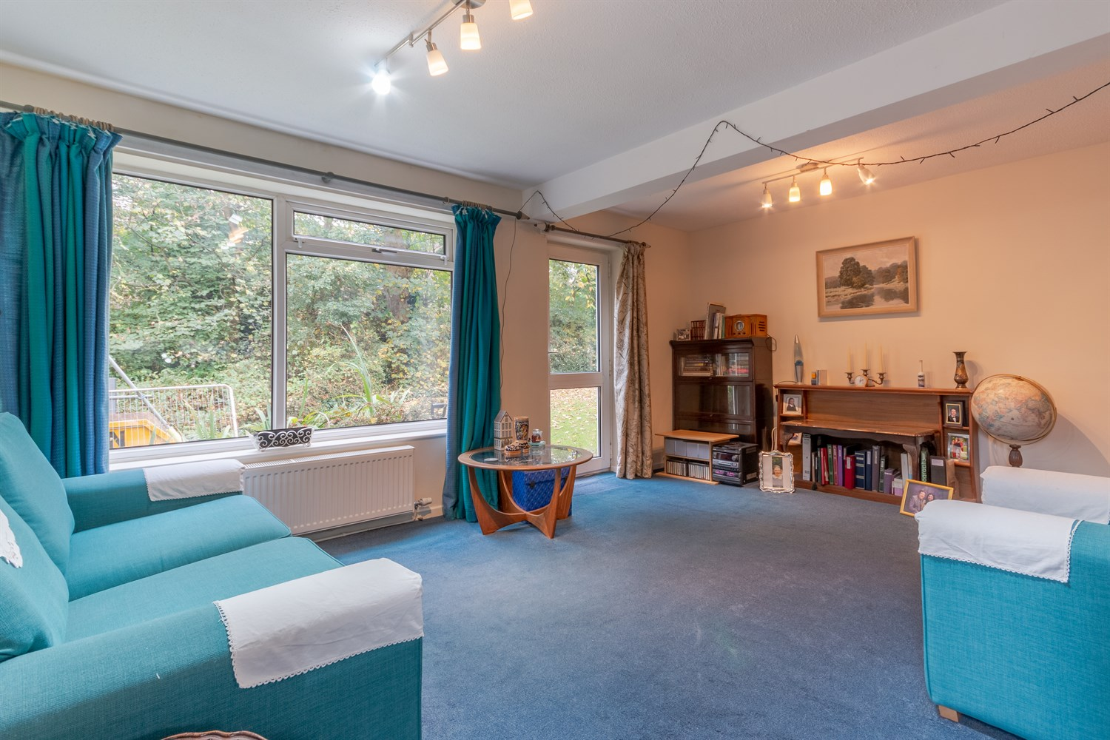

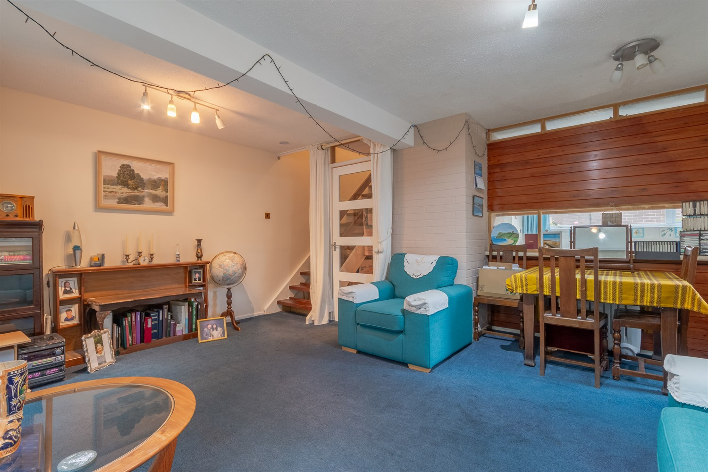

|  |
| --- |
| **Hallway**  Via front entrance door. Gas central heating radiator. |
| **Guest WC**  Fitted with a two piece suite comprising; WC and wash hand basin. Tiled walls and floor. uPVC double glazed window. Gas central heating radiator. |
| **Kitchen 2.45m (8'0) x 2.28m (7'6)**  Fitted with a range of wall, base and drawer units with worktops over. Integrated electric oven with 4-ring gas hob and extractor hood over. Integrated dishwasher. Space for washing machine and fridge/freezer. Stainless steel sink with mixer tap and drainer. Tiled floor and part tiled walls. Double glazed window to front. |
| **Lounge 5.08m (16'8) x 3.61m (11'10)**  Light and Airy living area with uPVC double glazed windows to the rear and side, and uPVC double glazed door leading out to the rear. Gas central heating radiator. |
| **First Floor**  Storage cupboard. |
| **Bedroom 1 2.99m (9'10) x 3.7m (12'2)**  Double bedroom with uPVC double glazed window to rear. Built in wardrobes. Gas central heating radiator. |
| **Bedroom 2 2.34m (7'8) x 2.95m (9'8)**  Second double bedroom with uPVC double glazed window to front. Gas central heating radiator. Store cupboard. |
| **Bedroom 3 1.93m (6'4) x 2.77m (9'1)**  Third bedroom with uPVC double glazed window to rear. Storage cupboard. |
| **Bathroom**  Fitted with a three piece suite comprising; bath with shower over, WC and wash hand basin. Tiled walls. uPVC double glazed window. |
| **Tenure**  Leasehold - 999 years from 1st November 1982 |
| **Service Charge**  The Service charge is £144.89 per month. |
| **Parking** |
| **Central Heating** |
| **Double Glazing** |

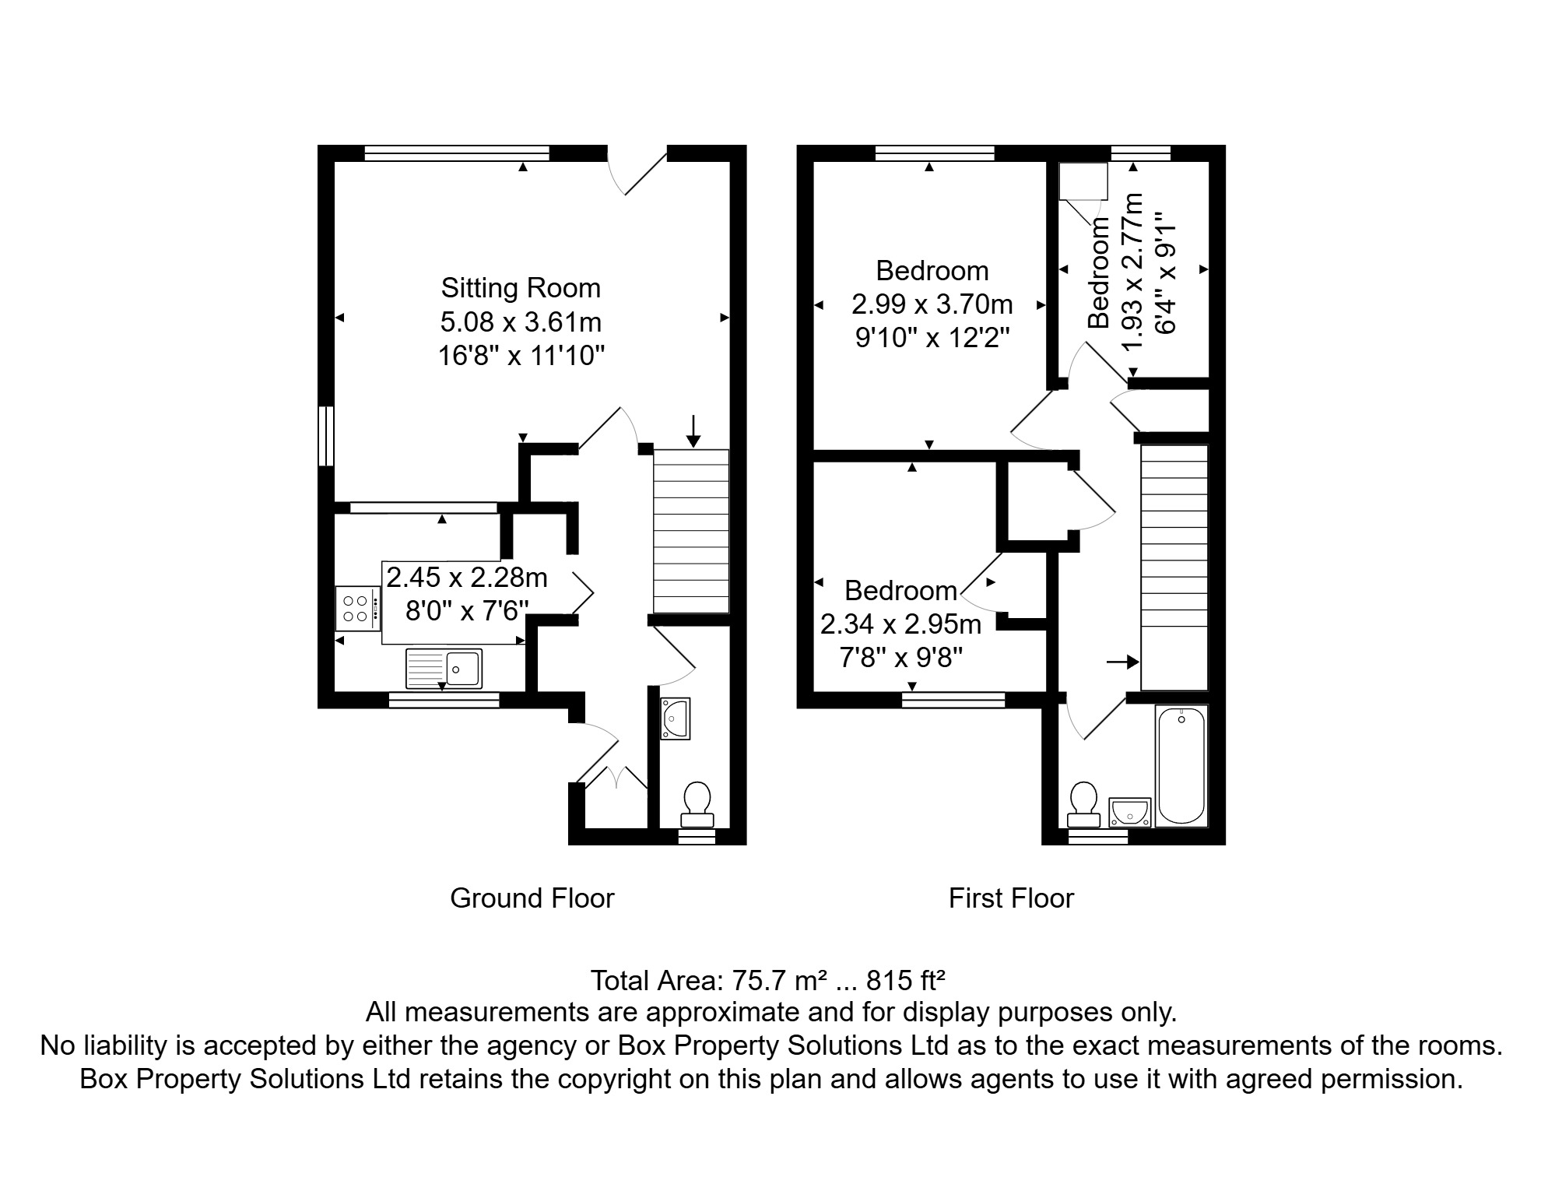

|  |  |
| --- | --- |
| These particulars are intended to give a fair description of the property, but their accuracy cannot be guaranteed, and they do not constitute an offer of contract. Intending purchasers must rely on their own inspection of the property. None of the above appliances/services have been tested by ourselves. We recommend purchasers arrange for a qualified person to check all appliances/services before legal commitment.  **Property Ref:** 2601  **For more information, please contact**  0113 258 1150 **|** [sales@adairpaxton.co.uk](mailto:sales@adairpaxton.co.uk) **|** www.adairpaxton.co.uk |  |