

**0113 258 1150**

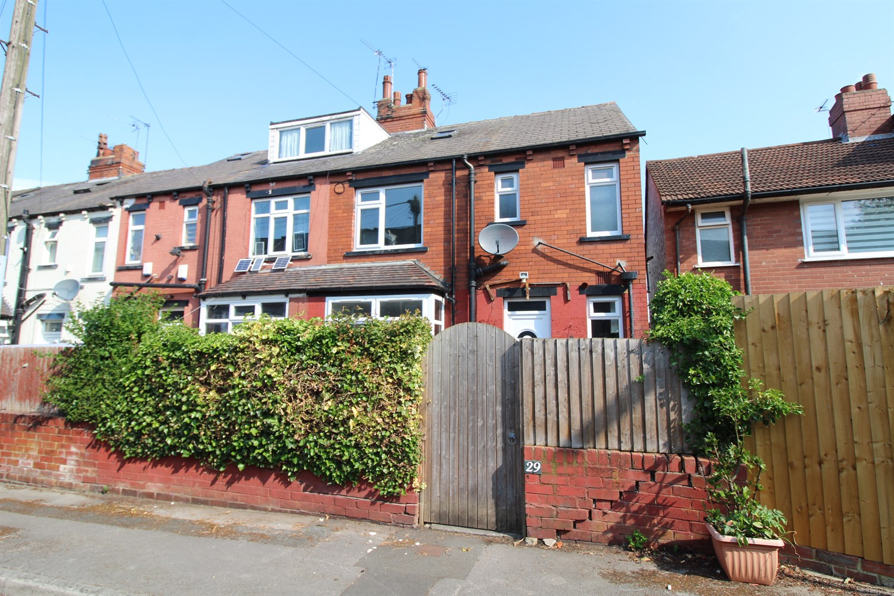



**For Sale £129,950.00**

**Nancroft Crescent, Armley**

**RECENTLY REFURBISHED TWO BEDRROM TERRACED HOUSE with STUDY - NO ONWARD CHAIN** Well presented two bedroom terraced house which is situated in a convenient location in Armley, close to excellent transport links and amenities. The property is a great first time buy or investment and briefly comprises; Hallway, lounge and kitchen to the ground floor. Cellar. Double bedroom, bathroom and office to the first floor. Second bedroom to the second floor. Externally, the property has an enclosed garden to the front.

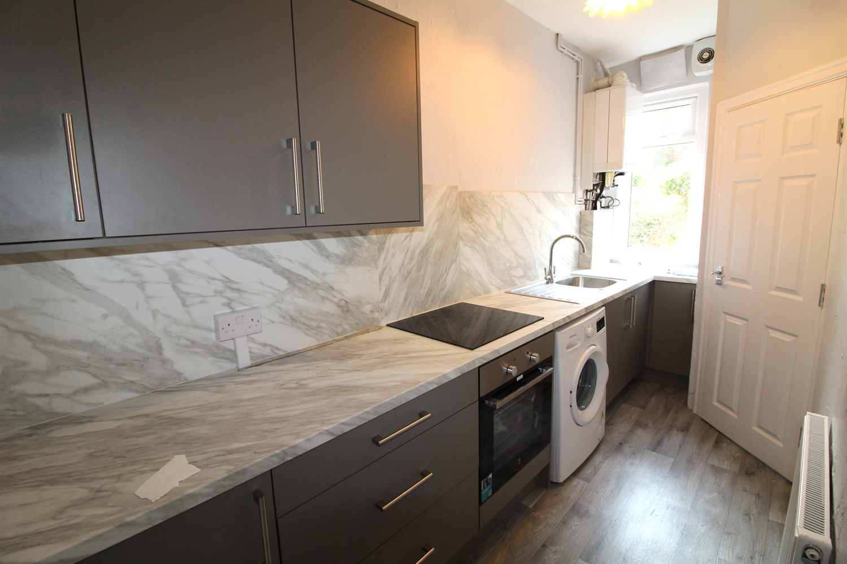

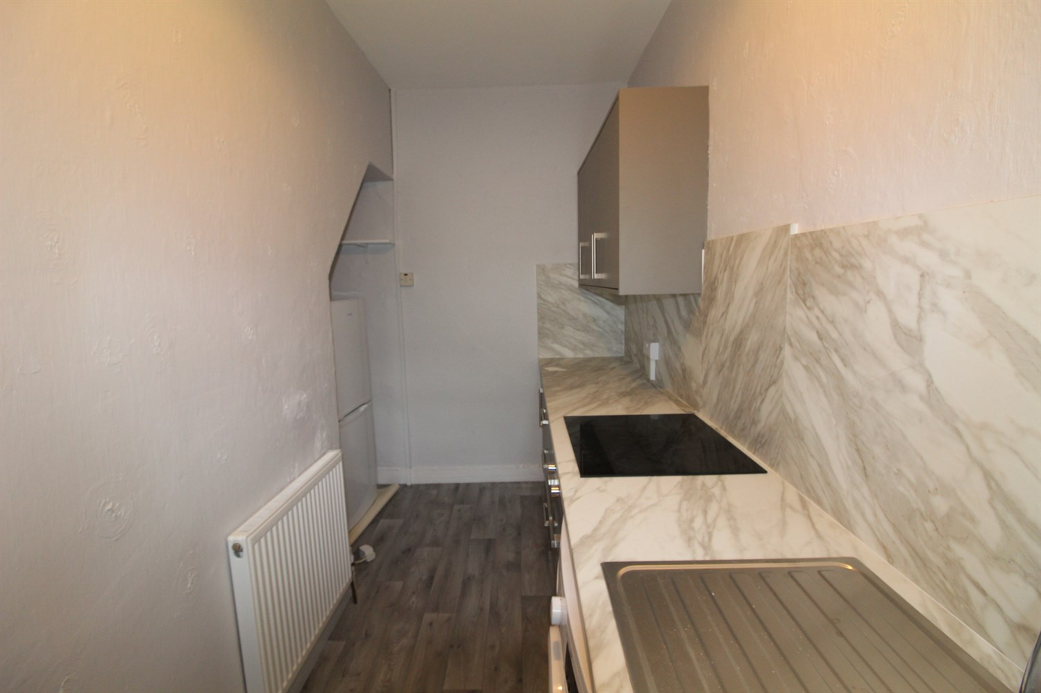

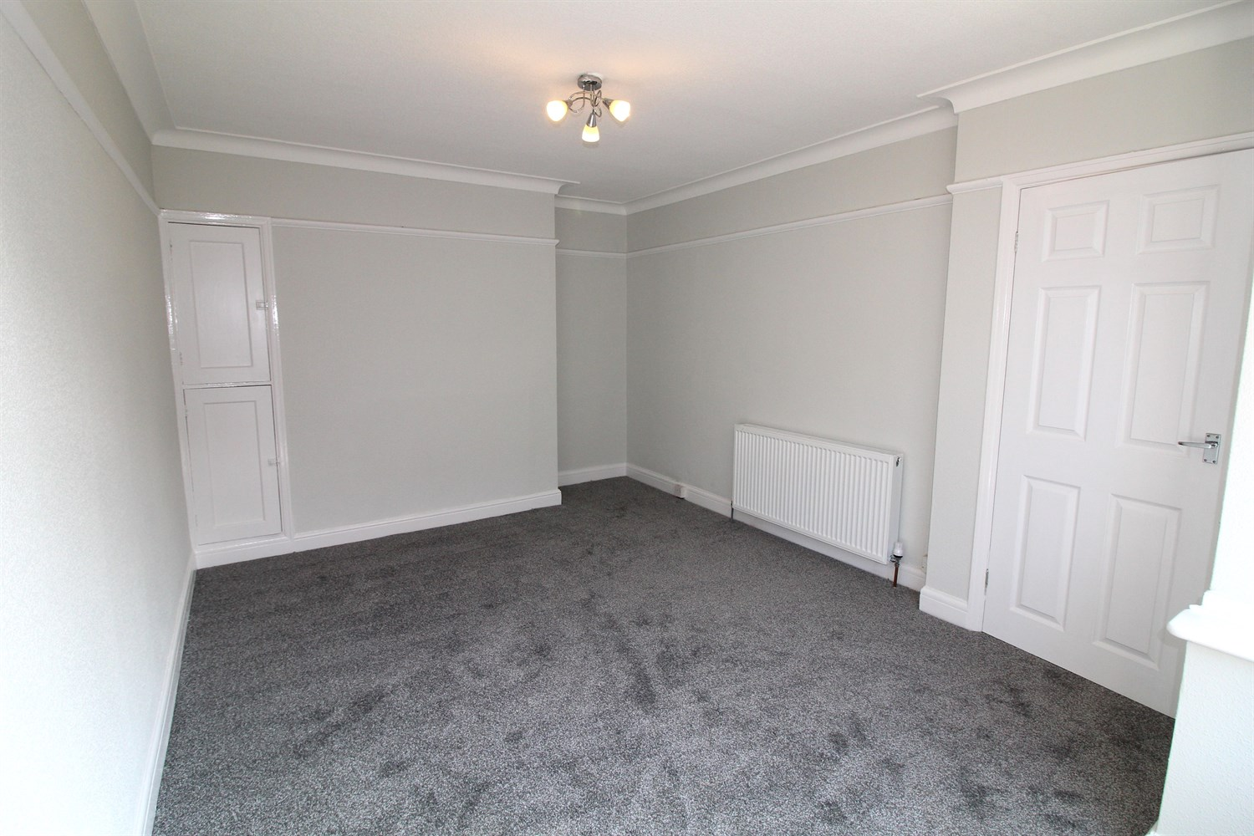

1 Bathroom(s)

1 Reception(s)

1 Bedroom(s)

00

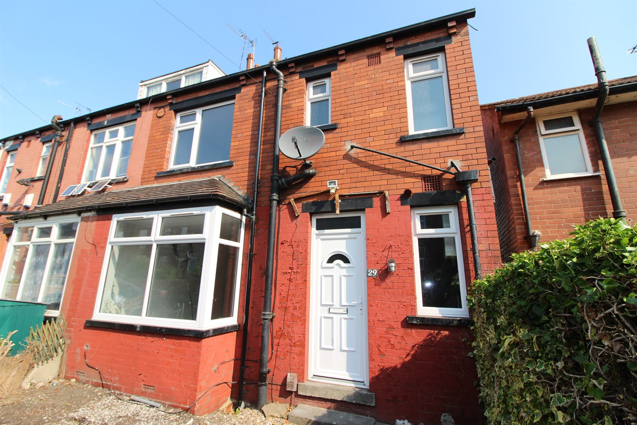

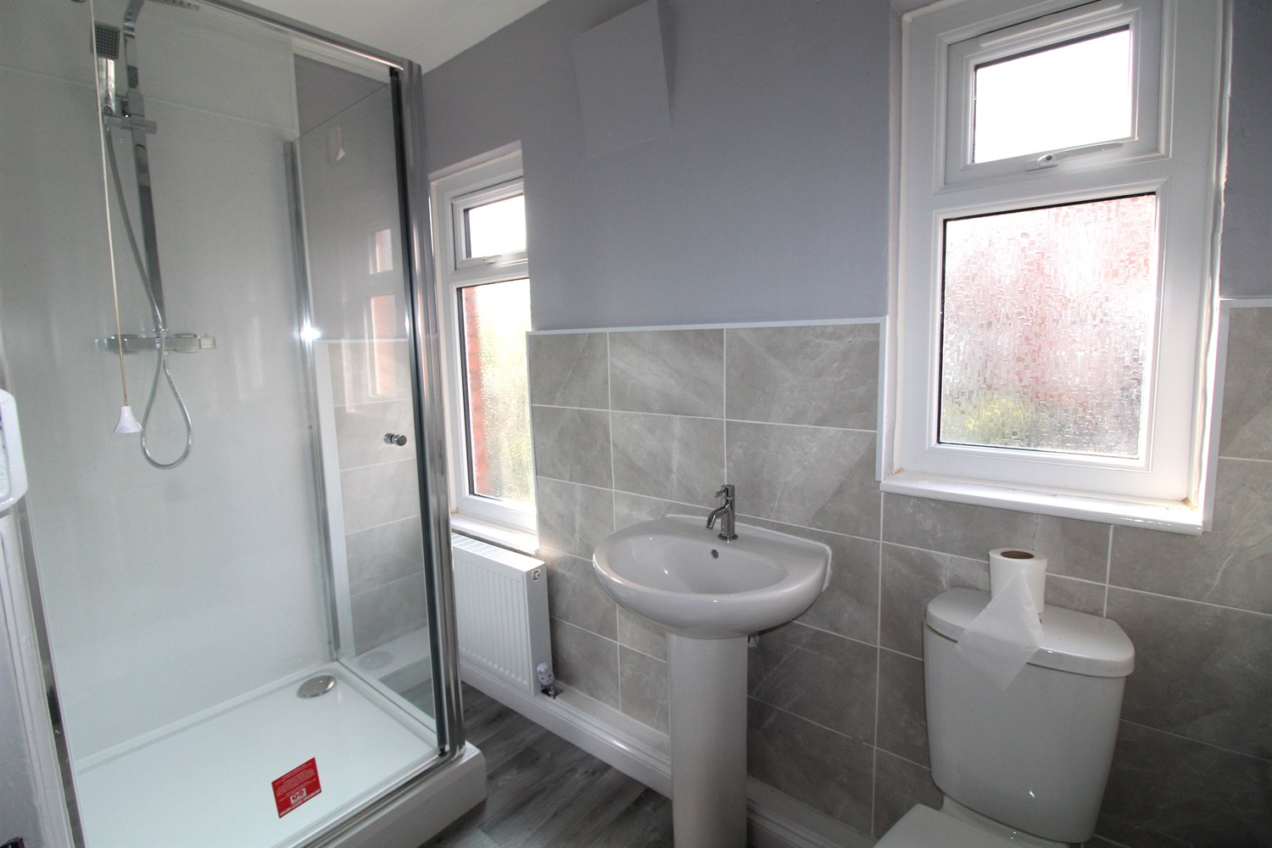

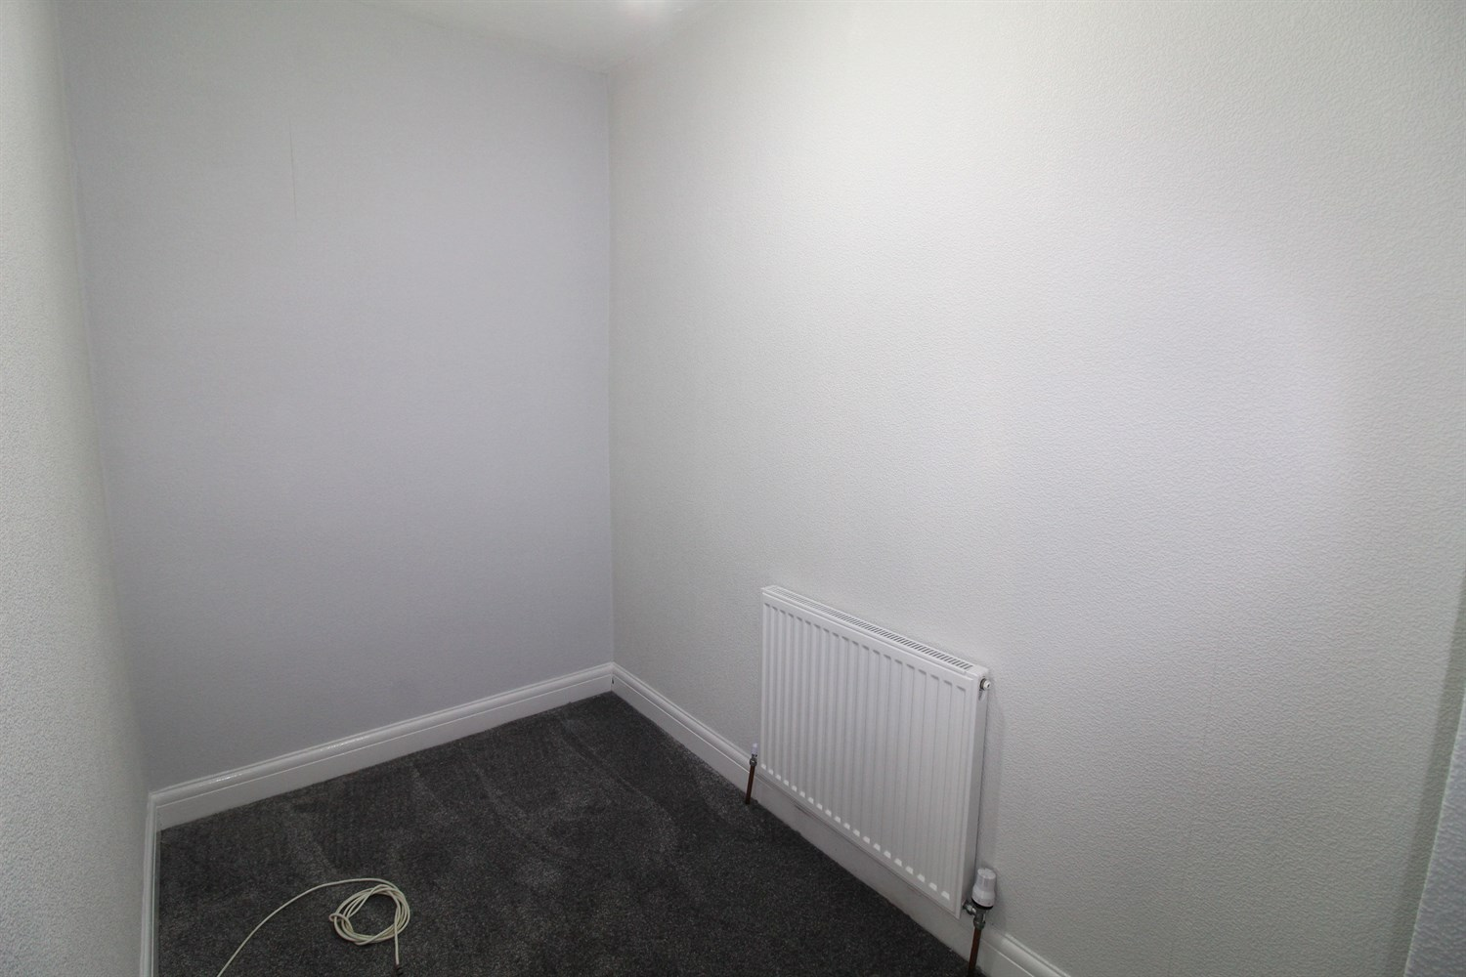

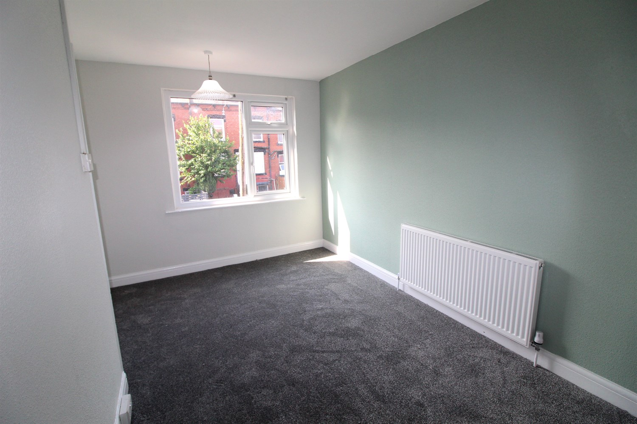

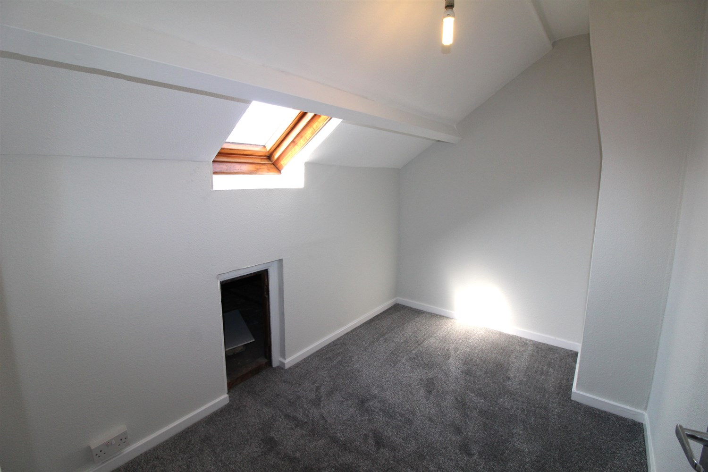

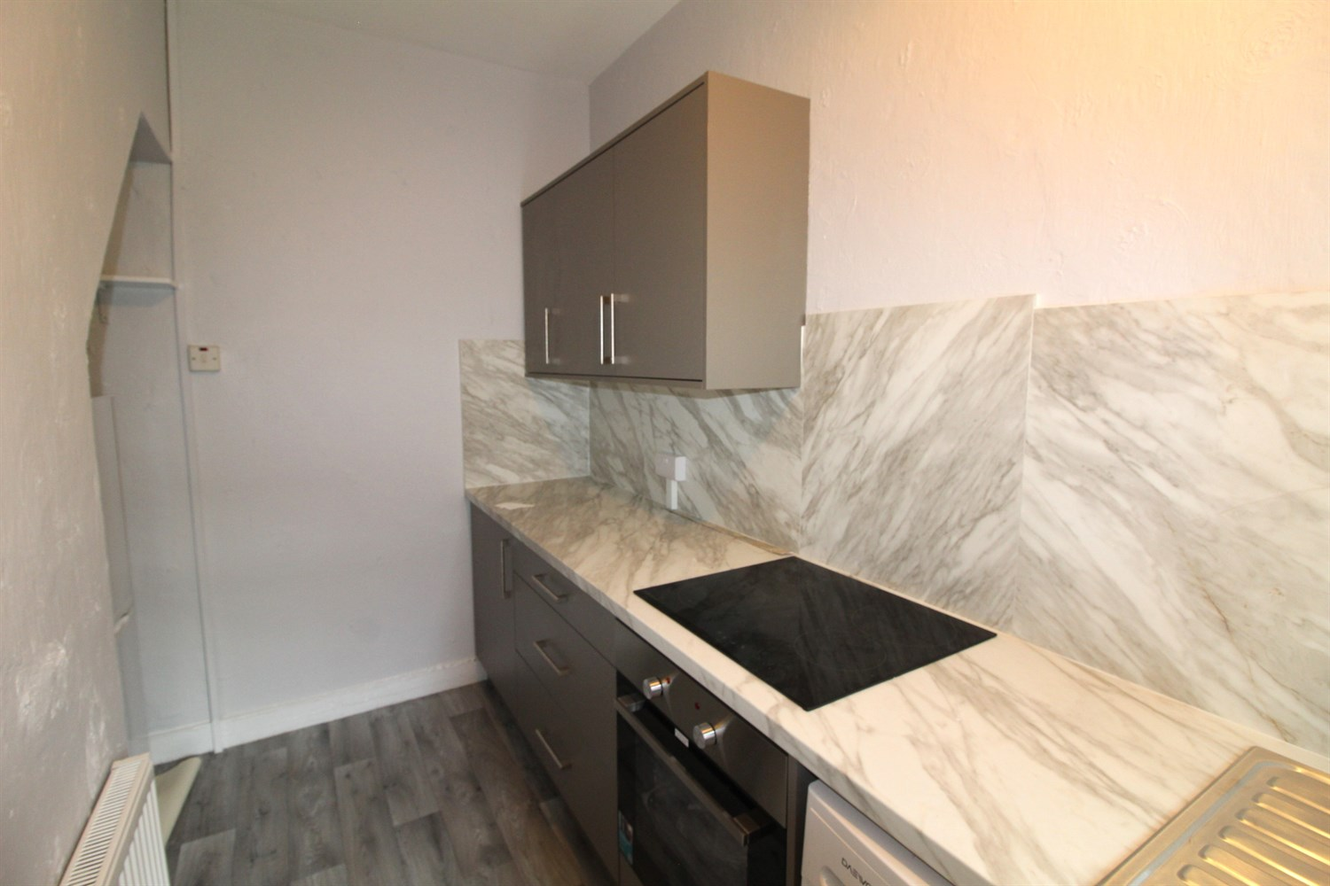

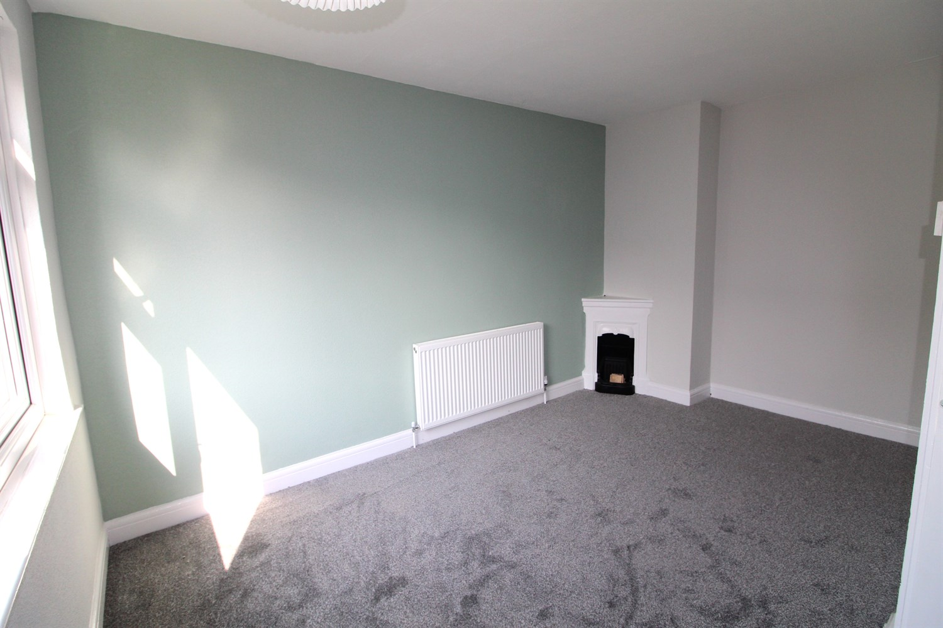

|  |
| --- |
| **Hallway**  Via front entrance door. |
| **Living Room**  A spacious living room with fireplace. Gas central heating radiator. uPVC double glazed window. |
| **Kitchen**  fitted with a range of wall and base units with worktops over, stainless steel sink with drainer. Access to basement. |
| **First Floor** |
| **Bedroom**  Double room with feature fireplace. Double glazed window. Gas central heating radiator. |
| **Study**  Home office. |
| **Bedroom 2**  Double bedroom with Velux window. Gas central heating radiator. |
| **Bathroom**  Fitted with a three piece suite comprising; shower cubicle, WC and wash hand basin. Two uPVC double glazed window. |
| **Home Information**  COUNCIL TAX BAND: A EPC Rating: D  Freehold property Street Parking  Broadband: Standard 18 Mbps 1 Mbps Good Superfast 80 Mbps 20 Mbps Good Ultrafast 1800 Mbps 1000 Mbps   Mobile availability: EE coverage likely. Three Limited. O2 limited. Vodafone limited coverage.  Utilities: Water supplied on standard meters. Electric mains supplied on standard meters. Gas mains supplied on standard meters. |

|  |  |
| --- | --- |
| These particulars are intended to give a fair description of the property, but their accuracy cannot be guaranteed, and they do not constitute an offer of contract. Intending purchasers must rely on their own inspection of the property. None of the above appliances/services have been tested by ourselves. We recommend purchasers arrange for a qualified person to check all appliances/services before legal commitment.  **Property Ref:** 6462  **For more information, please contact**  0113 258 1150 **|** [sales@adairpaxton.co.uk](mailto:sales@adairpaxton.co.uk) **|** www.adairpaxton.co.uk |  |