

**Riverside Court, Leeds**

**For Sale £139,950.00**

***WELL PRESENTED ONE BEDROOM APARTMENT IN LEEDS CITY CENTRE with ALLOCATED PARKING*** One bedroom apartment situated in an excellent development in a central and riverside location. The property briefly comprises; Communal entrance hall, private entrance hall, spacious lounge, kitchen with integrated fridge and washing machine, house bathroom and one double bedroom. Externally the development is gated and there is an allocated parking space and an additional private storage area on the ground floor. The apartment is a short walk to city centre shops and the train station.

**0113 258 1150**

**0800 000 000**

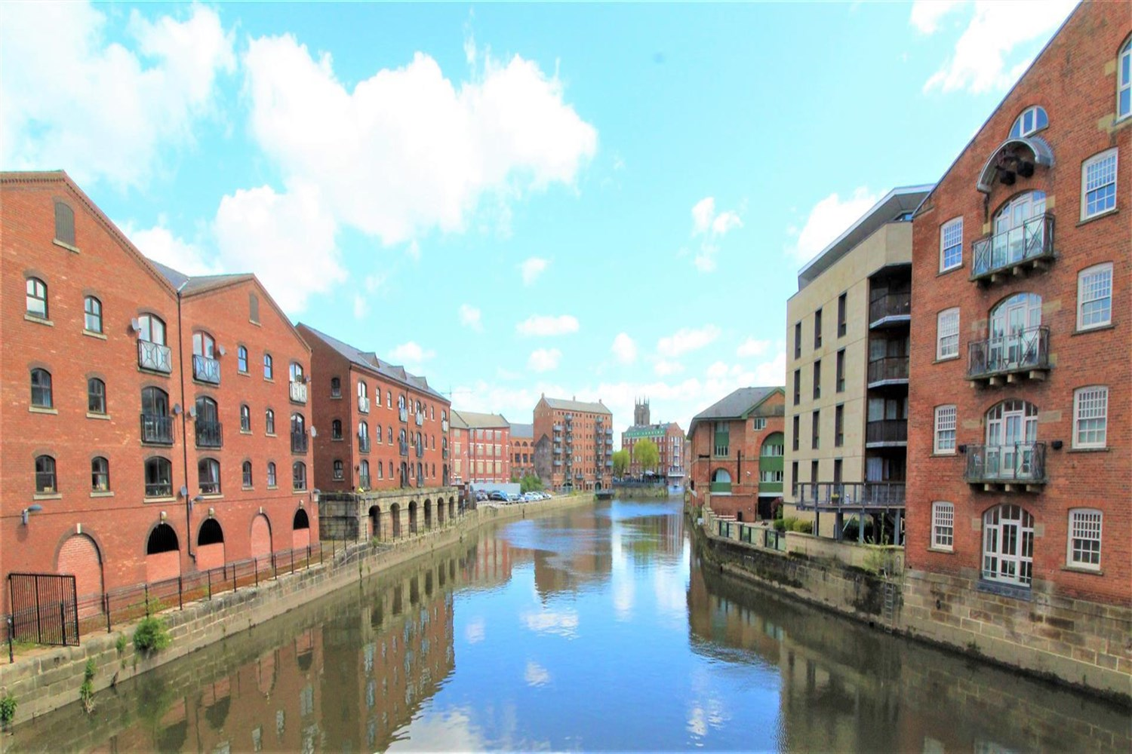



1 Reception(s)

1 Bathroom(s)

0 Bedroom(s)

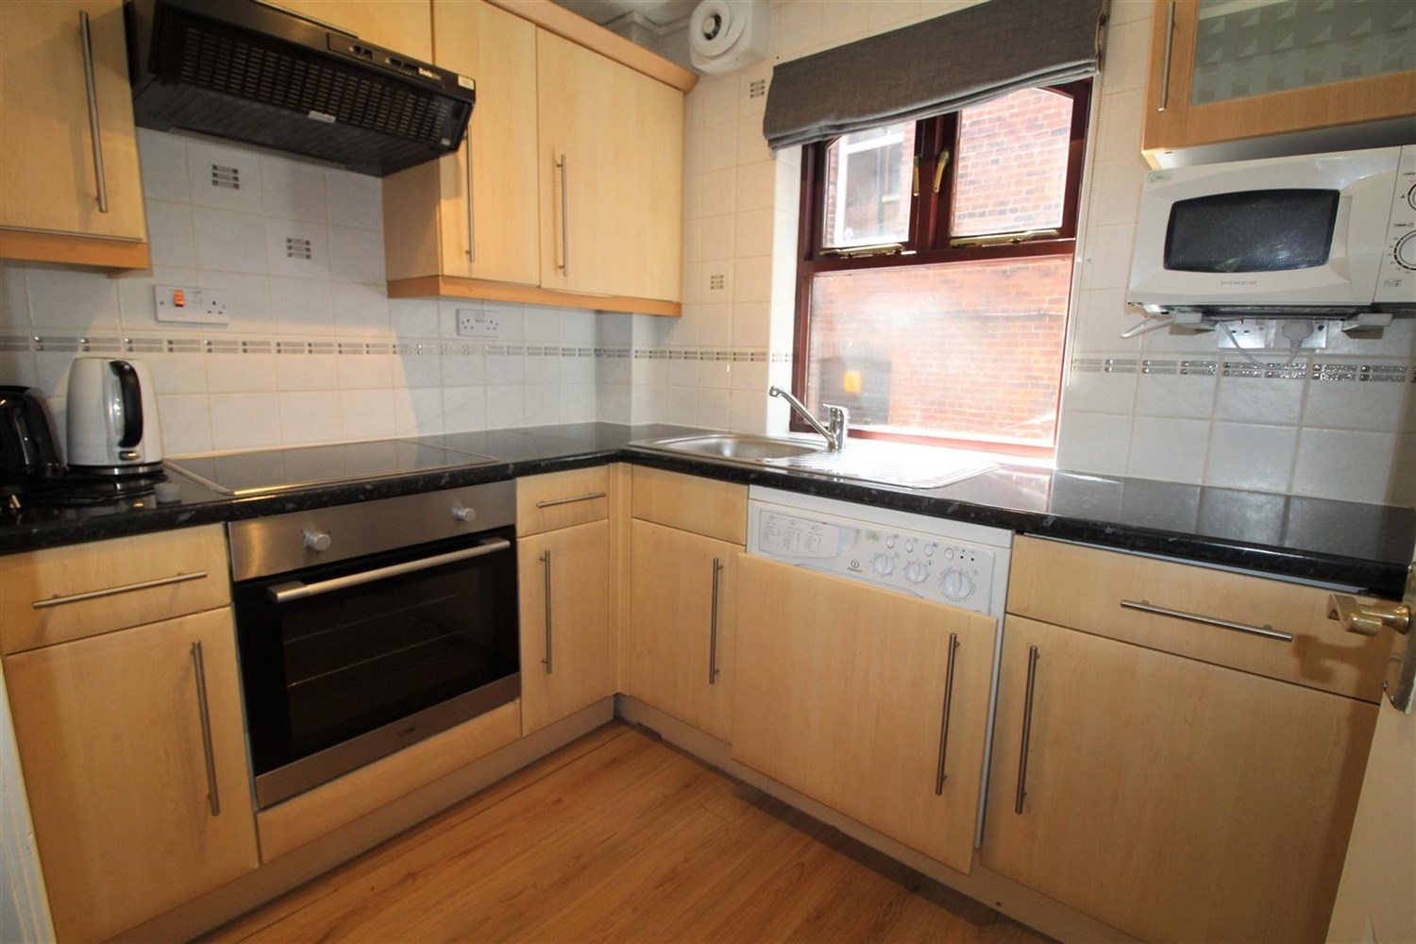

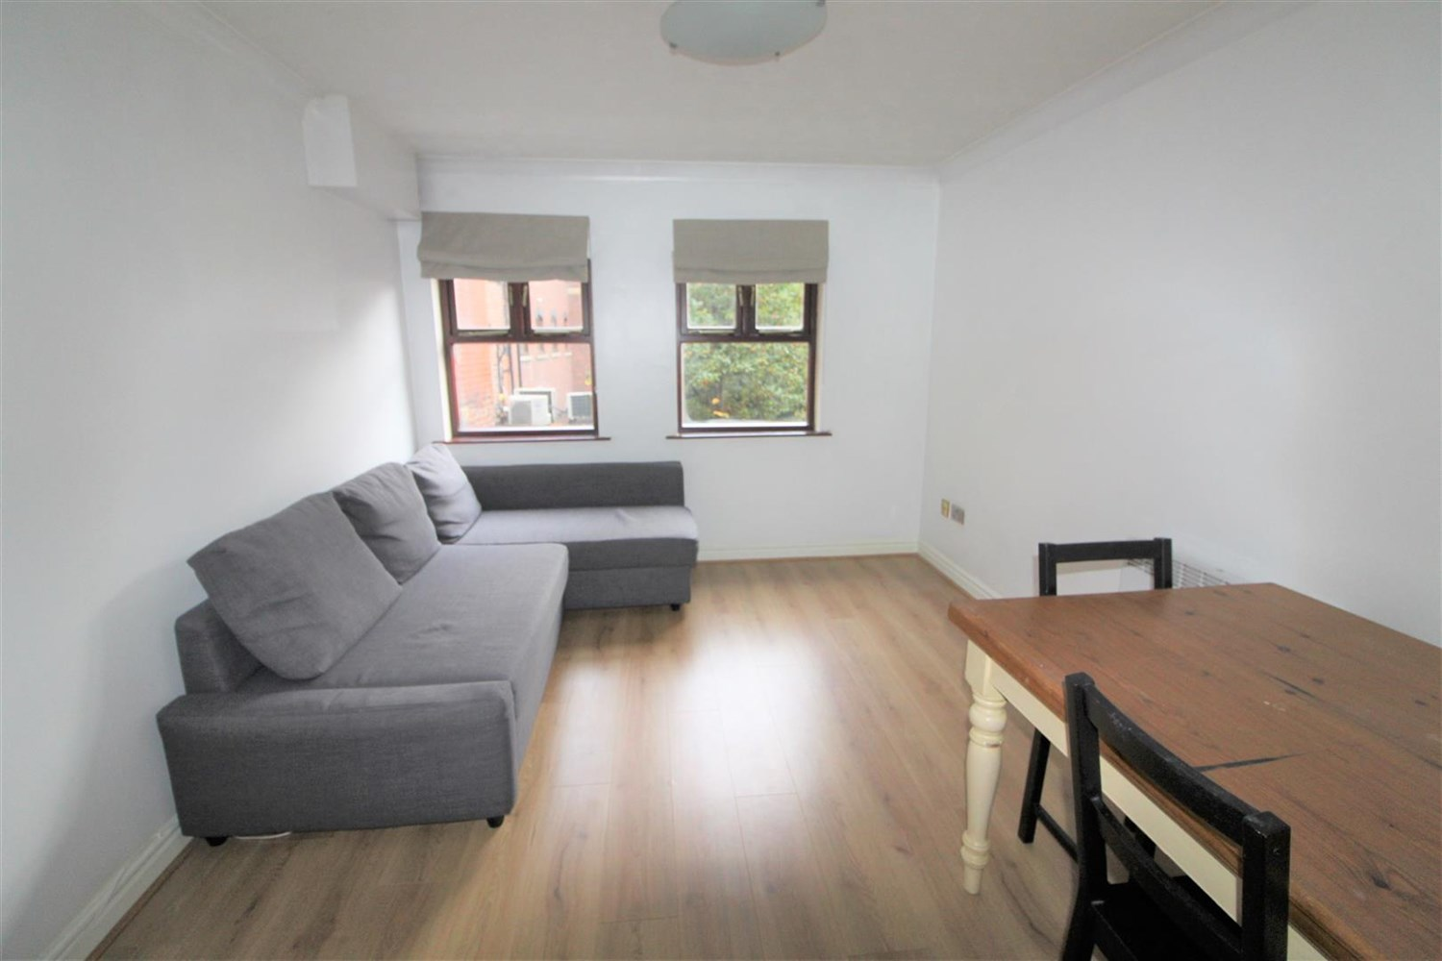

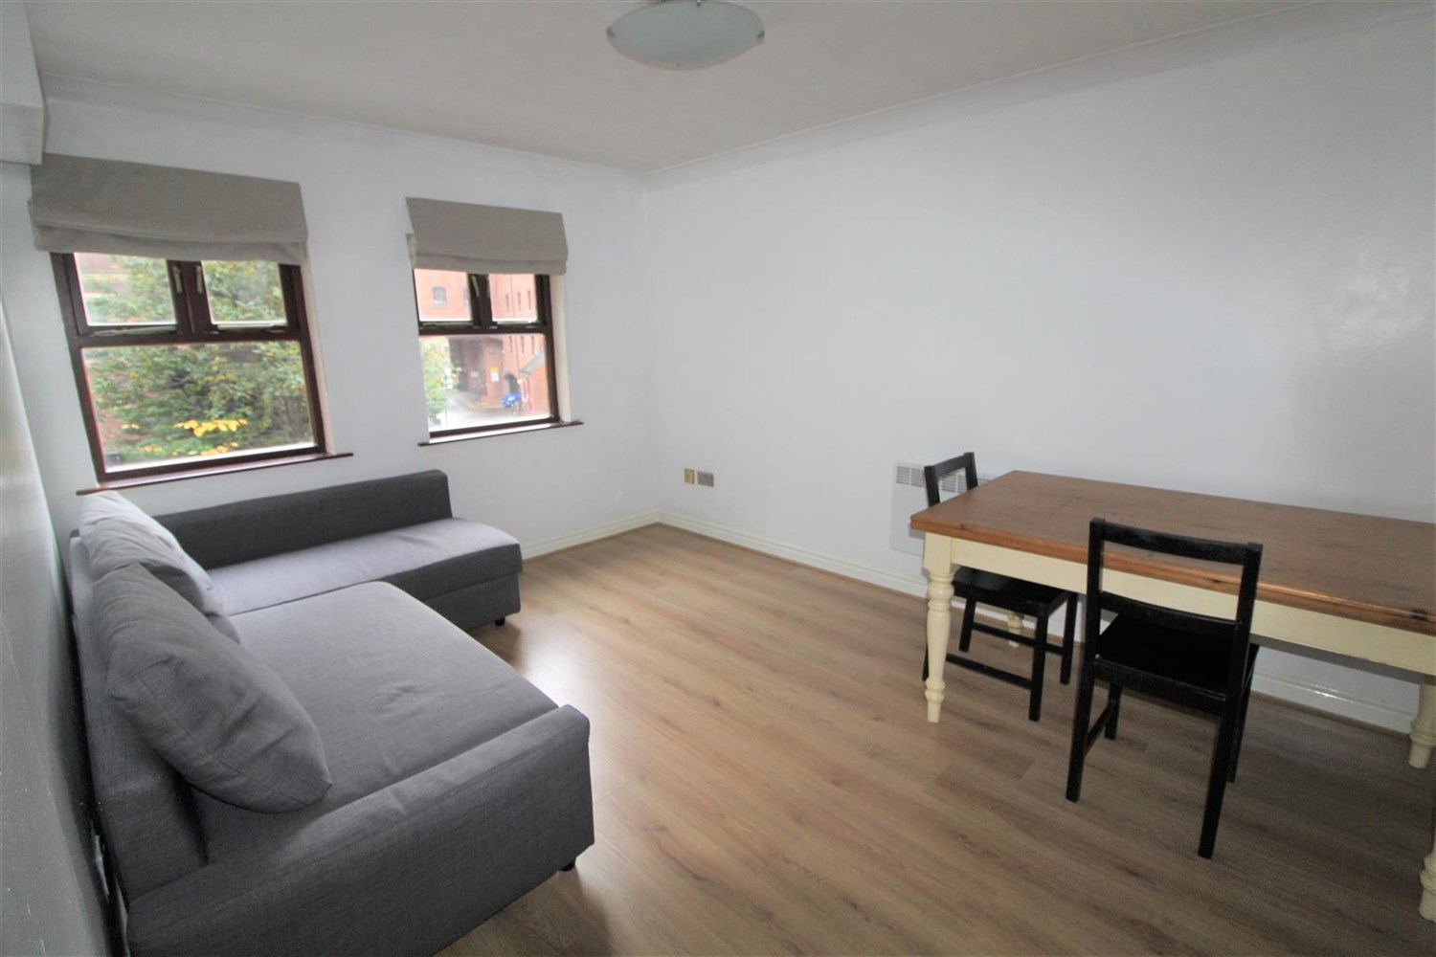

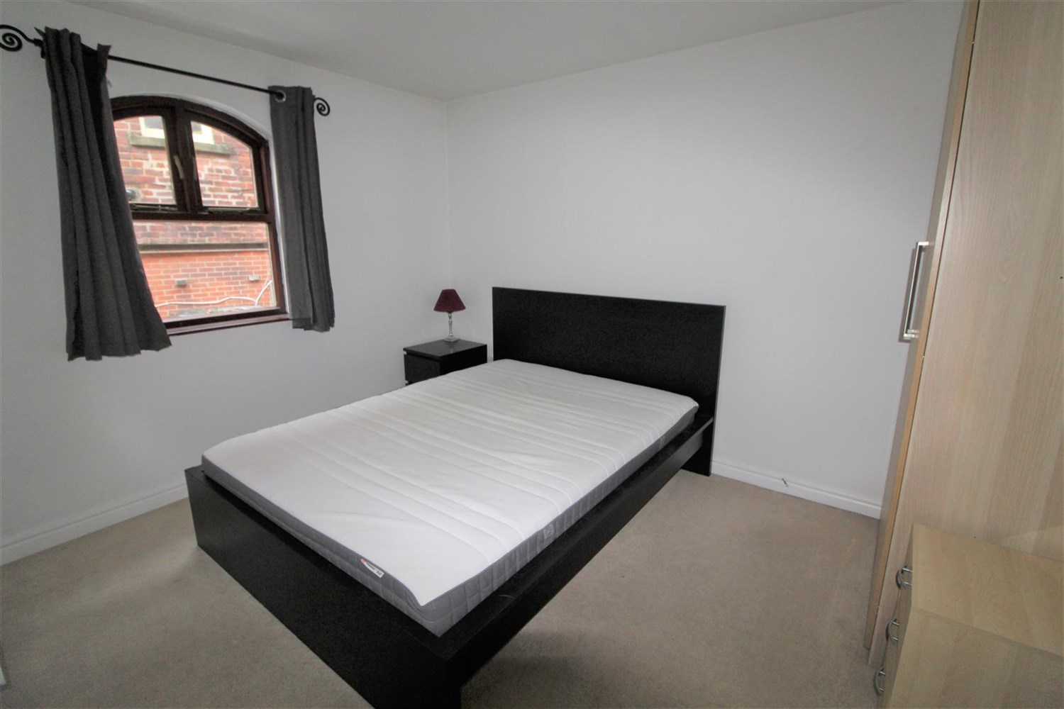

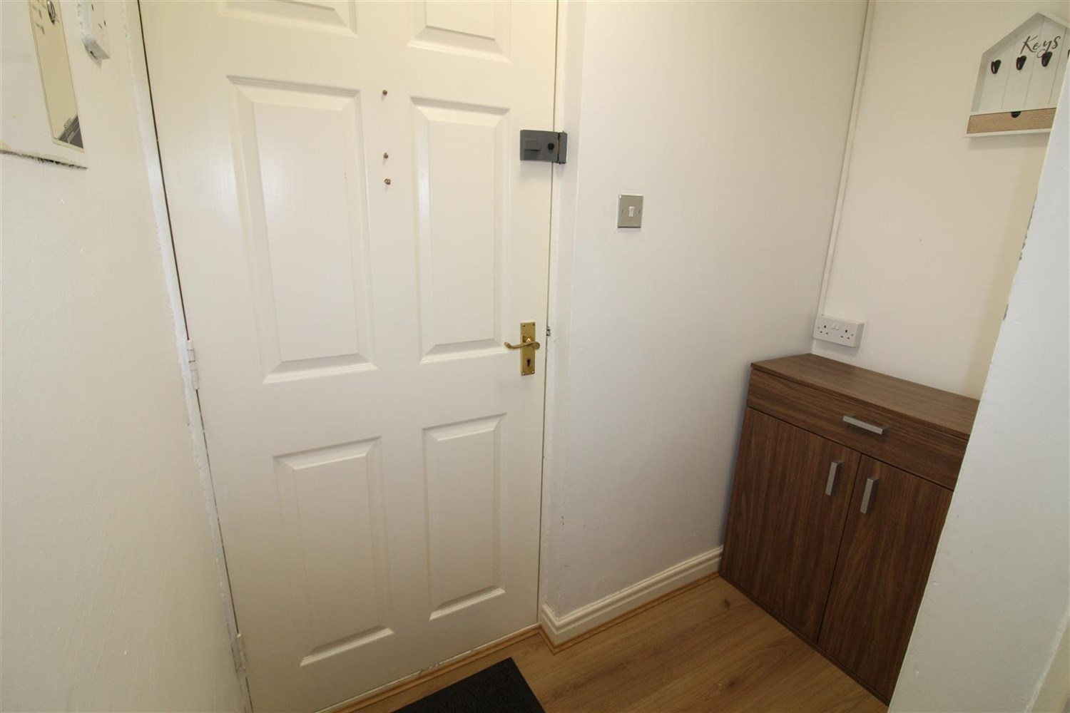

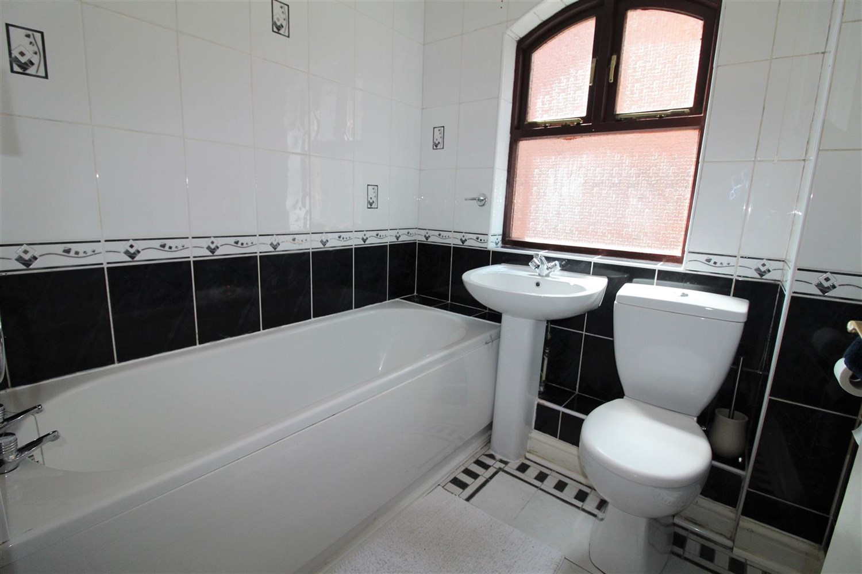

|  |
| --- |
| **Communal entrance**  Via entrance door. Stairs to all floors. |
| **Hallway**  Hallway with intercom. |
| **Living/Dining room**  Light and airy living room/dining area with two windows to side, electric heater. |
| **Kitchen**  Fitted with a range of wall and base units with work tops over. Electric cooker with cooker hood, tiled walls and wood effect flooring. |
| **Bedroom 1**  Good sized double bedroom with window to side. Electric heater. |
| **Bathroom**  Fitted with a three piece suite including bath, with shower overhead, WC and wash hand basin. Tiled walls. |
| **Secure Allocated Parking**  Allocated parking for one vehicle. |
| **Tenure**  Leasehold - Leasehold - 189 years from 1989.  £90 per annum |
| **Service Charge**  Service Charge - £180 per month. |

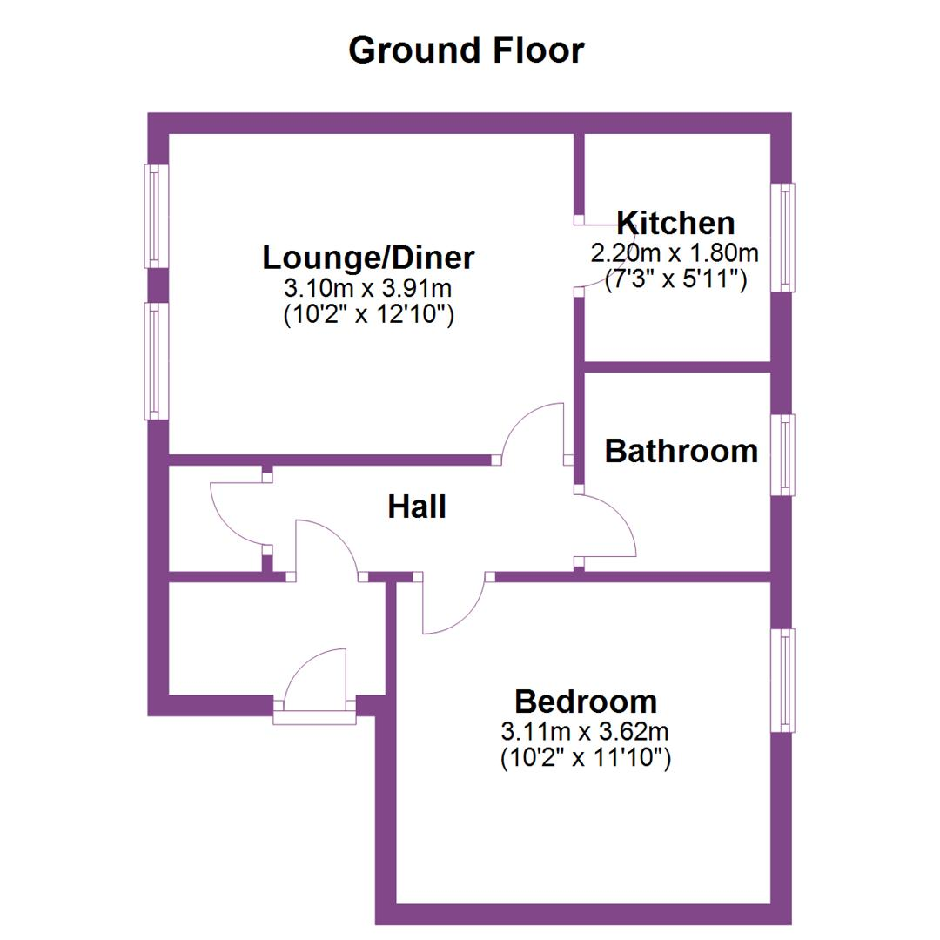

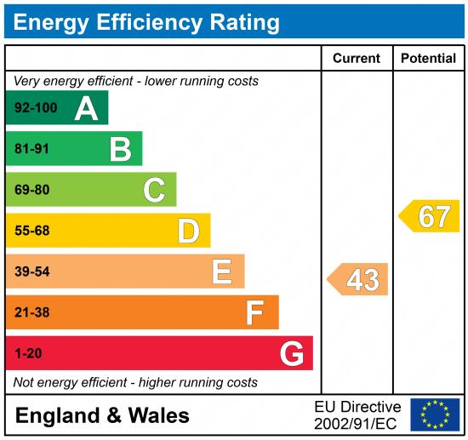

|  |
| --- |
|  |

These particulars are intended to give a fair description of the property, but their accuracy cannot be guaranteed, and they do not constitute an offer of contract. Intending purchasers must rely on their own inspection of the property. None of the above appliances/services have been tested by ourselves. We recommend purchasers arrange for a qualified person to check all appliances/services before legal commitment.

**Property Ref:** 6401

**For more information, please contact**

0113 258 1150 **|** [sales@adairpaxton.co.uk](mailto:sales@adairpaxton.co.uk) **|** www.adairpaxton.co.uk