

**0113 258 1150**

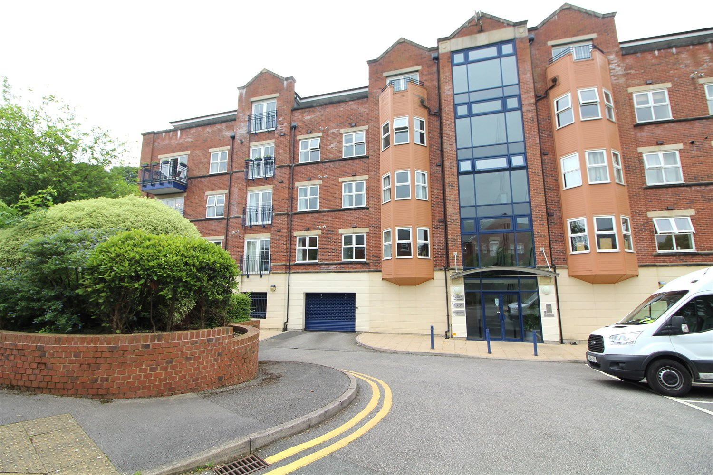



**Available to let £1,395.00pcm**

**Carisbrooke Road, Leeds**

****SPACIOUS TWO DOUBLE BEDROOM APARTMENT**** This third floor apartment is located in the highly popular area of Far Headingley and benefits from secure parking and a lift to all floors, this property must be viewed to appreciate the accommodation on offer. The apartment briefly comprises; Hall with storage cupboard, modern fitted kitchen, spacious living area, master bedroom with en-suite shower room, second double bedroom and a house bathroom. The apartment is within walking distance of the Village hotel, local shops, bars, restaurants and is also conveniently situated for road links into Headingley, the City Centre and the Ring Road. Furnished. Council tax band D, EPC rating B, deposit £1,695. Available 19th July. Sorry no pets.

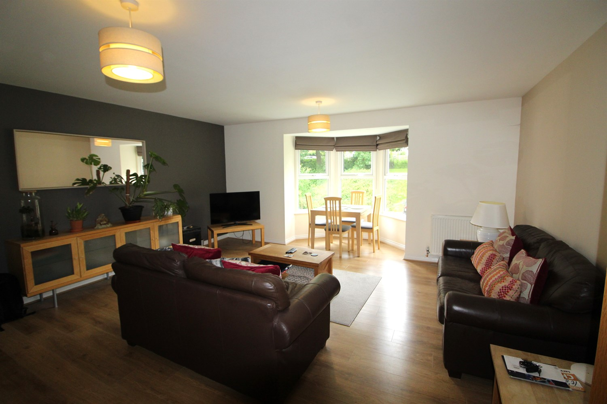

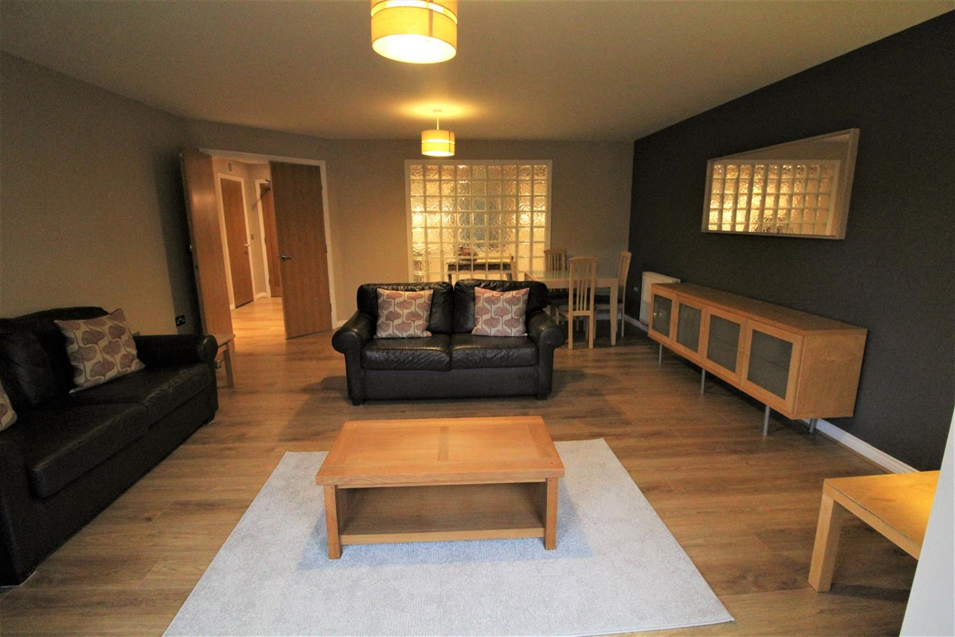

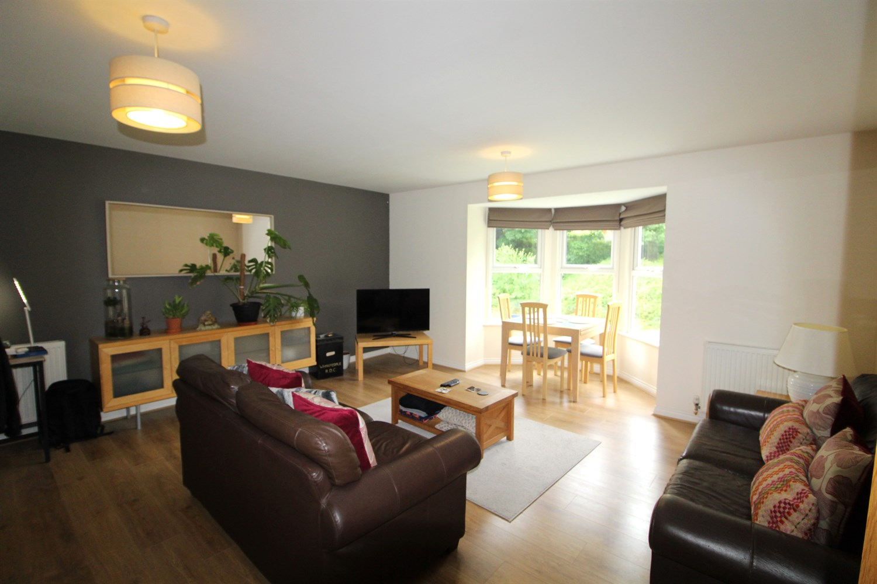

2 Bathroom(s)

1 Reception(s)

0 Bedroom(s)

00

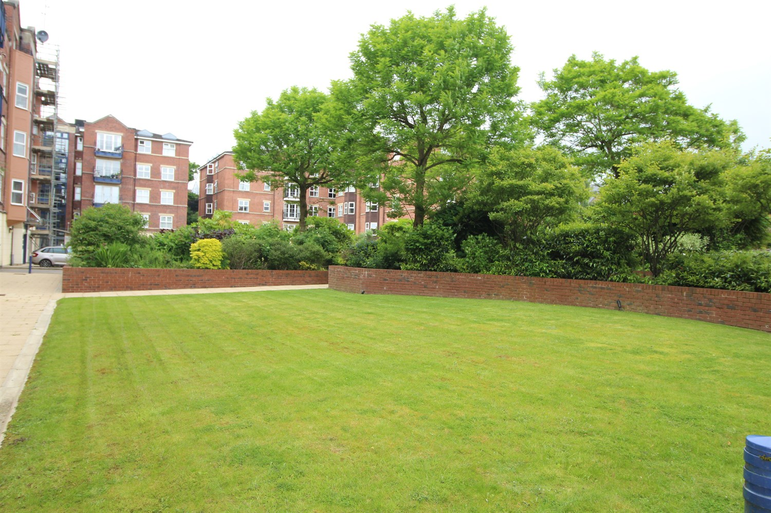

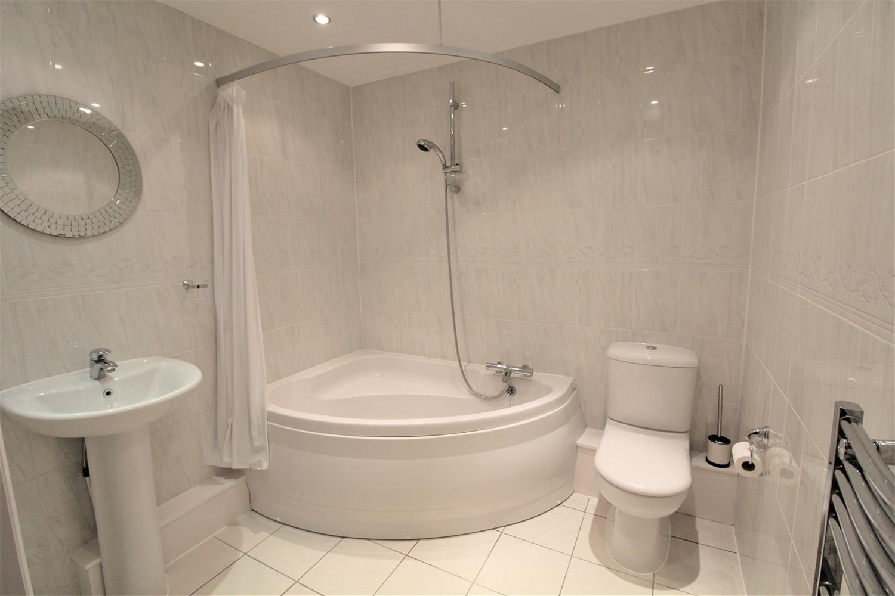

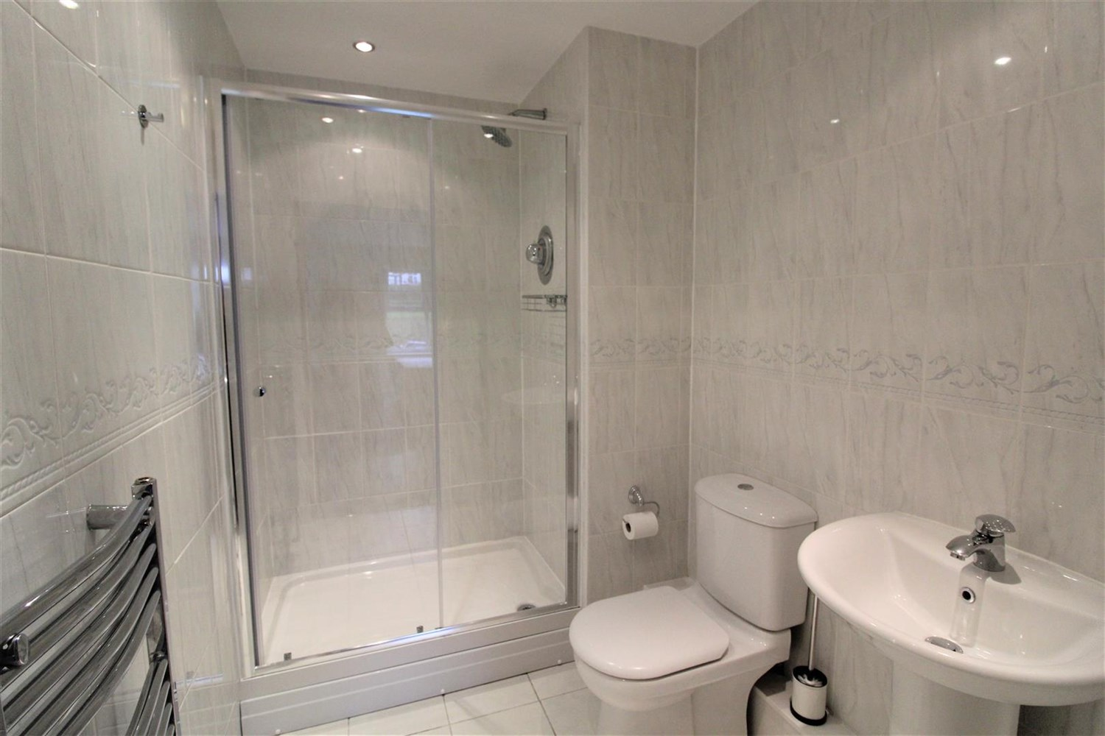

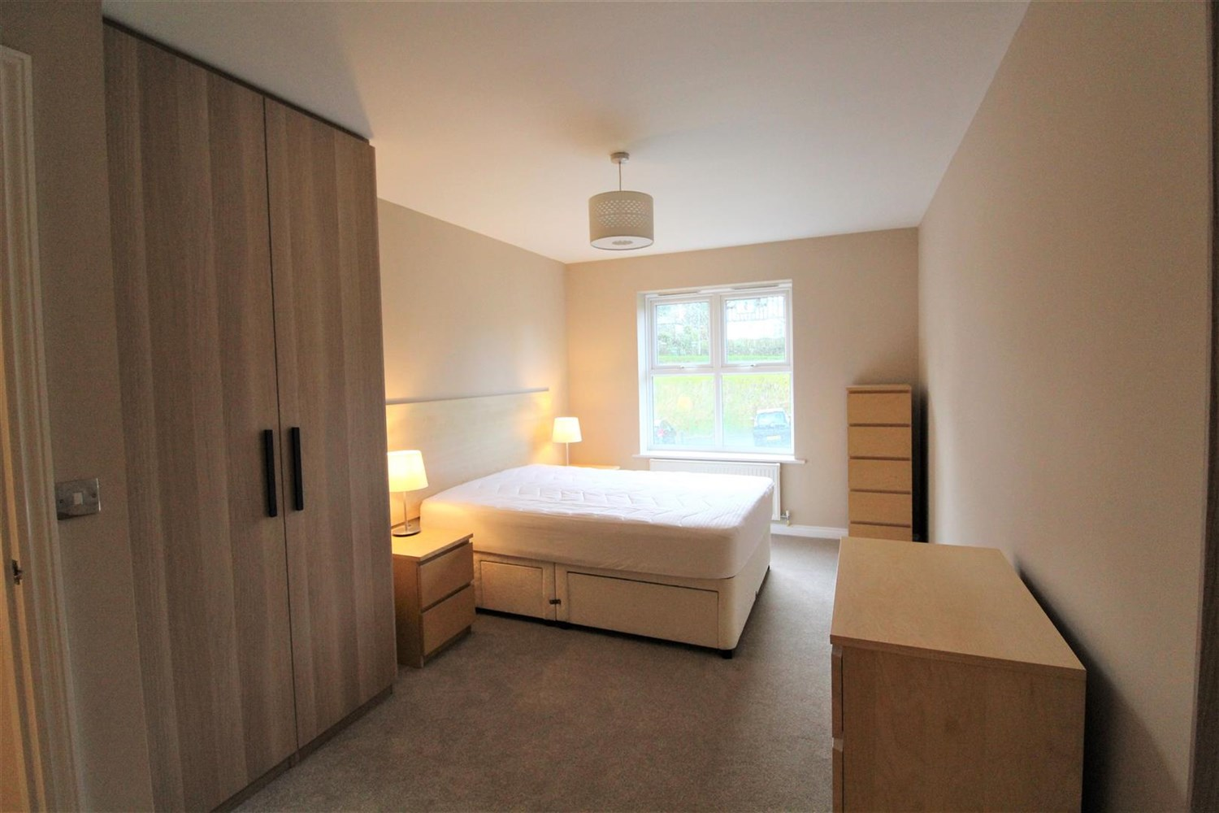

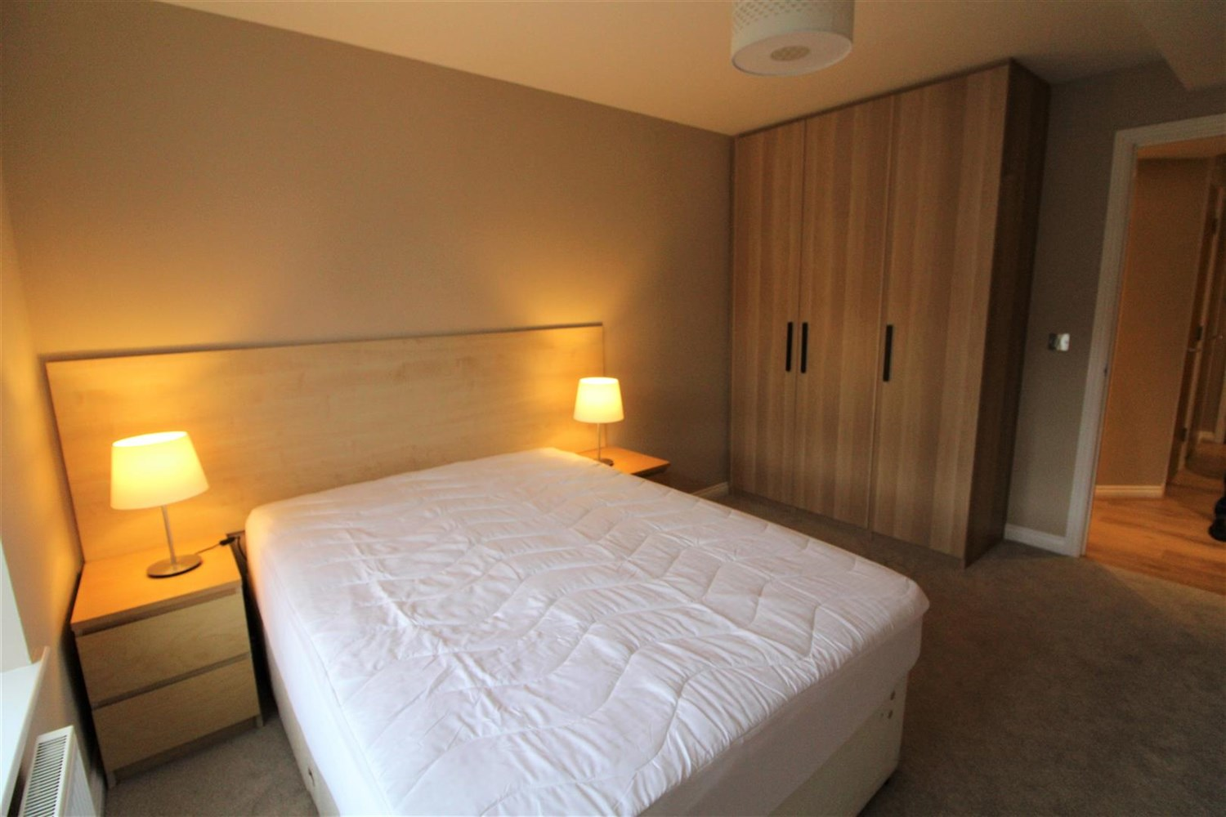

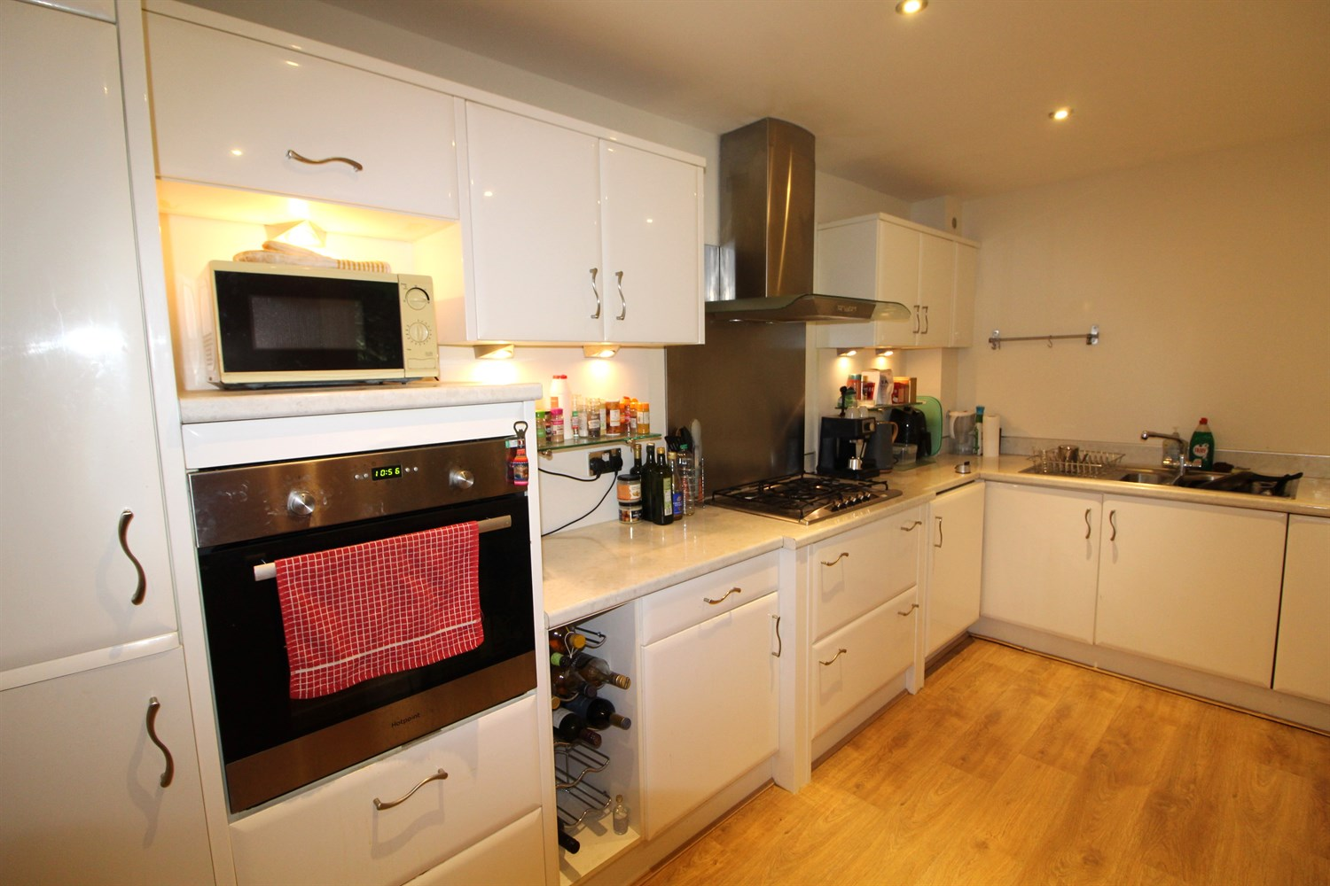

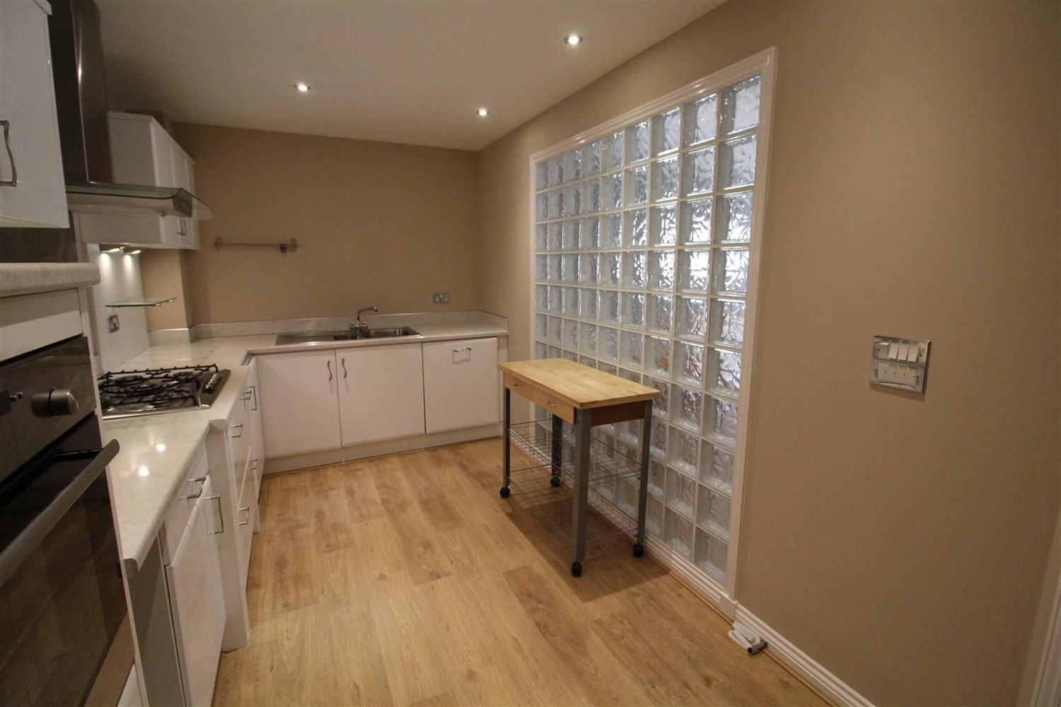

|  |
| --- |
| **Communal Entrance Hall**  Lift and stairs to all floors. |
| **Entrance Hall**  private entrance hallway. |
| **Living/Dining**  Large living room with window to front, space for large dining table. |
| Fitted with a range of modern wall, base and drawer units with worktops over. Integrated electric oven with gas hob and extractor hood above. Stainless steel sink with drainer and mixer tap. Glass wall on to lounge. |
| **Bedroom 1**  Large double bedroom with access to ensuite. window. |
| **En Suite**  Walk in shower, W/C and hand wash basin, tiled walls and floor. |
| **Bedroom 2**  Large double room with large wardrobes. Window. |
| **House Bathroom**  Corner bath with shower over head, W/C hand wash basin. tiled walls. |
| **Home Information**  COUNCIL TAX BAND: D EPC Rating B  6 Month tenancy only then onto rolling. Leasehold property Parking Broadband: Standard 15 Mbps 1 Mbps Good Superfast 80 Mbps 20 Mbps Good Ultrafast 1000 Mbps 1000 Mbps Mobile availability: EE likely to have good coverage . Three limited coverage. O2 limited. Vodafone limited coverage.  Utilities: Water supplied on standard meters. Gas and Electric mains supplied on standard meters. |

|  |  |
| --- | --- |
| These particulars are intended to give a fair description of the property, but their accuracy cannot be guaranteed, and they do not constitute an offer of contract. Intending purchasers must rely on their own inspection of the property. None of the above appliances/services have been tested by ourselves. We recommend purchasers arrange for a qualified person to check all appliances/services before legal commitment.  **Property Ref:** 2394  **For more information, please contact**  0113 258 1150 **|** [lettings@adairpaxton.co.uk](mailto:lettings@adairpaxton.co.uk) **|** www.adairpaxton.co.uk |  |