

**0113 258 1150**

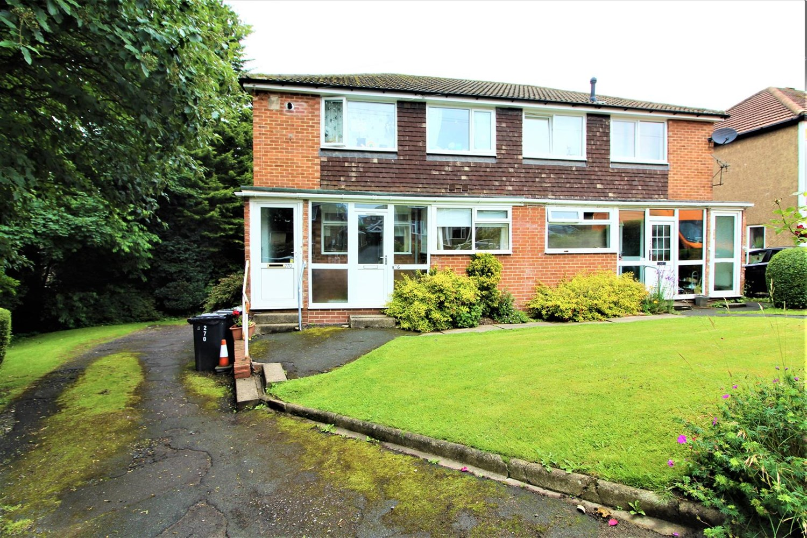



**Available to let £725.00pcm**

**Tinshill Road, LS16**

*** SPACIOUS, LARGER STYLE ONE BEDROOM GROUND FLOOR APARTMENT WITH TANDEM DOUBLE GARAGE*** Ideally located just a stone's throw away from Horsforth Train Station and all of the amenities that both Cookridge and Horsforth have to offer. The property comprises: Entrance porch, spacious lounge with superb views, modern fitted kitchen, double bedroom and bathroom. Externally there are communal gardens and a tandem double garage. The property benefits from partial double glazing. Early viewing is advised. Unfurnished. Council tax band B. EPC rating D. Deposit £720. Available 7th July.

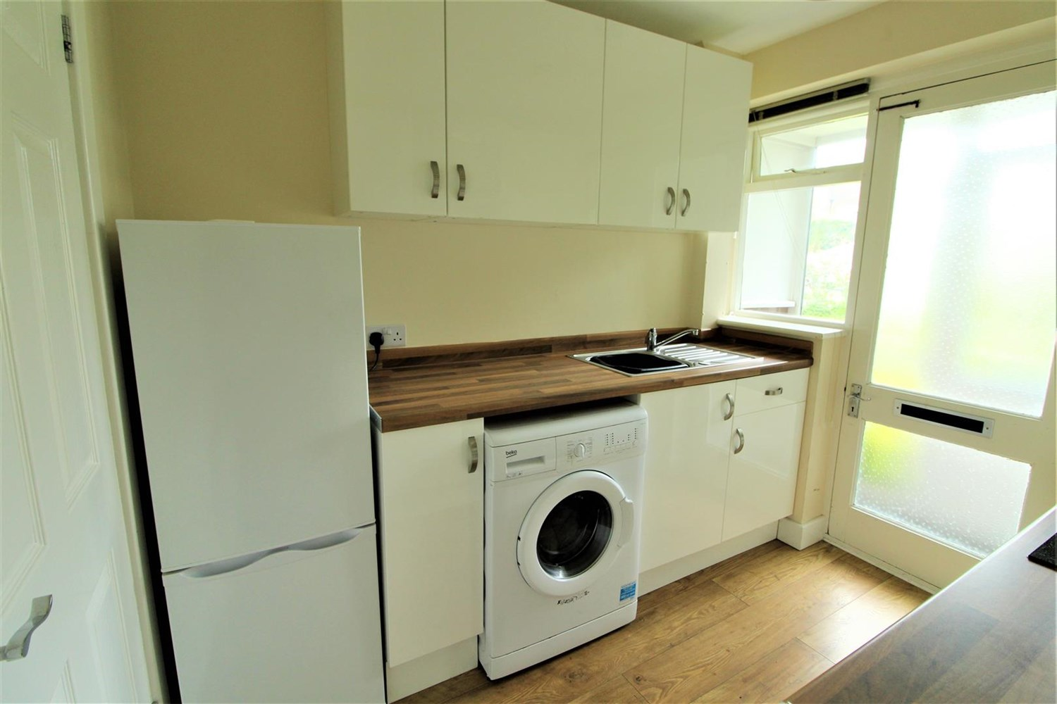

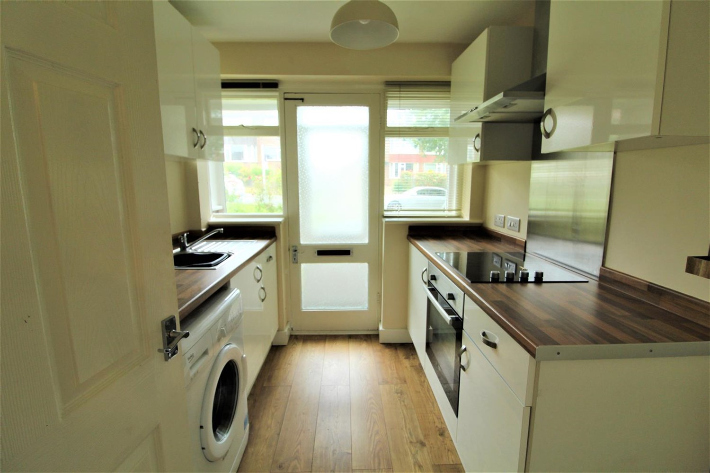

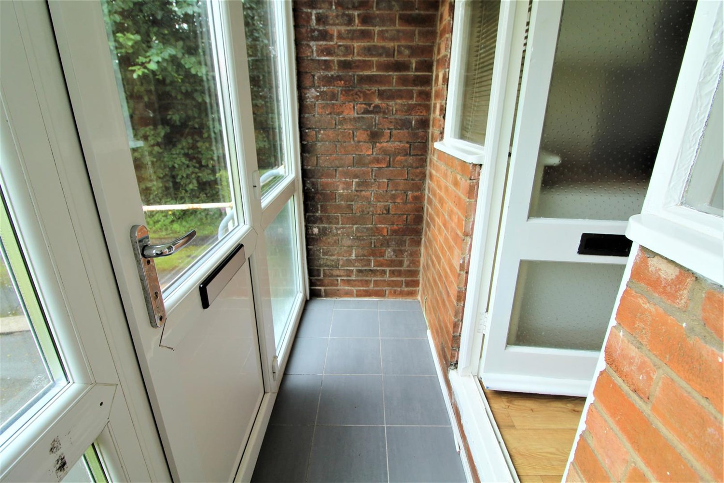

1 Bathroom(s)

1 Reception(s)

1 Bedroom(s)

00

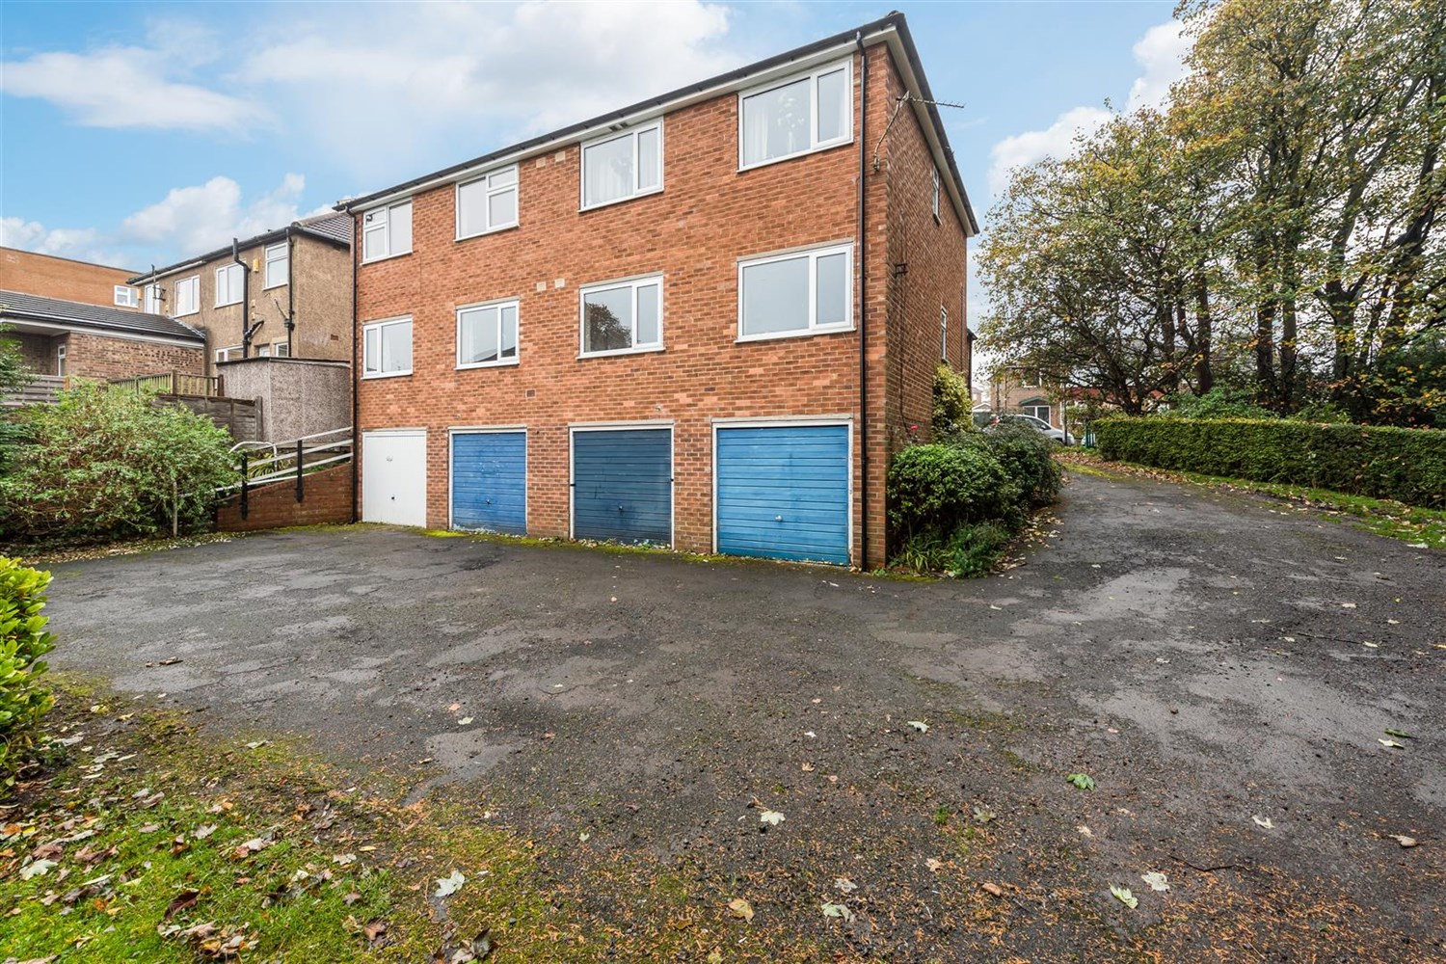

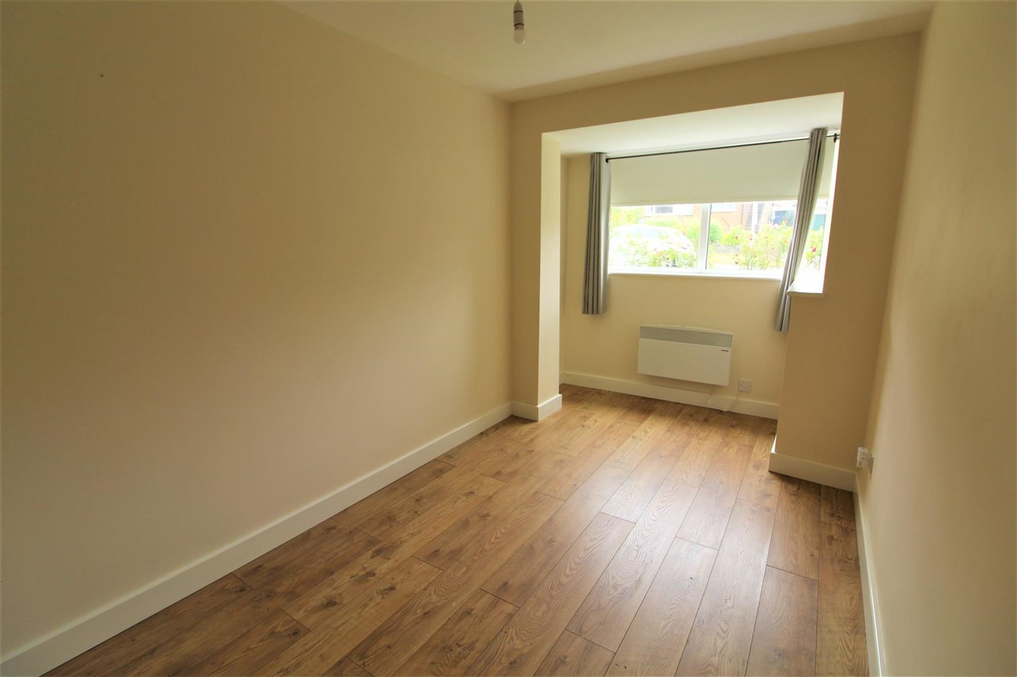

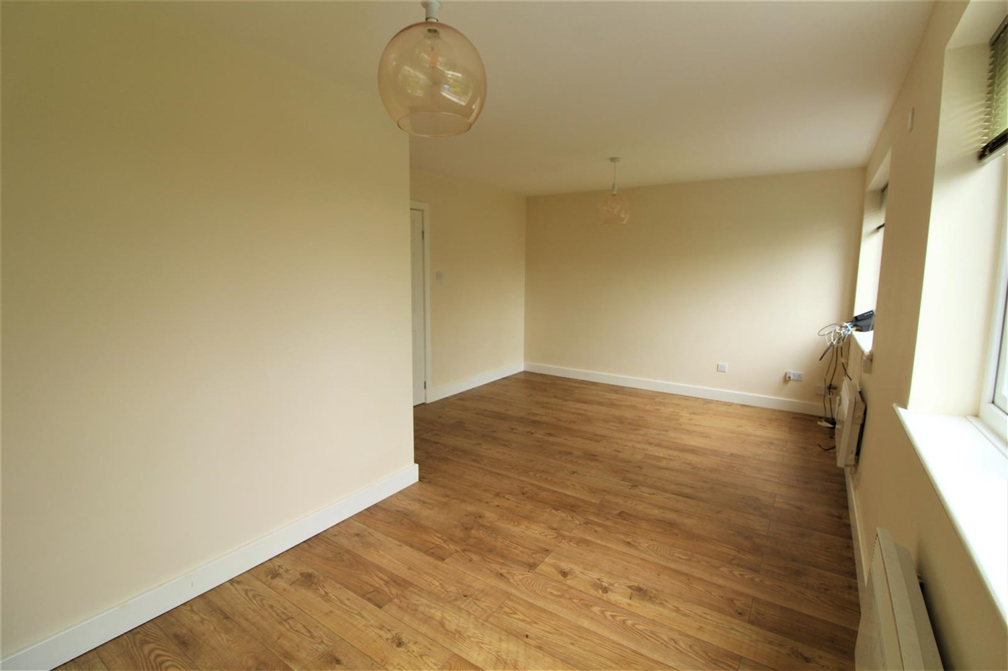

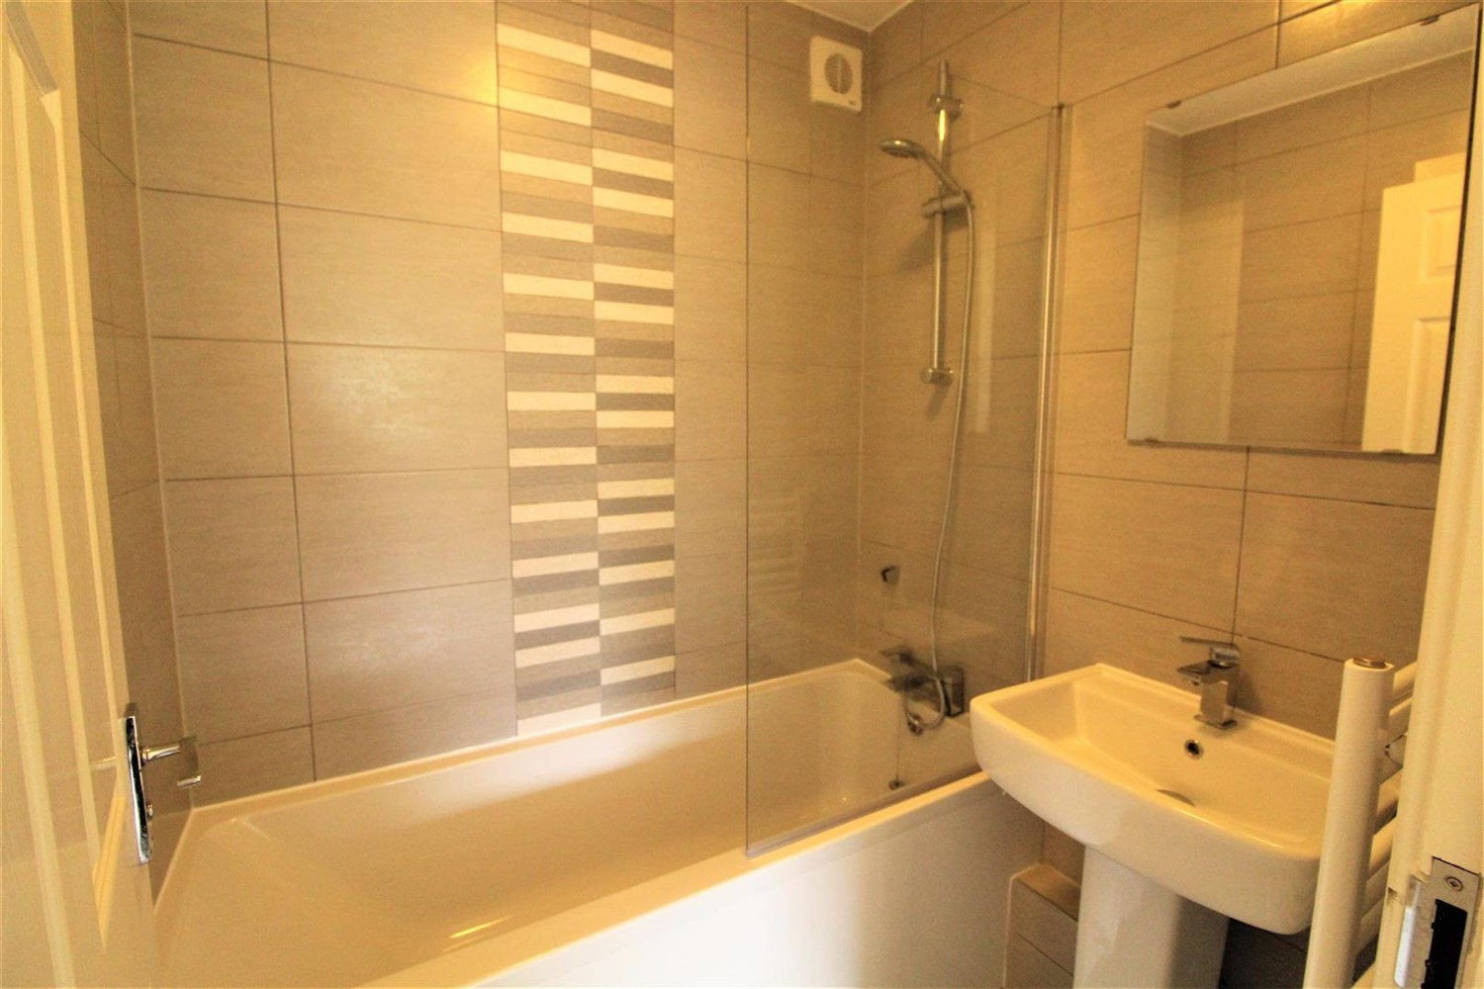

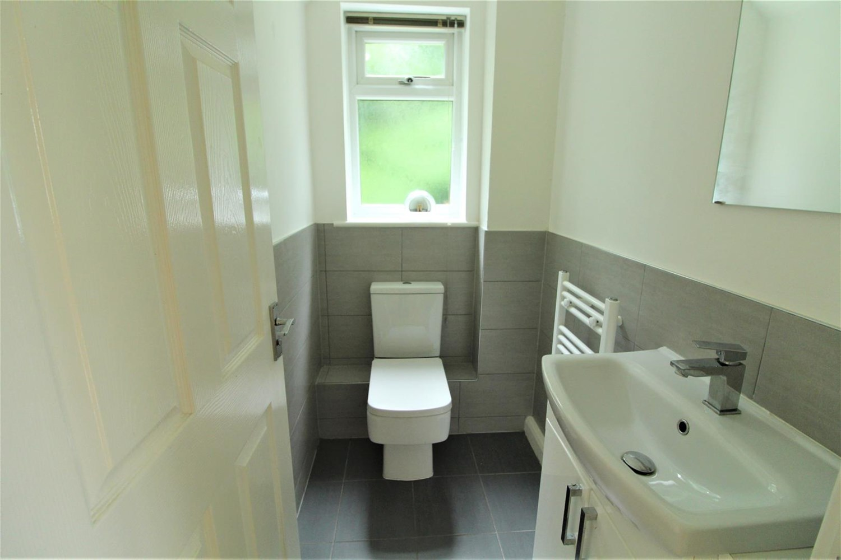

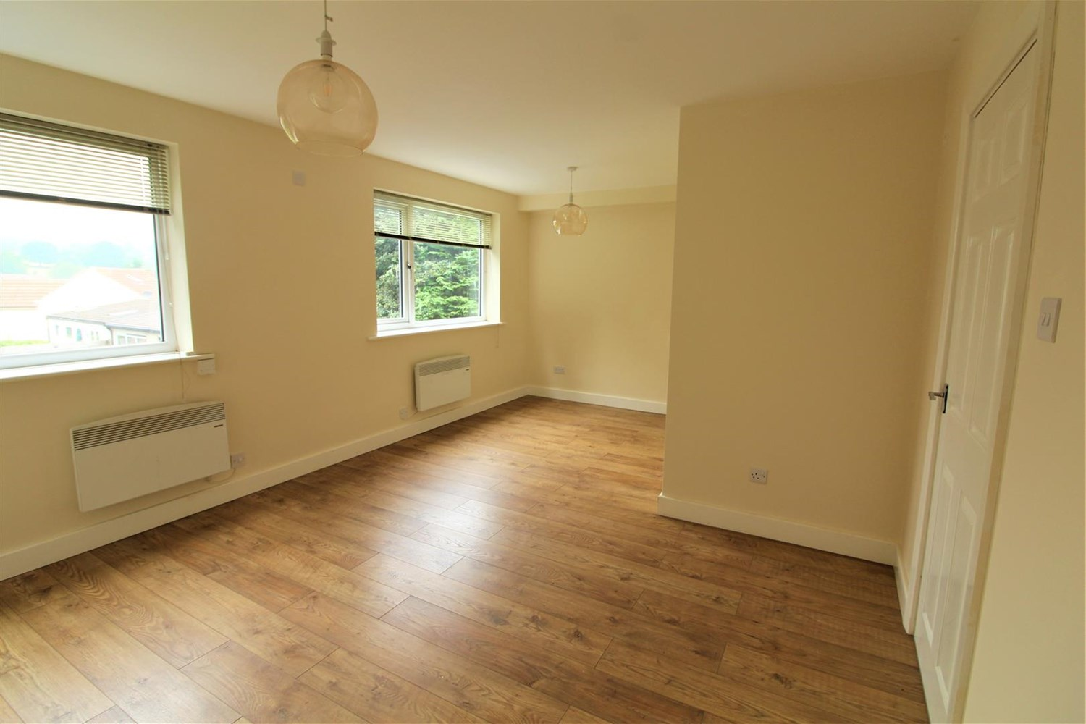

|  |
| --- |
| **Reception 1**  Large living area with two windows over looking the rear, electric wall heater. |
| **Kitchen**  Fitted with a range of wall and base units with worktops over, stainless steel sink with mixer tap and drainer, electric oven and hob, part tiled. Door leading to porch entrance. |
| **Bedroom 1**  Double bedroom with window to front, electric wall heater. |
| **Bathroom**  Two piece bathroom suite with shower over bath, hand wash basin, part tiled walls. |
| **Separate Bathroom**  Two piece W/C and hand wash basin, part tiled walls. |
| **Garage**  Garage with up and over door. |
| **Parking**  Off street parking. |
| **Home Information**  COUNCIL TAX BAND: B EPC Rating D  Leasehold property Off Road Market.   Broadband:  Standard 3 Mbps 0.5 Mbps Good Superfast 74 Mbps 20 Mbps Good Ultrafast 1800 Mbps 220 Mbps Mobile availability: EE limited Coverage . Three limited coverage. O2 likely to have good coverage. Vodafone limited coverage.  Utilities: Water supplied on standard meters. Electric mains supplied on standard meters. |

|  |  |
| --- | --- |
| These particulars are intended to give a fair description of the property, but their accuracy cannot be guaranteed, and they do not constitute an offer of contract. Intending purchasers must rely on their own inspection of the property. None of the above appliances/services have been tested by ourselves. We recommend purchasers arrange for a qualified person to check all appliances/services before legal commitment.  **Property Ref:** 6278  **For more information, please contact**  0113 258 1150 **|** [lettings@adairpaxton.co.uk](mailto:lettings@adairpaxton.co.uk) **|** www.adairpaxton.co.uk |  |