

**Church Street, Gildersome**

**For Sale £399,950.00**

**BEAUTIFULLY PRESENTED FOUR BEDROOM DETACHED HOUSE with NO ONWARD CHAIN** Finished to an exceptional standard, this delightful property has been completely refurbished throughout and has the feel of a new build property yet with the proportions and character features of a traditional home. Offered for sale with NO ONWARD CHAIN and IMMEDIATE VACANT POSESSION, this impressive property comprises: entrance hall, lounge with bay window, stunning high specification dining kitchen and utility room to the ground floor. To the first floor there is a spacious master bedroom, three further bedrooms and a modern house bathroom. Externally the property has a driveway offering off street parking for several vehicles. Situated in this sought after location of Gildersome, being close to local amenities, public transport and the nearby motorway links. An early internal viewing is highly recommended.

**0113 258 1150**

**0800 000 000**

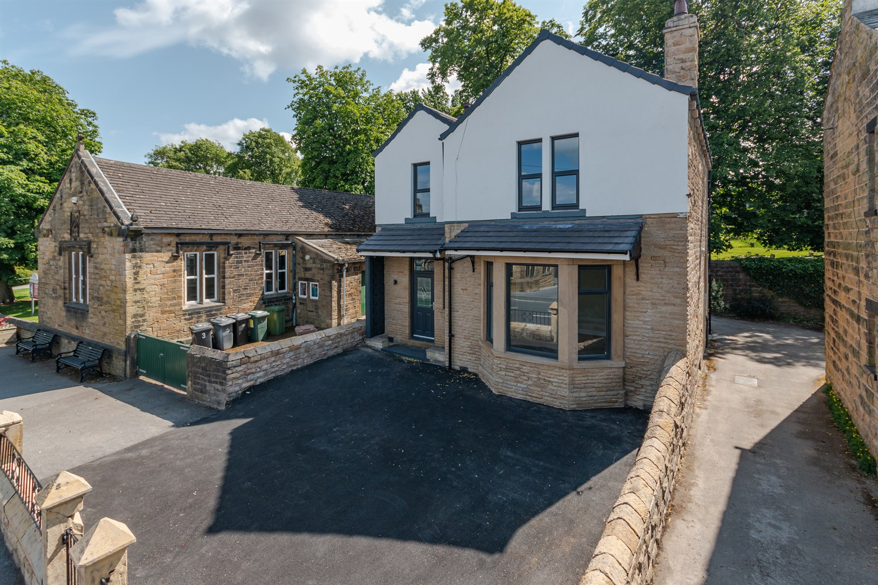

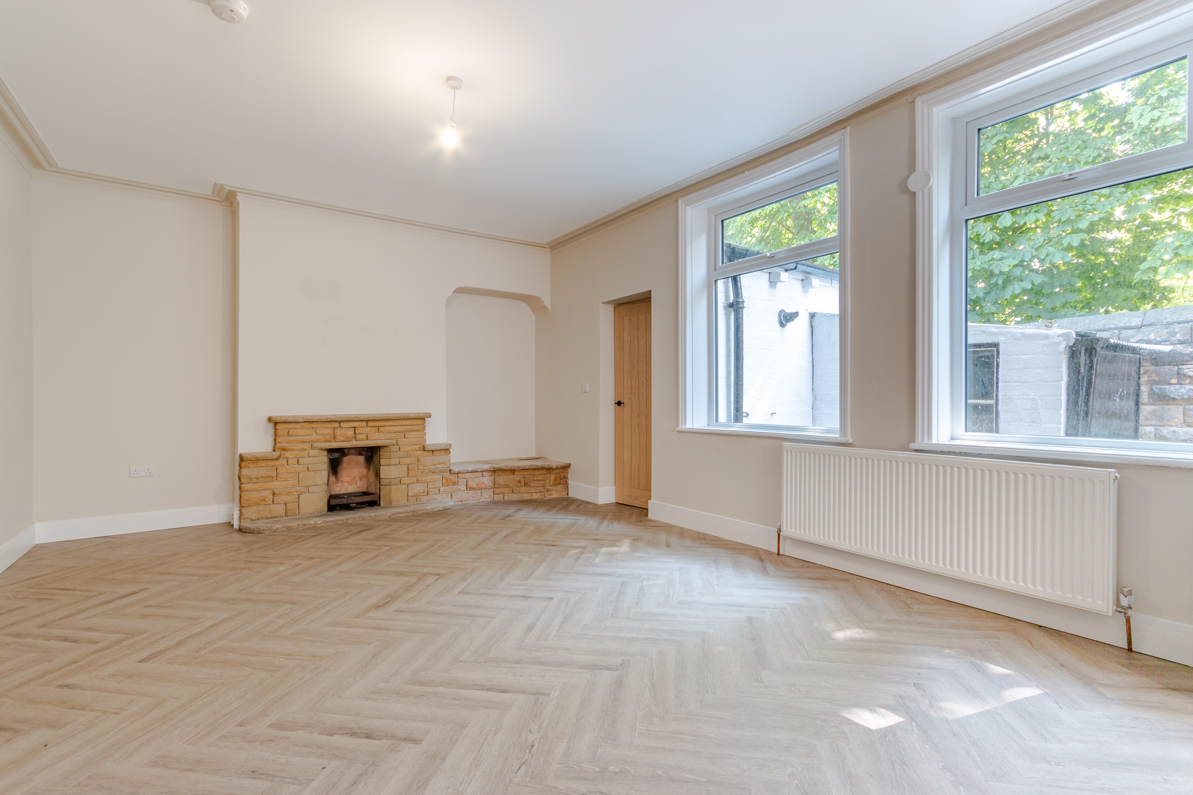

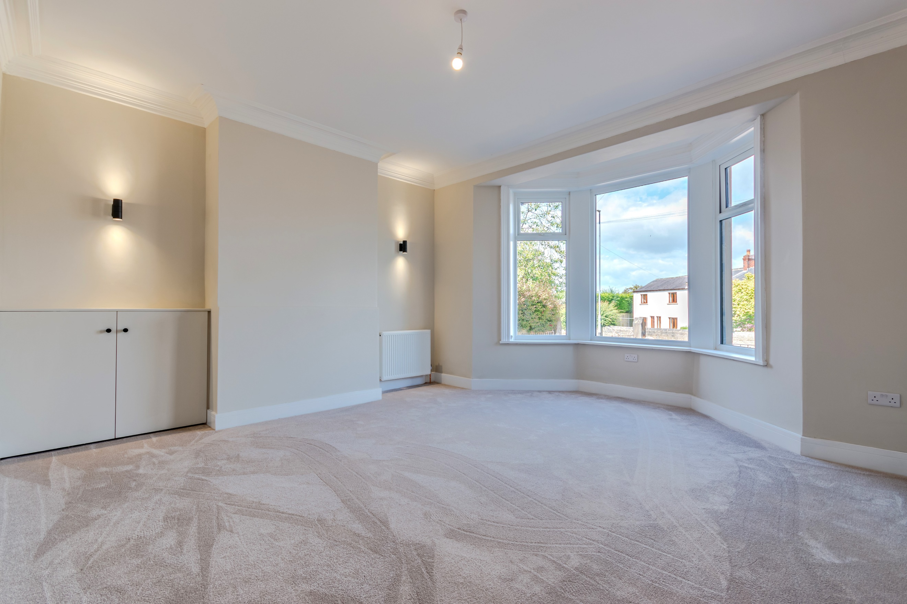

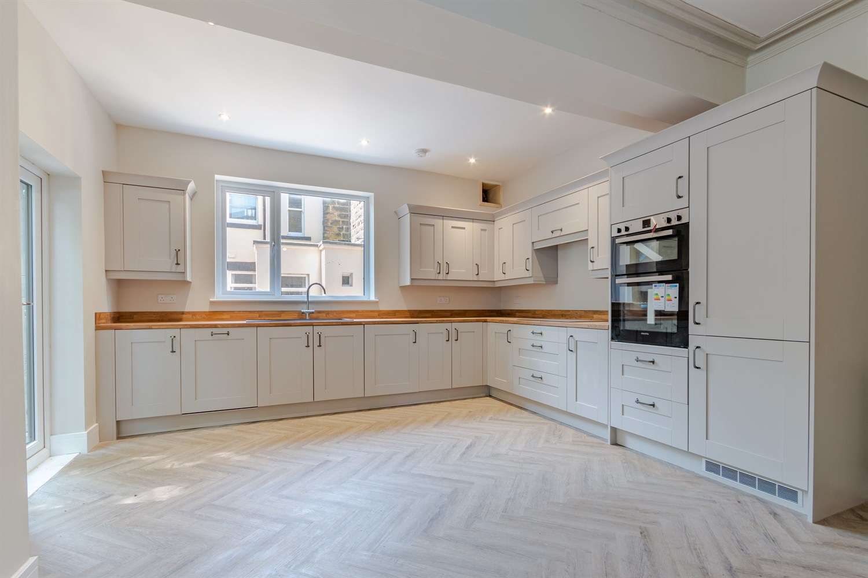

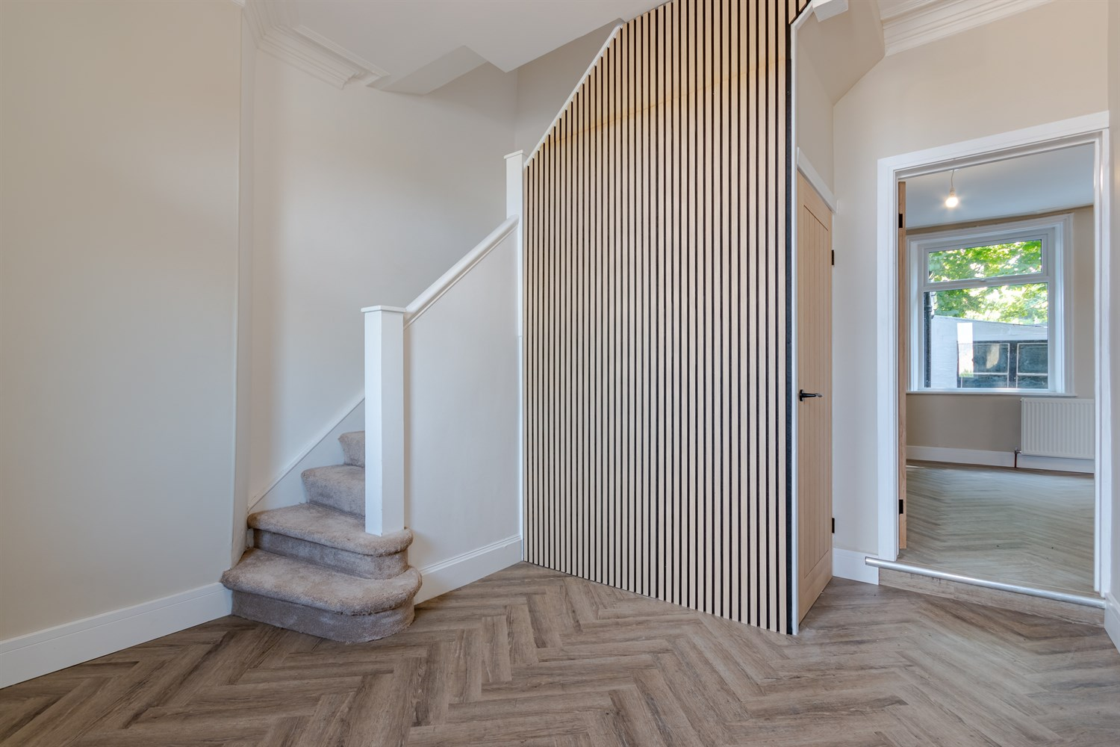

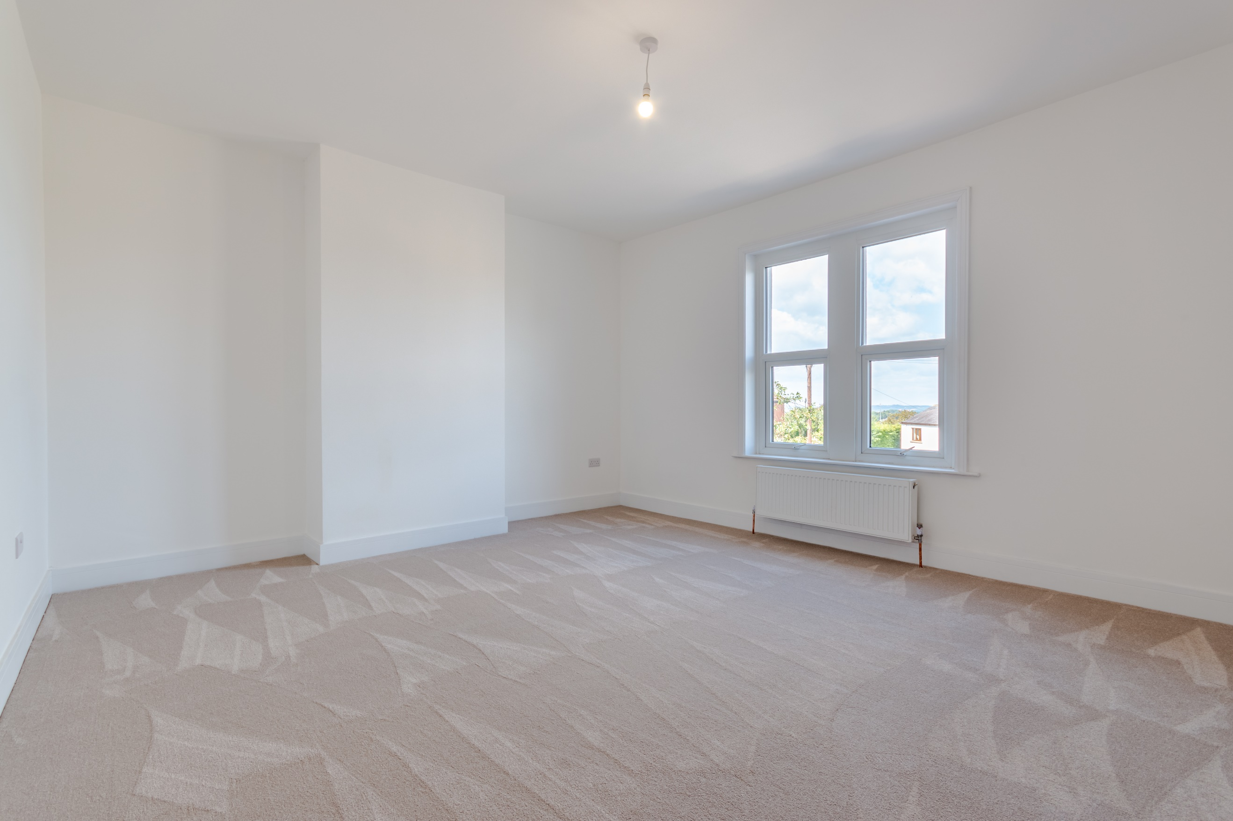

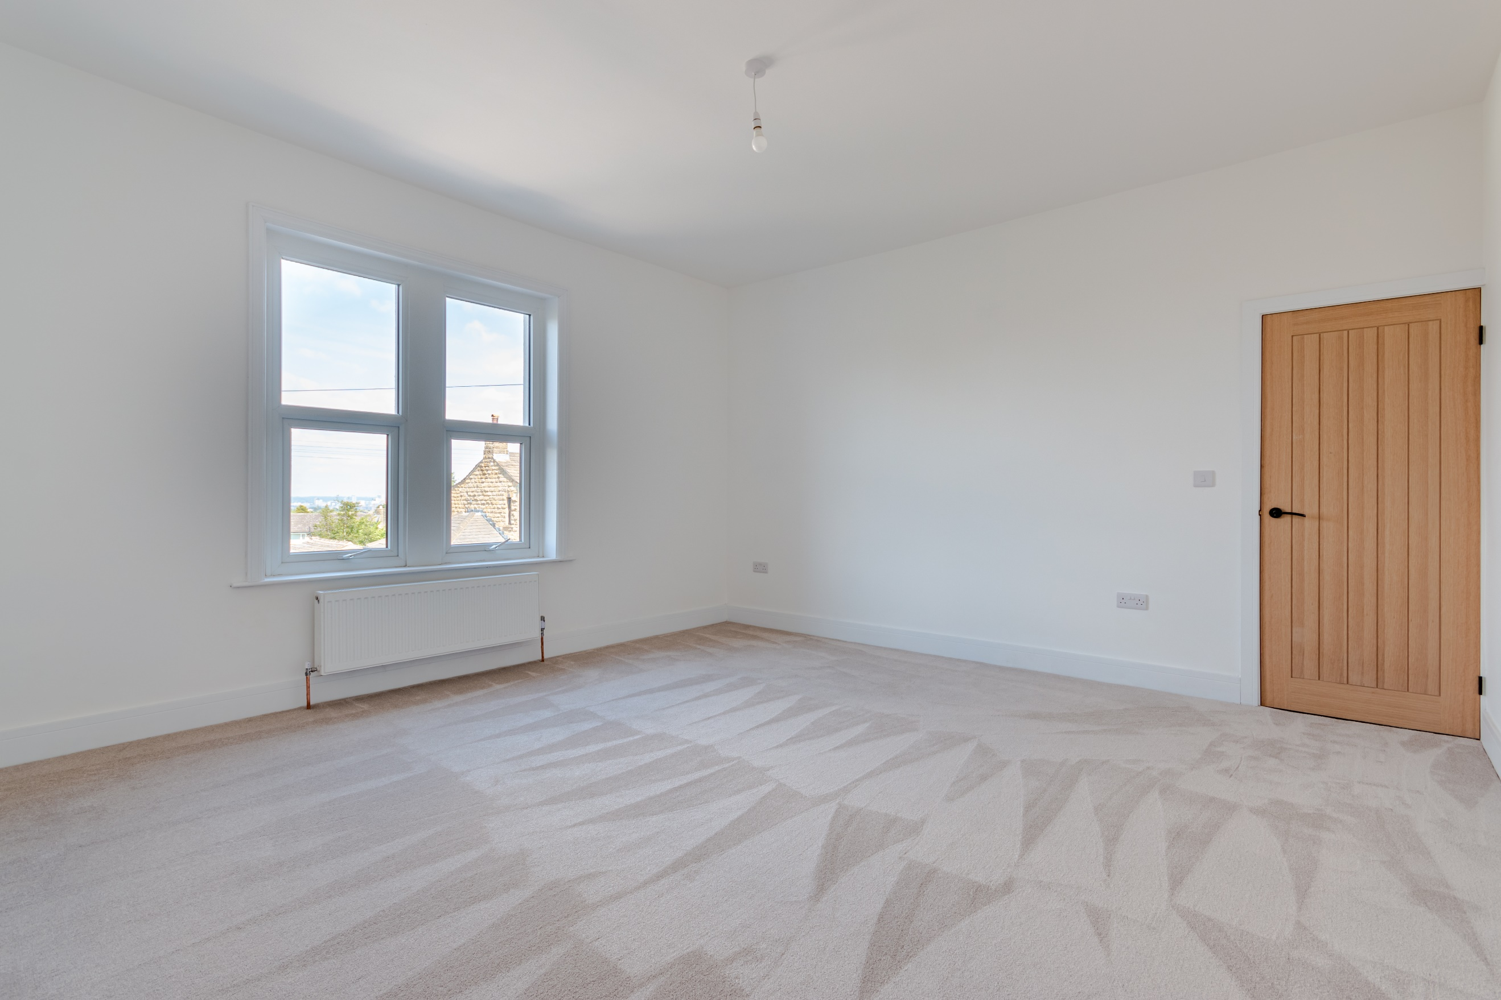

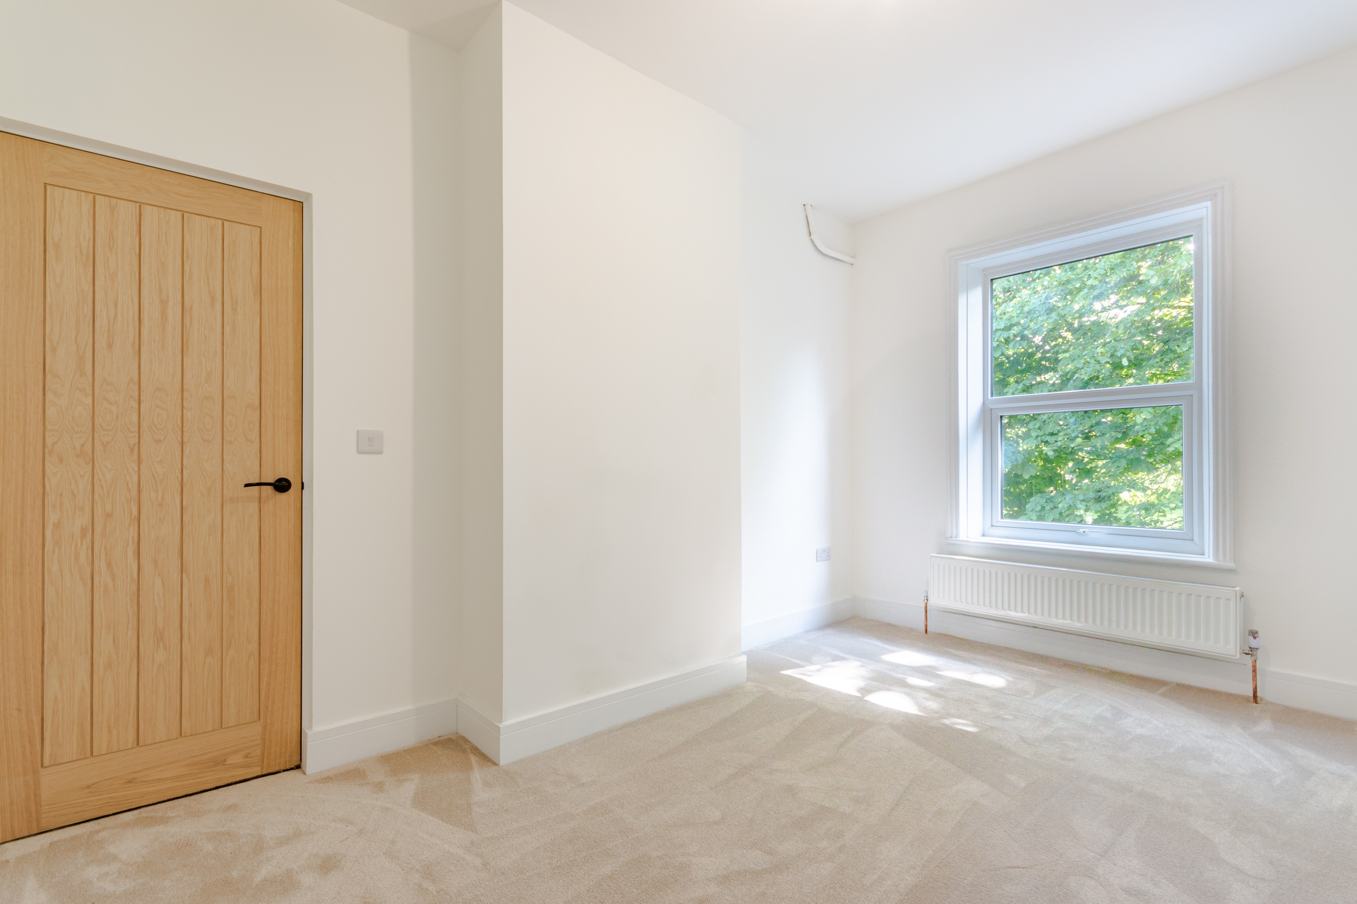

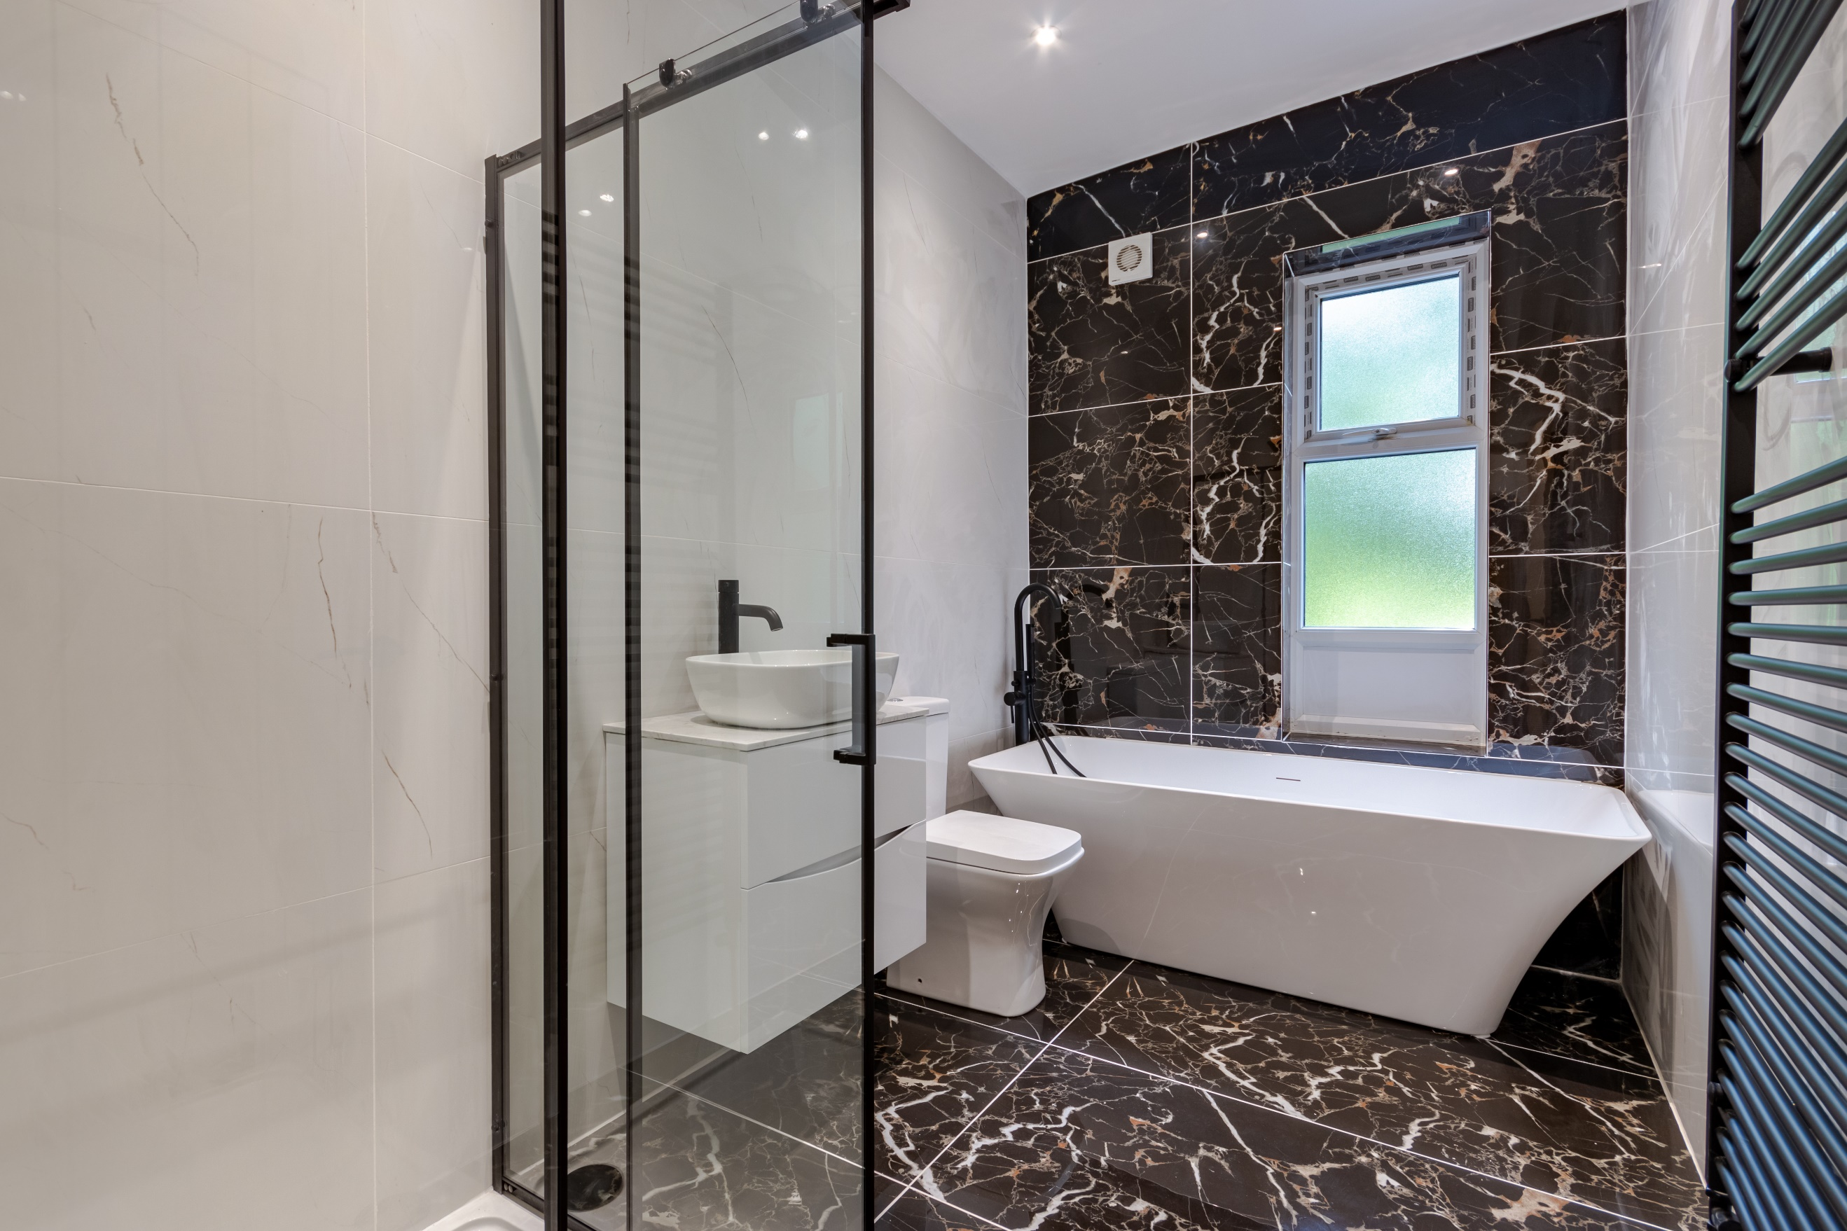

|  |
| --- |
| **Entrance Hall**  Via front entrance door. Under stairs storage. Stairs to first floor. |
| **Lounge 4.83m (15'10) x 4.25m (13'11)**  Light and airy living room with uPVC double glazed bay window to front. High ceiling. Gas central heating radiator. |
| **Kitchen / Diner 8.46m (27'9) x 4.25m (13'11)**  Fitted with a range of wall, base and drawer units with worktops over. Integrated double over, with hob and extractor hood over. Integrated dishwasher and fridge/freezer. 1.5 bowl sink with mixer tap and drainer. Inset ceiling spotlights. uPVC double glazed doors leading out to the rear. and uPVC double glazed window to side. Opening up to the dining area with two uPVC double glazed windows to the rear. Two gas central heating radiators. Feature stone fireplace. |
| **Utility/Store**  Access via the dining area, this room would be an ideal utility, home office or store room. |
| **First Floor** |
| **Bedroom 1 4.83m (15'10) x 4.25m (13'11)**  Spacious double bedroom with uPVC double glazed window to front. Gas central heating radiator. |
| **Bedroom 2 3.55m (11'8) x 4.25m (13'11)**  Second double bedroom with uPVC double glazed window to rear. Gas central heating radiator. |
| **Bedroom 3 2.76m (9'1) x 4.25m (13'11)**  Third bedroom with uPVC double glaze window to rear. Gas central heating radiator. |
| **Bedroom 4 3.47m (11'5) x 2.61m (8'7)**  Fourth bedroom with uPVC double glazed window to front. Gas central heating radiator. |
| **House Bathroom**  Fitted with a four piece suite comprising walk in shower cubicle, freestanding bath with freestanding shower mixer tap, WC and wash hand basin. Wall mounted heating towel rail. Tiled walls and floor. |
| **Outside**  To the front of the property is a driveway offering off street parking for several vehicles. |

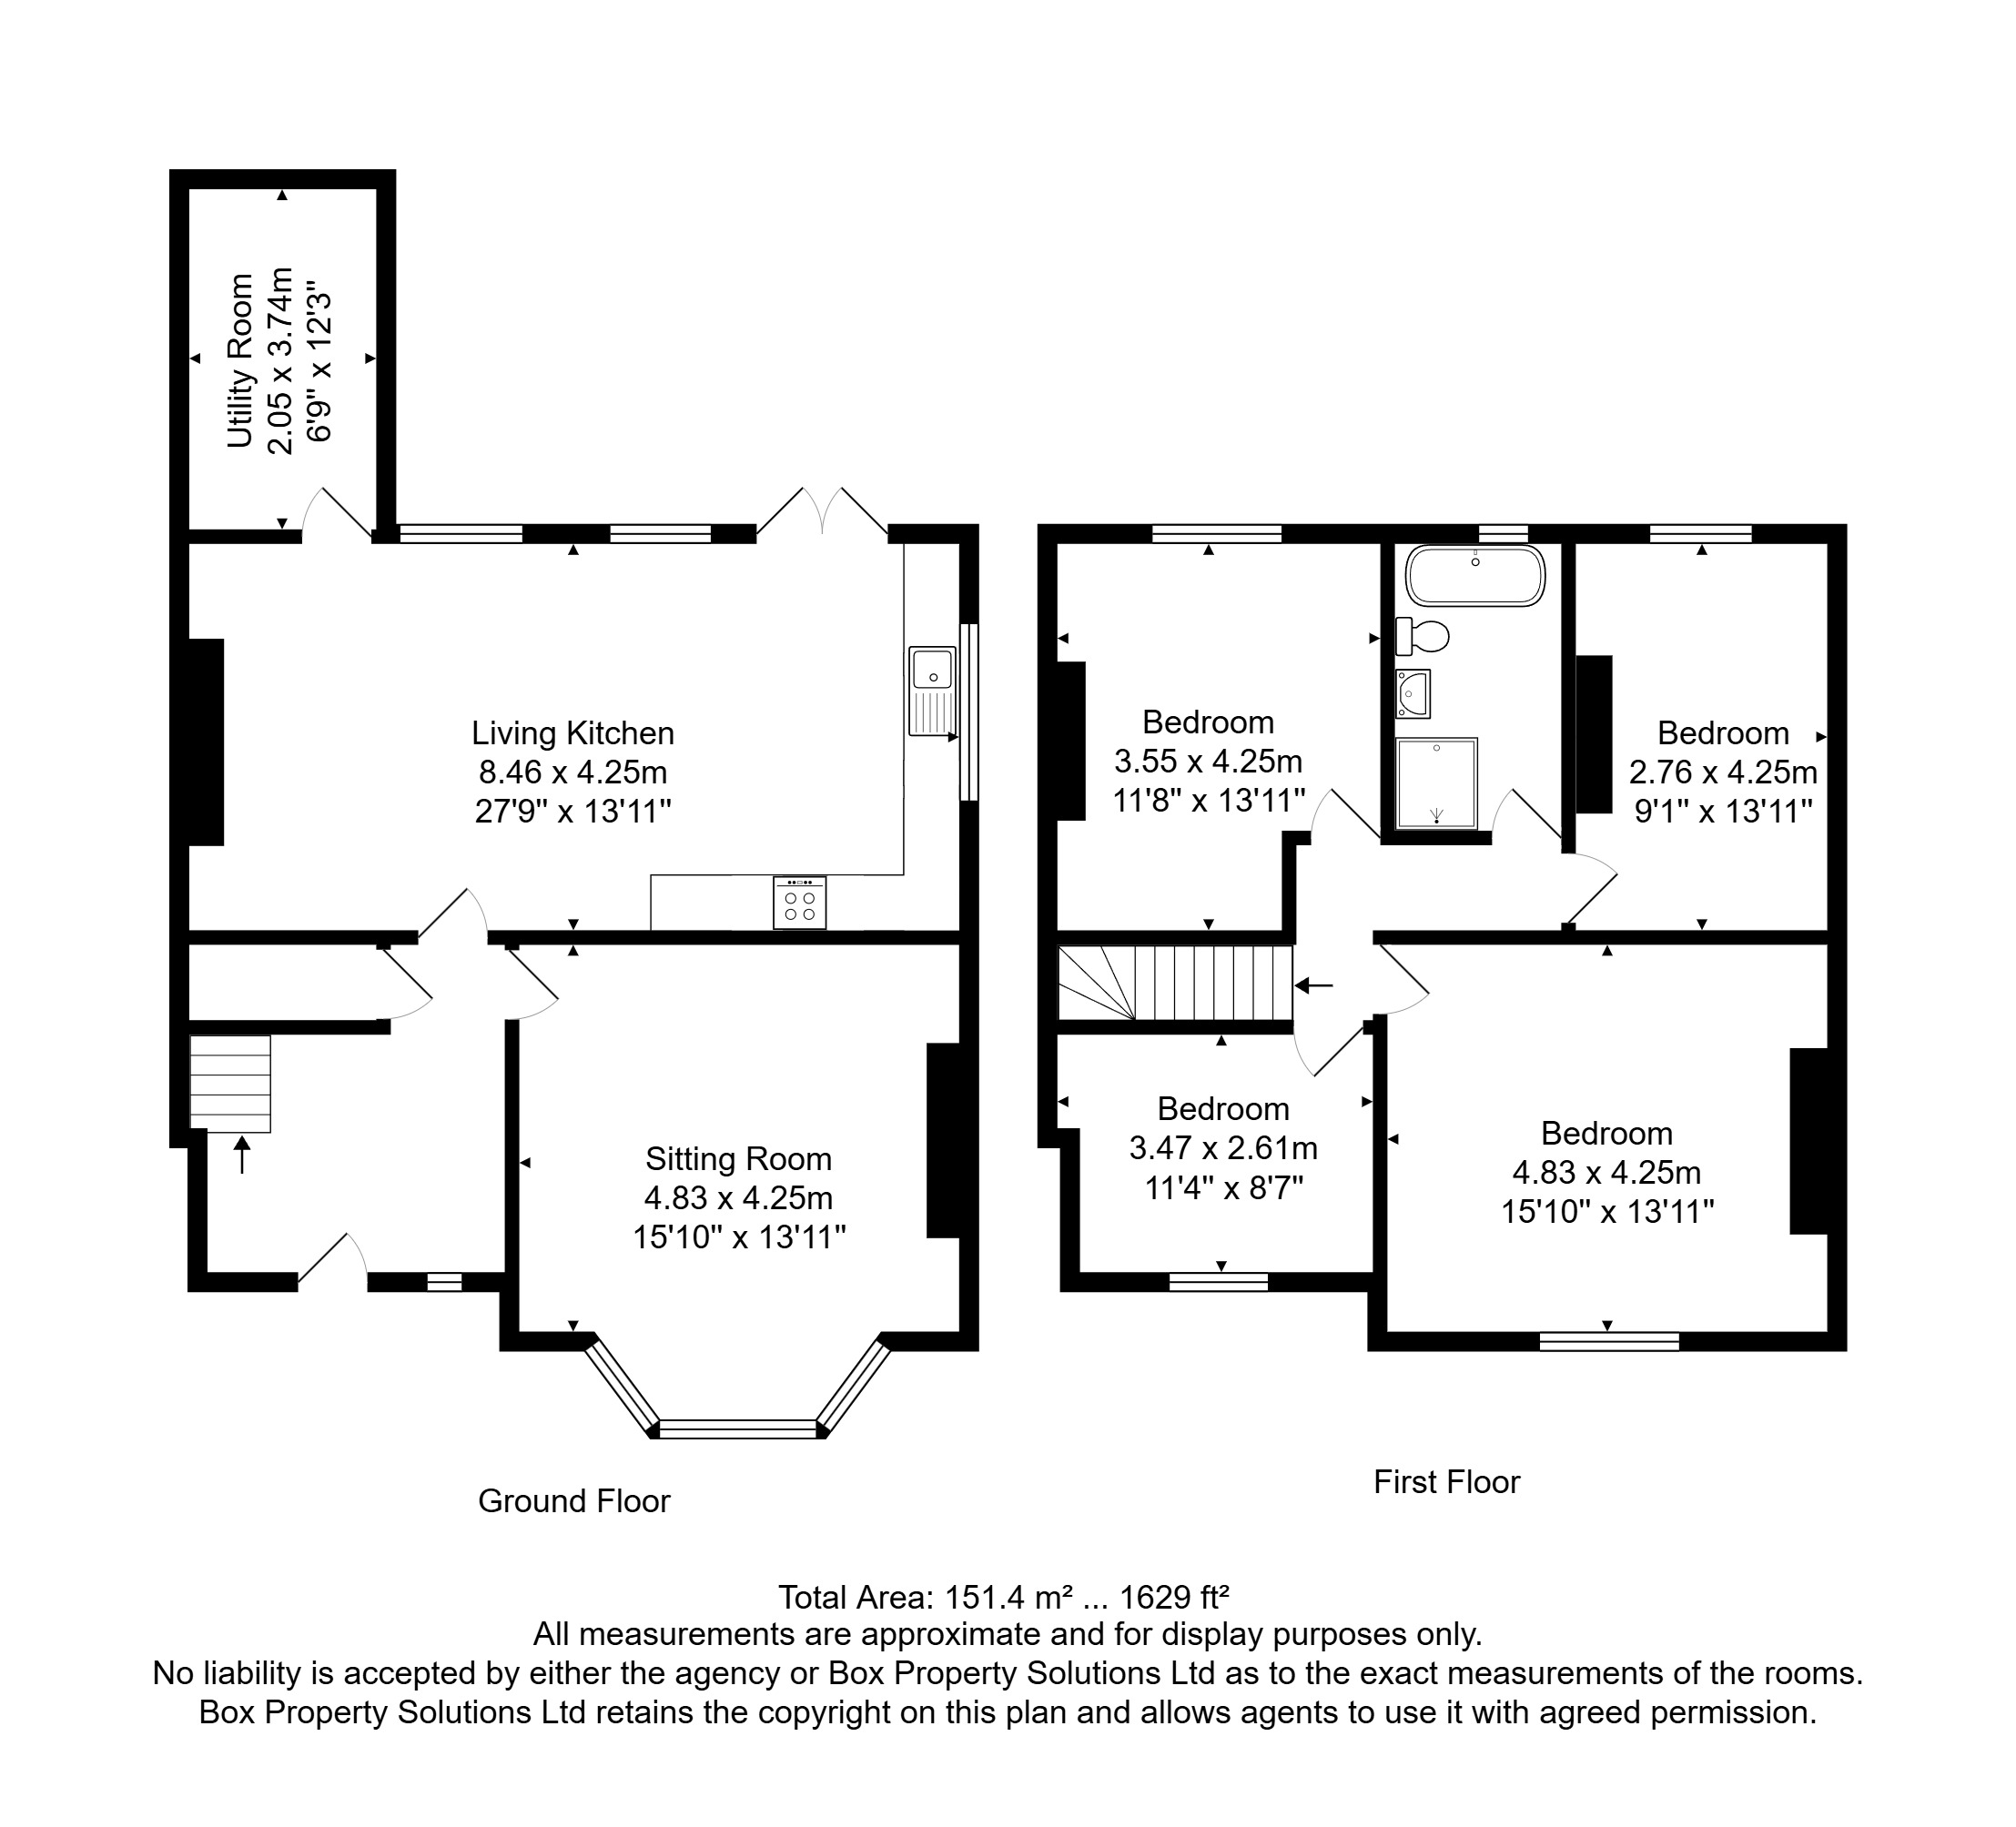

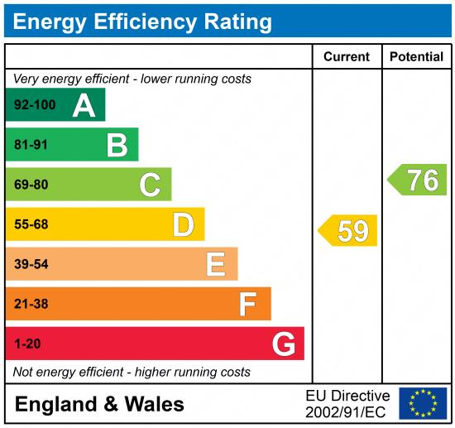

|  |
| --- |
|  |

These particulars are intended to give a fair description of the property, but their accuracy cannot be guaranteed, and they do not constitute an offer of contract. Intending purchasers must rely on their own inspection of the property. None of the above appliances/services have been tested by ourselves. We recommend purchasers arrange for a qualified person to check all appliances/services before legal commitment.

**Property Ref:** 6439

**For more information, please contact**

0113 258 1150 **|** [sales@adairpaxton.co.uk](mailto:sales@adairpaxton.co.uk) **|** www.adairpaxton.co.uk