

**Santorini, City Island, Leeds**

**For Sale £180,000.00**

***SPACIOUS TWO BEDROOM APARTMENT WITH SECURE PARKING*** EWS1 FIRE SAFTY COMPLIANT*** Located in this popular development, this spacious apartment briefly comprises: entrance hall, open plan living room/kitchen/diner with access to a balcony, two double bedrooms, and house bathroom. City Island enjoys well maintained communal gardens and benefits from a balcony with city views. Early internal viewing is highly recommended. Currently tenanted on a rolling basis.

**0113 258 1150**

**0800 000 000**

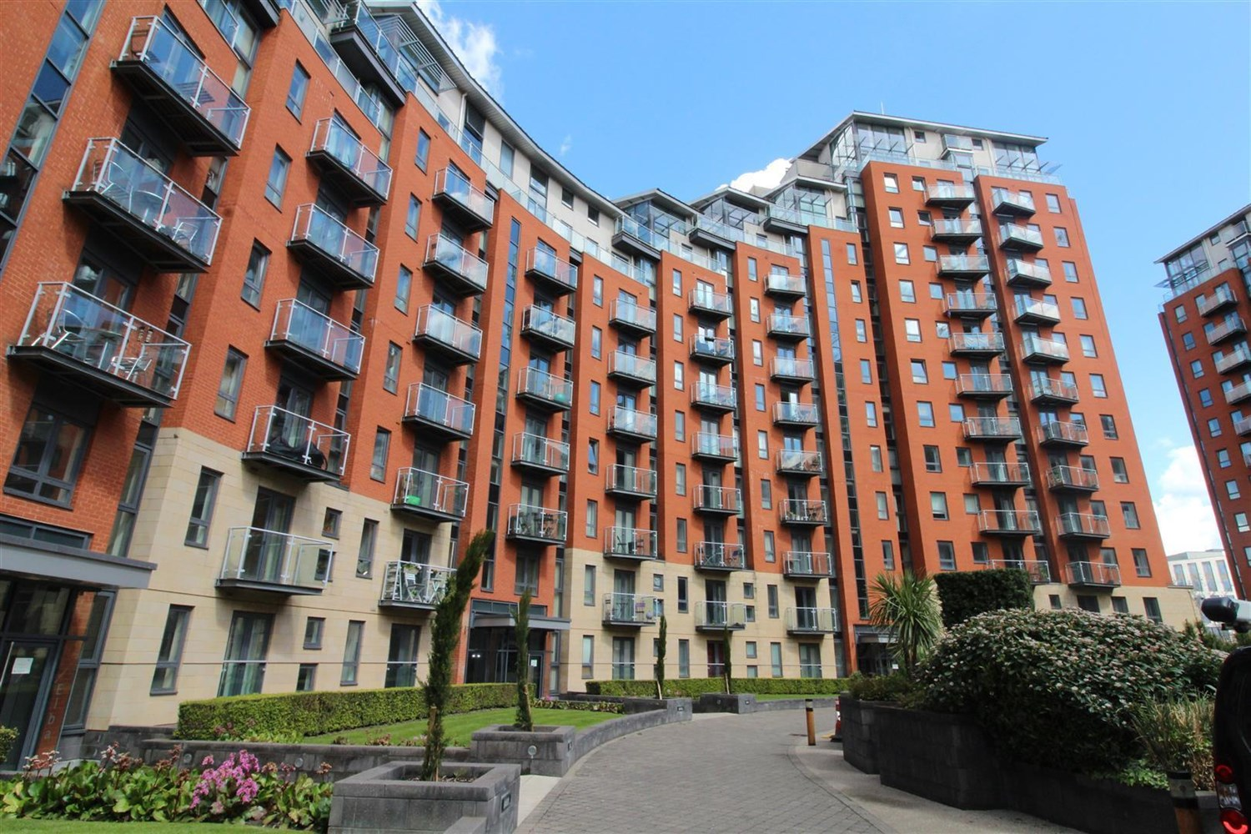



1 Reception(s)

1 Bathroom(s)

2 Bedroom(s)

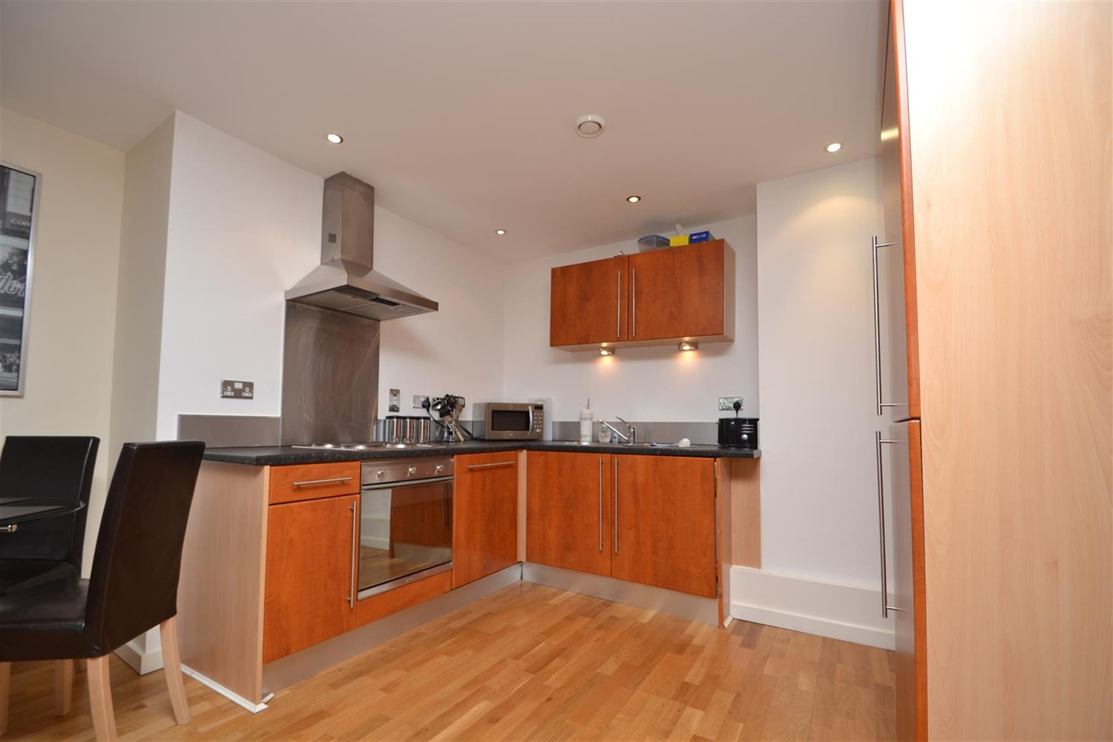

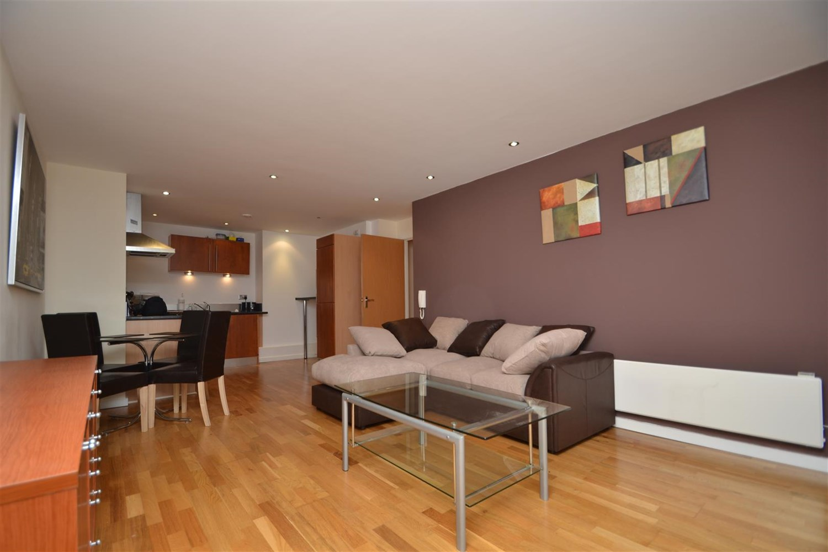

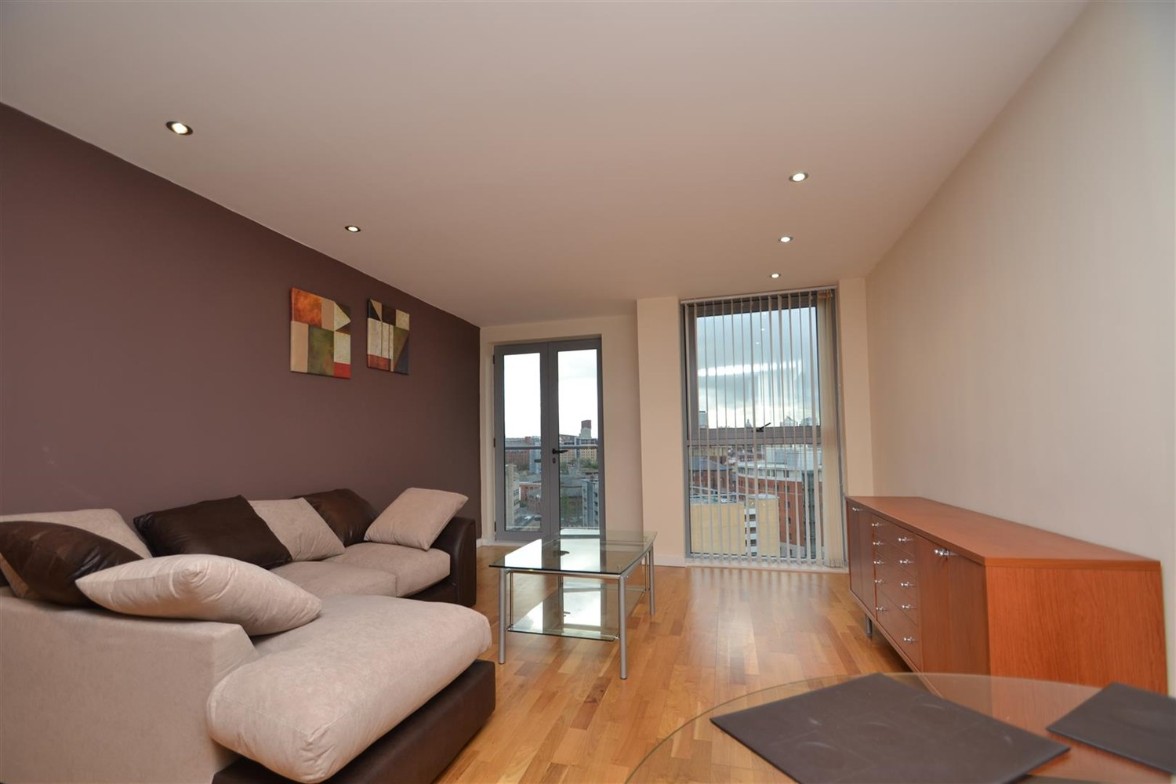

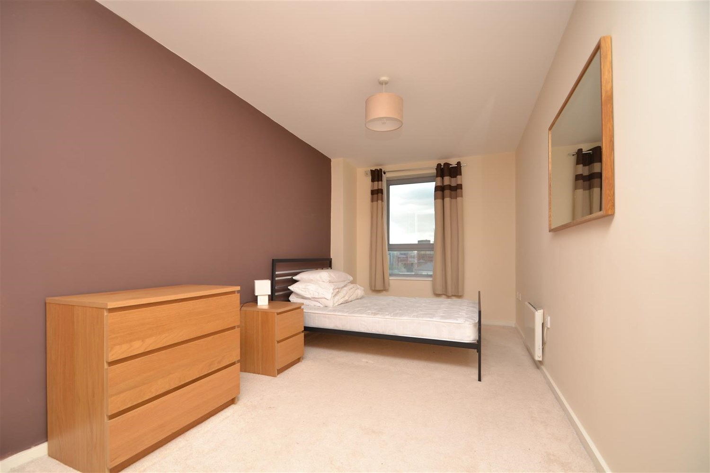

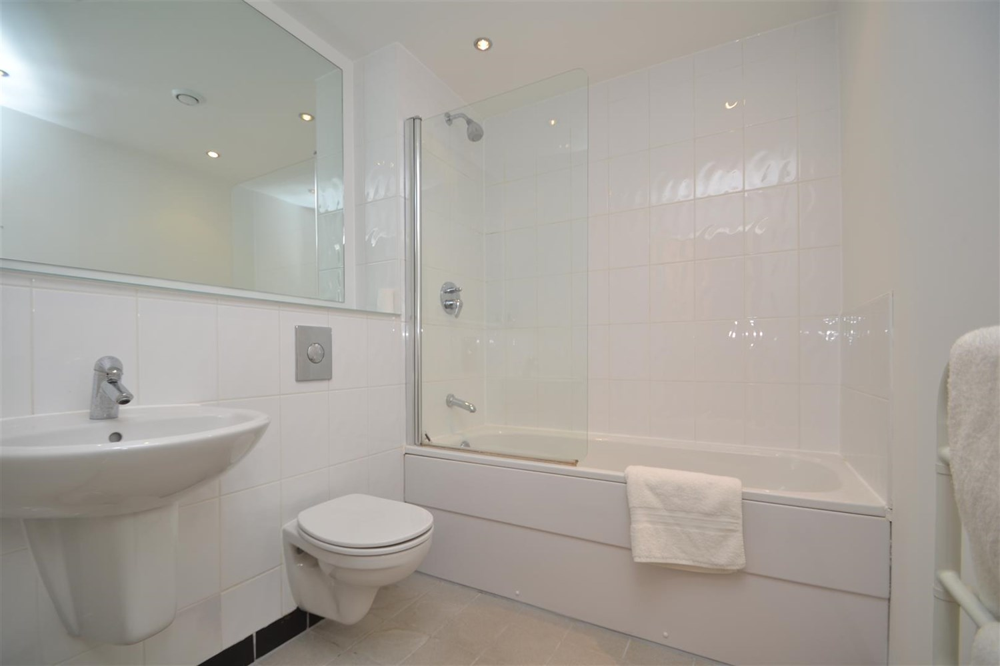

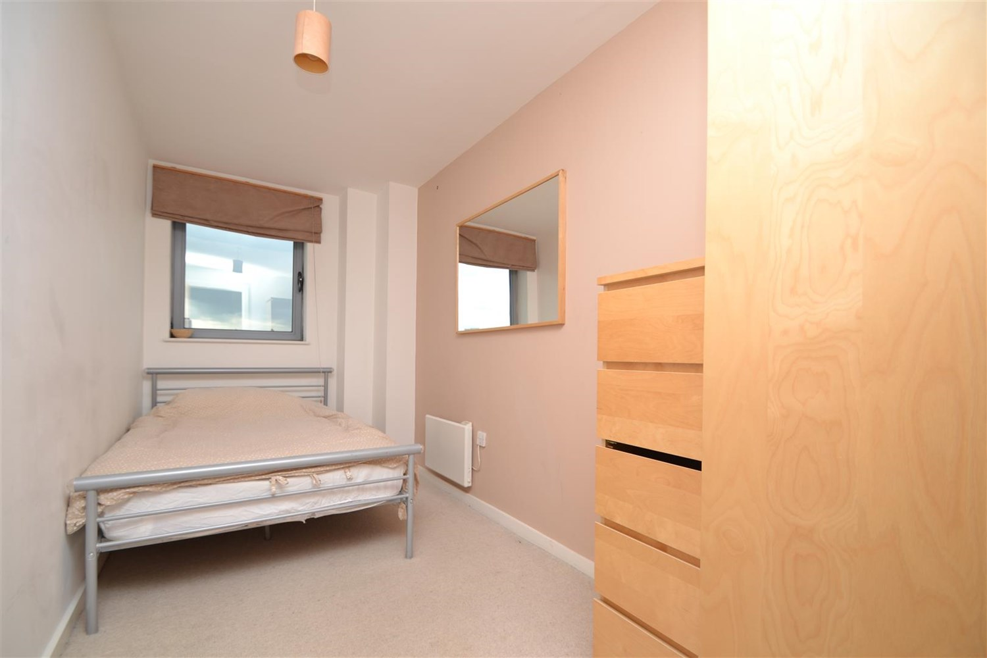

|  |
| --- |
| **Entrance Hall**  Communal entrance hall via entrance door with secure entry phone system. |
| **Private Entrance**  Private entrance hall via front entrance door. Laminate Flooring. |
| **Open Plan Living Kitchen**  A spacious open plan living space with laminate flooring, balcony with courtyard views, electric panel radiator and entrance phone. Kitchen houses a range of wall and base mounted units, single drainer steel sink unit with mixer tap and integrated appliances. Inset ceiling spotlights. |
| **Bedroom 1**  A generous sized carpeted room, with neutral decor, electric panel radiator and double glazed window. |
| **Bedroom 2**  Another spacious double bedroom, with neutral carpet, double glazed window and electric panel radiator. |
| **Bathroom**  A three piece white suite comprising bath with shower over and glass shower screen, low flush w.c and basin. Tiled floor, partially tiled walls and electric towel rail |
| **Service Charge**  Flat £172.86 per month Parking £41.50 per month |
| **Tenure**  999 years from 2003 Ground rent - £200 per annum |

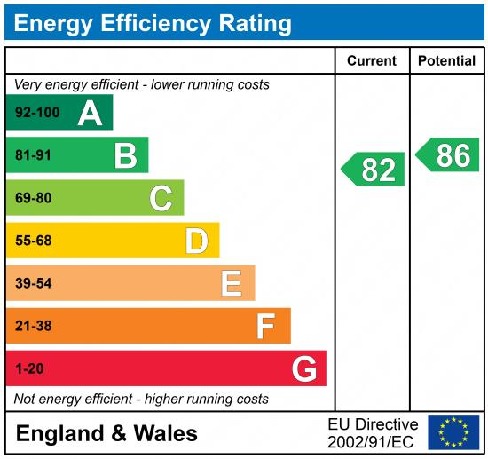

|  |
| --- |
|  |

These particulars are intended to give a fair description of the property, but their accuracy cannot be guaranteed, and they do not constitute an offer of contract. Intending purchasers must rely on their own inspection of the property. None of the above appliances/services have been tested by ourselves. We recommend purchasers arrange for a qualified person to check all appliances/services before legal commitment.

**Property Ref:** 194

**For more information, please contact**

0113 258 1150 **|** [sales@adairpaxton.co.uk](mailto:sales@adairpaxton.co.uk) **|** www.adairpaxton.co.uk