

**0113 258 1150**

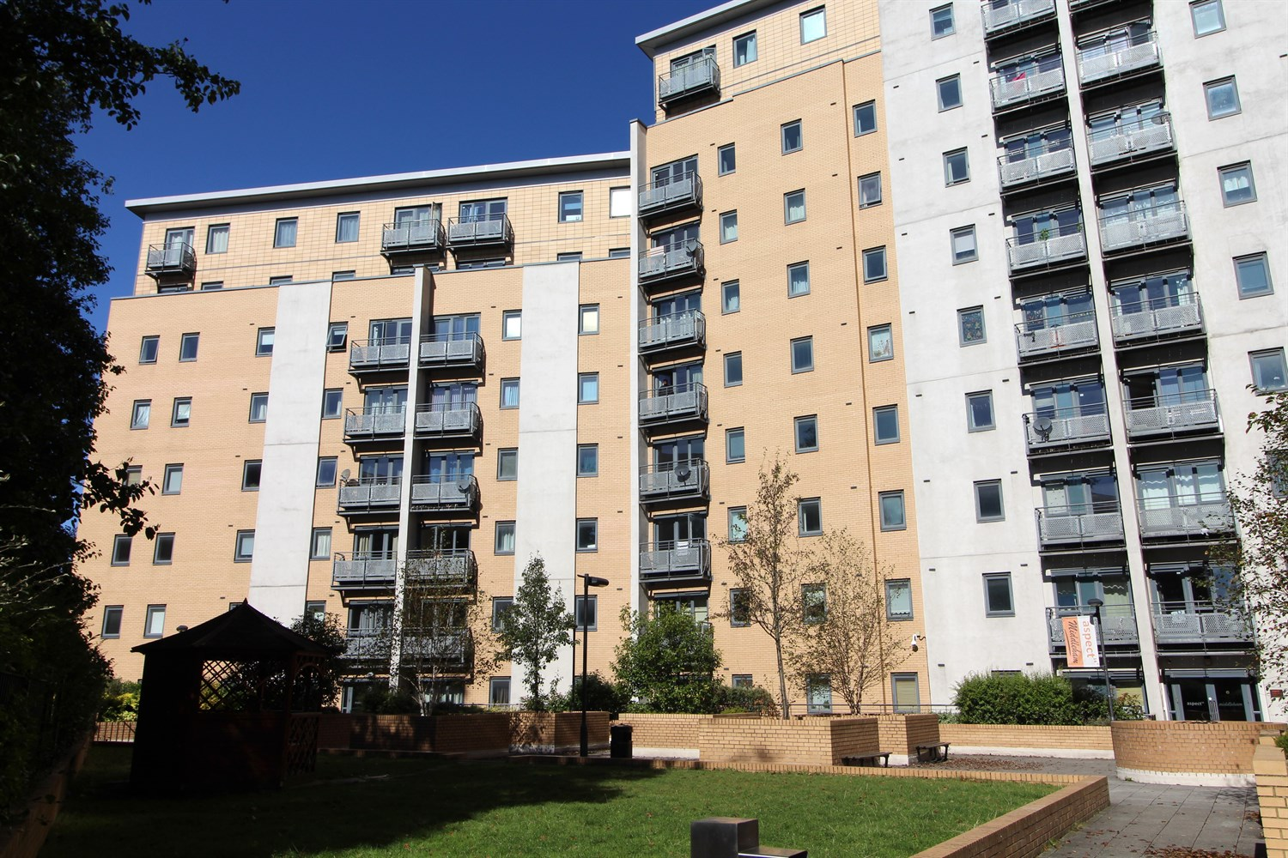



**For Sale £150,000.00**

**Aspect 14, Leeds**

***SPACIOUS TWO BED, TWO BATHROOM APARTMENT-NO CHAIN***Located in this popular development and built around a central courtyard. Close to all the amenities in Leeds city centre and handy for the University. Comprising; Hallway, open plan lounge/kitchen/diner, double bedroom with en-suite, second double bedroom and house bathroom.

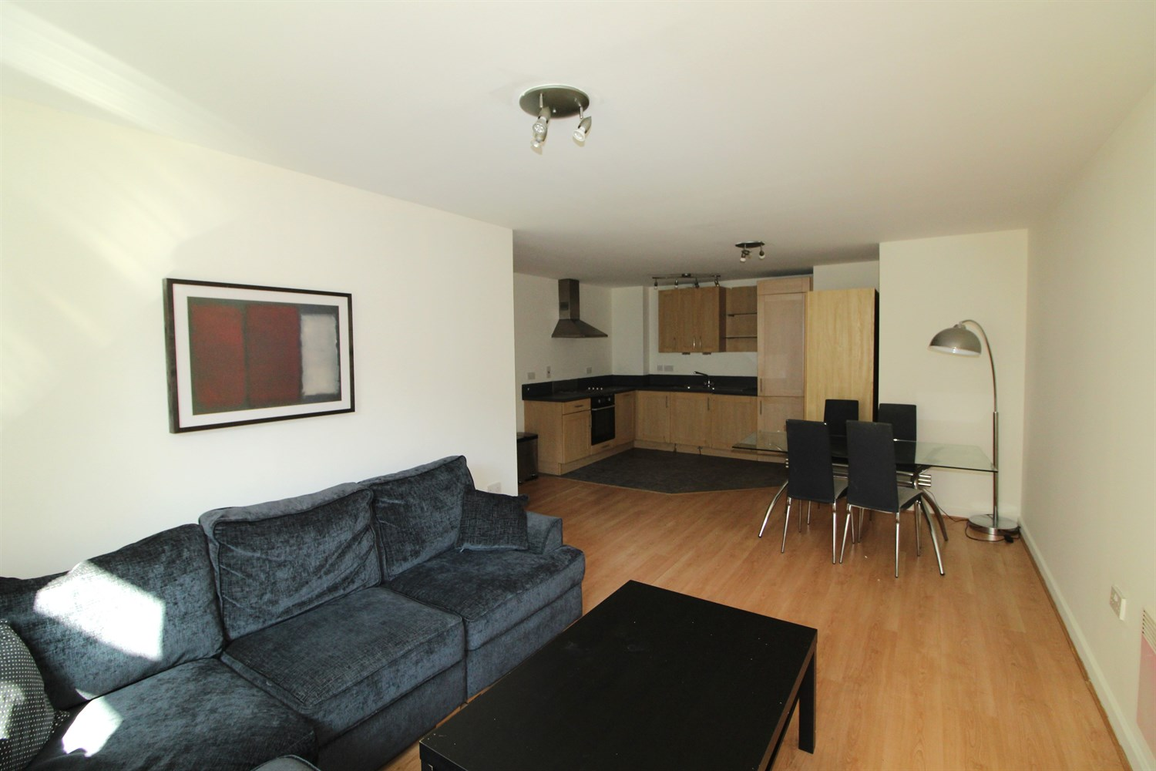

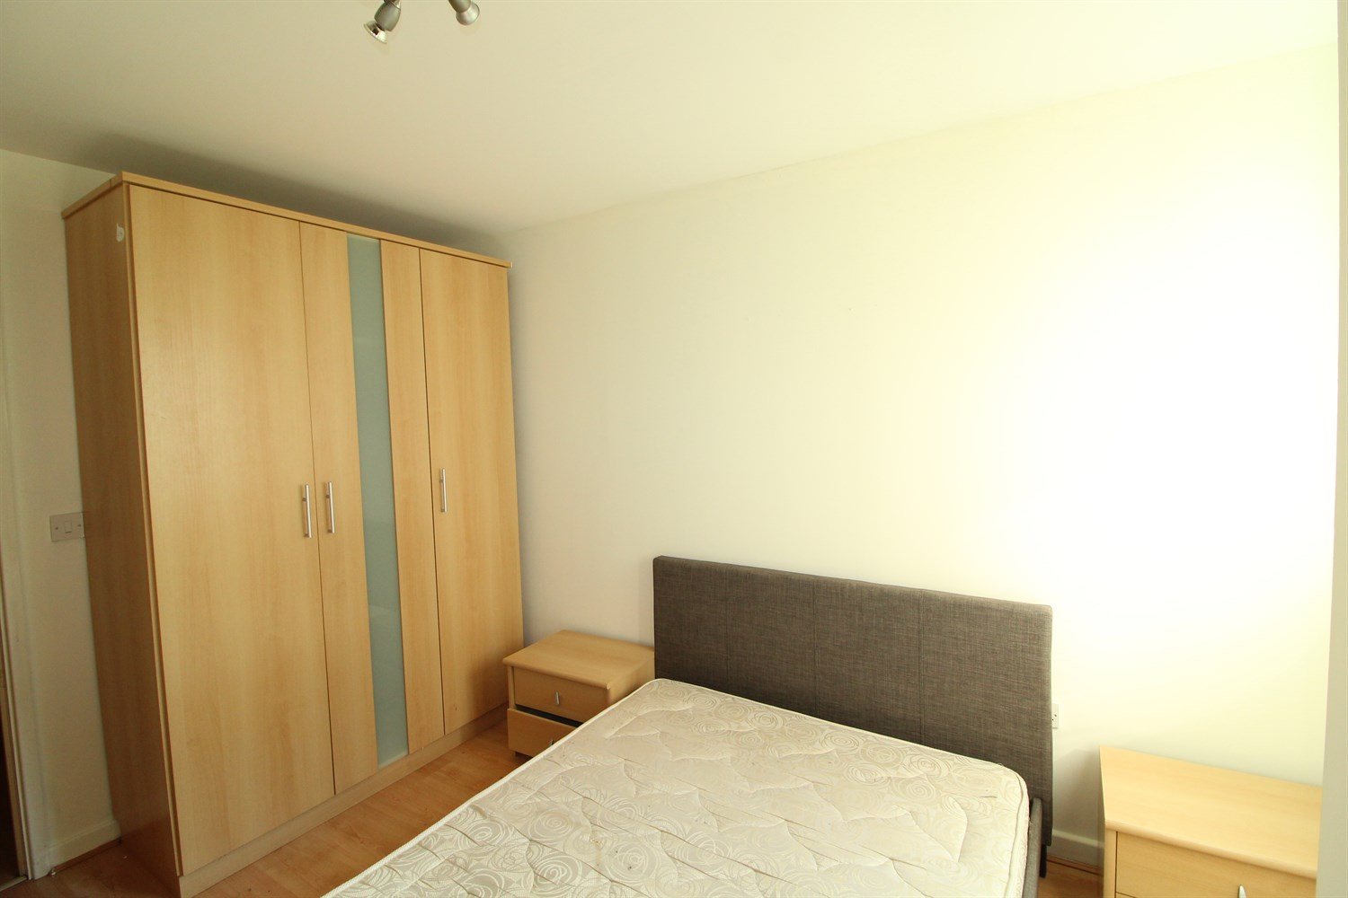

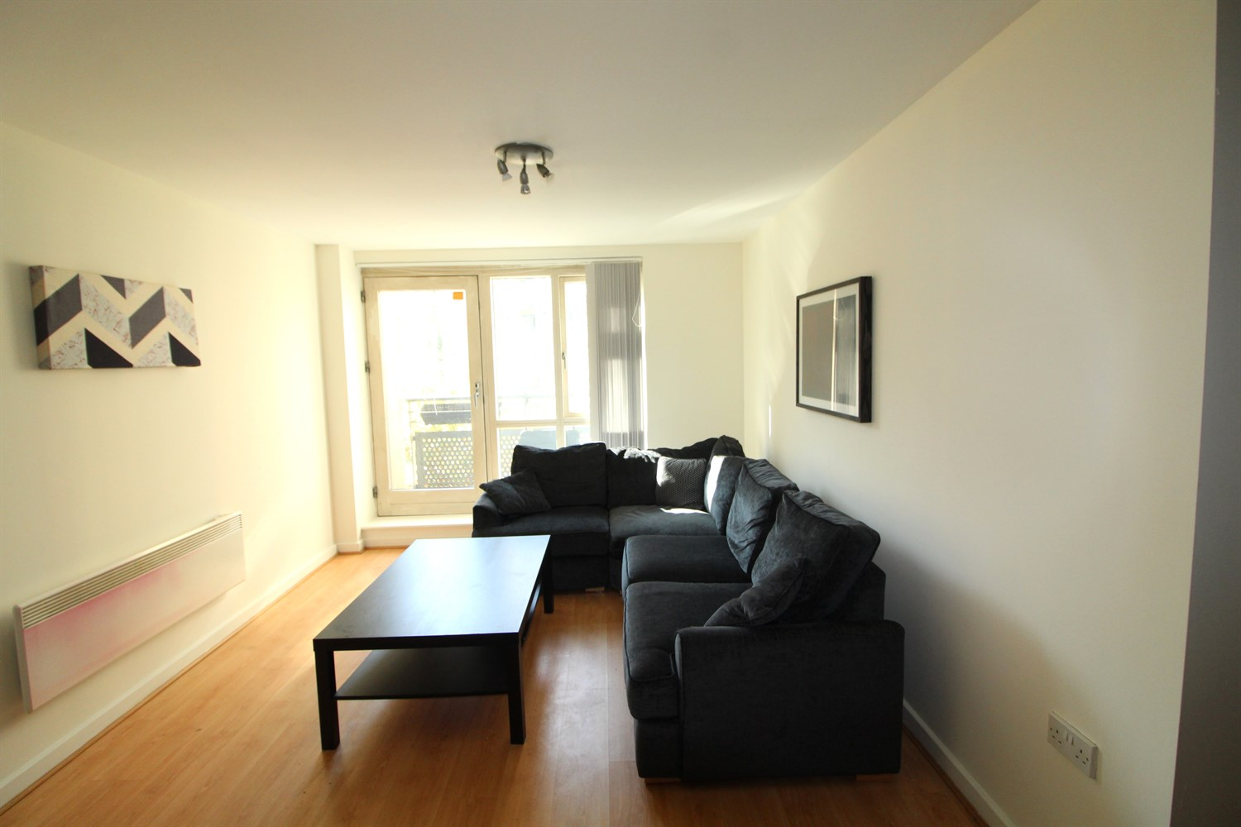

2 Bathroom(s)

1 Reception(s)

2 Bedroom(s)

00

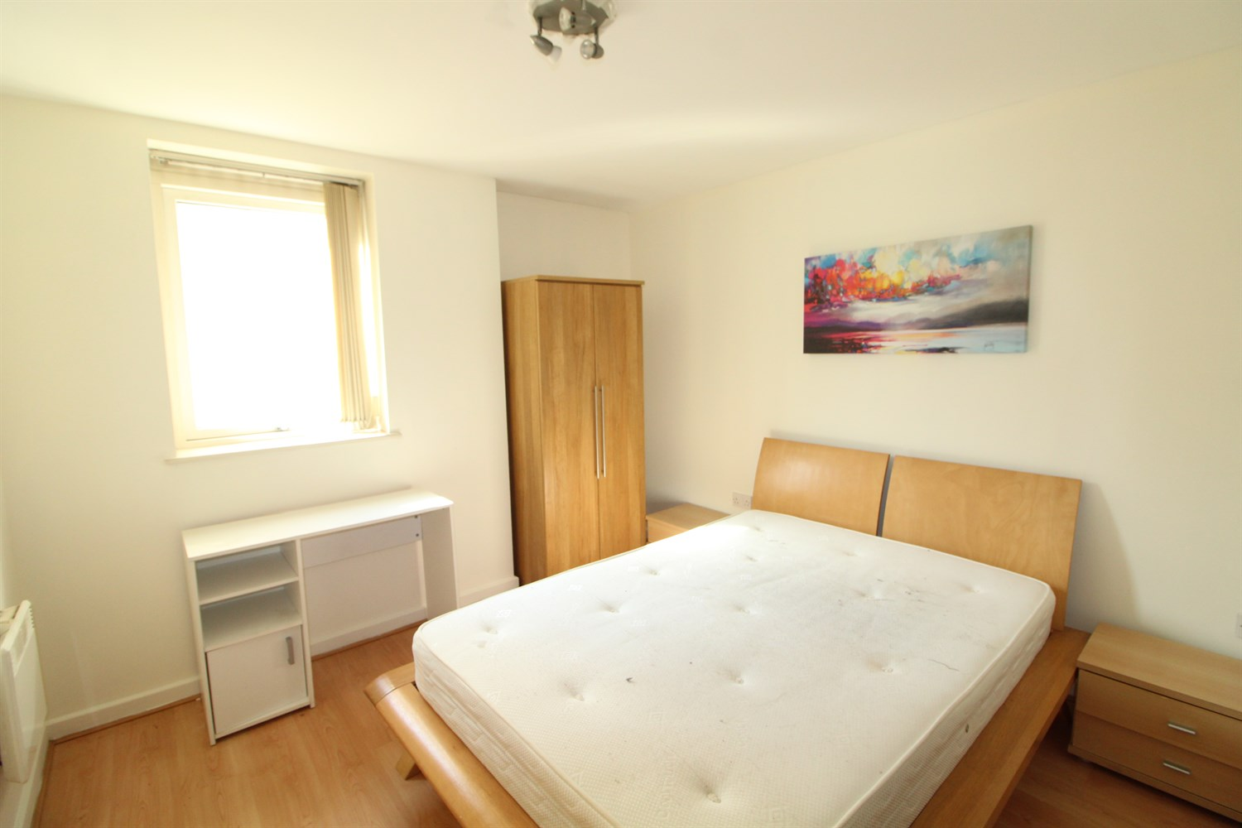

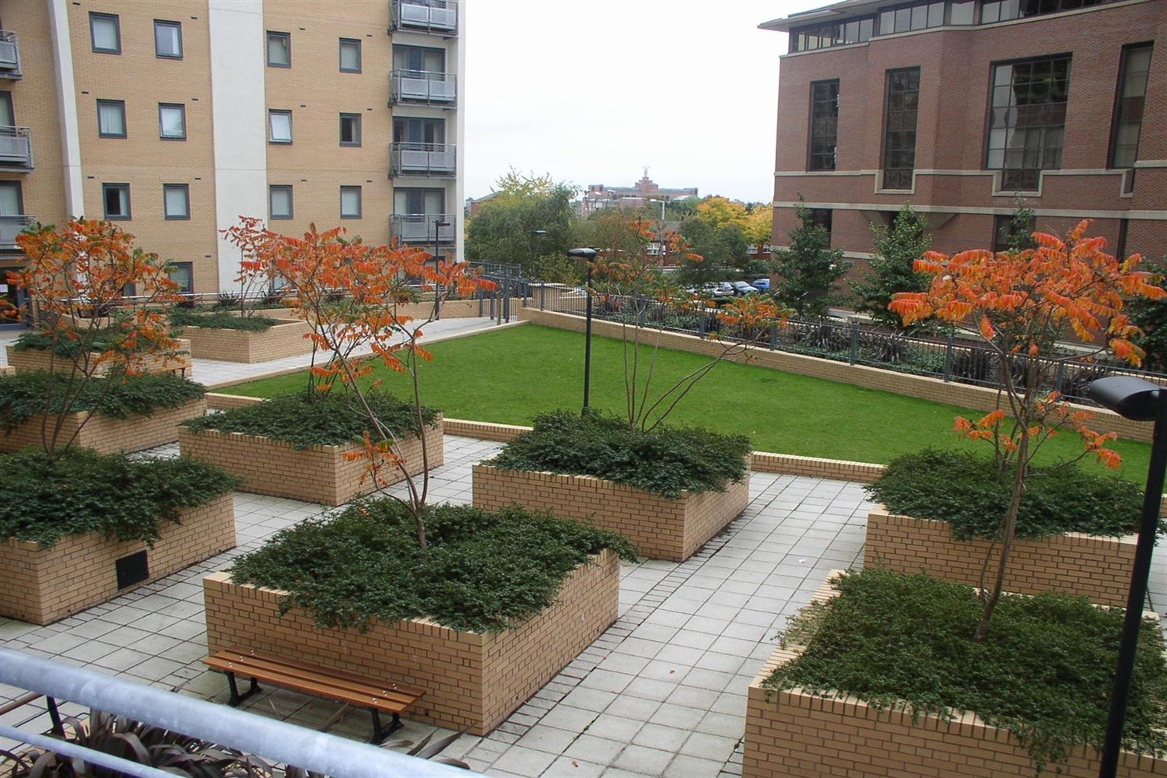

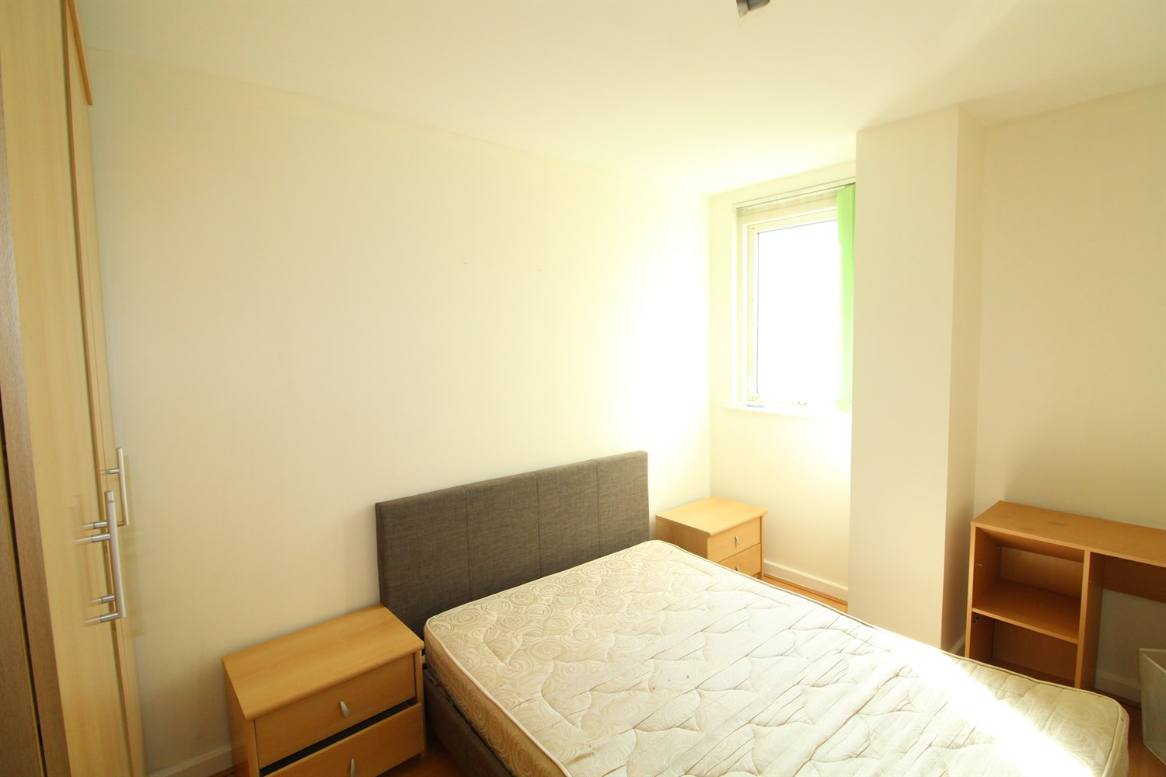

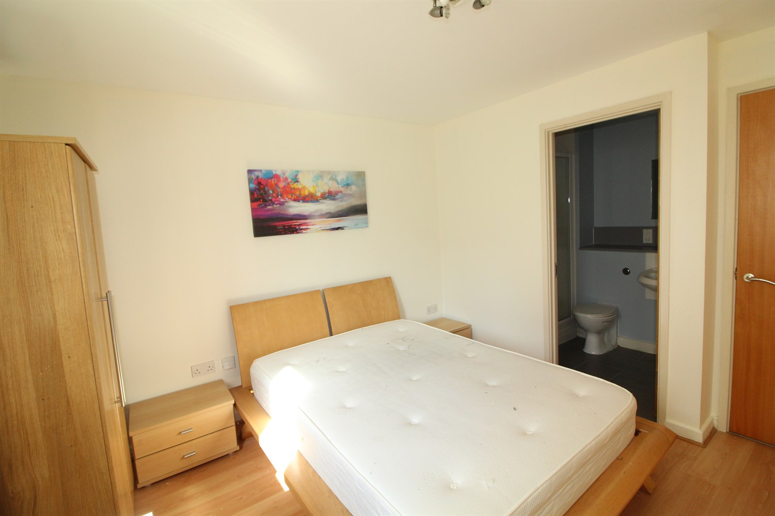

|  |
| --- |
| **Communal Entrance Hall**  Secure entrance with post boxes, video entrance phone and access to all floors via lift and stairs |
| **Hallway**  With laminate flooring, video entrance phone, storage cupboard |
| **Living/Dining and Kitchen**  Open plan living area with access to balcony. Kitchen area having a range of wall, base and drawer units with worktops over. integrated oven, hob and extractor, single drainer stainless steel sink unit with mixer tap, washing machine, fridge freezer and dishwasher. Electric radiator. |
| **Bedroom**  Double bedroom with double glazed window. Electric radiator. |
| **Ensuite**  En-suite shower room with shower cubicle, low flush w.c and basin. Heated towel rail. |
| **Bedroom**  Second double bedroom with double glazed window. Electric radiator. |
| **House Bathroom**  A bathroom suite comprising bath, low flush WC and basin. Heated towel rail. |
| **Service Charge**  Service charge £353.85 per quarter. |
| **Tenure**  Leasehold Lease term of 999 years, less one day starting on 1st January 2003 Ground rent - £297.85 per annum |

|  |  |
| --- | --- |
| These particulars are intended to give a fair description of the property, but their accuracy cannot be guaranteed, and they do not constitute an offer of contract. Intending purchasers must rely on their own inspection of the property. None of the above appliances/services have been tested by ourselves. We recommend purchasers arrange for a qualified person to check all appliances/services before legal commitment.  **Property Ref:** 5747  **For more information, please contact**  0113 258 1150 **|** [sales@adairpaxton.co.uk](mailto:sales@adairpaxton.co.uk) **|** www.adairpaxton.co.uk |  |