

**Clarence Road, Horsforth**

**For Sale £195,000.00**

***RECENTLY REFURBISHED ONE BEDROOM MID-TERRACE HOUSE WITH NO ONWARD CHAIN*** This delightful stone built terraced house sits in a sought after Horsforth location and simply must be viewed to be appreciated. Having been re-wired, re-plumbed and newly installed windows and doors, this property has been finished to an immaculate standard. The property briefly comprises: Modern open plan kitchen/living space to the ground floor. Cellar useful for storage. To the first floor there is a good sized double bedroom and a modern shower room. Located in this extremely sought after and convenient area of Horsforth, A short walk from the Forge train station and close to beautiful canal & river walks, is this lovely ready to move into stone back to back terrace. A really great first time buy, the property is also a stone's throw from the extensive shopping facilities on New Road Side.

**0113 258 1150**

**0800 000 000**

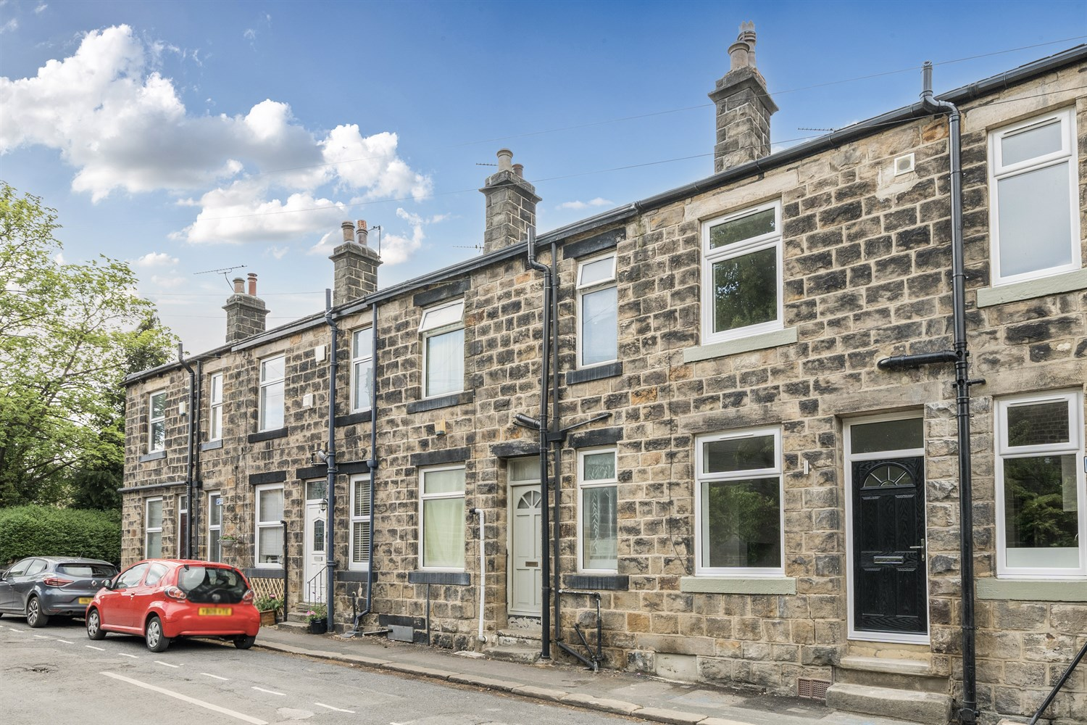

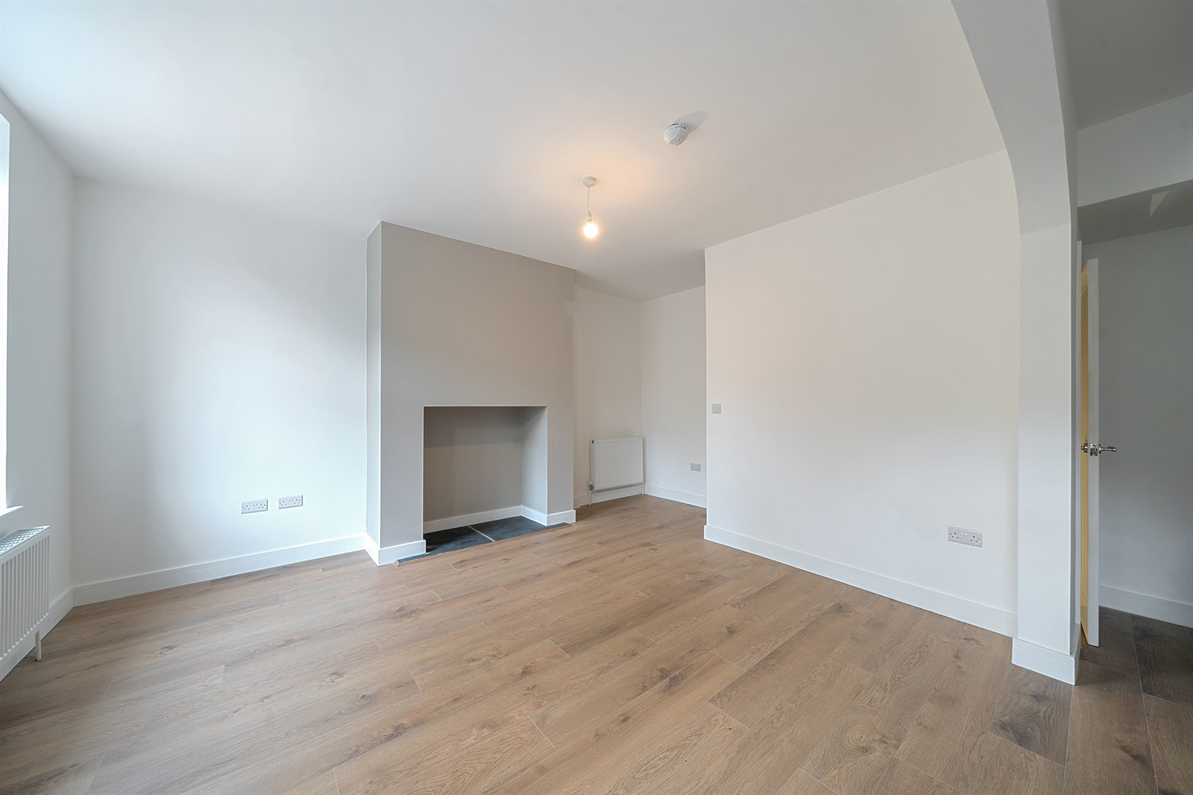

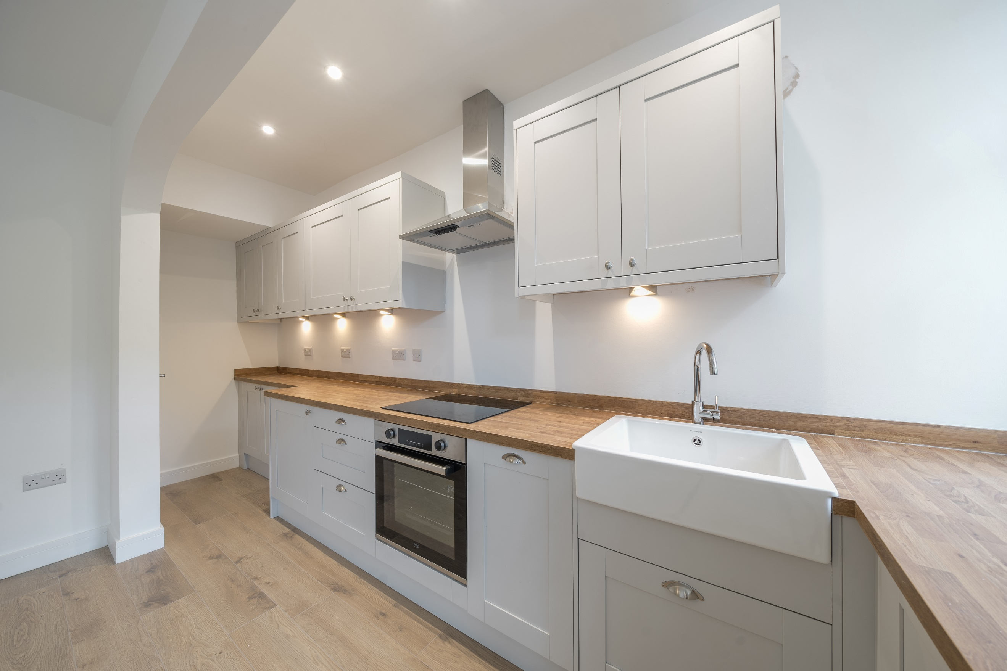

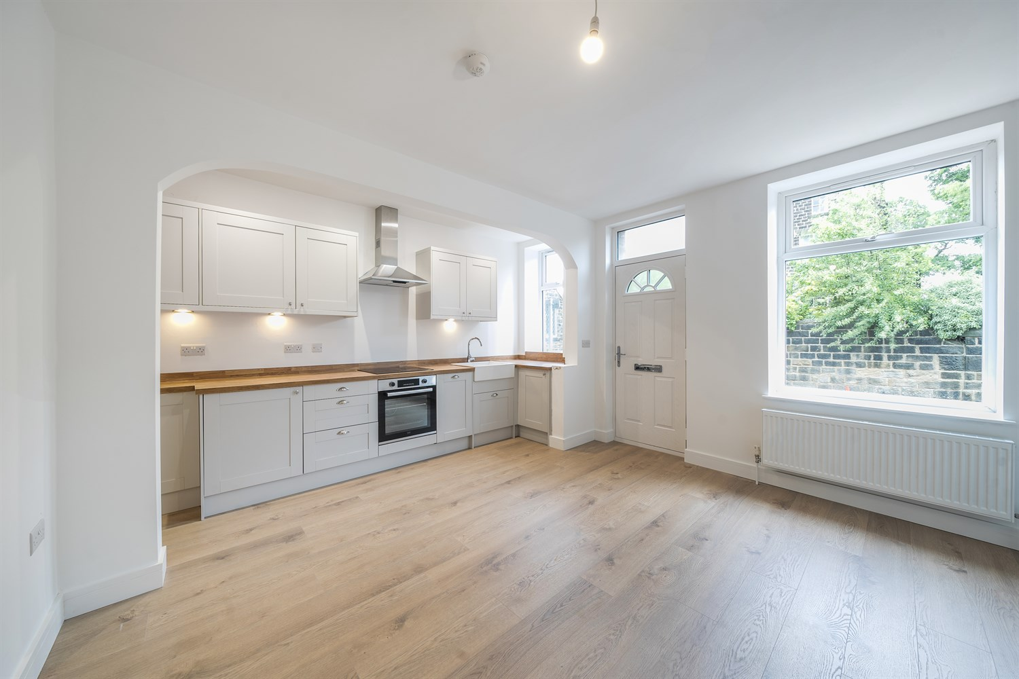

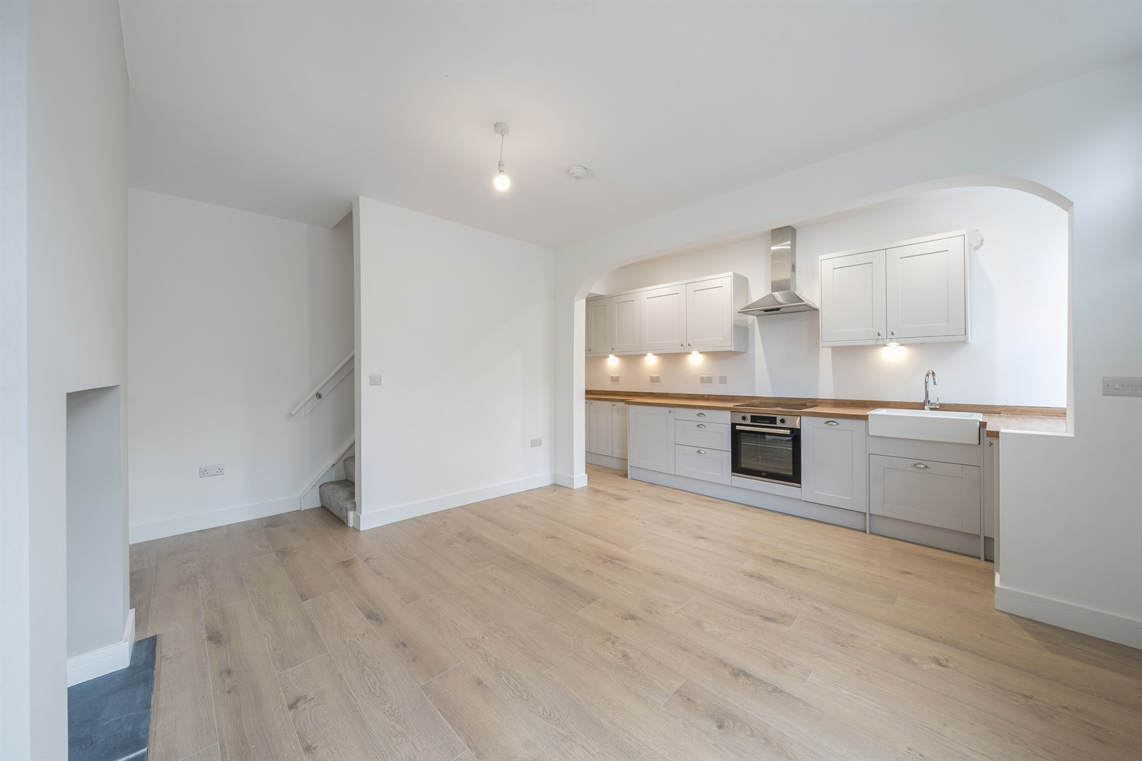

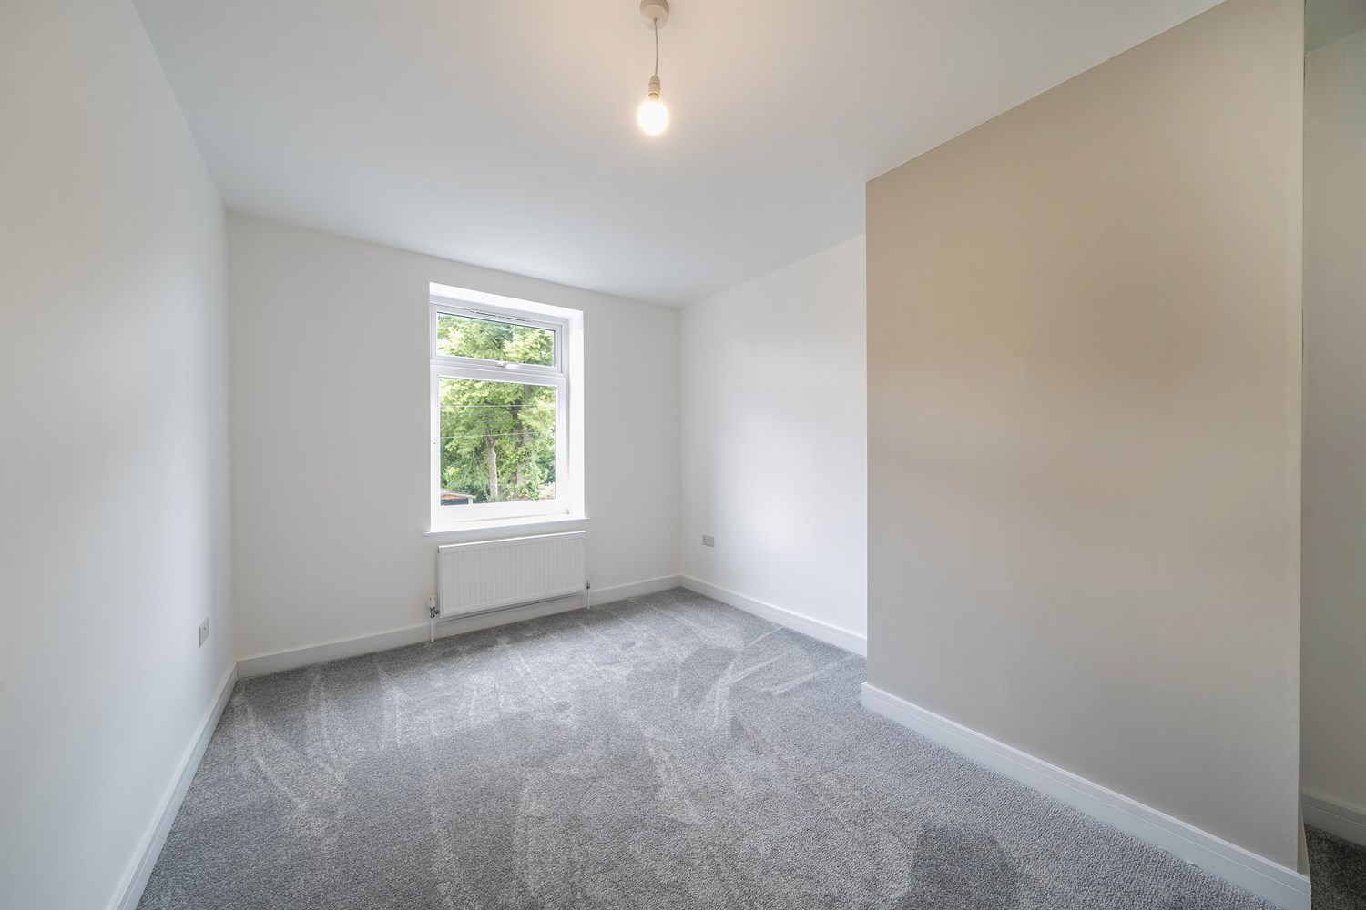

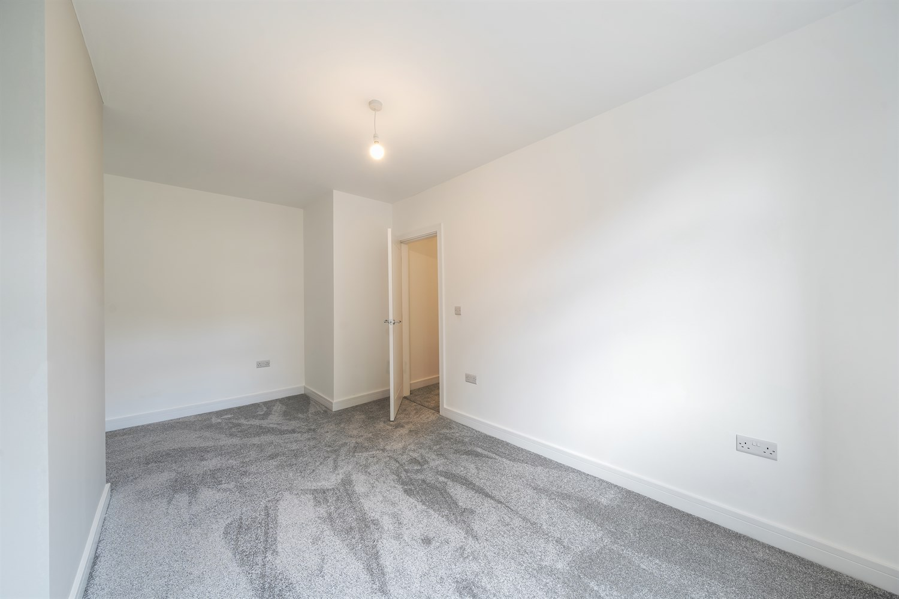

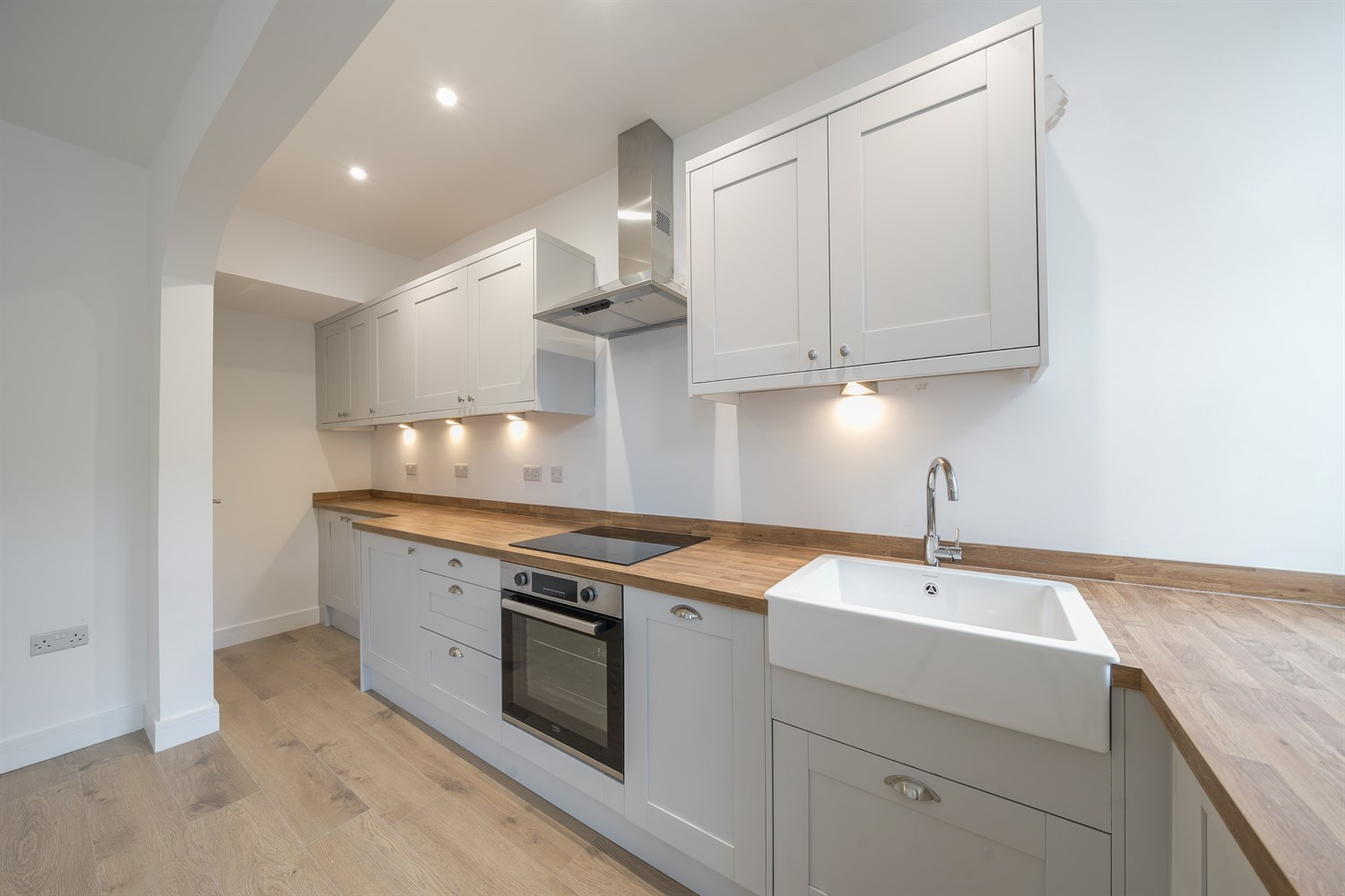

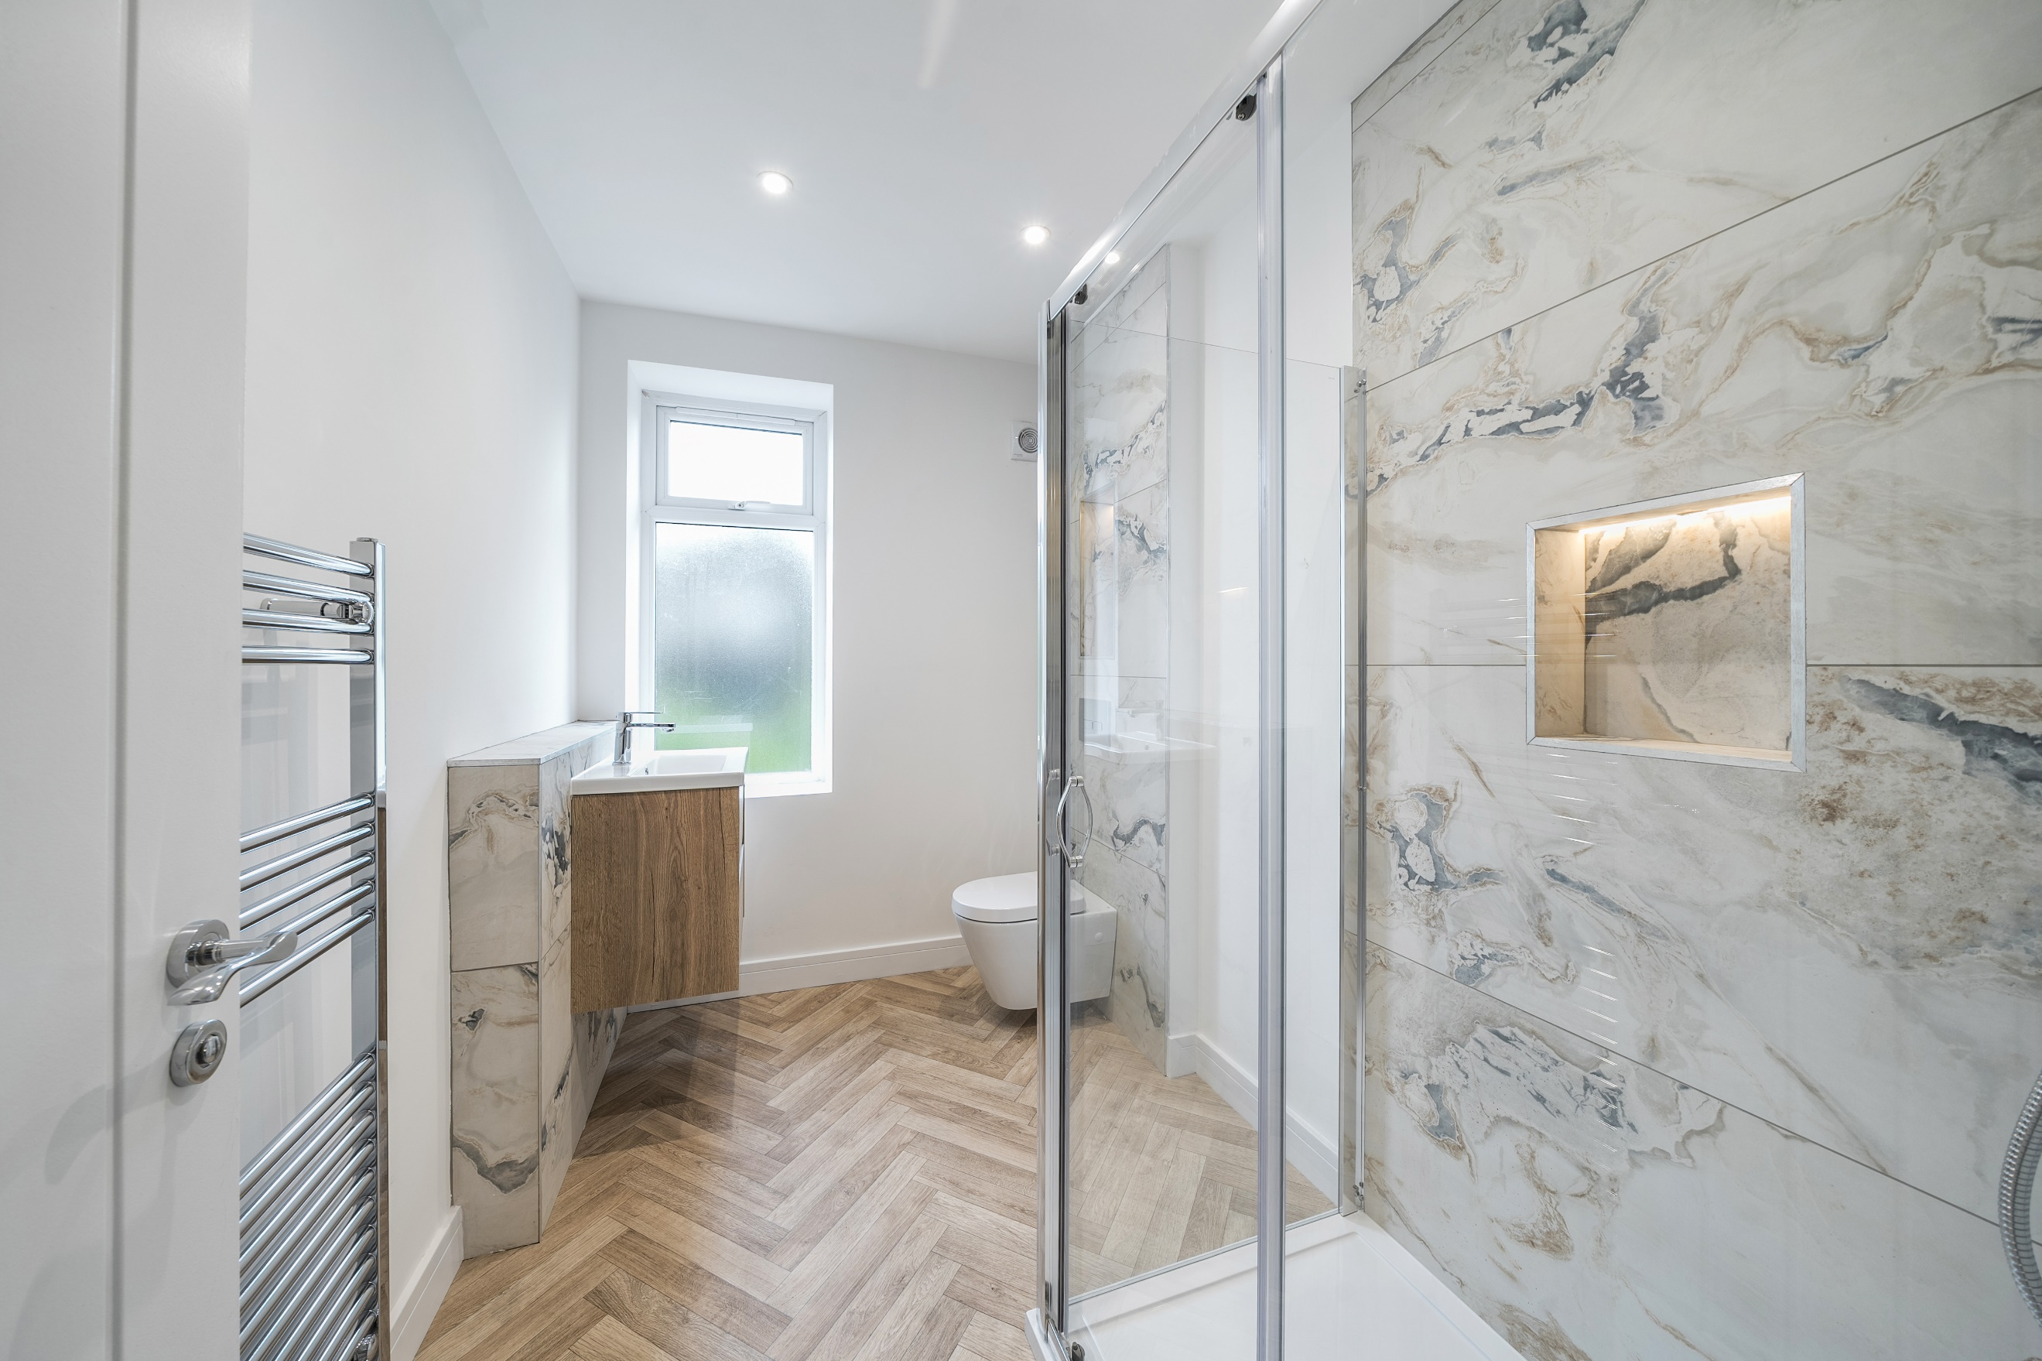

|  |
| --- |
| **Open Plan Kitchen/Lounge 5.02m (16'6) x 4.92m (16'2)**  Via front entrance door. Modern open plan living room/kitchen. Fitted with a range of wall, base and drawer units with work surface over. Ceramic sink and with mixer tap. Integrated electric oven and induction hob with stainless steel extractor above. Integrated dishwasher and fridge. Two UPVC double glazed windows to the front. Feature open fireplace ideal for log burning stove. Gas central heating radiator. |
| **Cellar**  Housing combi boiler. Useful for storage. |
| **First Floor Landing** |
| **Bedroom 4.92m (16'2) x 2.96m (9'9)**  Light and airy double bedroom with uPVC double glazed window to front. Gas central heating radiator. |
| **Shower Room**  Beautiful fitted shower room comprising; walk in shower cubicle, vanity wash hand basin and WC. Tiled walls. Wall mounted heated towel rail. uPVC double glazed window. |
| **On Street Parking** |

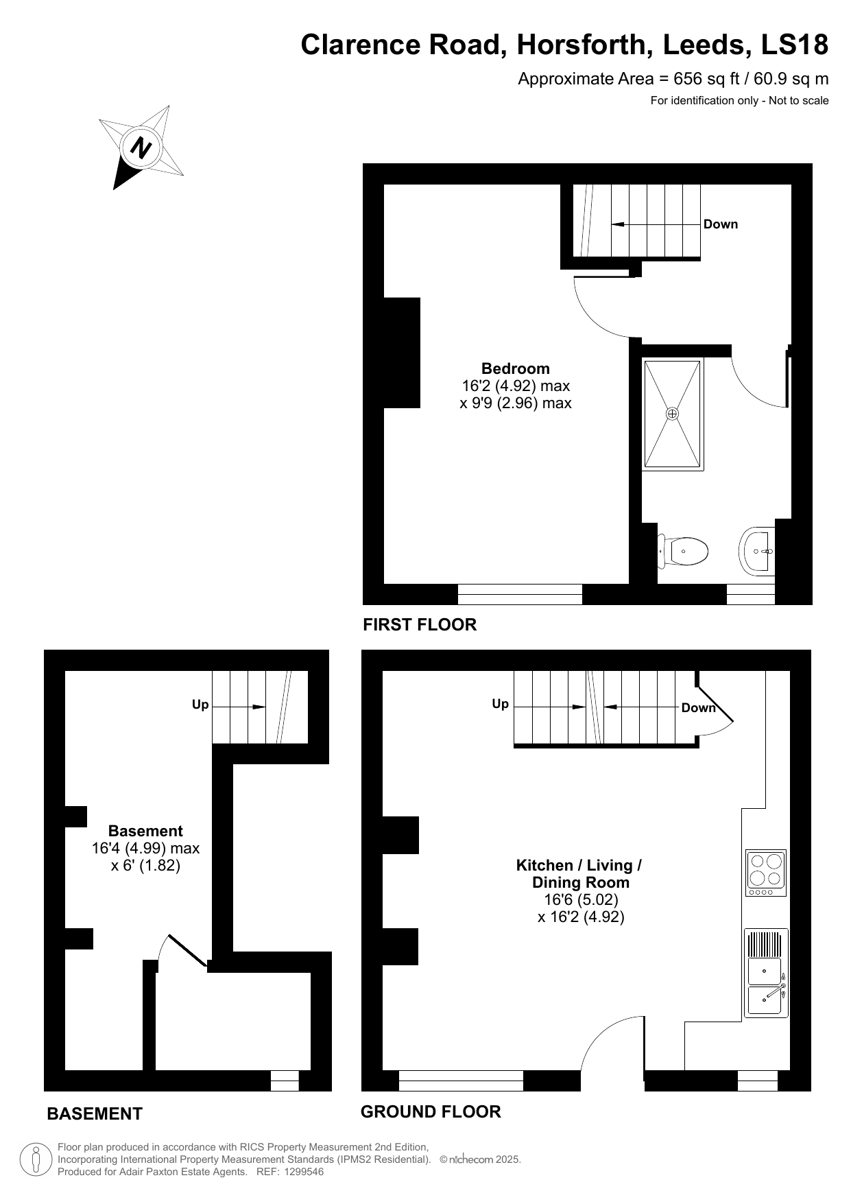

|  |
| --- |
|  |

These particulars are intended to give a fair description of the property, but their accuracy cannot be guaranteed, and they do not constitute an offer of contract. Intending purchasers must rely on their own inspection of the property. None of the above appliances/services have been tested by ourselves. We recommend purchasers arrange for a qualified person to check all appliances/services before legal commitment.

**Property Ref:** 6304

**For more information, please contact**

0113 258 1150 **|** [sales@adairpaxton.co.uk](mailto:sales@adairpaxton.co.uk) **|** www.adairpaxton.co.uk