

**0113 258 1150**

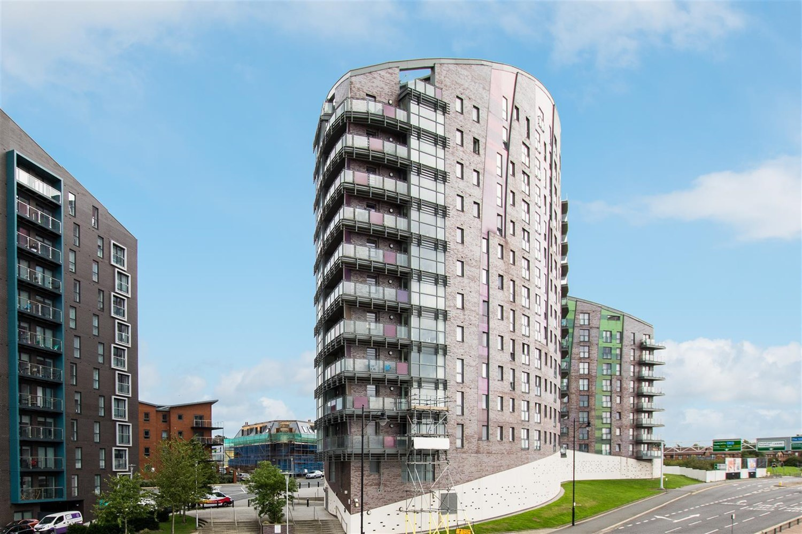



**For Sale £135,000.00**

**Echo Central, Leeds**

***BEAUTIFULLY PRESENTED TWO BEDROOM, TWO BATHROOM APARTMENT WITH PARKING*** Offered to the market is this two double bedroom sixth floor apartment. The apartment is located in the ever popular Echo City development close to Leeds City Centre. The property briefly comprises; Communal entrance hall with lifts and stairs to all floors, private entrance hall, open plan living room/kitchen/diner with integrated appliances, two double bedrooms, en-suite shower room and a contemporary bathroom. In addition there is an allocated parking space in the secure garage. Finished to a high standard throughout only an internal inspection will do justice to this lovely apartment.

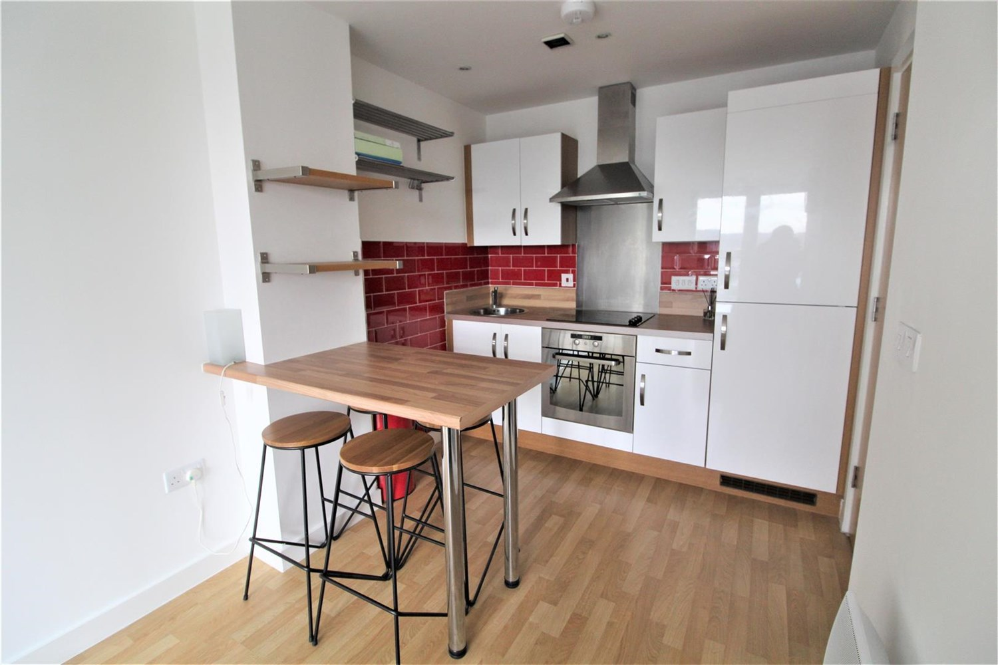

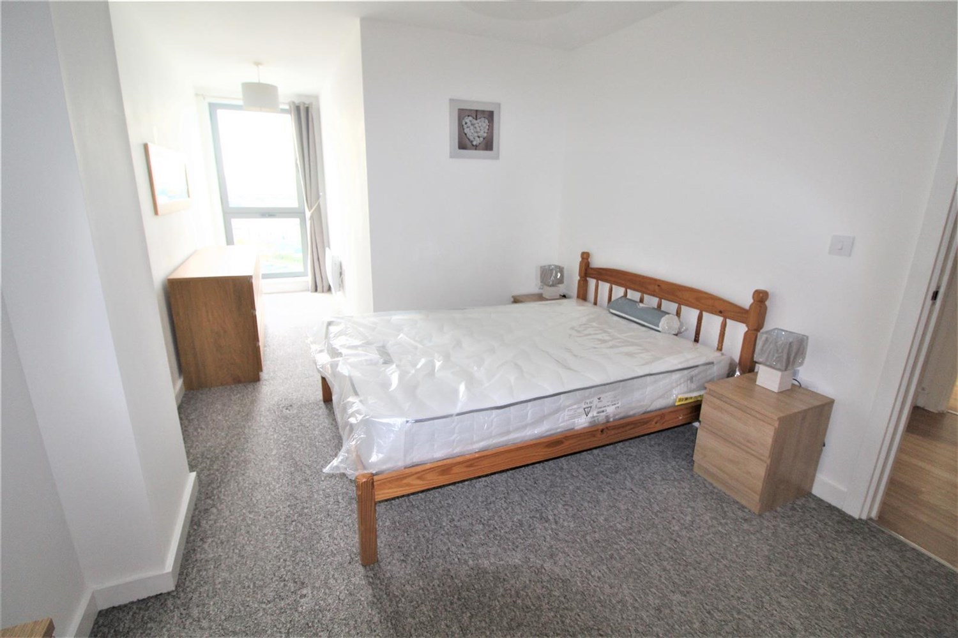

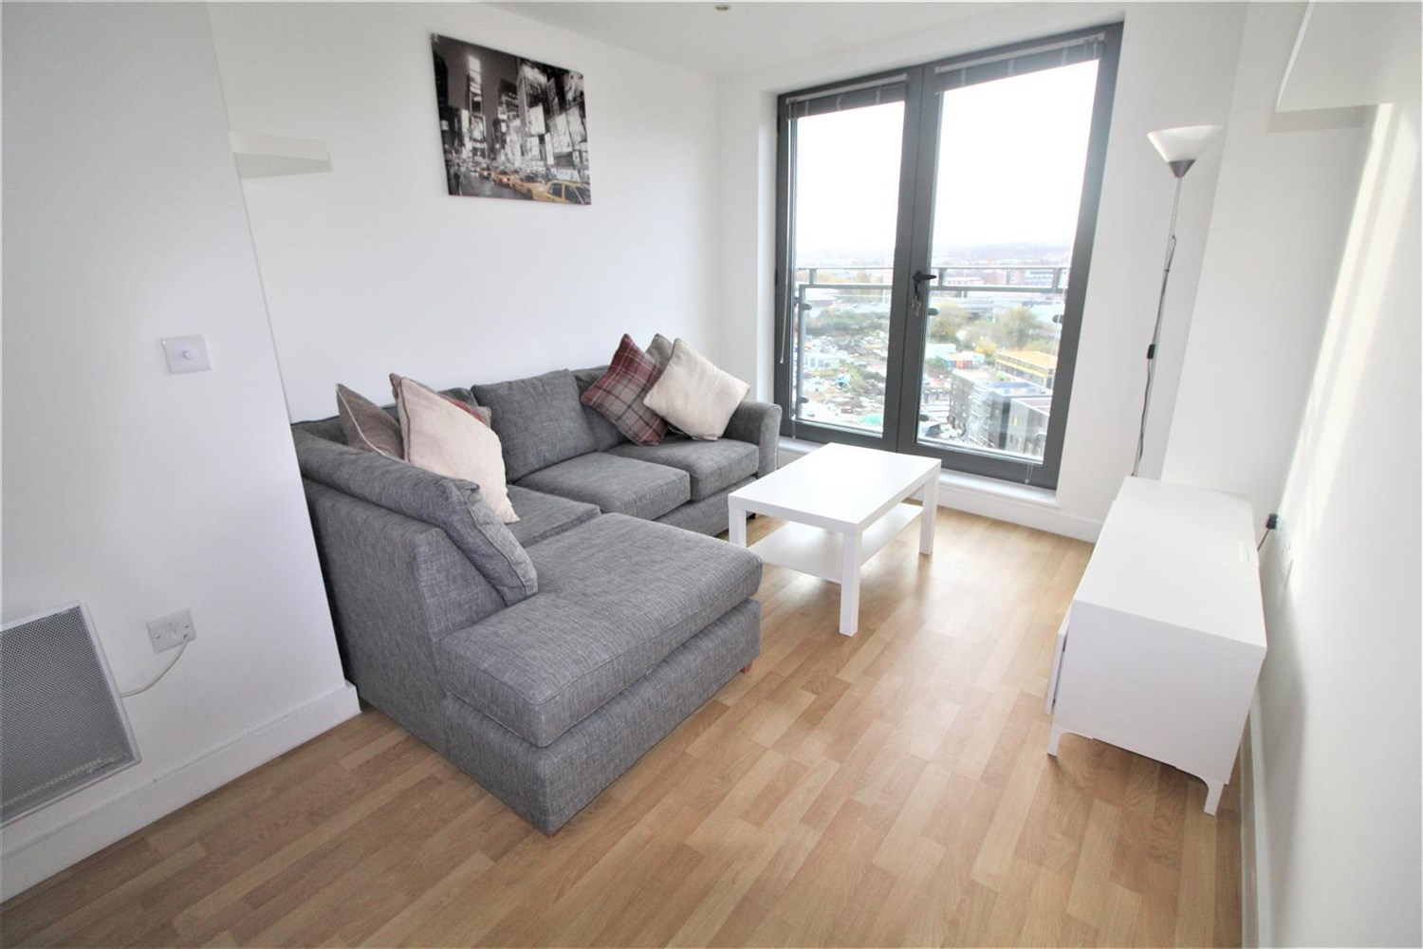

2 Bathroom(s)

1 Reception(s)

2 Bedroom(s)

00

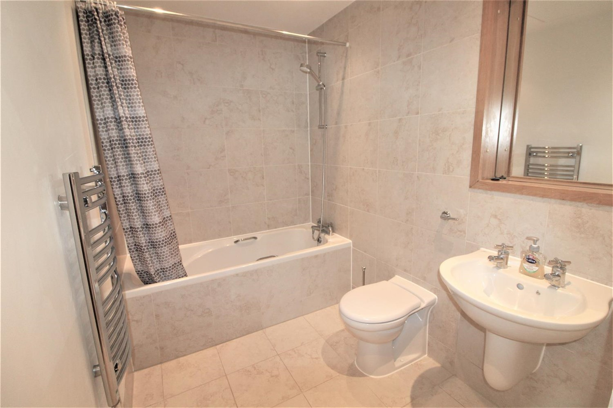

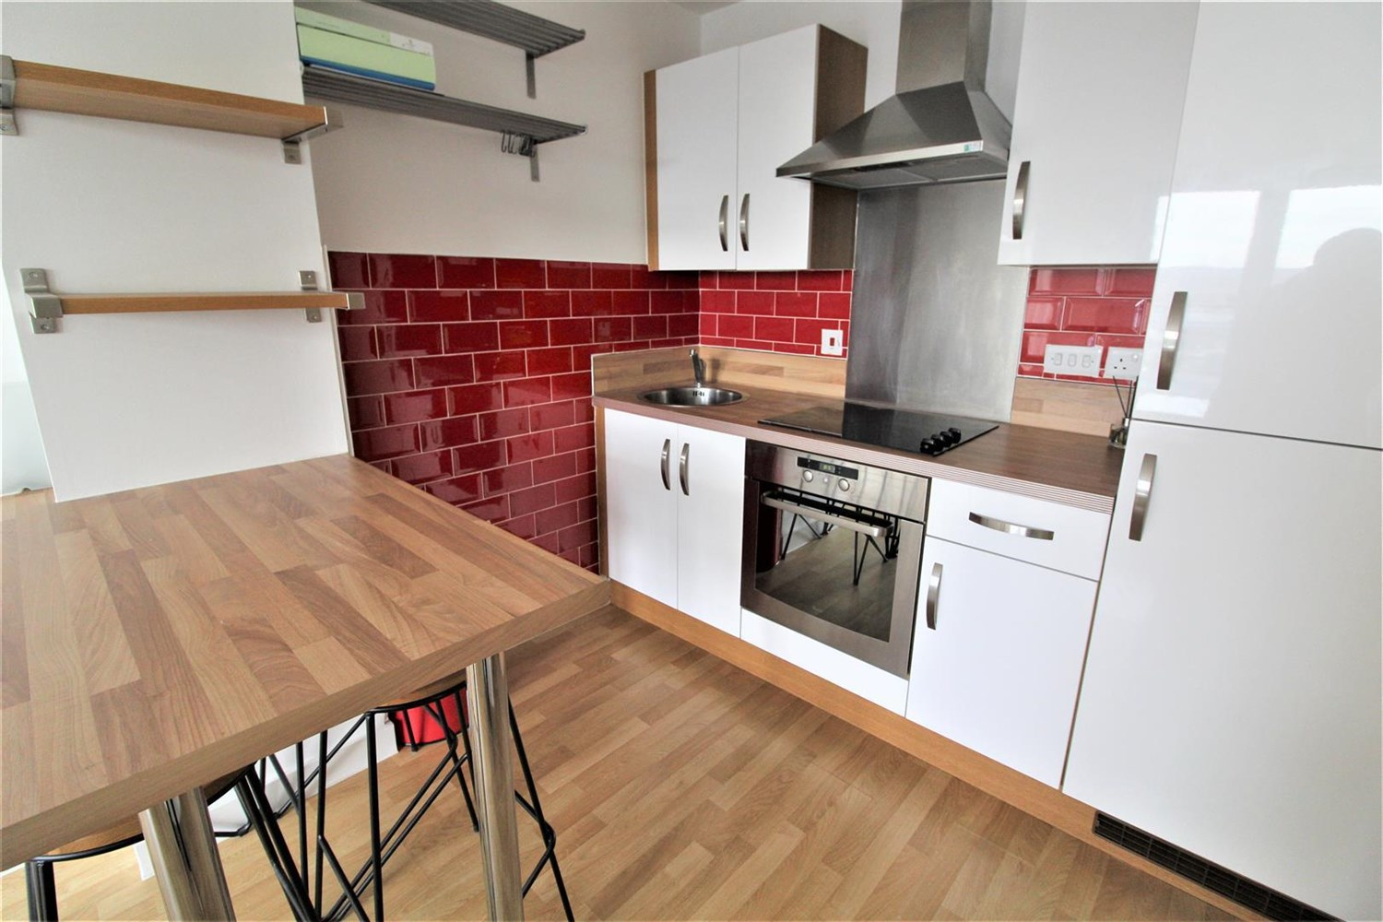

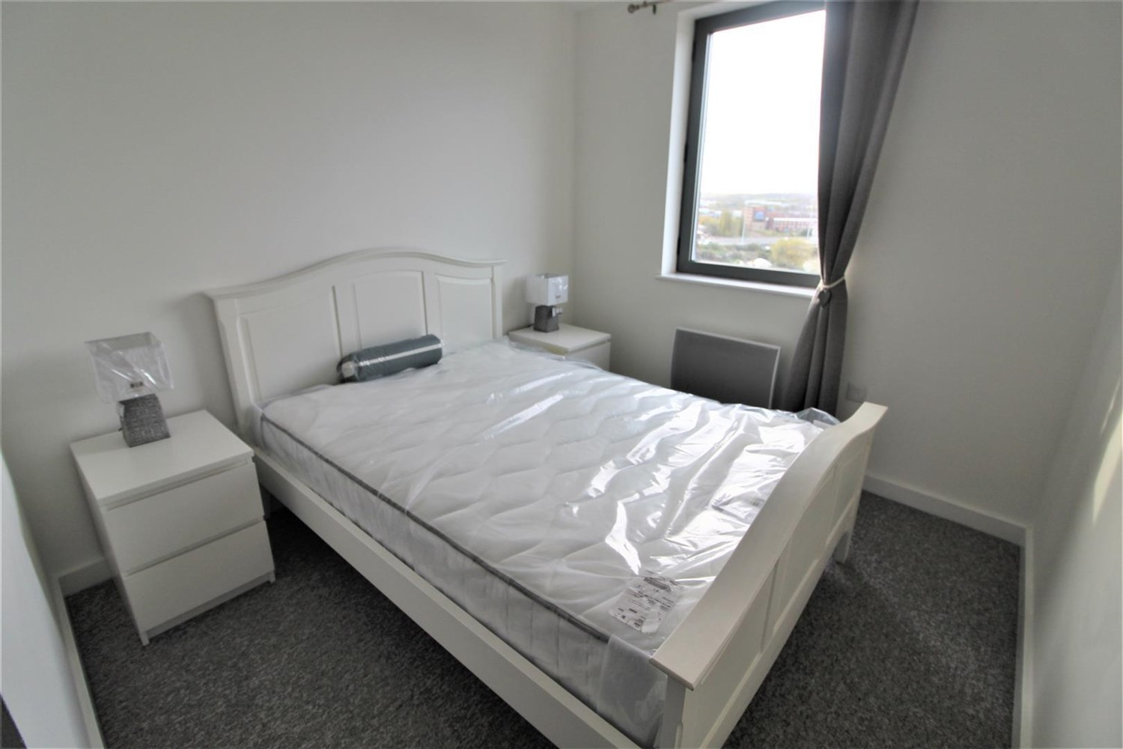

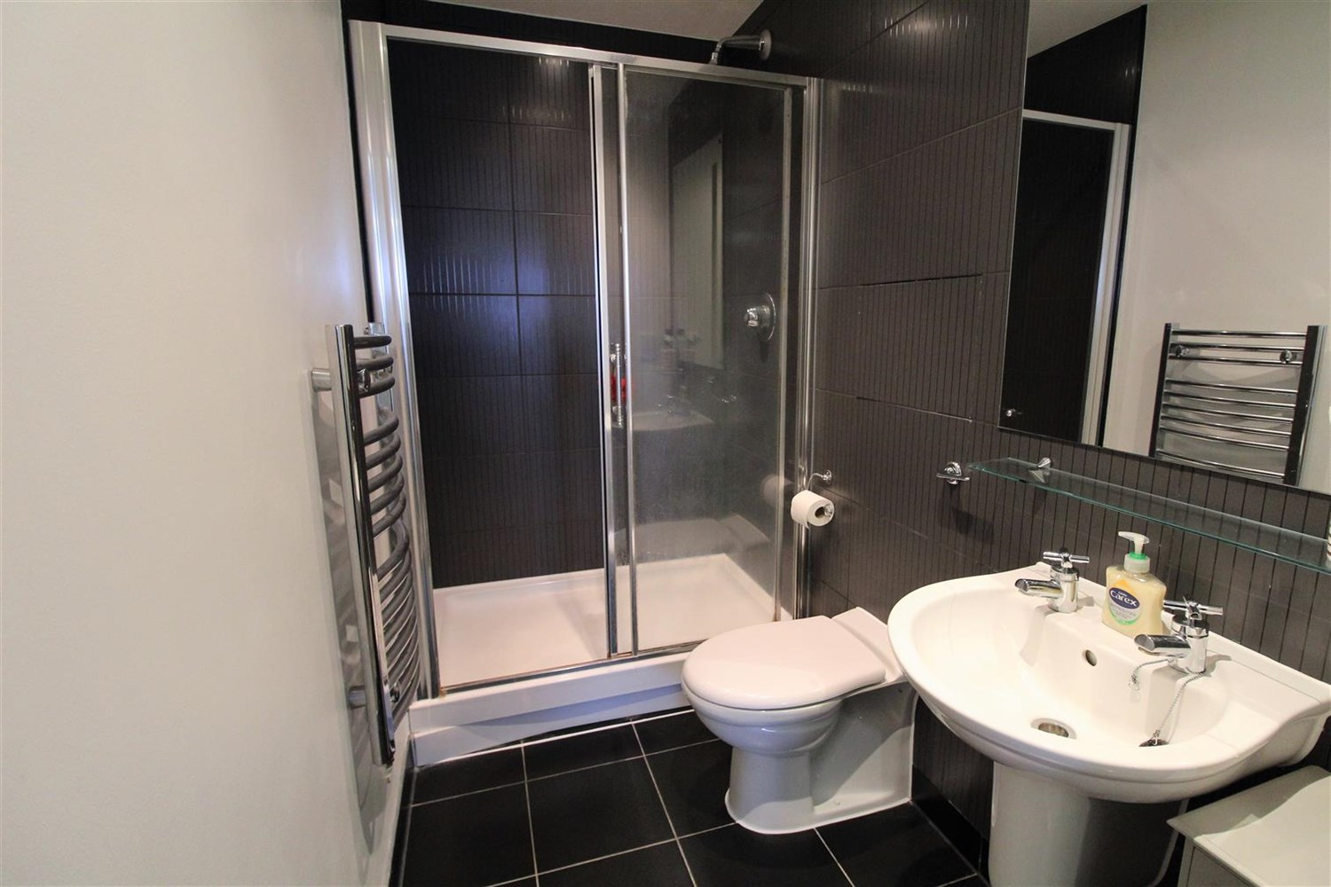

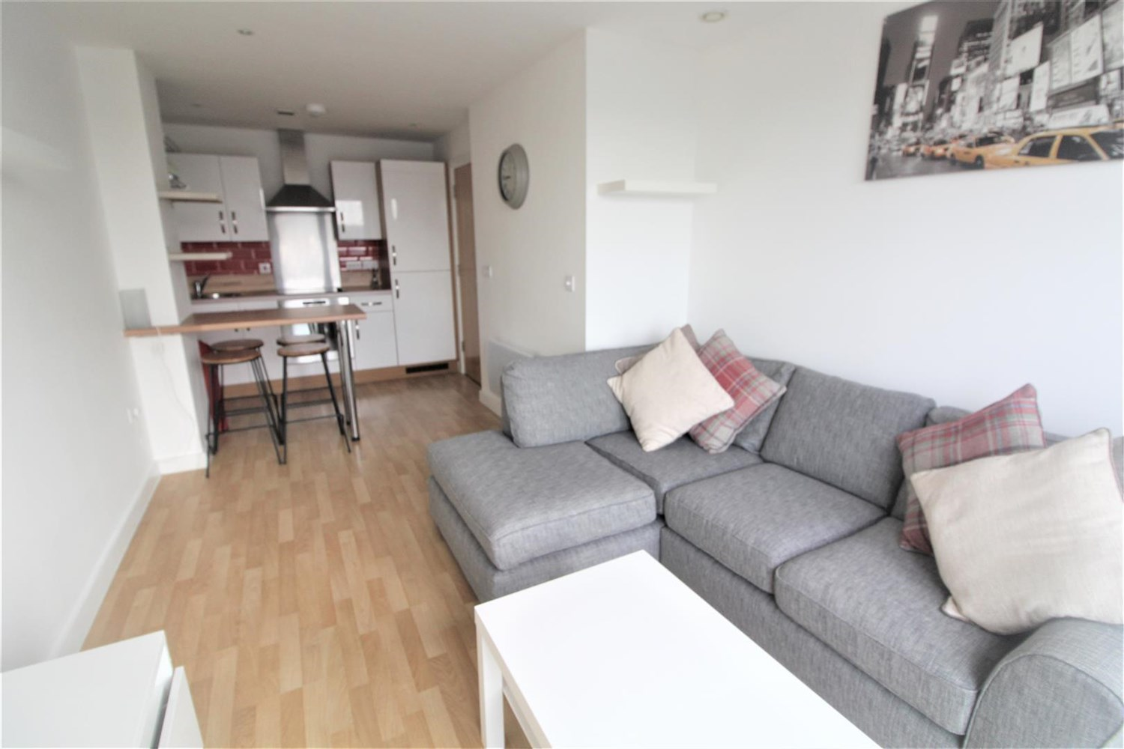

|  |
| --- |
| **Communal Entrance**  Communal entrance with secure intercom entry system. Lift access to all floors. |
| **Entrance Hall**  Laminate flooring. Useful storage cupboard housing the washing machine. Wall mounted electric heater. Entry phone system. |
| **Open Plan Living/Kitchen 6.2m (20'4) x 3m (9'10)**  Fitted with a range of wall, base and drawer units with work surfaces over and breakfast bar. Circular stainless steel sink with mixer tap. Integrated electric oven and ceramic hob with stainless steel extractor hood over. Integrated fridge/freezer. Splash back. Double glazed doors to Juliet balcony. Wall mounted electric heater. Inset ceiling spotlights. |
| **Reception 1**  Reception 1 |
| **Bedroom 1 6.5m (21'4) x 2.87m (9'5)**  A spacious double bedroom with double glazed window. Wall mounted electric heater. Door to en-suite. |
| **En-Suite Shower Room**  Fitted with a three piece white suite comprising shower cubicle, WC and wash hand basin. Part tiled walls. Chrome heated ladder towel rail. |
| **Bedroom 2 4.7m (15'5) x 2.57m (8'5)**  A spacious double bedroom with double glazed window. Wall mounted electric heater. |
| **Bathroom**  Fitted with a three piece white suite comprising bath with shower above, WC and wash hand basin. Part tiled walls. Chrome heated ladder towel rail. |
| **Tenure**  The lease is 155 years less one day, from 1 January 2007. Ground Rent of £200.00 is due 1 January each year. Service Charge is £624.62 per quarter. |
| **Home Information**  Service Charge - £624.62 per quarter Ground Rent - £200 per annum Council Tax - Band C Lease Term - 155 years from Jan 2007 - 134 years remaining Heating - Electric Water - Mains connected Broadband - No issues to report Mobile availability - No issues to report EWS1 Rating - B1 Construction type - Concrete and steel frame Flood Risk - Very Low |

|  |  |
| --- | --- |
| These particulars are intended to give a fair description of the property, but their accuracy cannot be guaranteed, and they do not constitute an offer of contract. Intending purchasers must rely on their own inspection of the property. None of the above appliances/services have been tested by ourselves. We recommend purchasers arrange for a qualified person to check all appliances/services before legal commitment.  **Property Ref:** 402  **For more information, please contact**  0113 258 1150 **|** [sales@adairpaxton.co.uk](mailto:sales@adairpaxton.co.uk) **|** www.adairpaxton.co.uk |  |