

**0113 258 1150**

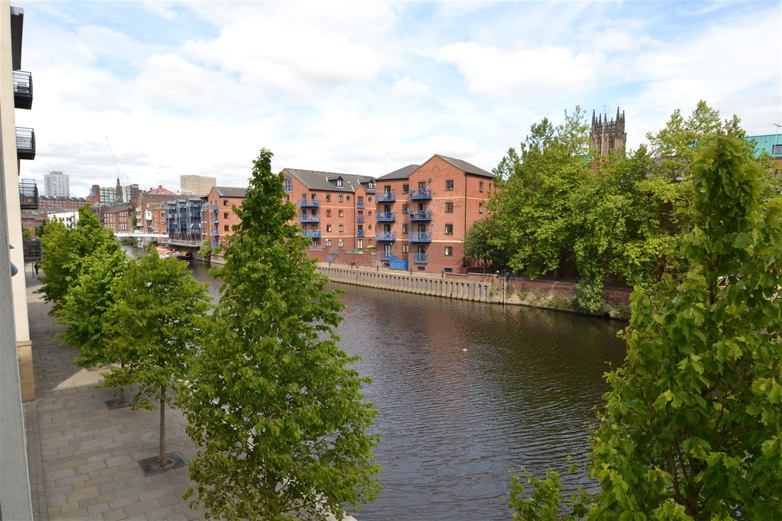



**For Sale £255,000.00**

**St James Quay, Bowman Lane, LS10**

***SPACIOUS TWO BEDROOM, TWO BATHROOM APARTMENT WITH SECURE ALLOCATED PARKING IN THIS SOUGHT AFTER LOCATION OF BREWERY WHARF*** Offered to the market is this stunning first floor apartment with no onward chain, offering delightful views over the river this property is MUST SEE! Located in the heart of Brewery Wharf with easy access to shops, bars and restaurants. The apartment also benefits from having gas central heating, on site concierge, residents gym and secure underground parking. The property briefly comprises: Entrance hall, Open plan living area and kitchen, balcony with views over the river, Master bedroom with en-suite shower room, second bedroom and house bathroom. Early internal viewings are highly recommended.

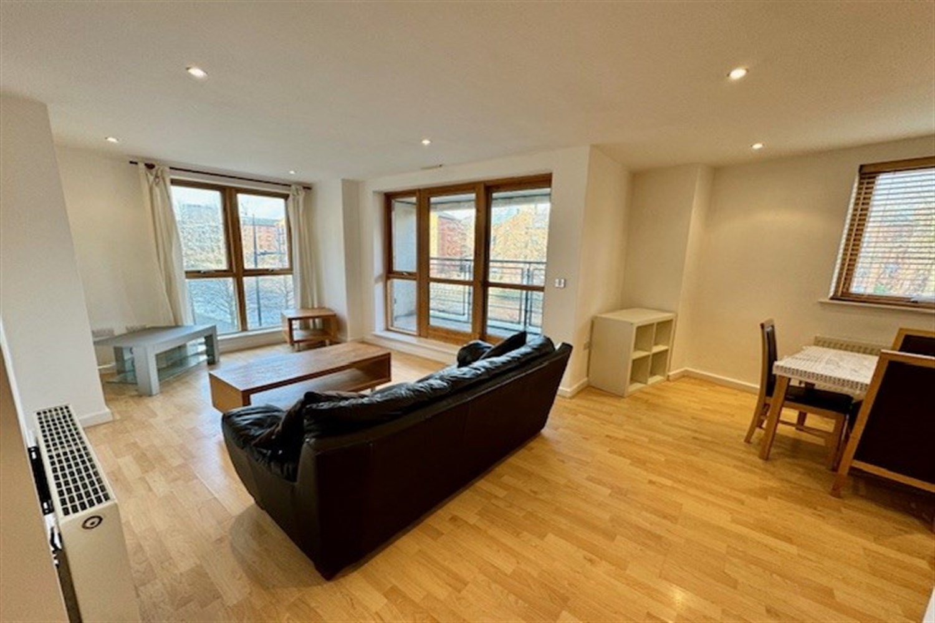

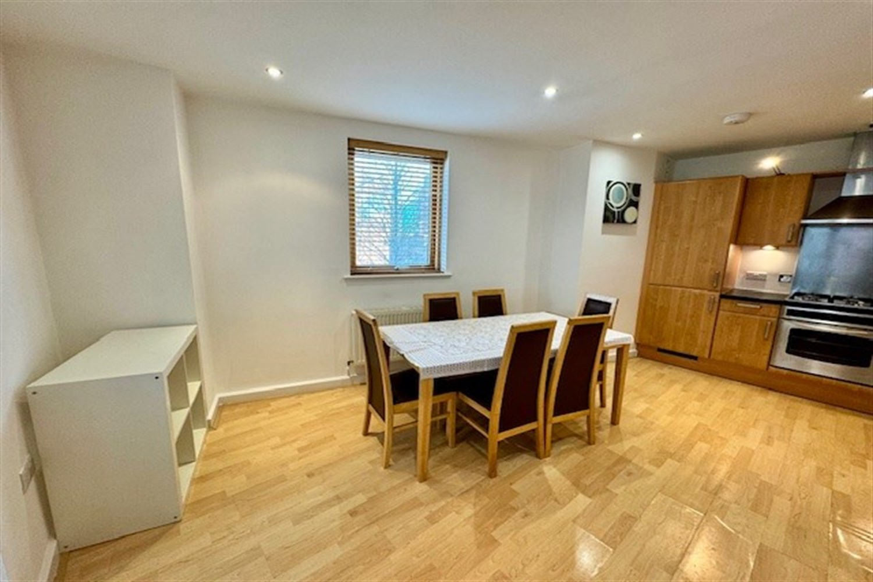

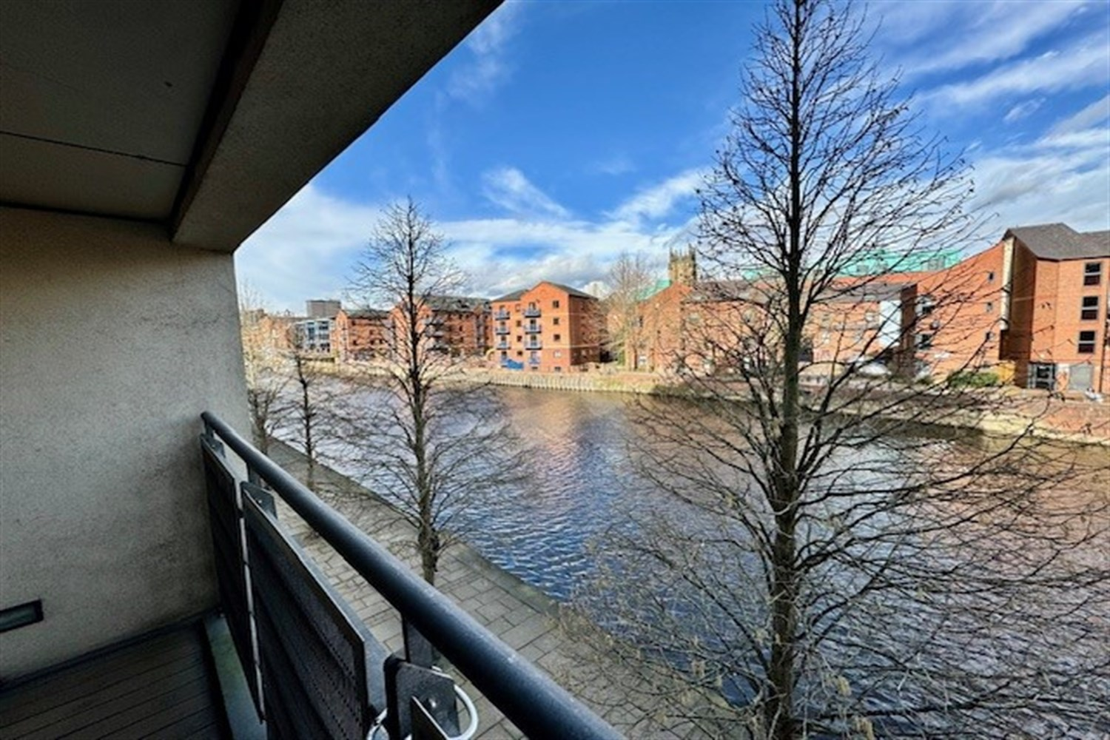

2 Bathroom(s)

1 Reception(s)

2 Bedroom(s)

00

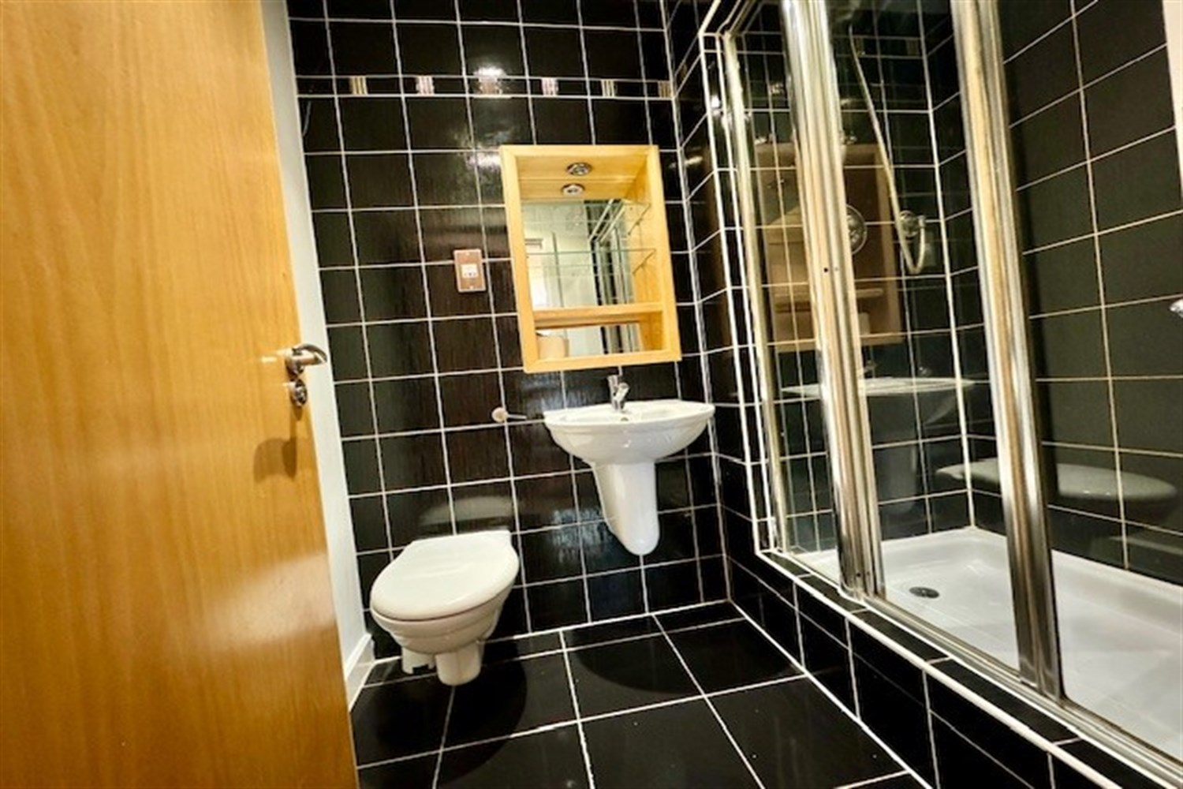

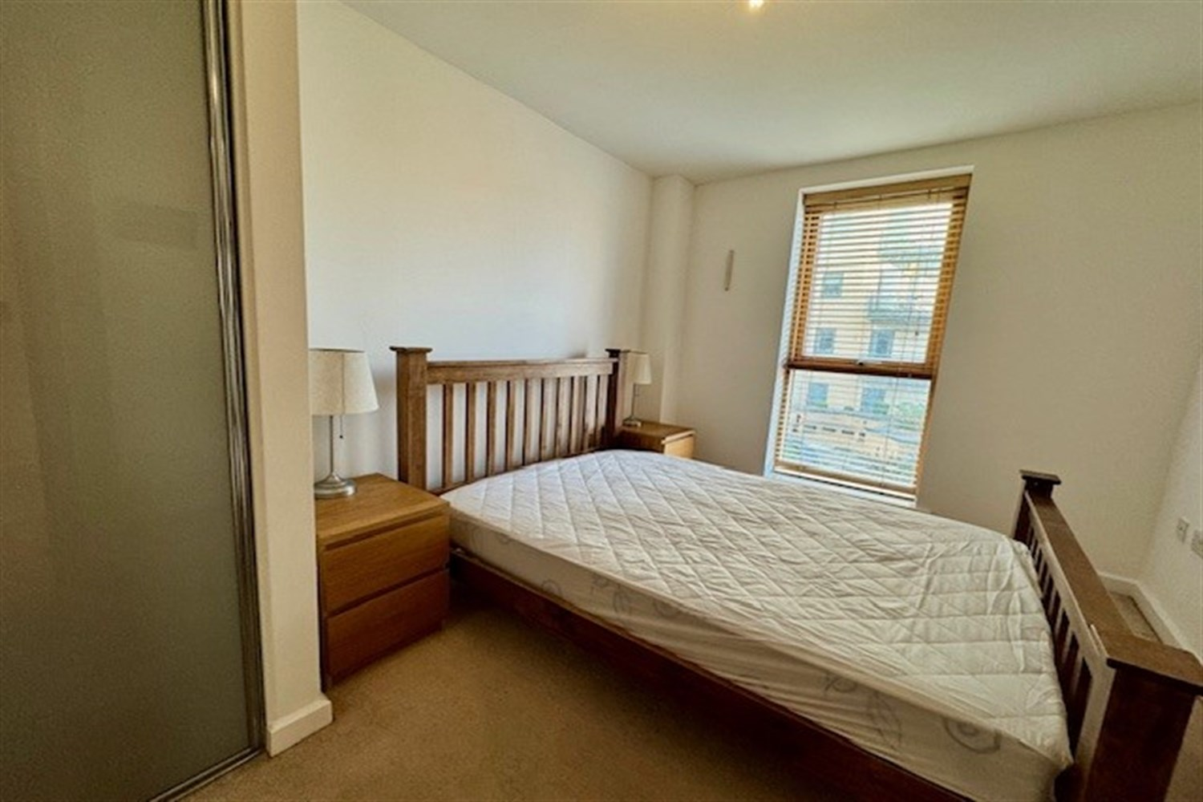

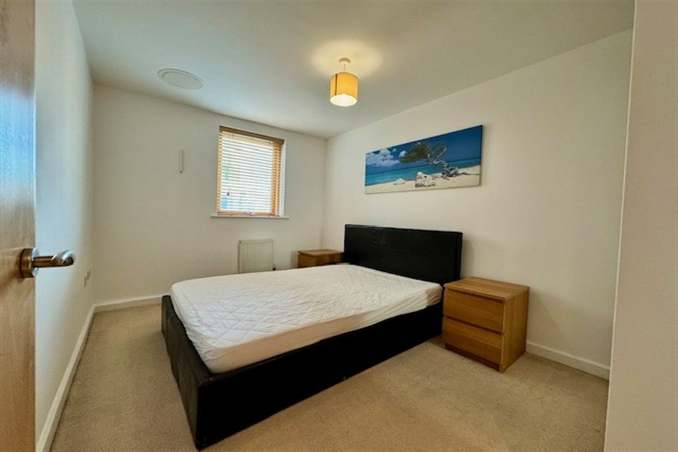

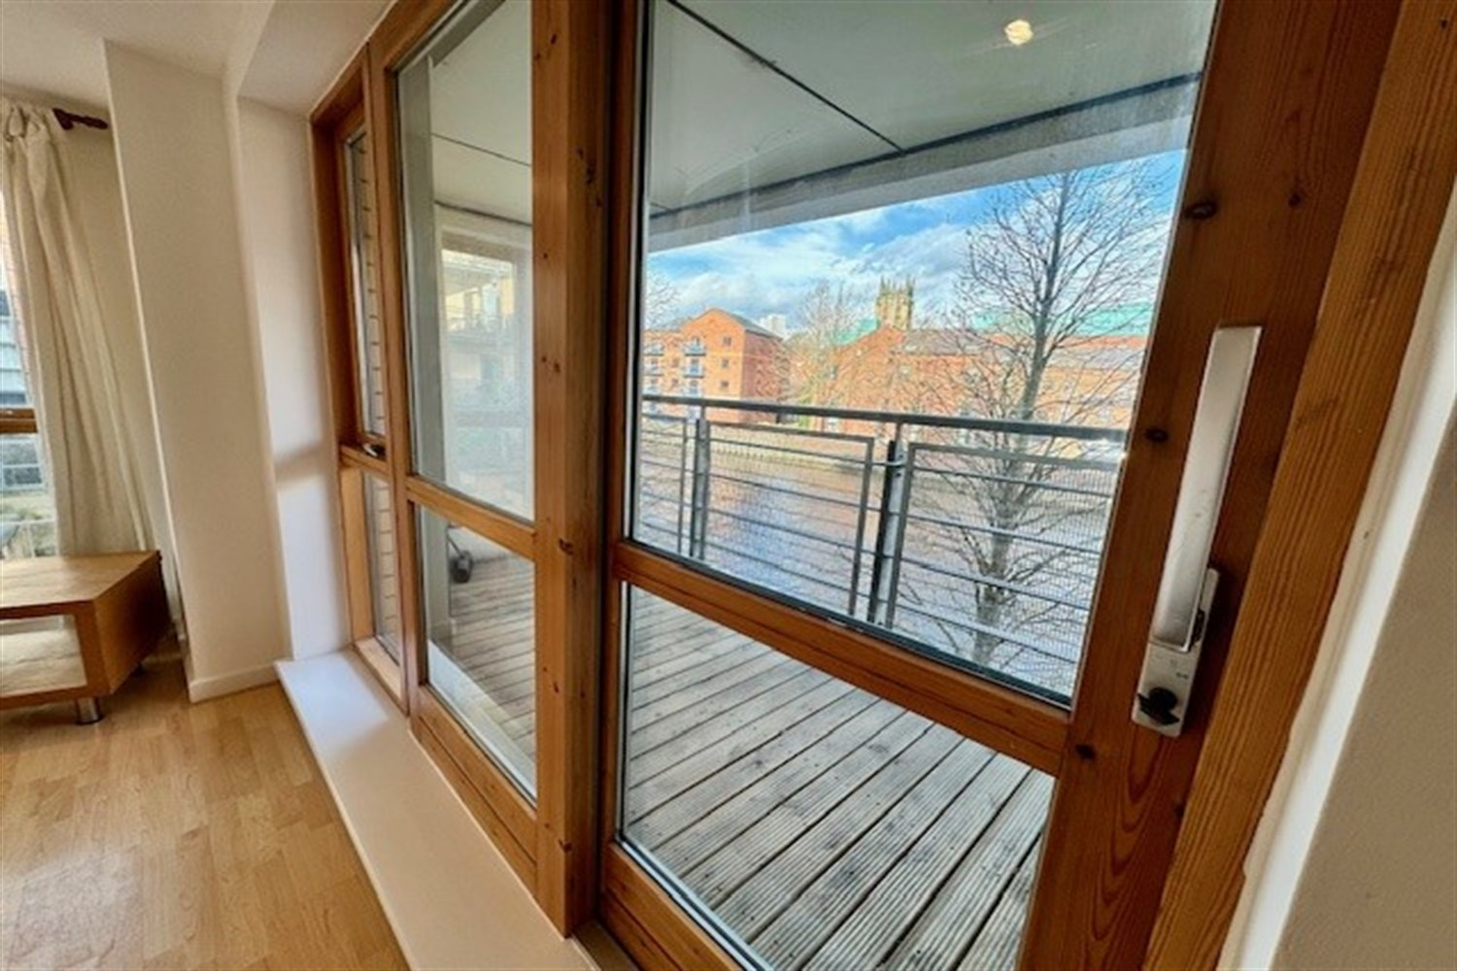

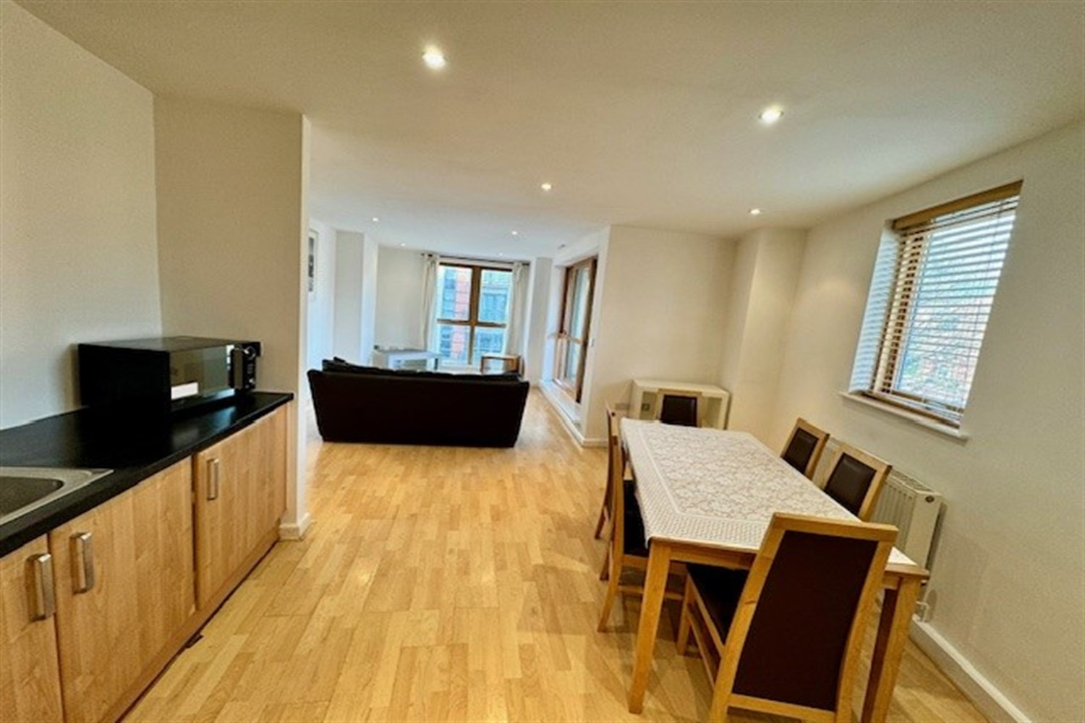

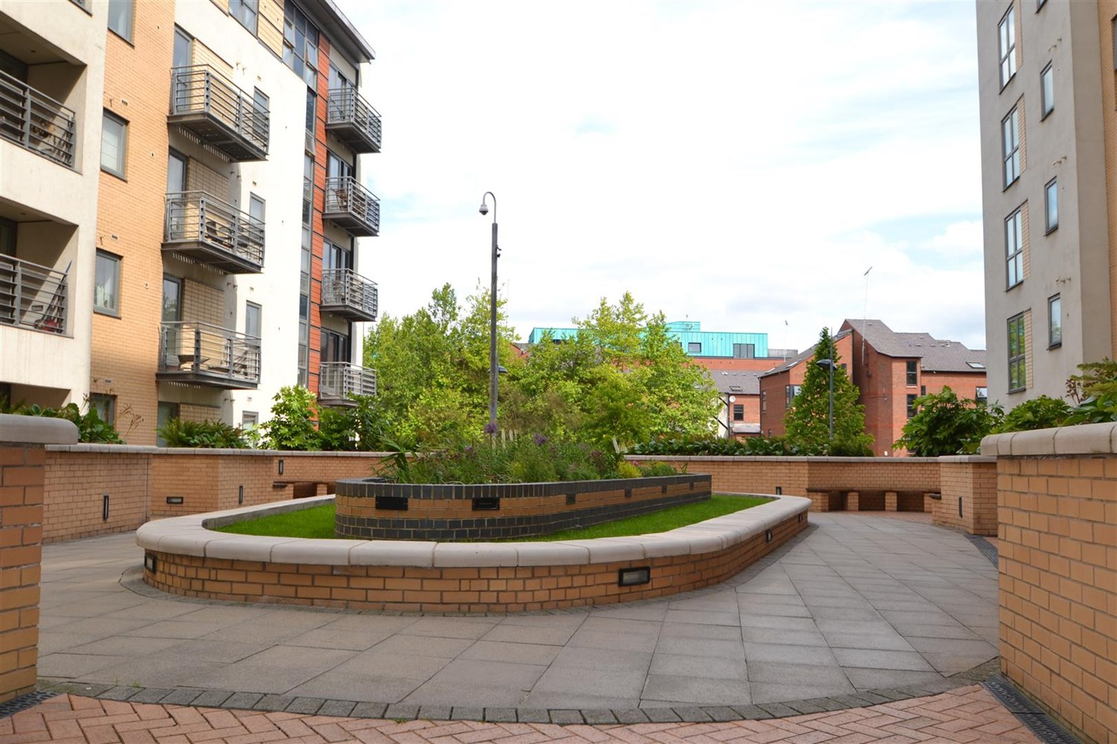

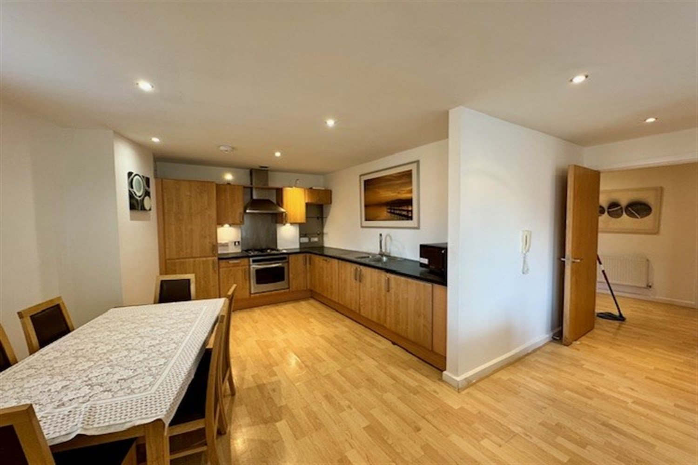

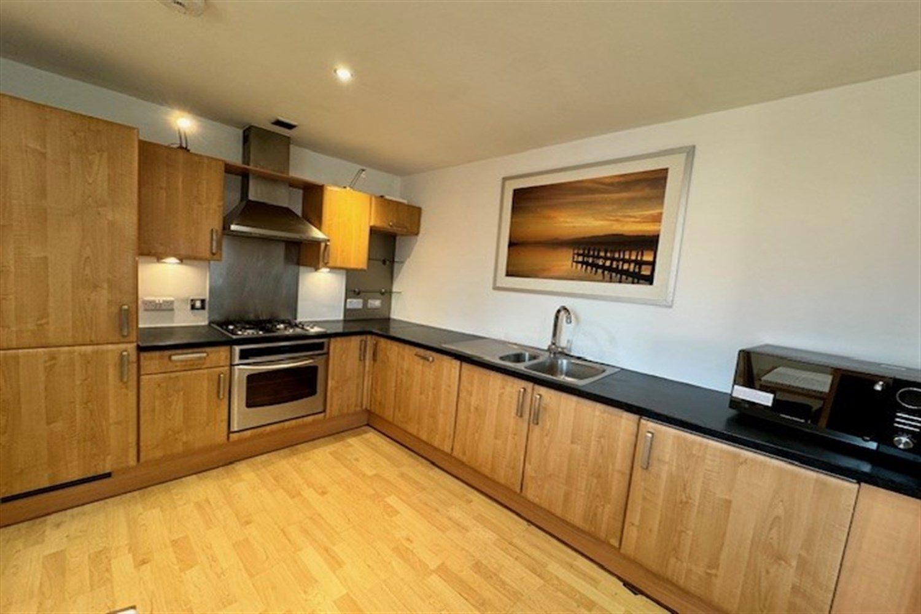

|  |
| --- |
| **Communal Entrance**  Communal entrance with telephone entry system, mail boxes and access to all floor via lift and staircase. |
| **Private Entrance Hall**  Private entrance with wood effect flooring, storage cupboard housing boiler and gas central heating radiator. |
| **Open Plan Living Room/Kitchen**  Open plan living area with wood effect flooring, gas central heating radiator and door to balcony boasting stunning waterfront views.  Kitchen area comprising a range of wall and base mounted units, single drainer stainless steel sink unit with mixer tap, built in oven hob and extractor, integrated fridge freezer and gas central heating radiator |
| **Master Bedroom**  A carpeted double room with double glazed window, gas central heating radiator and door leading to; |
| **En-Suite Shower Room**  Stylish white suite comprising low flush WC and basin, shower cubicle, tiling to walls and floor and heated towel rail |
| **Bedroom Two**  A further good sized double room with neutral carpet, double glazed window and gas central heating radiator. |
| **House Bathroom**  A contemporary white suite comprising low flush WC, hand wash basin, panelled bath with shower over and glass shower screen and heated towel rail |
| **Allocated Parking**  Single secure parking space. |
| **Tenure**  Lease is 999 years from January 1 2002. Annual ground rent £315 |
| **Service Charge**  Quarterly Service Charge £900.  Annual electricity charge for common parts £355. |

|  |  |
| --- | --- |
| These particulars are intended to give a fair description of the property, but their accuracy cannot be guaranteed, and they do not constitute an offer of contract. Intending purchasers must rely on their own inspection of the property. None of the above appliances/services have been tested by ourselves. We recommend purchasers arrange for a qualified person to check all appliances/services before legal commitment.  **Property Ref:** 6343  **For more information, please contact**  0113 258 1150 **|** [sales@adairpaxton.co.uk](mailto:sales@adairpaxton.co.uk) **|** www.adairpaxton.co.uk |  |