

**Lovell House, LS7**

**Available to let £795.00pcm**

New to the market, this newly decorated one bedroom apartment situated in the Northern Quarter is available for immediate occupation. With great access to local amenities, the Ring Road and motorway networks, this conveniently placed property is furnished and available Now. Deposit £915. Due to the lease this property has a no pets. Council tax band B, EPC rating B.

**0113 258 1150**

**0800 000 000**

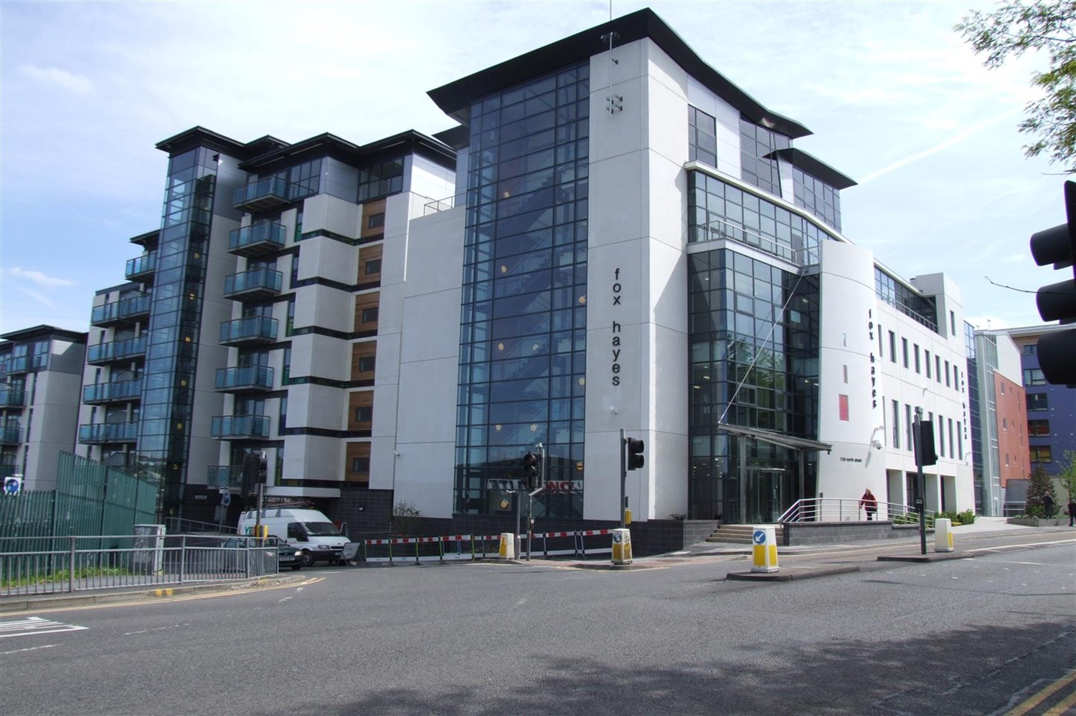



1 Reception(s)

1 Bathroom(s)

1 Bedroom(s)

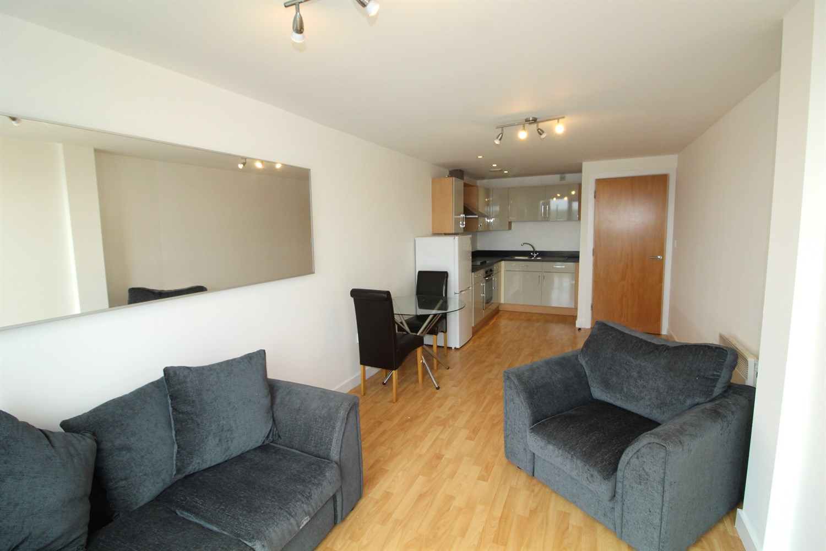

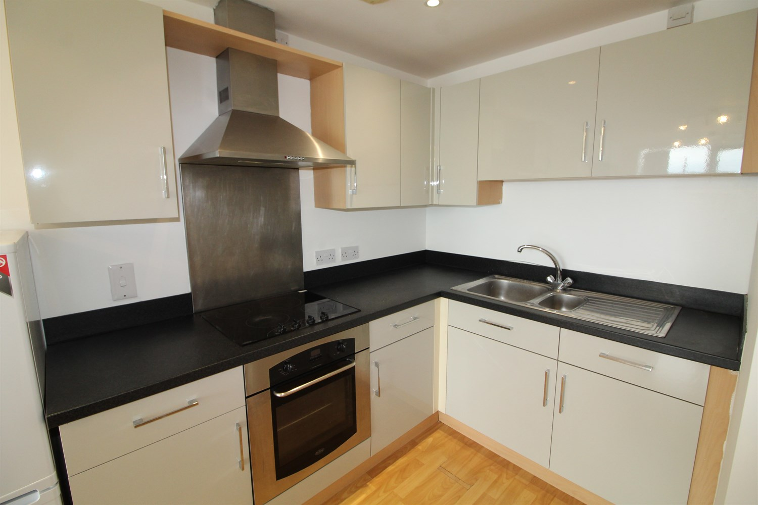

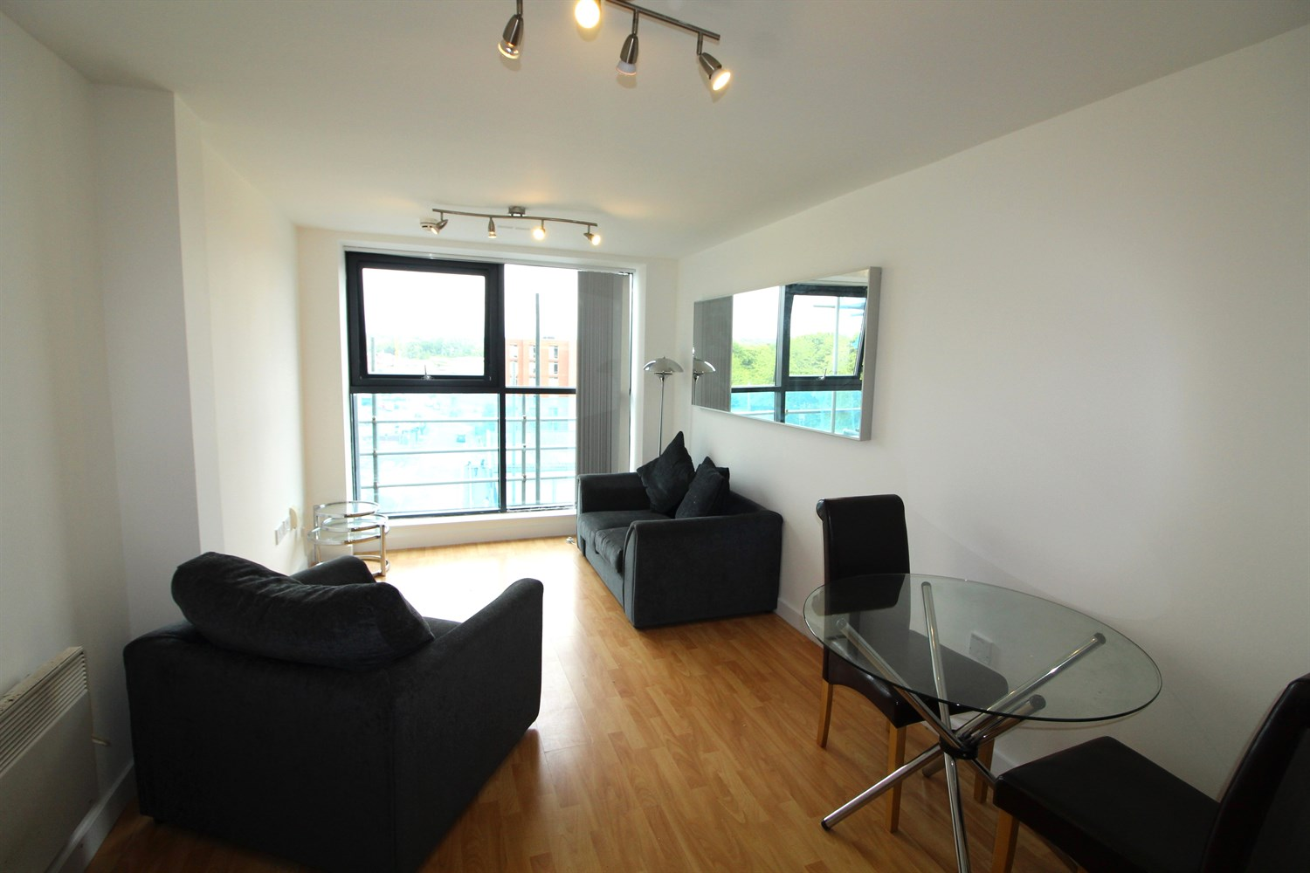

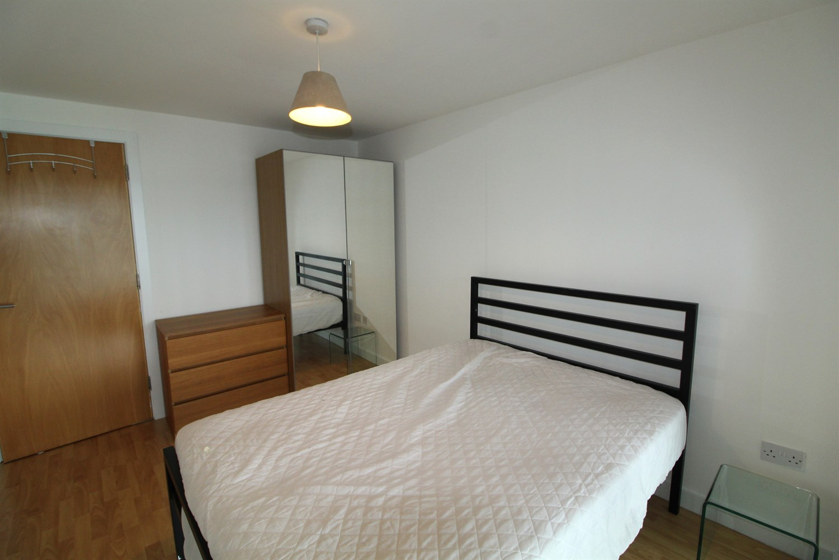

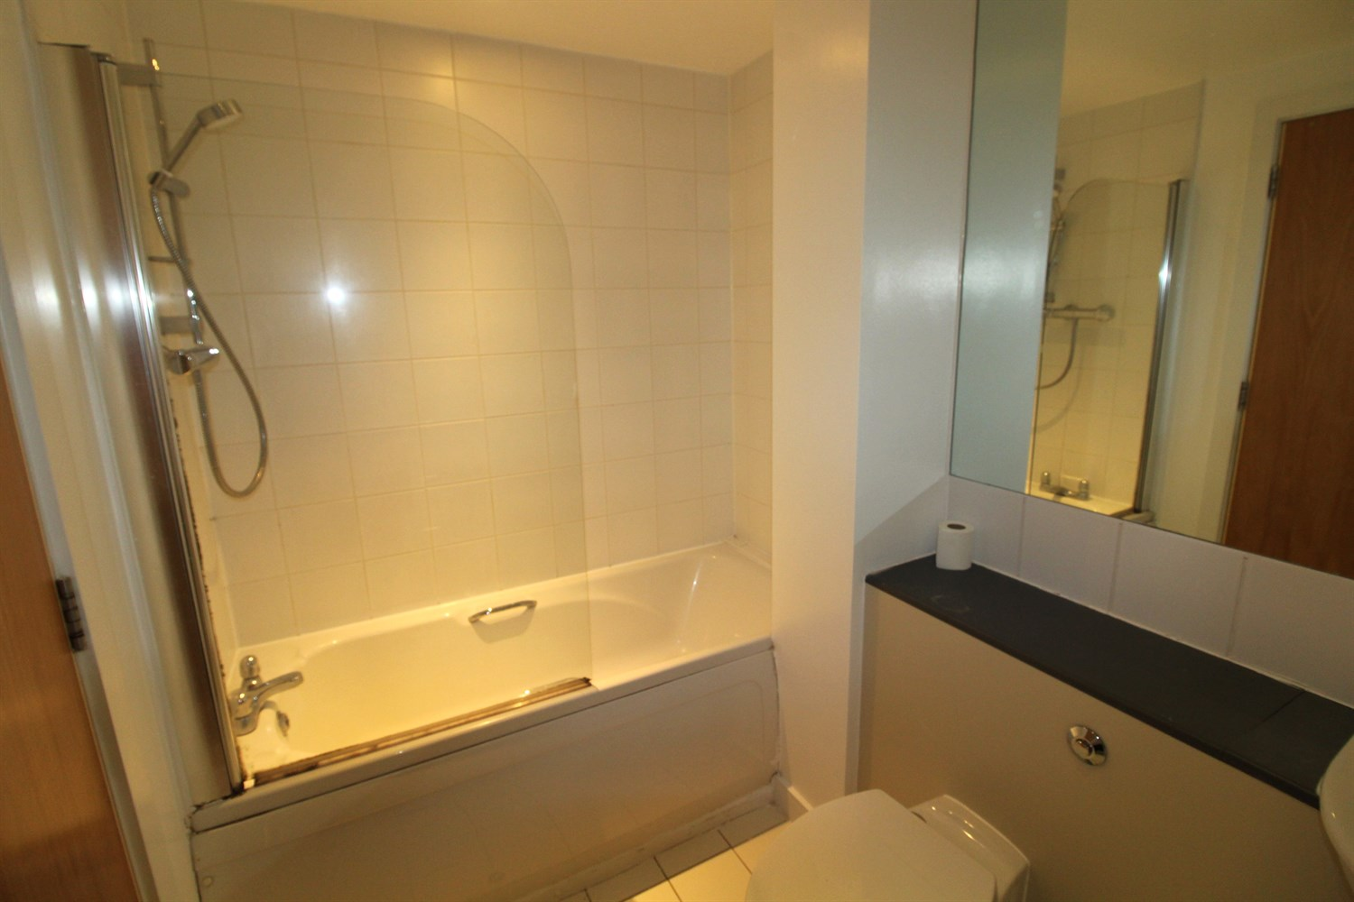

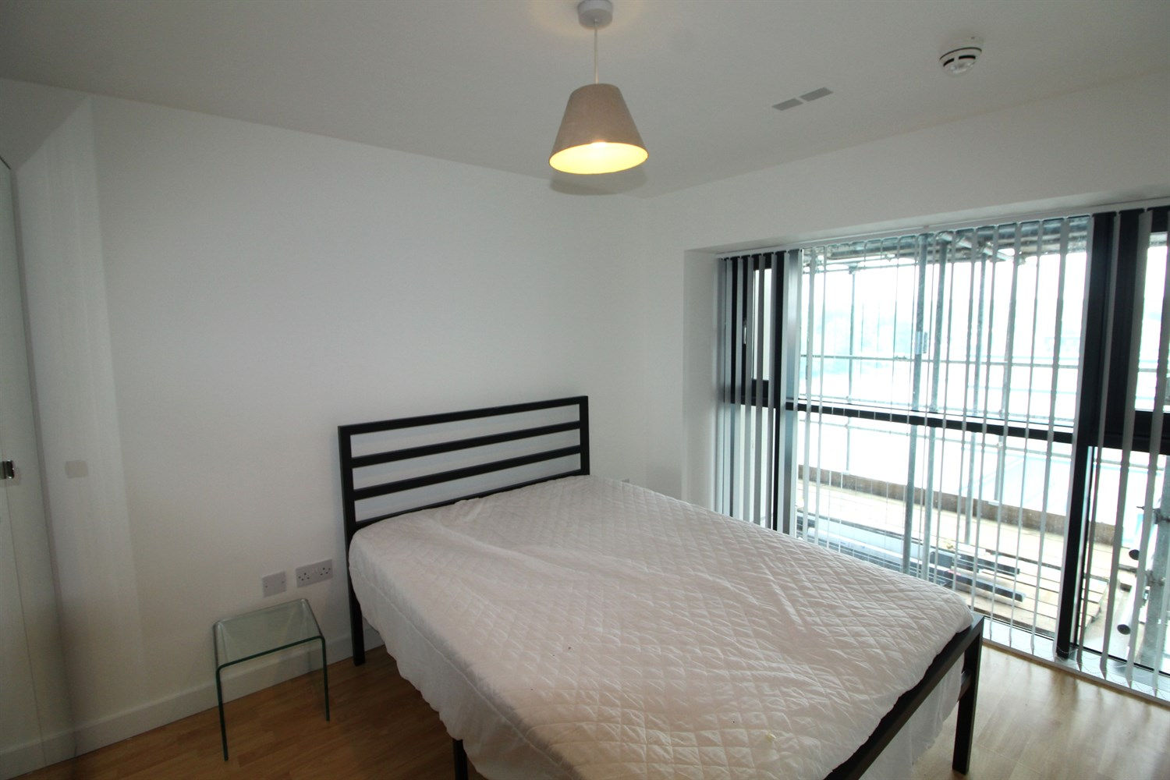

|  |
| --- |
| **Communal Entrance Hall**  Fob entry, lift and stairs to all floors. |
| **Private Entrance Hall**  Private entrance hall with entry system, laminate flooring and storage cupboard |
| **Living/ Kitchen**  A bright and spacious open plan living space with laminate flooring and electric panel radiator. The kitchen area is well stocked, and briefly comprises a range of wall and base mounted units, integrated oven hob and extractor and single drainer stainless steel unit with mixer tap |
| **Bedroom**  A generous sized double room with large double glazed windows, electric panel radiator and laminate flooring |
| **Bathroom**  A three piece white suite comprising bath with shower over, low flush w.c and basin. |
| **Home Information**  COUNCIL TAX BAND: B EPC Rating B  Leasehold property. Currently under going work for cladding.  Mobile availability: EE Likely Three Likely O2 Likely Vodafone Limited  Broadband: Standard 15 Mbps Superfast 100 Mbp Ultrafast 1000 Mbps  Electric on standard metres, water on standard metres. |

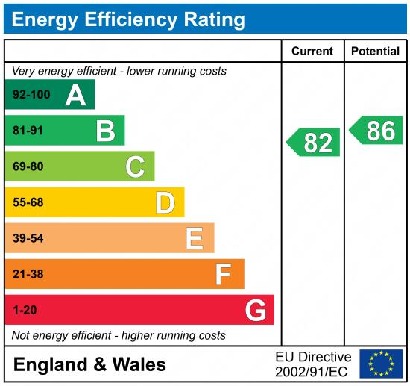

|  |
| --- |
|  |

These particulars are intended to give a fair description of the property, but their accuracy cannot be guaranteed, and they do not constitute an offer of contract. Intending purchasers must rely on their own inspection of the property. None of the above appliances/services have been tested by ourselves. We recommend purchasers arrange for a qualified person to check all appliances/services before legal commitment.

**Property Ref:** 6229

**For more information, please contact**

0113 258 1150 **|** [lettings@adairpaxton.co.uk](mailto:lettings@adairpaxton.co.uk) **|** www.adairpaxton.co.uk