

**Manor Mills, Ingram Street, Leeds**

**For Sale £175,000.00**

***TWO BEDROOM/TWO BATHROOM APARTMENT with PARKING - EWS1 COMPLIANT*** Being ideally located only a short walk from Leeds City Centre is this superb two bedroom apartment within the exciting Manor Mills development. Offering stylish and contemporary interior with modern fittings throughout. The apartment briefly comprises: Entrance Hall, open plan living room/kitchen with balcony, master bedroom with en-suite shower room, second double bedroom and house bathroom. Viewing highly recommended. This property is offered to the market with NO ONWARD CHAIN.

**0113 258 1150**

**0800 000 000**

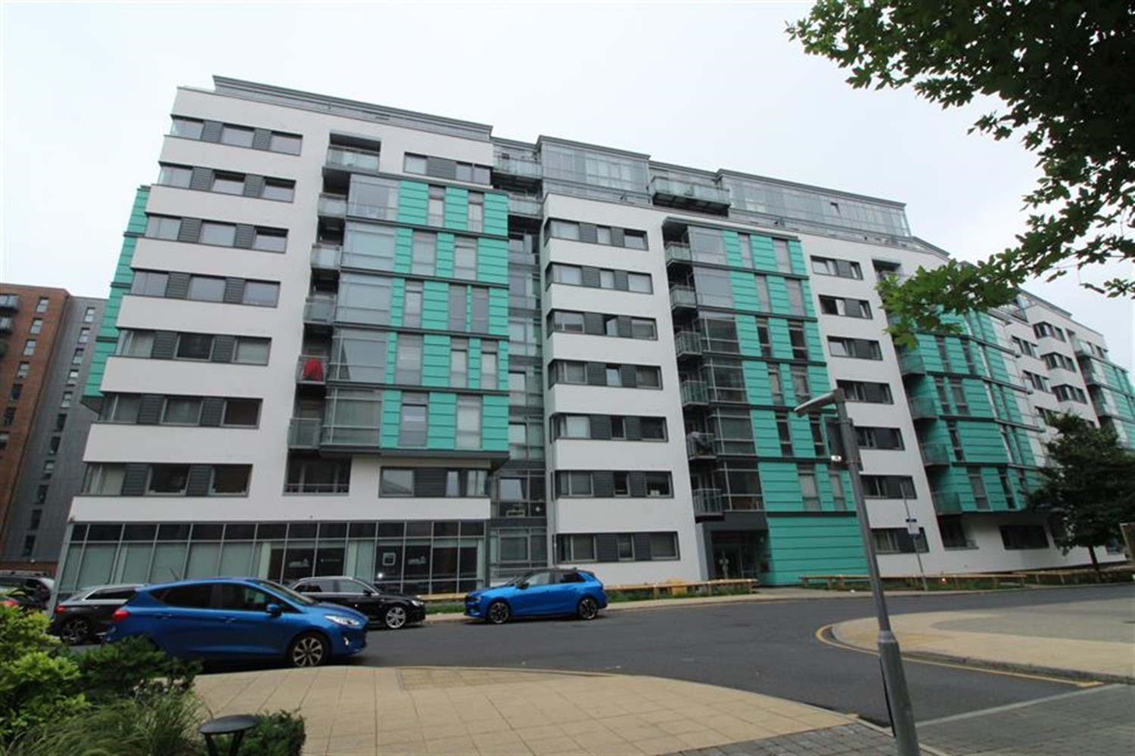



1 Reception(s)

2 Bathroom(s)

2 Bedroom(s)

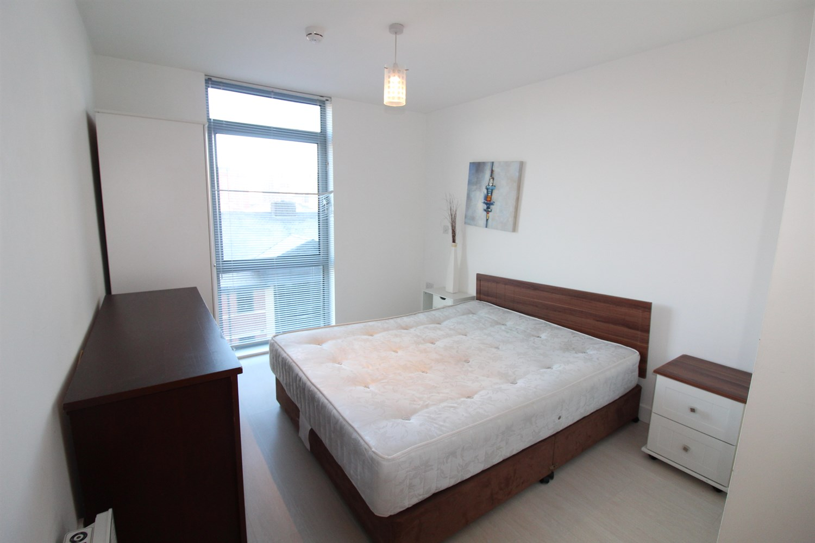

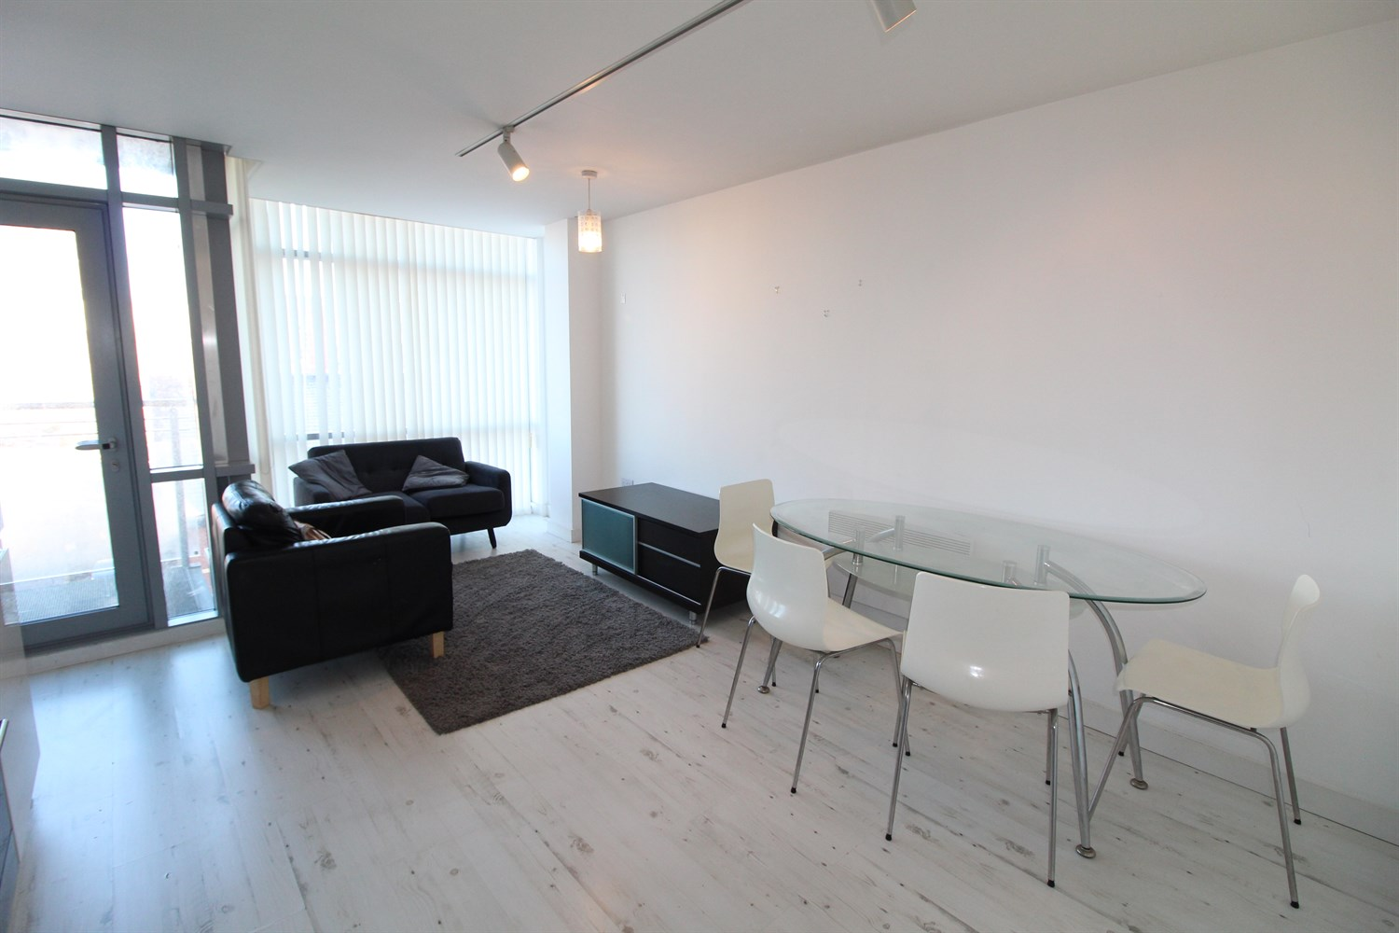

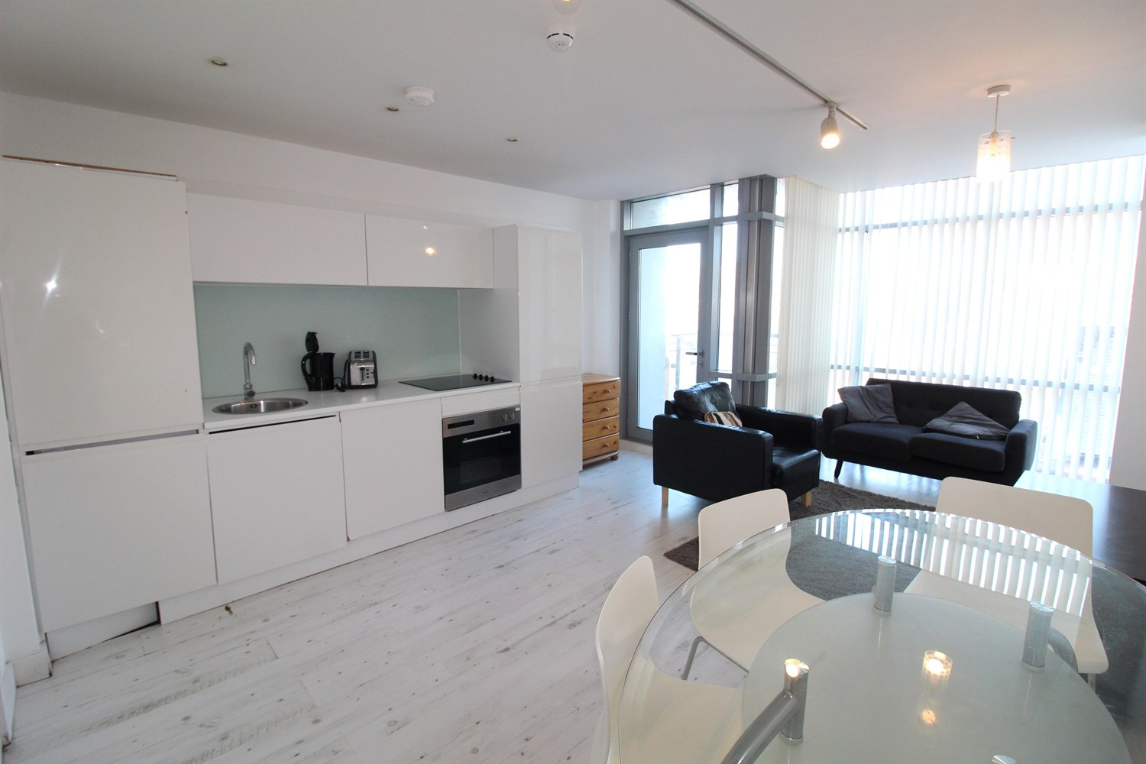

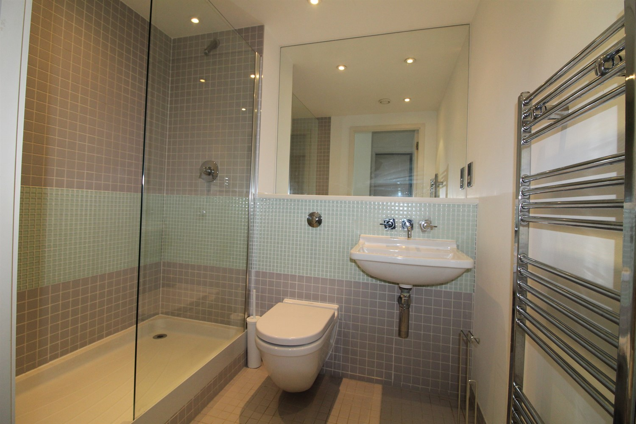

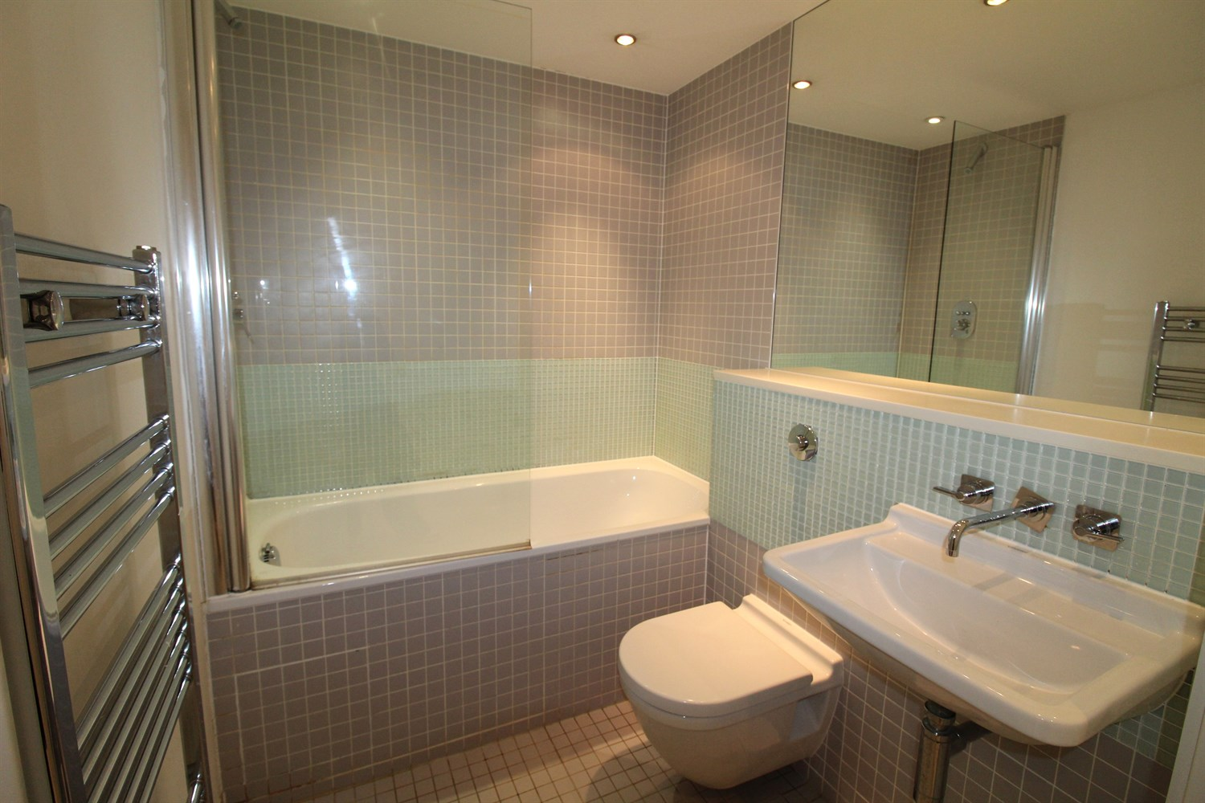

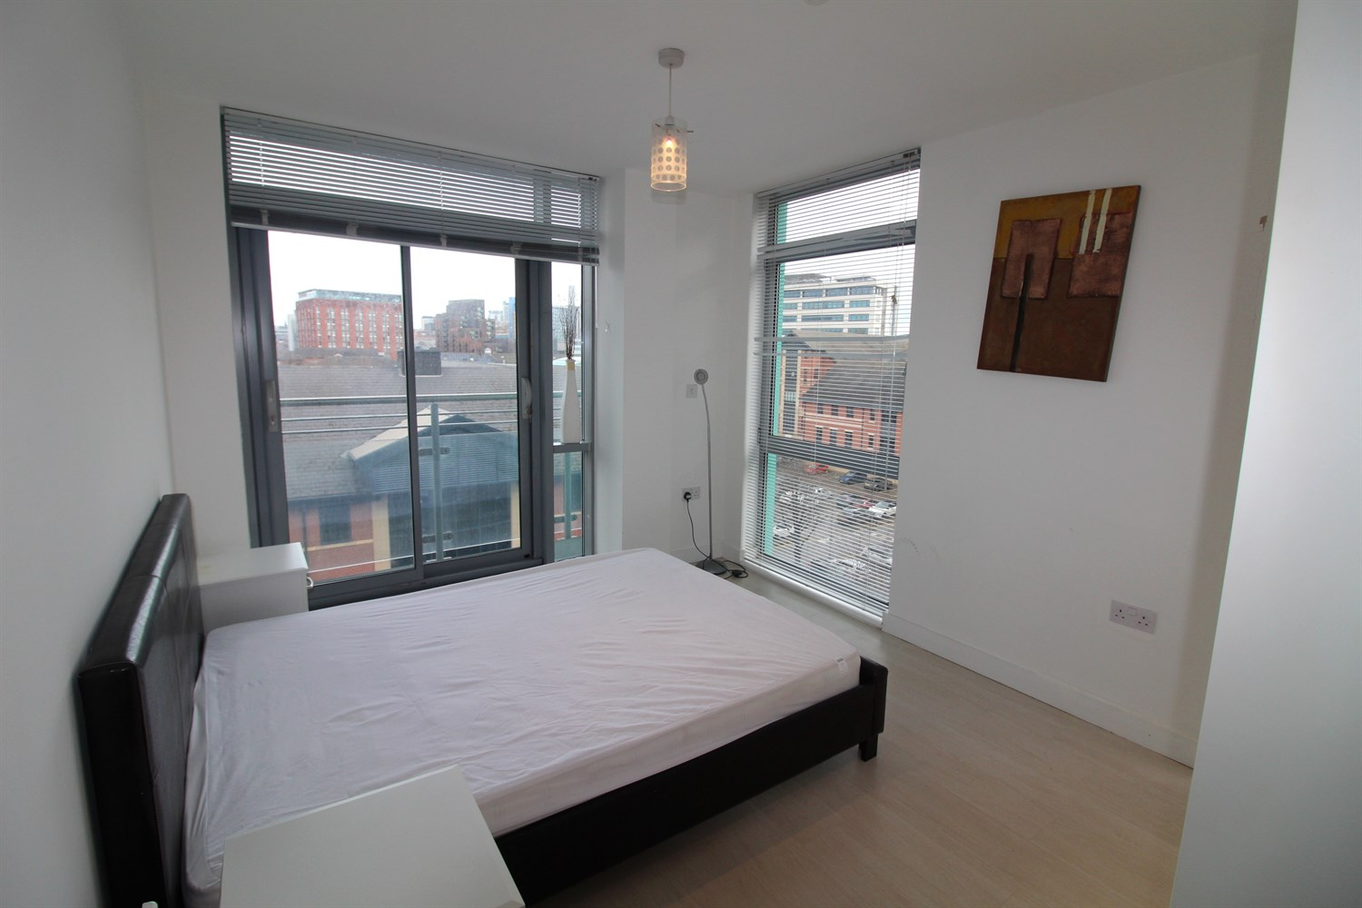

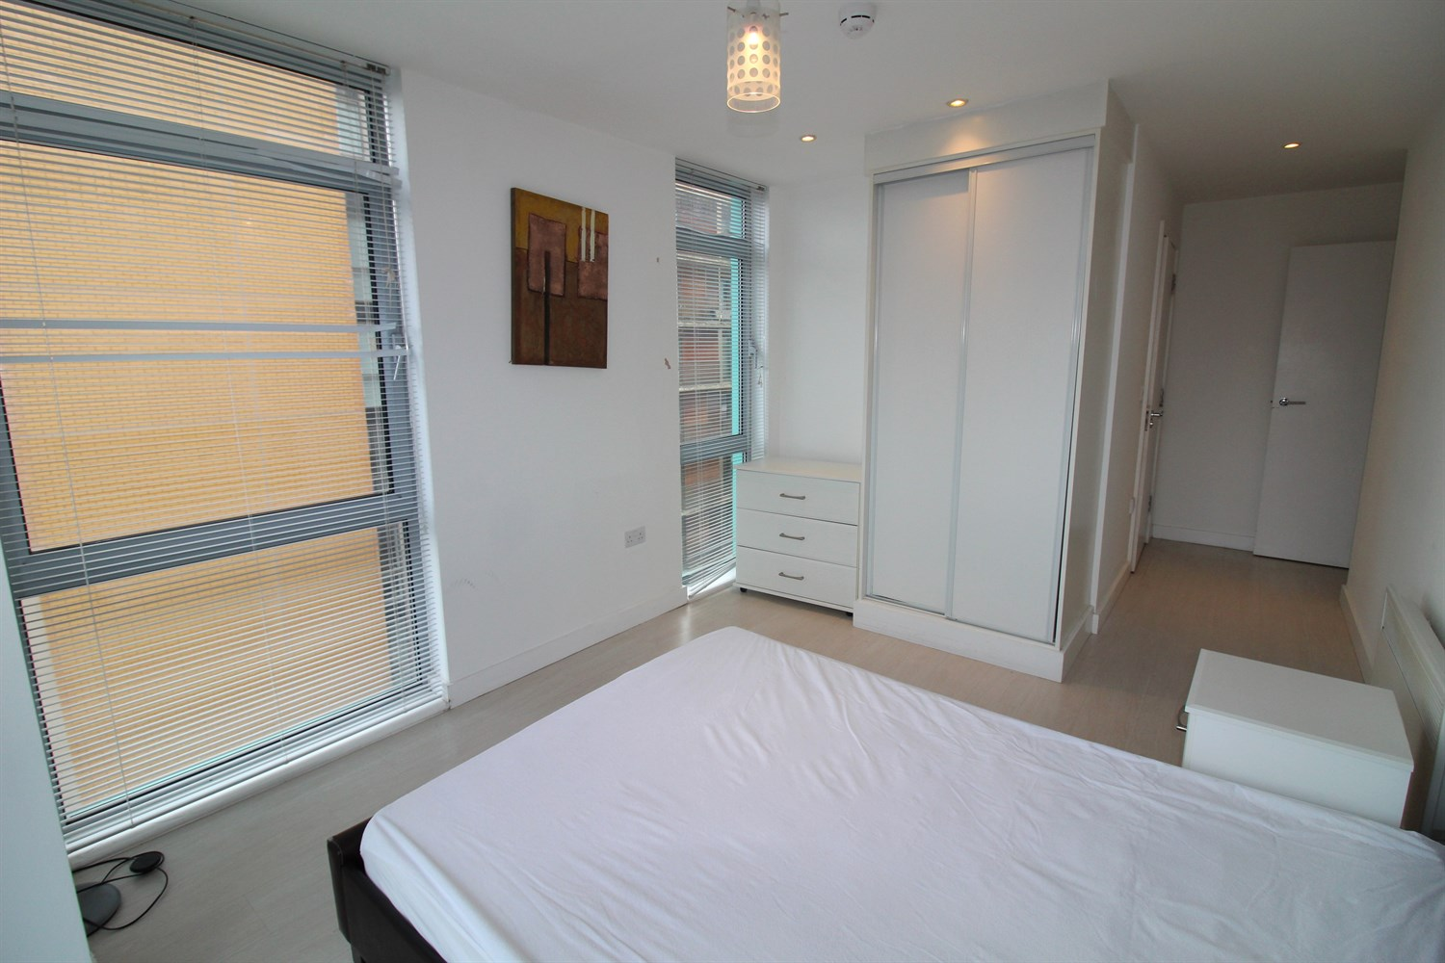

|  |
| --- |
| **Communal Entrance**  Stairs and lift to all floor. |
| **Hallway**  Via front entrance door. |
| **Open Plan Living Room/Kitchen**  Double glazed window and door leading to a balcony. Wall mounted electric heater. Inset ceiling spotlights. |
| **Kitchen**  Fitted with a range of wall, base and drawer units with worktops over. Integrated fridge/freezer, dishwasher and washing machine. Integrated oven with hob and extractor over. Stainless steel sink. Inset ceiling spotlights. |
| **Bedroom 1**  Master bedroom with double glazed windows to side and door leading to balcony. Built in wardrobes. Wall mounted electric radiator. |
| **En-Suite Shower Room**  Fitted with a three piece suite comprising; shower cubicle, wash hand basin and WC. Tiled walls and floor. |
| **Bedroom 2**  Double bedroom with double glazed window. Wall mounted electric radiator. |
| **Bathroom**  House bathroom comprising; Bath with shower over, wash hand basin and WC. Heated towel rail. Tiled walls and floor. |
| **Tenure**  Leasehold - 999 years from 2006 Ground Rent - £370.39 per annum |
| **Service Charge**  Service charge - £973.27 six monthly. Carpark service charge £120.60 |

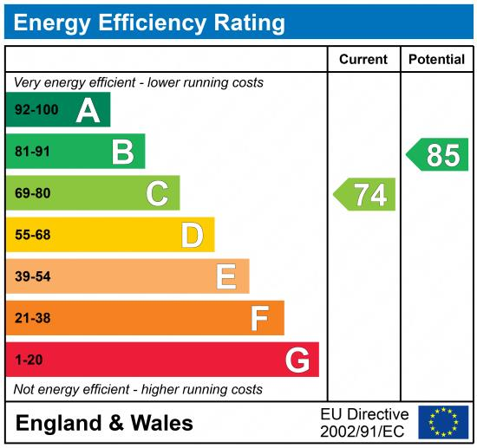

|  |
| --- |
|  |

These particulars are intended to give a fair description of the property, but their accuracy cannot be guaranteed, and they do not constitute an offer of contract. Intending purchasers must rely on their own inspection of the property. None of the above appliances/services have been tested by ourselves. We recommend purchasers arrange for a qualified person to check all appliances/services before legal commitment.

**Property Ref:** 5266

**For more information, please contact**

0113 258 1150 **|** [sales@adairpaxton.co.uk](mailto:sales@adairpaxton.co.uk) **|** www.adairpaxton.co.uk