

**Bonaire, Gotts Road**

**£850.00pcm**

Spacious one double bedroom apartment with allocated parking. Open plan living with balcony, kitchen is light and airy, and the apartment is tastefully decorated throughout.   
City Island itself is an incredibly popular development, situated around a central piazza and but a short stroll away from Leeds business and shopping districts, and is well placed for access to the motorway network and Ring Road. Internal inspection is highly recommended! Part furnished, council tax band C, EPC rating B, Deposit £980 Available Now.

**0113 258 1150**

**0800 000 000**

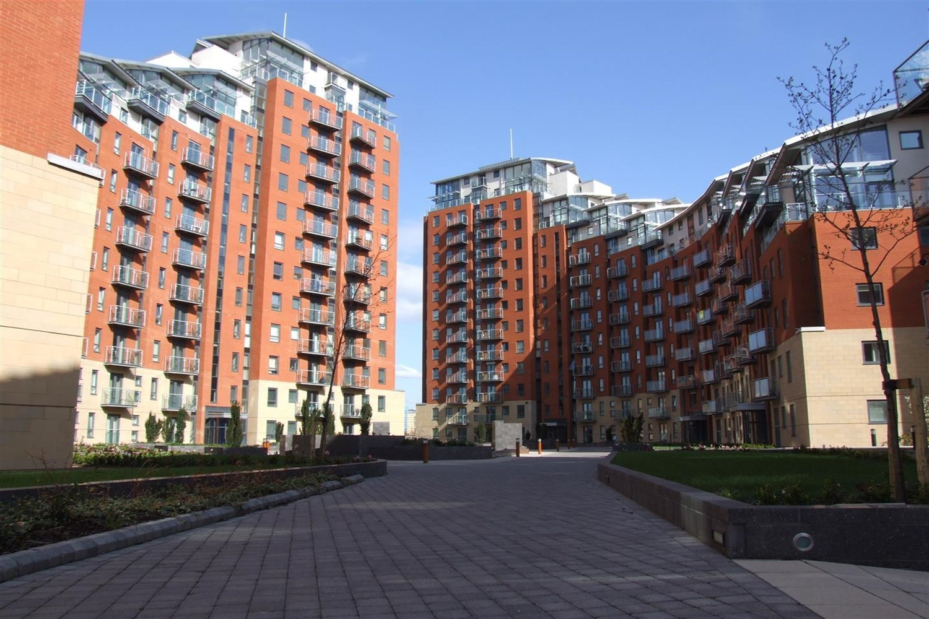

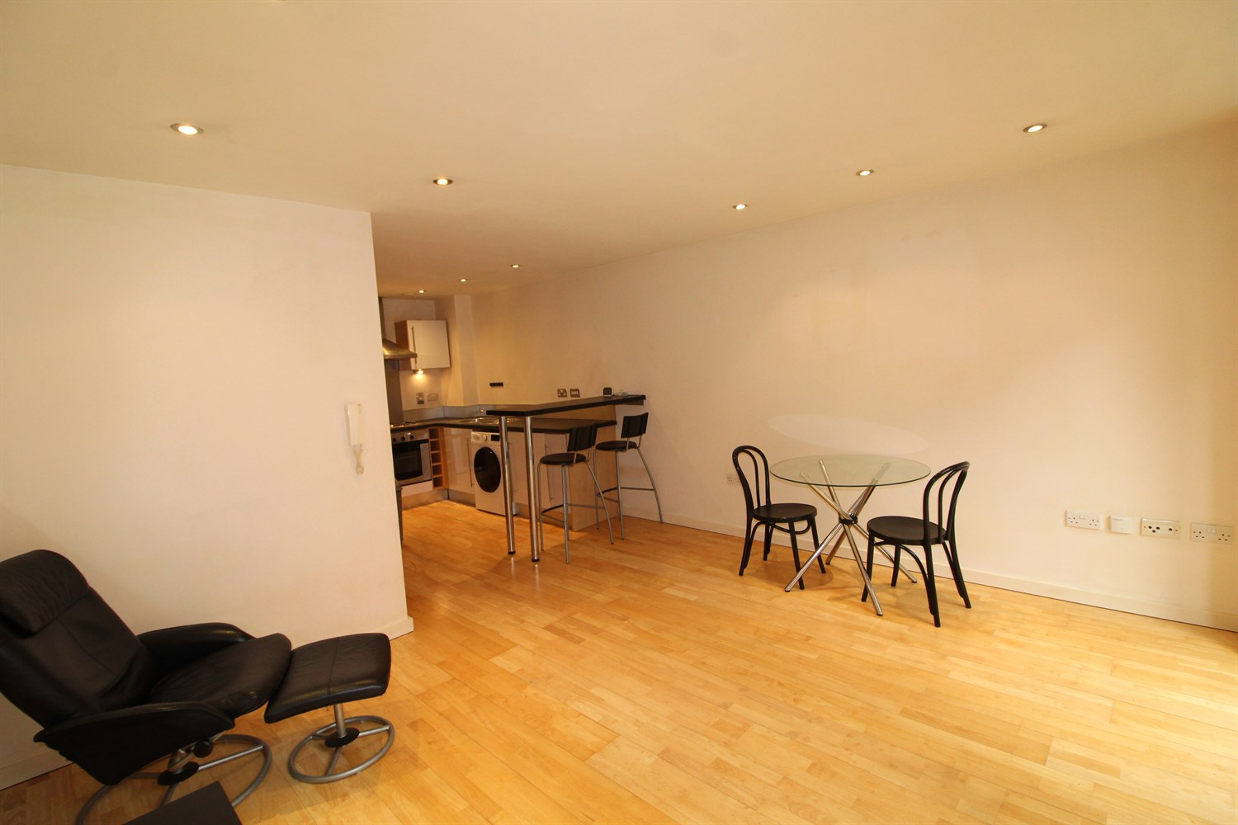

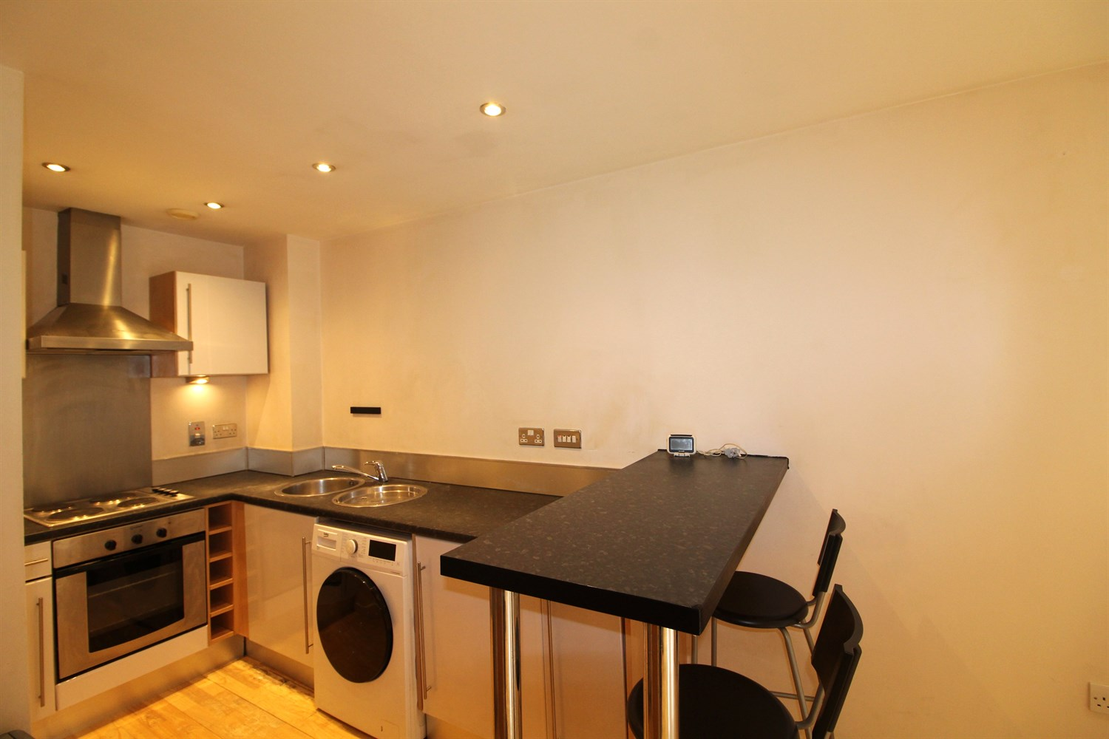

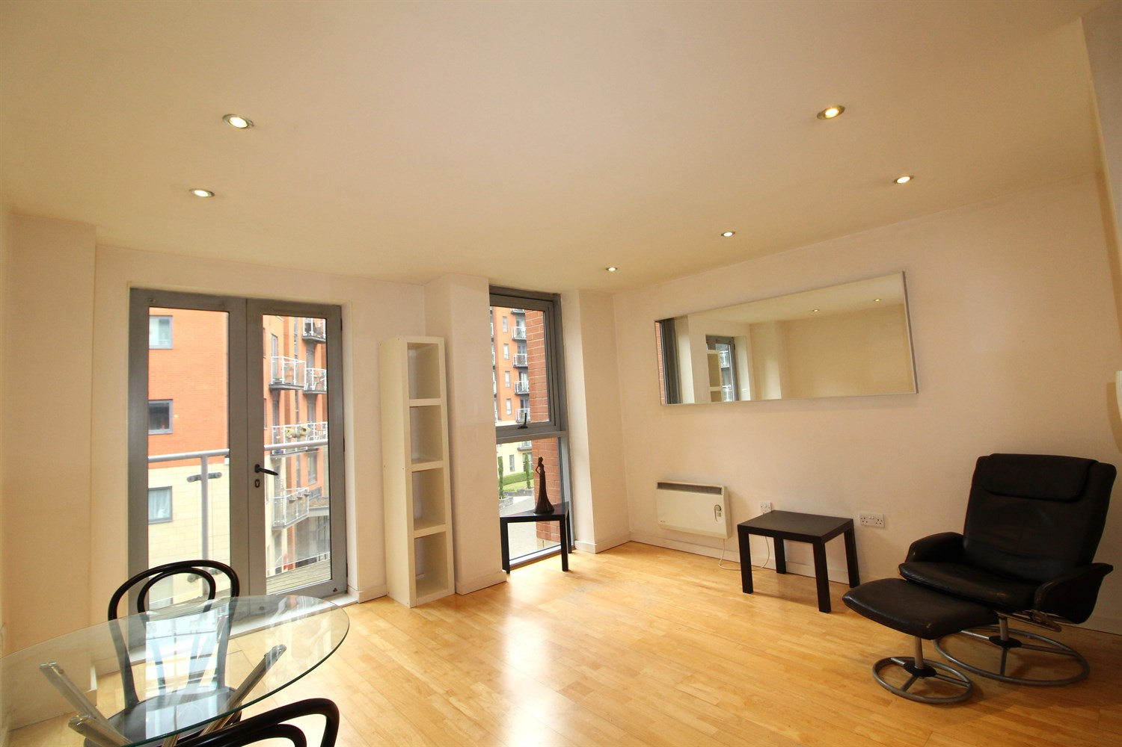

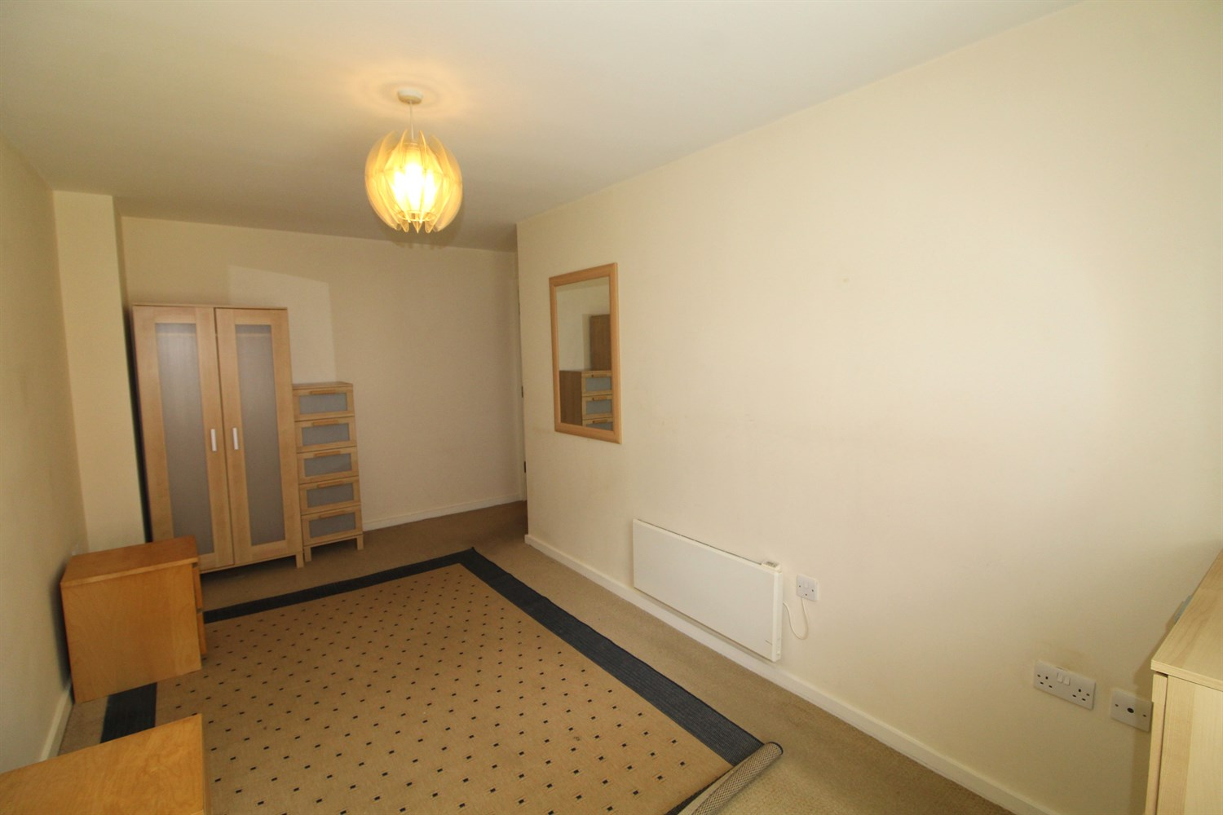

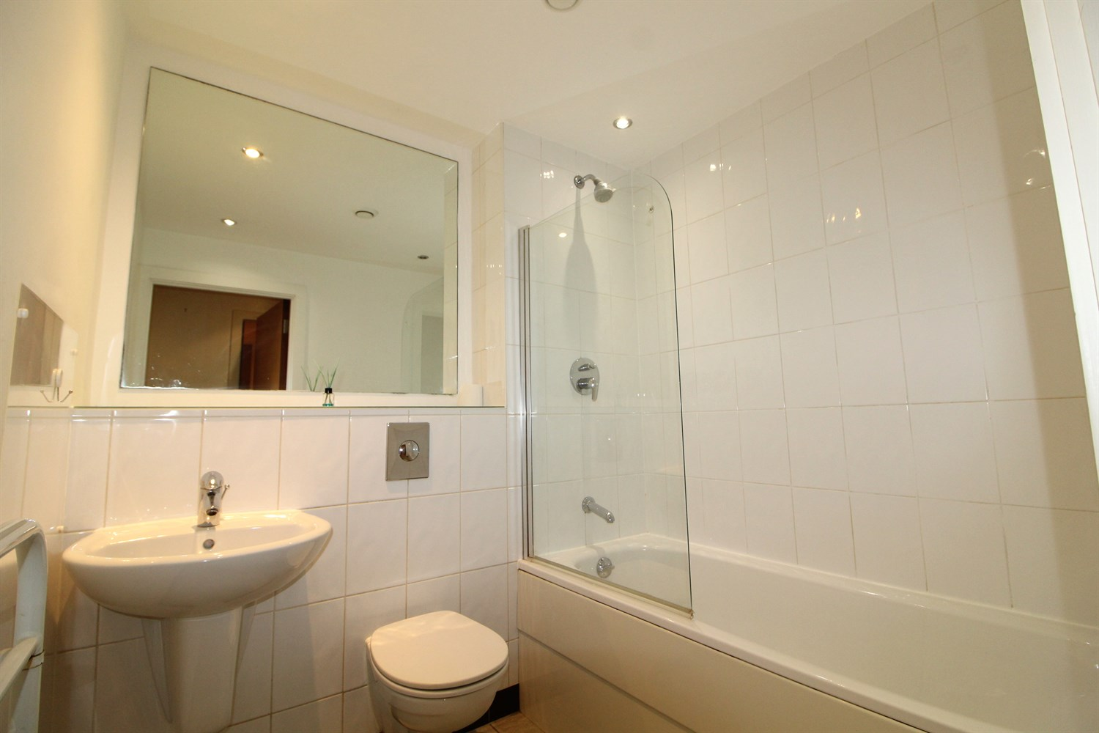

|  |
| --- |
| **Open Plan Kitchen and Living Room**  Open plan living /kitchen has a range of wall and base units, induction hob with electric oven, integrated fridge freezer, integrated washing machine and a balcony to the front over looking the communal gardens. |
| **Bedroom 1**  Double bedroom with built in wardrobes, electric wall heater and window. |
| **Bathroom**  The modern shower room has a three piece suite consisting; bath with shower over shower screen, low flush W/C. tiled walls. |
| **Communal Garden**  Communal garden area. |
| **Allocated Parking**  Underground parking space. |
| **Home Information**  Council Tax - D EPC Rating:   No Parking  Heating - Electric Water - Mains connected Broadband - No issues to report Mobile availability - No issues to report EWS1 Rating - A2 Construction type - Concrete frame Flood Risk - Very low |

|  |
| --- |
|  |

These particulars are intended to give a fair description of the property, but their accuracy cannot be guaranteed, and they do not constitute an offer of contract. Intending purchasers must rely on their own inspection of the property. None of the above appliances/services have been tested by ourselves. We recommend purchasers arrange for a qualified person to check all appliances/services before legal commitment.

**Property Ref:** 6243

**For more information, please contact**

0113 258 1150 **|** [lettings@adairpaxton.co.uk](mailto:lettings@adairpaxton.co.uk) **|** www.adairpaxton.co.uk