

**Rockery Croft, Horsforth**

**For Sale £130,000.00**

**TWO BEDROOM GROUND FLOOR APARTMENT with NO ONWARD CHAIN** Adair Paxton are pleased to offer this well presented two bedroom apartment, an ideal investment for a cash buyer. The apartment is located in a highly sought after and regarded development in the centre of popular Horsforth. Offering convenient access to many local shops, schools and services the property is also just a short stroll from a number of popular restaurants, cafes and bars. The property has been well maintained by the current owner but would now benefit from some cosmetic updating and briefly comprises; Communal entrance, lounge, kitchen, inner hallway leading to the master bedroom, second bedroom and house bathroom. Externally, there are well maintained communal gardens. An allocated parking space and visitor parking.

**0113 258 1150**

**0800 000 000**

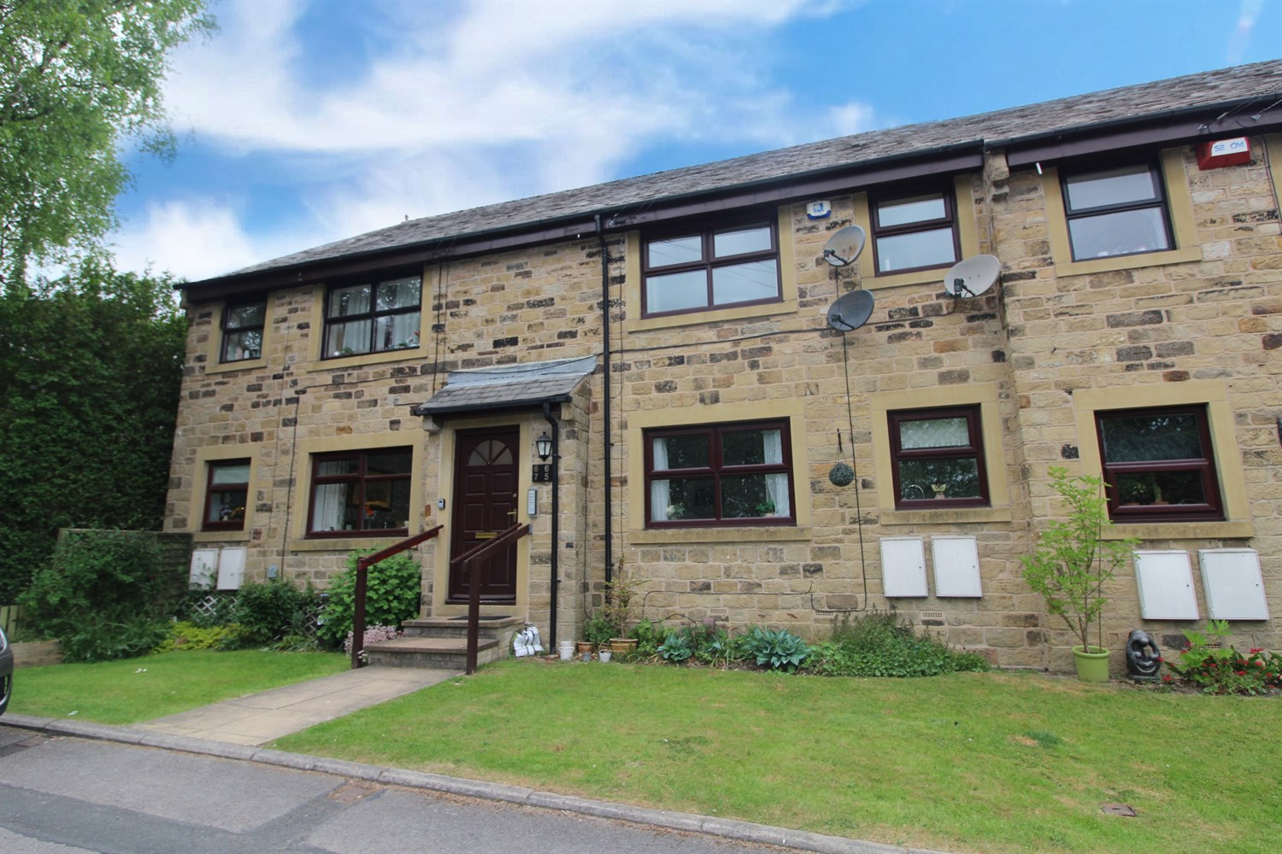



1 Reception

1 Bathroom

2 Bedrooms

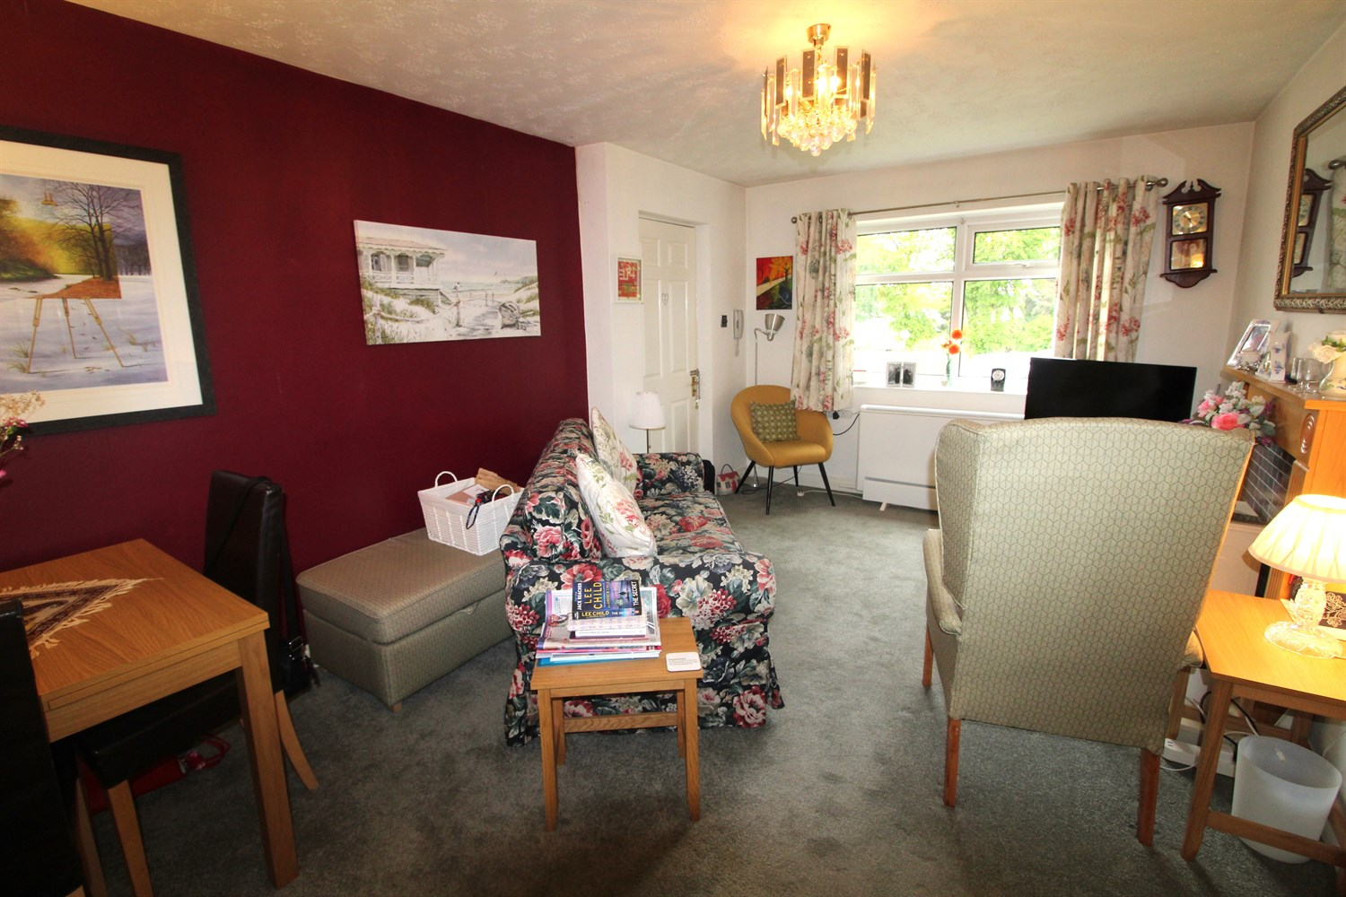

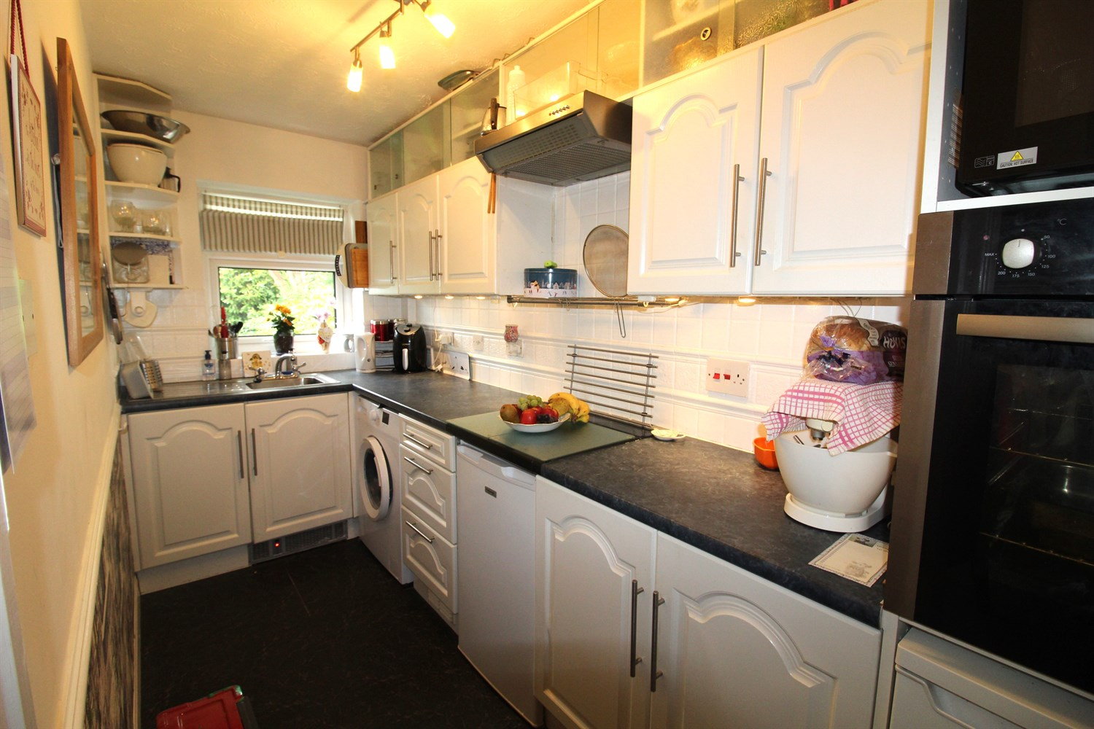

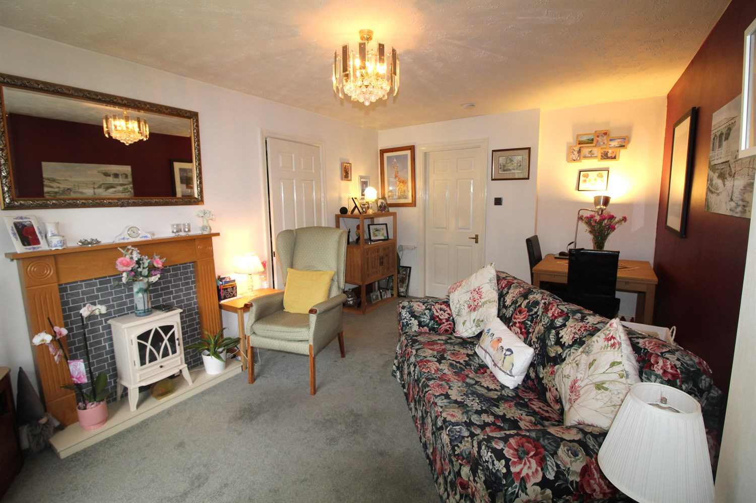

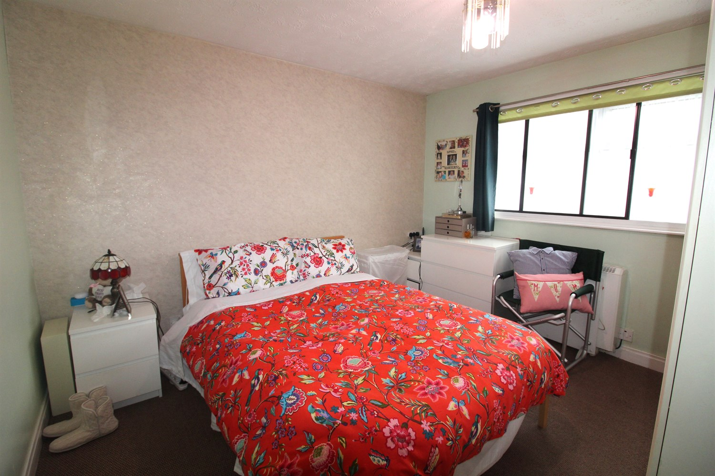

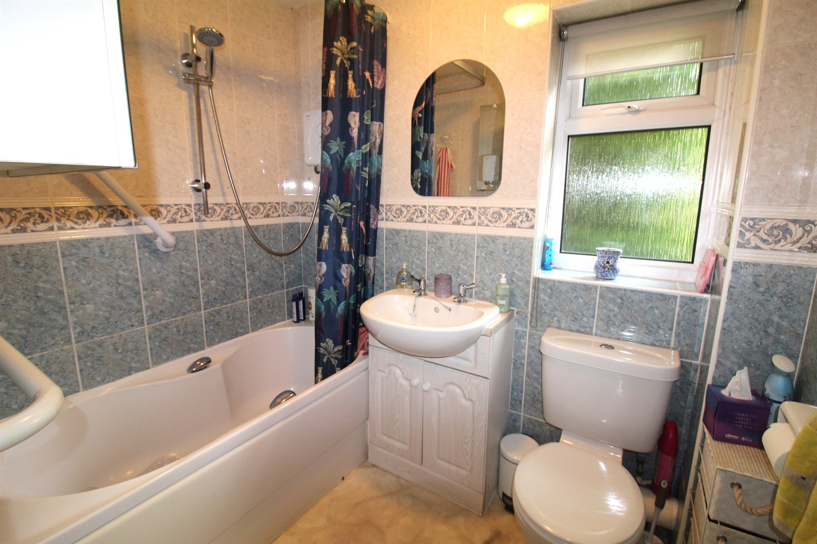

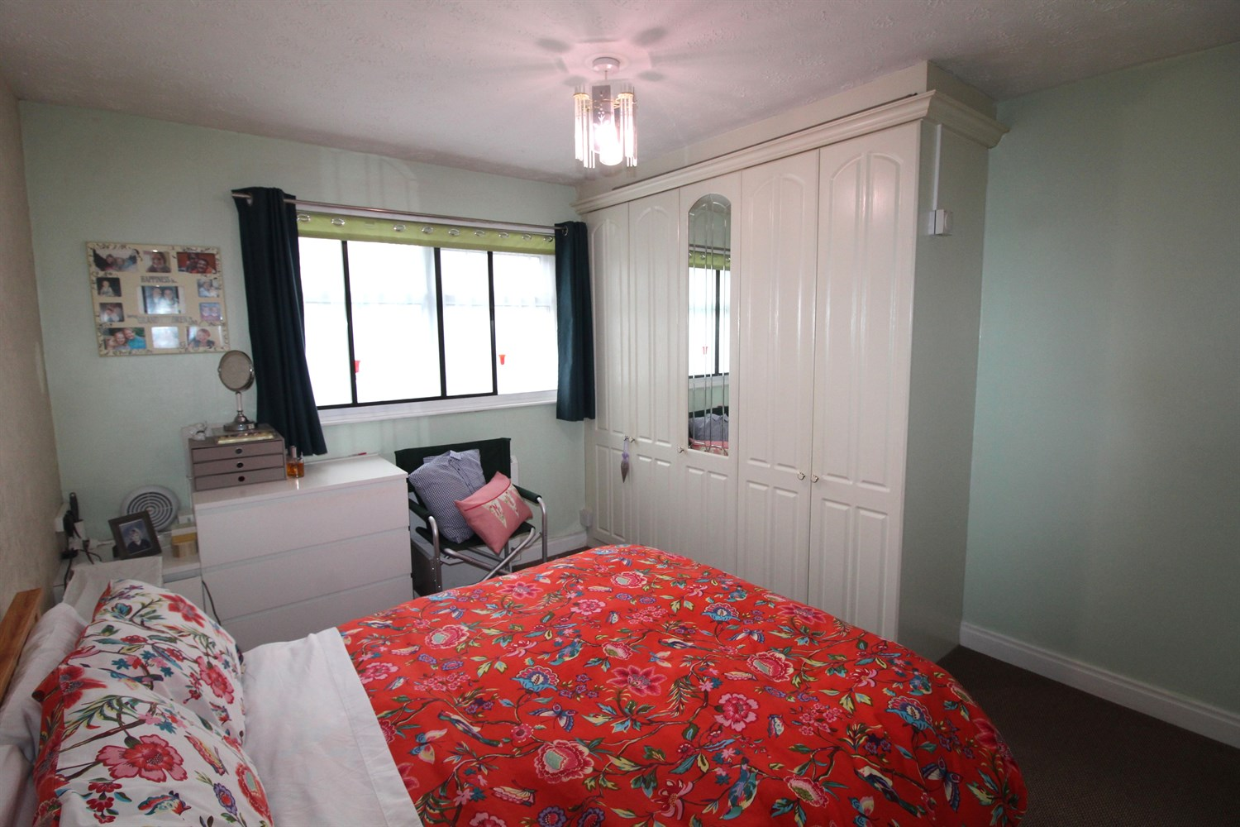

|  |
| --- |
| **Communal Hallway**  Via front entrance door. Secure intercom system. Door to apartment 7. |
| **Lounge 5m (16'5) x 3.2m (10'6)**  Spacious living area with uPVC double glazed window to front. Wall mounted electric radiator. |
| **Kitchen 3.57m (11'9) x 1.57m (5'2)**  Fitted with a range of wall, base and drawer units with worktops over. Integrated oven, 4-ring hob and extractor hood over. Space for washing machine, fridge and freezer. uPVC double glazed window to front. |
| **Inner Hallway** |
| **Bedroom 1 3.4m (11'2) x 3.15m (10'4)**  Light and airy double bedroom with uPVC double glazed window. Wall mounted electric radiator. Built in wardrobe. |
| **Bedroom 2 3.28m (10'9) x 2.18m (7'2)**  Second bedroom with uPVC double glazed window. Wall mounted electric radiator. |
| **Bathroom**  Fitted with a three piece white suite comprising; bath with shower over, WC and wash hand basin. Tiled walls. uPVC double glazed window. |
| **Outside**  Externally the property has well maintained communal gardens, an allocated parking space and visitor parking. |
| **Tenure**  Service charge £150 per month Ground rent - £15 per annum Leasehold - 62 years remaining |

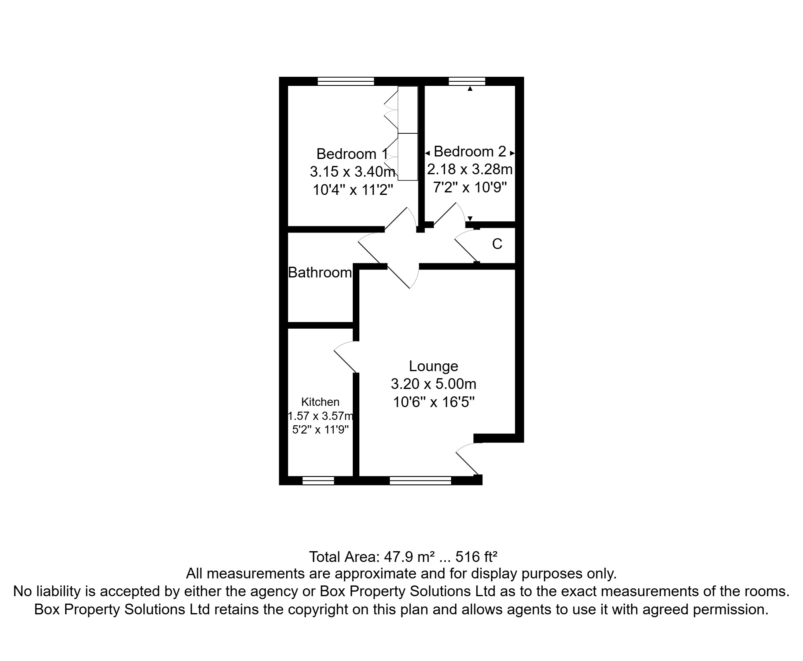

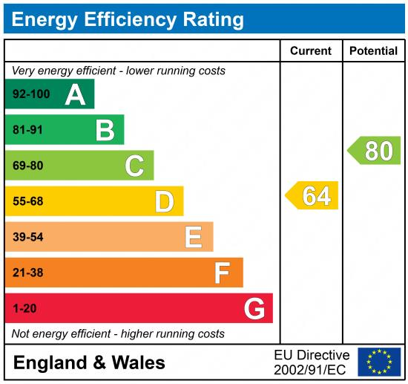

|  |
| --- |
|  |

These particulars are intended to give a fair description of the property, but their accuracy cannot be guaranteed, and they do not constitute an offer of contract. Intending purchasers must rely on their own inspection of the property. None of the above appliances/services have been tested by ourselves. We recommend purchasers arrange for a qualified person to check all appliances/services before legal commitment.

**Property Ref:** 6193

**For more information, please contact**

0113 258 1150 **|** [sales@adairpaxton.co.uk](mailto:sales@adairpaxton.co.uk) **|** www.adairpaxton.co.uk