

**0113 258 1150**

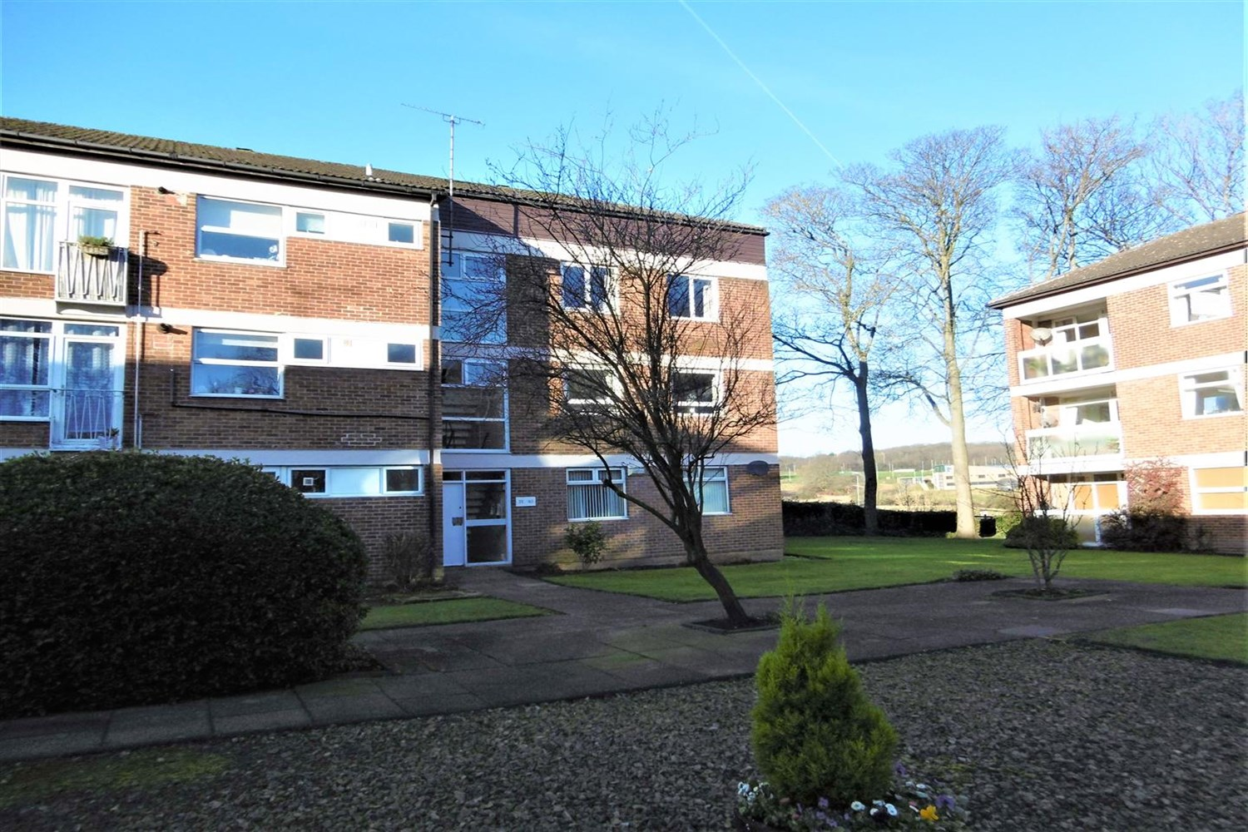



**Available to let £950.00pcm**

**Foxhill Court, Leeds,**

Three bedroom apartment, located in this highly regarded and well established development to the North of Leeds and close to the Outer Ring Road for those commuting is this very spacious ground floor apartment. Being set within delightful well kept communal gardens and offering ideal accommodation. The spacious accommodation has the benefit of gas central heating and security intercom. Comprising; lounge/diner, kitchen with appliances, three bedrooms, (two double, one single), Bathroom. Part Furnished. Deposit £1095. Available 16th June, council tax band C, EPC rating D.

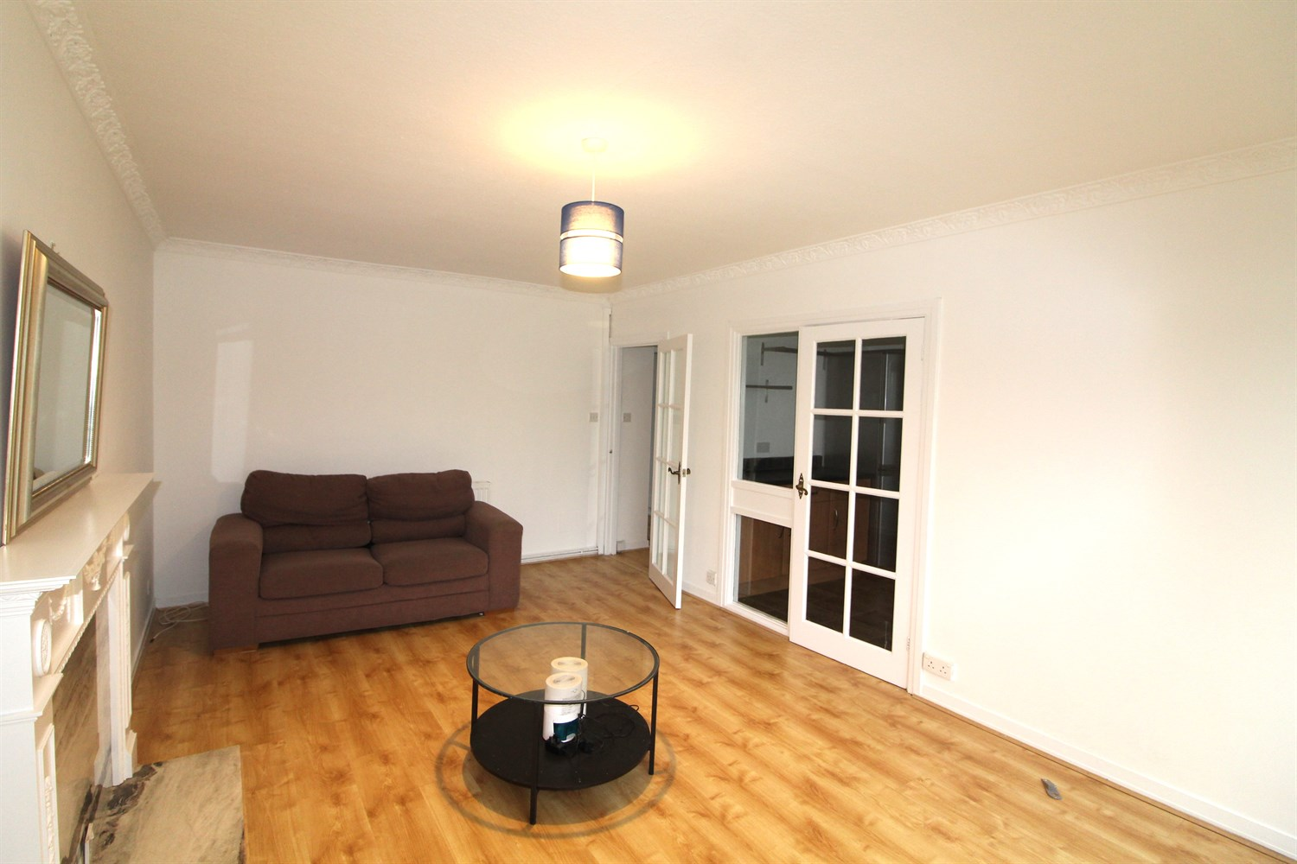

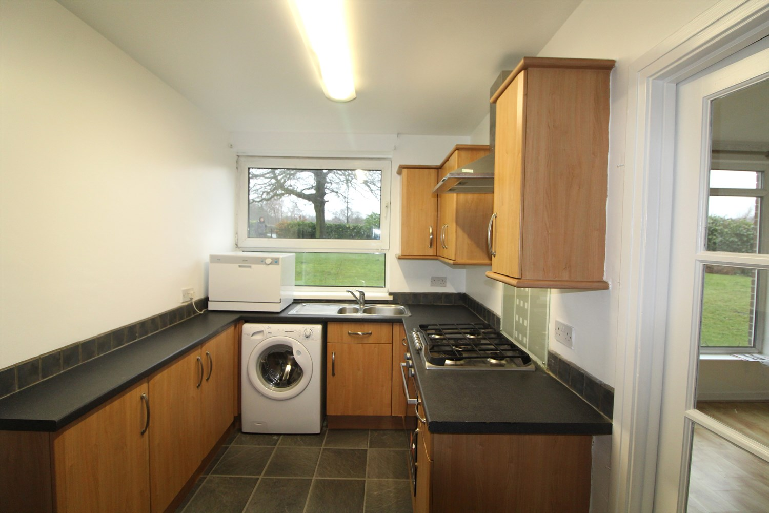

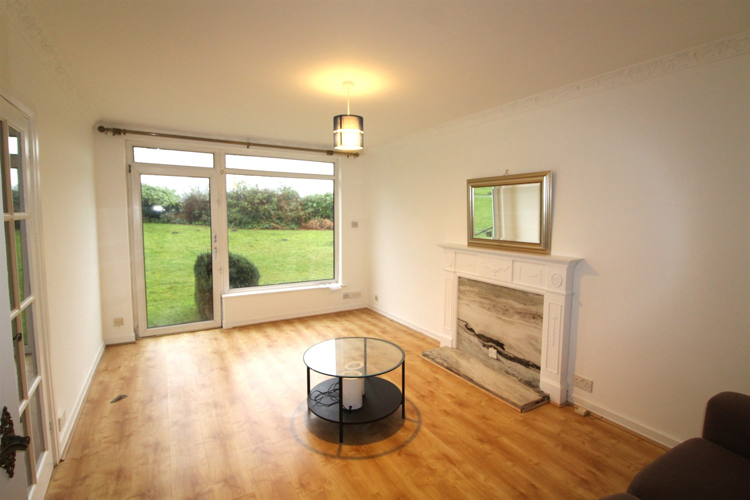

1 Bathroom(s)

1 Reception(s)

3 Bedroom(s)

00

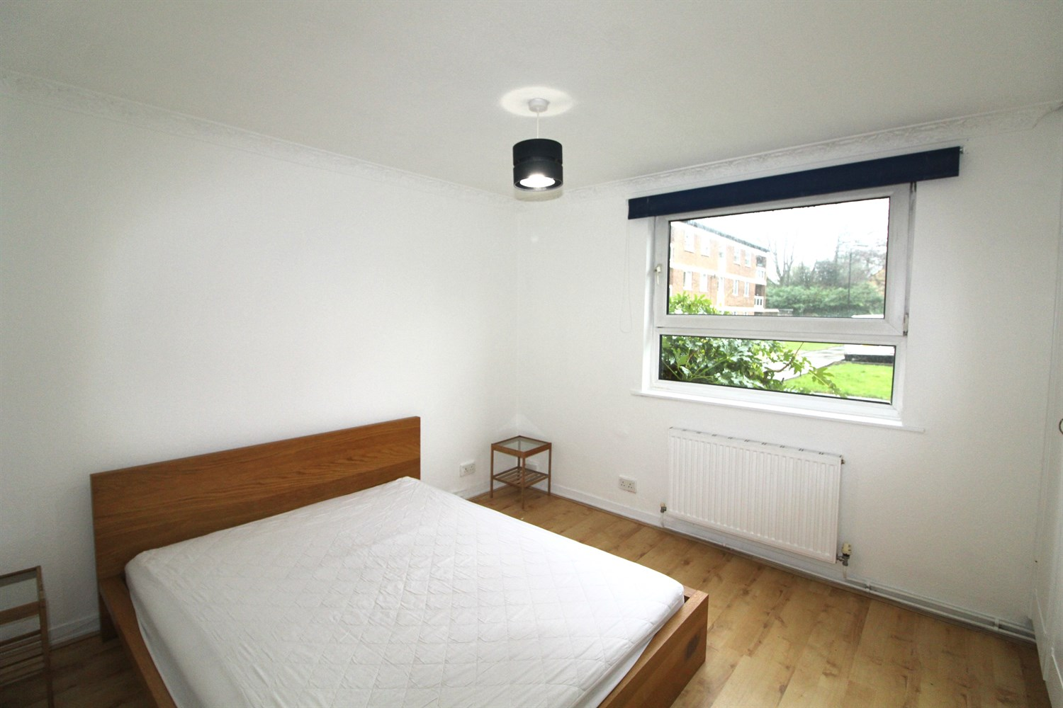

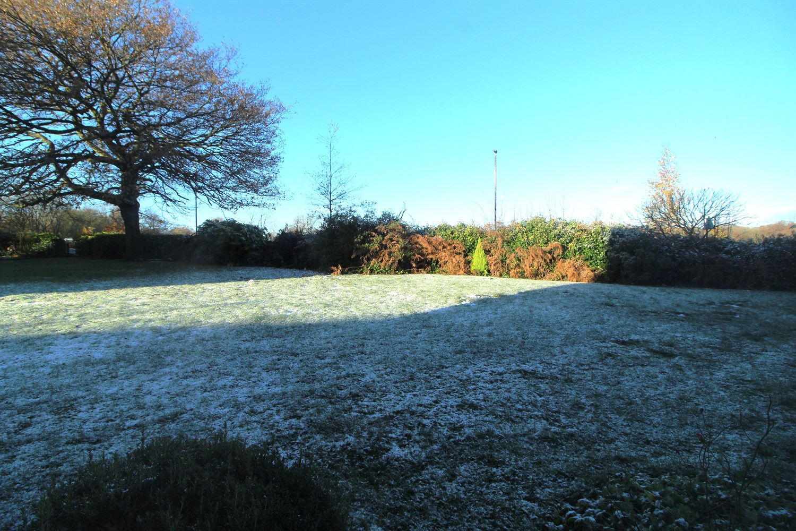

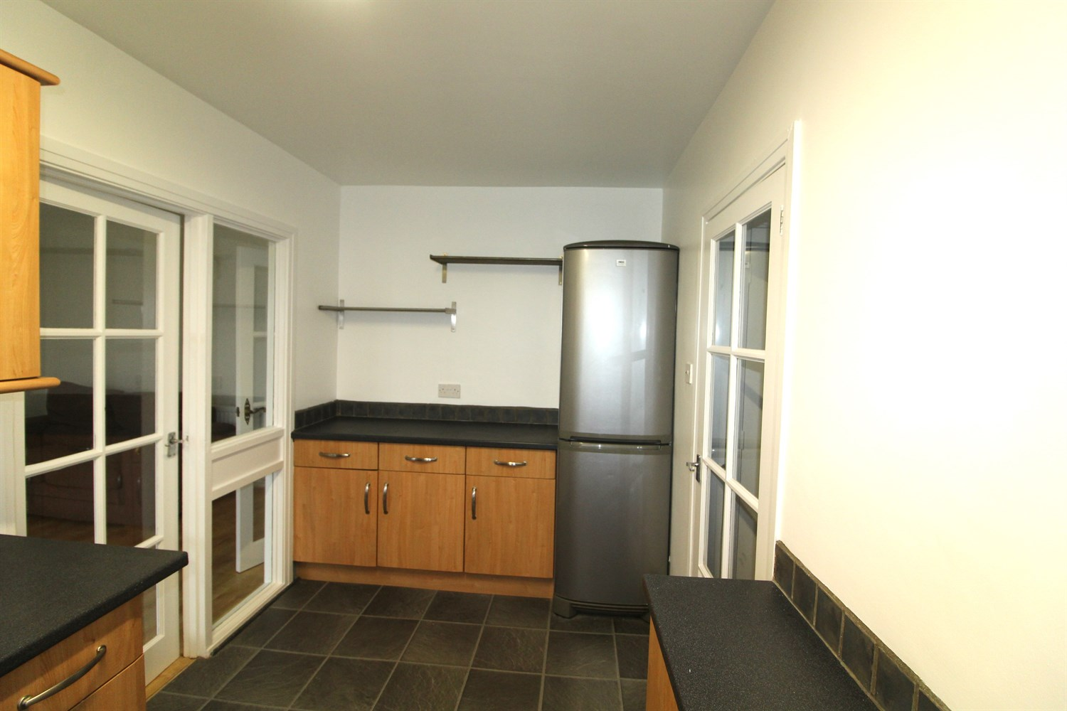

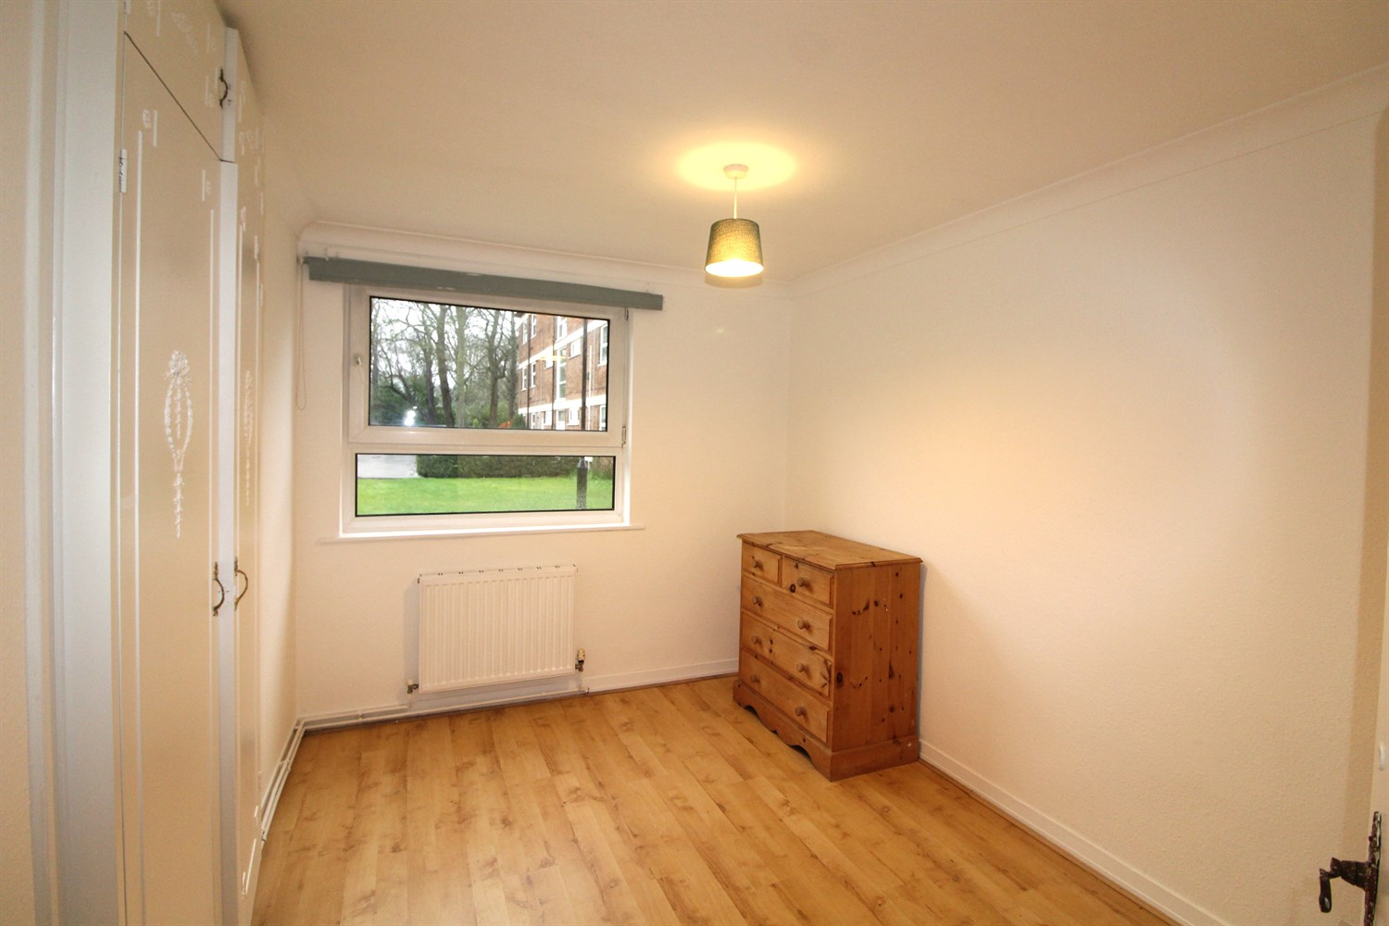

|  |
| --- |
| **Living Room**  Large light and airy living room with uPVC windows and door over looking the communal garden. |
| **Kitchen**  Fitted with a range of wall and base units with worktops over, stainless steel sink with mixer tap, gas cooker top and electric over with extractor over. Window to rear. |
| **Bedroom 1**  Double bedroom with built in wardrobes, window to front. |
| **Bedroom 2**  Second double bedroom with window to front, built in wardrobes, gas central heating radiator. |
| **Bedroom 3**  Single bedroom with window to side. |
| **Bathroom**  Three piece white bathroom suite with shower over bath, shower screen, W/C and hand wash basin, tiled walls and floor. |
| **Home Information**  COUNCIL TAX BAND: C EPC Rating D  Leasehold property: On street parking   Broadband: Standard 25 Mbps 2 Mbps Good Superfast --Not available --Not available Unlikely Ultrafast 1000 Mbps 100 Mbps Mobile availability: EE limited coverage. Three limited coverage. O2 likely to have good coverage. Vodafone limited coverage.  Utilities: Water supplied on standard meters. Electric mains supplied on standard meters. Gas meters supplied on standard meters. |

|  |  |
| --- | --- |
| These particulars are intended to give a fair description of the property, but their accuracy cannot be guaranteed, and they do not constitute an offer of contract. Intending purchasers must rely on their own inspection of the property. None of the above appliances/services have been tested by ourselves. We recommend purchasers arrange for a qualified person to check all appliances/services before legal commitment.  **Property Ref:** 587  **For more information, please contact**  0113 258 1150 **|** [lettings@adairpaxton.co.uk](mailto:lettings@adairpaxton.co.uk) **|** www.adairpaxton.co.uk |  |