

**0113 258 1150**

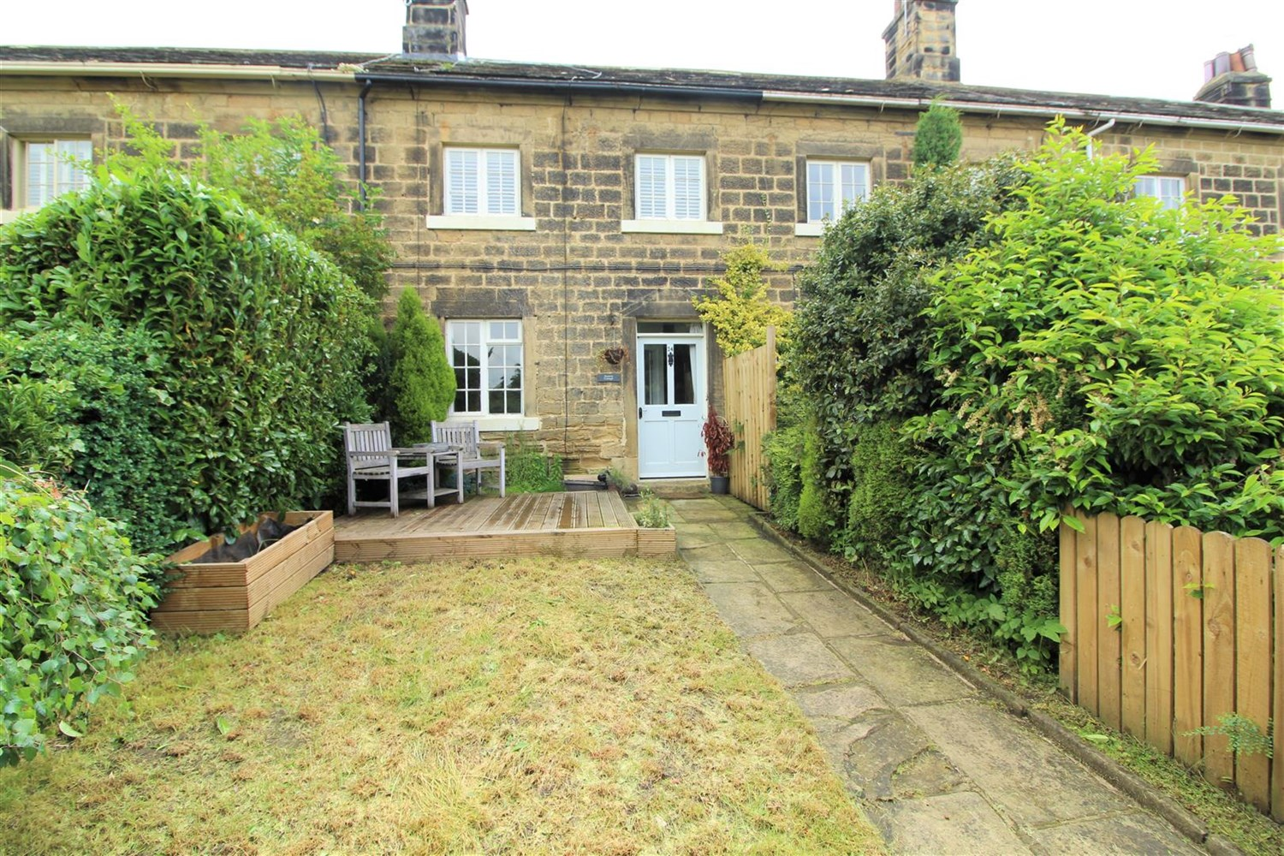



**Available to let £1,100.00pcm**

**Harrogate Road, Leeds,**

***STUNNING TWO BED CHARACTERFUL STONE COTTAGE IN THE SOUGHT AFTER LOCATION OF HAREWOOD***  
Comprising; Spacious lounge with beamed ceiling, feature fireplace and log burner, stylish kitchen/diner with shaker style units with an island, rear porch with cloakroom/WC. Master bedroom with fitted wardrobe and cupboard, second double bedroom, house bathroom with three piece suite and shower over bath. Neutral decor and carpets throughout. Enclosed front garden with lawn and decking area. Gas central heating. Unfurnished with white goods. Bond £1,265. Available 28th May 2024. Council tax band D, EPC rating D.

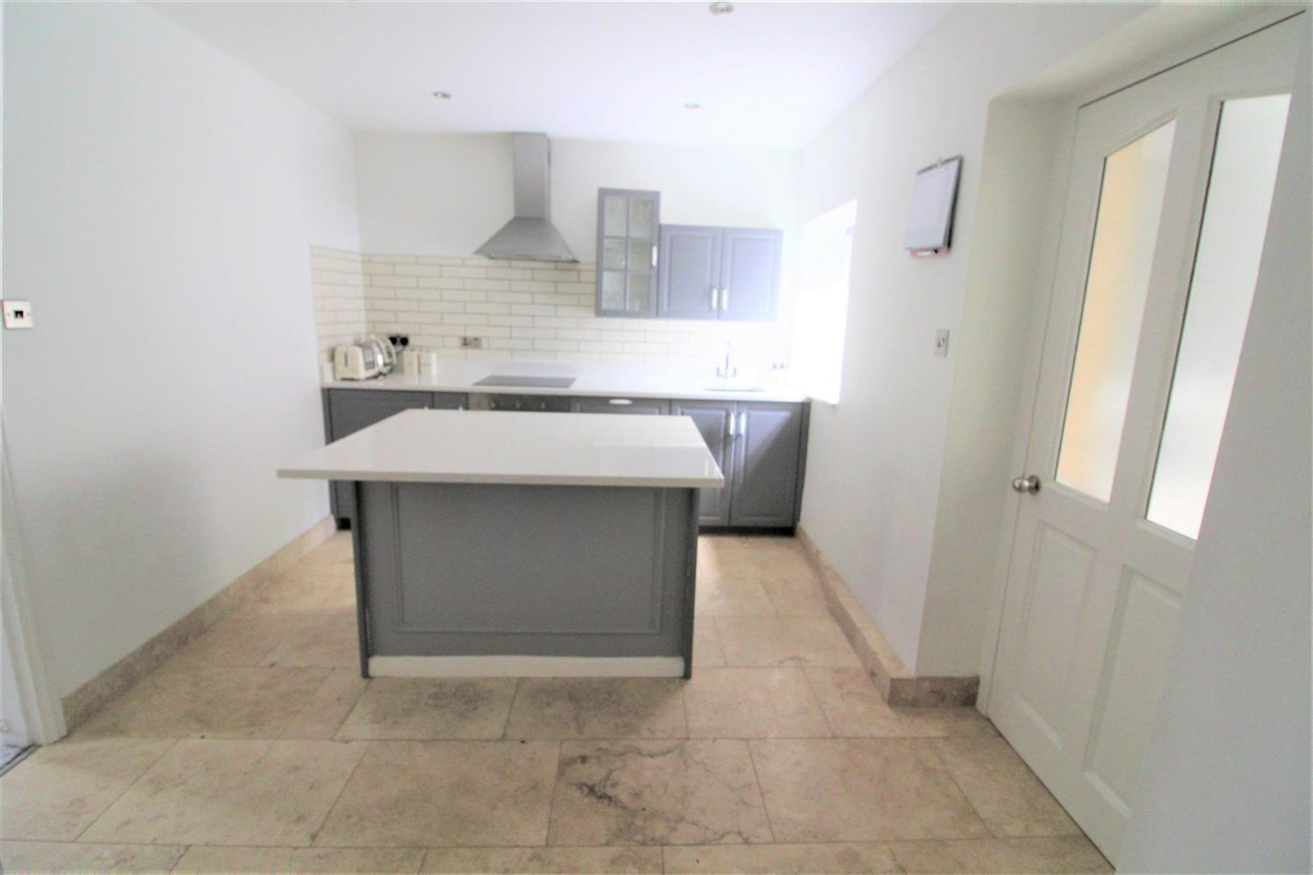

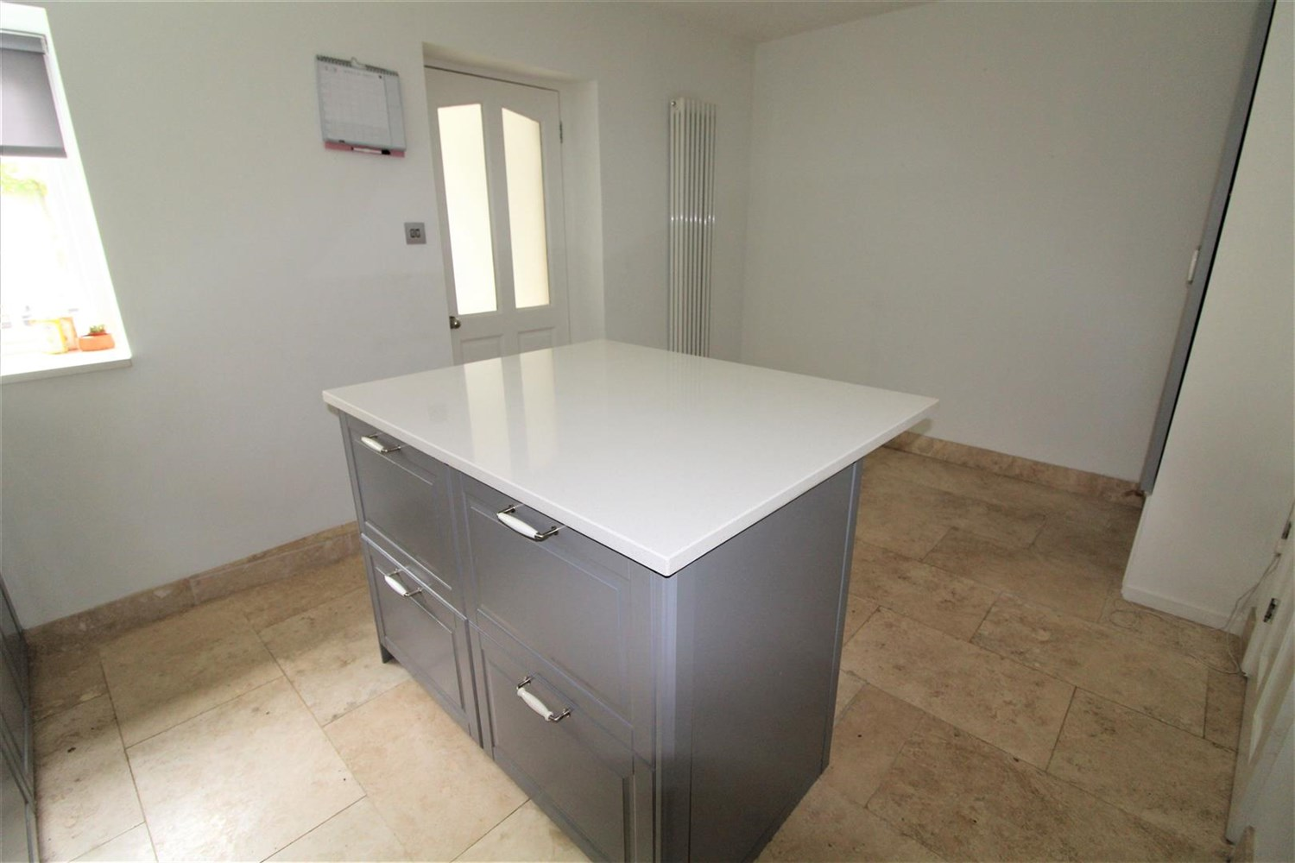

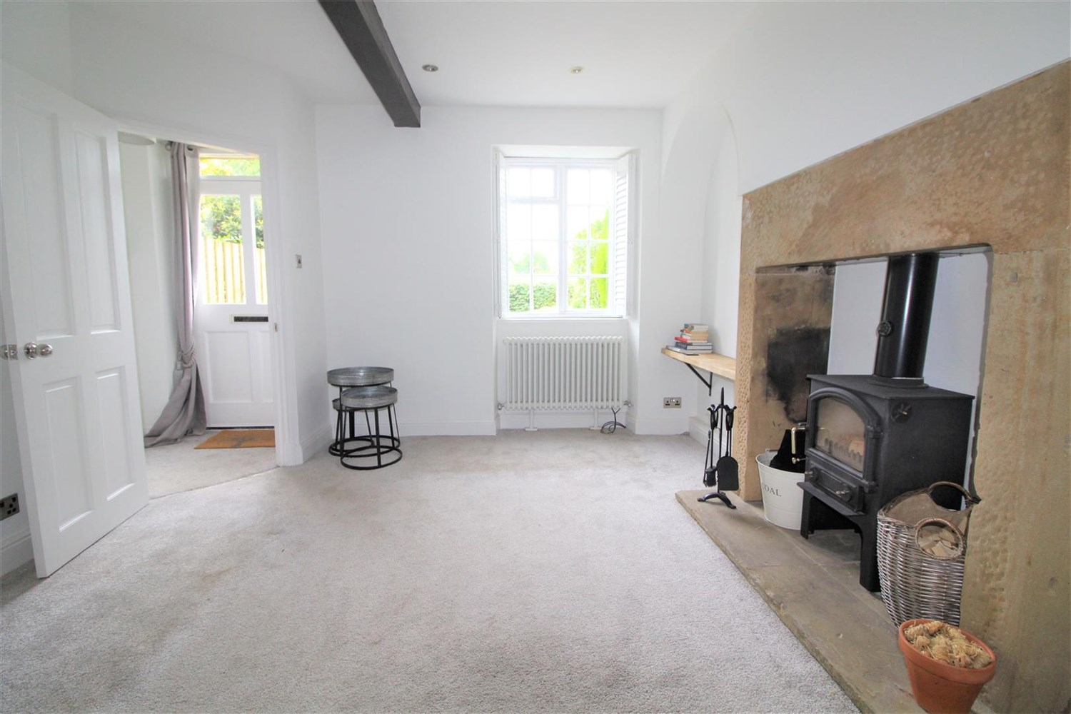

1 Bathroom(s)

1 Reception(s)

1 Bedroom(s)

00

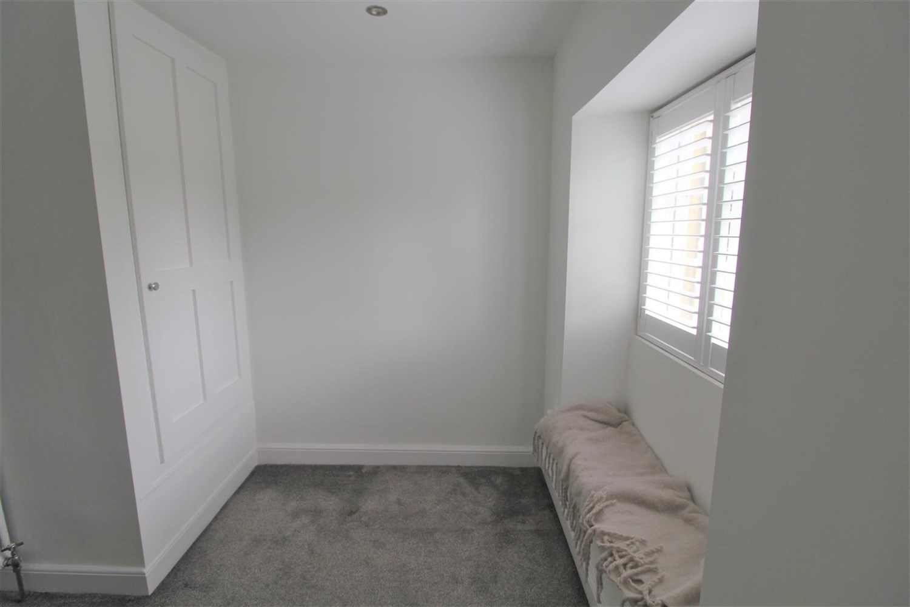

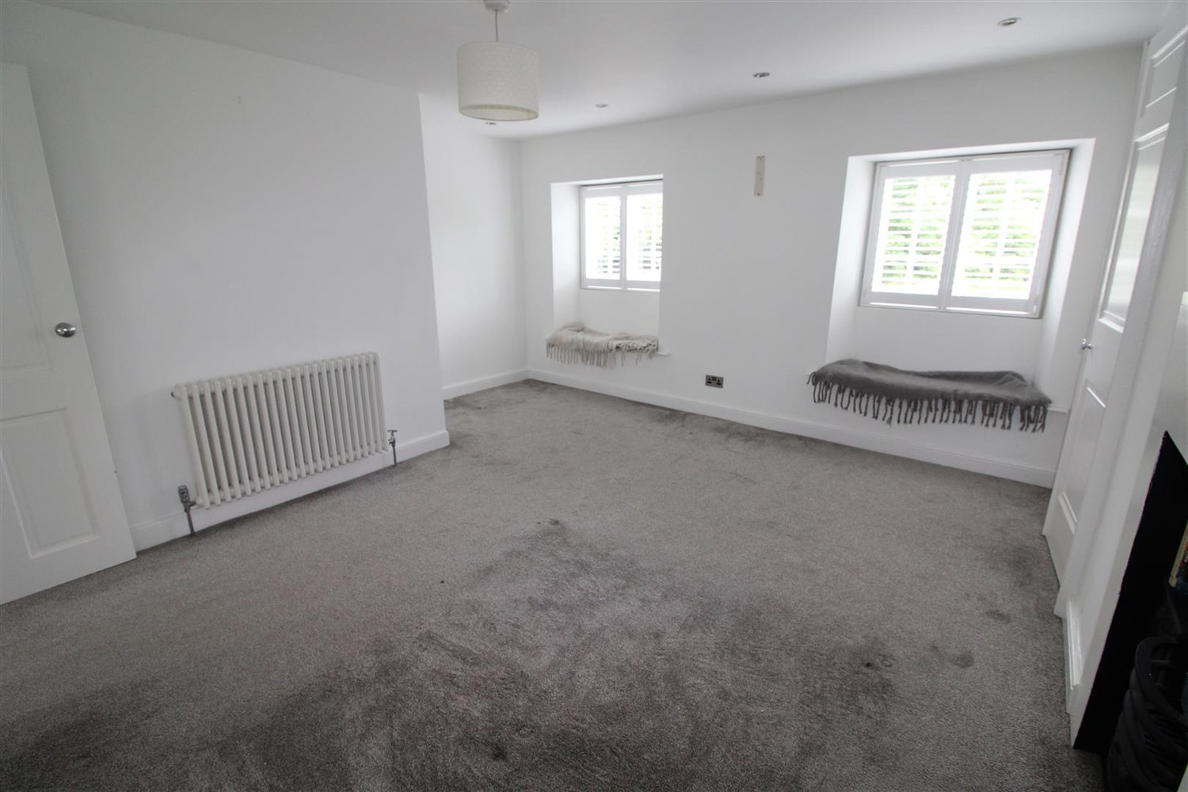

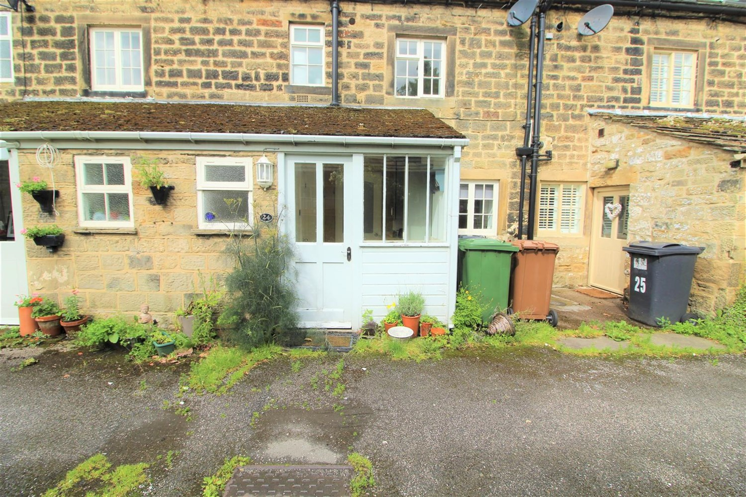

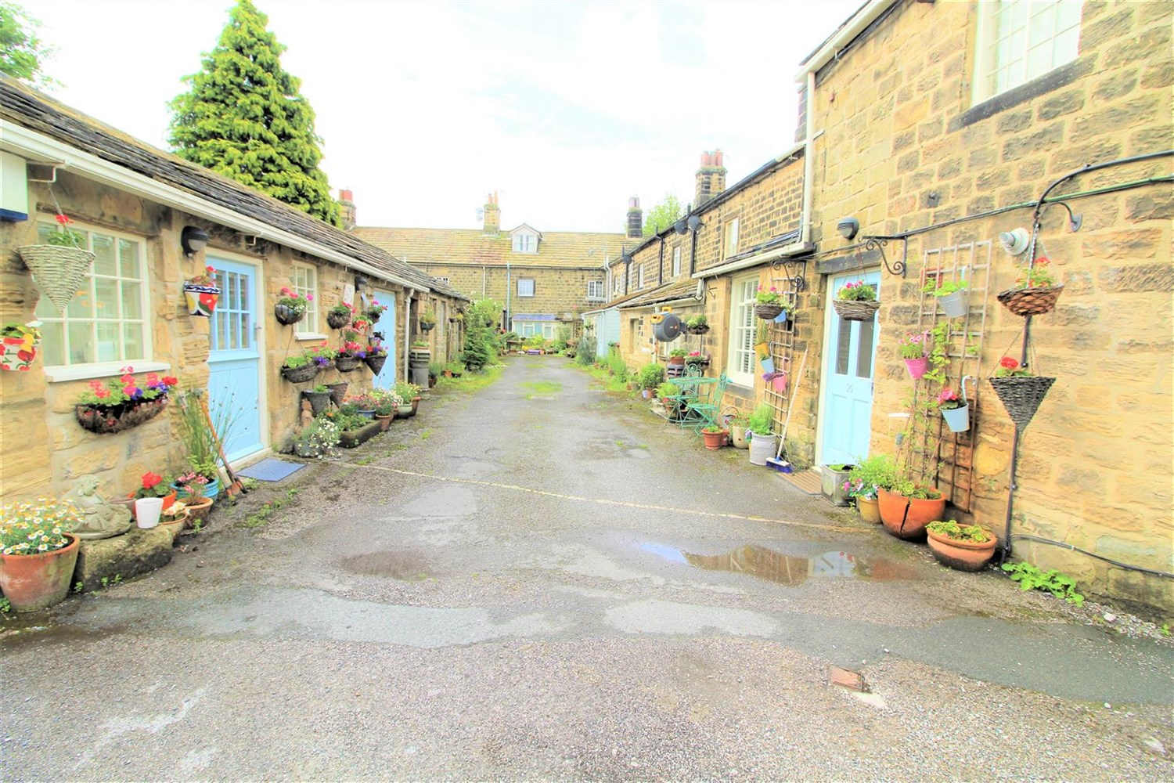

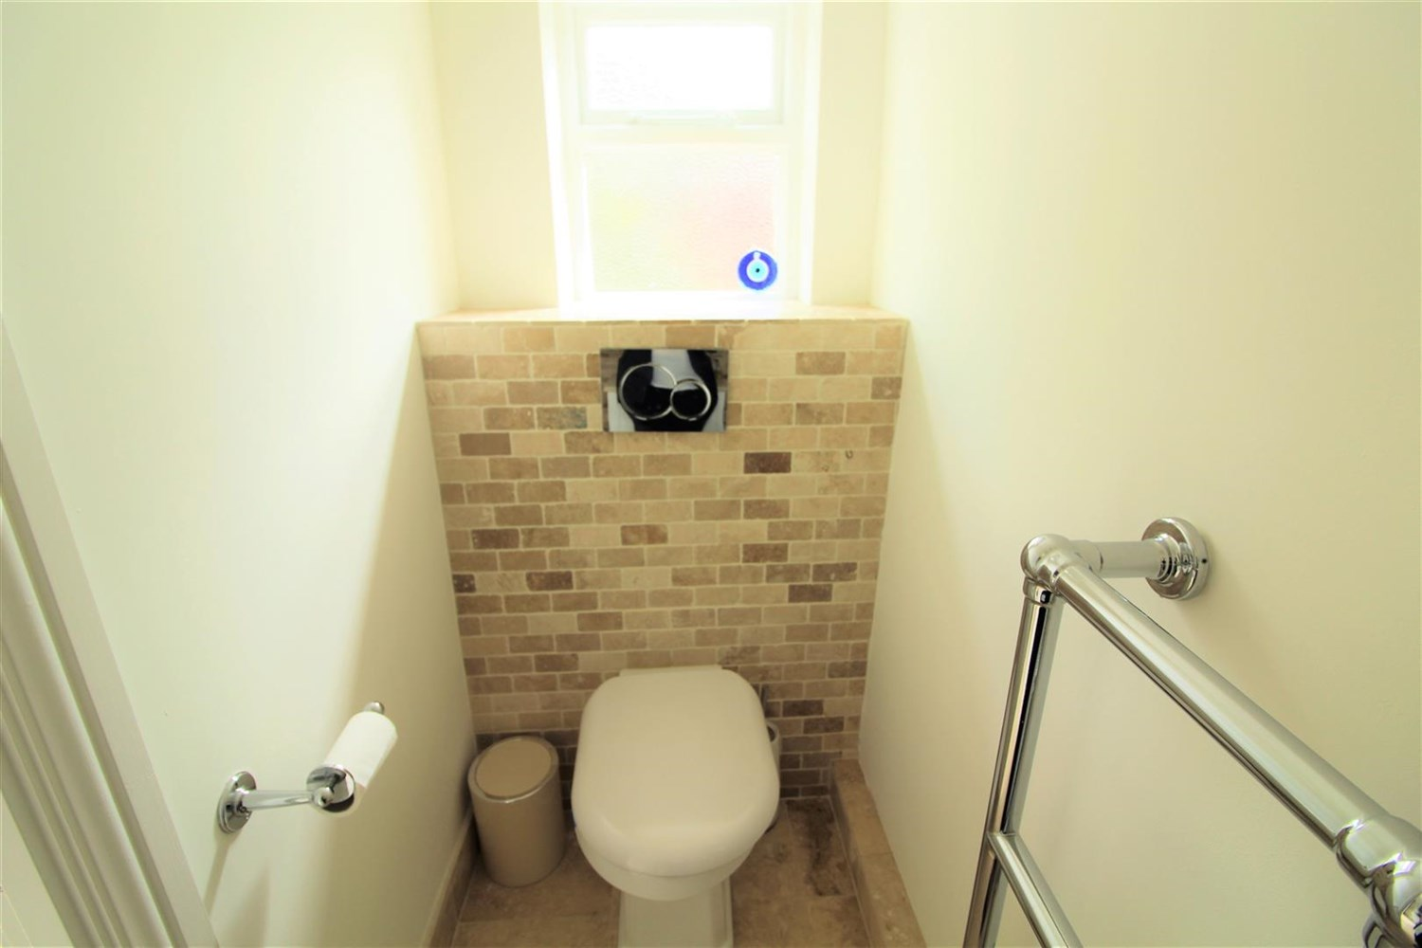

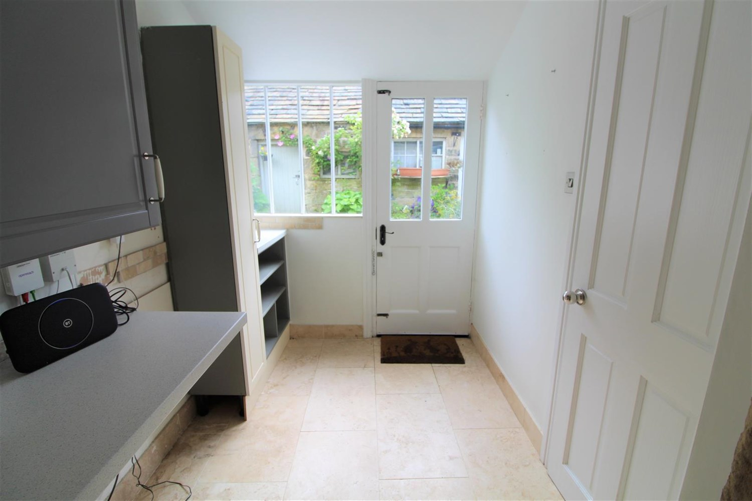

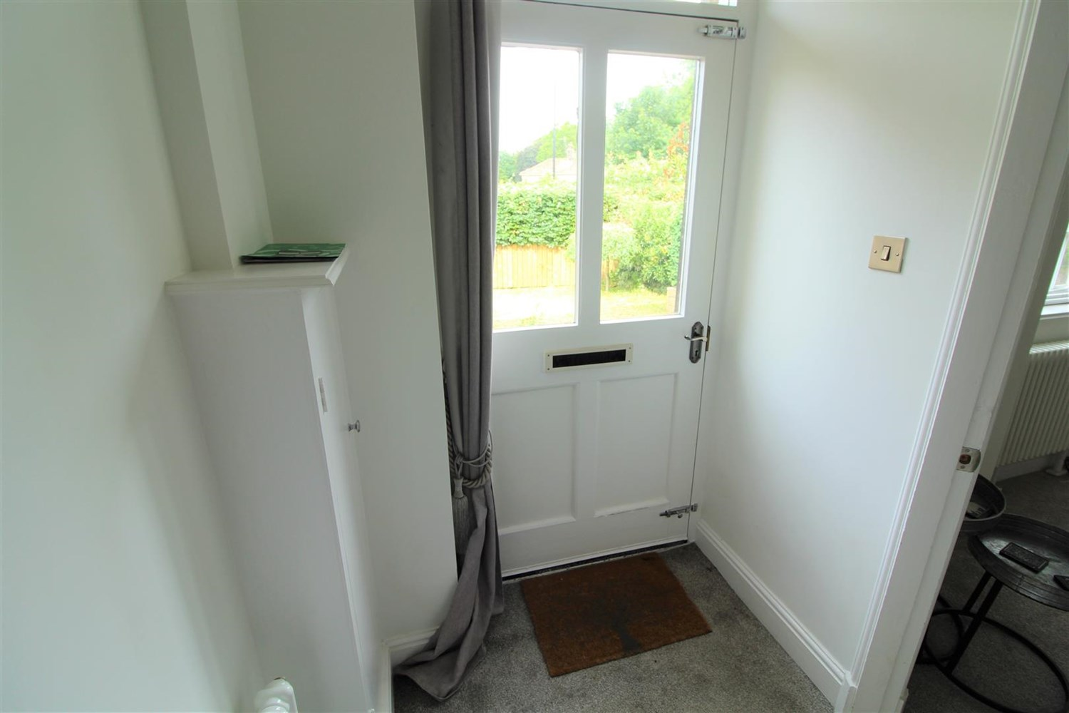

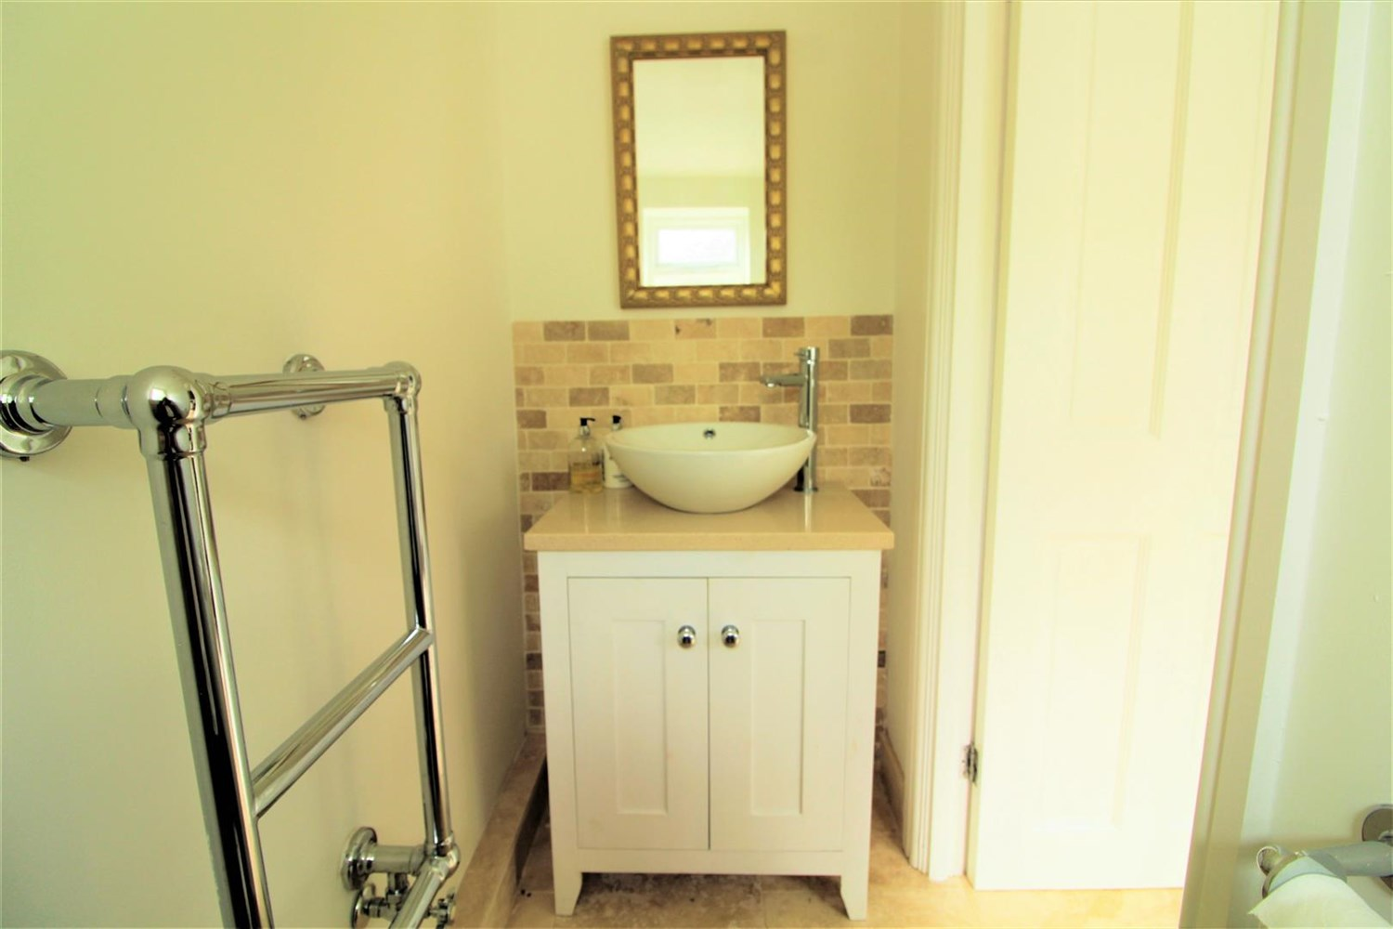

|  |
| --- |
| **Living Room**  Stunning living room with log burner fire, window to front. |
| **Kitchen**  Fitted with a range of wall and base units with worktops over, Island with breakfast bar. Sink with mixer tap, window to rear and door leading to rear. |
| **Downstairs W/C**  W/C with hand wash basin, tiled walls. |
| **Bedroom 1**  Double bedroom with two windows to front, steel fire place for show. |
| **Bedroom 2**  Double bedroom with window to rear. |
| **Bathroom**  Three piece white bathroom suite with shower over bath, shower screen, W/C and hand wash basin, tiled walls and floor, towel radiator, window to rear. |
| **Home Information**  COUNCIL TAX BAND: B EPC Rating: C  Leasehold property Parking Available  Mobile availability: EE limited coverage. Three likely to have good coverage. O2 likely to have good coverage. Vodafone likely to have good coverage. Broadband: Standard 18 Mbps 1 Mbps Good Superfast --Not available --Not available Unlikely Ultrafast --Not available --  Utilities: Water supplied on standard meters. Electric mains supplied on standard meters. |

|  |  |
| --- | --- |
| These particulars are intended to give a fair description of the property, but their accuracy cannot be guaranteed, and they do not constitute an offer of contract. Intending purchasers must rely on their own inspection of the property. None of the above appliances/services have been tested by ourselves. We recommend purchasers arrange for a qualified person to check all appliances/services before legal commitment.  **Property Ref:** 1930  **For more information, please contact**  0113 258 1150 **|** [lettings@adairpaxton.co.uk](mailto:lettings@adairpaxton.co.uk) **|** www.adairpaxton.co.uk |  |