

**Stanhope Avenue, Horsforth**

**To Let £2,500.00pcm**

***ADAIR PAXTON ARE DELIGHTHED TO OFFER THIS SUPERB, FIVE BEDROOM SEMI DETACHED HOUSE*** The property is conveniently located close to Horsforth train station, reputable schools and amenities. This extremely spacious home has lots of character features combined with a modern, stylish theme throughout! This family home is set over three floors and briefly comprises; entrance hall, spacious lounge, dining room, fitted kitchen with access out to the garden. To the first floor there are two double rooms both with cast iron fireplaces, a single bedroom and luxurious house bathroom. To the second floor are two further double bedrooms and Jack & Jill bathroom with access from both the bedrooms! Fully enclosed stone wall garden with decking to the immediate rear and lawned garden. Driveway. Furnished, Council tax band E, EPC rating E, Deposit £2880. Available 1st July 2025!

**0113 258 1150**

**0800 000 000**

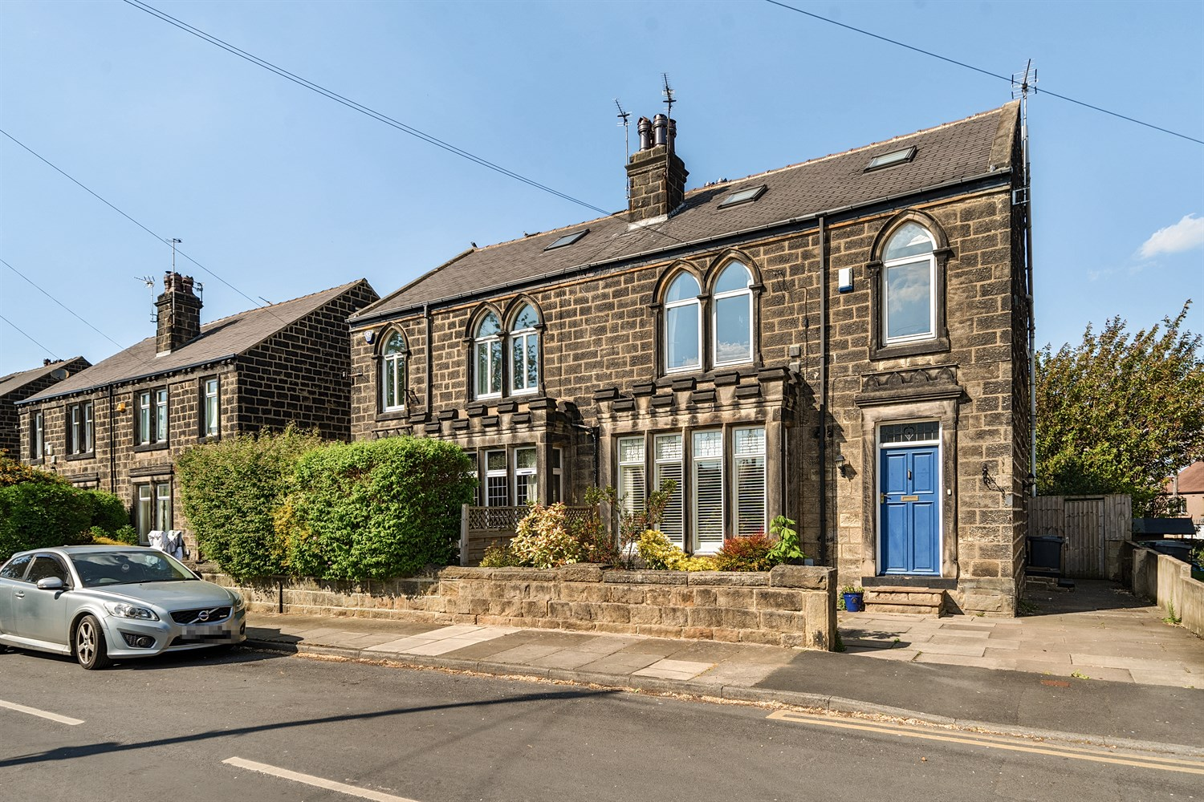

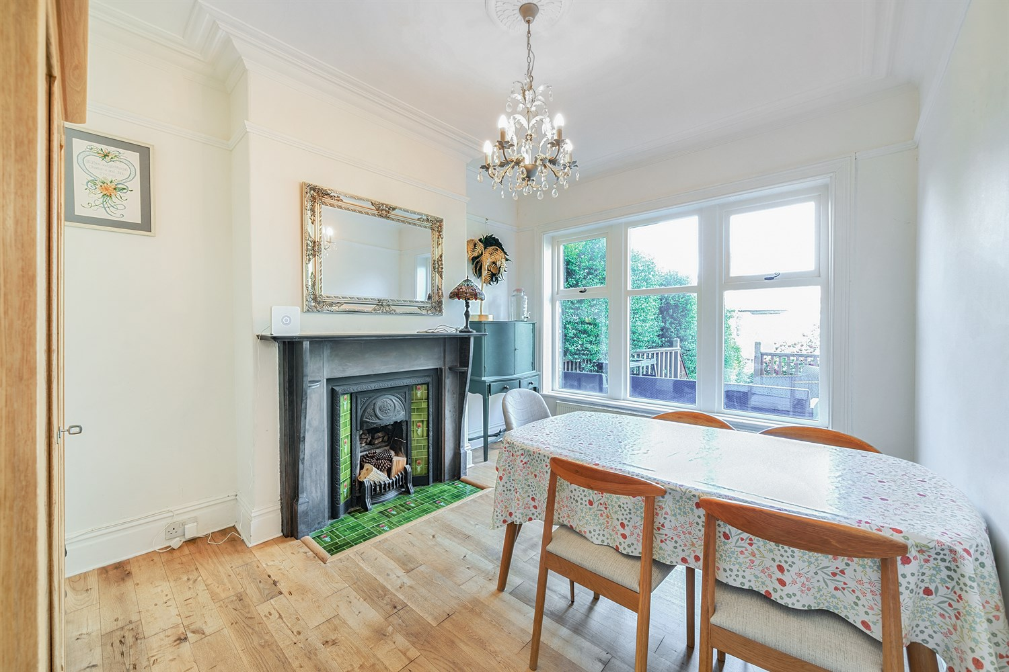

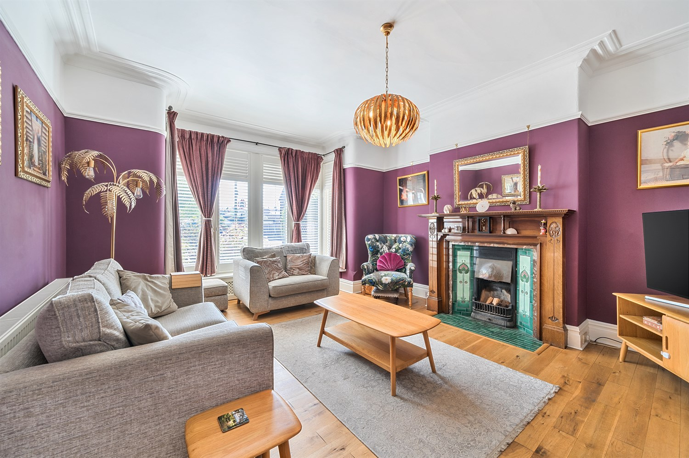

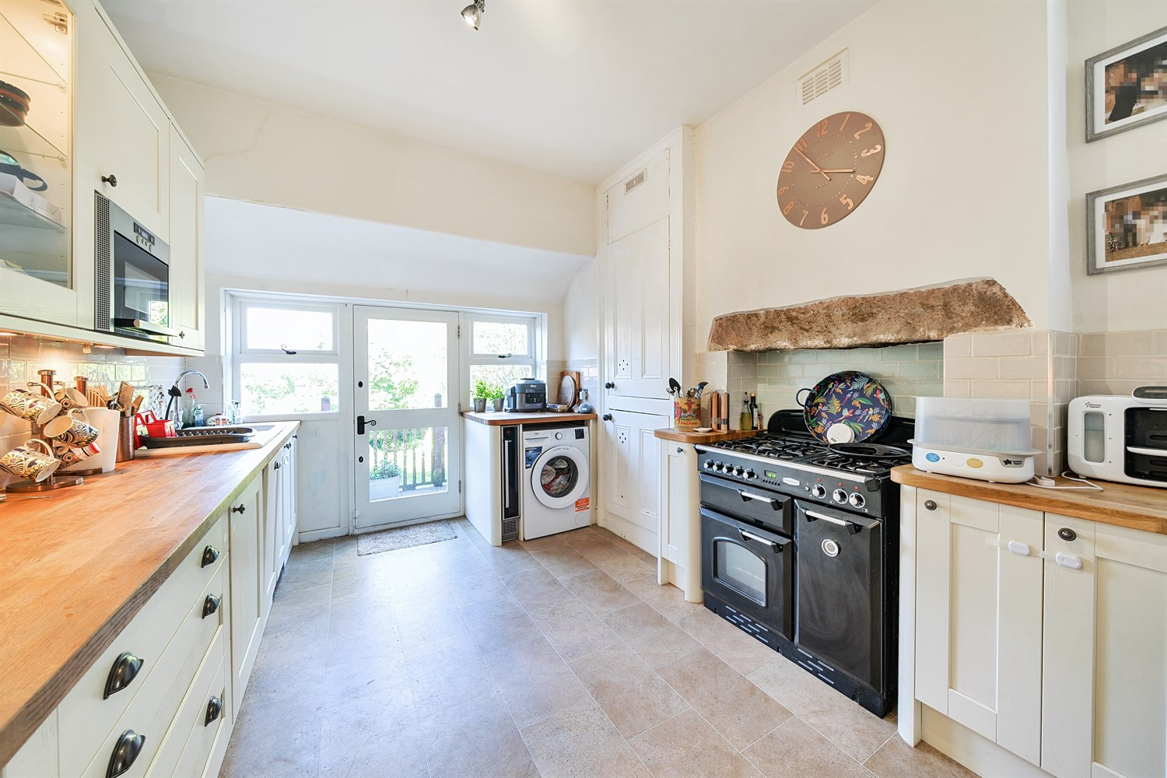

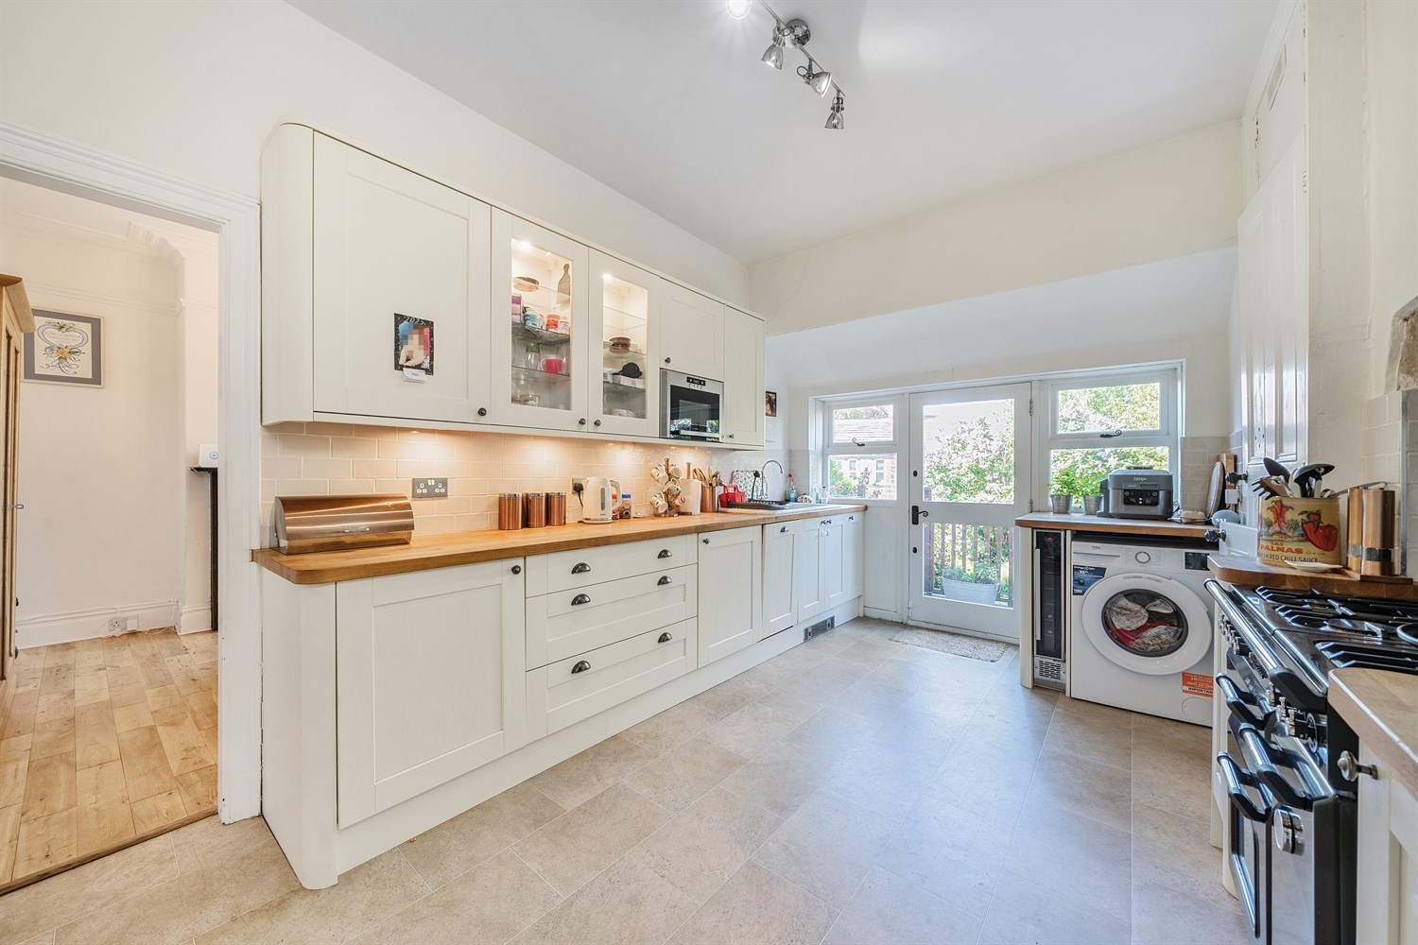

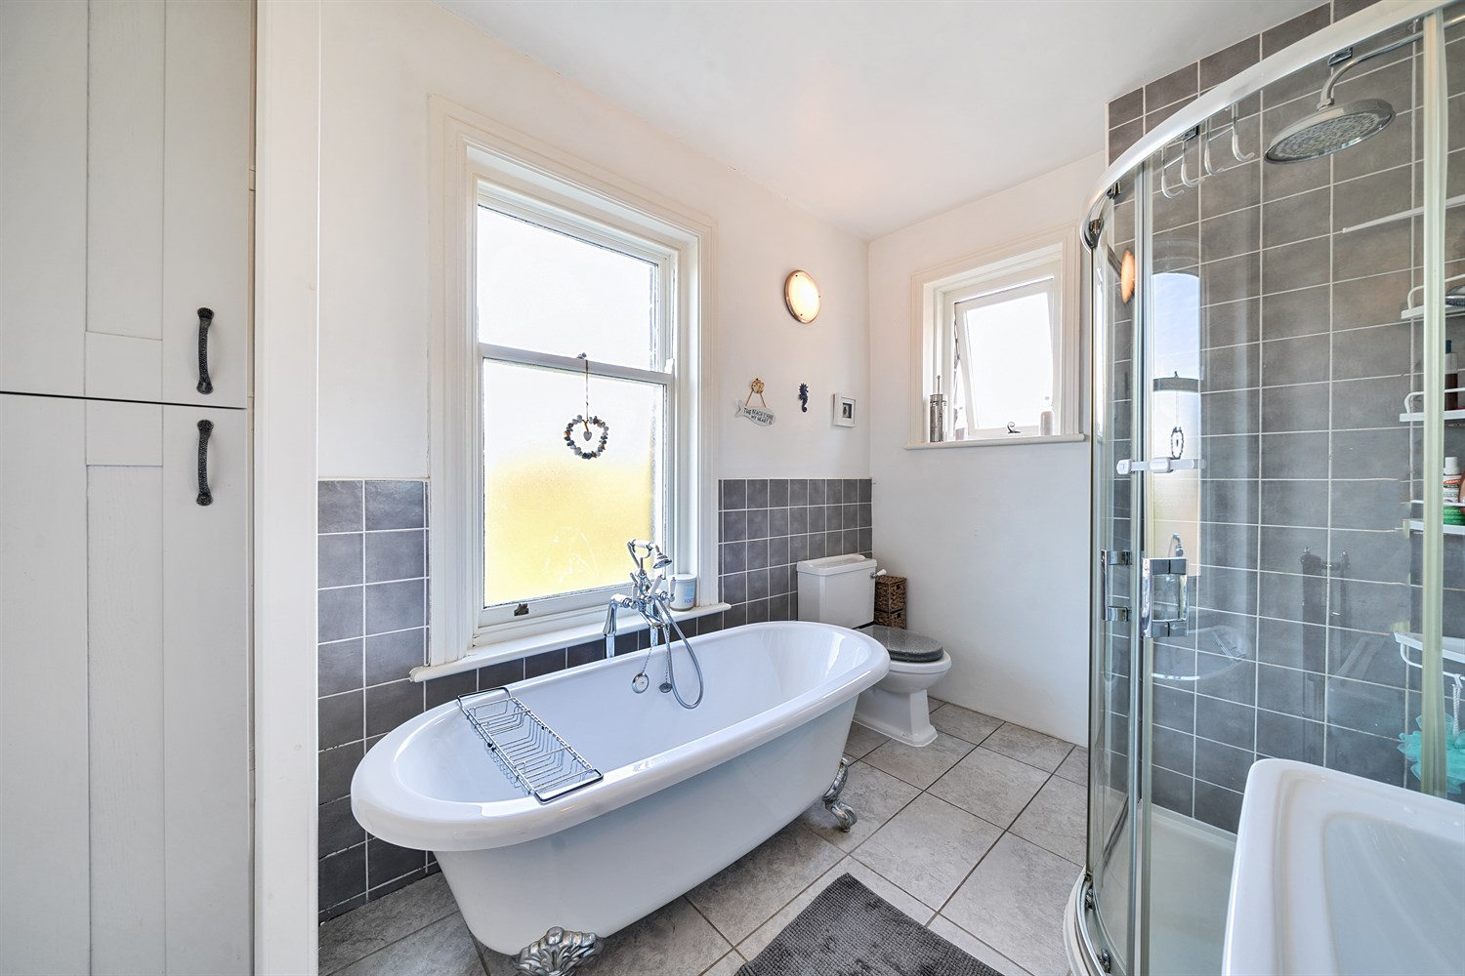

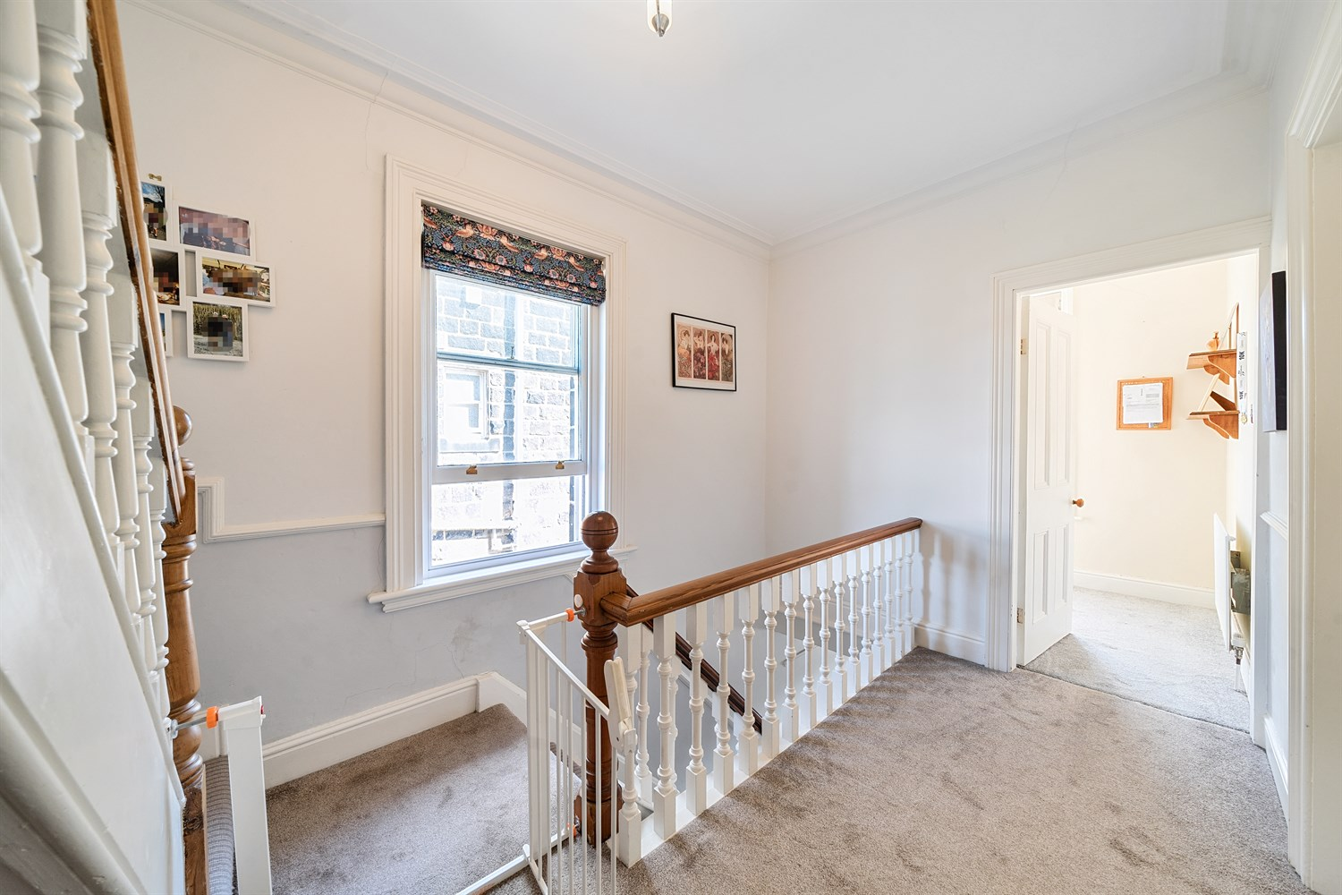

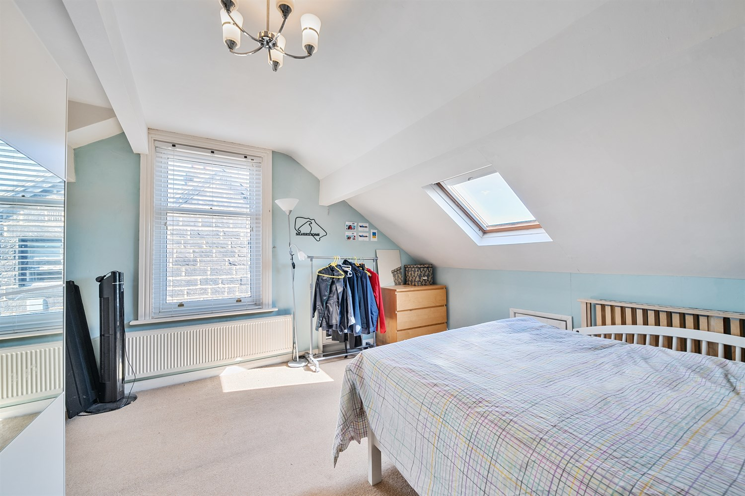

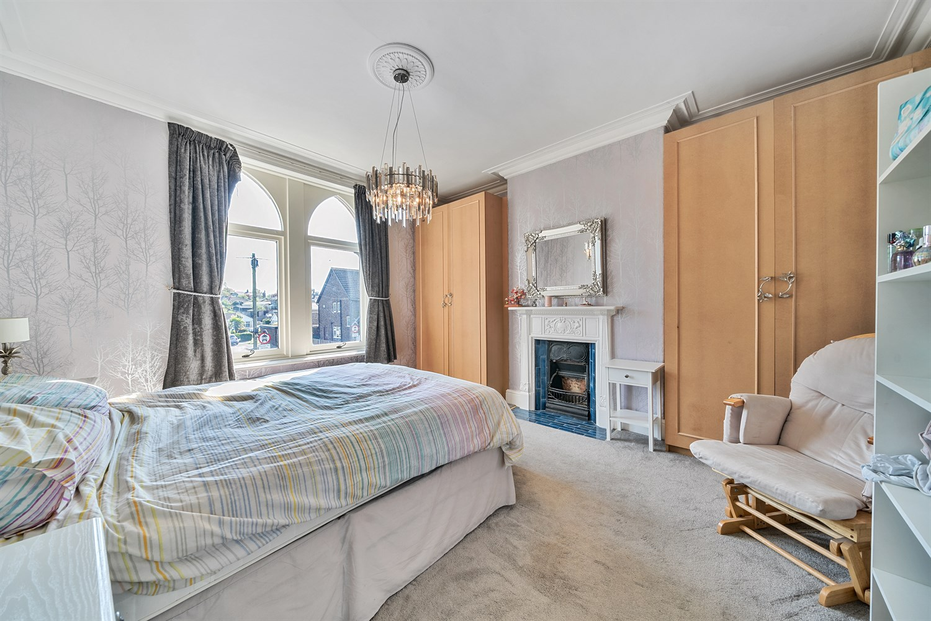

|  |
| --- |
| **Entrance Hall**  Impressive hallway with real character and stained glass door to kitchen, staircase up to first floor. |
| **Reception 1 5.08m (16'8) x 4.36m (14'4)**  A beautiful, spacious lounge with stunning black fireplace with cast iron inset and wood surround. Retaining feature picture rail and ceiling coving and with solid oak flooring. Lots of natural light large window to the front. |
| **Kitchen 4.7m (15'5) x 3.2m (10'6)**  Fitted kitchen with a range of wall and base units with solid timber worktops. Ceramic sink with mixer tap. Integrated wine cooler, dishwasher and fridge freezer. Range style gas cooker. Glass door to the rear of the kitchen leading on to the decking area. Wooden door to side. |
| **Dining Room 4.03m (13'3) x 3.28m (10'9)**  A lovely, light and airy room with feature fireplace with cast iron inset and tiled hearth and pleasant outlook over the rear garden. |
| **Bathroom**  Large four piece house bathroom with roll top, free standing bath, large walk in shower, WC and pedestal wash hand basin. A lovely modern, light and airy space with dual aspect to the rear and side elevations. |
| **First Floor**  A generous, light and airy landing with feature timber and balustrade staircase from ground floor and up to second floor. |
| **Bedroom 1 4.26m (14') x 4.14m (13'7)**  A large double bedroom with natural light from the window to the front, high ceiling and feature cast iron fireplace. |
| **Bedroom 2 4.07m (13'4) x 3.32m (10'11)**  A second double bedroom, with high ceiling and cast iron fireplace. Window facing the rear of the property Fitted wardrobes and long distance views. |
| **Bedroom 3 2.41m (7'11) x 2.1m (6'11)**  Single bedroom with feature window. |
| **Second Floor**  Access to both bedroom and bathroom. |
| **Bedroom 4 4.12m (13'6) x 3.98m (13'1)**  A double room room at the top of the house with amazing views to the rear elevation and Velux window. Access to Jack and Jill bathroom. |
| **Bedroom 5 6.19m (20'4) x 2.44m (8'0)**  Double bedroom with window to rear. Access to Jack and Jill bathroom. |
| **Jack and Jill Bathroom**  A good size and planned to service both bedrooms, compromising of bath with shower over, WC and hand wash basin. window to the rear. part tiled. |
| **Small Garden**  Driveway to the front and a fully enclosed garden to rear with a decked area and mainly lawned with shrubs around the outer garden. |
| **Cellar**  Large cellar good size for storage. |
|  |

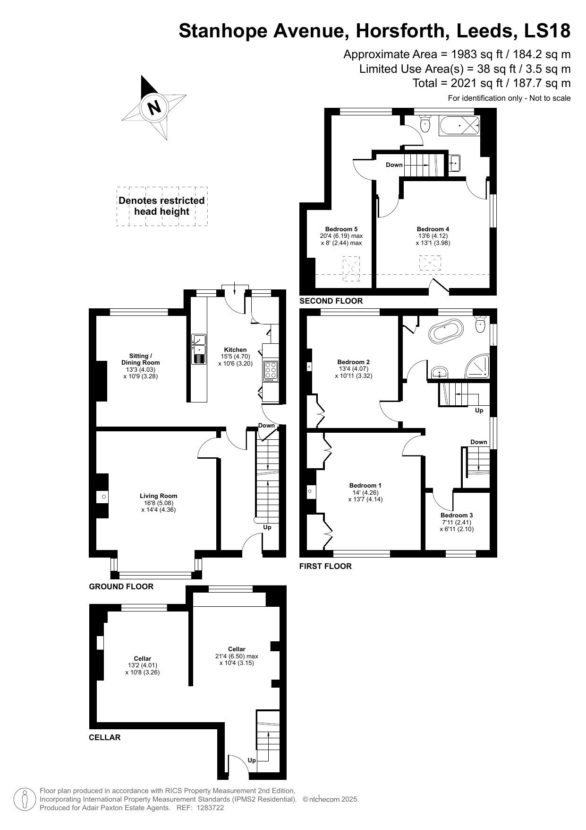

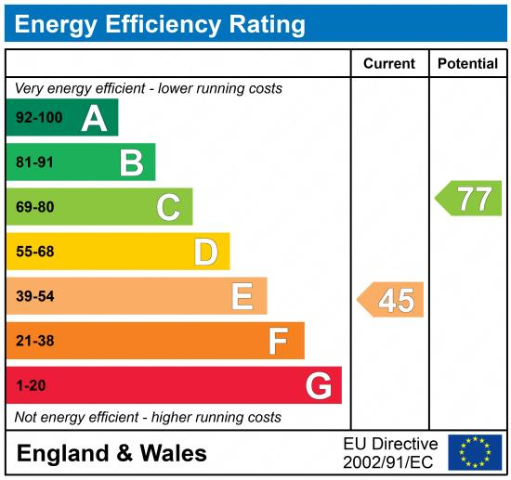

|  |
| --- |
|  |

These particulars are intended to give a fair description of the property, but their accuracy cannot be guaranteed, and they do not constitute an offer of contract. Intending purchasers must rely on their own inspection of the property. None of the above appliances/services have been tested by ourselves. We recommend purchasers arrange for a qualified person to check all appliances/services before legal commitment.

**Property Ref:** 5634

**For more information, please contact**

0113 258 1150 **|** [lettings@adairpaxton.co.uk](mailto:lettings@adairpaxton.co.uk) **|** www.adairpaxton.co.uk