

**0113 258 1150**

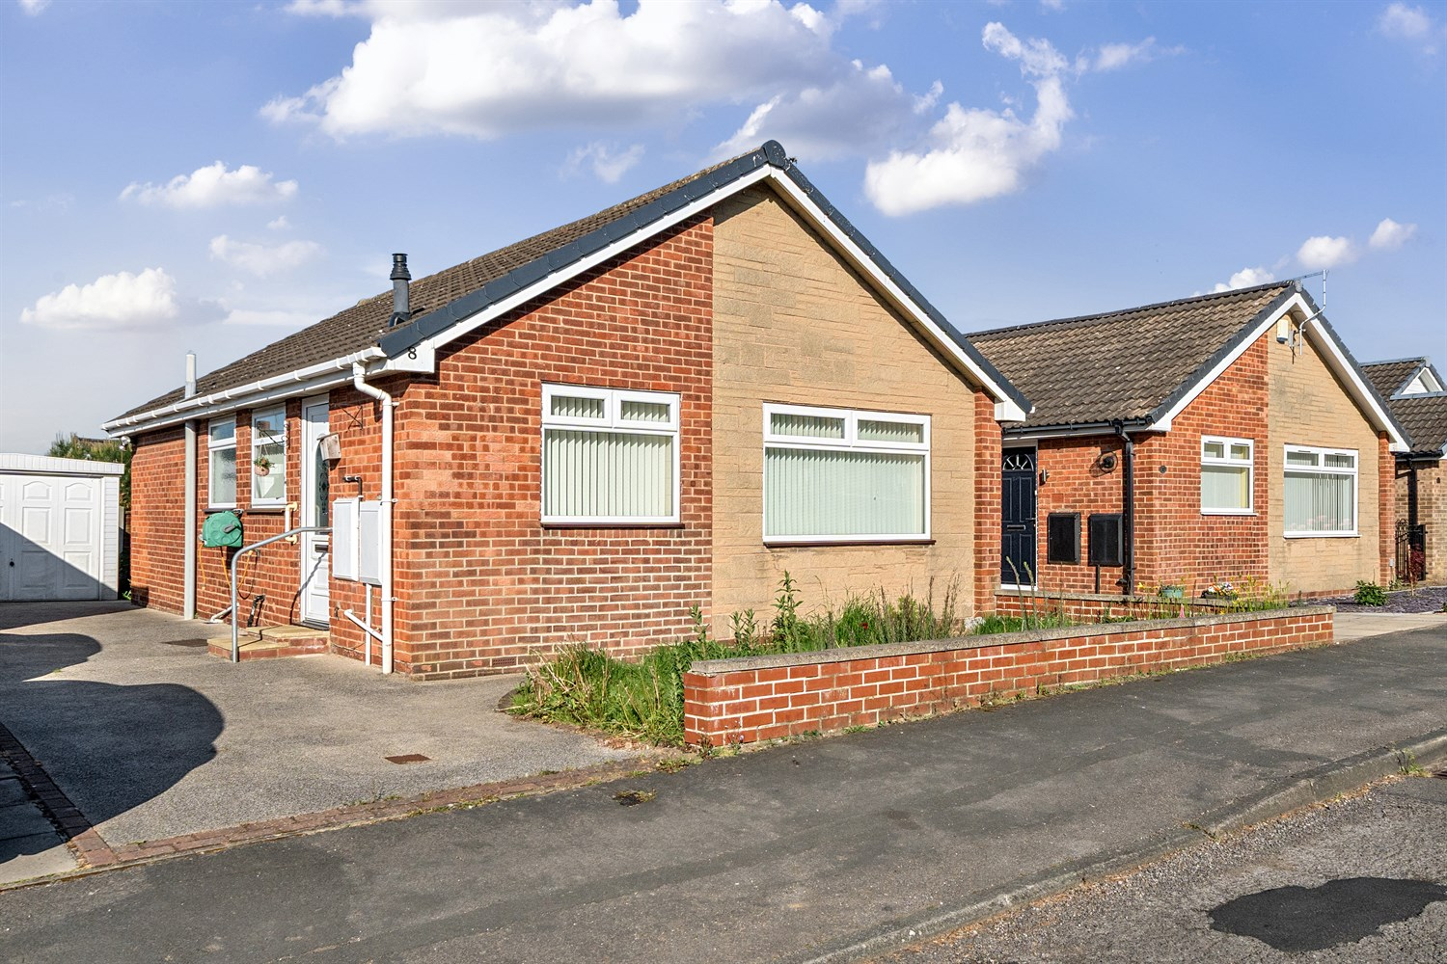



**For Sale £235,000.00**

**Baildon Avenue, Kippax**

**TWO BEDROOM DETACHED BUNGALOW with NO ONWARD CHAIN** Situated in this popular residential area of Kippax, having easy access to local shops, schools and public transport and within easy reach of the A1/M1 motorway. The property is now in need of updating and briefly comprises; dining kitchen, lounge, two double bedrooms and a house bathroom. Externally, the property has a driveway leading to a detached garage and a small garden to the rear.

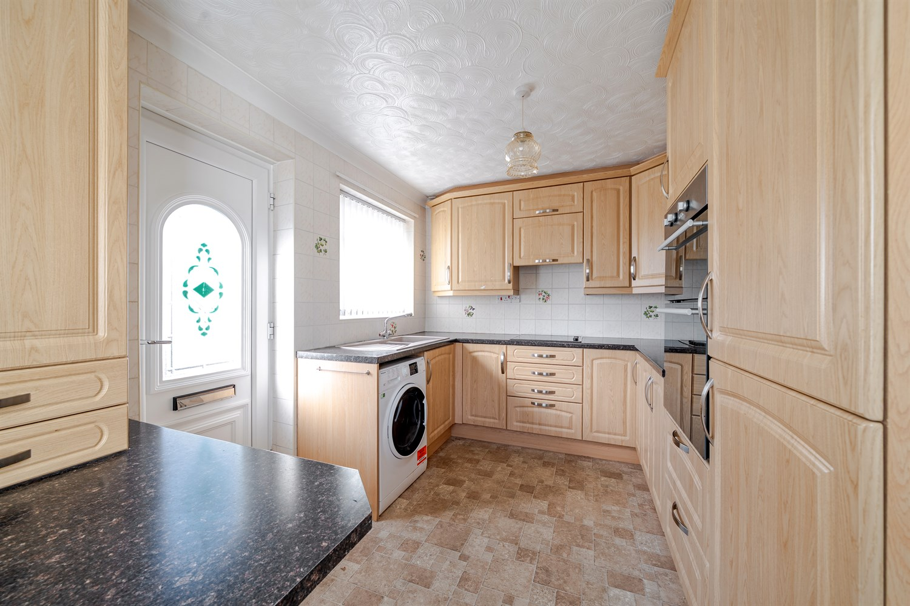

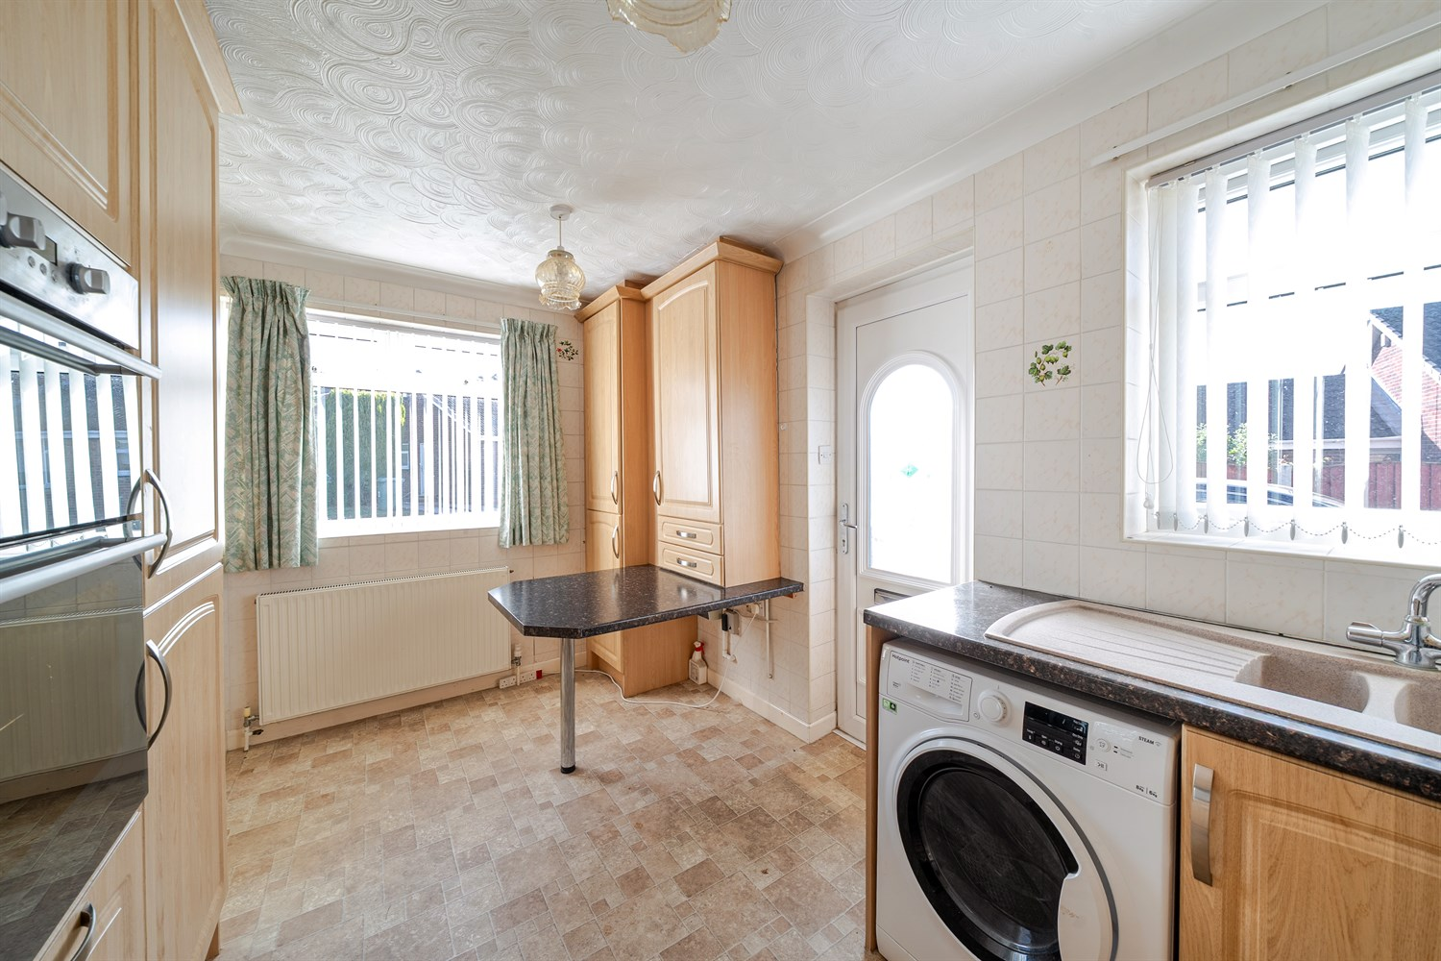

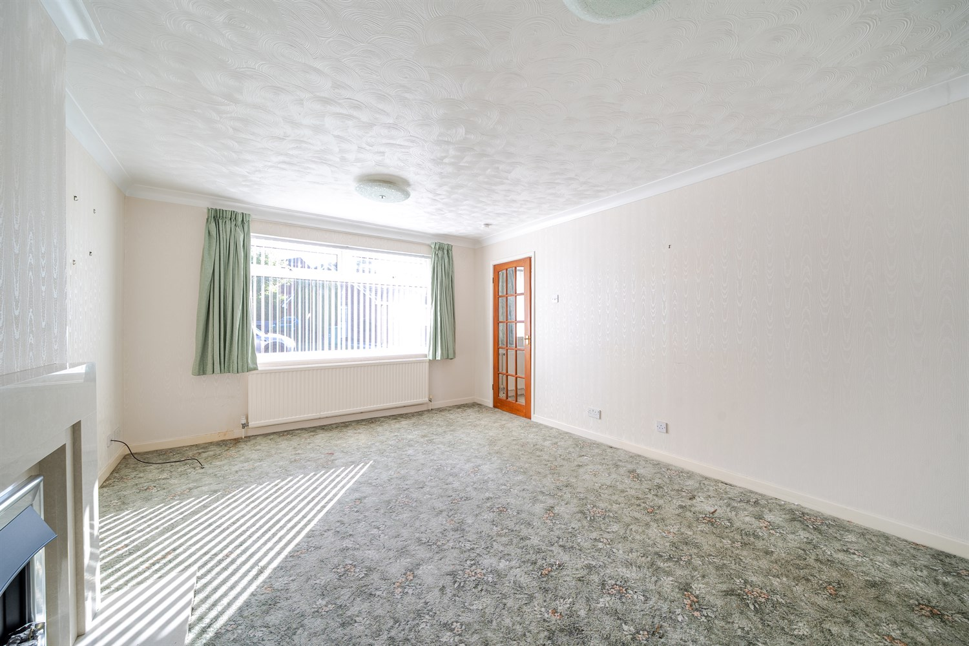

1 Bathroom(s)

1 Reception(s)

2 Bedroom(s)

00

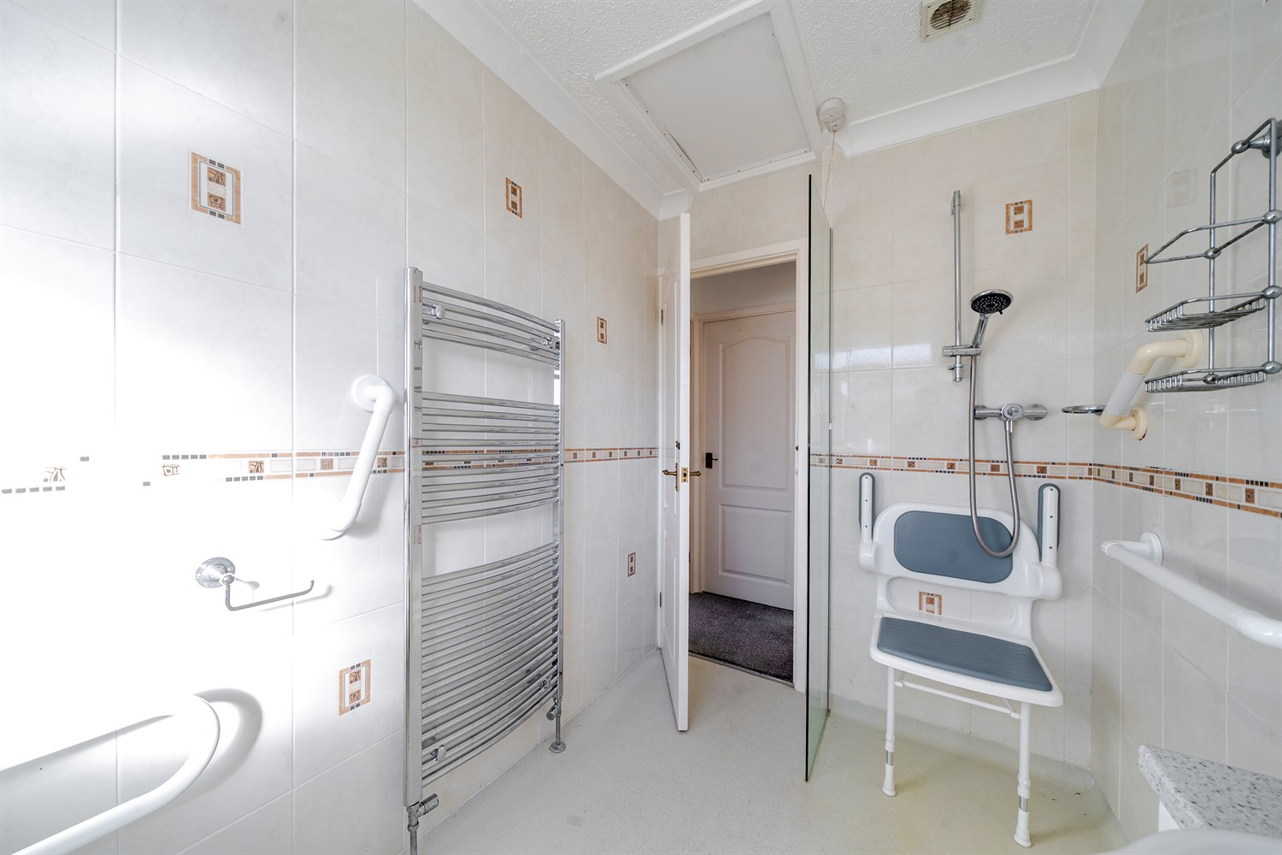

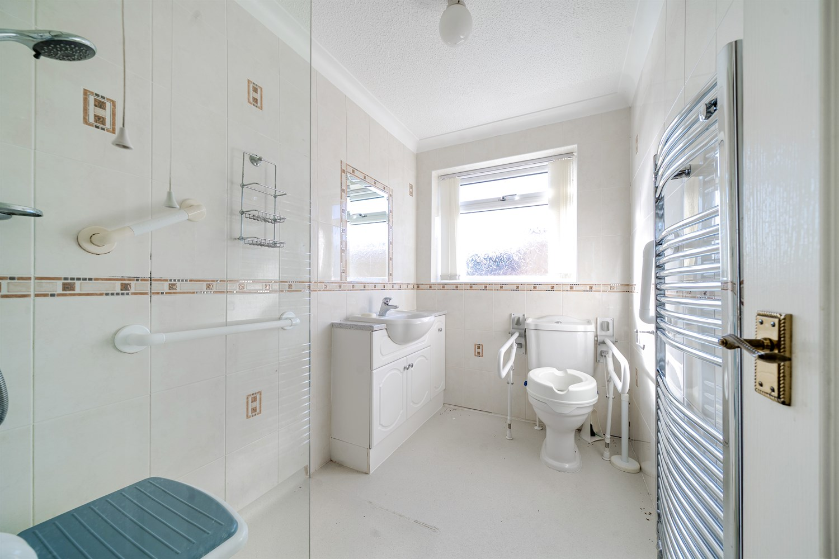

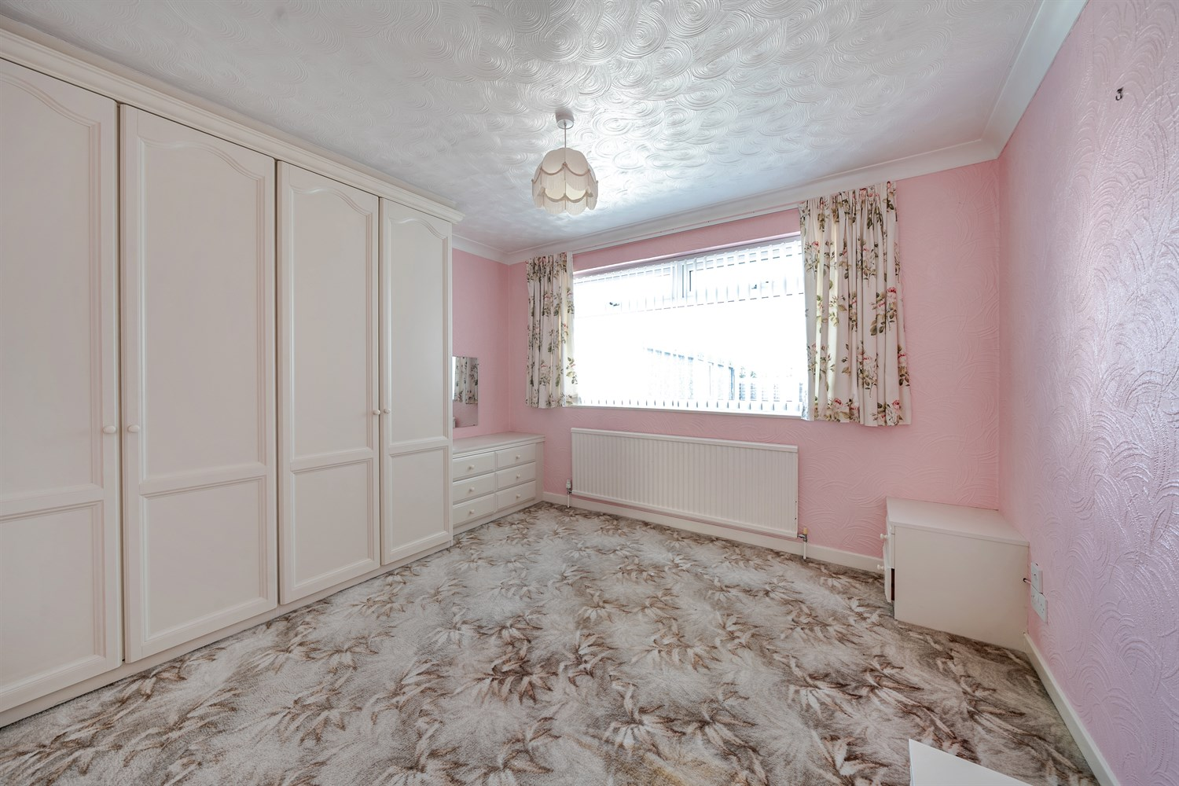

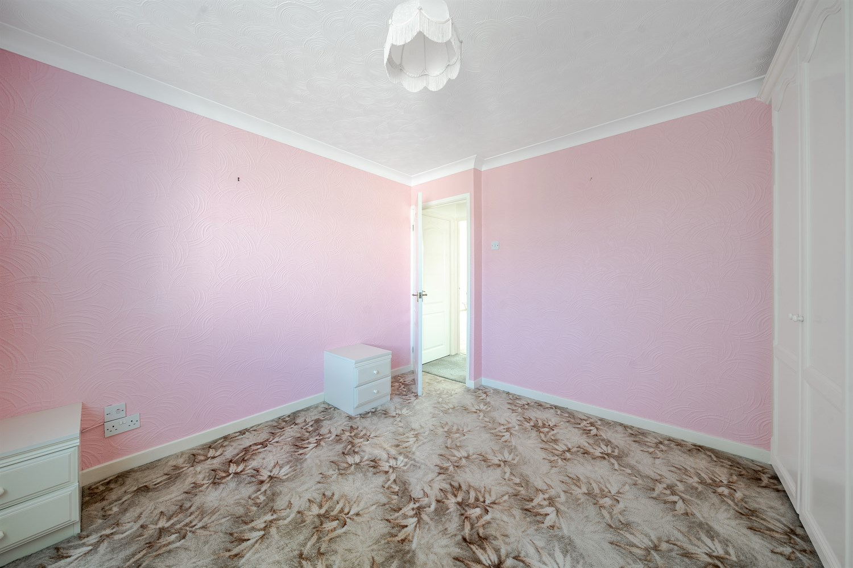

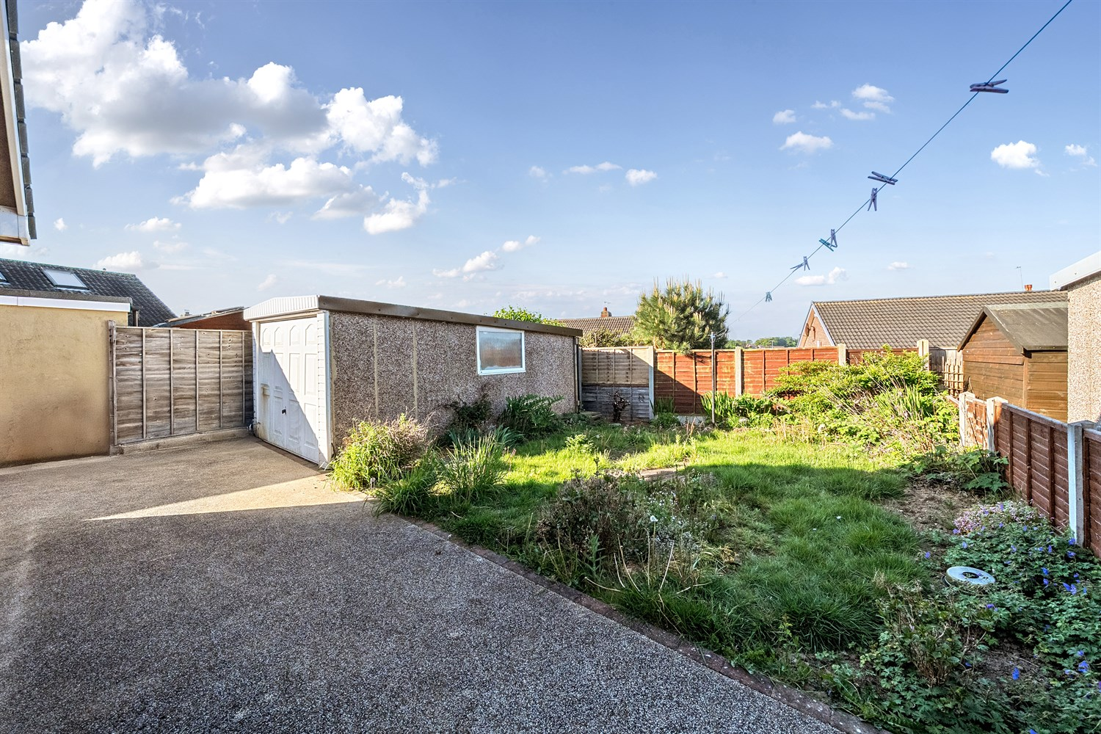

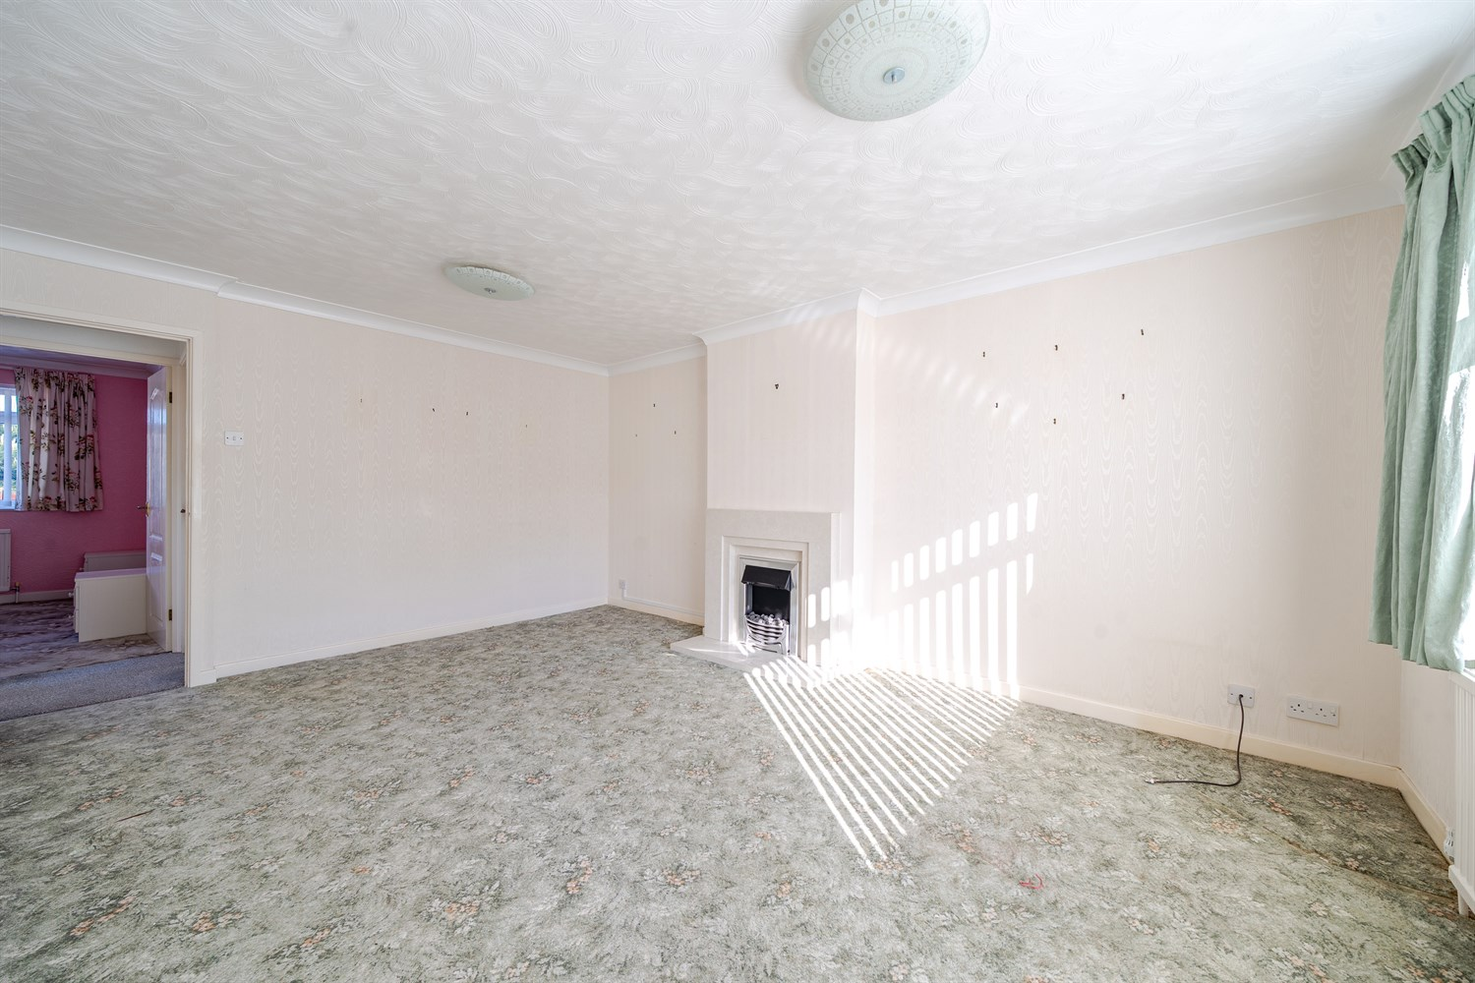

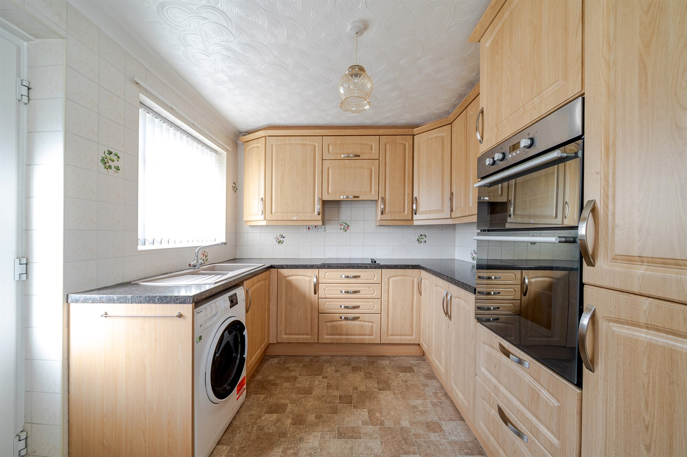

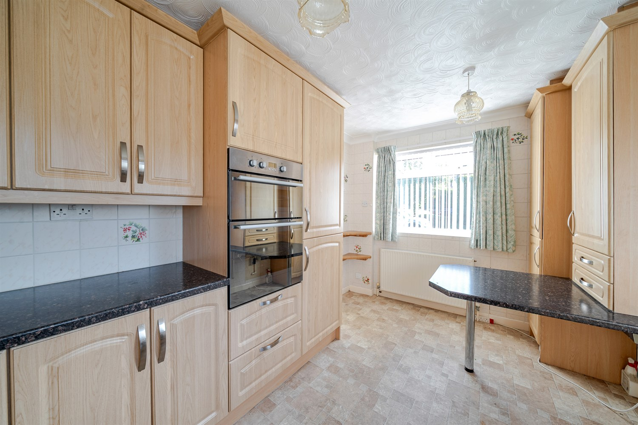

|  |
| --- |
| **Kitchen 4.14m (13'7) x 2.6m (8'6)**  Accessed via side entrance door. Fitted with a range of wall, base and drawer units with worktops over. Integrated oven, electric hob and extractor hood over. Stainless steel sink with mixer tap and drainer. Part tiled walls. uPVC double glazed window to side. |
| **Reception 1 5.02m (16'6) x 3.72m (12'2)**  Light and airy living room with uPVC double glazed window to front. Gas central heating radiator. |
| **Bedroom One 3.49m (11'5) x 3.33m (10'11)**  Double bedroom with uPVC double glazed window to rear. Built in wardrobes. Gas central heating radiator. |
| **Bedroom Two 4.04m (13'3) x 2.82m (9'3)**  Second double bedroom with uPVC double glazed to rear. |
| **Shower Room**  Walk in shower cubicle, WC and wash hand basin. Wall mounted heated towel rail. Double glazed window. |
| **Outside**  To the front of the property is a small garden with a shared driveway leading to a detached garage. To the rear of the property is a lawned garden. |
| **Garage**  Detached garage with up and over door. |
| **Parking** |

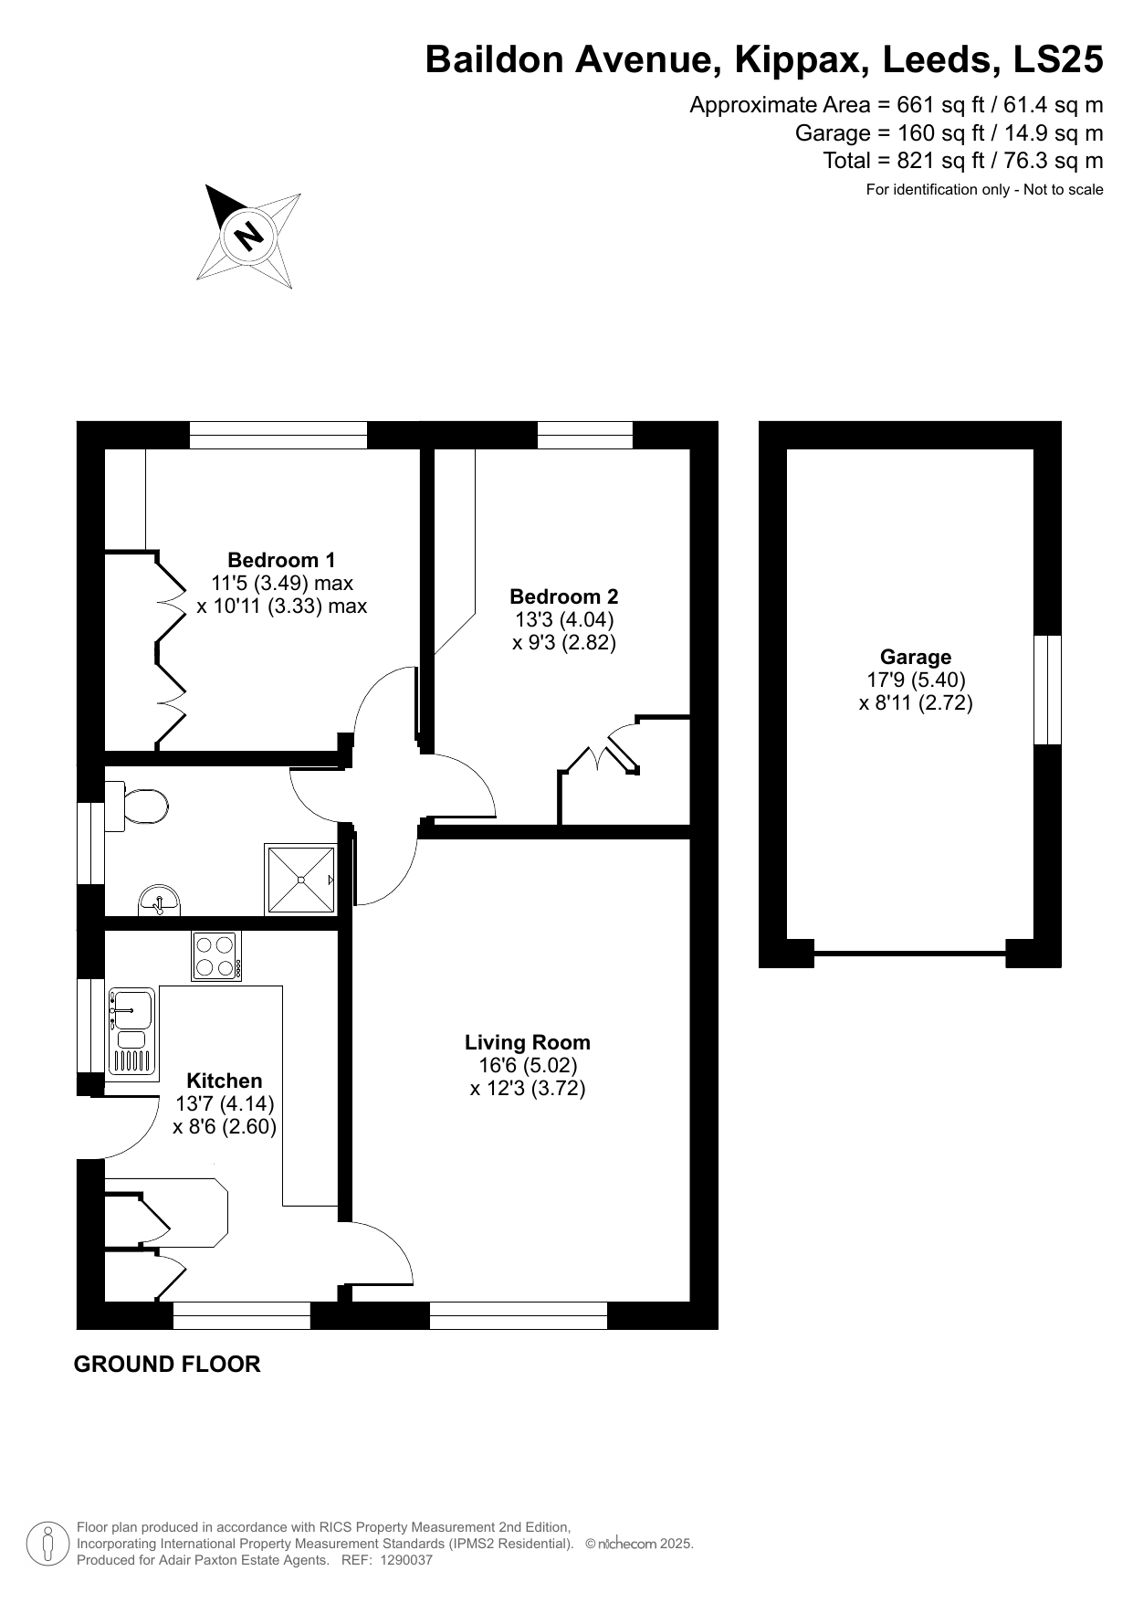

|  |  |
| --- | --- |
| These particulars are intended to give a fair description of the property, but their accuracy cannot be guaranteed, and they do not constitute an offer of contract. Intending purchasers must rely on their own inspection of the property. None of the above appliances/services have been tested by ourselves. We recommend purchasers arrange for a qualified person to check all appliances/services before legal commitment.  **Property Ref:** 6106  **For more information, please contact**  0113 258 1150 **|** [sales@adairpaxton.co.uk](mailto:sales@adairpaxton.co.uk) **|** www.adairpaxton.co.uk |  |