

**0113 258 1150**

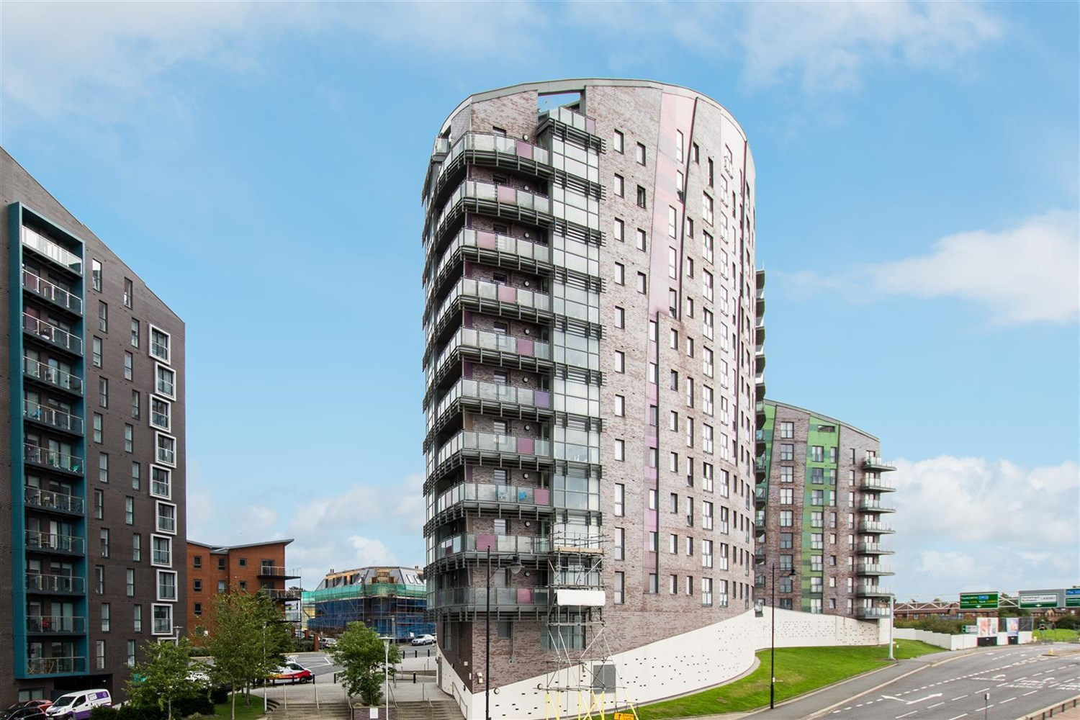



**Available to let £950.00pcm**

**Echo Central 1, LS9**

***TWO BED/TWO BATH APARTMENT WITH SECURE PARKING IN THIS POPULAR ECHO CENTRAL 1 DEVELOPMENT*** Great links to the motorway network and a short walk to all the amenities Leeds city centre has to offer. Briefly comprising; Entrance hallway, open plan lounge/dining/kitchen, two double bedrooms, the master having en-suite shower room, house bathroom, allocated parking space. Furnished. Council tax band C, EPC Rating C ,Bond £1,095. Available 30th May 2025.

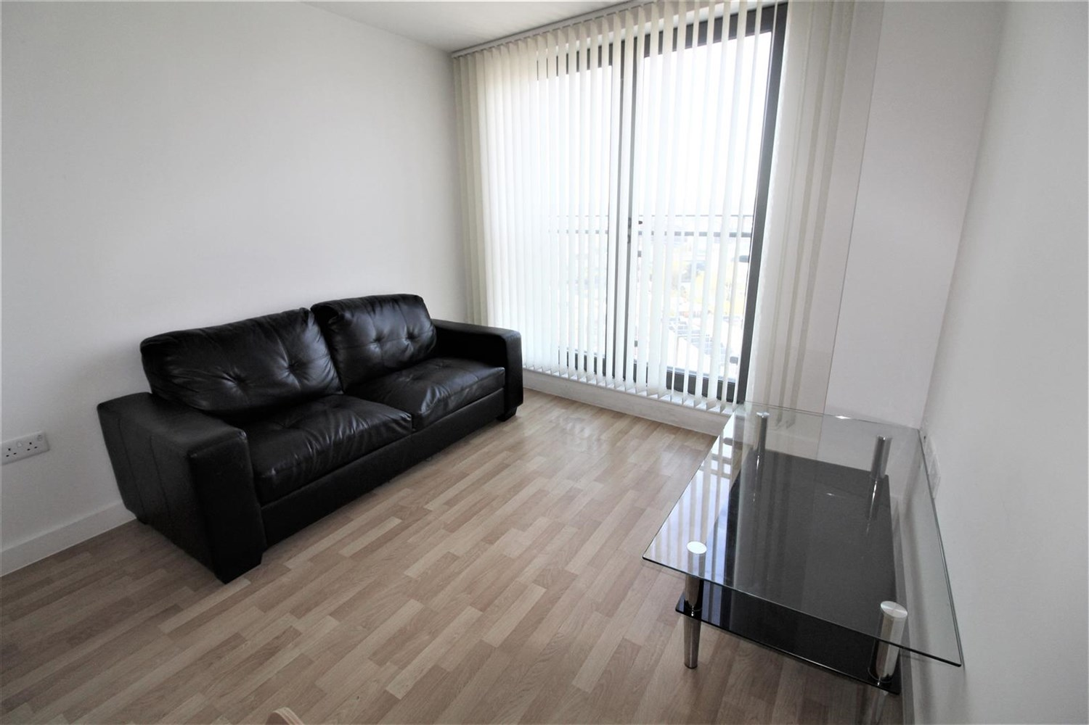

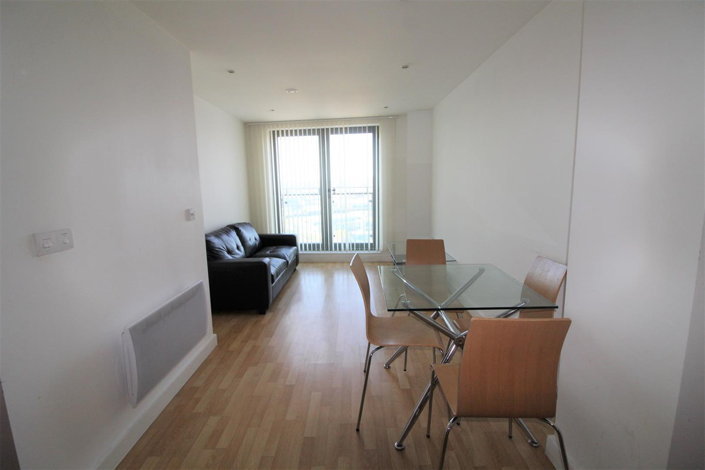

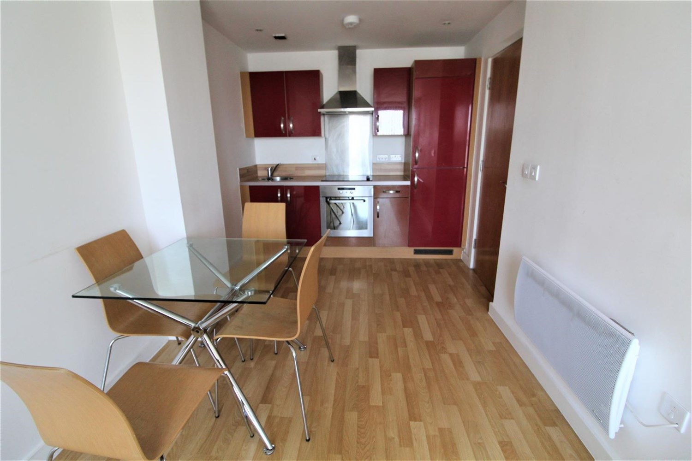

2 Bathroom(s)

1 Reception(s)

2 Bedroom(s)

00

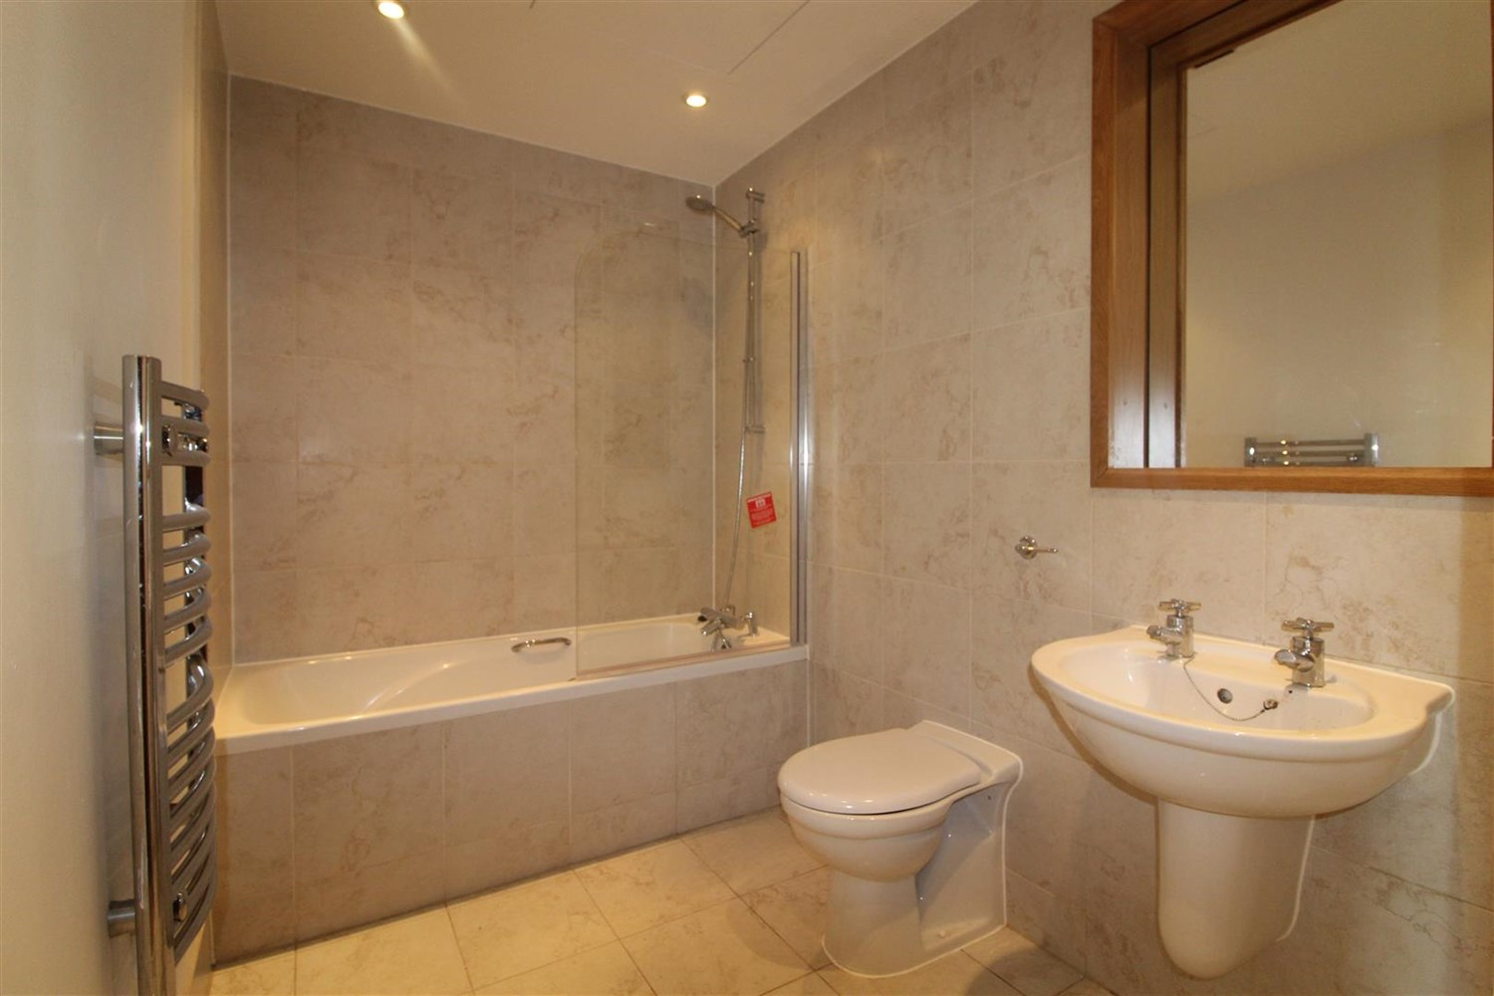

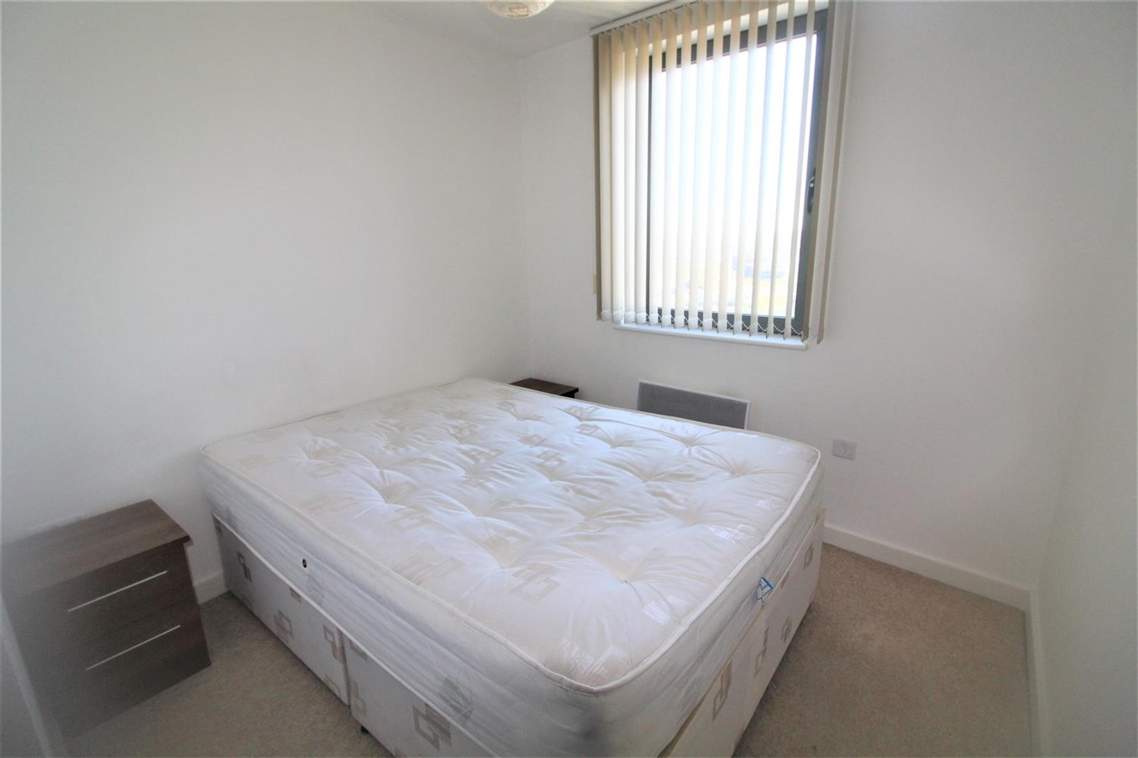

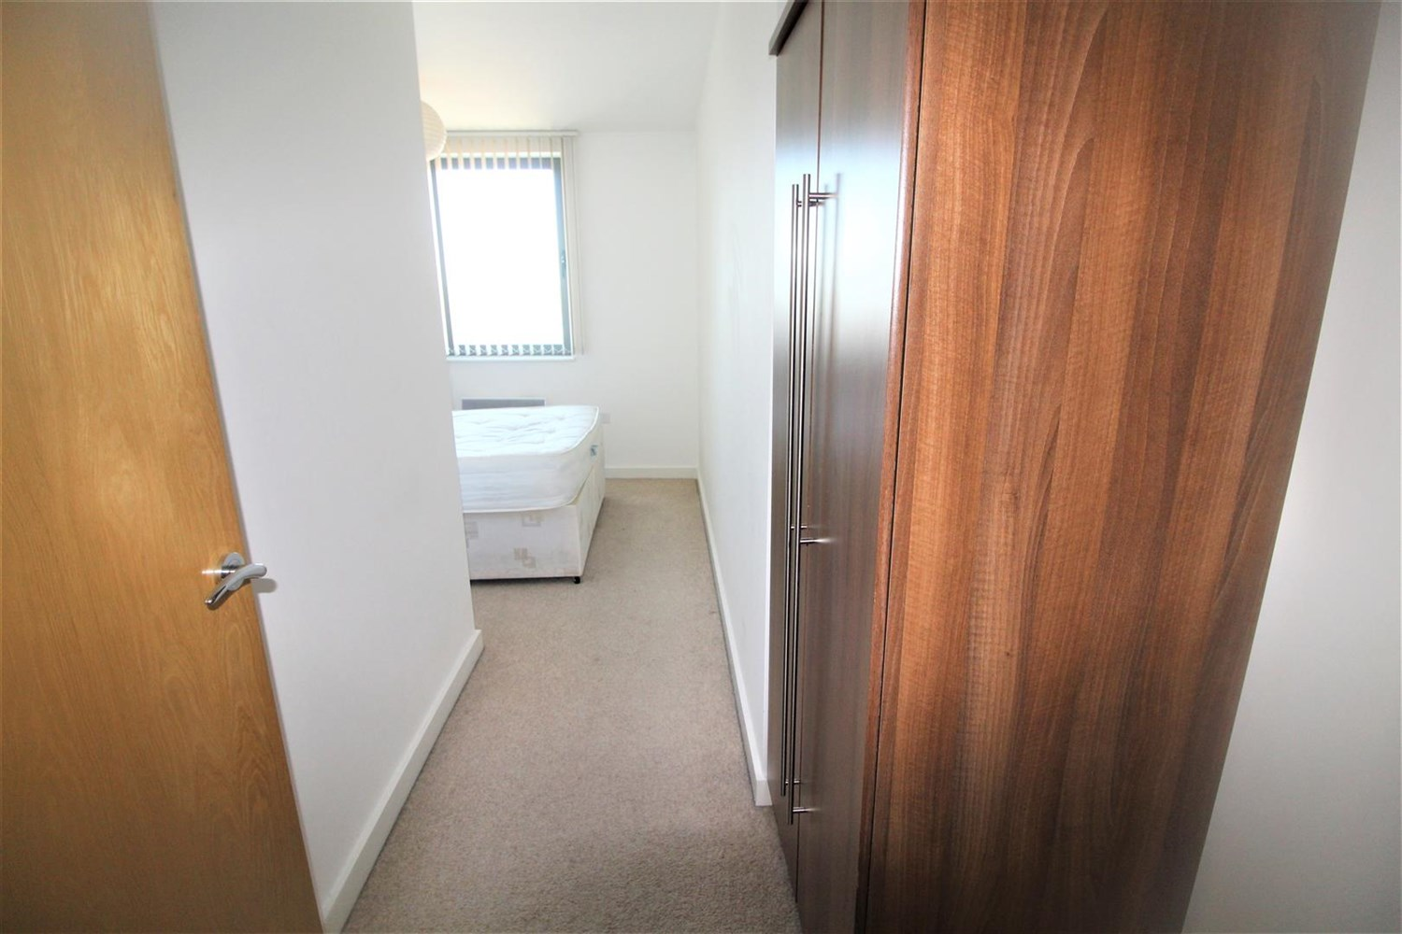

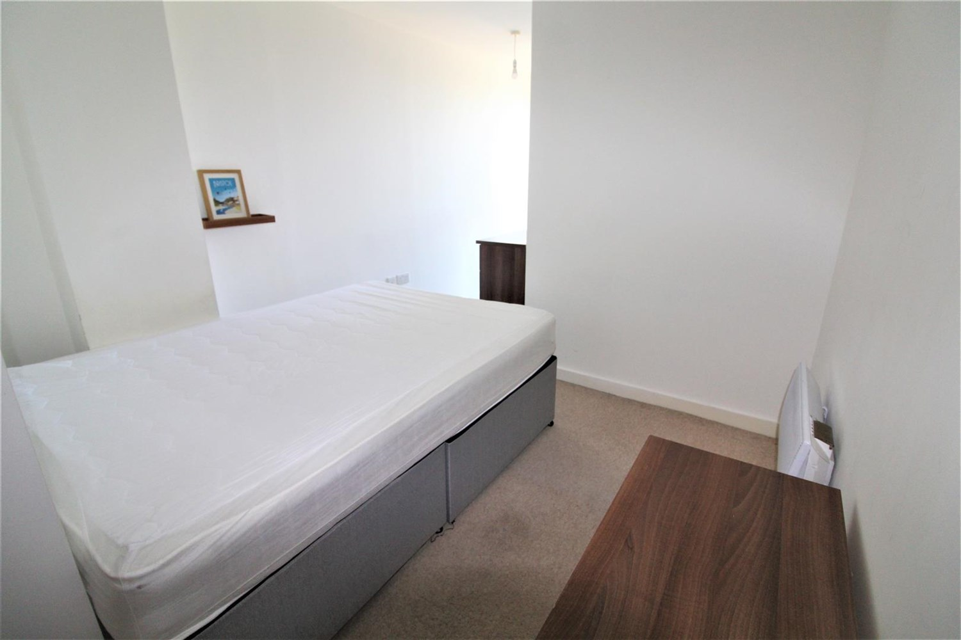

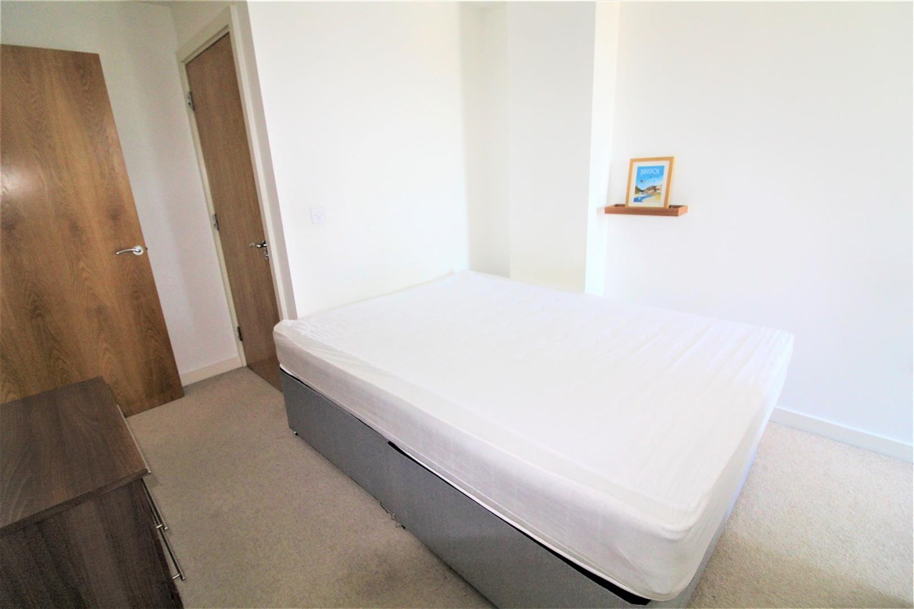

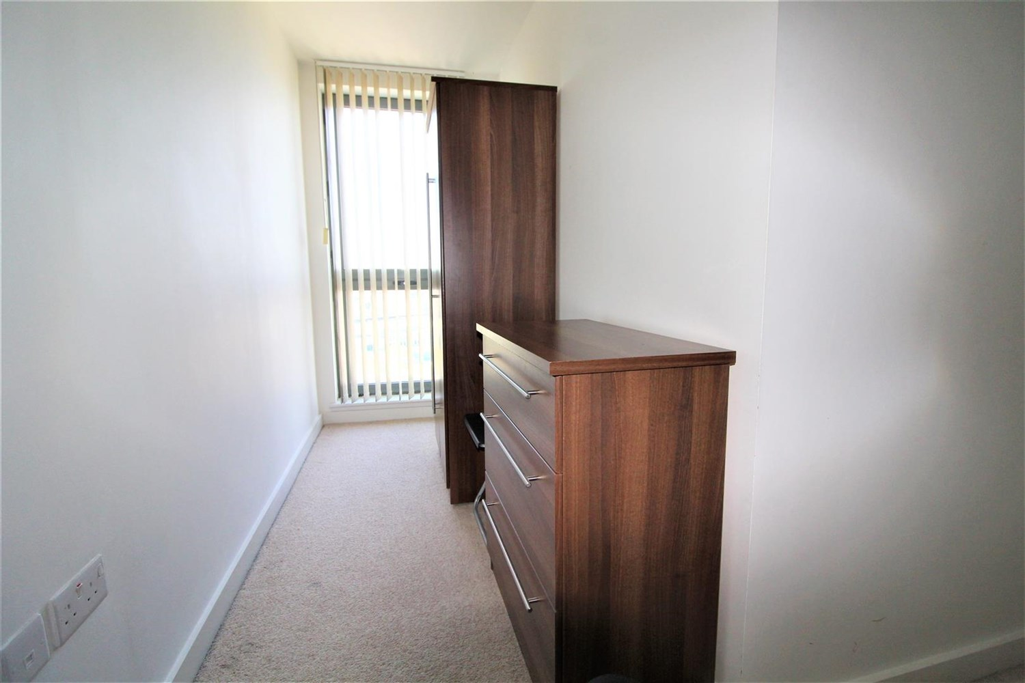

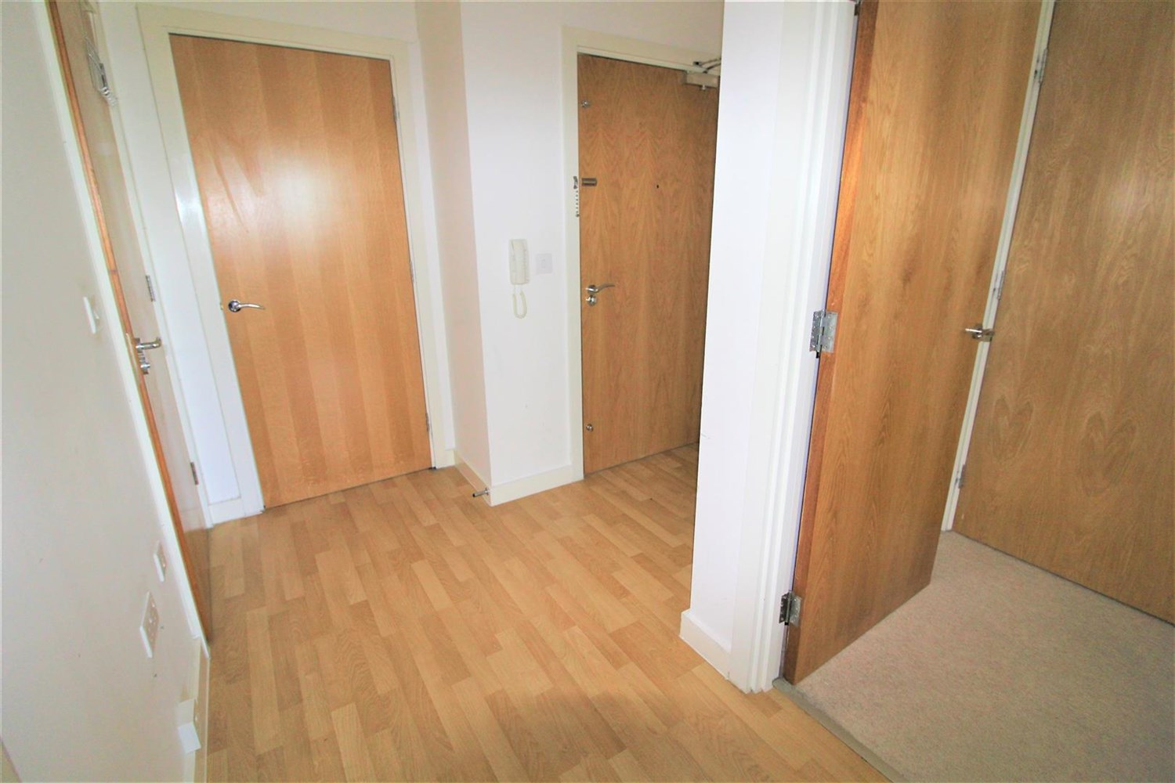

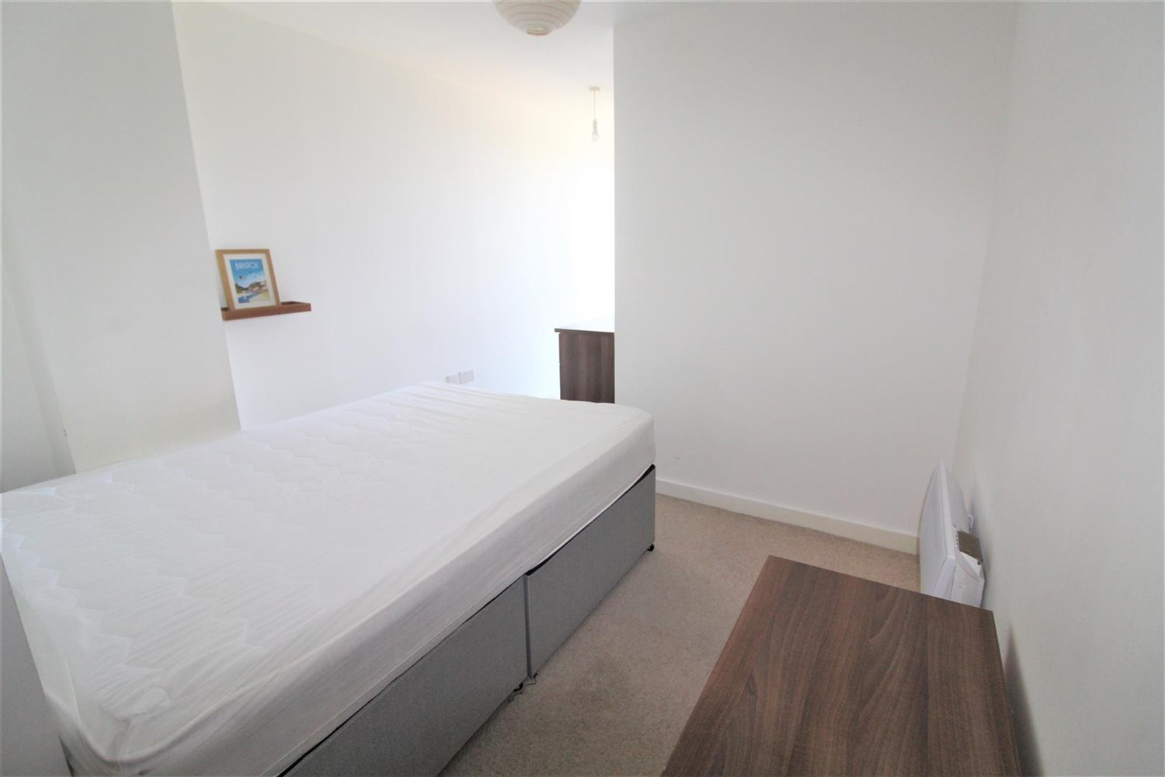

|  |
| --- |
| **Communal Entrance Hall**  Letter boxes lifts to all floors. |
| **Private Entrance Hall**  Storage cupboard housing washing machine and intercom. |
| **Open Plan Kitchen and Living Room**  Fitted with a range of wall, base and drawer units with work surfaces over and breakfast bar. Circular stainless steel sink with mixer tap. Integrated electric oven and ceramic hob with stainless steel extractor hood over. Integrated fridge/freezer. Splash back. Double glazed doors to Juliet balcony. Wall mounted electric heater. Inset ceiling spotlights. |
| **Bedroom 1**  A spacious double bedroom with double glazed window. Wall mounted electric heater. Door to en-suite. |
| **En Suite**  Fitted with a three piece suite comprising shower cubicle, WC and wash hand basin. Part tiled walls. Chrome heated ladder towel rail. |
| **Bedroom 2**  A spacious double bedroom with double glazed window. Wall mounted electric heater. |
| **Bathroom**  Fitted with a three piece suite comprising bath with shower above, WC and wash hand basin. Part tiled walls. Chrome heated ladder towel rail. |
| **Home Information**  COUNCIL TAX BAND: C EPC Rating C  Leasehold property Allocated Parking.  Broadband: Standard 9 Mbps 0.9 Mbps Good Superfast 80 Mbps 20 Mbps Good Ultrafast 1000 Mbps 1000 Mbps  Mobile availability: EE Limited ThreeLikely to have good coverage O2 Likely to have good coverage Vodafone Likely to have good coverage.  Electric mains supply, water on mains supply. |

|  |  |
| --- | --- |
| These particulars are intended to give a fair description of the property, but their accuracy cannot be guaranteed, and they do not constitute an offer of contract. Intending purchasers must rely on their own inspection of the property. None of the above appliances/services have been tested by ourselves. We recommend purchasers arrange for a qualified person to check all appliances/services before legal commitment.  **Property Ref:** 5619  **For more information, please contact**  0113 258 1150 **|** [lettings@adairpaxton.co.uk](mailto:lettings@adairpaxton.co.uk) **|** www.adairpaxton.co.uk |  |