

**0113 258 1150**

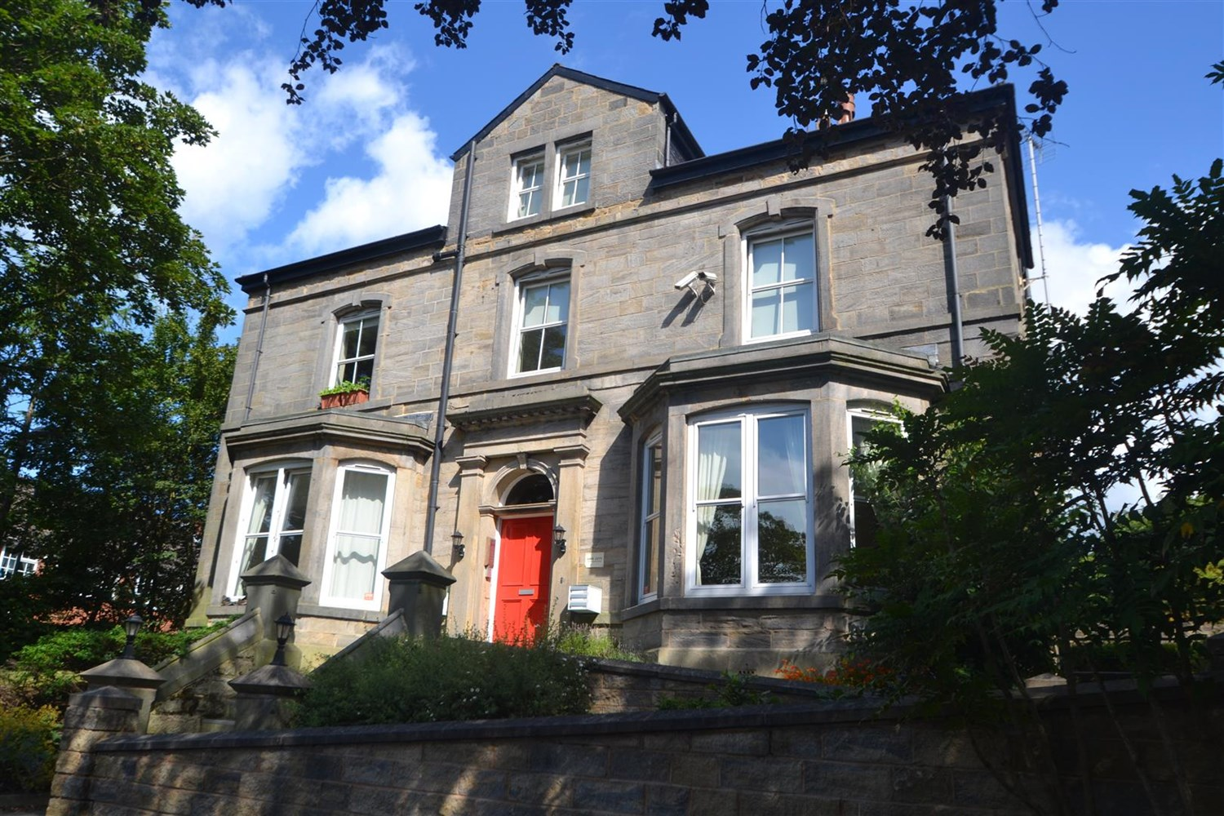



**Available to let £895.00pcm**

**Westbury Gardens, LS16**

Adair Paxton are delighted to offer this lovely two bed duplex apartment in this sought after residential area of North Leeds. The ground floor accommodation is located in a converted building in a gated development with off road parking. Comprising; Spacious living and kitchen area with modern fixtures and fittings, one double bedroom, one single bedroom, modern bathroom and storage space. Gas central heating. Off road parking. Furnished. Bond £1030. Available 4th June. Council tax band B, EPC rating C, Due to the lease this property has a no pet policy .

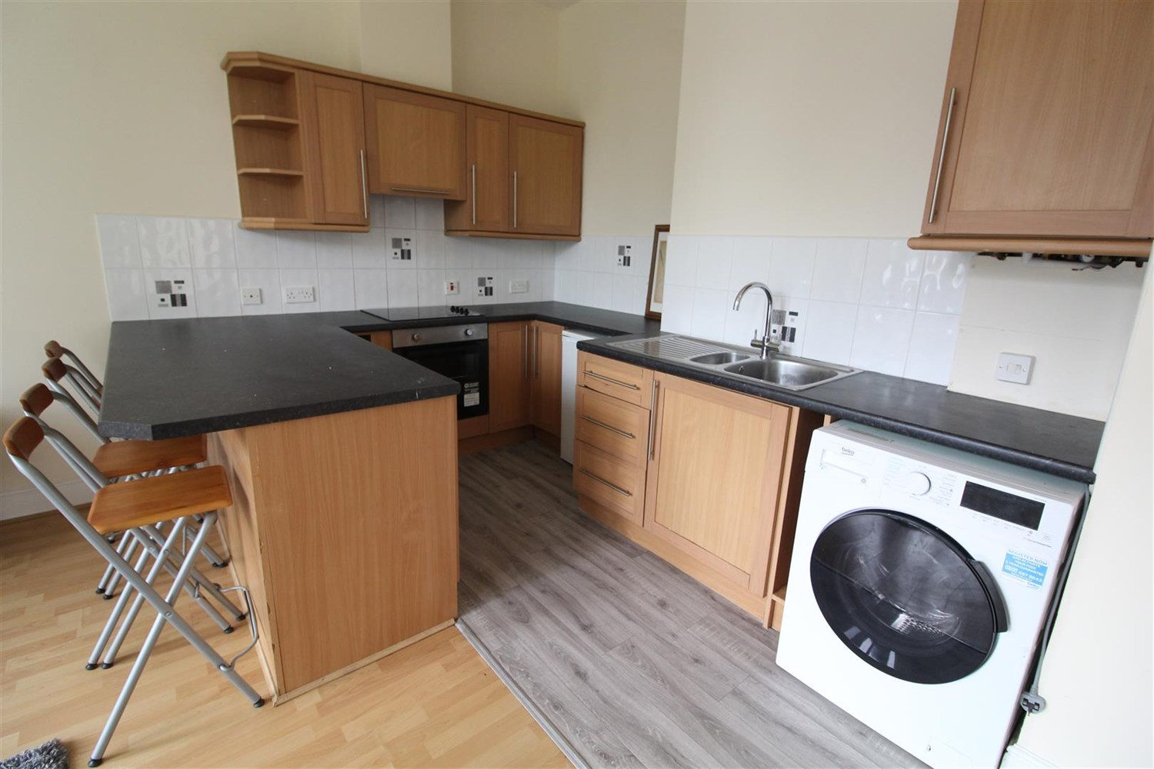

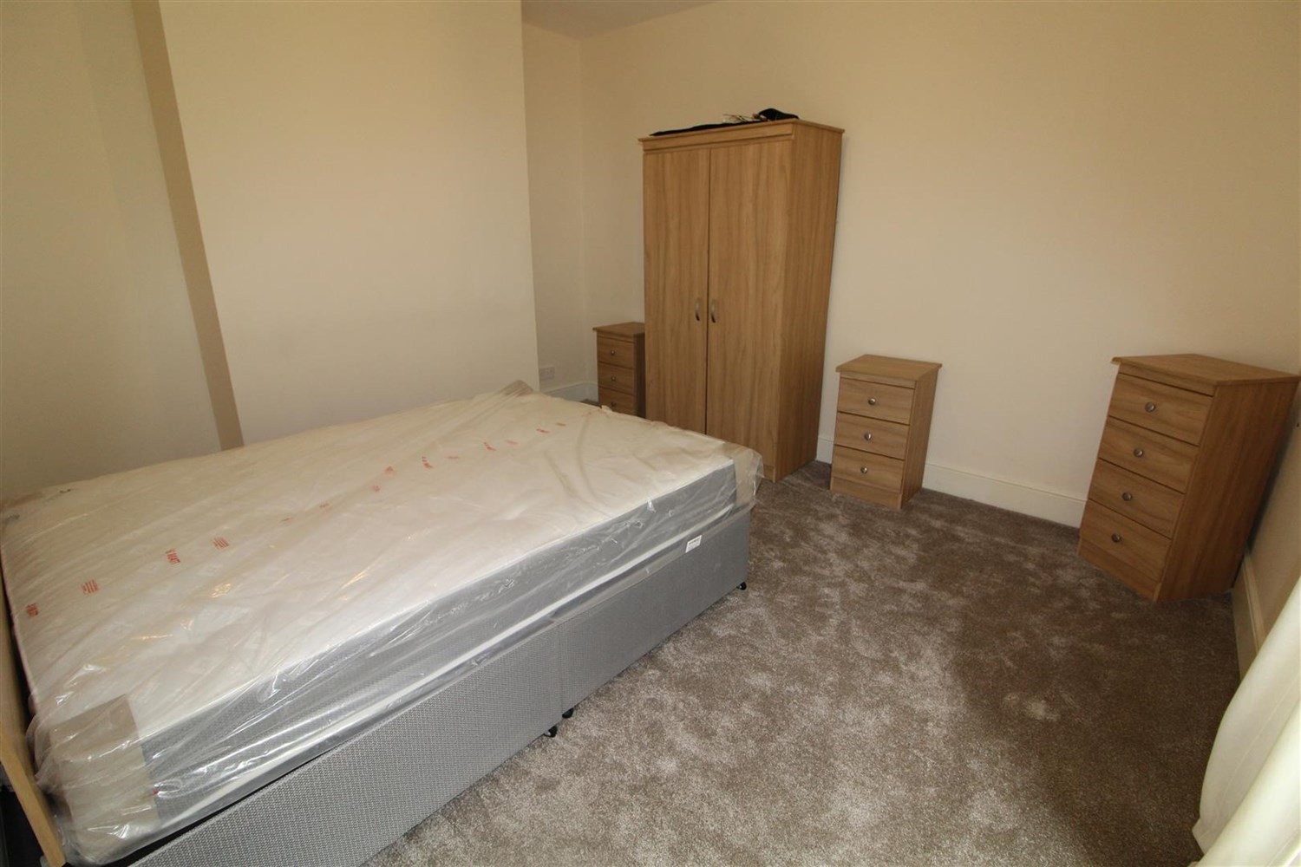

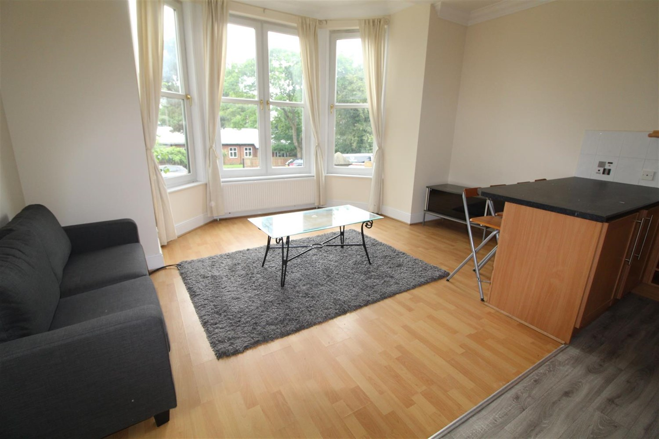

1 Bathroom(s)

1 Reception(s)

2 Bedroom(s)

00

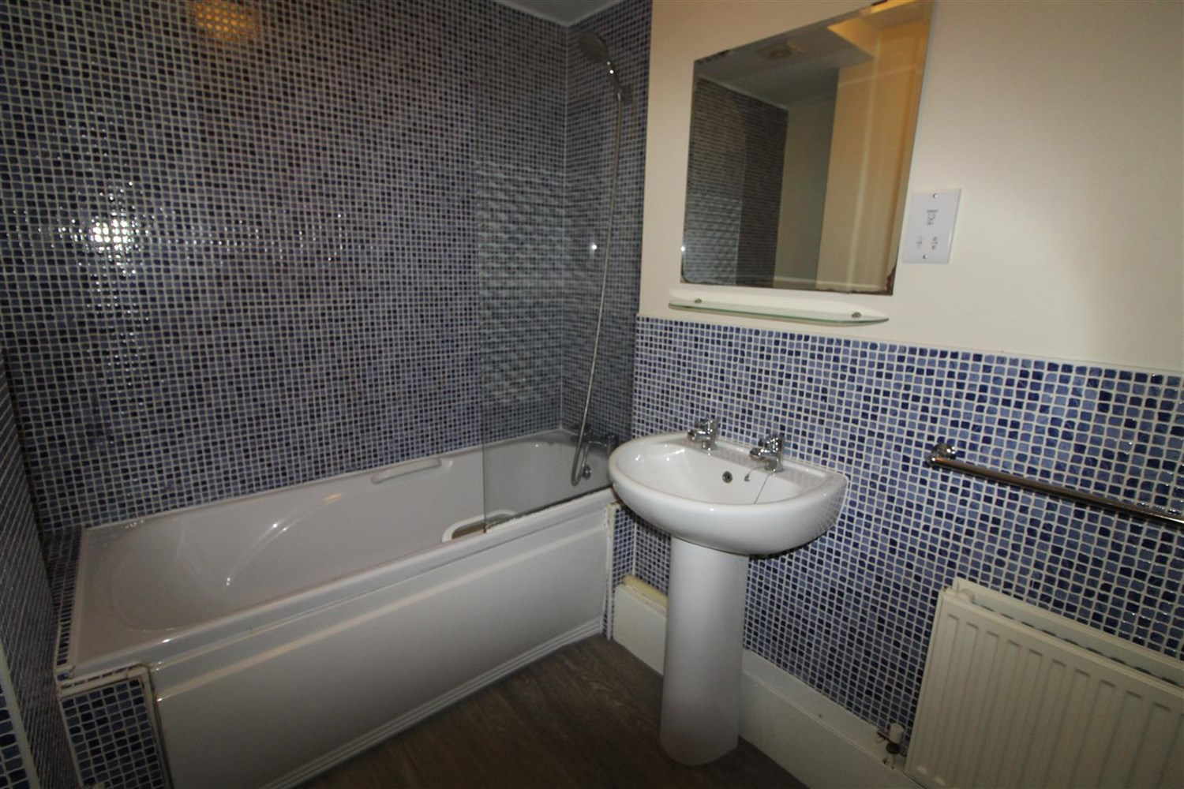

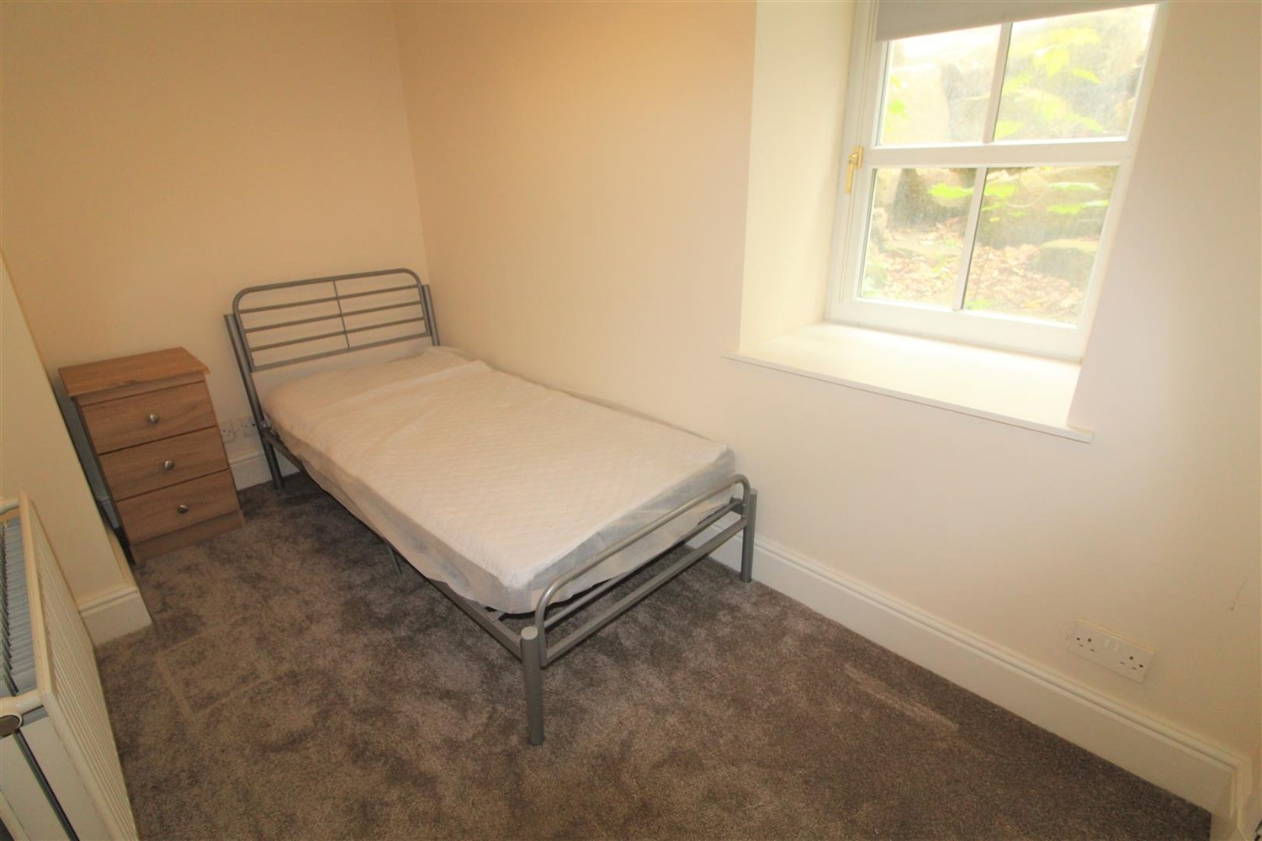

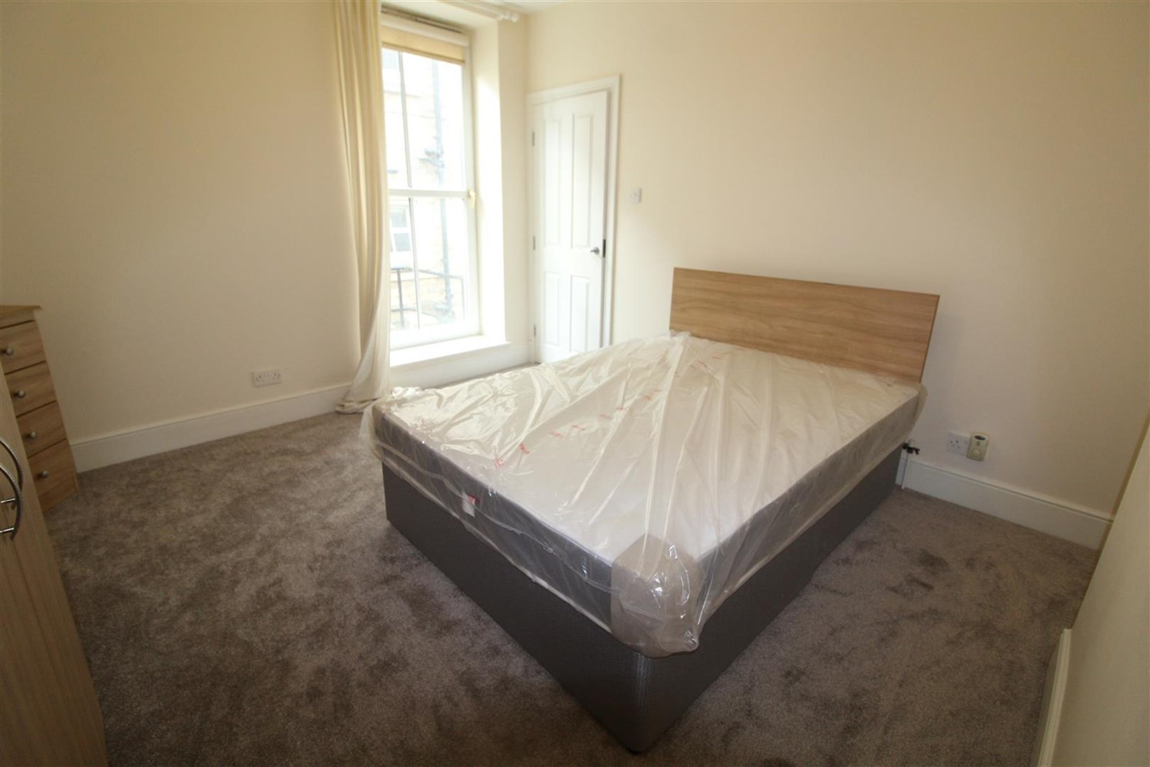

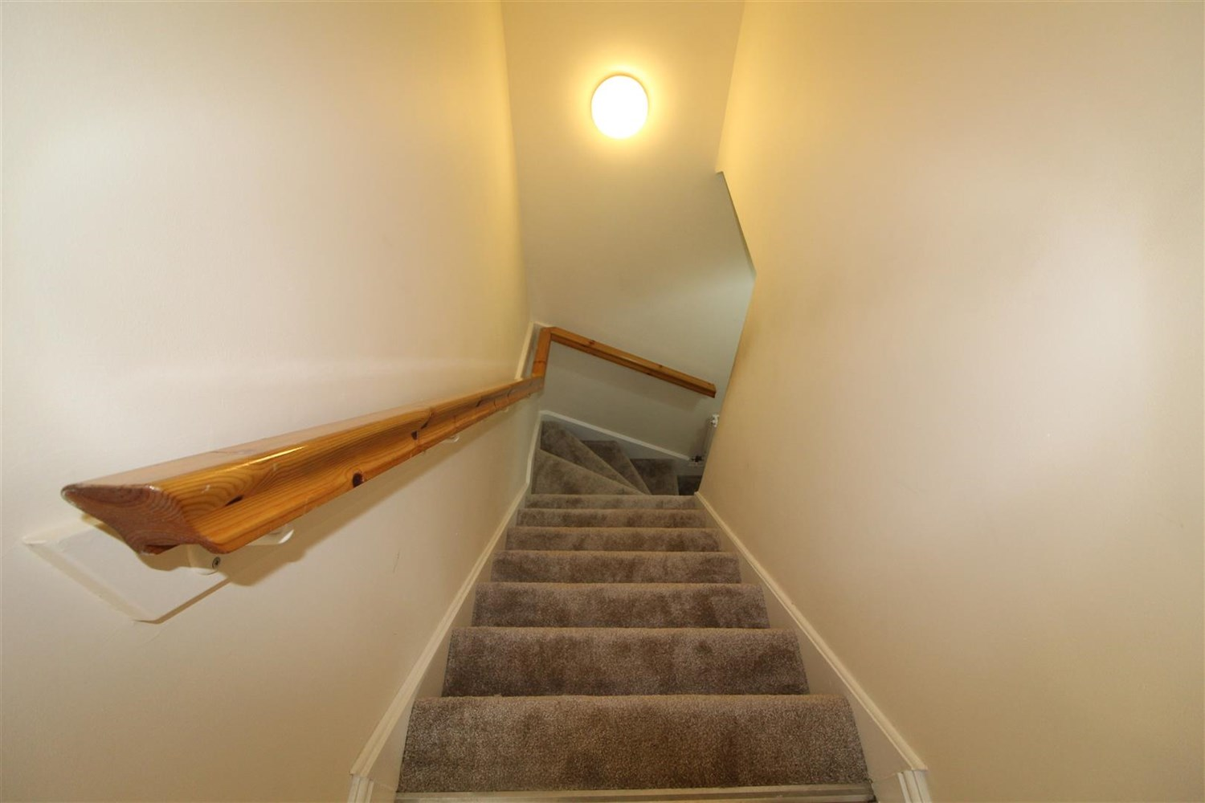

|  |
| --- |
| **Communal Entrance**  Communal entrance. |
| **Open Plan Living /Kitchen**  Open plan living space with laminate flooring, feature bay window and gas central heating radiator. Kitchen area comprising a range of wall and base mounted units, one a half bowl stainless steel sink with mixer tap and drainer and built in oven, hob and extractor. Window. |
| **Bedroom 1**  A good sized carpeted double room with gas central heated radiator and double glazed window |
| **Lower Level** |
| **Bedroom 2**  A carpeted double room with |
| **Bathroom**  Three piece white suite comprising bath, low flush w.c and basin. |
| **Home Information**  COUNCIL TAX BAND: B EPC Rating: C  Leasehold property Parking Available  Mobile availability: EE limited coverage. Three likely to have good coverage. O2 likely to have good coverage. Vodafone likely to have good coverage. Broadband: Standard 18 Mbps 1 Mbps Good Superfast --Not available --Not available Unlikely Ultrafast --Not available --  Utilities: Water supplied on standard meters. Electric mains supplied on standard meters. |

|  |  |
| --- | --- |
| These particulars are intended to give a fair description of the property, but their accuracy cannot be guaranteed, and they do not constitute an offer of contract. Intending purchasers must rely on their own inspection of the property. None of the above appliances/services have been tested by ourselves. We recommend purchasers arrange for a qualified person to check all appliances/services before legal commitment.  **Property Ref:** 5965  **For more information, please contact**  0113 258 1150 **|** [lettings@adairpaxton.co.uk](mailto:lettings@adairpaxton.co.uk) **|** www.adairpaxton.co.uk |  |