

**0113 258 1150**

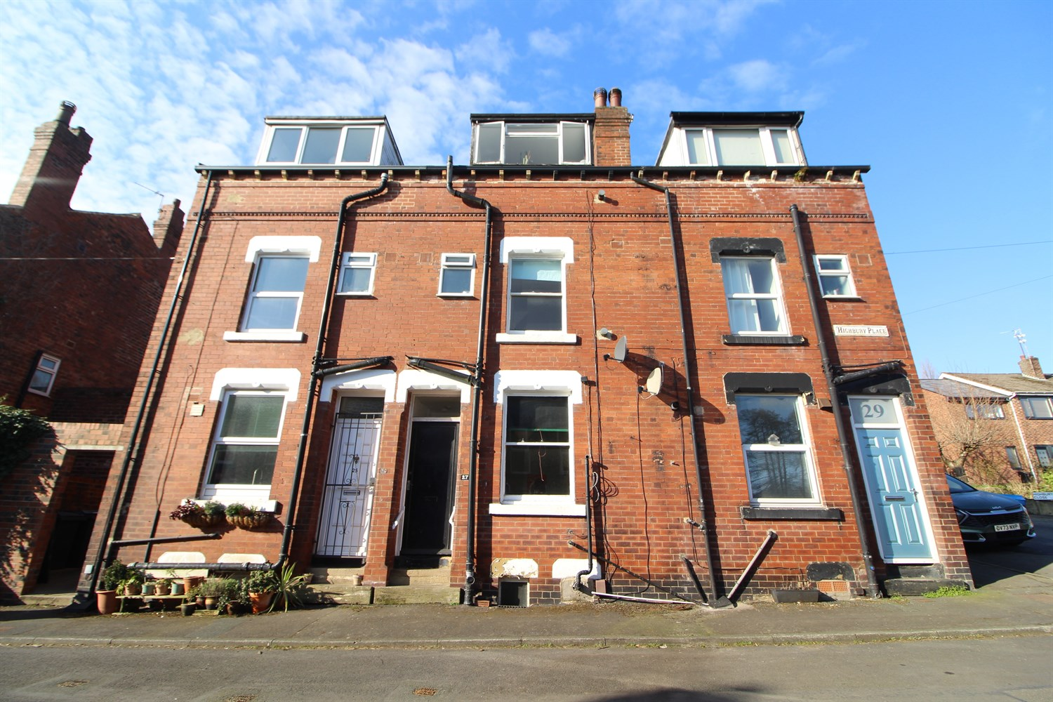



**Available to let £650.00pcm**

**Highbury Place, LS6**

Being ideally located in the heart of the ever popular and well regarded 'Highburys' conveniently placed for local amenities of Meanwood including the nearby Waitrose supermarket, and the excellent bars and restaurants of nearby Headingley is this mid back-to-back terrace. Offering versatile ONE/TWO BEDROOM accommodation arranged over THREE FLOORS plus useful cellar store. Having gas central heating the interior briefly comprises of: Entrance to Living/Dining Kitchen with a range of beech fronted units and fitted laminate flooring, basement cellar. First Floor: Living Room/ Bedroom, House Bathroom with three piece white suite and electric shower over bath. Second Floor: Double Attic Bedroom. Unfurnished. Deposit £750. Available 23rd April Council Tax Band A, EPC Rating D.

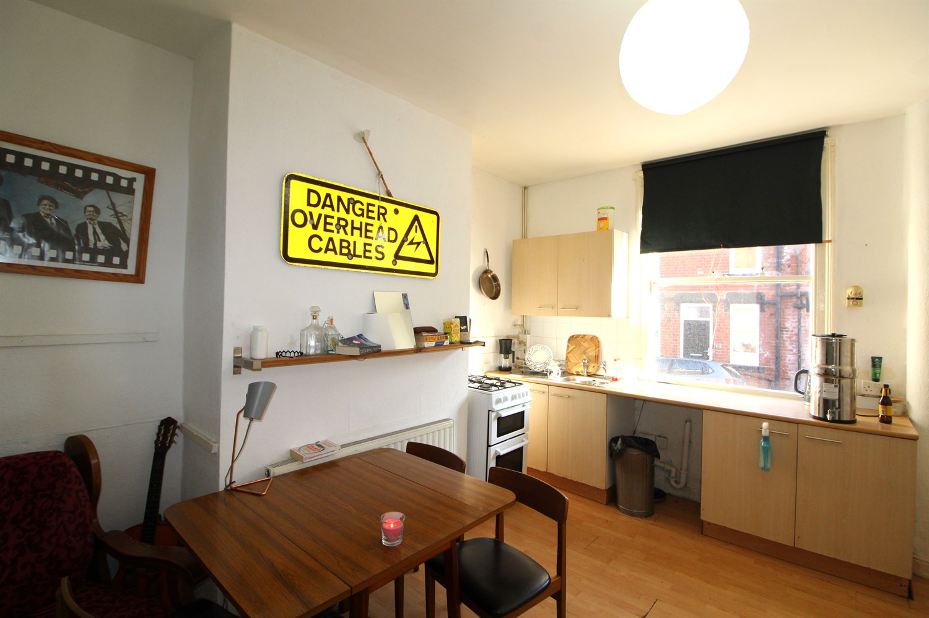

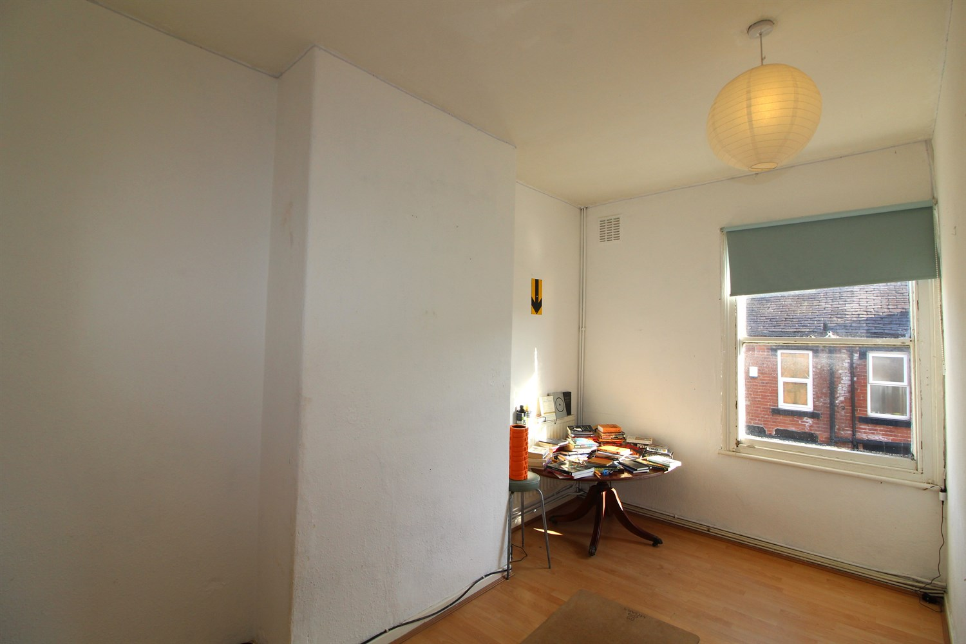

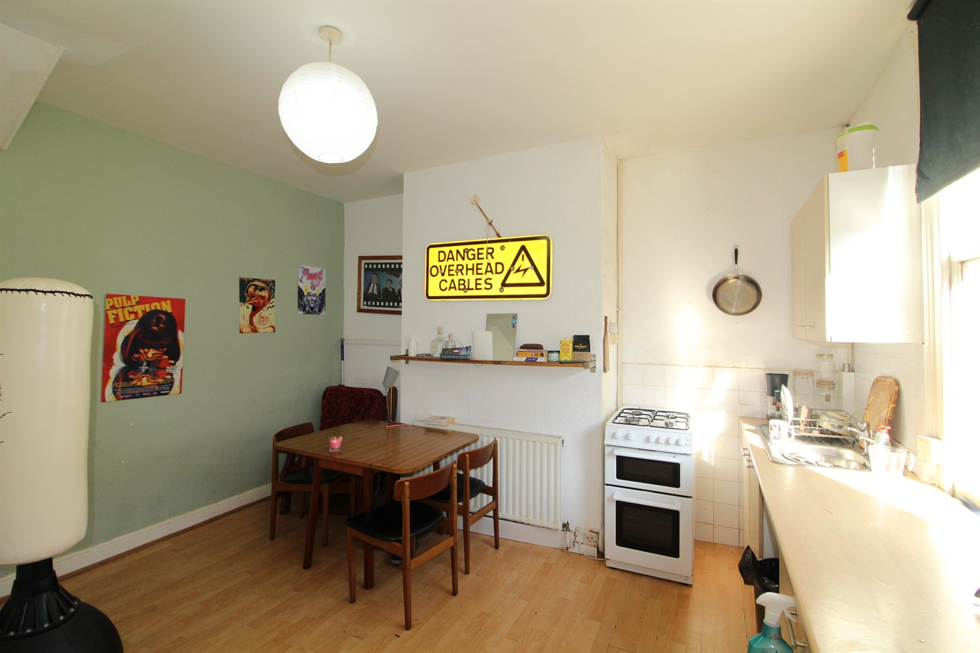

1 Bathroom(s)

1 Reception(s)

2 Bedroom(s)

00

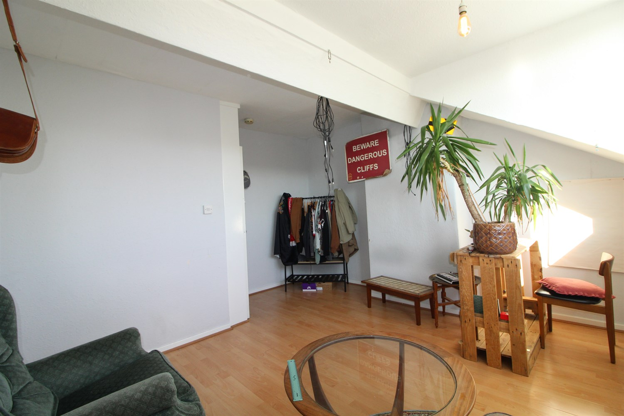

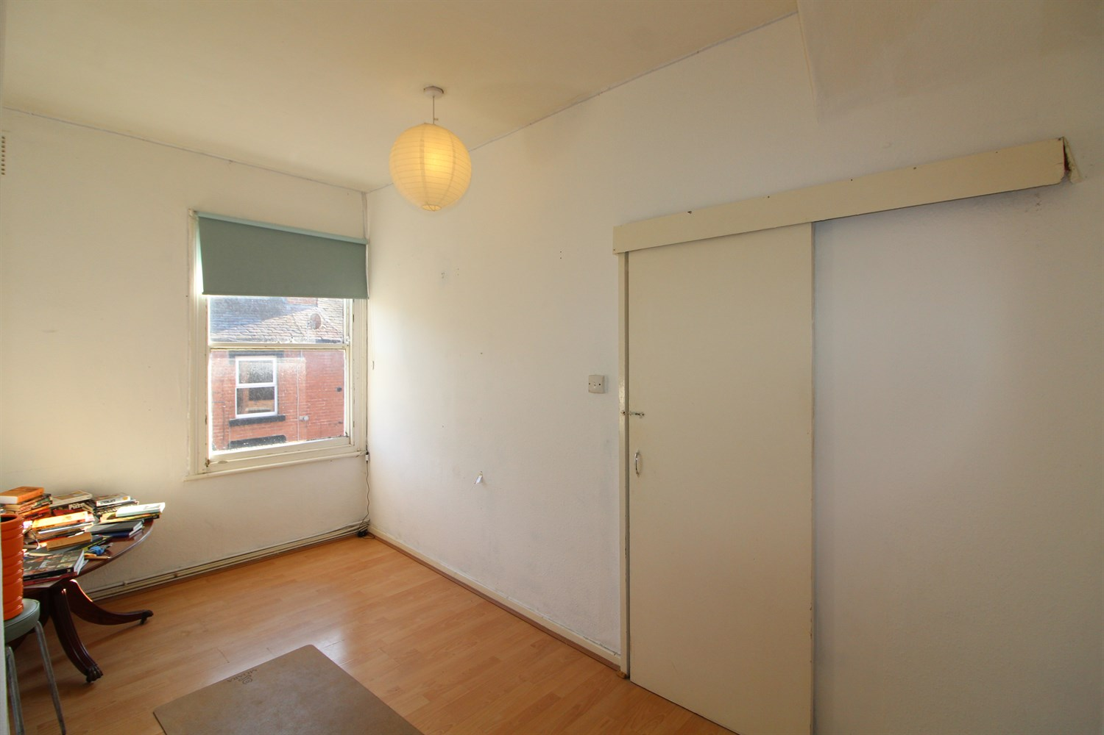

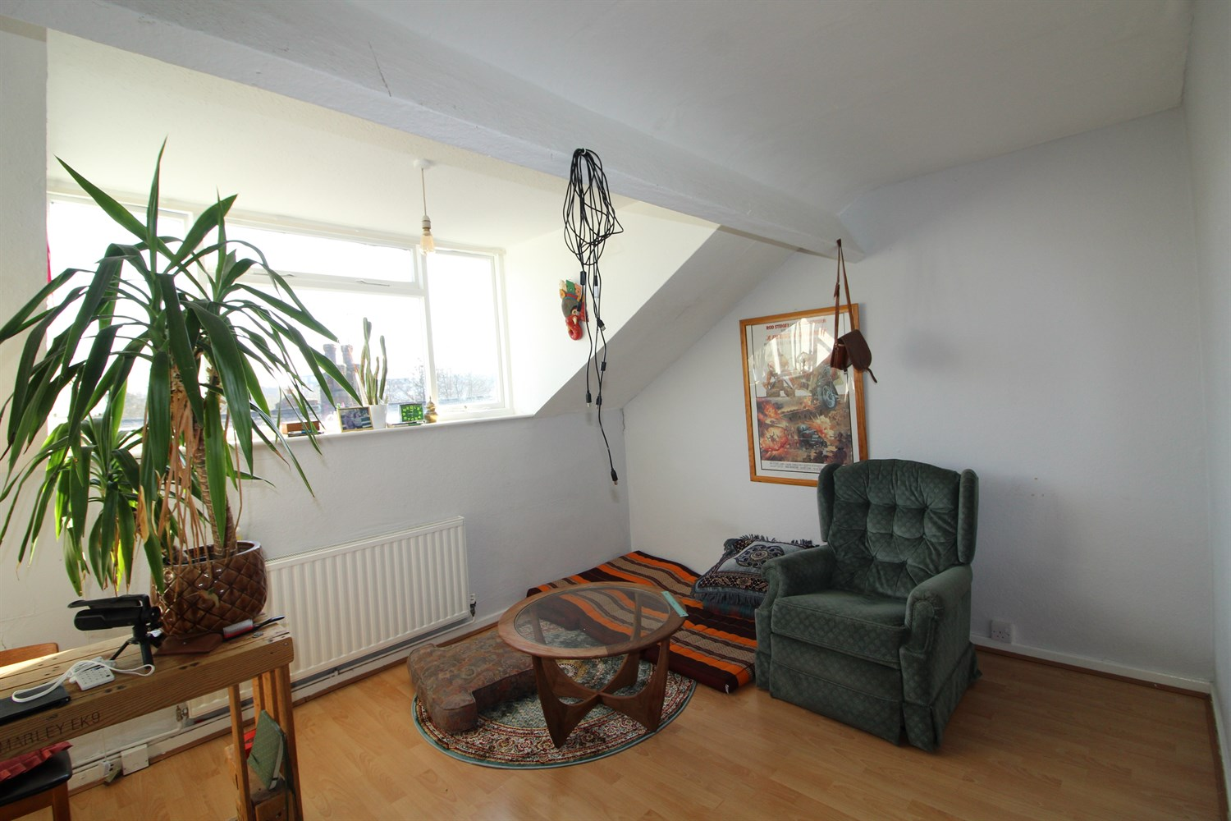

|  |
| --- |
| **Open Plan Kitchen and Living Room**  Open plan kitchen and living area with window to front, gas central heating radiator. Kitchen fitted with a range of wall and base units with worktops over, gas cooker and space for a washing machine. |
| **Bedroom**  Located on the first floor is a second bedroom with window to the front, gas central heating radiator. |
| **House Bathroom**  Fitted with a three piece bathroom suite with shower over, w/c and hand wash basin, part tiled walls. |
| **Master Bedroom**  Located on the second floor is this large double bedroom with window to the front, gas central heating radiator. |
| **Home Information**  COUNCIL TAX BAND: A EPC Rating: D  Freehold property On street parking  Broadband: Standard 14 Mbps 1 Mbps Good Superfast 216 Mbps 31 Mbps Good Ultrafast 1800 Mbps 1000 Mbps Mobile availability: EE Limited, Three Likely to have good coverage O2 likely to have good coverage, Vodafone Likely  Gas and Electric mains supply, water on mains supply. |

|  |  |
| --- | --- |
| These particulars are intended to give a fair description of the property, but their accuracy cannot be guaranteed, and they do not constitute an offer of contract. Intending purchasers must rely on their own inspection of the property. None of the above appliances/services have been tested by ourselves. We recommend purchasers arrange for a qualified person to check all appliances/services before legal commitment.  **Property Ref:** 5410  **For more information, please contact**  0113 258 1150 **|** [lettings@adairpaxton.co.uk](mailto:lettings@adairpaxton.co.uk) **|** www.adairpaxton.co.uk |  |