

**0113 258 1150**

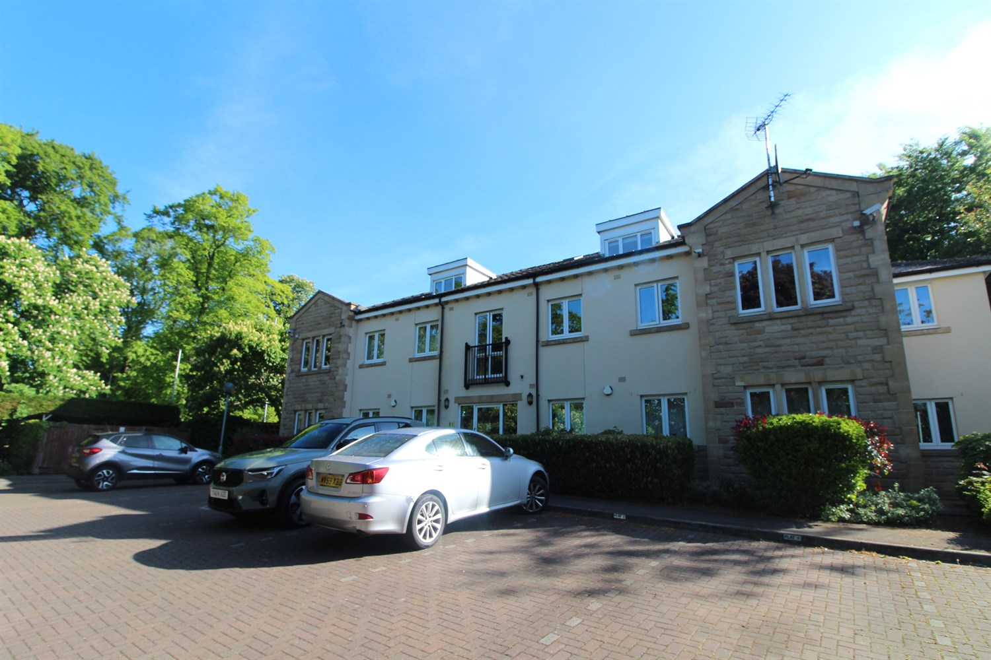



**For Sale £155,000.00**

**Earls Court, King Lane, Moortown**

**TWO BEDROOM GROUND FLOOR APARTMENT - NO CHAIN** A good sized two bedroom, ground floor floor apartment situated in the sought after location of Moortown. The property must be viewed to be appreciated and briefly comprises: Communal entrance hall, private entrance hall, open plan living room/kitchen, master bedroom, second double bedroom and house bathroom. The property also benefits from attractive gardens and an allocated parking space.

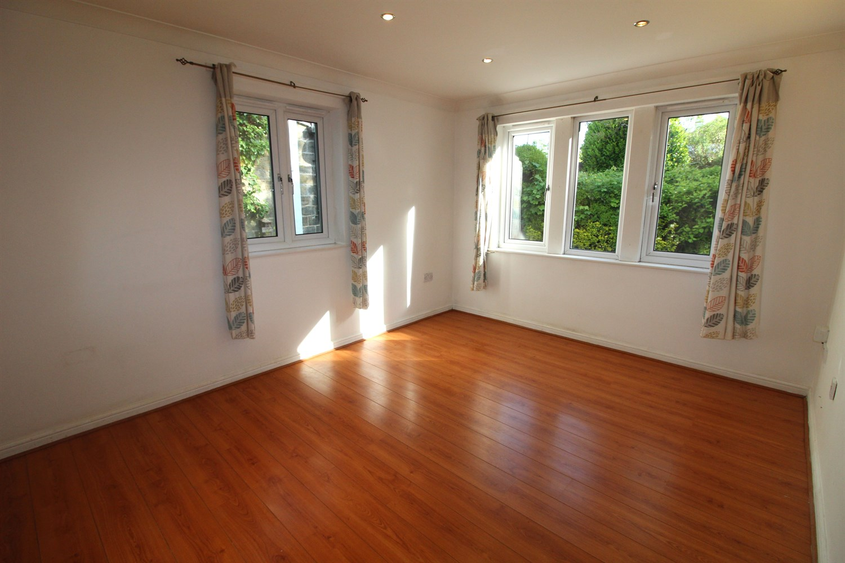

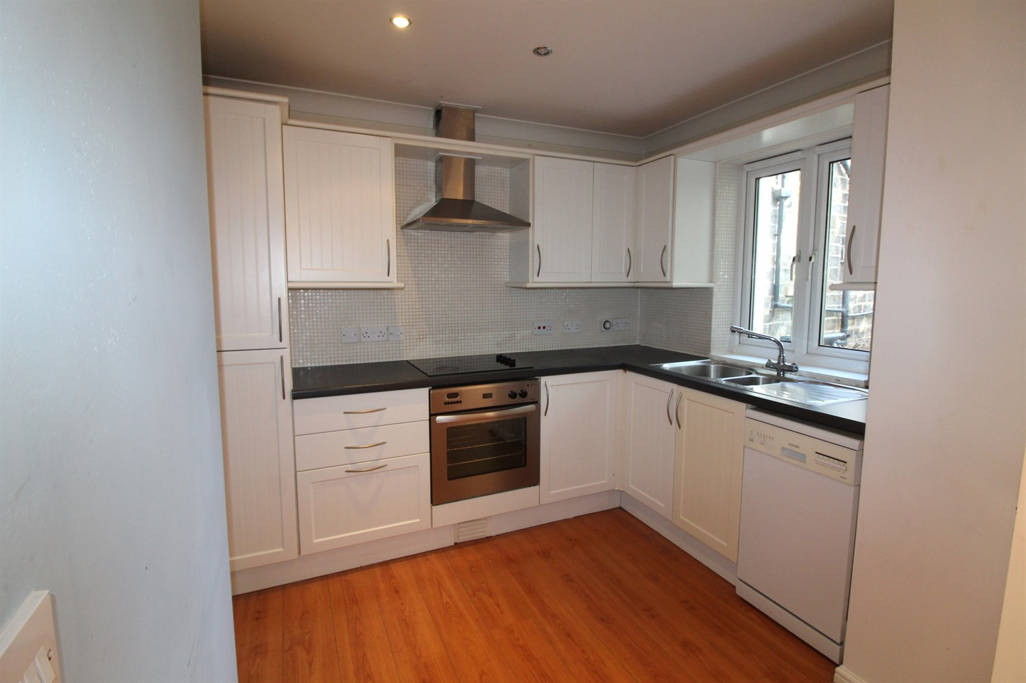

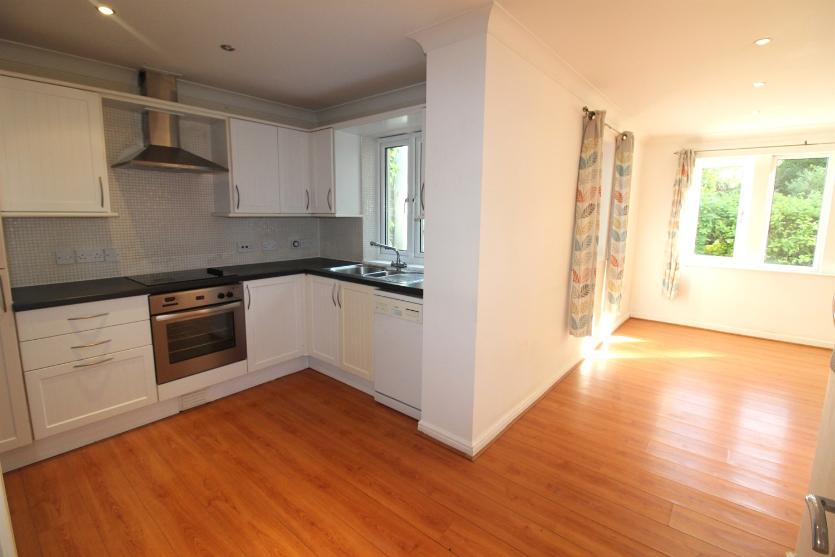

1 Bathroom(s)

1 Reception(s)

2 Bedroom(s)

00

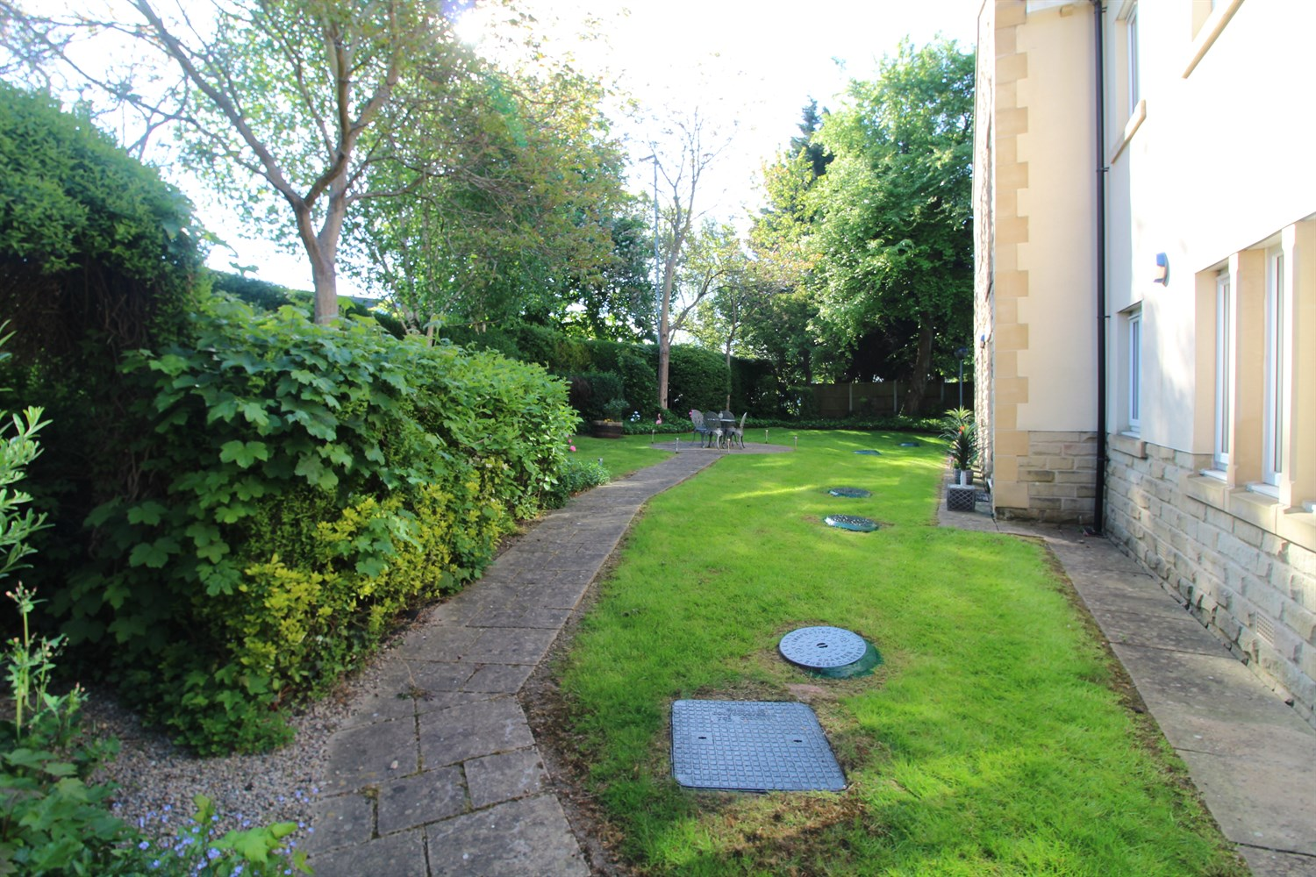

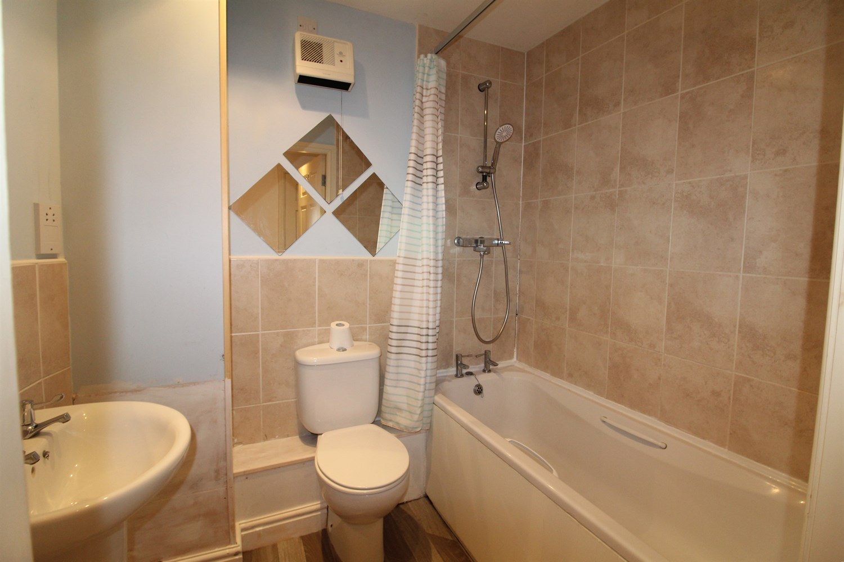

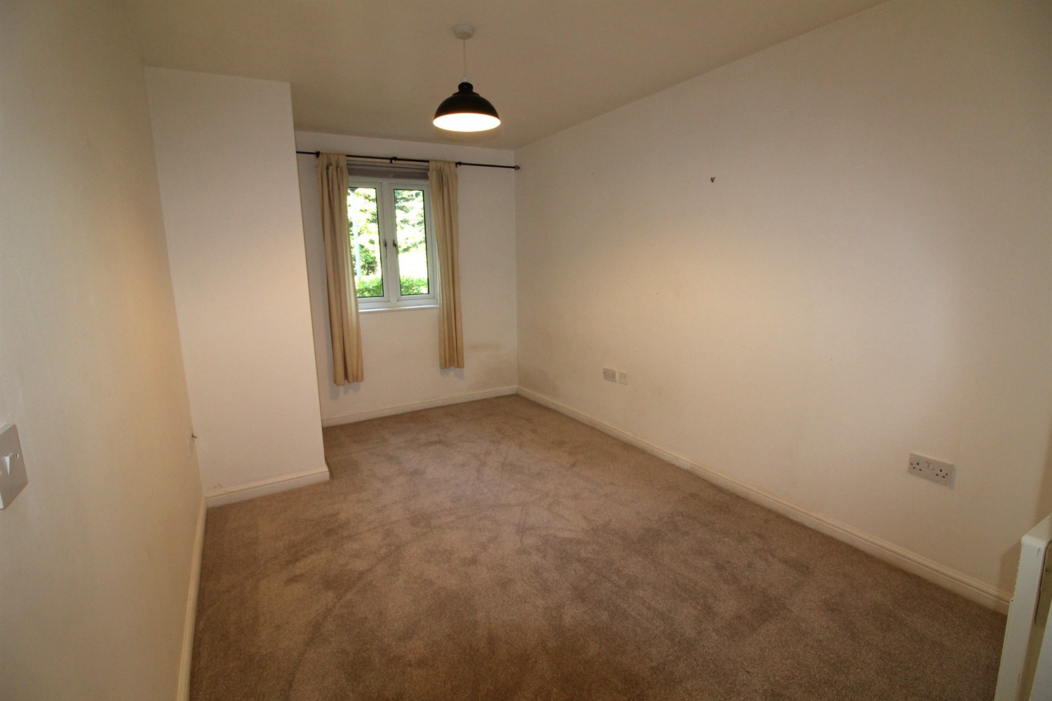

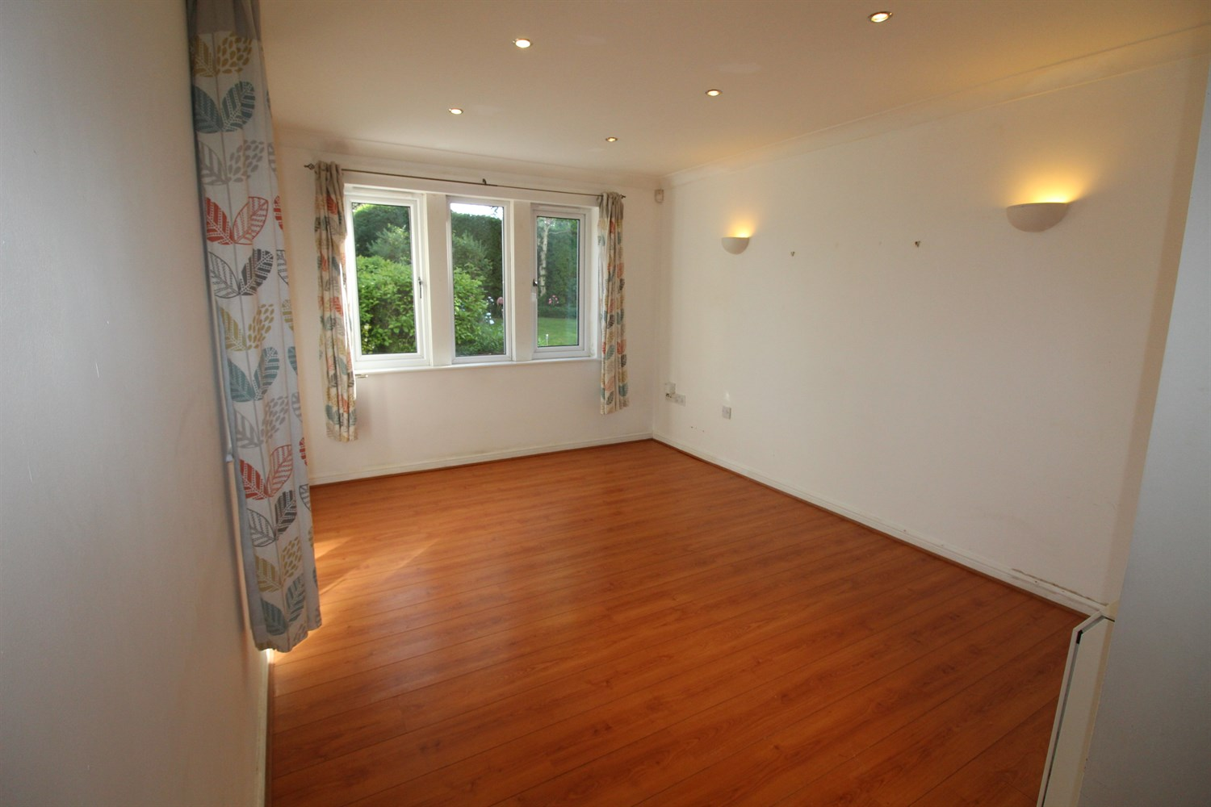

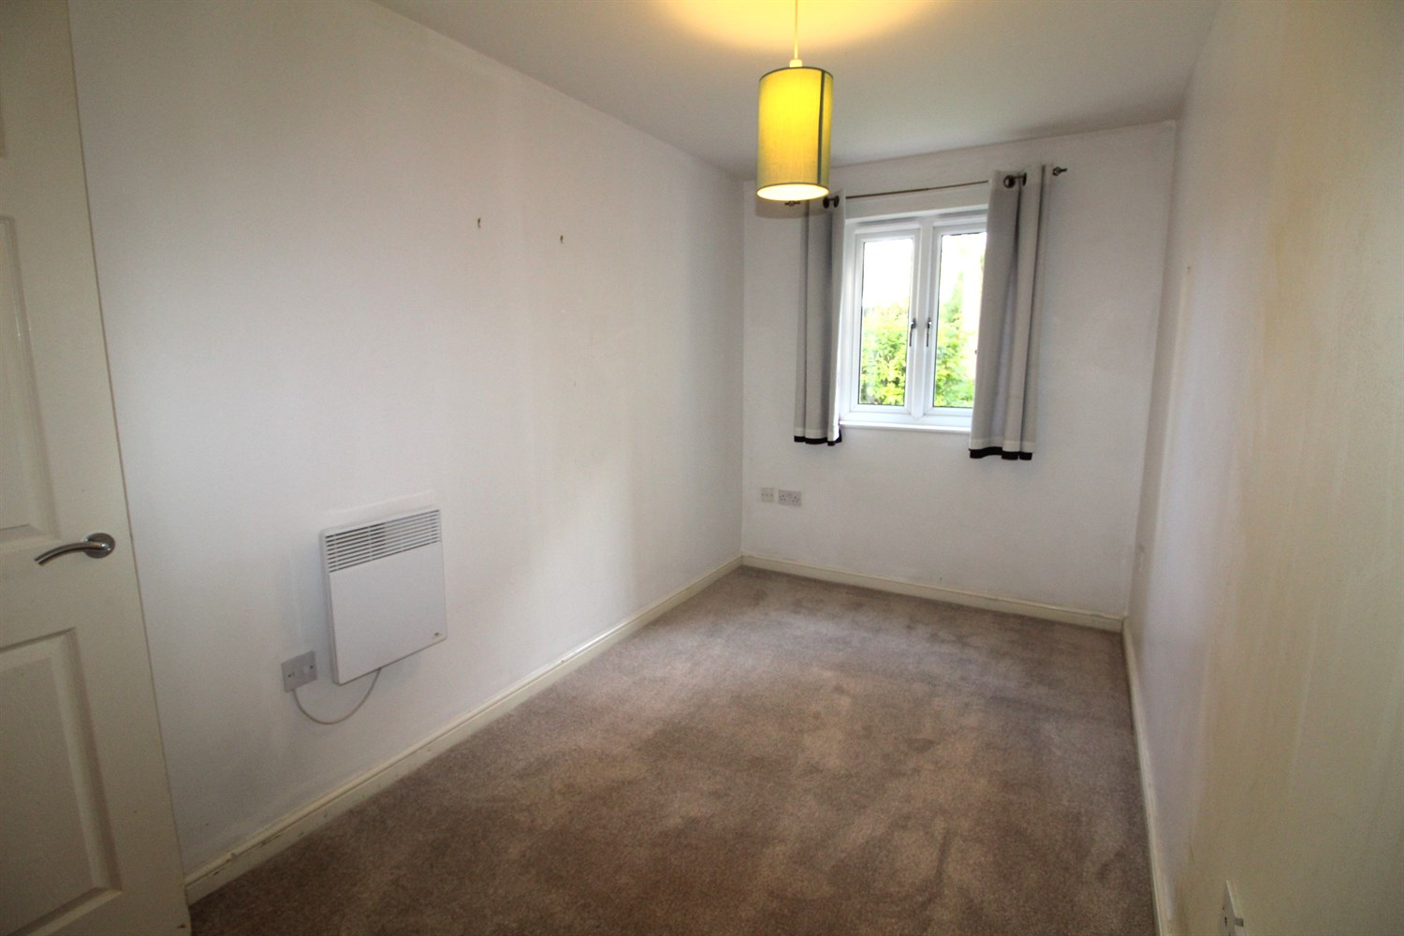

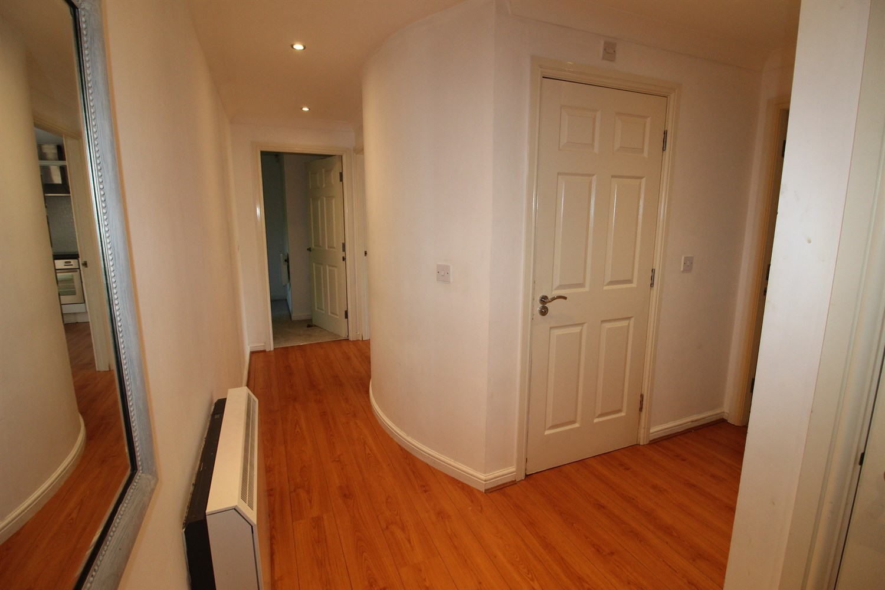

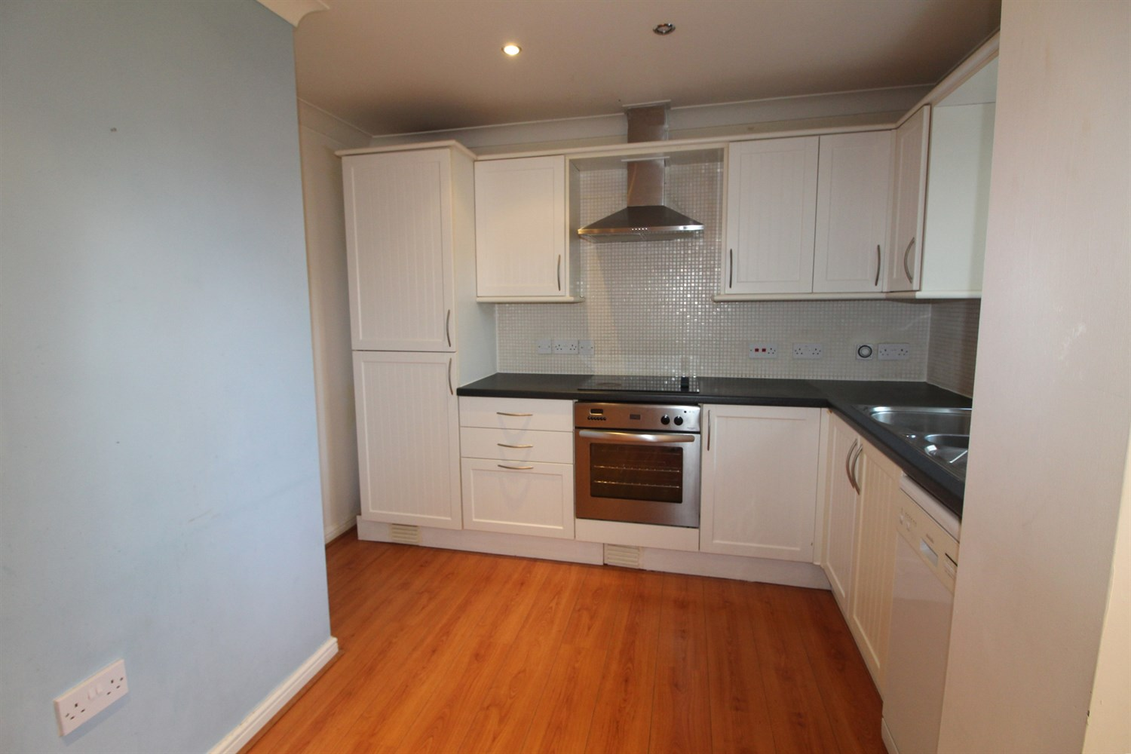

|  |
| --- |
| **Communal Hallway**  Via main entrance door. Secure entry phone system. |
| **Hallway**  Via front entrance door. Wall mounted electric radiator. |
| **Kitchen**  Fitted with a range of wall, base and drawer units with worktops over. Integrated electric oven with 4-ring hob and extractor hood over. Integrated fridge/freezer. Space for dishwasher. uPVC double glazed window. |
| **Lounge 0m (') x 3.18m (10'5)**  Light and airy living area with uPVC double glazed window to rear and side. Wall mounted electric radiator. |
| **Bedroom 1**  Double bedroom with uPVC double glazed window. Wall mounted electric radiator. |
| **Bedroom 2**  Second bedroom with uPVC double glazed window. Wall mounted electric radiator. |
| **Bathroom**  Fitted with a three piece suite comprising; bath with shower above, WC and wash hand basin. |
| **Outside**  Well maintained communal gardens. Allocated parking. |
| **Service Charge**  Service Charge - £350 per quarter. |
| **Tenure**  Ground rent - £175 per annum 104 years remaining |

|  |  |
| --- | --- |
| These particulars are intended to give a fair description of the property, but their accuracy cannot be guaranteed, and they do not constitute an offer of contract. Intending purchasers must rely on their own inspection of the property. None of the above appliances/services have been tested by ourselves. We recommend purchasers arrange for a qualified person to check all appliances/services before legal commitment.  **Property Ref:** 6081  **For more information, please contact**  0113 258 1150 **|** [sales@adairpaxton.co.uk](mailto:sales@adairpaxton.co.uk) **|** www.adairpaxton.co.uk |  |