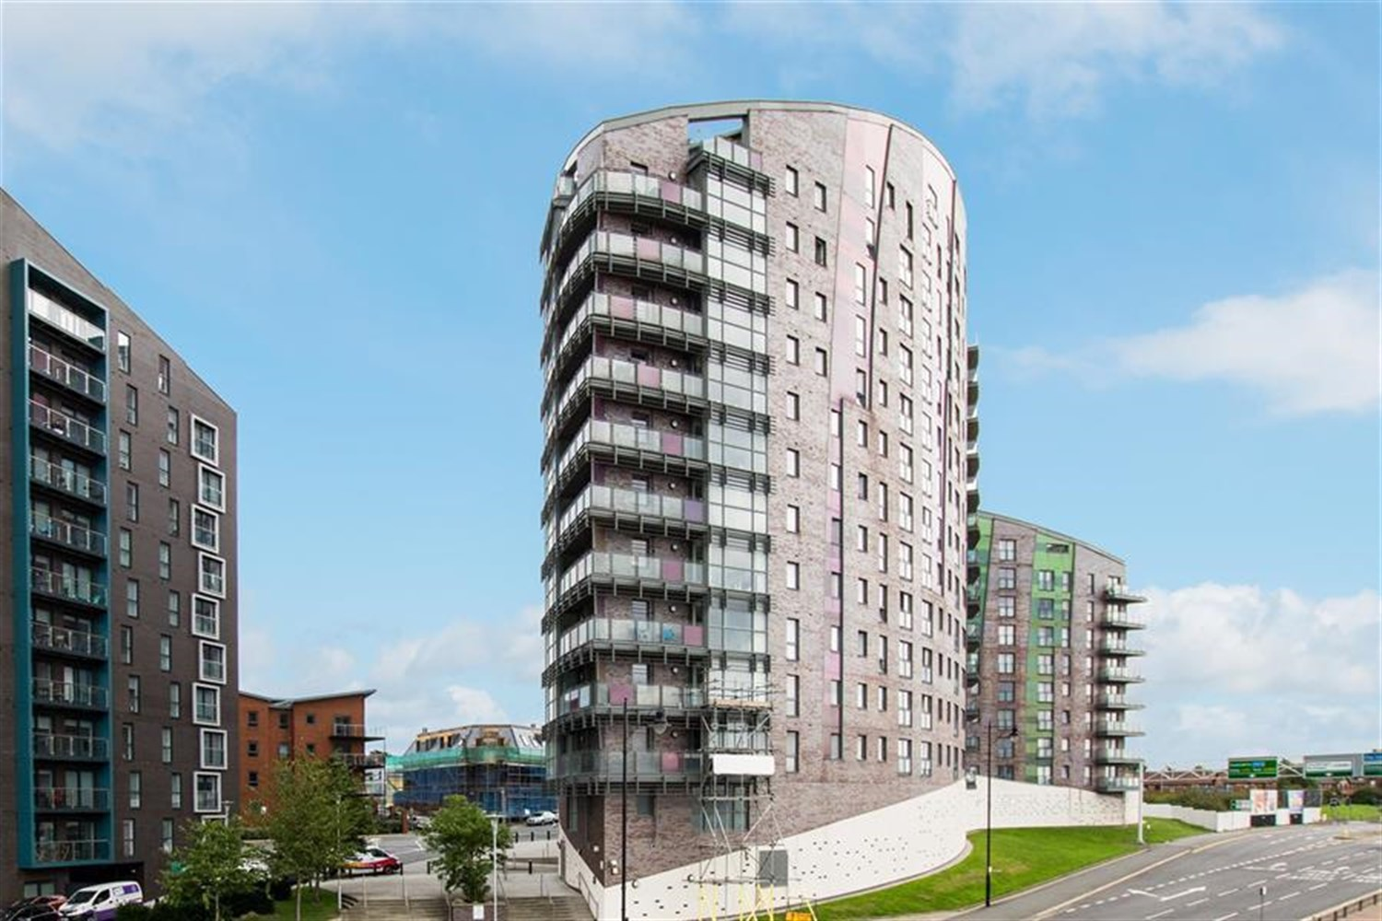



|  |  |
| --- | --- |
| **Echo Central One, Leeds**  **For Sale £95,000.00**  **Apartment** | |
|  |

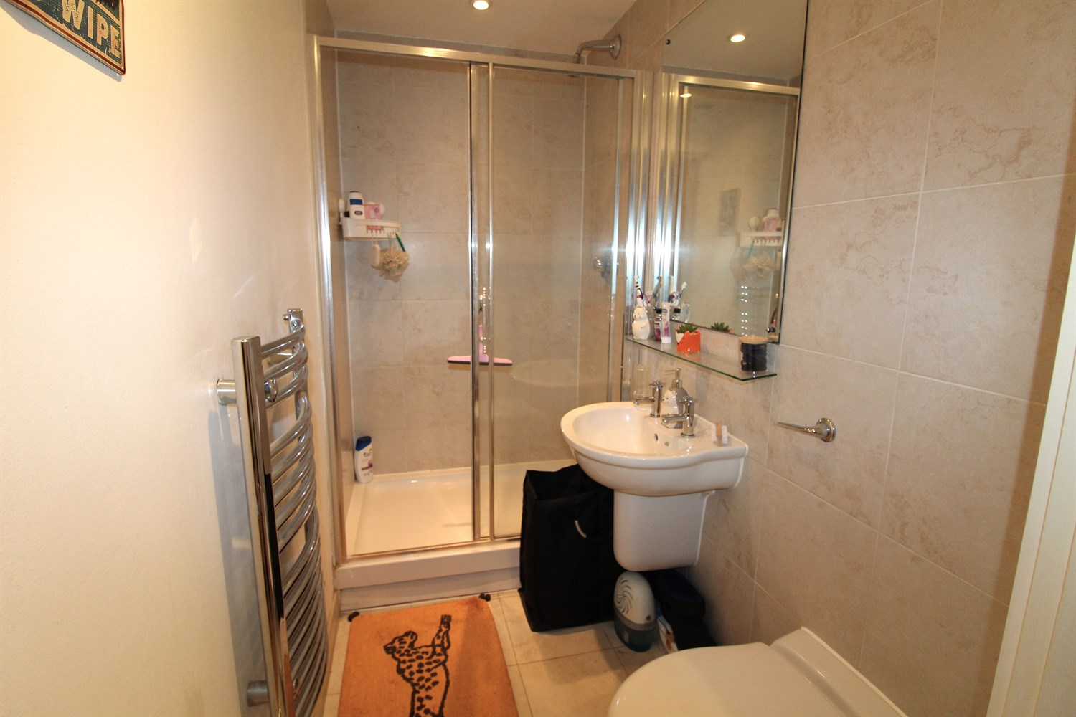

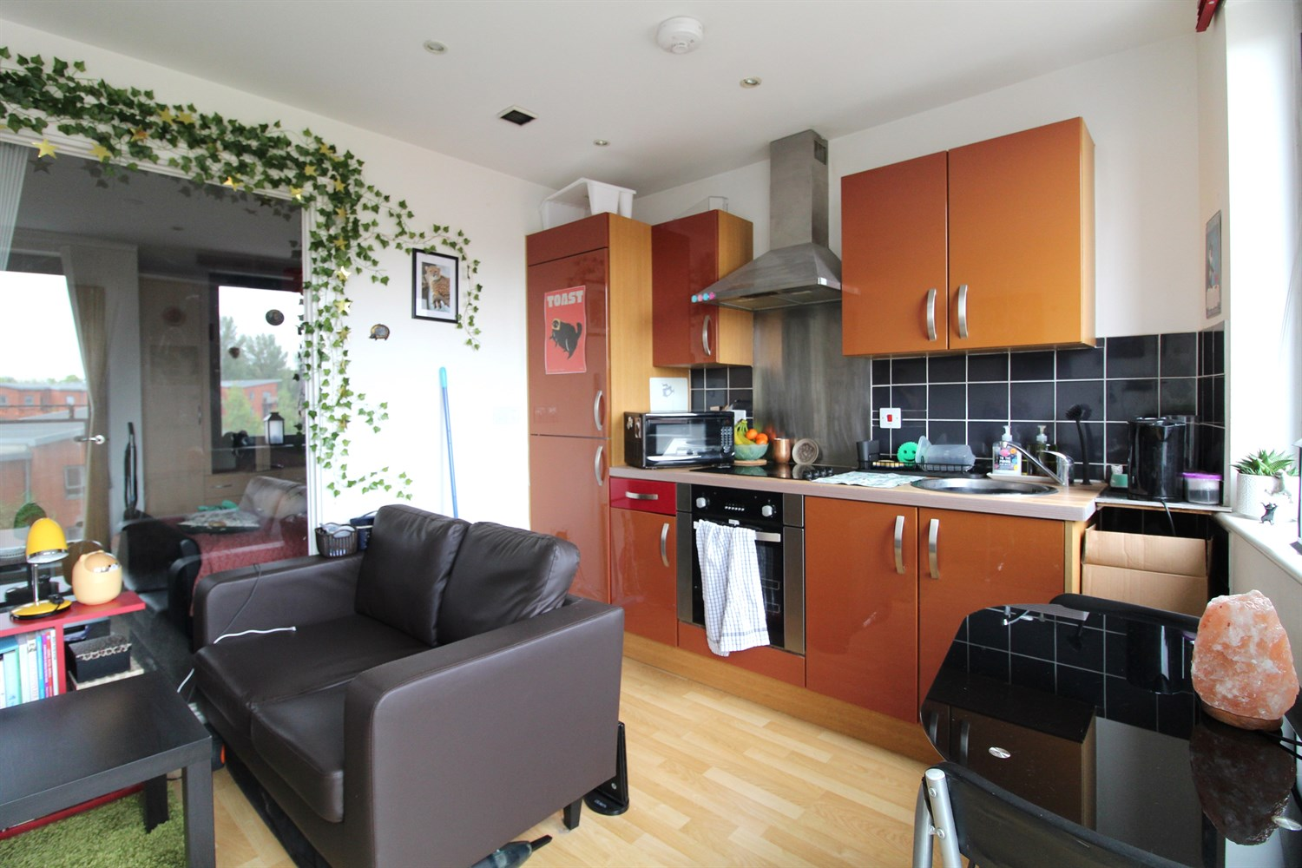

1 Bathroom(s)

0 Reception(s)

0 Bedroom(s)

00

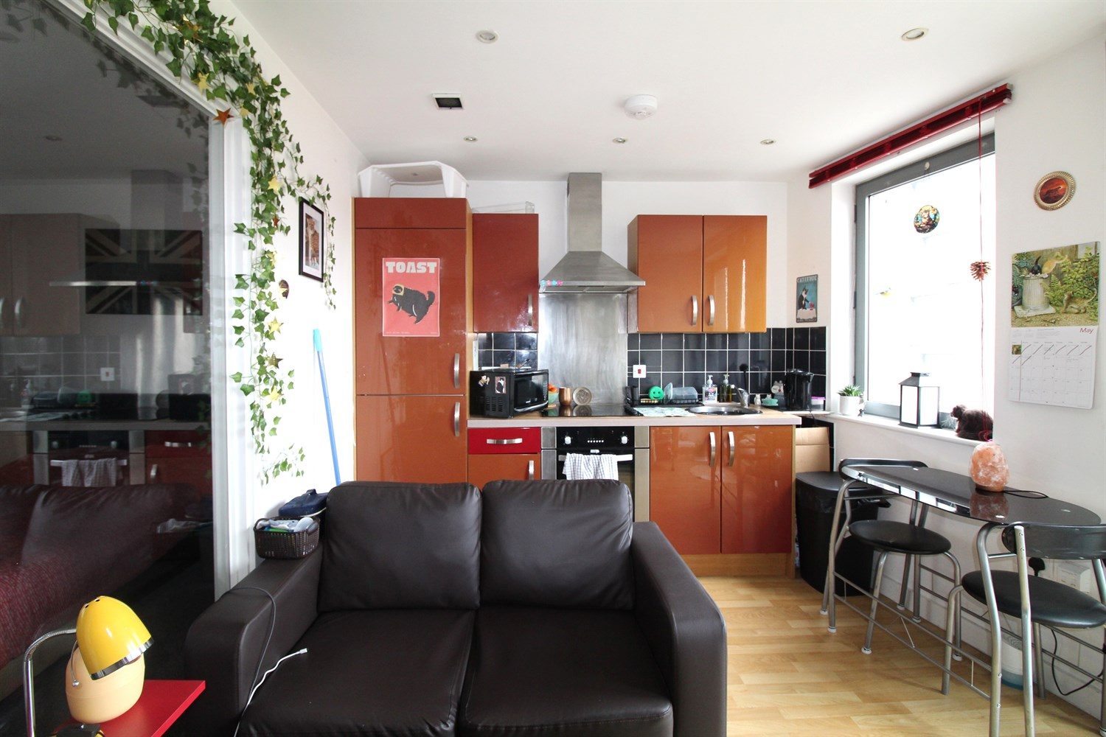

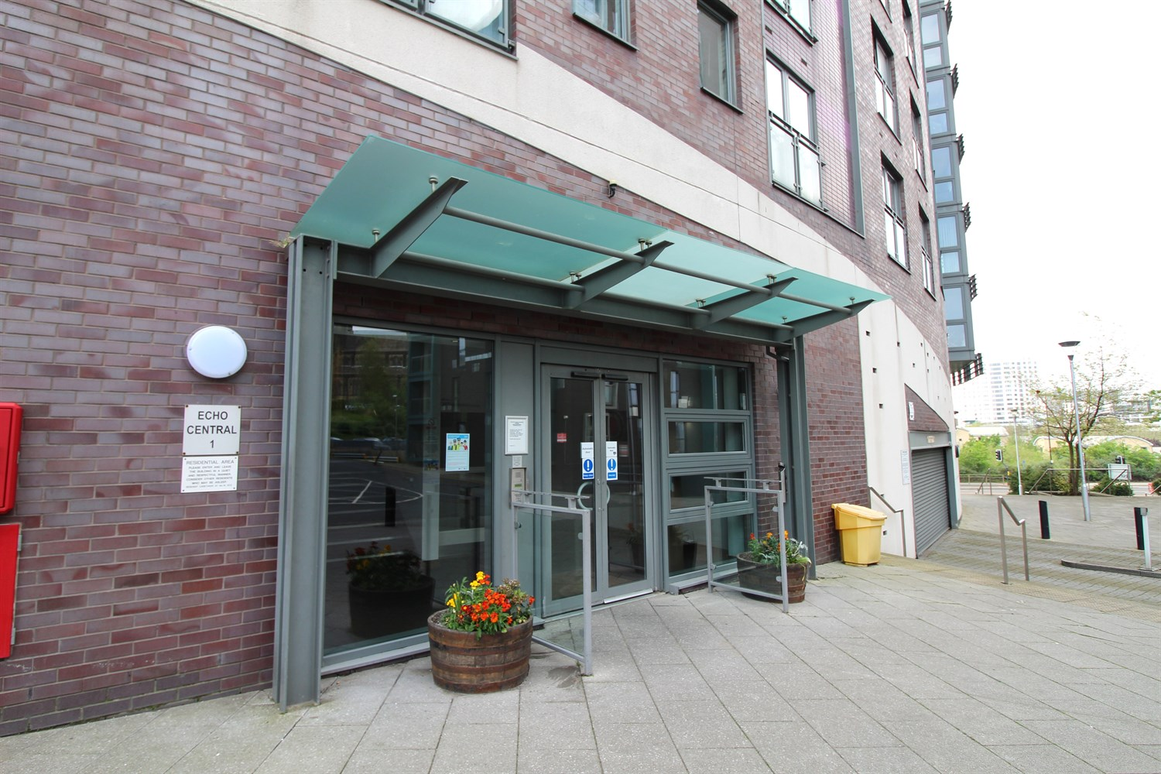

|  |
| --- |
| **Communal Entrance**  Entry via secure video intercom entry system. Stairs and lift to all floors. |
| **Private Hallway**  Secure video intercom entry system. Wall mounted electric heater. Storage cupboard housing the washing machine. |
| **Open Plan Living Room/Kitchen**  Contemporary open plan living room/kitchen with double glazed French doors opening to a Juliet balcony. Wall mounted electric heater. Open plan to the living room and fitted with a range of high gloss wall, base and drawer units. Stainless steel sink with mixer tap. Integrated electric oven and hob with extractor hood over. |
| **Shower Room**  Fitted with a modern three piece white suite comprising shower cubicle, wash hand basin and low level WC. Chrome heated ladder towel rail. Tiled floor. Part tiled walls. |
| **Tenure**  Lease Term - 150 years from Jan 2007 - 134 years remaining The Service Charge is £410.34 per quarter. The Ground Rent is £200 per year. |
| **Home Information**  Service Charge - £410.34 per quarter Ground Rent - £200 per annum Council Tax - Band A Lease Term - 150 years from Jan 2007 - 134 years remaining Heating - Electric Water - Mains connected Broadband - No issues to report Mobile availability - No issues to report EWS1 Rating - B1 Construction type - Concrete and steel frame Flood Risk - Very Low |

|  |  |
| --- | --- |
| These particulars are intended to give a fair description of the property, but their accuracy cannot be guaranteed, and they do not constitute an offer of contract. Intending purchasers must rely on their own inspection of the property. None of the above appliances/services have been tested by ourselves. We recommend purchasers arrange for a qualified person to check all appliances/services before legal commitment.  **Property Ref:** 2290  **For more information, please contact**  0113 258 1150 **|** [sales@adairpaxton.co.uk](mailto:sales@adairpaxton.co.uk) **|** www.adairpaxton.co.uk |  |