

**The Point, Whitehall Place, Leeds**

**For Sale £85,000.00**

***SPACIOUS ONE BEDROOM SECOND FLOOR APARTMENT***9.8% YIELD*** Adair Paxton are delighted to offer this well presented, one Bedroom upper floor flat, a short walk into Leeds City Centre area. The property briefly comprises; communal entrance, private hallway, Open plan living room/kitchen, double bedroom and house bathroom. The apartment is ideally situated within close proximity to all that city living has to offer with fantastic shops, bars, clubs and restaurants. With added benefit from easy access to main roads and train stations. An early viewing is highly recommended to appreciate the accommodation on offer. Council Tax Band - B

**0113 258 1150**

**0800 000 000**

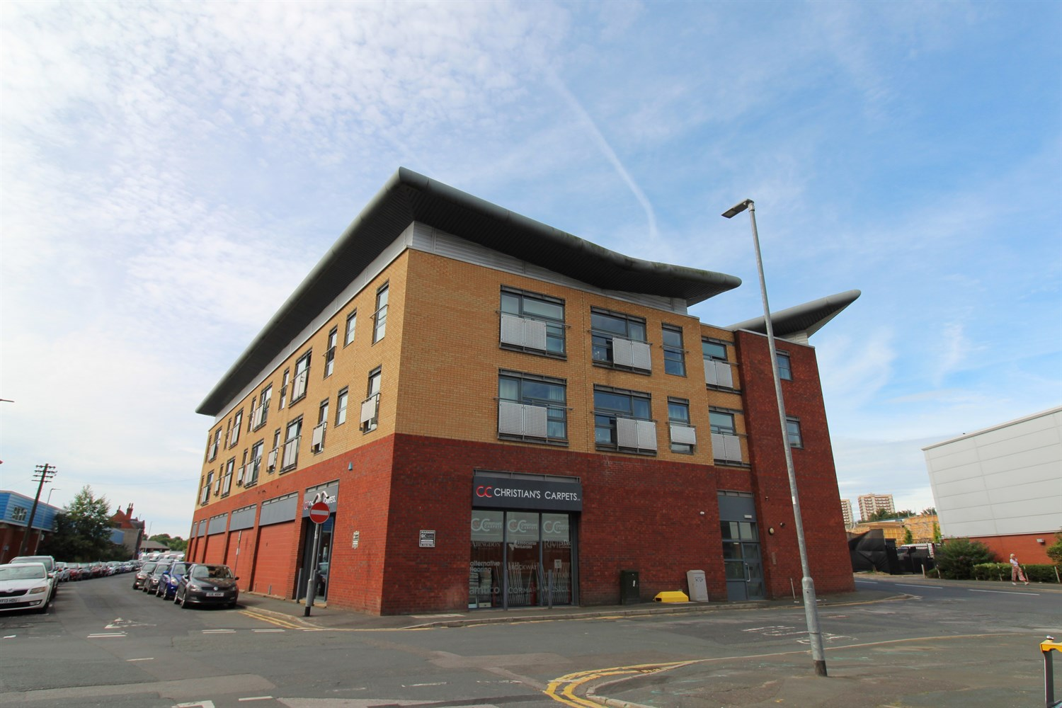



1 Reception(s)

1 Bathroom(s)

1 Bedroom(s)

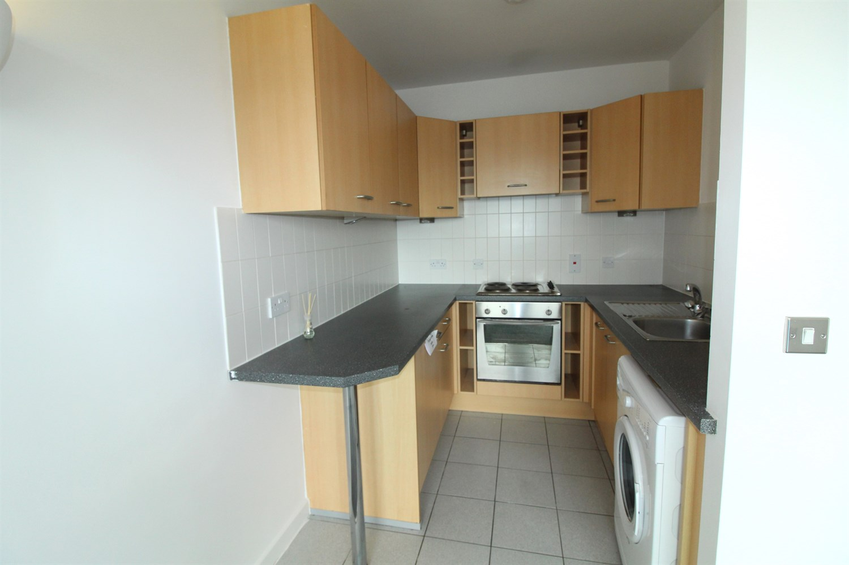

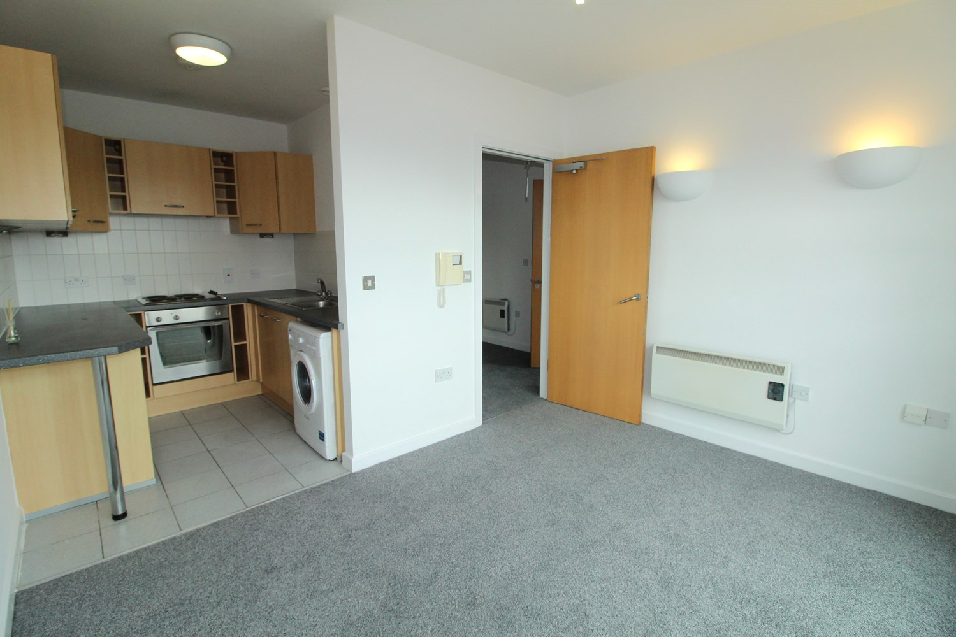

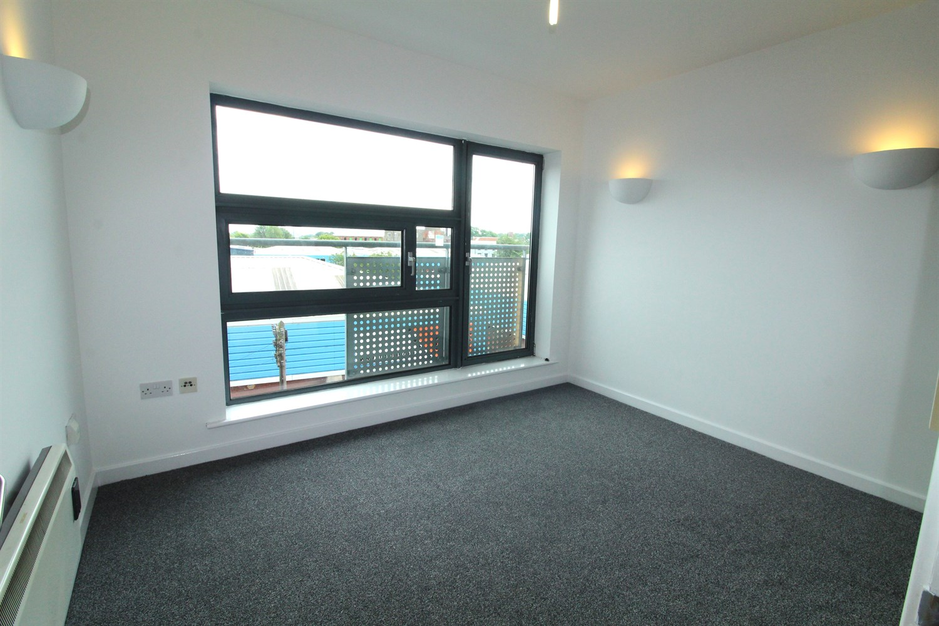

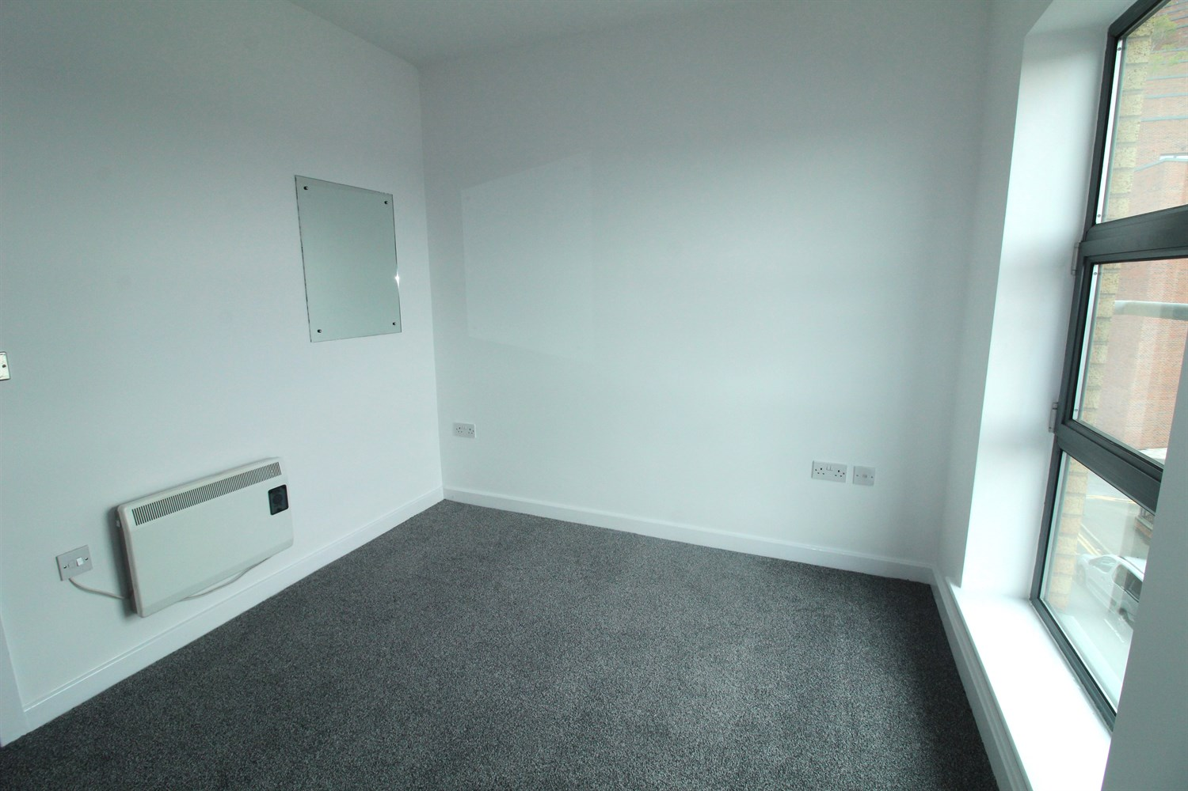

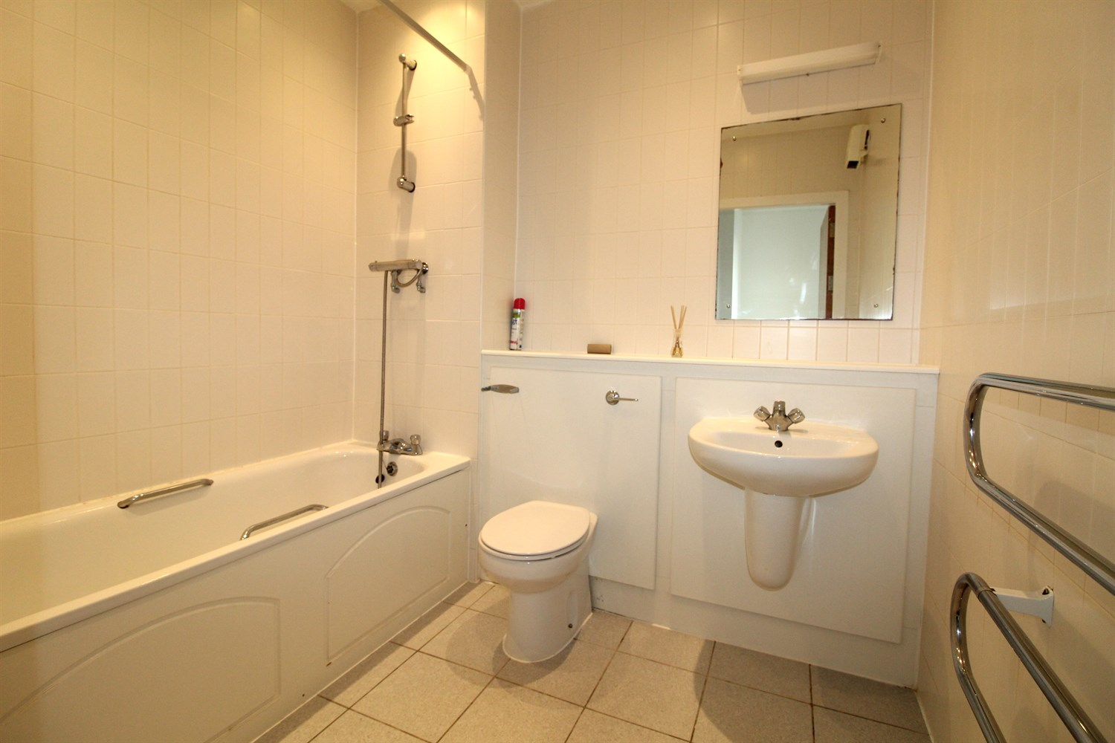

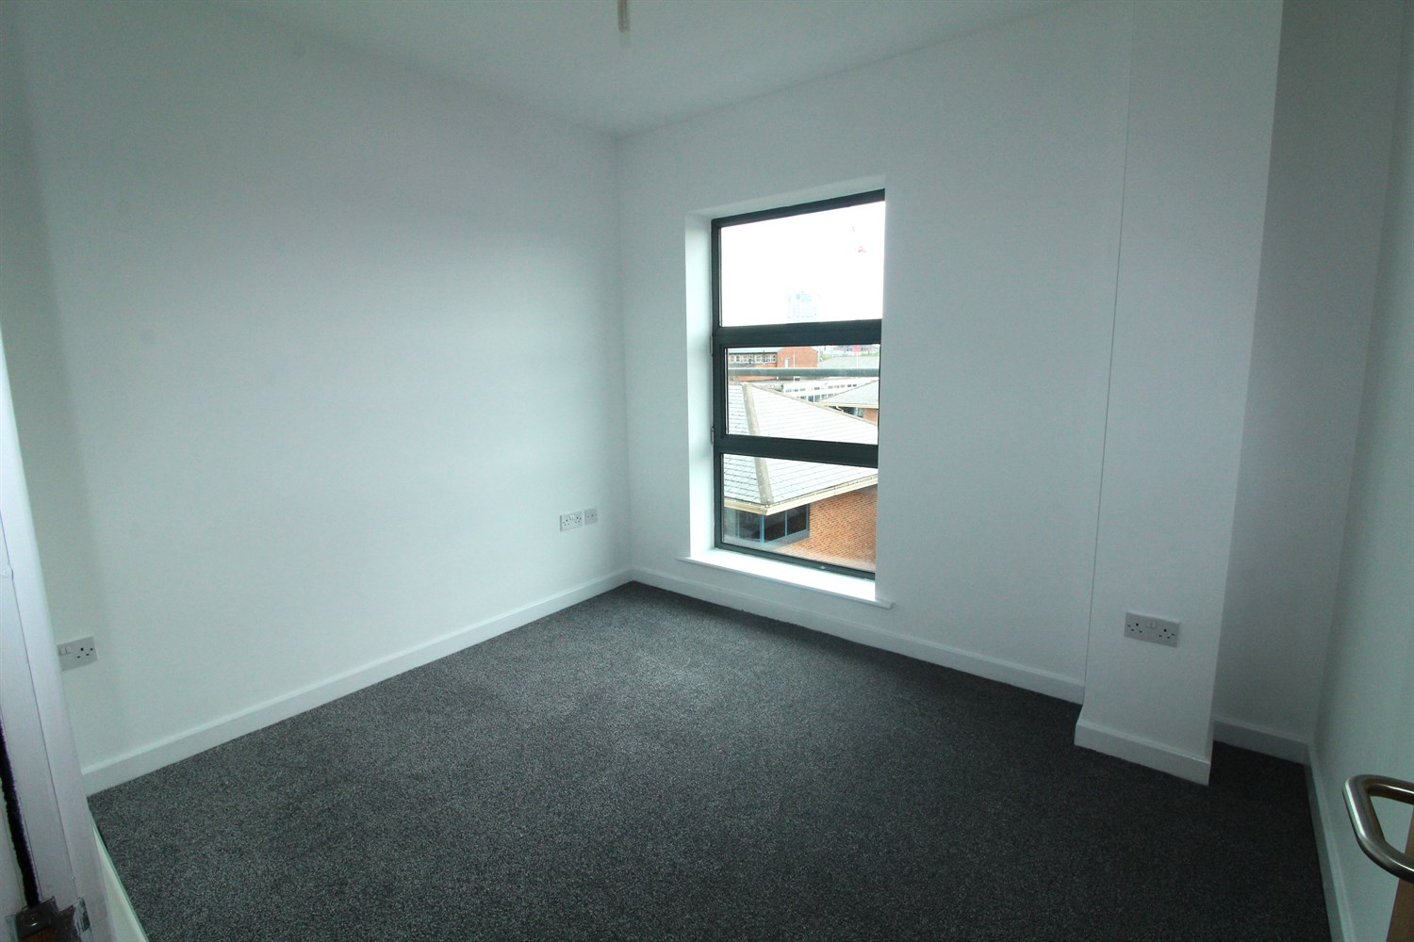

|  |
| --- |
| **Communal Entrance**  Secure communal entrance with video entry system, and access to all floors via stairs. |
| **Private Entrance**  Via front entrance door. Wall mounted electric heater. Storage cupboard housing water heater. |
| **Kitchen**  Fitted with a range of wall, base and drawer units with worktops over. Integrated over with 4-ring hob and extractor hood over. Space for washing machine. Integrated fridge. Part tiled walls. |
| **Lounge**  Light and airy living area with double glazed window and door. Wall mounted electric radiator. |
| **Bedroom 1**  Double bedroom with double glazed window. Wall mounted electric radiator. |
| **Bathroom**  Fitted with a three piece white suite comprising; bath with shower above, WC and wash hand basin. Tiled walls and floor. |
| **Tenure**  Leasehold - 125 years from 2004. Service Charge - £1651 Ground rent - Peppercorn |
| **Home Information**  Service Charge - £1651.56 Ground Rent - Peppercorn Council Tax - B Lease Term - 125 years from 2004 Heating - Electric Water - Mains connected Broadband - No issues to report Mobile availability - No issues to report Construction type - Concrete Flood Risk - Very low |

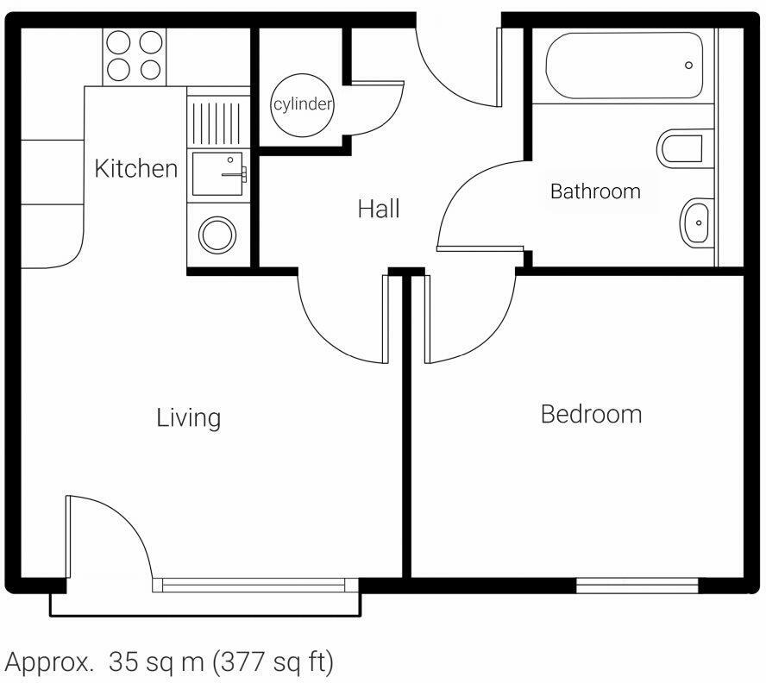

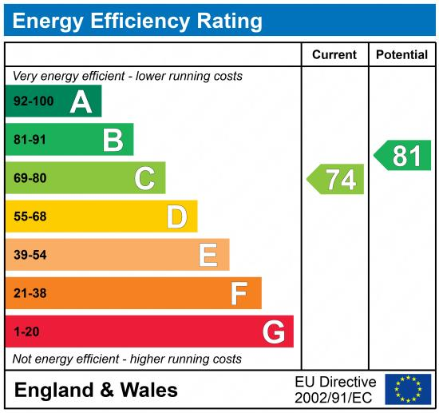

|  |
| --- |
|  |

These particulars are intended to give a fair description of the property, but their accuracy cannot be guaranteed, and they do not constitute an offer of contract. Intending purchasers must rely on their own inspection of the property. None of the above appliances/services have been tested by ourselves. We recommend purchasers arrange for a qualified person to check all appliances/services before legal commitment.

**Property Ref:** 3024

**For more information, please contact**

0113 258 1150 **|** [sales@adairpaxton.co.uk](mailto:sales@adairpaxton.co.uk) **|** www.adairpaxton.co.uk