

**Briar Cottage, Holland Mount, Bramhope**

**For Sale £245,000.00**

**THREE BEDROOM COTTAGE - NO ONWARD CHAIN - FANTASTIC VIEWS OVER OPEN COUNTRYSIDE** Adair Paxton are pleased to offer to the market this three bedroom end terrace house full of charm and character, in the heart of the beautiful and popular village of Bramhope. Just a short stroll to the famous "Fox and Hounds" pub and other local amenities, this lovely property briefly comprises; Hallway, living room and kitchen to the ground floor. To the first floor there are the bedrooms and a house bathroom. Externally the property has gardens to the front and on street parking. Council Tax Band D. EPC rating D.

**0113 258 1150**

**0800 000 000**

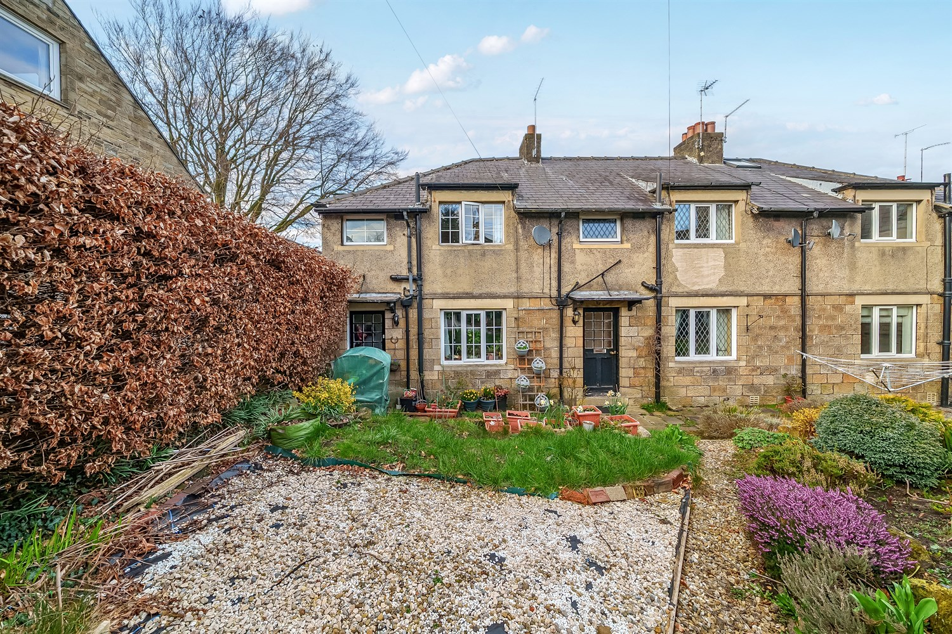



1 Reception(s)

1 Bathroom(s)

3 Bedroom(s)

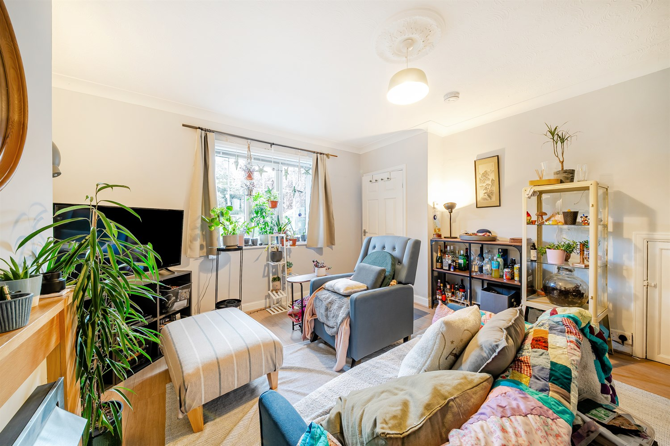

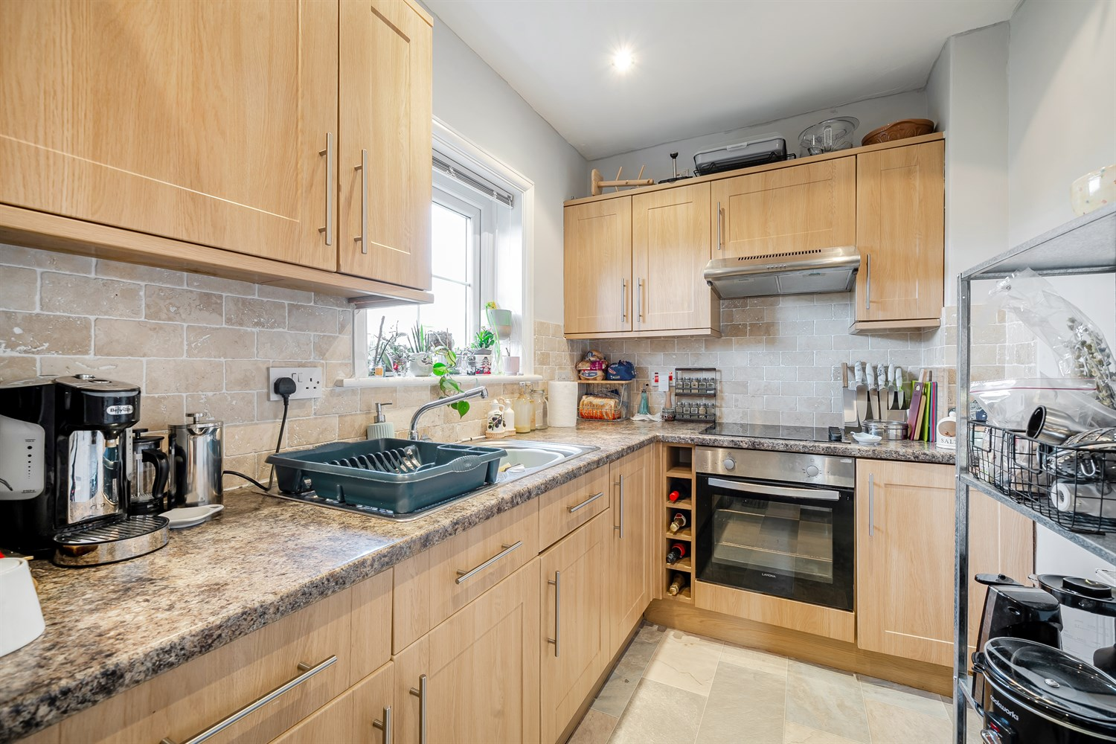

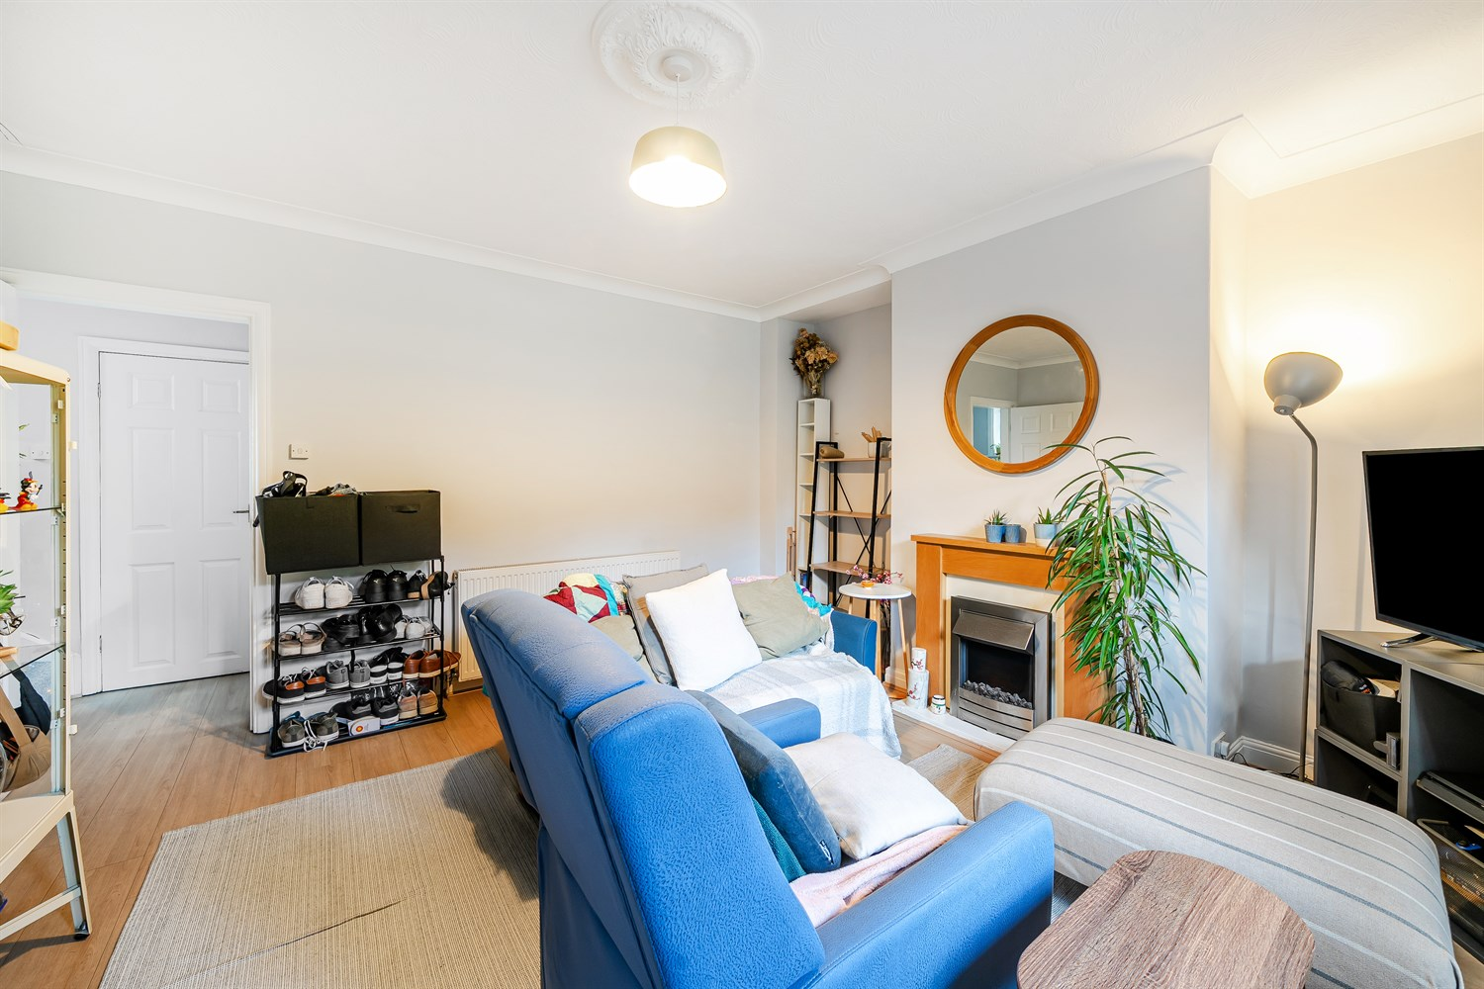

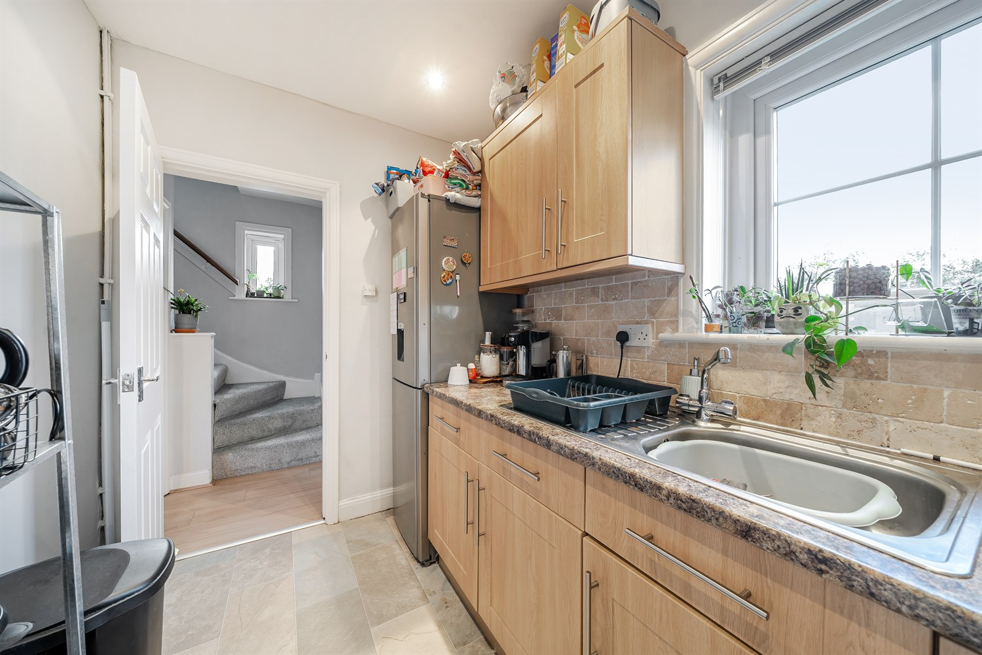

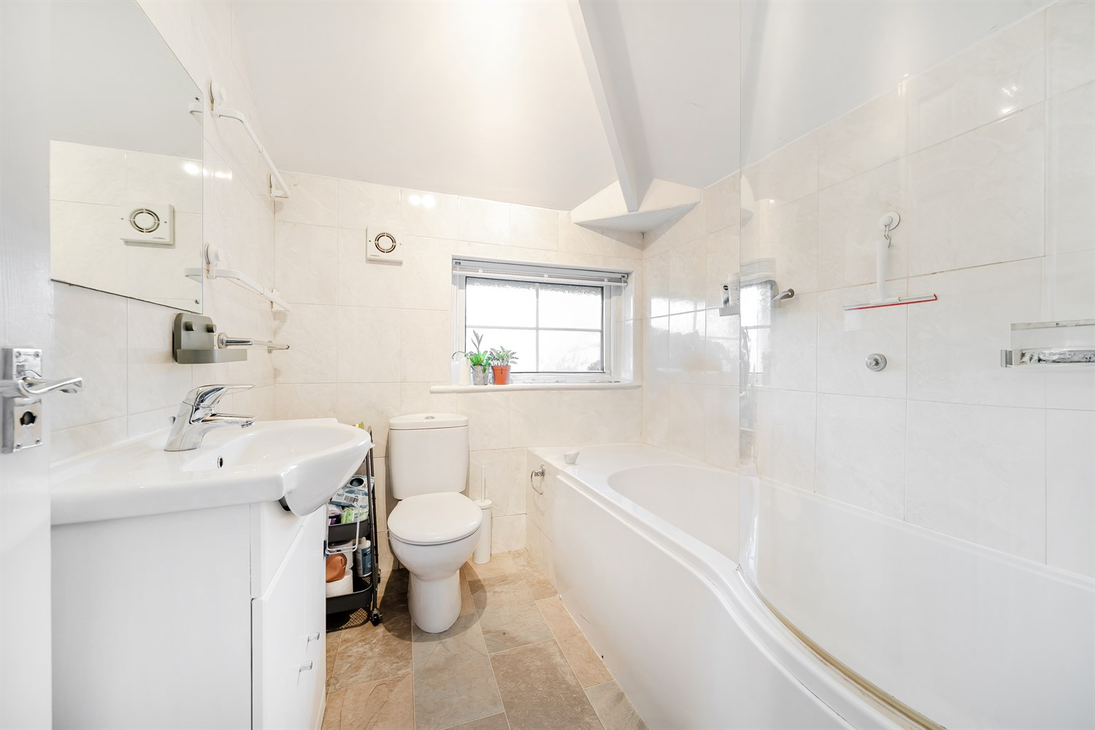

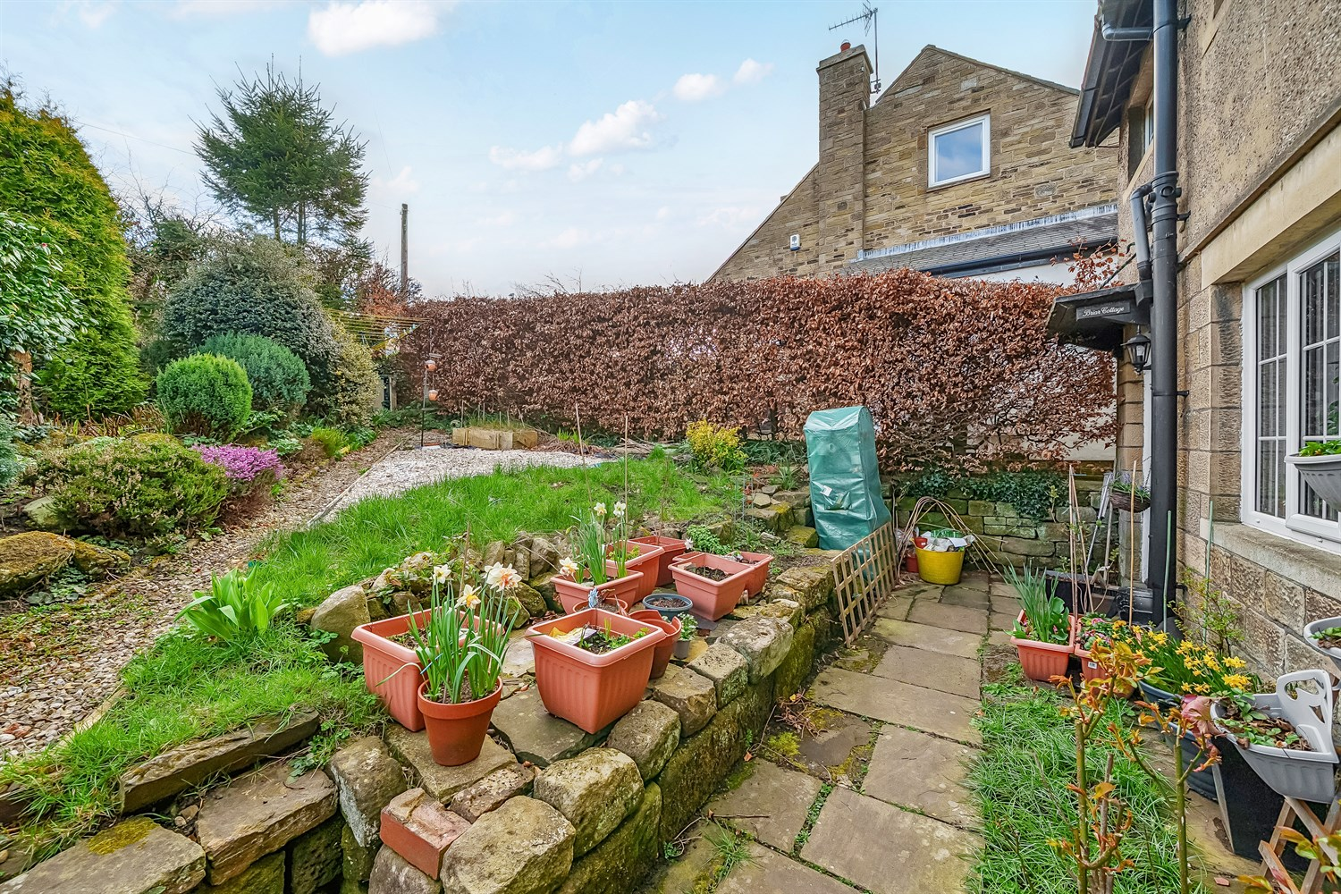

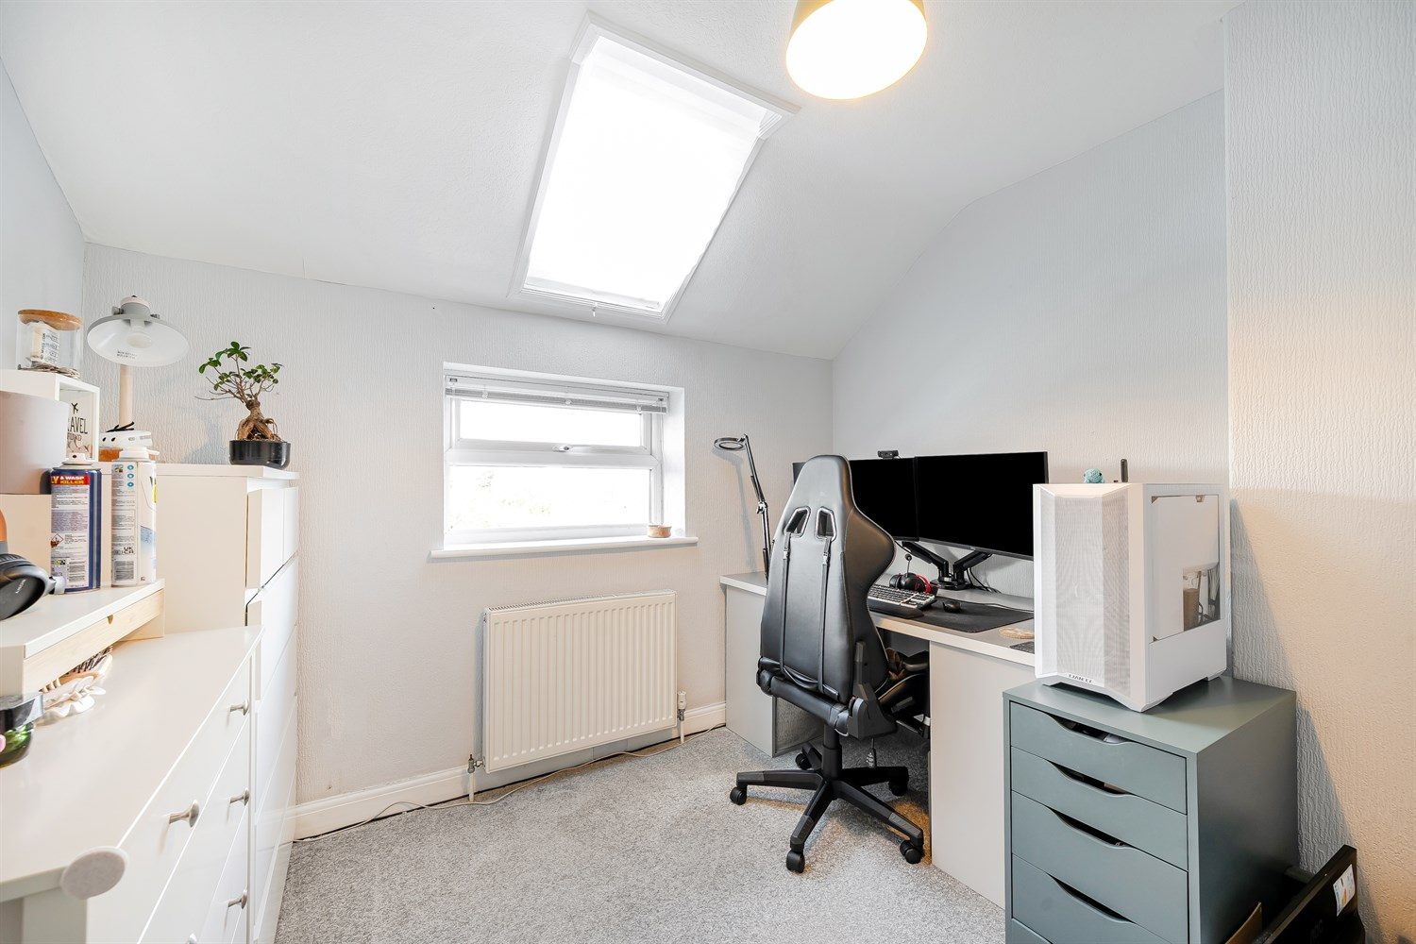

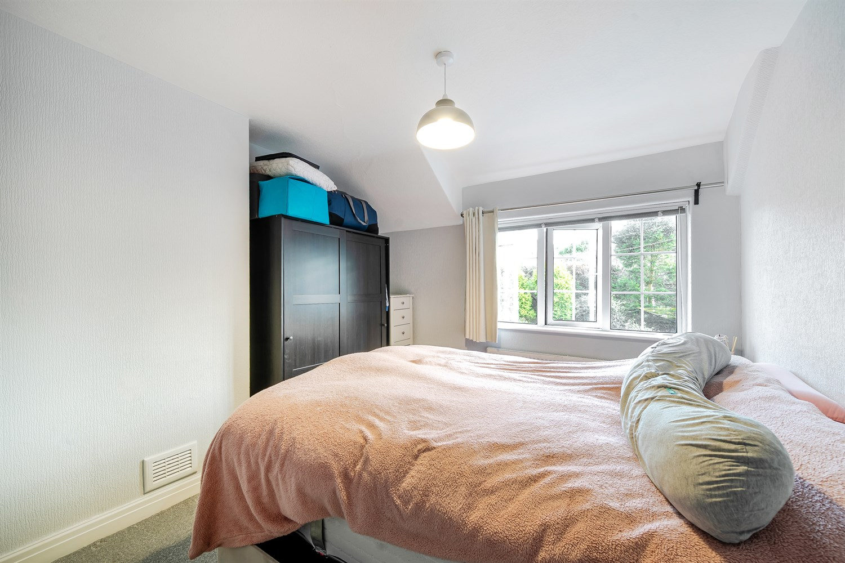

|  |
| --- |
| **Lounge 4.24m (13'11) x 4.24m (13'11)**  Light and Airy living room with double glazed window to front. Gas central heating radiator. |
| **Kitchen 3.28m (10'9) x 1.88m (6'2)**  Fitted kitchen comprising; wall, base and drawer units with worktops over. Integrated oven with 4-ring hob and extractor hood over. Sink with mixer tap and drainer. Tiled walls. Double glazed window. Inset ceiling spotlights. |
| **Utility Room 1.85m (6'1) x .8m (2'7)**  Plumbed for washing machine |
| **Bedroom 1 3.52m (11'7) x 3.32m (10'11)**  Double bedroom with double glazed window to front. Gas central heating radiator. |
| **Bedroom 2 2.96m (9'9) x 2.75m (9'0)**  Second double bedroom with double glazed window to rear offering views over open fields. Gas central heating radiator. |
| **Bedroom 3 2.2m (7'3) x 1.81m (5'11)**  Third bedroom with double glazed window to rear overlooking open fields. Gas central heating radiator. |
| **Bathroom**  Fitted with a three piece white suite comprising; bath with hand shower over, WC and wash hand basin. Tiles walls. Double glazed window. |
| **Outside**  Externally the property has a south facing garden to the front. |
| **Central Heating** |
| **Double Glazing** |

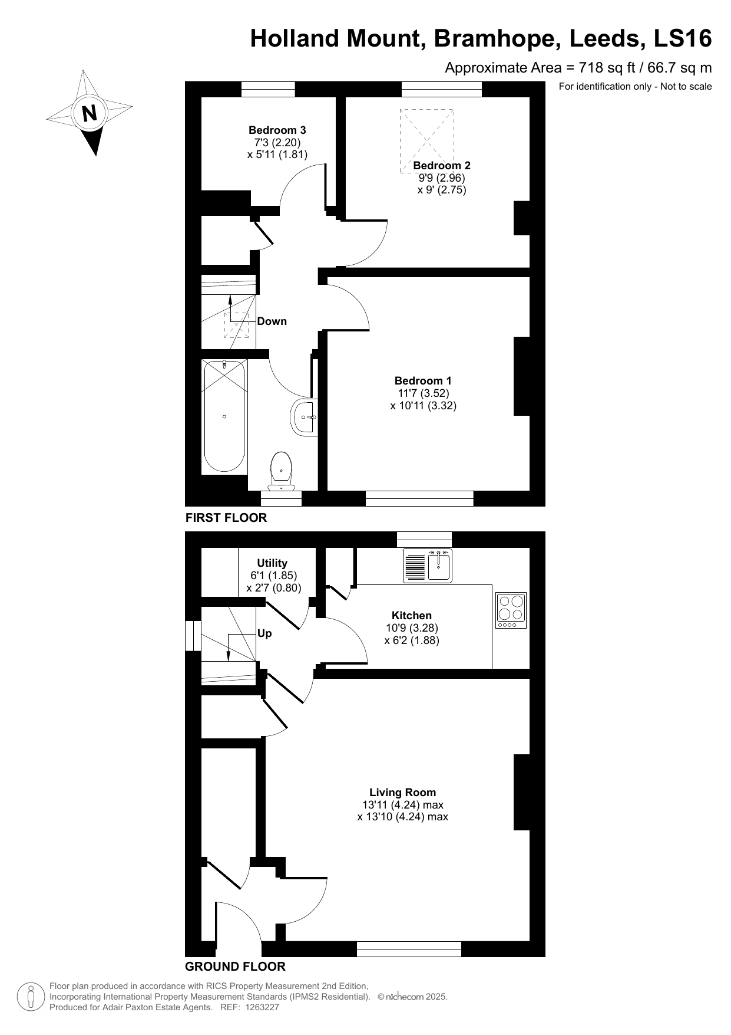

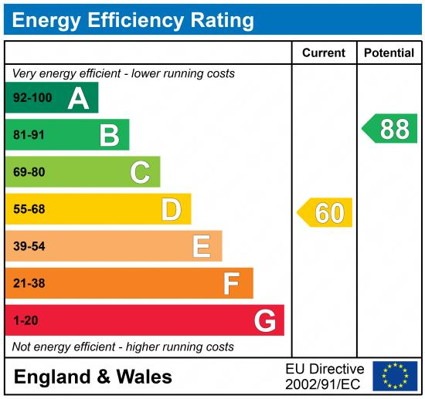

|  |
| --- |
|  |

These particulars are intended to give a fair description of the property, but their accuracy cannot be guaranteed, and they do not constitute an offer of contract. Intending purchasers must rely on their own inspection of the property. None of the above appliances/services have been tested by ourselves. We recommend purchasers arrange for a qualified person to check all appliances/services before legal commitment.

**Property Ref:** 5671

**For more information, please contact**

0113 258 1150 **|** [sales@adairpaxton.co.uk](mailto:sales@adairpaxton.co.uk) **|** www.adairpaxton.co.uk